Household and market survey on availability of adequately iodized salt in the Volta region, Ghana

Faith Agbozo^{a*}, Joyce B. Derª, Nutifafa J. Glover^{b} and Basma Ellahi^{c}

ªSchool of Public Health, University of Health and Allied Sciences, Ho, Ghana; ^{b}Nutrition Unit, Volta Regional Health Directorate, Ghana Health Service, Ho, Ghana; and ^{c}Faculty of Health and Social Care, University of Chester, Chester, UK

*Corresponding author.

Email:faagbozo@uhas.edu.gh
Postal address: University of Health and Allied Sciences, School of Public Health. PMB 31, Ho, Volta region - Ghana

Abstract
Consumption of adequately iodized salt (AIS)≥15ppm is one of the criteria for measuring progress towards universal salt iodization (USI) and sustainable elimination of iodine deficiency disorders. After series of behaviour change interventions aimed at increasing utilization of AIS, this survey was conducted to evaluate extent of achievement of USI. Cross-sectional survey was conducted in 1,961 households and 350 markets to estimate the iodine levels of salt consumed or sold. Three degrees of iodization were estimated from fine, coarse and granular texture salt using MBI rapid field test kits. Differences in iodization levels were determined using Bonferroni test in STATA. Determinants for household utilization of AIS were identified using regression analysis and reported as odds ratio (OR). Availability of AIS in households (24.5%) and markets (30.9%) was far below the 90% recommendation. No differences were observed in urban (26.8%) and rural (24.1%) households. Households that used fine-texture salt (OR: 40.13; CI: 30.1-53.4) or stored salt in original packs (OR: 8.02; CI: 6.01-10.70) were more likely to consume AIS. Across districts, highest household availability of AIS was 51.7% while the least was 7.5%. The district with the highest market availability of AIS was 85.7% while the least was 8.3%. Almost 32% of the traders were aware that selling non-iodized salt was unauthorized but out of this, only 12% sold AIS. Health promotion strategies should emphasis appropriate handling and storage of salt throughout the supply chain. To ensure adequate salt fortification with iodine, improved surveillance of factories and mining sites is recommended.
Key words: Iodized salt; universal salt iodization; household salt; retail salt; iodine deficiency disorders.

Introduction
Iodine is an essential micro-nutrient for humans and animals. It is required to synthesize thyroid hormones which control the body’s metabolic rate. Deficiency of this mineral has a wide range of negative consequences such as still births, congenital abnormalities and decreased cognitive capacity (Mannar and Bohac 2009). Humans require iodine, an essential component of the thyroid hormones, thyroxin, and triiodothyronine(Gebremariam, Yesuf et al. 2013). The World Health Organization (WHO) recommends population requirement of iodine of 150µg/day for adults and adolescents 13 years of age and older, 200µg/day for pregnant and lactating women, 120µg/day for children aged 6–12 years, and 90µg/day for children aged 0–59 months (WHO 2004).
Iodine deficiency disorders (IDD) refers to all the effects of iodine deficiency on growth and development in human and animal populations(Hetzel 2004). IDD are major public health problems in several areas of the world, especially in developing countries. Globally, about 30% of the world's population live in areas with iodine deficiency and its complications (Zimmermann, Jooste et al. 2008). It is reported that at least 350 million Africans are at risk of iodine deficiency. According to WHO estimates, goitre presents in 28.3% of the African population and accounts for approximately 25% of the global burden of iodine deficiency as measured by disability-adjusted life years (Okosieme 2006).
In Ghana, iodine deficiency is a problem with public health significance. It is estimated that 120,000 children born each year are at risk of intellectual impairment due to iodine deficiency in Ghana. Also, approximately 15,600 (13%) of the newborns are severely impaired and are therefore unable to develop properly, resulting in an average of 22 million-dollars loss in productivity (Ghartey 2010). In 1995, less than 1% of households in Ghana consumed adequately iodized salt (AIS) (UNICEF 2008). This situation pre-empted successive government to initiate a combination of educational, legal and economic interventions through the Ministry of Health targeted at individuals, groups and communities to increase iodization of salt at production site, promote sale and consumption of AIS among the general population. As a result, fortification of salts with iodine through the universal salt iodization (USI) programme was implemented in an attempt to minimize the complications associated with iodine deficiency.
Universal salt iodization (USI) has been extremely effective at reducing the burden of IDD and represents a major global public health success. In Africa, great progress has been made towards the elimination of IDD, saving millions of children from its adverse effects, largely due to the increased household availability of iodized salt (Seal, Creeke et al. 2006). USI involves the iodization of all human and livestock salt. Adequate iodization of all salt delivers iodine in the required quantities to the population on a continuous and self-sustaining basis (WHO 2007). In 1994, WHO and UNICEF recommended USI as a safe, cost-effective and sustainable strategy to ensure sufficient intake of iodine by all individuals. The recommendation was for all countries with demonstrated iodine deficiency to make USI mandatory (WHO/UNICEF 1994).
Consequently, Ghana passed a legislation in 1996 to enforce the iodization of all salt following WHO recommendations (Government of Ghana 1996). The legislation mandated the fortification of salt produced for human and animal consumption with potassium iodate (KIO₃) to alleviate conditions associated with iodine deficiency. The target was to cover at least 90% of the population. The standards set in 1996 specified that 100 parts per million (ppm) of potassium iodate be added during production in order to maintain a concentration of 50 ppm at the point of retail. In 2006, these were revised by the National Salt Iodization Committee to 50 ppm during production to achieve a minimum of 15 ppm of KIO₃ at the retail and household levels (Nyumuah, Hoang et al. 2012).
Following the implementation of USI in 1996, a number of surveys were conducted by the Ghana Health Service to assess iodine levels of salt used in households. During the six-year survey period, percentage use of adequately iodized salt (AIS) at the household level did not meet the national target of 90% none follow any peculiar trend. In 2002, almost half (49.1%) of households in Ghana possessed adequately iodized salt. This decreased marginally to 41.5% in the subsequent year and then increased to 74.1% in 2005. In 2006, AIS was found in half (50.8%) of Ghanaian households. Again, this decreased to 32.4% in 2007 and then increased again to 74% in 2008(Ghana Health Service 2005, Ghana Health Service 2007).
Despite these national surveys reporting availability of iodized salt in some households, follow-up surveys conducted during the 2000s to assess prevalence of IDD showed that cases of goitre was persistently high in Ghana(Ghana Health Service 2000). Therefore, following the Food and Drugs Board amendment Act (Act 523 of 1996), the Ministry of Health and the Ghana Health Service launched and propagated health promotion and educational campaigns to create awareness about the importance of consuming AIS(Ghana Health Service 2005).
Health education, the core component of health promotion, was the main strategy to achieve their objective. Stakeholders in the salt supply chain were empowered with information on the benefits of using iodized salt and the effects of deficiency. Through the Nutrition Department of Ghana Health Service in partnership with UNICEF, the new communication and advocacy campaign on USI in Ghana was launched in October 2013. It was dabbed the ‘smart salt campaign’. The aim was to sensitize and solicit support of stakeholders on iodized salt.
Mass social mobilization campaigns in the print and electronic media as well as face-to-face awareness activities in communities, schools, public places and health facilities were initiated to increase the number of households consuming AIS. Ultimately, the goal was to improve iodine nutrition of Ghanaians thereby minimizing incidence of iodine deficiency complications such as goitre, growth and mental retardation. As part of the health promotion strategy to increase use of AIS, health protection regulations and policies were enacted and in some cases strengthened. This included the policy on mandatory labeling of commercially processed salt with as either or not iodized. Earlier in 2006, the President's Special Initiative on Salt was established in Ghana with the mandate to promote salt iodization.
The synergetic effect of the above health promotion interventions targeted at health education, prevention and protection resulted in increased awareness on salt iodization. For instance, between 1991 and 1993, a study conducted to assess the prevalence and severity of iodine deficiency disorders in Ghana revealed that 98% of respondents had no knowledge about iodized salt (Asibey-Berko 1995). However, in 2012, a cross-sectional survey conducted in the Bia district of the Western region showed that 90.4% of the respondents had some knowledge about iodized salts. Nonetheless, this high knowledge was not commensurate with the use and consumption of iodized salt as 35.4% of the study households were found to have no iodized salt(Buxton and Baguune 2012).
The Volta region located in the south-eastern part of Ghana is one of the ten regions with poor health indicators. Results of the multiple indicator cluster survey conducted in 2006 showed that only 2% of households in the Volta region used adequately iodized salt(Ahiadeke, Ackah et al. 2012). Consequently, the nutrition unit under the Volta regional health directorate initiated series of health promotion interventions in all 25 districts of the region to educate and empower individuals, households and communities so as to facilitate and encourage behavioral and socio-environmental responsive actions and changes conducive to the healthy lifestyle of purchasing and consuming adequately iodized salt. Concurrently, salt mining communities and firms in the region were also sensitized on the legislative instrument on salt iodization to ensure that at the point of production, iodization of salt is done per the national regulation of 50 ppm potassium iodate. In line with activities of the nutrition unit, this survey was intended to evaluate impact of these behaviour-change communication strategies on iodine levels of salt used in households and sold across market centers in the region with the aim of assessing the extent to which universal salt iodization is achieved.

Methods

Study location
The survey was conducted in the Volta Region which is one of 10 administrative regions in Ghana with Ho as the regional capital. The region is located along the southern half of the eastern border of Ghana and shares border with the Republic of Togo. Internally, the region shares boundary with four regions. Greater Accra, Eastern and Brong Ahafo regions are to the west, Northern Region to the north and Gulf of Guinea to the south. The region covers a total land area of 20,570 km² with a total population of 2,118,252 consisting of 495,603 households of which 33.7% are located in the urban areas with the remaining being rural settlements (Ghana Statistical Service 2012).The region has 25 administrative districts consisting of five municipalities and 20 ordinary districts. Apart from two districts that were omitted from the survey due to technical challenges, the remaining 23 districts partook in either or both the household and market surveys.

Study design and sampling
The study was designed as a cluster randomized cross-sectional household and market surveys. At the household level, the target population were members of households mainly involved in food purchasing and/or preparation while for the market survey, traders who sold salt were the target population.
Twenty-three out of the 25 districts in the Volta region participated in the household survey. Each district was further divided into clusters originally known as sub-districts. Out of the 103 sub-districts randomly sampled, 183 communities dotted across rural and urban areas of the region involving 1,961 households were randomly included in the survey. The number of households was determined using a sample size formula for cluster surveys at 2.2% margin of error with the assumption that 14% of households in the Volta region used non-iodized salt (Ahiadeke, Ackah et al. 2012).On the contrary, the market survey was conducted in only 13 districts. These 13 districts had market centers that served at least 5,000 inhabitants. At each of the markets, traders who sold salt were recruited onto the study using the systematic sampling method. In all, 350 salt traders were randomly selected with an average of 25 traders from each of the 13 districts.

Data collection procedures
Simple structured routine field questionnaires were used to gather the needed information through face-to-face interviews, observations and testing of salt samples for iodine.
Data was collected between August and November 2014 by trained field workers who were either technical nutrition officers or community health nurses in the Ghana Health Service. Textures and crystal sizes of the salt samples were categorized as fine, coarse and granular. In addition, method of storage and how the salt was displayed for sale were observed and recorded.
Homemakers provided responses to questions ranging from the texture of salt used for household meal preparations, why iodized salt should be used for cooking and observation of how household salt was stored. The salt traders on the other hand were asked the source of supply/purchase of the salt, why iodized salt should be consumed and awareness of the prohibition of sale of non-iodized salt in Ghana. The type and texture of salt sold as well as how the salt was presented or packaged for sale were observed and documented.

Testing iodine content of salt
Each interviewer was given the UNICEF-supplied salt iodization test kits manufactured by MBI in India for estimating potassium iodate levels in salt (registration number: M009; production date: July 2012; expiry date: December 2014). The kits provided good qualitative indication of the presence of iodine and could discriminate between iodine levels at zero ppm, less than 15 ppm and ≥15 ppm. Evaluation of the degree of iodization was based on the colour change observed as against the three different levels of estimation.
Upon adding a drop or two of the test solution to the salt sample, adequately iodized salt (iodine ≥15 ppm) turned dark blue during testing; inadequately iodized salt (<15 ppm) turned light blue and where no iodine was present (zero ppm), there was no change in colour of the salt. However, the test kit could not measure the exact iodine content of salts. Also supplied with the test solution was a retest solution designed for rechecking and verification of iodine indications at zero and less than 15 ppm. The retest solution lowered the pH in salts with high alkalinity and thus increased the likelihood of detecting slight changes in iodine.

Statistical analyses
Data was entered into SPSS (version 20.0) and transferred into STATA (version 11) for analysis. Frequencies and percentages were calculated for the degrees of iodization. Differences between the three levels of iodization were determined using Chi-square and Bonferroni tests at statistical significance level of p<0.05. Where differences were observed, variables that generated the differences were determined using LSD (least significant differences), a form of multiple comparisons post-hoc test. Multiple logistic regression analyses were done to determine the factors that significantly predicted the sale and household usage of adequately iodized salt.

Ethical considerations
Ethical approval was obtained from the Research Ethics Committee of the Faculty of Health and Social Care at the University of Chester in the United Kingdom (RESC0514-517). Verbal informed consent was obtained from all homemakers and salt traders who had voluntarily agreed to participate in the survey.

Results

Availability and use of adequately iodized salt in the households

Levels of iodization of salt samples available in households and the storage methods
Out of the 1961 households visited, salt samples tested in a quarter of the households (24.5%, n=483) were adequately iodized (≥15ppm). Salt samples tested in 695 households representing 35.4% were found to be inadequately iodized (<15ppm) while in the remaining 783 households (39.9%), the salt samples tested contained no iodine (zero ppm potassium iodate).
Almost half (46.8%, n=917) of salt types available in the households were coarse in texture with the remaining being either granular (29.0%, n=569) or fine (24.2%, n=475). The salts with fine texture were refined packaged brands processed and distributed by salt manufacturing companies. The main brands identified were Annapurna® and U-too® iodized salt. Typically, the coarse and granular salt types were directly supplied from indigenous salt mining companies along the coastal belts of Ghana. In almost half of the households visited, salt was stored in covered plastic and glass containers (49.7%, n=975) while in 37.8% of the households, it was stored in either open containers (18.0%, n=352) or in polythene bags (19.8%, n=388). In the remaining 12.5% (n=246) of the households, salt was used from the original packs in which they were purchased. Of the 24.6% households (n=483) whose salt samples was adequately iodized, 26.8% (n=109) and 24.1% (n=374) were found in urban and rural households respectively (p=0.190).
Table 1 show that both texture of salt and method of storage were significantly associated with iodine levels. Over 77% of salt that was fine in texture was adequately iodized compared to 6% and 10% of the coarse and granular types respectively (<0.0001). Also, 65.0% of salt stored in the original pack significantly contained the highest iodine level.
Households that used fine salt were 40 times more likely to consume AIS compared to households that used coarse and granular salt (OR: 40.13; CI: 30.1-53.4). Similarly, households that stored salt in their original packs were eight times more likely to consume AIS compared to households that stored salt in uncovered containers (OR: 8.02; CI: 6.01-10.70).

Homemakers knowledge on benefits of using adequately iodized salt
Generally, homemakers’ knowledge on the benefits of using AIS was good. Sixty-eight percent of the homemakers knew the importance of consuming iodized salt. Advantages mentioned included goitre prevention (34.5%), brain development (13.5%) and proper child growth (12.6%). Other advantages cited included increase productivity and prevention of miscarriages. However, this knowledge did not translate into household availability and usage of AIS because out of the 1,340 homemakers who knew the essence of consuming iodized salt, only 414 of them (21.1%) possessed adequately iodized salt in their homes.

Availability of adequately iodized salt in market centres

Levels of iodization of salt types sold on the markets, source of supply and storage methods
From the market survey, it was observed that iodine content of the 350 salt samples tested at the 13 market centers across the Volta region were almost evenly distributed between the three levels of iodization. Adequately iodized salt (≥15ppm) was 30.9% (n=108), inadequately iodized salt (<15ppm) was 36.3% (n=127) and non-iodized salt (0ppm) was 32.9% (n=115).
Quarter (n=84) of the tested salt sample was coarse in texture 45.1% (n=158) was granular and the remaining 30.9% (n=108) samples were fine in texture. According to the traders, most of the coarse and granular salt types were purchased from salt mining sites along the coast of Ghana. Specifically, 57.1% of the traders had their salt supplied from the Ada mining site, 15.7% from Keta basin and 8.9% from Saltpond/Elmina area. The remaining proportion (17.7%) was the factory-processed salt brands supplied by key distributors.
Out of the 350 salt samples tested on the markets, nearly half (44.6%, n=156) was observed to be stored in large receptacles and openly displayed for sale. Only 18.6% (n=65) was protected in large transparent polythene bags. Salt sold in the original packs was 29.7% (n=104) while the remaining 7.1% were dispensed into handy miniature polythene bags and sold at relatively lower prices. As in the case of the household salt, table 2 shows that a higher proportion of the fine texture salt found on the market was adequately iodized (60.2%). Similarly, 62.5% of the salt sold in their original packs was adequately iodized.

Traders knowledge on benefits of using adequately iodized salt
Just as observed in the household survey, knowledge of salt traders on the benefits of using AIS was good. However, a forth (n=93) of the traders were unaware of any benefits. Again, a third of traders (n=238) knew that sale of non-iodized salt was unauthorized in Ghana. Yet only 12.3% (n=43) of this group sold adequately iodized salt (p=0.006).

Comparison of iodine levels of salt in households and markets
Table 3 shows a comparison of the proportion of adequately iodized salt sold on markets and available in households across the region. Apart from three districts, there were generally no significant differences in the proportions of adequately iodized salt found in households and markets. Figures 1 a/b is a pictorial presentation of the percentage categories of AIS recorded in the region. Although none of the districts met the WHO criteria of 90% universal salt iodization, at the household level, North Dayi district was found to possess the highest proportion of adequately iodized salt (51.7%) whereas Biakoye district had the least proportion of AIS (7.5%). Similar to findings on the household availability of iodized salt, again North Dayi district recorded the highest percentage of AIS (86%) at the retail point. Conversely, adequately iodized salt was the least available (8.3%) at market centers in the Nkwanta South district.

Discussion
Although 68% homemakers and 73% traders were aware of the health benefits of consuming adequately iodized salt, only 24.5% of household salt and 30.9% of salt sold in markets had iodine above the recommended 15ppm. Both the household and market surveys revealed that fine salt in texture and salt sold or stored in the original pack were the most adequately iodized. Typically, the fine salt type are manufactured and packaged by salt processing companies who tend to follow the fortification regulations due to the ease of follow-up on their activities.
Universal salt iodization (USI) is the recommended intervention for preventing and correcting IDD. The Ghana national guideline on salt iodization was revised in 2006 with the minimum amount of KIO3 in salt at the household and retail levels reduced to 15ppm. Between the year 2002 and 2008, report of national surveys on household availability of AIS were inconsistent with proportions of AIS ranging from 32% to 74%. As a result, the Ghana Health Service through its allied bodies renewed efforts to achieve the 90% USI targets set by the WHO and International Council for Control of IDD by promulgating health promotion campaigns to improve the iodine nutrition of the Ghanaian population.
In 2012, findings reported by Ahiadeke’s analysis of the nationally representative multiple indicator cluster survey of Ghana for the year 2006 presented Volta region as the region with the least proportion of AIS (2%). This was closely followed by the northern and Upper East regions recording 4% each and the Central and Upper West regions with 5% availability of AIS. Conversely, Greater Accra and Ashanti regions had the highest proportion of AIS (24%) (Ahiadeke, Ackah et al. 2012). Compared to the 2% household availability of AIS recorded in 2006, findings from this present study shows that a quarter of households in the Volta region possess AIS. Although this is far below the 90% target, it is an indication that the health promotion strategies initiated by the nutrition unit of the Volta regional health directorate to increase the consumption of iodized salt such as radio programmes and educational activities in schools, clinics and community centers to raise awareness regarding the benefit of iodine is positively affecting the behaviours and choices of individuals, families and communities within the region.
This study revealed that 68% of the homemakers and 73% of the traders who sold salt were aware of the health benefits of consuming AIS. These findings are comparable with that observed in a cross-sectional study in the Bia District of the Western region in which knowledge and practices regarding iodine deficiency disorders and intake of iodized salt were assessed (Buxton and Baguune 2012). According to the authors, 72% of the respondents who were responsible for meal preparation were aware of fortification of salt with iodine. Also, the iodine content of 75.6% of the tested salt samples was above 25 ppm. However, due to variability in the levels of iodization measured in this study as against that used by Buxton and Baguune, it is difficult to make comparisons of the iodine content of the salt samples tested in the two studies. Again, unlike their study which was conducted at the district level, this survey had a wider coverage making it regionally representative.
Although consumers’ knowledge regarding benefits of consuming iodized salt is good, same cannot be said of appropriate salt handling. For instance, Buxton noted that 43% of respondents were not aware of the volatility of iodine in unprotected salt (Buxton and Baguune 2012). In this study, while 31% of salt tested at the markets contained 15ppm potassium iodate, there was a 6%-point reduction at the household level. Methods of handling of the commodity at the retail point could account for the reduction in iodine levels from retail to consumption point.
Similar studies conducted in Africa showed varied findings. In 2012, a community-based cross-sectional study that assessed the availability of adequately iodized salt at the household level in Gondar town in Ethiopia revealed a 28.9% availability of AIS (Gebremariam, Yesuf et al. 2013). In 2014, another study conducted in Laelay Maychew district also in Ethiopia with the aim of assessing the availability of iodized salt in rural communities showed that utilization of adequately iodized salt was 33% with 44% respondents having no knowledge of the benefits of consuming iodized salt (Gidey, Alemu et al. 2015). However, the regional average of 24.5% iodization level recorded in this study is lower than the national coverage recorded in Tanzania (58.4%) and Egypt (68.3%) (Izzeldin 2010). This situation necessitates the intensification of health educational programmes and public awareness campaigns on iodized salt use. To this regard, the general public especially homemakers in charge of meal preparation have to be empowered to identify iodized salt.
A number of factors such as storage duration, storage condition, size of the crystals, impurities, moisture, ambient temperature, humidity and sunlight exposure are known to influence stability of iodine in salt, (Stewart, Solomons et al. 1996).Therefore changing environmental conditions that occur during storage and distribution could lead to iodine losses in unprotected salt (Diosady 2004).Unlike the market survey where 45% of the salt was exposed to the atmosphere, storage practices observed in households was fairly good with over 82% of the salt samples properly stored either in covered containers, polythene bags or in original packs. This finding is comparable to studies in South Iraq and Ethiopia (Takele, Belachew et al. 2004, Ebrahim and Muhammed 2012, Gidey, Alemu et al. 2015).
It was found in this study that fine texture salt and salt stored in the original packs had higher levels of iodine. The fine types are usually commercially processed in factories where standardization regulations are typically not compromised. Hence it was expected that 90% of the ‘fine’ salt was to be adequately iodized but this target was not met in either the household or market survey. Despite this short-fall, some adherence with iodization protocols coupled with protection offered from the packaging may contribute to the relatively higher estimated iodine levels found in the fine salt types. Similar studies in industrialized and non-industrialized countries such as Canada, Iraq and Ethiopia have shown that iodine content in packed salt is mostly adequately iodized than non-packed salts and this is due to good storage in a suitable environment and keeping away from sunlight (Ebrahim and Muhammed 2012, Gebremariam, Yesuf et al. 2013).
It was not surprising that only 32% of traders knew that sale of non-iodized salt was unauthorized in Ghana because just one third of AIS was found on the markets surveyed. Considering availability and accessibility of small-scale salt producers to the region, universal salt iodization targeted at 90% of households should have been attained. But this was not the case. Non-adherence to salt production protocols has been cited as a major factor adversely affecting the achievement of USI and consequently availability of adequately iodized salt at the household level(Affam and Asamoah 2011). Apart from the levels of iodine added during production, other factors affect the stability and adequacy of iodine in salt. In this study, if only a fifth of salt produced and purchased from Ada and Keta mining sites (the two major mining sites in Ghana) were adequately iodized, then it will have repercussions on the household availability of AIS. Again, 70% of the retail salt was purchased from small-scale salt producers, placing emphasis on the need to target this group in the health promotion programmes on USI.

Implications for public health promotion and education
In both the household and market surveys, the North Dayi recorded the highest proportion of AIS and thus made tremendous progress towards achieving USI in the region. Reasons for this achievement could be investigated and best practices replicated across the region using the positive deviant behavior and social change approach to promote iodine nutrition. To ensure that this healthy lifestyle is sustained and improved, effective community action and supportive environment should be promoted through dissemination of findings to community members to create self-awareness and zeal for greater achievement.
Key activities created supportive environments at a variety of levels by providing instrumental supports such as food vouchers or supplements, group support,
As means of increasing purchase and subsequently consumption of AIS, it is important that more AIS are made available at market centers. To this end, health protection measures such as the reinforcement of Ghana’s legislation on USI is required. Salt traders should be particularly targeted for health promotion interventions on USI. This should include education on regulations on salt iodization and field visits to ascertain compliance. Investigations into the health promotion policy to identify obstacles to the adoption of USI might be necessary. Monitoring division of regulatory bodies should improve on their surveillance systems at small scale salt mining sites and factories to ensure adherence to salt iodization regulations at point of production.
As was done in the UNICEF-supported smart salt campaign, salt traders could be given iodine kit test salt sold by small scale salt procedures before purchase.
To achieve universal salt iodization, tailored education and health promotion activities on production, marketing and consumption of adequately iodized salt at all levels of the supply chain should be intensified. Public education should place emphasis on appropriate handling and storage conditions for iodized salt in order to conserve the iodine. Also, the general public should be made aware of guidelines on production, packaging, distribution, retail, and storage of salt.
Progressively, the nation will have to consider the option of making only refined packaged salt available at the retail level as this study has shown that salt that is fine in texture and properly packed is better iodized and also protected from adverse weather conditions than those purchased from small scale salt miners and producers.

Strengths and limitations of the study
This is one of the few studies in which iodine content of salt has been measured at the retail point. Besides, the household survey involved almost 2,000 households recruited from rural and urban communities of the Volta region thus making findings from the household survey regionally representative and results generalizable. On the other hand, generalizing findings from the market survey to the entire region should be done with caution as only half of the districts within the region were included in the market survey. Finally, testing of iodine levels in salt was mainly qualitative and hence provided estimates of the iodine content. Therefore, the exact amount of iodine in the tested salt samples could not be ascertained.

Conclusion
Availability of adequately iodized salt at market centers and in households across the Volta region was far below the recommended 90% target. Households that used commercially packaged refine brands of salt had the highest likelihood of consuming adequately iodized salt. To achieve USI, health promotion interventions targeted at salt procedures, distributors, retailers and consumers should place emphasis on the impact of adequate salt iodization on public health. This should involve health education and public awareness campaigns on proper handling of salt at all stages of the supply chain, health prevention through counseling on the essence of consuming AIS and routine testing of salt for iodine and finally, health protection through law enforcement on USI.

Conflict of Interests
The authors declare that they have no conflict of interests.

Acknowledgment
We acknowledge Prosper Evadzi at the Institute for Coastal Research, Helmholtz-Zentrum Geesthacht, Germany, for converting some of the data into geographic information. Thanks to the Ghana Health Service Volta Regional Health Directorate especially the Director, staff of the Nutrition Unit, as well as the District Nutrition Officers and Community Health Nurses who assisted with data collection.

References
Affam, M. and D. Asamoah (2011). "Economic potential of salt mining in Ghana towards the oil find." Research J. Environ. Earth Sci3(5): 448-456.
Ahiadeke, C., C. Ackah, R. Aryeetey and A. Acquah (2012). "Factors influencing the use of adequately iodated salt in Ghana." African Journal of Food Science6(3): 58-64.
Asibey-Berko, E. (1995). "Prevalence and Severity of Iodine Deficiency Disorders in Ghana. ." Proceedings of the National Workshop on Iodine Deficiency Disorders in Ghana: 15-23.
Buxton, C. and B. Baguune (2012). "Knowledge and practices of people in Bia District, Ghana, with regard to iodine deficiency disorders and intake of iodized salt." Archives of Public Health70(1): 5.
Diosady, L. L. (2004). "Stability of iodine in iodized salt used for correction of iodine deficiency disorders." Food and Nutrition Bulletin2: 240–250.
Ebrahim, S. and N. Muhammed (2012). "Consumption of iodized salt among households of Basra city, South Iraq." EMHJ18(9).
Gebremariam, H. G., M. E. Yesuf and D. N. Koye (2013). "Availability of Adequately Iodized Salt at Household Level and Associated Factors in Gondar Town, Northwest Ethiopia." ISRN Public Health2013.
Ghana Health Service (2000). Annual Report for the Year 2000. Accra, Ghana, Ghana Health Service.
Ghana Health Service (2005). Imagine Ghana Free of Malnutrition: A Concept Paper for Addressing Malnutrition in Ghana as a Developmental Problem, using Health as an Entry Point Accra. Accra, Ghana, Ghana Health Service.
Ghana Health Service (2007). Annual Report for the Year 2007. Accra, Ghana, Ghana Health Service.
Ghana Statistical Service (2012). 2010 Population and Housing Census Final Results. Accra, Ghana, Ghana Statistical Service http://www.statsghana.gov.gh/docfiles/2010phc/2010_POPULATION_AND_HOUSING_CENSUS_FINAL_RESULTS.pdf (accessed on June 2014).
Ghartey, A. B. (2010). Nutrition Policy and Programs in Ghana. The limitation of a single sector approach. H N P D i s c u s s i o n Paper NW Washington, DC, USA, The International Bank for Reconstruction and Development / The World Bank.
Gidey, B., K. Alemu, A. Atnafu, M. Kifle, Y. Tefera and H. Sharma (2015). "Availability of Adequate Iodized Salt at Household Level and Associated Factors in Rural Communities in Laelay Maychew District, Northern Ethiopia: A Cross Sectional Study." Journal of Nutrition and Health Sciences2(1): 1.
Government of Ghana (1996). Food and Drugs (Amendment) Act, Act 523 GCP/A594/300/10/96. G. o. Ghana. Accra, Assembly Press.
Hetzel, B. (2004). "An overview of the global program for the elimination of brain damage due to iodine deficiency." Towards the Global Elimination of Brain Damage Due to Iodine Deficiency (Hetzel BS eds).
Izzeldin, S. (2010). Latest Status of Iodine Nutrition. Geneva Switzerland, World Health Organization Regional Office for the Eastern Mediterranean, Permanent Advisory Committee in Nutrition.
Mannar, M. V. and L. Bohac (2009). ACHIEVING UNIVERSAL SALT IODIZATION: Lessons Learned and Emerging Issues. Ottawa, Canada, The Micronutrient Initiative and The Network for Sustained Elimination of Iodine Deficiency.
Nyumuah, R. O., T.-C. C. Hoang, E. F. Amoaful, R. Agble, M. Meyer, J. P. Wirth, L. Locatelli-Rossi and D. Panagides (2012). "Implementing large-scale food fortification in Ghana: lessons learned." Food & Nutrition Bulletin33.
Okosieme, O. (2006). "Impact of iodination on thyroid pathology in Africa." Journal of the Royal Society of Medicine99(8): 396-401.
Seal, A. J., P. I. Creeke, D. Gnat, F. Abdalla and Z. Mirghani (2006). "Excess dietary iodine intake in long-term African refugees." Public health nutrition9(01): 35-39.
Stewart, C., N. Solomons, I. Mendoza, S. May and G. Maberly (1996). "Salt iodine variation within an extended Guatemalan community: The failure of intuitive assumptions." Food and Nutrition Bulletin (UNU).
Takele, L., T. Belachew and T. Bekele (2004). "Iodine concentration in salt at household and retail shop levels in Shebe town, south west Ethiopia." East African medical journal80(10): 532-539.
UNICEF (2008). Sustainable elimination of iodine deficiency: progress since the 1990 World Summit for Children, UNICEF.
WHO (2004). WHO Global Database on Iodine Deficiency. Geneva, Switzerland, World Health Organization Department of Nutrition for Health and Development.
WHO (2007). "Assessment of iodine deficiency disorders and monitoring their elimination: a guide for programme managers."
WHO/UNICEF (1994). World Summit for Children - Mid Decade Goal: Iodine Deﬁciency Disorders. UNICEF-WHO Joint Committee on Health Policy. Geneva, United Nations Children’s Fund, World Health Organization.
Zimmermann, M. B., P. L. Jooste and C. S. Pandav (2008). "Iodine-deficiency disorders." The Lancet372(9645): 1251-1262.

Tables

Table 1: Texture of salt types available in households, mode of storage and the corresponding iodization levels
Variable | Levels of iodine in salt |  |  | P value*
Variable | No iodine  (0ppm) | Inadequately iodized  (<15ppm) | Adequately iodized  (≥15ppm) | P value*
Texture (%)  Fine† | 7.4 | 15.4 | 77.3 | <0.0001
Coarse† | 52.8 | 40.9 | 6.3 | <0.0001
Granular† | 46.4 | 43.4 | 10.2 | <0.0001
Storage method (%) |  |  |  | <0.0001
Covered container† | 37.2 | 38.7 | 24.1
Uncovered container | 51.7 | 38.6 | 9.7
Polythene bag | 52.1 | 34.0 | 13.9
Original package† | 14.6 | 20.3 | 65.0
Results are represented at the household level. *P value obtained from Chi-square test. †Post hoc analysis showed that these variables contributed to the significant differences observed

Table 2: Texture of salt types available in market places, how it is displayed for sale and the corresponding iodization levels
Variable | Levels of iodine in salt: % (N=350) |  |  | P value*
Variable | No iodine (0ppm) | Inadequately iodized (<15ppm) | Adequately iodized (≥15ppm) | P value*
Texture  Fine† | 3.7 | 36.1 | 60.2 | <0.0001
Coarse† | 17.9 | 38.1 | 44.0 | <0.0001
Granular† | 60.8 | 35.4 | 3.8 | <0.0001
Displayed of salt for sale |  |  |  | <0.0001
Kept in large poly bags | 35.4 | 38.5 | 26.2
Uncovered bowls | 42.3 | 42.3 | 15.4
Original package† | 14.4 | 23.1 | 62.5
Poured in handy poly bags | 44.0 | 48.0 | 8.0
Note: *P value obtained from Chi-square test. †These variables contributed to the significant differences observed.

Table 3: Comparison of adequately iodized salt available on markets and in households
Districts/  Municipalities* | Adequately iodized salt |  | P–value†
Districts/  Municipalities* | Markets (%) (N=350) | Households (%) (N=1961) | P–value†
North Dayi | 85.7 | 51.7 | 0.006
Kpando | 29.4 | 45.6 | 0.212
Hohoe | 42.1 | 35.0 | 0.393
Ho West | 36.8 | 31.4 | 0.855
Afadjato South | 20.0 | 24.8 | 0.716
North Tongu | 46.2 | 23.8 | 0.789
Krachi East | 11.1 | 22.8 | 0.032
Ho | 18.2 | 21.7 | 0.870
Ketu North | 10.5 | 10.0 | 0.242
Nkwanta South | 8.3 | 19.4 | 0.925
Nkwanta North | 30.0 | 40.9 | 0.164
Kadjebi | 44.4 | 30.4 | 0.114
Biakoye | 20.0 | 7.5 | 0.032
*Unlike the household survey, the market survey was conducted in fewer districts thereby reducing the variables for comparison; †differences derived from Chi-square test

Figures
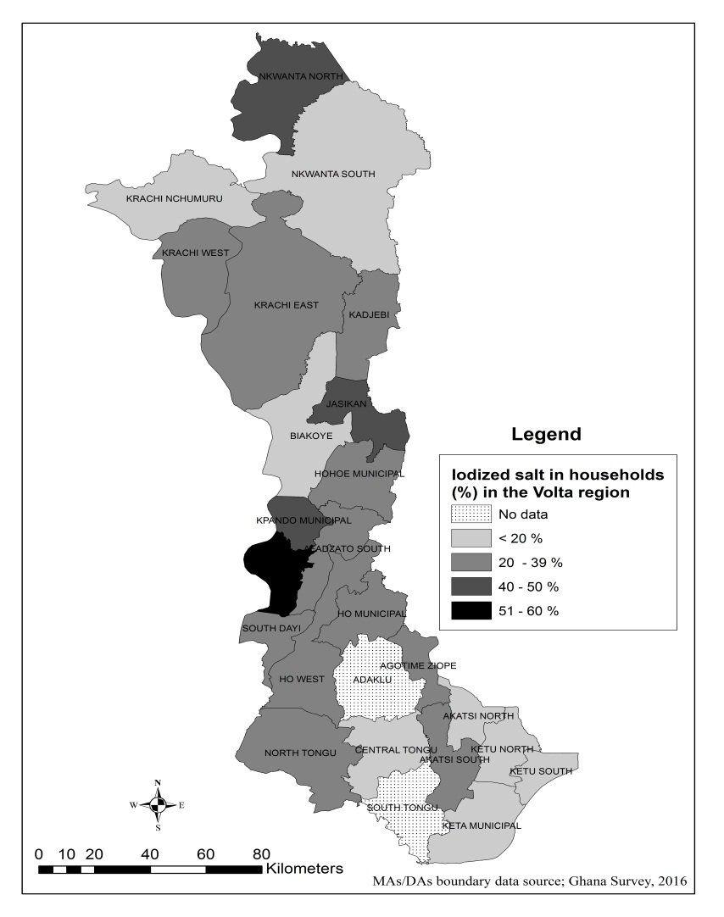 | 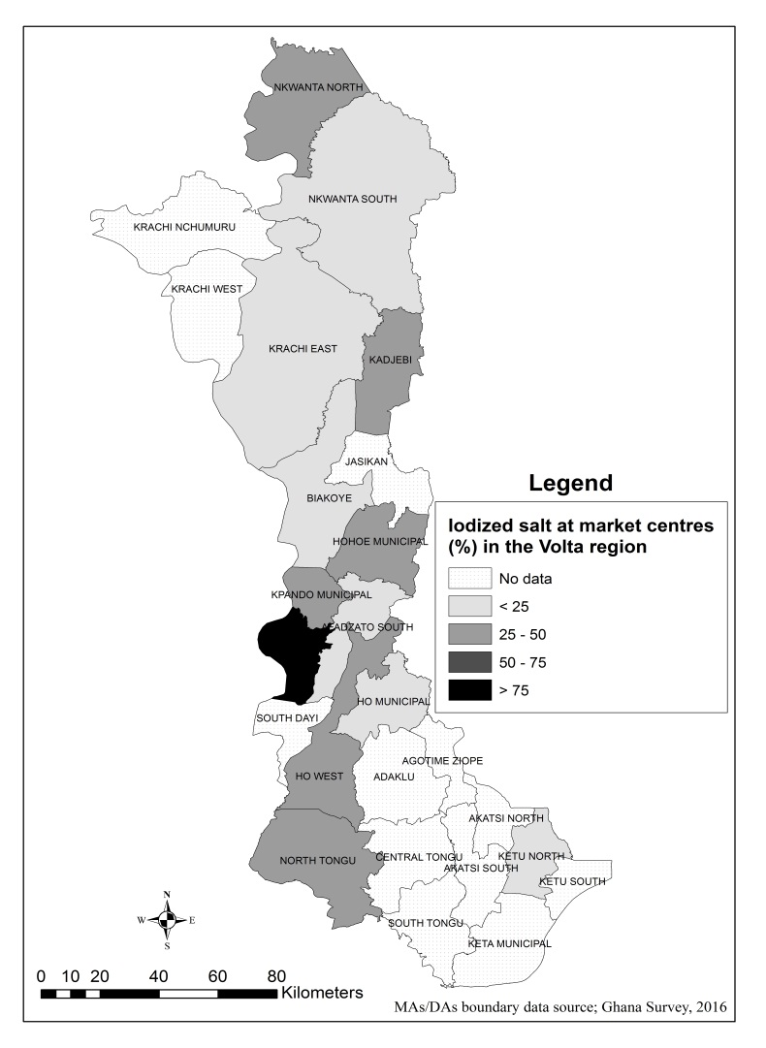
Figure 1a/b: Map of the Volta region showing proportions of adequately iodized salt found in households and market centres across selected districts

