The effectiveness of glyburide compared to insulin in the management of gestational diabetes mellitus: A systematic review

Jephthah O. Odiba, Dr. Mzwandile A. Mabhala
Address for correspondence: Department of Community Health and Wellbeing, University of Chester, Riverside Campus, Chester, CH1 1SF, United Kingdom
Email address: a.mabhala@chester.ac.uk

ABSTRACT
Background: Insulin therapy has been the mainstay in managing women with gestational diabetes mellitus (GDM), but some disadvantages of insulin have led to the use of glyburide, which is inexpensive in some countries, to manage GDM. However, there has been debate over its effectiveness, efficacy and safety when compared to insulin for maternal glycaemic control, and some adverse neonatal outcomes in GDM.
Method: A systematic review of eight randomised controlled trial (RCT) studies was undertaken to compare glyburide and insulin. Studies involving 849 participants were included in the quantitative analysis.
Results: There was no significant difference between glyburide and insulin in maternal fasting (P= 0.09; SMD: 0.13; 95% CI: -0.02 to 0.28) and postprandial (P= 0.45; SMD: 0.05; 95% CI: -0.09 to 0.19) glycaemic control and glycosylated haemoglobin (P= 0.35; SMD: 0.08; 95% CI: -0.08 to 0.24). When compared with insulin, glyburide had an increase risk ratio (RR) for neonatal hypoglycaemia (P= 0.0002; RR: 2.27; 95% CI: 1.47 to 3.51) and large for gestational age babies (P= 0.03; RR: 1.60; 95%CI: 1.06 to 2.41). Estimation of standard mean difference shows that neonatal birth weight was significantly higher in subjects receiving glyburide than in the insulin group (P= 0.002; SMD: 0.21; 95% CI: 0.08 to 0.35).
Conclusions: Glyburide was seen to be clinically effective and a safer alternative to insulin for maternal glycaemic control in GDM women. It is affordable, convenient and requires no comprehensive educative training at the time of initiation of therapy. However, its adverse outcomes – neonatal hypoglycaemia, high neonatal birth weight and large for gestational age babies – call for careful monitoring of GDM patients for any need for supplemental insulin.

Keywords: gestational diabetes mellitus, glyburide, insulin

1. Introduction

Globally, gestational diabetes mellitus (GDM) is associated with about 14% of complicated pregnancy cases per annum. Amongst the common complications are macrosomia, haemorrhage, hypertensive disorder, stillbirth and type 2 diabetes mellitus (T2DM). The World Health Organisation (WHO) prioritised improvement in maternal health, including management of GDM, as one of its Millennium Development Goals (MDG) [1, 2]. However, the rapid rise in the incidence of GDM reduces the likelihood of attaining this goal [3].
There is a wide range of therapeutic measures to control GDM, including dietary changes and physical activities either alone or in combination, but insulin therapy remains the technique of choice after diet and physical exercise [4-6]. A majority of women who use diet and physical activities incorporate either insulin or oral hypoglycaemic agents in their treatment plan [4, 5]. However, the disadvantages of insulin use – such as multiple daily injection sites, maternal weight gain, risk of hypoglycaemia, cost of drugs, handling and storage, and the modifications to drug administration based on body mass index, glucose level and lifestyle [6] – have led to the consideration of sulfonylurea (oral hypoglycaemic agents) as a preferred alternative [6].
The formerly traditional use of sulfonylurea drugs in pregnancy has now been discouraged due to the risks of fetal teratogenicity and neonatal hypoglycaemia as a result of its 10-16% maternal-to-fetal transfer rate [4, 5]. By contrast, glyburide has been found to have low risk of infant growth and teratogenicity, minimal in vitro foetal transfer rate, and safer in vivo fetal-to-maternal transfer rate at a dose of up to 20mg per day [4]. Furthermore, it is an inexpensive oral medication compared to insulin [7] and requires no special storage condition nor special training to administer.
There have been several RCTs that compared glyburide and insulin in the management of GDM. However, most lack statistical power. Therefore, this systematic review aims to provide a pooled estimate of RCTs comparing the relative effectiveness of glyburide and insulin on maternal glycaemic control and neonatal outcomes.
2. Methods
2.1 Search Strategy
We performed a systematic review and meta-analysis in accordance with the standards set by the Preferred Reporting Items for Systematic Review and Meta-analysis (PRISM) checklist (figure 1). We carried out an extensive electronic database search of published and unpublished RCTs comparing glyburide and insulin in the management of GDM. We searched Cochrane Library (Issue 6, 2014), PubMed, CINAHL Plus with Full Text, MEDLINE, BioMed Central, Health Technology Assessment (HTA), and Latin American and Caribbean Health Sciences (LILIACS) between the years 2000 and 2014. We use the key words “glyburide” AND “insulin” AND “management of gestational diabetes mellitus”, and also “Glyburide” AND “GDM”. We also hand-searched references of retrieved articles to identify studies not captured by our primary search strategy.
2.2 Study Selection
Figure 1 illustrates how the PRISM checklist was used to document the process of study selection [8]. We included randomised controlled trial studies comparing GDM patients treated with glyburide versus GDM patients treated with insulin. The inclusion criteria were: a) participants were patients with GDM irrespective of their age, gravidity and parity, b) study design was RCT, c) intervention entails studies that compare glyburide and insulin medication, and d) outcome entails studies that measure one or more of these endpoints: 1) maternal fasting plasma glucose (FBS), 2) 2-hours postprandial plasma glucose (OGTT), 3) maternal glycosylated haemoglobin (HbAIC), 4) neonatal hypoglycaemia (NH), and 5) large-for-gestational age baby (LGA) and birth weight at delivery (BW). Case control studies, observational studies, retrospective studies, and women with pre-gestational diabetes and type 2 diabetes were excluded.
2.3 Data Extraction and Quality Assessment
Data were extracted in duplicate by two independent reviewers (J.O. and M.A.M.) [9]. Table 1 shows the data that were abstracted regarding the baseline characteristics of the included studies [9]. These included: year of publication, study design, country of study, study size, comparison patient characteristics, glyburide group requiring insulin, dose of glyburide, dose of insulin, duration of study, and loss to follow up.
Data were extracted and appraised in accordance to the methodological quality, outcomes measures and predetermined criteria relevant to the research questions. Figure 2 illustrates how the characteristics for quality appraisal such as random sequence generation, blinding treatment for subjects and personnel, outcome assessments, completeness of outcomes data, objective reporting and risks of potential bias were evaluated using Review Manager (Revman) Version 5.1 (CDSR) [10], high risk of selection bias was detected in one of the studies [6] this was taken into consideration in analysis and interpretation of findings. Furthermore, for such a small study it was concluded that including it will not influence the overall outcome of the study.
2.4 Statistical Analysis
All data analyses were performed using Review Manager 5.1 (Nordic Cochrane Centre). The quantitative analyses were performed using the fixed effect model. For continuous outcomes, standardised mean differences (SMD) and 95% confidence intervals (CI) were calculated. For the dichotomous outcomes, risk ratio (RR) and 95% CI were calculated.
The heterogeneity was estimated statistically by the Chi-squared test (P > 0.1, which suggested a lack of heterogeneity for continuous variables) and I-squared test value (I2 > 75% was regarded as great heterogeneity). In addition, homogeneity of studies was graphically assessed using visual interpretation of forest plots.
3.0 Results
As represented in figure 1, a total of 185 potential articles were screened. Eight articles fulfilled all the inclusion criteria and were included in the systematic review. The characteristics and quality assessments of the studies are presented in tables 1 and 2. Overall quality and each study assessment are represented in figure 2. Both glyburide and insulin subjects were matched for age, body mass index, gestational weeks, fasting and 2-hour postprandial blood glucose, and glycosylated haemoglobin level at the time of entry to the study.
A total of 849 subjects were included in these eight studies (418 on glyburide and 431 on insulin) as presented in table 3.
Figure 1: Search strategy for randomised controlled trials included in this study

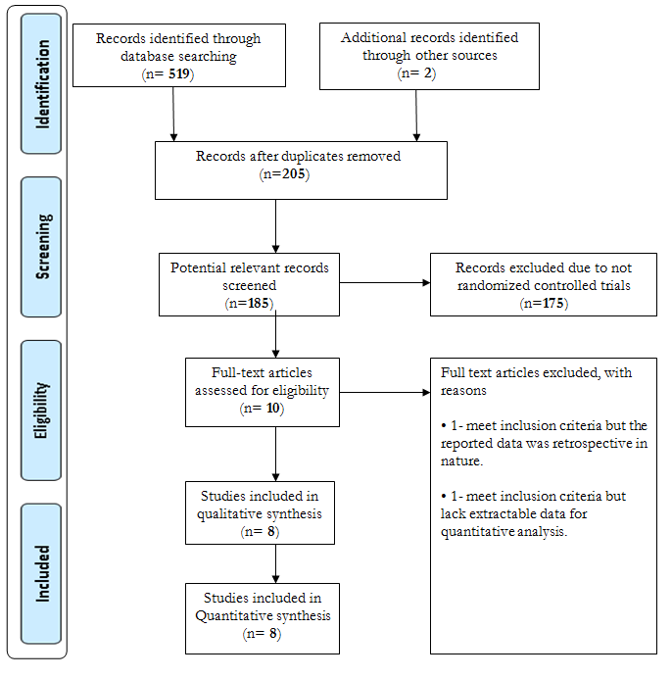

Table 1: Characteristics and quality assessment of included studies
First author (year of publication) | Study design | Country of study | Study size/comparison |  | Patient characteristics | Glyburide group requiring insulin (n) | Dose of glyburide | Dose of insulin | Duration of study | Loss to follow up
First author (year of publication) | Study design | Country of study | Glyburide (n) | Insulin (n)
Langer et al. 2000 [1] | Randomised controlled trials | Texas, United States | 201 | 203 | 404 GDM women between 18 and 40 years old | 8 | 9 ± 6mg/day | 85 ± 48 units/day | Not stated | undeclared
Bertini et al. 2005 [2] | Randomised controlled trials | Joinville SC, Brazil | 24 | 27 | 70 GDM women | 5 | 5-20mg/day | 0.7-0.9 units/kg | 9 months | undeclared
Anjalakshi et al. 2006 [3] | Randomised controlled trials | Chennai, India | 10 | 13 | 26 GDM women | 0 | 0.625mg and dose titrated once a week | 0.1units/kg and increased weekly | Not stated | Greater than 10%
Silva et al. 2007 [4] | Randomised controlled trials | Joinville SC, Brazil | 32 | 36 | 68 GDM women, minimum 18 years old | 6 | 5-20mg/day | 0.7-0.9 units/kg | 1 year and 5 months | Not significant
Ogunyemi et al. 2007 [5] | Randomised controlled trials | Los Angeles, United States | 48 | 49 | 97 GDM women | 3 | 5 mg | 60 units | 3 years | Less than 10%
Lain et al. 2009 [6] | Randomised controlled trials | Pittsburgh, United States | 41 | 41 | 99 GDM women | 1 | 8 ± 6.7mg/day | 51.3 ± 33.4 units/day | 3 years | Greater than 10%
Mukhopadhyay et al. 2012 [7] | Randomised controlled trials | Kolkata, India | 30 | 30 | 60 GDM women | 0 | 2.5 mg and increased weekly to a maximum dose of 20mg/day | 0.7 units/kg three times a day and increased when necessary | 1 year | undeclared
Anjali et al. 2013 [8] | Randomised controlled trials | New Delhi, India | 32 | 32 | 64 GDM women | 2 | 5 ± 1.9mg/day to a maximum dose of 20mg/day | 33.8 ± 22.9 units/day to a maximum dose of 84 units /day | 1 year | Less than 10%

Figure 2: Summary of systematic review authors’ judgement on methodological quality of included studies
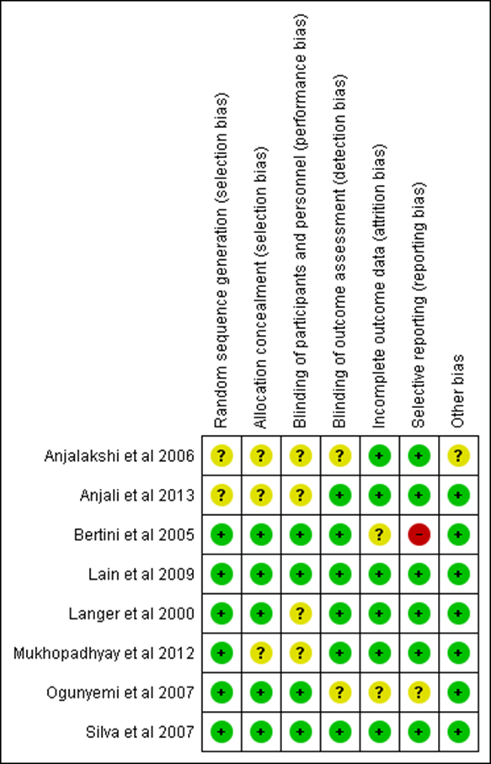
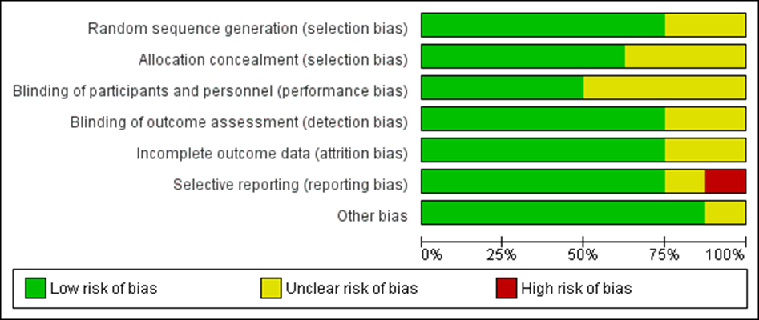
3.1 Maternal Glycaemic Control
The data on fasting blood glucose were reported in five studies (Figure 3.1a). The average blood glucose was slightly lower in the insulin group than the glyburide group, but the difference was not statistically significant (P= 0.09; SMD: 0.13; 95% CI: -0.02 to 0.28) and the 95% confidence interval crosses the line of no effect.
Figure 3.1(a): Data on fasting blood glucose in insulin group compared with the glyburide group
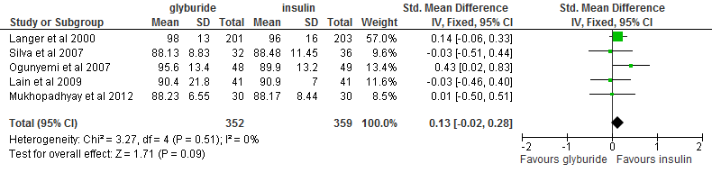
The mean postprandial blood glucose was reported in seven studies (Figure 3.1b). There was no significant difference in postprandial glycaemic control between glyburide and insulin (P= 0.45; SMD: 0.05; 95% CI: -0.09 to 0.19), although the overall estimated effects slightly favours insulin groups compared to glyburide with the 95% confidence interval crossing the line of no effect.
Figure 3.1(b): Mean postprandial blood glucose between glyburide and insulin
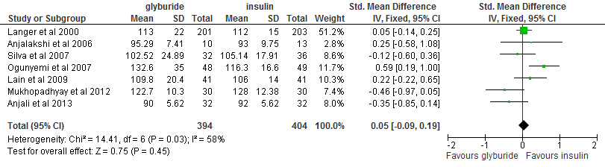
Glycosylated haemoglobin control was reported in four studies (Figure 3.1c) and no statistical difference was observed between the two treatment groups (P= 0.35; SMD: 0.08; 95% CI: -0.08 to 0.24), although again the overall estimated effects slightly favours insulin and the 95% confidence interval crosses the line of no effect.
Figure 3.1(c): Glycosylated haemoglobin control
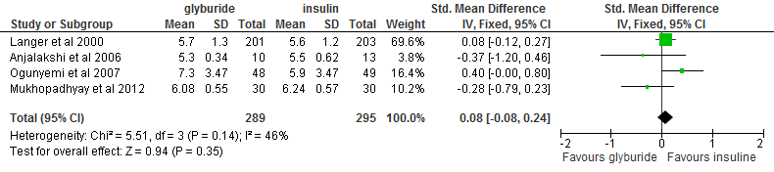
3.2 Neonatal Outcomes
Neonatal birth weight was reported in eight studies (Figure 3.2a). There was a significant difference in the neonatal birth weight between glyburide and insulin groups (P= 0.002; SMD: 0.21; 95% CI: 0.08 to 0.35). The overall estimated effects favours insulin, indicating neonatal birth weight was significantly higher in patients receiving glyburide than those receiving insulin. The 95% confidence interval does not cross the line of no effect.
Figure 3.2(a): Neonatal birth weight between glyburide and insulin groups 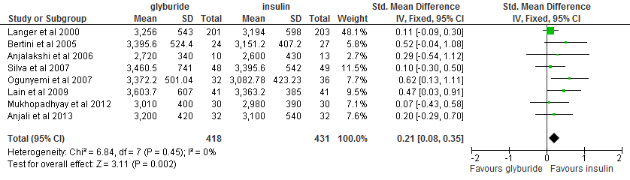
Neonatal hypoglycaemia was observed in seven studies, defined as when the mean neonatal blood glucose value was less than 40mg/dl (Figure 3.2b). Incidence of cases of neonatal hypoglycaemia was significantly greater among neonates born from GDM women treated with glyburide than those treated with insulin. There was a statistically significant difference between the two treatments groups (P= 0.0002; RR: 2.27; 95% CI: 1.47 to 3.51), and the 95% confidence interval does not cross the line of no effect.
Figure 3.2(b): Neonatal hypoglycaemia among neonates born from GDM women treated with glyburide compared to insulin groups 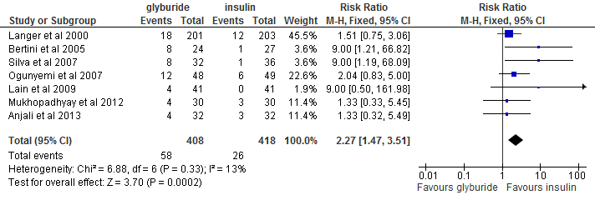
Neonatal birth weight at or above the 90th percentile was considered large for gestational age and was reported in five studies (Figure 3.2c). There was a significant difference between the two groups treated with glyburide and insulin (P= 0.03; RR: 1.60; 95%CI: 1.06 to 2.41), with incidence of large for gestational age babies significantly higher in glyburide groups. The 95% confidence interval does not cross the line of no effect.
Figure 3.2(c): Incidence of large for gestational age babies in glyburide groups compared to insulin groups
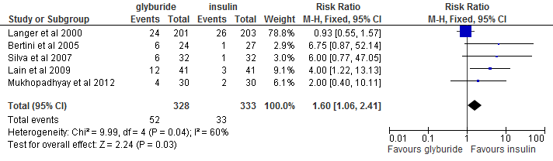
Outcome | Included studies | Included participants | Heterogeneity Chi-squared (p) | I-Squared (%) | 95% CI | P
Maternal fasting plasma glucose control | 5 | 711 | 3.27 (p=0.51) | 0.0 | SMD 0.13 (-0.02 to 0.28) | 0.09
Maternal postprandial plasma glucose control | 7 | 798 | 14.41 (p=0.03) | 58 | SMD 0.05 (-0.09 to 0.19) | 0.45
Glycosylated haemoglobin control | 4 | 584 | 5.51 (p= 0.14) | 46 | SMD 0.08 (-0.08 to 0.24) | 0.35
Neonatal birth weight | 8 | 849 | 6.84 (p=0.45) | 0.0 | SMD 0.21 (0.08 to 0.35) | 0.002
Neonatal hypoglycaemia | 7 | 829 | 6.88 (p=0.33) | 13 | RR 2.27 (1.47 to 3.51) | 0.0002
Large for gestational age | 5 | 661 | 9.99 (p= 0.04) | 60 | RR 1.60 (1.06 to 2.41) | 0.03
Table 2: Summary of systematic review analysis results

Chi-squared test value p > 0.1 suggested a lack of heterogeneity for continuous variables.
I-squared test value I2 > 75% was regarded as great heterogeneity.
4.0 Discussion
Eight RCT studies were included in the systematic review, aiming at comparing glyburide and insulin for the management of GDM (figure 3.1 a, b and c). The results showed a P value of (P= 0.09; SMD: 0.13; 95% CI: -0.02 to 0.28 in maternal fasting blood glucose, 2-hours postprandial glucose level and glycosylated haemoglobin level, which could be interpreted as no strong evidence that the intervention has an effect. However, it has be noted that this study presented two P values one represented summary effect is from Z test and the other from χ2 related to the degree of heterogeneity. In both cases P values in this study, they have been greater than arbitrary P ≥ 0.05. This could be attributed to the fact that most of the studies included in this review were small. It has been established that in small meta-analysis greater P values are common, however, this should not be taken to imply that an intervention has no important benefits.
Figures 3.1a indicates SMD = 0.13 in favour of glyburide over insulin in the control of blood glucose. These findings compare favourably with previous studies that compared glyburide and insulin therapy in management of GDM [4, 5]. Langer, Conway, Berkus et al. [5] went further, explaining that glyburide reduces hyperglycaemia by increasing peripheral glucose utilisation, decreasing hepatic gluconeogenesis and increasing insulin sensitivity through an increase in intracellular calcium in the beta cell and concurrently stimulating insulin productivity [5].
The analysis revealed that there was a direct relationship between postprandial glycaemic level and pregnancy outcomes (figure 3.2 a, b and c) [11-16]. Consistent with previous studies which showed that glyburide was effective on postprandial glycaemic control [17, 18]; seven studies [11-16] showed no significant difference between patients treated with insulin and those treated with glyburide [figure 3.2 a, b and c].
With regard to neonatal birth weight, this study showed significant difference between the two groups treated with glyburide and insulin (P= 0.03; RR: 1.60; 95%CI: 1.06 to 2.41), with incidence of large for gestational age babies significantly higher in glyburide groups (figure 3.2c). These findings were inconsistent with the previous observational study conducted by Chmait, Dinise and Moore [19] which showed no statistical differences between these two treatment groups [19].
Furthermore, this study showed a positive RR = 1.6 [fig 3.2c] of large for gestation age babies among GDM women treated with glyburide compared to those treated with insulin. These findings can be compared with a retrospective cohort study conducted by Cheng et al. [20] which also indicated a greater likelihood of higher birth weight of infants above 4000g for GDM mothers treated with glyburide compared to insulin treatments.
While glyburide appears to be a promising alternative to insulin in treating GDM, there have been several prominent side effects associated with it. Several studies [4, 20] found that there is a 2.27 times greater likelihood of neonatal hypoglycaemia in mothers treated with glyburide compare to insulin treatments. In addition there are other reported side effects such as respiratory distress, jaundice, skin allergy, anaphylactic reactions, elevated liver enzymes, haematological disorder and low visual acuity due to imbalanced glycaemic level [20]. The retrospective cohort study conducted by Cheng et al. [20] revealed that neonates born to mothers treated with glyburide have a greater propensity to be admitted to NICU compared to those managed using insulin.
5.0 Conclusion
In summary, glyburide is clinically as effective as insulin when used alone in the management of GDM, and provides a best efficacy and safety option when supplemented with insulin for those patients unresponsive to glyburide.
Competing interests
The authors declares that they have no competing interest.
Authors’ contributions
J.O. originated the research idea, performed the analysis and drafted the manuscript, while M.A.M. provided methodological expertise, assisted with analysis, and shaped and prepared the manuscript for publication. Both authors read and approved the final manuscript.
Acknowledgement
The authors wish to thank Pauline Alexander for advice during the development of this project, and Roger Whiteley who generously gave his time and editorial expertise in shaping this article. A very special gratitude goes to the reviewers of this paper, who will have expended considerable effort on our behalf.

References:
[1] Veeraswamy, S., Vijayam, B., Gupta, V.K., Kapur, A. (2012) The public health relevance and approach. Diabetes Research and Clinical Practice. 97(3), 350-358.
[2] United Nations (2014) We can end poverty: millennium development goals and beyond 2015. Available from: http://www.un.org/millenniumgoals/.
[3] Rotheram-Borus, M.J., Tomlinson, M., Swendeman, D., Lee, A., Jones, E. (2012) Standardized functions for smartphone applications: examples from maternal and child health. International Journal of Telemedicine Applications, 1(16), 21-21.
[4] Dhulkotia, J.S., Bolarinde, O., Fraser, R., Farrell, T. (2010) Oral hypoglycaemic agent’s vs insulin in management of gestational diabetes: a systematic review and meta-analysis. American Journal of Obstetrics and Gynaecology, 203(5), 1- 9.
[5] Langer O, Conway D L, Berkus M D, Xenakis E M-J, Gonzales O: A comparison of glyburide and insulin in women with gestational diabetes mellitus. New England Journal of Medicine 2000, 343(16), 1134-1138.
[6] Bertini, A.M., Silva, J.C., Taborda, W., Becker, F., Bebber, F.R.L., Viesi, J.M.Z., Aquim, G., Ribeiro, T.E. (2005) Perinatal outcomes and the use of oral hypoglycaemic agents. Journal of Perinatal Medicine, 33(6), 519-523.
[7] Goetzl, L., Wilkins, I. (2002) Glyburide compared to insulin for the treatment of gestational diabetes mellitus: a cost analysis. Perinatology, 22, 403-406.
[8] Altman, D.G., Schulz, K.F., Moher, D. (2001) The revised CONSORT Statement for reporting randomized trials: explanation and elaboration. Annals of Internal Medicine, 134, 663-694.
[9] Centre for Reviews and Dissemination (2009) Systematic reviews: CRD's guidance for undertaking reviews in health care http://www.york.ac.uk/inst/crd/pdf/Systematic_Reviews.pdf.
[10] Higgins, J., Green, S (2011) Cochrane handbook for systematic review of interventions version 20 5.1.0 11. http://handbook.cochrane.org/.
[11] Anjalakshi, C., Balaji, V., Balaji, M.S., Seshiah, V. (2007) A prospective study comparing insulin and glibenclamide in gestational diabetes mellitus in Asian Indian women. Diabetes Research and Clinical Practice, 76(3), 474-475.
[12] Silva, J.C., Bertini, A.M., Taborda, W., Becker, F., Bebber, F.R., Aquim, G.M., Viesi, J.M. (2007) Glibenclamide in the treatment for gestational diabetes mellitus in a compared study to insulin. Archives of Endocrinology and Metabolism, 51(4), 541-6.
[13] Ogunyemi, D., Jesse, M., Davidson, M. (2007) Comparison of glyburide versus insulin in management of gestational diabetes mellitus. Endocrinology Practice, 13(4), 427-428.
[14] Lain, K.Y., Garabedian, M.J., Daftary, A., Jeyabalan, A. (2009) Neonatal adiposity following maternal treatment of gestational diabetes with glyburide compared with insulin. American Journal of Obstetrics and Gynaecology, 200(5), e1-e6.
[15] Mukhopadhyay, P., Sankar, T.B., Kyal, A., Saha, P.D. (2012) Oral hypoglyceamic Glibenclamide: Can it be a substitute to insulin in the management of gestational diabetes mellitus? A comparative study. Journal of South Asian Federation of Obstetrics and Gynaecology, 4(1), 28-31.
[16] Anjali, T., Mayanglambam, R.D. (2013) Glyburide as treatment option for gestational diabetes mellitus. Journal of Obstetrics and Gynaecology Research, 39(6), 1147-1152.
[17] Esposito, K., Giugliano, D., Nappo, F., Marfella, R., Campanian Postprandial Hyperglycemia Study Group (2004) Regression of carotid atherosclerosis by control of postprandial hyperglycaemia in type 2 diabetes mellitus. Circulation, 110, 214-219.
[18] Kremer, C.J., Duff, P. (2004) Glyburide for the treatment of gestational diabetes. American Journal of Obstetrics and Gynaecology, 190(5), 1438-1439.
[19] Chmait. R., Dinise, T., Moore, T. (2004) Prospective observational study to establish predictors of glyburide success in women with gestational diabetes mellitus. Journal for Perinatology, 24(10), 617-622.
[20] Chang, L-C., Liu, C-H., Yen, E. H-W. (2012) Treatment of gestational diabetes mellitus: glyburide compare to subcutaneous insulin therapy and associated perinatal outcomes. Journal of Maternal-Fetal and Neonatal Medicine, 25(4), 379-384.

