Carbon Dioxide Rich Microbubble Acceleration of Biogas Production in Anaerobic Digestion

MAHMOOD K.H. AL-MASHHADANI^{*(a)}, STEPHEN J. WILKINSON^{(c)}, WILLIAM B. ZIMMERMAN^{(a)}
ª Department of Chemical Engineering, College of Engineering, University of Baghdad, Iraq.
^{b} Department of Chemical Engineering, University of Chester, Thornton Science Park, Pool Lane, Ince, Chester CH2 4NU, UK.
^{c} Department of Chemical and Biological Engineering, University of Sheffield, Mappin Street, Sheffield S1 3JD, UK.

Corresponding author: Tel: +964 (0)7719069201, MAHMOOD K.H. AL-MASHHADANI (mkh_control@yahoo.com)

Abstract
This paper addresses the use of anaerobic bacteria to convert carbon dioxide to biomethane as part of the biodegradation process of organic waste. The current study utilises gaslift bioreactors with microbubbles generated by fluidic oscillation to strip the methane produced in the gaslift bioreactor. Removal of methane makes its formation thermodynamically more favourable. In addition, intermittent sparging of microbubbles can prevent thermal stratification, maintain uniformity of the pH and increase the intimate contact between the feed and microbial culture with lower energy requirements than traditional mixing. A gaslift bioreactor with microbubble sparging has been implemented experimentally, using a range of carrier gas, culminating in pure carbon dioxide, in the anaerobic digestion process. The results obtained from the experiments show that the methane production rate is approximately doubled with pure carbon dioxide as the carrier gas for intermittent microbubble sparging.

Keywords: Microbubble , Anaerobic Digestion, Methane, Carbon dioxide, Fluidic oscillation, Airlift bioreactor.

- Introduction
Renewable fuels have become the main focus for many researchers interested in the production of sustainable energy. Alternative clean sources of energy are available, for instance, solar, hydroelectric, wind and bio-fuels such as bio-diesel and bio-ethanol from agricultural crops, waste or microalgae. None of these sources, however, have so far been able to produce sufficient energy to provide a substitute for fossil fuels (Schenk et al., 2008; Scott et al., 2010; Singh, 2012, Chisti, 2005; Eriksen, 2008; Kadam (1997)).
Anaerobic digestion represents a renewable energy source (Budzianowski, 2012; Wang et al., 1999). It is commonly used for nutrient and energy recovery from biomass and also to stabilise the sludge produced in wastewater treatment (Tiehm et al., 2003). Organic matter is broken down through four biodegradation stages into methane (CH₄), carbon dioxide (CO₂), varying amounts of hydrogen sulphide (H₂S), and the digested sludge, which can be used as a soil fertilizer (Poeschl et al., 2010; Budzianowski, 2012). Bio-methane can be used for the generation of electricity or used as a biofuel for vehicles after upgrading processes. The production and upgrading costs of biogas are lower than the costs of production and upgrading of bio-fuel produced from agriculture crops or from microalgae (Appels, et al. 2008; Sahlstrom 2003; Ahring, 2003; Metcalf & Eddy, 2003). However the challenges facing anaerobic digestion implementation have become a major obstacle to this source becoming a leading renewable energy source. Among these challenges are the low volumetric yields of biogas and difficulties relating to the stability of large-scale continuous operation (Salomoni, & Petazzoni , 2006; Metcalf and Eddy, 2003).
This paper introduces the premise of using a microbubble sparging system in anaerobic digestion (AD) primarily to extract methane from the bioreactor. Methane has a low solubility in water and therefore is likely to adhere to the organic phase -- biomass and microbial membranes. The typical exit route for methane from an AD reactor is to build up a gas layer on the organic phase until sufficient volume is created that buoyant forces detach a large bubble, which is in equilibrium with the aqueous phase due to the long contact time. In this paper, we report on experiments that periodically sparge with a bubble size distribution that includes sub 100 micron size microbubbles. Such microbubbles have a terminal rise velocity 10⁻³ m/s or less, and as shown in AL-Mashhadani et al (2015a), are readily entrained and therefore have a long residence time – minutes rather than seconds. These circulating microbubbles provide local gas-liquid interfaces which can interact with the methane-rich boundary layers of the organic phase to provide an exit route from the system. Hypothetically, the build-up of methane rich boundary layers surrounding microorganisms could serve as an inhibitor to their metabolism in accordance with Le Chatelier’s principle. Such thermodynamic principles are important in anaerobic processes such as those considered in this work which operate close to chemical equilibrium (Hoh & Cord‐Ruwisch, 1996). Reducing the chemical activity of the product gases in solution (or the fugacity in the gaseous phase) leads to a negative change in Gibbs free energy. Hence the reaction becomes thermodynamically favourable and provides impetus for the formation of more products. We will describe the chemical potential non-equilibrium thermodynamic drivers underpinning the hypothesis in section 2; methods and materials in section 3; and the results in section 4. Our conclusions will be presented in section 5.

- Hypothesis of present study
Sparging of anaerobic digestors will affect the dissolved concentrations of gaseous species such as CH₄, CO₂, H₂, NH₃, H₂S. Since all of these gases are produced by anaerobic digestion of biomass, the most common effect will be for sparging to reduce levels of these species by a stripping effect. This would certainly be the case for sparging with an inert carrier gas such as N₂. On the other hand, if sparging is carried out with sufficiently high partial pressures of a gas that is produced during anaerobic digestion, there may be a driving force for this species to enter solution thereby increasing its dissolved concentration. If we restrict ourselves to the key species involved in anaerobic carbon catabolism, Note that we are neglecting any other gaseous products or intermediates, most notably NH₃ and H₂S.
The mathematical relationship between Gibbs free energy and species partial pressure is as follows:
$CH_{3}CH_{2}COOH+2H_{2}O\underset{→}{ }CH_{3}COOH+CO_{2}+3H_{2}$ (1)
$$∆G=∆G^{o}+RT ln\frac{ {[CH_{3}CH_{2}CH_{2}COOH]}^{}[CO_{2}]{[H_{2}O]}^{3}}{{[CH_{3}COOH]}^{}{[H_{2}O]}^{2}} (2)$$
Where ∆G is the Gibbs free energy change, ∆Gº is the standard Gibbs free energy, R is universal gas constant, $T$ is temperature of reaction.
From the above equation, it is possible to note that decreasing the partial pressure of the products contributes negatively to the Gibbs free energy, hence the reaction becomes thermodynamically favourable towards the formation of more products, and vice versa (Gary 2004). Biogases produced by AD can be either present in a gaseous film or dissolved in the bulk liquid as equations (1) and (2) are completely general. For ideal gases, the partial pressure is equal to the fugacity from which the chemical potential and species activity can readily be computed.
In biological processes, some required reactions are not spontaneous – i.e. they are thermodynamically unfavourable (+∆G). Typically, these reactions are driven forward by one of two mechanisms as described below.
The first mechanism employed in metabolic networks is to provide enough energy to endergonic reactions to convert them to spontaneous reactions. Reducing the partial pressure (chemical potential) of products by their removal is another method that can be used to make reactions spontaneous in bioprocesses sharing intermediates. This principle underlies reactive separation that is a staple chemical engineering approach to intensify reactions. For example, fermentation of acetate in anaerobic digestion has a positive standard Gibbs free energy and this reaction shown in equation (3) is, therefore, thermodynamically not favoured unless the partial pressure of hydrogen can be reduced by methanogenic bacteria to sufficiently low levels such as 10⁻⁴ atm.
$CH_{3}CH_{2}CH_{2}COOH+2H_{2}O\underset{→}{ }2CH_{3}COOH+2H_{2}$ $∆G^{o}=+ 48.1 {kJ}/{mole}$ (3)

There has been much investigation of the mathematical relationship between partial pressure and Gibbs free energy with widespread applications. But the major results have emerged from biological processes, particularly for bio-hydrogen production. This process has caused debate among researchers about how to control the partial pressure of hydrogen or carbon dioxide and its effects on the production of hydrogen. Many researchers have noted that an increase in hydrogen production could be achieved by reducing the partial pressure of hydrogen or carbon dioxide or both depending on the following equation:
$C_{6}H_{12}O_{6}+2H_{2}O\underset{→}{ Bacteria }{2CH}_{3}COOH+{2CO}_{2}+4H_{2}$ (4)
Tanisho et al. (1998); Park et al., (2005); Alshiyab et al., (2008) studied the effects of the reduction of the partial pressure of carbon dioxide on hydrogen production. Tanisho et al., (1998) found that hydrogen production increased when the partial pressure of carbon dioxide decreased. Park et al. (2005) demonstrated that reducing the concentration of carbon dioxide from 24.5% to 5.3% in the headspace caused an increase in the hydrogen yield of 43%. Alshiyab et al. (2008) indicated that there was an increase in the hydrogen yield when partial pressure of carbon dioxide was decreased. Moreover, Liang et al. (2002); Mizuno et al., (2000); Kim et al. (2006), Kraemer and Bagley (2008) all reported that reducing the partial pressure of hydrogen caused an increase in hydrogen production rate. These investigations have shown the importance of the removal of gases from biological processes and the effect this has on increasing production of hydrogen.
Similarly, for anaerobic digestion, the removal of some gases during the fermentation could therefore enhance the favourability of biological reactions and intensify the production of methane. However, the overall effect is complicated by the multiple intermediate reaction steps as shown in Figure 3 and the relative populations of the bacteria facilitating each step. For example, a decrease in the number of bacteria that consume gaseous intermediates (CO₂ and H₂) in methane production can oppose the effect of physically removing these gases. It is clear to the authors of this work, therefore, that further theoretical and experimental study of systems to manipulate the concentrations gaseous species in anaerobic digestion is required.
This work was motivated by the idea that injection of microbubbles into the bioreactor can locally modify in the heterogeneous environment near the particulate organic phase and the microorganisms. In general, microorganisms show surfactant properties, hence are likely to interact with microbubble gas-liquid interfaces.
This paper proposes a simple hypothesis which can be summarized as follows. The use of a sparging system in anaerobic digestion should increase the methane production rate by locally reducing the partial pressure of methane, while enhancing mixing efficiency. See Al-Mashhadani et al. 2015a for an explanation of how microbubbles increase liquid mixing. In addition, the present study also tests a new microbubble generation technology for the sparging of anaerobic digesters. Microbubbles generated by a fluidic oscillator were injected in an airlift bioreactor to intensify the performance of the digestion process.
Zimmerman et al. (2009, 2010, and 2011) describe the use of fluidic oscillation to generate microbubbles.

- Material and method
3.1 The Experimental Setup
Two lab-scale digesters of the same dimensions were used in the present study: a conventional digester and a gaslift digester provided with a ceramic diffuser to sparge microbubbles generated by fluidic oscillation as shown in Figure 1. The gaslift digester was subjected to different patterns of aeration: pure nitrogen (N2-generated (Peak scientific Ltd) with 99.9%) in the first set of experiments; pure nitrogen followed up by pure carbon dioxide was sparged with the different sparging regimes in the set experiments; circulation of diluted and undiluted biogas was carried out in the third set of experiment, finally pure carbon dioxide was sparged in the final experiment. All gases were sparged through a micro porous ceramic diffuser (HP technical ceramics) with 20 µm size pores. Both digesters were operated under mesophilic conditions. The biogas was collected continuously before and after bubbling intervals, while the concentrations of methane, carbon dioxide, and hydrogen sulphide were measured using a biogas analyser. The gaslift digester was sparged periodically with different gases, however, carbon dioxide rich bubbles was sparged for only 5 min daily to prevent a drop in the pH value. The design of the digesters is described in our previous studies (Al-Mashhadani et al. 2012(a) and 2015a). The flow rate used in the current experiments was 300-400 ml/min.

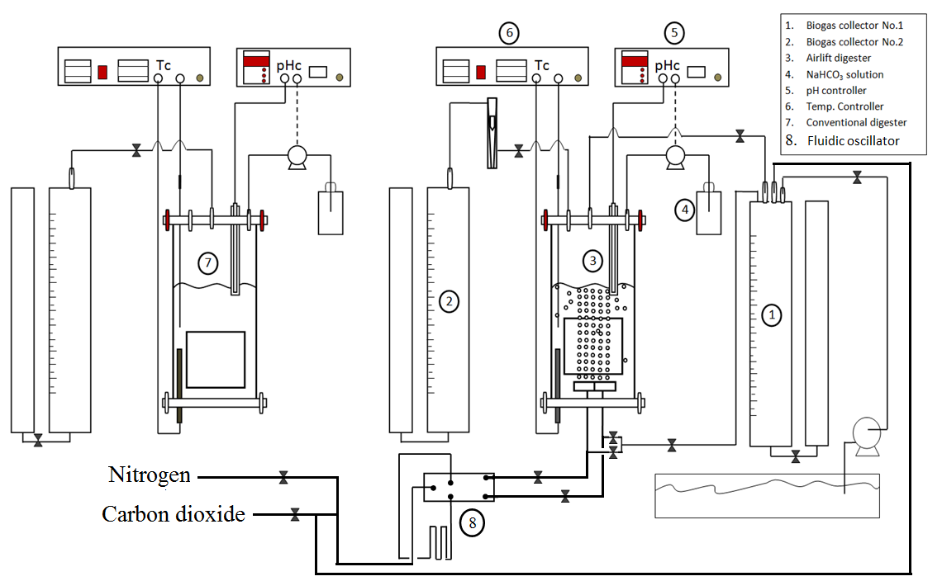
Figure 1: Schematic of experimental work. Two digesters: a gaslift (or airlift) digestor and an unsparged digester as a control are compared in this work. Sparging is carried out using carbon dioxide rich microbubbles, with composition a controlled variable with five different levels from 0-100% CO₂.

Table 1 Operational conditions applied in the first set of experiments.
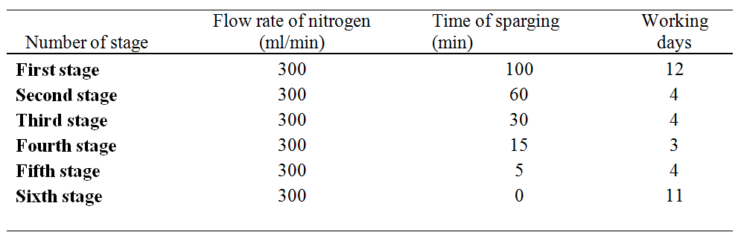

Table 2 Operational conditions applied in the second set of experiments
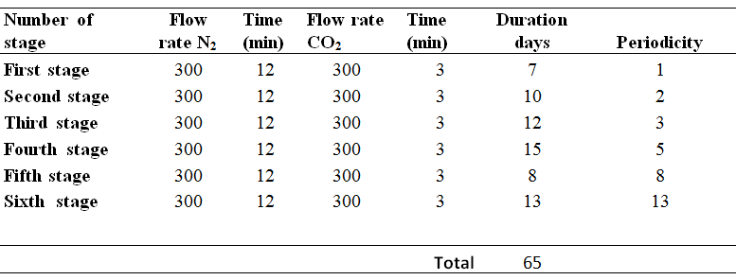
Each digester contains digested sludge, which was collected from the outlet stream of a full-scale mesophilic digester at the Woodhouse wastewater treatment plant in the city of Sheffield in the UK. In each digester kitchen waste was used as a substrate for bacteria, 15 ml was fed daily to the digester to provide an appropriate organic loading as suggested previous studies. In order to maintain the volume of sludge in each anaerobic digester, 12-15 ml was discharged daily from each reactor. Additional losses due to evaporation explain why less than 15 ml was sometimes discharged to keep a constant level in the digester (AL-Mashhadani et al. 2015b). The chemical oxygen demand (COD) of the digested sludge and kitchen waste were about 33 and 127 g/L respectively.
In the present study, a proportional-integral-derivative (PID) controller was used to maintain the temperature in the digester at 35±1ºC. A temperature control system was constructed using a 500 W heater and thermocouple sensor type K with a range of -128ºC to 539ºC.
Continuous measurement of biogas yield was accomplished by means of the downward displacement of acidic aqueous solution (0.2 M HCL, pH<4). Methane, carbon dioxide and hydrogen sulphide concentration in the biogas captured using the collection system were measured daily using a biogas analyser (Data Gas UK analyser, Model 0518). Each digester was provided with a pH controller. The pH control system used in this study is an ON/OFF relay controller, which consists of three main parts (Controller, peristaltic pump and pH probe sensor). The type of pH controller system used in the experiment experiment was a BL931700 pH minicontroller.
  - Microbubbles size analysis
Since the use of microbubbles was a key aspect of this work, we report an analysis of bubble sizes from the same ceramic diffuser and fluidic oscillator (Zimmerman et al, 2009) for the water/air system with same gas flow rate (300 ml/min) as used for the sparged digestor. The study was done using a high speed camera. The reactors used in the experiments were cylindrical in shape but this made it difficult to directly measure bubble size in the cylinder due to curvature distortion. Therefore, a rectangular tank with the same diffuser materials was constructed for bubble sizing. Estimation of the bubble size distribution was carried out by image analysis software, which gives the area of the bubbles' cross section in two dimensions.
Figure 2 shows the micro-bubbles' diameter distribution. An image containing more than 130 bubbles was analysed. The average diameter of these bubbles was 550µm with the 400-500µm and 500-600µm diameter range being the most abundant, respectively having relative frequencies of 37% and 27% of the total number of bubbles. The relative frequency of larger bubbles decreases with increasing diameter and no bubbles are found with diameters greater than 1100µm. Only about 5% of bubble diameters are smaller than 400µm, spread over the range 0-400µm. The presence of very small bubbles with diameters of less than 100µm is interesting and, although they only occupy a very small fraction of the total, these may have a disproportionately large effect in promoting biogas production as discussed later.
The bubble size distribution at various points throughout the tank would be much more representative than that in the plume above the diffuser. However, the isolating a plane of bubbles for measuring purpose is necessary to get the accurate average of bubble’s diameter by optical approaches. Of course, taking the many lines of pores hence planes bubbles at different areas of diffuser was considered in the present study. There are two manuscripts (Brittle et al. 2015 and Rehman et al. 2014) in production that compare optical, laser diffraction and acoustic resonance spectroscopy as methodologies for bubble sizing.
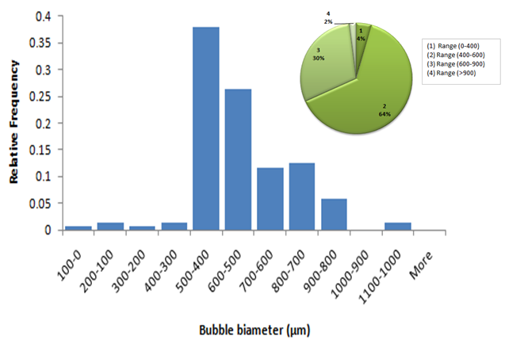
Figure 2: Bubble size distribution using the ceramic diffuser for the air/water system at 300 ml/min
- Results and discussion
As can be seen in Figure 3, some of these reactions have a negative standard Gibbs free energy signifying that the reactions are spontaneous and favourable thermodynamically, while others have a positive sign, which means these reactions are unfavourable energetically and oppose spontaneous production of methane causing the failure of the digestion process as a whole (Metcalf and Eddy, 2003; Schmidt and Ahring, 1993). However, there is a relationship between the methanogenic and acidogenic bacteria that is termed “mutually beneficial”. This relationship helps to convert unfavourable reactions into favourable reactions by maintaining a very low partial pressure of hydrogen. The partial pressure should be lower than 10⁻⁴ atm (Ahring and Westermann, 1988), to allow the necessary equilibrium shift in the right direction and formation of more formate and acetate. Thus, the actual Gibbs free energy change will be negative under these conditions.
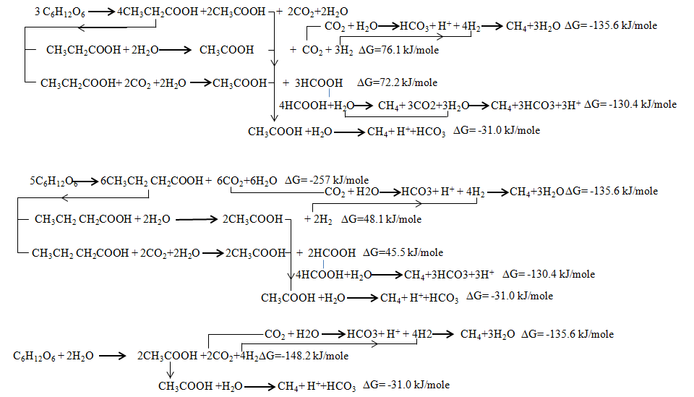
Fig 3: Biological reactions in anaerobic digestion
In fact, the methanogenic bacteria play an important role in the process. Therefore, the failure to provide a suitable environment for these bacteria opposes hydrogen from being consumed in sufficient quantity and thus will inevitably lead to accumulation of VFAs and occurrence of low pH, and ultimately the failure of this process (Metcalf and Eddy, 2003; McCarty and Smith, 1986; Schmidt 1993).
4.1 Sparging with Pure Nitrogen
The effects of sparging with nitrogen (Table 1) on the performance of anaerobic digestion were investigated in our previous study (AL-Mashhadani et al. 2012(b)). The results showed that using nitrogen leads to stripping of carbon dioxide and hydrogen produced from degradation of the organic matter. These gases are necessary for the generation methane by hydrogen reduction bacteria, as is illustrated in the following equations.
$3C_{6}H_{12}O_{6} \underset{→}{ }4CH_{3}CH_{2}COOH + 2CH_{3}COOH +2CO_{2} + {2H}_{2}O$ (5)
$CH_{3}CH_{2}COOH + 2H_{2}O \underset{→}{ }CH_{3}COOH + CO_{2}+ 3H_{2}$ (6)
$C_{6}H_{12}O_{6} \underset{→}{ }CH_{3}CH_{2}CH_{2}COOH + 2CO_{2} +2H_{2}$ (7)
$CH_{3}CH_{2}CH_{2}COOH+2 H_{2}O\underset{→}{ }2CH_{3}COOH+2H_{2}$ (8)
$C_{6}H_{12}O_{6} + 2H_{2}O \underset{→}{ } 2CH_{3}COOH + 2CO_{2}+ 4H_{2}$ (09)
${CO}_{2} + {4H}_{2}\underset{↔}{Hydrogen reduction bacteria} {CH}_{4}+{2H}_{2}O$ (10)

Therefore, methane production was reduced in comparison to conventional digestion as can be seen in Figure 4.

Fig 4: Effect of sparging with nitrogen on biomethane production.
Figure (5) shows the cumulative methane production from two anaerobic digesters: a gaslift digester operating with microbubble (GDM) and a control of a conventional digester. The figure indicates that during the first eight working days, the accumulated methane production from the GDM was more than that produced from the control digester. But this does not mean that methane production increased throughout the entire period. The figure illustrates that the rate of methane produced from the GDM decreased from daily, while the rate of methane produced by the traditional digester remained more or less stable throughout the test period. Therefore, there was slightly more total methane production in the control digester than in the GDM digester. On the other hand, the GDM produced more carbon dioxide than the control digester throughout the test period although production decreased daily, as is shown in the Figure (6). It seems that the stripping process removed all the biogas found in the digester: either as dissolved gas, bubbles, or in the headspace and, in addition the growth of anaerobic bacteria was slow.

Figure 5: Cumulative methane production from the GDM and conventional digester in the first stage.

Figure 6: Cumulative carbon dioxide production produced from the GDM and conventional digester in the first stage
The results obtained from the experiments show that the sparging process, using pure nitrogen in anaerobic fermentation to breakdown organic matter, has a negative effect on biogas production generally and on methane production especially. Less methane was produced in the airlift digester than produced from the unsparged digester. Even when the sparging time was changed, this situation remained the same, although the decline in methane production was less when the sparging period decreased and cessation of sparging led to a return of the production of methane to expected levels as illustrated in Figure 7. If the responses are collated within the same figure, a clear picture can be obtained about the role of sparging with nitrogen on methane production. Figure 8 shows the production of methane in the two digesters during different sparging periods across 38 days. It can be clearly seen that the decline in methane production occurred in the early stages of the experiment, especially when the sparging time was 100 or 60 min. This decline then started to slow down when the sparging period was reduced to 30, 15 and 5 min. A big increase in methane production ensued when sparging with nitrogen ceased completely.
It can be concluded that the use of sparging has an effect across the different stages of methane production, since the process does not just strip methane gas produced in the final stage, but also strips the carbon dioxide and hydrogen that are necessary for other bacteria involved methane production.

Figure 7: Percentage ratio of cumulative methane production from the sparged digesters compared to the unsparged digester during the six stages of sparging.

Figure 8: Methane produced from the sparged digesters and unsparged digester
The daily methane production before and after the sparging process in the gaslift digester is illustrated in Figure 9. The results were compared with those for methane production in the control digester. The data indicate that the use of nitrogen for sparging in the gaslift digester leads to a decrease in methane production, with a subsequent return to normal methane production when the sparging process is stopped. The sparging system was stopped at day 28, so the methane production returned to expected value. Hence the conclusion is that N₂ sparging is always poorer than upsparged for the rate of methane production.
The use of inert gases such as nitrogen or argon has been shown previously to increase the efficiency of hydrogen production in the biodegradation of glucose in biohydrogen processes (Tanisho, et al. 1998, Park et al. 2005, Alshiyab, et al. 2008). These experiments demonstrated that the increase in efficiency is due to the sparging with nitrogen stripping the hydrogen and carbon dioxide. This stripping process causes a reduction in the partial pressure of hydrogen and carbon dioxide, thereby making the Gibbs free energy change more negative and encouraging hydrogen reduction bacteria to degrade organic material more quickly and produce more hydrogen. However, and according to our results, this behaviour does not apply to all biological processes, in particular, not to processes that consist of more than one stage and have mutually beneficial relationships across these stages, as is case in anaerobic digestion which consists of four stages, with mutually beneficial relationships between the second and fourth phases. The gases produced at a certain stage are used in another stage. Therefore, the use of inert gases (such as nitrogen) in anaerobic digestion adversely affects the production of biogas. Indeed, these gases can remove all the other gases necessary for the intermediate bio-transformations in the same process, as was the case in our tests with pure nitrogen. The results showed that much less methane was produced when nitrogen was used by reducing the activity (concentration or partial pressure depending on phase) of methane and carbon dioxide.

Fig 9: Methane produced in the sparged digester (before and after sparging the process) and in the unsparged digester

4.2 Staging sparging with nitrogen followed by CO₂ replenishment.
To investigate the path of bioreactions in anaerobic digestion, carbon dioxide was sparged after nitrogen to replenish any carbon dioxide stripped out during the nitrogen sparging (see Table 2). The first regime of sparging every day lasted for 7 working days. Figure 10 shows that the cumulative methane production from the gaslift digester was more than that from the control digester. Figure 11 shows that large amount of methane was obtained during sparging with pure nitrogen and carbon dioxide. However, the yield of methane fell from day to day as shown in the Figure 12.

Fig 10: Cumulative biomethane produced from the sparged digester and unsparged digester in the first stage

Fig 11: Biomethane produced from the sparged digester (before and after the sparging process)

Fig 12: Biomethane produced from sparged digester and unsparged digester in the first stage
In second stage the sparging regime was carried out every 48 hours. In second stage the sparging regime was carried out every 48 hours. Figure 13 indicates that the production of methane from both digesters is almost the same during these periods of operation.

Fig 13: Biomethane produced from the sparged digester and the unsparged digester in the second stage
The efficiency of methane production in both digesters (i.e. gaslift reactor and unsparged digester) was estimated for the first stage and second stage and the results are collated in the same Figure 14. Although the efficiency of methane production in the gaslift digester in the first stage was greater than that of the unsparged digester, the efficiency decreased continuously. However in the second stage, the decline in the efficiency of methane production was reduced.

Fig 14: Efficiency of cumulative methane production from sparged digester and unsparged digester in second stage
As discussed above, the production of methane in anaerobic digestion requires the presence of carbon dioxide and hydrogen, as reactants, at the same time. The period of bubbling was therefore increased to allow the bacteria to produce more hydrogen to react with the carbon dioxide. However, stopping the sparging process in the gaslift anaerobic digester for 48 hours did not achieve the effect of increasing methane production within this digester. According to the results, the production of methane was stable at 1.7 litres per day. This equalled the amount of biogas produced in the conventional digester; thus, the net efficiency of microbubble sparging was about zero during this period.
In the third stage, the gaslift digester was sparged every 72 hours (3 days). The period of operation was 12 days. Again, the target of this stage was to provide enough time to generate hydrogen to react with carbon dioxide via methanogenic bacteria to produce methane. Figure 15 displays methane production from the gaslift and conventional digesters, while Figure 16 shows the efficiency of methane production in the gaslift digester compared with the unsparged digester for days 21 to 29 of the period of operation.

Fig 15: Cumulative biomethane production from the sparged digester and unsparged digester up to the third stage

Fig 16: Efficiency of cumulative biomethane production from the sparged digester and unsparged digester up to the third stage

It can be seen that the effect of sparging once every three days is to give stable daily methane production at a very similar rate to the unsparged reactor. Indeed, when the frequency of sparging was reduced still further to once every five days and lower, the same results was observed. In other words, the daily production rates of the sparged and unsparged digester are very similar and quite constant over time.
The gaslift digester produced less methane than the conventional digester. The efficiency remained at around -6%. Although the unsparged digester produced more methane than the gaslift digester, cumulative methane production from the gaslift digester still exceeded that of the conventional digester because methane production in the unsparged digester was less than the cumulative methane production in the gaslift digester in the first days, as shown in the Figure 17. It seems that stopping the sparging for a longer period increases the amount of methane stripped from the sludge; however, it is difficult to strip more methane than the amount found originally in the digester, either as bubbles, dissolved, or in the headspace of the digester. This is evident from the results obtained from the subsequent tests whereby the sparging process was stopped for 8 and 13 days as illustrated in Figure 17.

Fig 17: Cumulative biomethane production from the sparged digester and unsparged digester up to fourth stage
For example, in first the bubbling process (i.e. at the beginning of the experiment), the amount of methane stripped was approximately 2.5 litres, whilst daily continuing of the sparging led to a decrease in the methane stripped from the digester as shown in the Figure 18. However, stopping the bubbling process gave the bacteria time to compensate the stripped biogas. Therefore, it can be seen that the amount of methane increases when the non-sparging time increases.

Fig 18: Average biomethane production from sparged digester
As is well-known, the solubility of methane in distilled water is about 0.017 mg/l, this means that the amount of methane that can dissolve in each digester is no more than 0.24 L. However, the volume of methane stripped from the sludge was about 2.5 L (i.e. 25% of the gaslift digester’s volume). This means that methane held in the unsparged digester, either in dissolved form or as small trapped bubbles was the equivalent of up to 12 times its solubility in distilled water. In fact, density, viscosity, and bubbles size are important parameters in determining the terminal velocity of the bubbles in the fluid, according to Stoke’s equation. In addition, the suspended solids in the sludge present obstacles that significantly hamper even large bubbles from rising to the top. The sparging process contributes to moving the suspended solids away from the large bubbles, thus the effect of suspended solids on the rising biogas bubbles is reduced, whilst, the small bubbles become attached (by coalescence) to nitrogen bubbles to form big bubbles that are able to overcome the effects of the physical properties of the sludge.
Thus, when bacteria produce biogas, that biogas dissolves in the sludge until a state of equilibrium is achieved, and then the remaining bubbles either stay as bubbles or rise upward and leave the sludge.
In the conventional digester, because the sludge is already over-saturated, the methane produced from the anaerobic bacteria will leave the digester directly in bubbles, and go into the collector. Therefore, the sparging process will help to remove all methane (dissolved or remaining bubbles) from the sludge. Meanwhile, the anaerobic bacteria will continue to produce methane until the sludge reaches a state of saturation. Then, the sparging process can be repeated. The time required to reach a state of saturation with methane depends on the activity of the anaerobic bacteria.
The headspace also contains some biogas, since the pressure in this area of the reactor is 1 atm; therefore, the biogas exiting from the sludge in the gaslift digester remains in the headspace until the pressure increases to more than 1 atm. In addition, biogas can be stripped if the digester is sparged with pure nitrogen or any other gas, whilst increasing the sparging time does not lead to the stripping of any more methane than that originally found in the sludge or in the headspace.
The lower methane production of the first stage was particularly apparent in the first six days (about 12%), while in the fifth stage, the percentage of methane in the biogas rose to about 40%. This increase in the concentration of methane in the produced biogas reduces the difference in the amount of methane produced in the gaslift and conventional digesters.
The above results illustrated that the sparged digester produced less methane than the unsparged digester, even when the non-sparging periods were increased. The results indicated that compensation of carbon dioxide in the sparged digester does not lead to increased production of methane, even for very infrequent patterns of sparging. The data showed again the negative role of nitrogen in the sparging system depletes hydrogen in digester. It was found in this part of the study that the application of microbubbles generated by a fluidic oscillator in a sparging system does not give a sustainable increase in methane production in comparison to methane production in a conventional anaerobic digester.
The above results point to the negative role of nitrogen in the process through bio-hydrogen removal from anaerobic digestion, which is considered one of the important materials in the formation of methane. Therefore, the carbon dioxide compensation encourages other bio-reactions in digestion.
The methane production by methanogenic bacteria is carried out via two routes: the fermentation of acetate and the combination of carbon dioxide and hydrogen according to equations (11) and (12):
$∆G^{o}=+ 48.1 {kJ}/{mole}$ $∆G=-31.0$
${CH}_{3}COOH+H_{2}O\underset{↔}{Acetate reduction bacteria} {CH}_{4}+{CO}_{2}$ $∆G^{o}=-31.0 {kJ}/{mole}$ (11)
${CO}_{2} + {4H}_{2}\underset{↔}{Hydrogen reduction bacteria} {CH}_{4}+{2H}_{2}O$ $∆G^{o}=-135.6 {kJ}/{mole}$ (12)

In spite of the relative Gibbs free energy of acetate reduction being less than that of hydrogen reduction, the first reaction produces more methane than the second reaction (14Metcalf and Eddy, 1991). In addition, carbon dioxide is used for the formation of acetate, which represents an essential material in the production of methane from propionate and butyrate, as is shown in equation (13) and (14).
$CH_{3}CH_{2}COOH+ 2CO_{2}+ {2H}_{2}O \underset{→}{ } 2CH_{3}COOH+ 3HCOOH$ (13)
$CH_{3}CH_{2}CH_{2}COOH+ CO_{2}+ {2H}_{2}O \underset{→}{ } 2CH_{3}COOH+ 2HCOOH$ (14)
Sparging with carbon dioxide, therefore, will tend to increase the production of methane from carbon dioxide and hydrogen (equation (12)), but will also tend to increase acetate production via the fermentation of butyrate and propionate in reactions (13) and (14). The resulting increased supply of acetate could counteract the direct negative effect of higher levels of CO₂ in reaction (11), increasing methane production through this more important route as well as reaction (12).
4.3 Recycling the biogas
4.3.1 Recycling the Undiluted Biogas
The third set of experiments was aimed at maintaining the concentration of biogas in the sludge by recirculation of biogas produced in the same digester. Figure 19 represents methane production from sparged and unsparged digestion. It can be clearly seen that more methane was produced from the sparged digester than from the unsparged digester. This behaviour was not evident in previous experiments when either nitrogen or nitrogen followed up by carbon dioxide were used.

Figure 19: Methane produced from sparged and unsparged digester
In addition, the conventional digester produced less methane than the sparged digester for the first 37 days. Then, the pattern of behaviour changed, since the unsparged digester began to produce more methane than the other digesters, especially between 40 and 46 days. The reason for this reduction is that sedimentation of suspended solids occurred in the conventional digester, which made the sludge lighter than the sludge in the other digesters. This process contributed to a reduction in thermal resistance, thus the heat transfer flux to all areas of the reactor increased. As a result, during days 40-46 then unsparged (conventional) digester was operating closer towards thermophilic operation (i.e. temperature= 42 ºC) and this gave temporarily increased methane production until this issue was rectified. The problem was addressed by changing the setting on the controller to ensure that all the digesters were operating at 35 ºC as shown in Table 3. After fixing the problem, methane production in the unsparged digester returned to normal.
Table 3: The temperature of the sludge before and after adjusting the setting of the controller
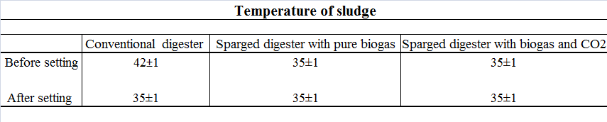

4.3.1 Recycling the CO₂ Diluted Biogas
In the third set of experiments, methane concentration in biogas produced from sparged digestion was diluted by carbon dioxide. The aim of the dilution was to strip more methane from the sludge, since the transfer of methane from the liquid phase to the gas phase increases when the concentration of methane in the bubbles is less than that in the sludge. Figure 20 shows the cumulative methane production from the conventional digester and sparged digester after dilution of the biogas.
Whilst similar problems occurred to those experienced in the previous part, the cumulative methane production was higher than with conventional unsparged operation.
Recycling the biogas to the anaerobic digester in both cases led to an increase in methane production, maintaining the concentration of gases in the digestion, improving the efficiency of mixing and preventing the formation of thermal layers in the reactor.
The data obtained from the experiment illustrated that recirculation of biogas (either pure gas or biogas diluted with carbon dioxide) in anaerobic digestion did not, contrary to previous studies, reduce the performance of the digestion, although the proportion of methane in the gas phase reached as much as 60%.

Figure 20: Cumulative methane production from sparged digester and unsparged digester.

In fact, we observed an increase in the total methane produced by using sparging with both undiluted recycled biogas as well as recycled biogas that had been diluted by carbon dioxide. Thus the bio-degradation steps continued without any negative effect on the production of methane. Low solubility of methane in the liquid and high carbon dioxide concentration in the biogas contributed to controlling the solubility of methane in the liquid phase.
On the other hand, the presence of methane gas and carbon dioxide together helped in controlling the environment of the whole process. Indeed, the methane acted as a determinant of the amount of carbon dioxide dissolved in the liquid phase. Therefore, it can be noted that the pH value remained within the required level as shown as in the Figure 21.
In addition, the recycling process causes stripping of hydrogen sulphide, the presence of which has a negative effect on the efficiency of methanogenic bacteria in the digester.
The results obtained from these experiments (recycling the diluted and undiluted biogas) demonstrated that recycling the biogas does not reduce the efficiency of the process; in fact, the data show that the gaslift anaerobic digester produced more methane than the unsparged digester.

Figure 21: pH values in the sparged digester (before and after bubbling process)

4.4 Sparging with pure CO2 microbubbles
Figure 22 shows that the digester sparged by CO₂ produces methane faster than the conventional digester. Sparging with carbon dioxide (without a nitrogen sparge as in Figures 5-13) also helps in the removal of methane found in the headspace of the digester.

Fig 22: Methane produced from the gaslift digester and the conventional digester over 19 days of operation.
After the daily sparging process is complete, the equilibrium partial pressure of the methane in the headspace is significantly reduced. The methane level then increases as the methane produced by the bacteria is transferred to the headspace until the next sparging event. The results show that production of methane in the digester with carbon dioxide exceeded the quantity produced by the unsparged digester by 109% as shown in Figure 23.

Fig 23: Cumulative methane production from the gaslift digester and conventional digester when the pure carbon dioxide is sparged
The high interfacial areas, resulting from the small microbubble size, and the low solubility of methane are parameters that play an important role in this process. These factors enable the sparging system to remove a large amount of methane in a short time while the small effect on the value of the pH is quickly compensated and controlled at the required level as can be seen in Figure 24.

Fig 24: pH value in the gaslift digester sparged by pure carbon dioxide for a 5 min period daily
Figure 24 shows quite clearly that CO₂ rich microbubbles have a dramatic effect on the production rate of methane. Although periodic, daily sparging does extract the methane content of the liquid medium during its operation, and has a residual effect of lowering the partial pressure of the methane in the headspace for some time, we find that all the biogas produced has a nearly constant composition. An argument has been made surrounding equations 12 and 13 that chemical thermodynamic non-equilibrium drivers with high CO₂ activity should spur greater methane production speed. But an overall mass balance would show that these arguments are insufficient to warrant a 109% increase in biogas production rate. The chemical species mass balance requires more H₂ to reduce CO₂ to CH₄. What is the source of this extra H₂ flux?
Ultimately, there is only one source of H₂ in an anaerobic digester -- the organic material used as a substrate by the bacteria consortium. Hence an additional concept is needed to describe why CO₂ rich microbubbles accelerate the H₂ flux from the organic substrate. If methanogens are fixing H₂ on CO₂, from where is it sourced, as H₂ is the limiting reactant and present at zero dissolved concentration, as the methanogens are hydrogen starved? In our opinion, the only source for additional hydrogen is the sugary biomass which is hydrolysed more rapidly if methane is produced more rapidly. Based on some of our novel and, as yet, unpublished results on low energy microbubble induced cell lysis in Pseudomonas putida, we can speculate on one possible mechanism for the additional flux of hydrogen.
Figure 2 shows that there is a small fraction of CO₂ microbubbles, about one percent, that are sufficiently small, to have high enough interfacial energies to support free radicals (less than 100 micron diameter). When such a microbubble collides with a cell wall / membrane, the free radical disrupts it, and the CO₂ is then released into the cytoplasm, creating a pH shock locally, potentially lysing the cell. This concept has been coined the "hammer and wedge" mechanism. The free radical is the wedge that prises open the cell membrane before being hit with the pH shock hammer. Alternatively, microbubbles that dissolve away are also known to create free radicals like a sonochemistry ultrasound cavitation created bubble collapse (Takahashi et al. 2007). Pure CO₂ microbubbles could dissolve away completely if the liquid is subsaturated. Microbubbles with lower CO₂ composition (higher N₂ content) showed less increase in methane production rate, consistent with both lower pH shock, but also less propensity for total dissolution. The issue of low energy cell lysis via sub 100 micron bubble population fractions with high CO₂ content is being explored with an ongoing experimental programme.
According to results obtained from the above five sets of experiments, the effect of sparging system on the methane production at different gases can be summarized in the Table 4.
Table 4: Effect the sparging system on methane produced from anaerobic digester
CO₂ fraction | Gas used in sparging system | Efficiency
0 | Pure Nitrogen | Negative effect (see Figure 5)
 | Pure Nitrogen + pure carbon dioxide | Zero effect
40%  80% | Recycling the undiluted biogas | Positive effect (12-14%)
40%  80% | Recycling the diluted biogas by carbon dioxide | Positive effect (10-12%)
100% | Pure carbon dioxide | Positive effect (100-110%)
5 Conclusions
This study discusses how a sparging system was applied in anaerobic digestion using an airlift bioreactor and different gas types (nitrogen, nitrogen and carbon dioxide, biogas (methane and carbon dioxide) and pure nitrogen under mesophilic conditions.
The results show that the application of the bubbling system with pure nitrogen in anaerobic digestion had a negative effect on the production of methane. This was because the sparging system stripped the carbon dioxide and hydrogen that are consumed by hydrogen utilising methanogenic bacteria in a route which normally accounts for 30% of total methane production. The results obtained from the experiments also showed that compensation with carbon dioxide after nitrogen bubbling does not lead to a sustained increase in daily methane production, regardless of the length of the period of sparging. This is despite the fact that sparging does initially increase methane production, but this is not sustained as was found for sparging with pure nitrogen. The results indicate that the daily sparging regime actually leads to a decrease in methane production, but this can be corrected by less frequent sparging to give the same production as can be achieved in a conventional digester. However, the results indicated that recirculation of biogas in anaerobic digestion process can enhance production of methane (10-14%).
The present study has also investigated the effect of periodic, daily sparging with carbon dioxide in a batch anaerobic fermenter. The type of gas in sparging system in biological processes plays an important role in determining the path of bio-reactions, in particular, processes that consist of more than one stage and have mutually beneficial relationships across these stages, as is case in anaerobic digestion. The results also showed that the digester sparged with carbon dioxide and using microbubbles generated by a fluidic oscillator produced more methane than the unsparged digester. The data obtained from the current experiments indicate that the sparging system helps in stripping the methane produced by anaerobic bacteria. Removal of biogas from the headspace contributes to the transfer of biogas dissolved in the sludge to the headspace due to the difference in concentration between the two phases. Ultimately, the increased biogas production rate must be due to greater release of H₂ from the organic substrate, but the mechanism whereby CO₂-rich microbubbles achieve this is still unknown.
The general trend is clear that increasing the CO₂ fraction within the microbubble increases the production rate of methane, and taken to its extreme, pure CO₂ has a surprisingly large effect – more than doubling the methane production rate. This is completely unexpected on the grounds of the stripping mechanism alone, as both pure nitrogen and pure CO₂ strip out all the available methane. Recycling with biogas, since it left the bioreactor in equilibrium with the liquid medium, has the effect of permitting stripping methane without stripping CO₂. Diluting the biogas with CO₂ increases the stripping effect, but stripping with microbubbles, due to the high surface area per unit volume, should strip all the methane. Hence on the basis of stripping alone, pure CO₂ microbubbles should not increase the methane production over diluted biogas. Alternatively, we can invoke thermodynamic principles to explain this effect. Considering the metabolic routes to methane, there are two in which CO₂ is utilised. Firstly, it is consumed by hydrogenotrophic methanogens and secondly it can be reduced to acetate via the Wood–Ljungdahl pathway of acetogenesis. This latter route has been proposed as the means by which injection of CO₂ has enhanced methane production form anaerobic digestion in previous research work (Fernández, Soares, Villa, Vale, & Cartmell, 2014; Salomoni et al., 2011). Neither of these studies, however, have addressed the issue that greater production of H₂ must also occur since it is a co-substrate in both these routes. This requires us to consider additional mechanisms to explain our striking results, such as the release of more sugary materials from the feedstock by additional cell lysis, must be in play, as greater methane production rate can only occur with greater H₂ metabolic flux, as it is the limiting reagent in methanogenesis.

- Acknowledgments

W.Z. would like to acknowledge support from the EPSRC (Grant No. EP/I019790/1) and for support from the 4CU Programme Grant, 4cu.org.uk, (EP/K001329/1). W.Z. would also like to acknowledge the Royal Society for a Brian Mercer Innovation award and the Royal Academy of Engineering for an industrial secondment with AECOM Design Build. MKHaM would like to thank the Ministry of Education and Baghdad University for a doctoral scholarship.

- References
Ahring B. and Westermann P. 1988, Product Inhibition of Butyrate Metabolism by Acetate and Hydrogen in a Thermophilic Coculture., Applied and Environmental Microbiology, Vol. 54, No. 10, p. 2393-2397.
Ahring, B. 2003. Perspectives for anaerobic digestion biomethanation i.springer berlin / heidelberg, 81, PP. 1-30.
Al-Mashhadani, M. K. H., Bandulasena, H. C. H. and Zimmerman, W. B. 2012(a). CO₂ Mass Transfer Induced through an Airlift Loop by a Microbubble Cloud Generated by Fluidic Oscillation. Industrial and Engineering Chemistry Research, 51, 1864-1877.
Al-Mashhadani M. K. H., Wilkinson S. J., Zimmerman W. B., 2012(b), “Removal of acid-gases from digested sludge using microbubble generated by fluidic oscillation” , The Sixth International Conference on Environmental Science and Technology, Texas, USA.
Al-Mashhadani M. K. H., Wilkinson S. J., Zimmerman W. B., 2015(a). Airlift Bioreactor for Biological Applications with Microbubble Mediated Transport Processes, Chemical Engineering Science, Vol 137, PP. 243-253.
Al-Mashhadani M. K. H., Wilkinson S. J., Zimmerman W. B., 2015 (b). Laboratory Preparation of Simulated Sludge for Anaerobic Digestion Experimentation. Journal of Engineering, Vol 21 (6), PP. 131-145.
Alshiyab, H., Kalil, M. S., Hamid, A. A. and Yusoff, W. M. W. 2008. Removal of headspace CO₂ increases biological hydrogen production by C. acetobutylicum. Pakistan Journal of Biological Sciences, 11, 2336-2340.
Appels, L., Baeyens, J., Degrève, J. and Dewil, R. 2008. Principles and potential of the anaerobic digestion of waste-activated sludge. Progress in Energy and Combustion Science, 34, 755-781.
Brittle S, Desai PD, Ng WC, Dunbar A, Howell R, Tesar V, Zimmerman WB. 2015, Minimising Microbubble Size through Frequency Control, Chemical Engineering Research and Design 104, 357–366.
Budzianowski, W. M. 2012. Sustainable biogas energy in Poland: Prospects and challenges. Renewable and Sustainable Energy Reviews, 16, 342-349.
Chisti, Y. 2007. Biodiesel from microalgae. Biotechnology Advances, 25, 294-306.
ERIKSEN, N. T. 2008. The technology of microalgal culturing. Biotechnology Letters, 30, 1525-1536.
Fernández, Y. B., Soares, A., Villa, R., Vale, P., & Cartmell, E. (2014). Carbon capture and biogas enhancement by carbon dioxide enrichment of anaerobic digesters treating sewage sludge or food waste. Bioresource technology, 159, 1-7.
Gary R. K. “The Concentration Dependence of the S Term in the Gibbs Free Energy Function: Application to Reversible Reactions in Biochemistry,” Journal of Chemical Education, Vol. 81, No. 11, 2004, pp. 1599-1604.
Hoh, C., & Cord-Ruwisch, R. (1996). A practical kinetic model that considers endproduct inhibition in anaerobic digestion processes by including the equilibrium constant. Biotechnology and bioengineering, 51(5), 597-604.
Kadam, K. L. 1997. Power plant flue gas as a source of CO₂ for microalgae cultivation: economic impact of different process options. Energy Conversion and Management, 38, 505-510.
Kim, D. H., Han, S.-K., Kim, S.-H. and Shin, H.-S. 2006. Effect of gas sparging on continuous fermentative hydrogen production. International Journal of Hydrogen Energy, 31, 2158-2169.
Kraemer, J. T. and Bagley, D. M. 2008. Optimisation and design of nitrogen-sparged fermentative hydrogen production bioreactors. International Journal of Hydrogen Energy, 33, 6558-6565.
Liang, T.-M., Cheng, S.-S. and WU, K. L. 2002. Behavioral study on hydrogen fermentation reactor installed with silicone rubber membrane. International Journal of Hydrogen Energy, 27, 1157-1165.
Mccarty, P. L. and Smith, D. P. 1986. Anaerobic Waste-Water Treatment .4. Environmental Science and Technology, 20, 1200-1206.
Metcalf and Eddy 1991 and 2003. Wastewater Engineering Treatment and Reuse, McGraw Hill.
Mizuno, O., Dinsdale, R., Hawkes, F. R., Hawkes, D. L. and Noike, T. 2000. Enhancement of hydrogen production from glucose by nitrogen gas sparging. Bioresource Technology, 73, 59-65.
Park, W., Hyun, S. H., OH, S. E., Logan, B. E. & Kim, I. S. 2005. Removal of headspace CO₂ increases biological hydrogen production. Environmental Science and Technology, 39, 4416-4420.
Poeschl, M., Ward, S. and Owende, P. 2010. Prospects for expanded utilization of biogas in Germany. Renewable and Sustainable Energy Reviews, 14, 1782-1797.

Rehman F, Medley GJ, Bandulasena H, Zimmerman WB, 2015, Fluidic oscillator-mediated microbubble generation to provide cost effective mass transfer and mixing efficiency to the wastewater treatment plants. Environmental Research, 137,32-39.
Sahlström, L. 2003. A review of survival of pathogenic bacteria in organic waste used in biogas plants. Bioresource Technology, 87, 161-166.
Salomoni C. and Petazzoni E. 2006. CO₂ Capture and Use in Organic Matter Digestion for Methane Production, Patent, WO 2006108532 A1.
Salomoni, C., Caputo, A., Bonoli, M., Francioso, O., Rodriguez-Estrada, M., & Palenzona, D. (2011). Enhanced methane production in a two-phase anaerobic digestion plant, after CO₂ capture and addition to organic wastes. Bioresource technology, 102(11), 6443-6448.
Schenk, P. M., Thomas-Hall, S. R., Stephens, E., Marx, U. C., Mussgnug, J. H., Posten, C., Kruse, O. and Hankamer, B. 2008. Second Generation Biofuels: High-Efficiency Microalgae for Biodiesel Production. Bioenergy Research, 1, 20-43.
Schmidt, J. E. and Ahring, B. K. 1993. Effects of Hydrogen and Formate on the Degradation of Propionate and Butyrate in Thermophilic Granules from an Upflow Anaerobic Sludge Blanket Reactor. Applied and Environmental Microbiology, 59, 2546-2551.
Scott, R. I., Williams, T. N. & Lloyd, D. 1983. Oxygen Sensitivity of Methanogenesis in Rumen and Anaerobic Digester Populations Using Mass-Spectrometry. Biotechnology Letters, 5, 375-380.
Singh, V. 2012. Effect of corn quality on bioethanol production. Biocatalysis and Agricultural Biotechnology, 1, 353-355.
Takahashi, M. Chiba, K. and Li, P. 2007. Free-radical generation from collapsing microbubbles in the absence of a dynamic stimulus. The Journal of physical Chemistry B,111 (6), 1343-1347.
Tanisho, S., Kuromoto, M. and Kadokura, N. 1998. Effect of CO₂ removal on hydrogen production by fermentation. International Journal of Hydrogen Energy, 23, 559-563.
Tiehm, A., Nickel, K., Zellhorn, M. and Neis, U. 2001. Ultrasonic waste activated sludge disintegration for improving anaerobic stabilization. Water Research, 35, 2003-2009.
Wang, Q., Kuninobu, M., Kakimoto, K., I. Ogawa, H. & Kato, Y. 1999. Upgrading of anaerobic digestion of waste activated sludge by ultrasonic pretreatment. Bioresource Technology, 68, 309-313.
Zimmerman, W. B., Hewakandamby, B. N., Tesar, V., Bandulasena, H. C. H. & Omotowa, O. A. 2009. On the design and simulation of an airlift loop bioreactor with microbubble generation by fluidic oscillation. Food and Bioproducts Processing, 87, 215-227.
Zimmerman, W. B., Tesař, V. & Bandulasena, H. C. H. 2011. Towards energy efficient nanobubble generation with fluidic oscillation. Current Opinion in Colloid and; Interface Science, 16, 350-356.

