A PILOT RANDOMISED CONTROLLED TRIAL INVESTIGATING

PSYCHOTHERAPEUTIC INTERVENTIONS FOR

IMPROVING THERAPIST ENGAGEMENT

Anna Gidlow

1523443

MSc Psychology (Conversion)

PS7112 Research Dissertation

2015/2016

University of Chester

A PILOT RANDOMISED CONTROLLED TRIAL INVESTIGATING
PSYCHOTHERAPEUTIC INTERVENTIONS FOR
IMPROVING THERAPIST ENGAGEMENT

Word count: 8,764

Declaration

This work is original and has not been submitted in relation to any other degree or qualification.

This research received ethical approval from the Department of Psychology Ethics Committee on 22/04/2016, DOPEC code AGKH220416.


Signed: ……………………….. (Anna Gidlow)
Date: ……10/10/2016……..

Acknowledgments

I would first like to thank my supervisor Dr Kevin Hochard of the Psychology department at the University of Chester. He was always available to offer help and advice when needed, whilst also encouraging me to trust my own work.

I would also like to thank the co-supervisors of the project Samantha Flynn and Dr Lee Hulbert-Williams of the Psychology department at the University of Chester for all their input and support during the initial stages of the project.

Finally, I would like to express my thanks to the technicians of the Psychology department at the University of Chester; Rhian McHugh for explaining how to use the eye tracking equipment, Adam Kingston for helping to solve any technical issues, and for his help with analysing the eye tracking data, and Bryan Hiller for helping to set up the equipment, and always being around to answer any questions.

Department of Psychology
Supervision Meeting Log 2015/2016


Name: Anna Gidlow
Degree Programme: MSc Psychology (Conversion)
Dissertation Supervisor: Dr Kevin Hochard

Date | Supervisors present | Topics discussed
20/01/2016 | Dr Kevin Hochard  Dr Lee Hulbert-Williams  Samantha Flynn | Ideas for potential research topics.  (Area: clinical psychology).
27/01/2016 | Dr Kevin Hochard  Dr Lee Hulbert-Williams  Samantha Flynn | Behaviour of therapists, and their ability to sit through and deal with uncomfortable situations.
03/02/2016 | Dr Kevin Hochard  Dr Lee Hulbert-Williams  Samantha Flynn | Group discussion – independent literature searches.  Decision to focus on therapist verbal and non-verbal behaviours during discussion of an emotive topic, and how we can improve therapist engagement.
10/02/2016 | Dr Kevin Hochard  Dr Lee Hulbert-Williams  Samantha Flynn | Randomised controlled trial – CBT/ACT.  Operationalising measures:  - Explicit attention: recall questionnaire  - Implicit attention: eye gaze (using eye tracker).
24/02/2016 | Dr Kevin Hochard  Samantha Flynn | Decided on video stimulus (suicide attempt).  Discussion about methods of recruitment, sample size, and ethical considerations (e.g., target recruitment groups).
09/03/2016 | Dr Kevin Hochard  Samantha Flynn | Discussion about CBT and ACT interventions.

Date | Supervisors present | Topics discussed
16/03/2016 | Dr Kevin Hochard  Samantha Flynn | First practice of CBT intervention exercises.  Discussion about completing application for ethical approval (deadline 23/03/2016).
06/04/2016 | Dr Kevin Hochard  Samantha Flynn | First practice of ACT intervention exercises.
18/04/2016 | Dr Kevin Hochard | Discussion – completing ethics amendment form.
27/04/2016 | Dr Kevin Hochard  Samantha Flynn | Eye tracker training with Rhian McHugh.  Discussion after receiving full ethical approval.  Posters displayed (psychology and counselling).
04/05/2016 | Dr Kevin Hochard | Full run through of exercises in CBT intervention.
20/05/2016 | Dr Kevin Hochard | Full run through of exercises in ACT intervention.  Study advertised on RPS.
15/06/2016 | Dr Kevin Hochard | Equipment set up and tested.  Quick run through of study protocol.
22/06/2016 | Dr Kevin Hochard | Discussion after completing study with first group of participants (difficulties and observations).
15/07/2016 | Dr Kevin Hochard | Data analysis – will use either 2 x ANCOVA (recall questionnaire and eye gaze) or MANCOVA.  Discussion about writing dissertation.
17/08/2016 | Dr Kevin Hochard | Power – is a pilot study so will be underpowered.
14/09/2016 | Dr Kevin Hochard | End of data collection: discussion about findings, difficulties encountered, data analysis, and ideas for future studies.
03/10/2016 | Dr Kevin Hochard | Verbal feedback on first draft of dissertation.

Supervisor’s signature …………………………. Date: 08/10/2016
Student’s signature …………………………. Date: 10/10/2016

Table of contents

Declaration ……………………………………………………………………………………. iii
Acknowledgements …………………………………………………………………………... iv
Supervision meeting logs …………………………………………………………………….. v
List of tables …………………………………………………………………………………… ix
Lists of figures …………………………………………………………………………………. x
Abstract ………………………………………………………………………………………... xi

1. INTRODUCTION …………………………………………………………………………... 1
Psychotherapeutic methods ………………………………………………………… 1
Cognitive behavioural therapy (CBT) …………………………………….... 1
Acceptance and commitment therapy (ACT) ……………………………... 2
Factors affecting the success of psychotherapy ………………………………….. 3
Therapist effects …………………………………………………………….. 4
Significance of the therapeutic alliance …………………………………… 5
Training therapists to deal with uncomfortable discussions..................... 6
Research objectives ………………………………………………………………... 10
Hypotheses ………………………………………………………………………..… 12
2. METHOD ………………………………………………………………………………..… 13
Design ……………………………………………………………………………….. 13
Participants ………………………………………………………………………..… 13
Ethical considerations ……………………………………………………... 13
Exclusion criteria …………………………………………………………… 14
Materials ………………………………………………………………………..…… 14
AAQ-II ……………………………………………………………………….. 14
Video scenario ……………………………………………………………... 15
Recall questionnaire ……………………………………………………..… 15
Intervention booklets …………………………………………………...….. 15
Procedure ………………………………………………………………………….... 17

Data preparation ………………………………………………………………….… 18
Statistical analysis ………………………………………………………………….. 19
3. RESULTS ………………………………………………………………………………… 20
Hypothesis 1 ………………………………………………………………………... 21
Hypothesis 2 ………………………………………………………………………... 21
4. DISCUSSION …………………………………………………………………………….. 22
Explanation of results ……………………………………………………………… 23
Recall questionnaire ………………………………………………………. 23
Eye gaze …………………………………………………………...………. 24
Connectedness to client ………………………………………………….. 25
Evaluation of pilot study …………………………………………………………… 26
Difficulties encountered during the study ……………………………….. 27
Limitations of the study ………………………………………………….... 30
Suggestions for future work ………………………………………………………. 32
5. CONCLUSION …………………………………………………………………………… 34
6. REFERENCES …………………………………………………………………………... 35
7. APPENDICES ……………………………………………………………………………. 45
A. Application for ethical approval ………………………………………………... 45
B. Application for ethical approval amendment form …………………………... 46
C. Acceptance and Action Questionnaire-II (AAQ-II) …………………………... 47
D. Video scenario ………………………………………………..…. <see data disc>
E. Recall questionnaire with answers ……………………………………………. 48
F. CBT intervention booklet ……………………………………………………….. 49
G. ACT intervention booklet …………………………………………………….… 58
H. Study protocol …………………………………………………………………... 66
I. Eye tracker data analysis …………………...……………….….. <see data disc>
J. PsychoPy behavioural data ………………………...………….. <see data disc>
K. SPSS data file ……………………………………..……………. <see data disc>
L. SPSS data output ……………………………………………….. <see data disc>

List of tables

- Outline of CBT and ACT intervention exercises ……………………………….… 16
- Descriptive statistics for CBT and ACT intervention groups ……………….…… 20

List of figures

- Experimental set-up ………………………………………………………………… 17
- PsychoPy video stimulus summary ……………………………………………….. 18
- Example screenshot of a fixation ………………………………………………….. 30

Abstract

Evidence consistently shows that therapist verbal and non-verbal behaviours both contribute to the outcome of psychotherapy. Therapists must learn how to deal with, and control these behaviours during uncomfortable discussions with clients. The present pilot study investigated whether brief cognitive behavioural therapy (CBT)-based or acceptance and commitment therapy (ACT)-based interventions could improve therapists’ levels of engagement with a video scenario in which the sensitive topic of an attempted suicide is discussed. Participants in the CBT group (n = 10) and the ACT group (n = 10) were compared on levels of implicit attention (measured by a recall questionnaire), and explicit attention (measured by eye gaze) to the scenario. Behavioural measures assessed differences between groups in terms of connectedness with the client and her story. No significant main effects were found between the two groups for levels of engagement or connectedness. This study suggests that both CBT- and ACT-based interventions may help to improve therapists’ skills in dealing with uncomfortable discussions. These initial findings also suggest that ACT-based interventions may be more effective than CBT-based interventions but a fully-powered study must be completed before drawing conclusions.

Introduction

It is estimated that approximately one in four adults in England experience a mental health problem (Health and Social Care Information Centre, 2015; Mental Health Foundation, 2015). As mental health difficulties can impact upon many aspects of daily life, research into effective treatments is warranted, and mental health problems are considered a major public health concern (Anderson, McClintock, Himawan, Song & Patterson, 2016; Mental Health Foundation, 2015). One of the main forms of treatment of mental health problems is psychotherapy, which aims to help clients understand and manage distressing negative thoughts and experiences, with the view to making substantial positive changes in their lives (Egan, 2014; Moorey, 2013).

Psychotherapeutic methods

The behaviour therapy movement aims to develop empirically validated treatments to help clients deal with mental health concerns (Hayes, Luoma, Bond, Masuda & Lillis, 2006). Essentially all measures of psychopathology assume that in order to be deemed psychologically healthy, the individual must be free of any disordered ways of thinking (Harris, 2009; Hayes et al., 2006; Hawton, Salkovskis, Kirk & Clark, 1989). The field of psychotherapy therefore focuses on controlling thoughts and feelings, anxiety management, and cognitive restructuring (Hayes, Strosahl & Wilson, 1999).

Cognitive behavioural therapy (CBT).

CBT is considered to be the gold-standard empirically validated treatment for anxiety disorders due to high clinical efficacy, and ease of implementation (Arch et al., 2012; Tolin, 2010). Extensive research has demonstrated the efficacy of CBT in treating a wide range of psychological disorders including generalised anxiety disorder, social anxiety disorders, and phobias (Arch et al., 2012; Lappalainen et al., 2007). CBT primarily focuses on problem-solving, and evaluating and challenging dysfunctional or negative thoughts and behaviours in areas outside the clinical setting (Davey, 2014; Hawton et al., 1989; Scherr, Herbert & Forman, 2015). CBT is largely a self-help therapy, which aims to help clients not only deal with current problems that they are facing in their lives, but also prepare them to deal with similar problems in the future (Hawton et al., 1989). The aim is to reduce avoidance of anxiety-provoking situations, which can help the client look forward to the future, instead of dwelling on past negative experiences (Hawton et al., 1989).

Acceptance and commitment therapy (ACT).

In recent years, research focus has shifted towards a third wave of contextualistic approaches in behaviour therapy, one of which is acceptance and commitment therapy (ACT; Hayes et al., 1999), which involves acceptance and mindfulness-based interventions (Arch et al., 2012; Hayes et al., 2006). ACT is about values-guided, mindful action; the client is encouraged to think about what is important to them as a person, and to use these core values to guide and inspire changes in their behaviour (Harris, 2009; Luoma, Hayes & Walser, 2007). The client is taught to accept things that cannot be changed but encouraged to make changes in line with their personal values (Hayes et al., 1999). ACT assumes that one can live a positive and fulfilling life, regardless of psychological symptoms, as long as we use mindfulness skills to promote psychological resilience or flexibility, and to help deal with these painful thoughts and feelings in the present moment (Harris, 2009). ACT focuses on two core psychological processes: cognitive fusion (getting caught up in negative thoughts), and experiential avoidance (ongoing suppression of unwanted thoughts and feelings) (Harris, 2009). ACT uses carefully developed experiential or existential exercises, designed to help the client willingly connect with negative or unwanted thoughts, feelings or memories (Harris, 2009; Hayes et al., 1999).
The theoretical roots of ACT lie in relational frame theory (RFT), which claims that human language and cognition are learned and contextually controlled to allow links to be made between similar events (Hayes et al., 2006; Hayes et al., 1999). Whereas CBT attempts to control or eliminate negative thoughts or feelings (Arch et al., 2012), the assumption underlying ACT is that focusing on such dysfunctional thoughts increases their behaviour-regulatory function, meaning we can be controlled by our thoughts and emotions (Hayes et al., 1999). Hence, instead, ACT focuses on the importance of verbal language, combined with mindfulness, acceptance and cognitive defusion techniques to promote behavioural changes that are in line with a client’s personal values (Arch et al., 2012; Hayes et al., 1999; Luoma et al., 2007; Moreno-Agostino, Galván-Domínguez & Álvarez-Iglesias, 2015). ACT therefore focuses upon changing the context of thoughts by improving psychological flexibility (Arch et al., 2012).

Factors affecting the success of psychotherapy

Traditionally, research into effective psychotherapy treatments broadly assumed that a treatment’s success was independent of the individual therapist, and that therapists themselves did not exert influence over treatment outcome (Okiishi, Lambert, Nielsen & Ogles, 2003). This was mainly because clinical trial research usually aims to minimise individual therapist effects by employing standardised treatments and manuals to discover the effect of different therapeutic techniques on client outcome (Anderson, Ogles, Patterson, Lambert & Vermeersch, 2009; Okiishi et al., 2003). This seemingly narrow focus upon treatment variables may lead to unreliable or flawed assumptions (Blow, Sprenkle & Davis, 2007).
More recently, research has consistently demonstrated that during psychotherapy the behaviour of both the client and the therapist can influence the success of the treatment (Anderson et al., 2009; Chapman & Rosenthal, 2016; Egan, 2014; Kahn, 2001; Lindgren, Folkesson & Almqvist, 2010). There is substantial evidence that the variance in therapy outcomes can be explained in part by individual therapists, even in highly controlled experimental studies, in particular in their ability to handle challenging situations with clients (Anderson, Crowley, Himawan, Holmberg & Uhlin, 2016; Anderson et al., 2009; Blow et al., 2007; Dinger, Strack, Leichsenring, Wilmers & Schauenburg, 2008; Wampold & Brown, 2005). These therapist effects have been shown to be even larger than treatment effects (Lindgren et al., 2010).
Wampold (2001) distinguishes between the traditional medical model in which the variability in treatments affects therapy outcome to a greater extent than variability of therapists, and the current model of psychotherapy, which posits that the variability of therapists exceeds that of treatments. Using an abundance of evidence supporting the influence of therapist effects, Wampold (2001) completed a landmark meta-analysis which determined that 6-9% of the proportion of outcome variance can be accounted for by therapist effects, compared to a mere 1% for variability among treatments. According to Wampold (2001), ignoring such therapist effects can result in over-estimation of treatment effects, and incorrect conclusions about treatment efficacy can be drawn.

Therapist effects.

Research has been undertaken into both positive and negative therapist effects that can influence therapy success, and has revealed that some therapists possess more desirable characteristics than others, which in turn can improve the therapist’s efficacy with clients (Jacobson, Fox, Bell, Zeligman & Graham, 2015; Wampold, 2001). Chapman and Rosenthal (2016) focus on therapists’ therapy-interfering behaviours (TIB); anything that the therapist does during a session that can negatively affect the progress or outcome of the therapy, or impact upon the therapeutic relationship between the therapist and the client. For example, despite their best intentions, therapists may automatically say or do something that can hinder a client’s progress, such as using too much medical jargon, interrupting the client when they are talking, or actively avoiding uncomfortable discussions (Chapman & Rosenthal, 2016).
On the other hand, literature suggests that it is the therapist’s personal characteristics, or facilitative interpersonal skills (FIS) that are key factors in determining treatment success; larger rates of improvement have been reported by clients whose therapists had higher levels of FIS, including verbal frequency, warmth, emotional expression, empathy, and relationship building (Anderson, Crowley et al., 2016; Anderson, McClintock et al., 2016; Anderson et al., 2009; Hersoug, Høglend, Havik, von der Lippe & Monsen, 2009). Additionally, Anderson, McClintock et al. (2016) found that higher FIS therapists were more effective that lower FIS over shorter durations, and Anderson, Crowley et al. (2016) suggest that high FIS therapists form a collaborative therapeutic relationship more swiftly than low FIS therapists. Empathy and genuineness are consistently among the top process-outcome variables in determining therapist efficacy (Anderson, Crowley et al., 2016; Jacobson et al., 2015). Empathy is considered to be the therapist’s ability to understand the client and their emotions from their perspective, and to sympathise with what the client is thinking and feeling (Egan, 2014; Jacobson et al., 2015; Kahn, 2001). To be truly empathic, the therapist must be actively engaged with the client at all stages throughout the therapy, and showing emotion towards the client can help to improve the therapist-client relationship (Jacobson et al., 2015).

Significance of the therapeutic alliance.

As previously discussed, establishing a collaborative, reciprocal, trusting relationship between client and therapist is of paramount importance for successful therapy (Egan, 2014; Hawton et al., 1989; Lindgren et al., 2010; Sandhu, Arcidiacono, Aguglia & Priebe, 2015). This relationship in the field of psychotherapy is commonly referred to as the therapeutic alliance (Egan, 2014). The concept of “therapeutic presence” has recently been highlighted as a key component in developing an effective therapeutic relationship (McCollum & Gehart, 2010, p. 347). A therapist should be engaged and attentive to the client at all times during therapy (Egan, 2014), but the client must also feel able to disclose information and contribute to the session (Hawton et al., 1989; Sandhu et al., 2015). Hersoug et al. (2009) studied the quality of the therapeutic alliance, as rated by both clients and therapists, and found that both groups associated being distanced or disconnected with a weaker alliance in long-term therapies.
It is common knowledge that professionals working with clients in the mental health field require exceptional communication skills, as it can facilitate engagement and discussions between the therapist and the client, and reduce anxiety in both parties (Sandhu et al., 2015). However, it is important to be aware of the fact that both verbal, and non-verbal therapist behaviours can either promote or hinder the creation of the therapeutic alliance, and thus the course of treatment (Egan, 2014; Hersoug et al., 2009; Moreno-Agostino et al., 2015; Sharpley & Sagris, 1995).
The therapist can show their interest in what the client is talking about both non-verbally by nodding, and verbally through comments and questions (Hawton et al., 1989). By using appropriate non-verbal behaviours such as bodily movements (posture and gesture), facial expressions (smiles or frowns), and eye contact, the therapist can show they are listening intently, and are present and visibly engaged with the client (Dowell & Berman, 2013; Egan, 2014). Regarding eye movements, observing another person looking at you signals that their attention is directed at you, and longer fixation durations signify stronger allocation of attention (Hietanen, Myllyneva, Helminen & Lyyra, 2016; Marschner, Pannasch, Schulz & Graupner, 2015). A study by Dowell and Berman (2013) revealed that high eye contact and forward trunk lean towards the client enhanced both perceived therapist empathy, and treatment credibility. Such non-verbal behaviours play an important contribution to the therapeutic dialogue as they can communicate and reveal hidden emotions, offer insights into self-perceptions, and help to regulate conversation by encouraging disclosure (Cañadas & Lupiáñez, 2012; Egan, 2014; Marschner et al., 2015; Schneier, Rodebaugh, Blanco, Lewin & Liebowitz, 2011).

Training therapists to deal with uncomfortable discussions

It is imperative that professionals in the mental health field can disengage themselves from upsetting or distressing experiences whilst working with a client (Egan, 2014; Hertel, Benbow & Geraerts, 2012). Therapists must also be willing to sit with the anxiety that comes with pushing clients to discuss topics they may find challenging (Luoma et al., 2007), and learn how to deal with a client revealing details about themselves or their behaviours that the therapist does not morally agree with, for example abuse, addiction, or suicidal tendencies (Hayes et al., 1999). Suicide is the conscious and deliberate taking of one’s life, and the primary motivation appears to be a desire to escape from aversive feelings and mood states, including anxiety, worthlessness, and guilt (Hayes et al., 1999). In 2014 alone there were 6,122 registered suicides of people aged 10 or over in the United Kingdom (Office for National Statistics, 2016), hence it is clear that therapists need training in how to deal with this issue.
Rumination or brooding about one’s problems or negative experiences results in cognitive costs, such as difficulty in suppressing negative thoughts or mood (Joormann & Gotlib, 2008), which can be distracting. A study by Hertel et al. (2012) revealed that participants in a brooding group were sufficiently inattentive to targets, resulting in poor recall post-task. The authors proposed that feelings of competence and control should reduce this tendency to ruminate, thus increasing attention, and recall (Hertel et al., 2012). Trainees learning to deliver psychotherapy often have limited exposure to qualified professionals, and thus have restricted opportunities to observe the successful delivery of interventions to clients (Fairburn & Cooper, 2011). Consequently, early-career professionals may be concerned about their performance, and the more persistent these feelings of doubt and anxiety, the more distracting they will become, thus impacting upon performance (Gockel, Burton, James & Bryer, 2013). As well as helping to create a strong therapeutic alliance, non-verbal behaviours can also overtly display discomfort on the part of the therapist; a closed posture can be interpreted as defensive or a lack of willingness to engage with the client, and lack of eye contact can signal that the therapist is distracted or uncomfortable with the topic being discussed, both of which can limit opportunities for positive interactions (Egan, 2014; Schneier et al., 2011). Therapists may also limit eye gaze when they feel uncomfortable, as self-reported avoidance of eye contact has been associated with anxiety (Schneier et al., 2011)
Professionals have realised that the current methods of training are no longer sustainable as they are costly and require scarce expertise, and so there has been interest shown in internet-based training methods (Fairburn & Cooper, 2011), as well as internet delivered therapy (Hedman, 2014). During internet delivered therapy, the patient has contact with an assigned therapist (Hedman, 2014). Studies have shown that internet delivered therapy could be as effective as traditional face-to-face therapy for the treatment of common psychiatric disorders, including anxiety and depression (Hedman, 2014). A study by Bengtsson, Nordin and Carlbring (2015) revealed that several participants who worked in the helping profession reported that internet-based CBT (ICBT) training helped to improve focus and structure during sessions, but that the therapeutic alliance was more easily established during face-to-face therapy. This was mainly due to the fact that it was easier to offer direct feedback, ask follow-up questions, and easier to interpret body language, communicate warmth and empathy, and thus establish rapport (Bengtsson et al., 2015).
Despite CBT’s clear successes, there still remains a substantial gap between the evidence supporting such evidence-based psychotherapies, and their consistent practice in clinical settings (Scherr et al., 2015; von Ranson, Wallace & Stevenson, 2013). Some therapists remain reluctant to practice some of the key components, particularly exposure therapy, and it is speculated that this is due to therapist discomfort (Scherr et al., 2015). Therapists are averse to the temporary distress clients often experience during exposure therapy, and the secondary distress this can provoke in the therapists themselves (Scherr et al., 2015). Therapists who are less willing to experience this temporary discomfort may therefore be depriving clients of effective treatments to help solve their problems, and may instead rely on more drawn-out, slow-acting talking therapies (Scherr et al., 2015).
Therapists can only be taught how to deal with uncomfortable situations and the skills of visibly tuning in to clients to a certain extent; it is important that the therapist values the significance of respect and empathy, and is passionate about what they do as internal attitudes are reflected in external behaviours (Egan, 2014). Additionally, despite the fact that clinicians are usually aware of the importance of emotional support and well-honed listening skills, and have confidence in their ability to identify distress, many still feel they lack the necessary skills to truly help their patients (McCollum & Gehart, 2010; Moorey, 2013).
Mental health professionals who have been trained in CBT techniques, have shown increased confidence and ability to remain present with clients during difficult conversations, and increased competence in reducing client distress (Moorey et al., 2009; Moorey, 2013). In ACT, therapists aim to be fully present with clients, regardless of uncomfortable or emotional experiences that arise (Harris, 2009). The delivery of ACT training to clinicians has improved their ability to deal with, and overcome, uncomfortable experiences during therapy, for example clients with substance abuse problems, and the general stigma towards those with mental health difficulties (Hayes et al., 2004; Masuda et al., 2007). This is because by using ACT during their therapy sessions, therapists are in touch with their core values of compassion and respect, which facilitate the development of a non-judgmental, open, and genuine relationship (Harris. 2009). ACT training also encourages therapists to learn to sit with uncomfortable experiences, in order to give the client time to work through their own problems, without rushing in to reduce the therapist’s own anxiety (Harris, 2009).
McCollum and Gehart (2010) created a curriculum for trainee therapists based on mindfulness techniques, and results from journal entries revealed that the trainees believed they had developed improved therapeutic presence. The students were also able to emotionally connect with their client’s experiences, whilst also distancing themselves so as not to feel overwhelmed, a technique that is incredibly important for those in the helping professions (McCollum & Gehart, 2010). They were also better able to control their anxiety when meeting new clients (McCollum & Gehart, 2010). Findings from a study by Keane (2014) suggest that mindfulness practice can enhance key therapist abilities, such as attention, and qualities, including empathy. Importantly, 98% of participants claimed that their ability to deal with uncomfortable experiences had improved (Keane, 2014). Another study in which students received 10-minutes of mindfulness training before clinical interviewing classes revealed that students drew on mindfulness techniques to improve therapeutic presence and their ability to be emotionally available to their clients (Gockel et al., 2013). Chapman and Rosenthal (2016) recommend that therapists try to use mindfulness practices as a way to reduce TIBs, improve distress tolerance, and to help the therapist recognise when their own emotions are negatively impacting upon the success of therapy. Therapists also need to focus on developing their awareness of uncomfortable emotions or experiences, and how they can act as barriers during therapy (Scherr et al., 2015). However, it remains unclear how mindfulness-based interventions actually promote clinical skill development (Gockel et al., 2013).

Research objectives

Although studies investigating influential therapist characteristics are picking up pace (Slavin-Mulford, 2016), particularly in the communication of bad news and dealing with uncomfortable situations (Alelwani & Ahmed, 2014), the creation of a successful therapeutic alliance still remains a challenging and under-researched area (Blow et al., 2007; Hersoug et al., 2009; McCollum & Gehart, 2010). In addition, the majority of research into therapist characteristics to date has relied on self-report methodology, hence conclusions are restricted (Anderson, McClintock et al., 2016). An intervention in which trainees can learn how to increase their psychological and behavioural flexibility when faced with challenging encounters could be beneficial in improving therapy outcomes (Anderson et al., 2009; Scherr et al., 2015). Similar to Arch et al.’s (2012) study of comparing CBT and ACT treatment packages, we aim to investigate whether a brief CBT- or ACT-based intervention can improve therapists’ skills of attention and engagement during uncomfortable discussions.
Based on the understanding that eye contact is considered to be the cornerstone of non-verbal communication (Jarick & Kingstone, 2015), and the belief that uncomfortable experiences can provoke anxiety (Chapman & Rosenthal, 2016; Scherr et al., 2015) resulting in poor recall (Hertel et al., 2012), we designed a pilot study to test participant attention and engagement during the discussion of a sensitive topic. As previously discussed, therapists must learn how to deal with the topic of suicide, and so we chose to use a video stimulus in which a young woman who discusses her attempted suicide acts as a pseudo-client. During the experiment, participants were fitted with eye tracking glasses as eye tracking methods have been suggested to be a novel approach to measuring attentional control (Ellis, Wells, Vanderlind & Beevers, 2014). Explicit attention to the scenario was assessed using a recall questionnaire, which was designed to test whether the participants were listening carefully during the video.
As previously discussed, therapist effects can account for a substantial portion of the variance in therapy outcomes (e.g., Anderson et al., 2009; Chapman & Rosenthal, 2016; Lindgren et al., 2010). There are a multitude of different therapist effects that can affect therapy success, and so to mitigate this problem, we tried to control for several potentially confounding variables (McIlveen, Higgins, Wadeley & Humphreys, 1992). Previous research has shown that psychological flexibility can affect how willing a therapist is to deal with their own discomfort during challenging or emotive discussions (Scherr et al., 2015), and therefore we controlled for baseline psychological flexibility using the Acceptance and Action Questionnaire-II (AAQ-II; Bond et al., 2011). The importance of creating a strong, reciprocal therapeutic relationship to aid engagement of both parties has also been discussed (e.g., Egan, 2014; Hawton et al., 1989; Sandhu et al., 2015). In this study, we assessed participants’ levels of connectedness with the client and her story using self-report ratings following the video scenario, and these were also used as covariates during analysis. Personal experience of self-harm or suicide, in combination with self-reported ratings of intensity of the video, and difficulty to watch the video could have influenced how willing the participant was to engage with the scenario. Finally, any previous therapy training could have corresponded to an increased awareness of the importance of the therapeutic alliance construct, and therefore the participant may have been more likely to engage in actions to improve this alliance, which may not necessarily be attributable to the intervention (Anderson, Crowley et al., 2016).

Hypotheses

The aim of this pilot study was to help improve our knowledge of the kind of training required in CBT and ACT to improve therapists’ engagement and attention during uncomfortable discussions with clients. The hypotheses are as follows:

H₁: There will be a difference between the CBT- and ACT-based interventions on participant levels of engagement with the scenario as measured by
- Explicit attention to the scenario (post-test recall)
- Implicit attention to the scenario (eye gaze).

H₂: There will be a difference between the CBT- and ACT-based interventions on self-reported participant levels of connectedness with the client and her story.

Method

Design

A randomised controlled pilot trial was run to test the experimental hypotheses. The independent variable (IV) was composed of two groups; one group received a brief CBT-based intervention, and the other group received a brief ACT-based intervention. Participants were randomly assigned to one of the interventions using an online number generator, which chose between numbers 1 (CBT intervention) and 2 (ACT intervention) 20 times. Levels of engagement with the scenario were measured using a recall questionnaire, and eye gaze (percentage of fixations on the client’s face during the video). Levels of connectedness with the client and her story were self-reported during the video stimulus.

Participants

Twenty participants (4 males; 3 in CBT group, and 1 in ACT group) aged 20-57 years (M = 30.05 years, SD = 11.15) were recruited from a sample of students from the University of Chester using opportunity sampling techniques. There was no significant difference in the ages of the CBT (M = 27.90 years, SD = 9.91) or ACT (M = 32.20 years, SD = 12.42) groups, t(18) = -.856, p = .403. If applicable, research credits were provided upon completion of the study.

Ethical considerations.

Recruitment was restricted to counselling, psychology or nursing students studying at level 6 or above. Potential participants currently experiencing psychological distress were advised against taking part. The study received ethical approval from the University of Chester School of Psychology Ethics Committee (see appendices A and B), and research complied with the ethical code of conduct of the British Psychological Society. Written consent was obtained at the initial screening stage of the study, and debriefing information with links to relevant mental health resources was given at the end of the study.

Exclusion criteria.

Due to the use of eye tracking glasses during the experiment, it was necessary to ensure participants did not require glasses or thick contact lenses to watch the video stimulus. This is because the surface of the lenses can reflect the illuminators of the gaze tracking system in the eye tracking glasses, which reduces the accuracy of the gaze direction detection process (Gwon, Cho, Lee, Lee & Park, 2014; Nyström, Andersson, Holmqvist & van de Weijer, 2013). Additionally, participants were asked not to wear any eye makeup, especially mascara, as this could interfere with pupil detection, and thus reduce data quality (Holmqvist et al., 2011).

Materials

AAQ-II.

The 7-item Acceptance and Action Questionnaire-II (AAQ-II; Bond et al., 2011) was used to measure participants’ psychological inflexibility, or experiential avoidance (see appendix C). Answers were scored on a 7-point Likert scale, ranging from 1 = Never true to 7 = Always true. Higher scores indicated greater levels of psychological inflexibility (Bond et al., 2011). The AAQ-II score was recorded as a potential confounding variable, used to control for the effects of anxiety, depression, and stress (Bond et al., 2011) which could affect a participant’s engagement with the scenario. The reliability of the AAQ-II for the sample was determined to be good (α = .833) (Cronbach, 1951).

Video scenario.

The scenario included a video stimulus (see appendix D on data disc), in which a teenage girl suffering from depression discusses a suicide attempt. The scenario was presented on a 32-inch television screen, using PsychoPy software (version 1.83.04) (Peirce, 2007). A pair of fixed SensoMotoric Instruments (SMI) Eye Tracking Glasses (ETG), in combination with iView ETG (version 2.6) software was used to monitor and record the participant’s fixations whilst they watched the video stimulus. The data were analysed using SMI BeGaze (version 3.5.101) software, and exported to Microsoft (MS) Excel for further analysis.

Recall questionnaire.

A recall questionnaire (maximum score = 10) (see appendix E) was used to assess explicit attention to the video scenario. Higher scores were considered to indicate improved engagement with the scenario.

Intervention booklets.

Brief CBT- and ACT-based intervention booklets were created for the study (see appendices F and G, respectively). Both interventions were composed of four exercises, which the researcher worked through with the participant. An outline of the exercises used in the interventions is shown in Table 1.

Table 1
Outline of CBT and ACT intervention exercises
 | Exercise | Description | Duration
CBT | 1. Recognising cognitive biases | Identifying patterns of thinking: Researcher works with participant to help them view a problem in a more balanced way (Greenberger & Padesky, 1995). | 20 mins
 | 2. Diaphragmatic breathing | Centring the participant and improving focus: Relaxing shoulder muscles, and noticing movement of abdominal muscles during breathing (Bull, 1991). | 10 mins
 | 3. Goal setting and imagery | Improving motivation, by focusing on future possibilities and change. Guided imagery exercise: achieving goals related to therapeutic engagement (Hawton et al., 1989). | 15 mins
 | 4. Grounding approaches | Simple exercises to centre the participant, and engage with the environment (Harris, 2009).  Sensory awareness: ‘54321’ exercise (Norgaard, 2016).  Cognitive awareness: questions based on bringing the participant right up to the present moment. | 10 mins
ACT | 1. Values | Guided imagery exercise: retirement speech (participant thinks about their values, and what they would want to stand for in their life) (Hayes et al., 1999; Harris, 2009; Yu & Wright, 2015). | 20 mins
 | 2. Thought suppression | Demonstrates that trying to suppress negative thoughts increases the frequency of such thoughts (Hayes et al., 1999). Participant tries to suppress thoughts of a puppy for 1 minute, even when prompted by the researcher. | 10 mins
 | 3. Eye contact | Aims to demonstrate how maintaining eye contact for a prolonged period of time (3 minutes) can provoke uncomfortable feelings or sensations which need to be accepted in order to remain present (Hayes et al., 1999). | 10 mins
 | 4. Floating leaves on a stream | Defusion technique: Encourages being psychologically present (Hayes et al., 1999; Harris, 2009). Participant imagines themselves by a stream, places their thoughts on a leaf, and watches them float away (Harris, 2009). | 15 mins

Procedure

Participants were sent the information sheet by email 24 hours before the experimental study. Upon arrival, the participant answered screening questions to confirm their suitability for the study, before giving informed consent to participate. They were reminded that their participation was voluntary, and that they had the right to withdraw at any time. Participants subsequently completed the AAQ-II (Bond et al., 2011), and supplied demographic data (age and gender).
The researcher then guided the participant through the exercises in either the CBT- or ACT-based intervention booklet. Upon completion of the intervention, the participant was led to a research laboratory. The participant was seated 1.70 m from the television screen, which is considered to be an acceptable distance for social interactions (Hall, 1969). The position of the chair had been marked out with tape. The participant was fitted with SMI eye tracking glasses. Following 1-point calibration of the instrument, the researcher summarised the procedure to the participant, and then began the PsychoPy stimulus (see Figure 1 for experimental set-up). The automated scenario is outlined in Figure 2. The researcher stayed in the room during the experiment. Upon completion of the video stimulus, the eye tracking glasses were removed, and the participant was led back to the study room. The participant then completed the recall questionnaire, based on the scenario. Full written debrief and positive mood induction were provided on completion of the study (see appendix H for study protocol).

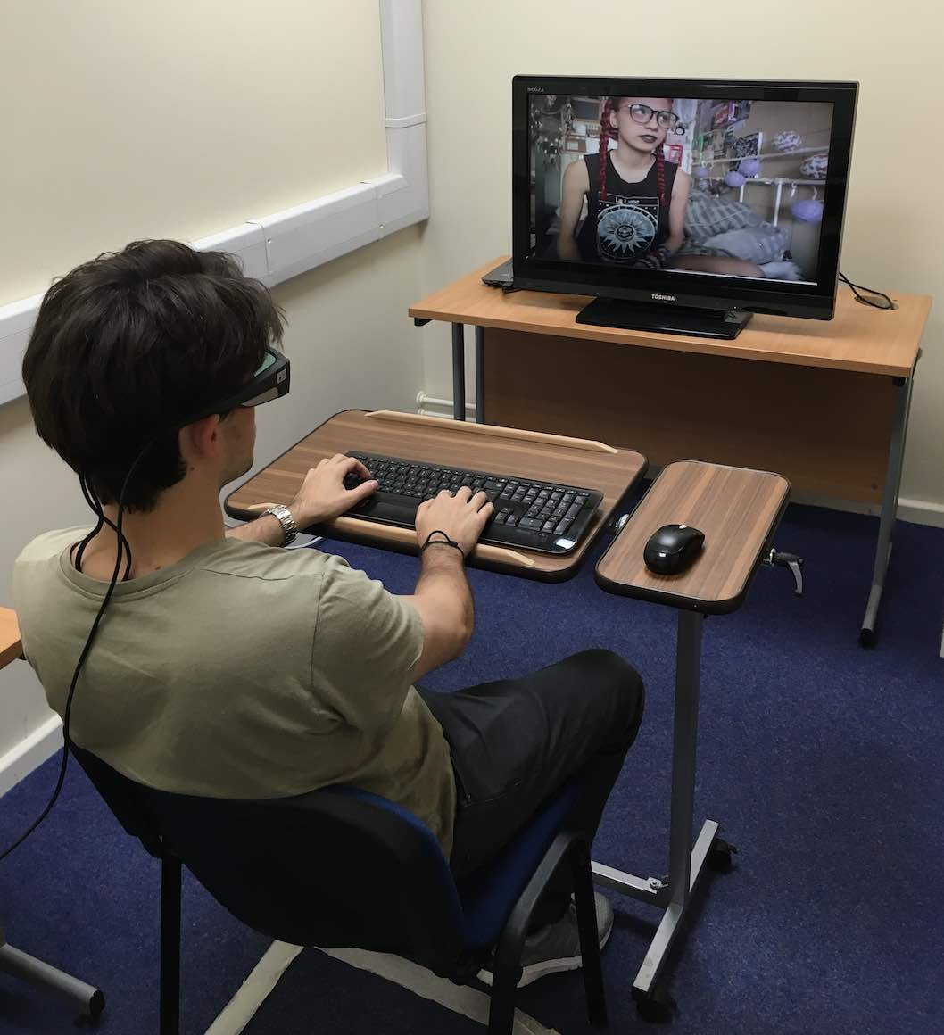
Figure 1. Experimental set-up. This figure illustrates the experimental arrangement during the video stimulus.
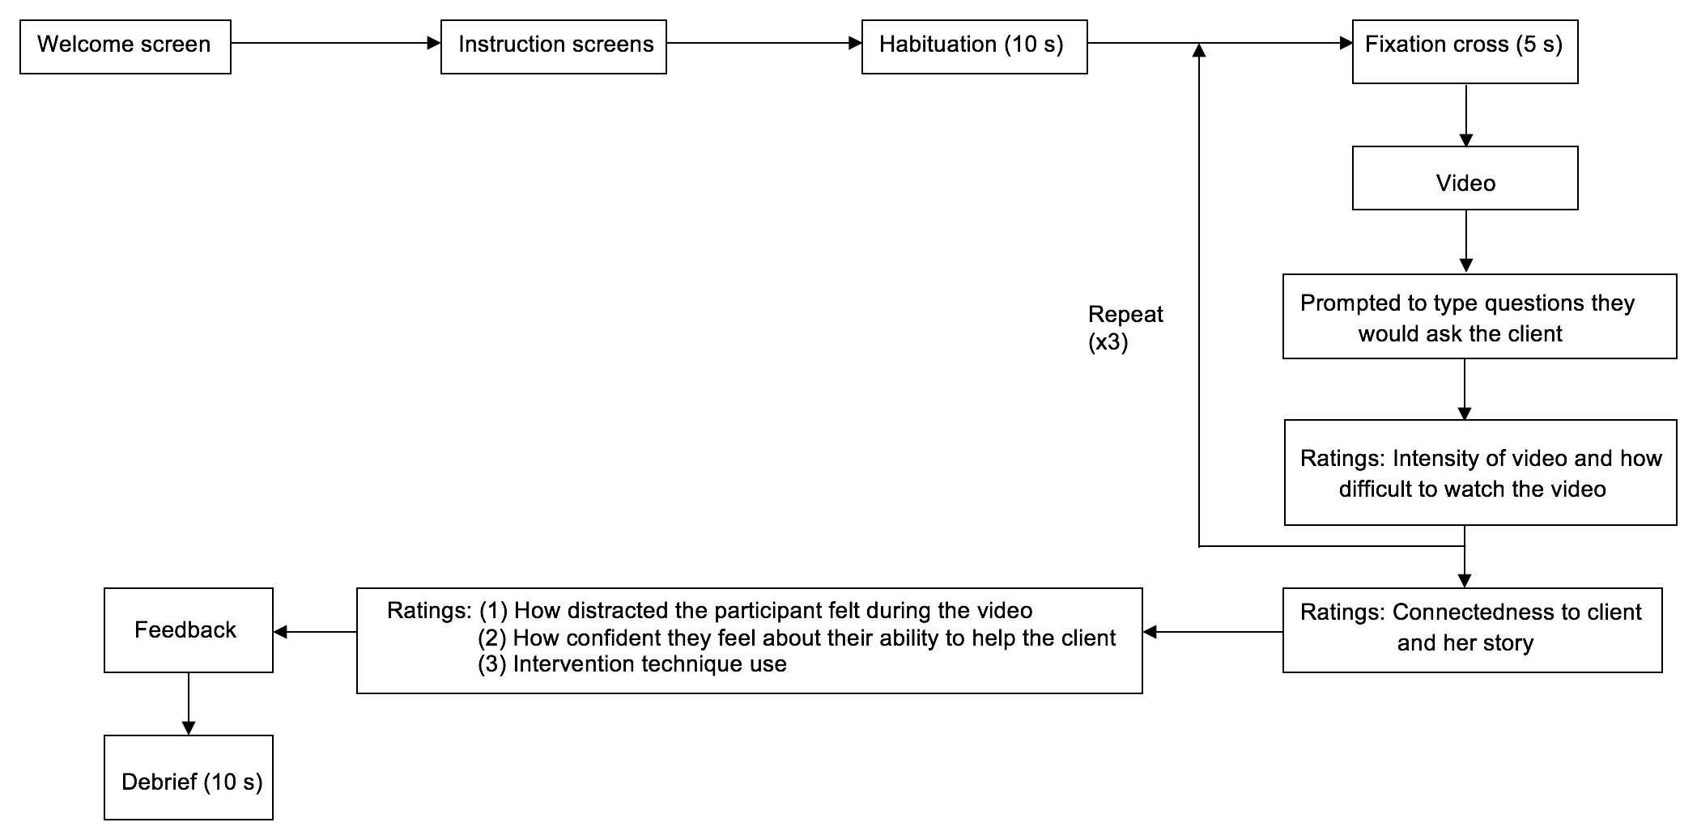

Figure 2. PsychoPy video stimulus summary. This figure illustrates the sequence of screens during the PsychoPy video stimulus, including participant self-report ratings.

Data preparation

Scores on the AAQ-II questionnaire (Bond et al., 2011) were reverse coded to provide a measure of psychological flexibility (1 = 7, 2 = 6, 3 = 5, 4 = 4, 5 = 3, 6 = 2, 7 = 1). Using SMI BeGaze (version 3.5.101) software, all fixation points for all participants were coded as 1 of 4 Areas of Interest (AOIs). The AOIs were: (1) Looking at the client’s face; (2) Looking at the client; (3) Looking at other areas of the screen; (4) Looking at areas away from the screen. All data were then exported to MS Excel for further analysis. The total time of fixations for each AOI was calculated, and based on the total time of fixations of all AOIs coded for the 4 video clips, percentages for each AOI were calculated. During preparation of the eye tracker data for analysis, it was observed that the total sum of fixation times varied fairly extensively between participants, from 8.60 mins (participant 19) to 19.11 mins (participant 2). Therefore, to ensure all data had been coded, the time between individual fixations was determined and summated, and added to the total time of fixations to give a total overall time, which was equivalent for all participants (approximately 21.5 mins) (see appendix I on data disc for all eye tracker data calculations). The behavioural data collected via PsychoPy were collated (see appendix J on data disc); average ratings of intensity of the video, and difficulty watching the video were calculated to resemble a therapeutic situation, in which the therapist would view the session in its entirety.

Statistical analysis

Preliminary univariate statistical tests were conducted on all study dependent variables (DVs) and covariates, and Cohen’s d effect sizes were calculated (Cohen, 1988). Two multivariate analyses of covariance (MANCOVAs) were subsequently performed. The first MANCOVA tested the hypothesis that there will be a difference in engagement of participants in the CBT and ACT intervention groups with the scenario. Recall questionnaire score, and percentage of time the participant spent looking at the client’s face were entered as DVs. The intervention group was entered as the fixed factor. Covariates incorporated in this analysis were video intensity ratings, difficulty to watch the video ratings, ratings of connectedness with the client and her story, psychological flexibility, previous experience of self-harm or suicide, and previous therapy training. The second MANCOVA tested the hypothesis that there will be a difference in participant levels of connectedness with the client and her story between the two intervention groups. Self-reported levels of connectedness with the client and her story (obtained via PsychoPy) were entered as DVs, and the intervention group as the fixed factor. Covariates in this analysis were experience of self-harm or suicide, and psychological flexibility. (See appendix K on data disc for SPSS data file, and appendix L on data disc for SPSS output).

Results

Data were analysed using IBM SPSS software (IBM Corp. Released 2013. IBM SPSS Statistics for Macintosh, Version 22.0. Armonk, NY: IBM Corp). Descriptive statistics and preliminary univariate analyses for the sample are reported in Table 2. Means and standard deviations (SD) are provided for ordinal and interval data, and frequency counts are given for categorical data.

Table 2
Descriptive statistics for CBT and ACT intervention groups
 | CBT (n = 10)  Mean (SD) | ACT (n = 10)  Mean (SD) | t/$χ2$ | p | d
Previous therapy training | 1 | 1 | .00 | 1.00
Experience of self-harm / suicide | 1 | 2 | .39 | .531
Psychological flexibility | 33.20 (6.66) | 37.90 (5.47) | -1.73 | .102 | .77
Video stimulus
Video intensity | 3.85 (1.17) | 3.18 (1.07) | 1.35 | .195 | .60
Difficulty watching video | 3.33 (1.42) | 2.85 (.93) | .88 | .389 | .40
Connectedness to client | 3.60 (1.17) | 4.00 (1.16) | -.77 | .452 | .34
Connectedness to story | 4.00 (1.25) | 3.80 (1.14) | .38 | .712 | .17
Outcome measures
Recall questionnaire | 5.90 (1.52) | 6.40 (.97) | -.88 | .392 | .39
Eye gaze face (%) | 41.28 (36.94) | 53.47 (39.85) | -.71 | .487 | .32
Eye gaze client (%) | 53.30 (37.99) | 38.41 (36.12) | .90 | .381 | .40
Eye gaze screen (%) | 4.74 (10.18) | 5.50 (7.58) | -.188 | .853 | .08
Eye gaze away (%) | .67 (1.36) | 2.63 (3.55) | -1.63 | .130 | .73

Hypothesis 1: Exploring the impact of the intervention on explicit and implicit attention to the scenario.
A first MANCOVA examined the effect of the intervention group on both recall questionnaire scores, and the percentage of time spent looking at the client’s face, while controlling for the confounding effects of several variables. The covariates in the analysis were: (1) Previous therapy training; (2) Experience of self-harm or suicide; (3) Psychological flexibility; (4) Video intensity rating; (5) Difficulty to watch video rating; (6) How connected the participant felt to the client; (7) How connected the participant felt to the client’s story.
Using Pillai’s Trace, the effect of the intervention group on both explicit attention (as measured by recall), and implicit attention (as measured by eye gaze) to the scenario was nonsignificant, V = .005, F(2, 10) = .026, p = .974, $η_{par}^{2}$= .005. Further univariate analyses showed that there were no significant effects of intervention group on either the recall questionnaire score, F(1, 11) = .046, p = .835, $η_{par }^{2}$= .004, or the percentage of time spent looking at the client’s face, F(1, 11) = .010 p = .923, $η_{par}^{2}$= .001.

Hypothesis 2: Exploring the impact of the intervention on participant levels of connectedness with the client and her story.
A second MANCOVA examined the effect of the intervention group on participant levels of connectedness with the client and her story, while controlling for the potentially confounding effects of previous self-harm or suicide, and psychological flexibility.
Using Pillai’s Trace, the effect of the intervention group on connectedness to client and her story was nonsignificant, V = .101, F(2, 15) = .846, p = .449, $η_{par}^{2}$= .101. Further univariate analyses showed that there were no significant effects of intervention group on either connectedness to the client, F(1,16) = 1.182, p = .293, $η_{par}^{2}$= .069, or her story, F(1, 16) = .003, p = .958, $η_{par}^{2}$= .000.
As all results were nonsignificant, no further planned comparisons or post hoc tests were carried out.
Discussion

The aim of this pilot study was to investigate whether a brief CBT- or ACT-based intervention could help to improve participants’ levels of engagement with a video scenario, during which the sensitive topic of an attempted suicide is discussed. Our results show that there was no significant difference between the levels of explicit attention (as measured by a recall questionnaire), or implicit attention (as measured by eye gaze on the client’s face) between the two intervention groups. Additionally, we did not find a significant difference between the levels of connectedness with the client or her story in the video scenario as an effect of intervention group.
The hypotheses in this study were given as non-directional hypotheses as, to date, well-controlled studies using ACT interventions are limited (Hayes et al., 2006). ACT research is still in its early stages of development, and interventions remain short and fairly restricted in scope (Hayes et al., 2006). Although we had hoped that participants in the ACT intervention would show superior engagement as studies have shown that ACT-based interventions can increase psychological and behavioural flexibility, thus improving a therapist’s ability to deal with uncomfortable situations (Anderson et al., 2009; Scherr et al., 2015), conclusions remain ambiguous. Available literature tends to suggest that there is no differential efficacy of ACT compared to active controls in the treatment of anxiety (Hacker, Stone & MacBeth, 2016), and CBT and ACT are equally effective interventions but cause behavioural changes via different processes (Arch et al., 2012; Hayes et al., 2006; Lappalainen et al., 2007).
Field (2013) recommends using Pillai’s Trace as the MANCOVA test statistic, as it is the most robust of the four statistics. We were therefore being conservative when analysing our data. However, whether a result is significant or not does not tell us about the importance of an effect (Field, 2013; Jacobson & Truax, 1991). Although analysis via t-tests revealed no significant differences between the two groups, using Cohen’s (1992) concept of small, medium and large standardised effect sizes, we can see that our results show small to medium effect sizes for both recall and eye gaze (d = .39 and d = .32 respectively) (see Table 1).

Explanation of results

Recall questionnaire.

Explicit attention to the scenario was assessed using a recall questionnaire. We decided to assess recall as it would show whether participants were actively engaged with the client during the entire therapy session. This skill is of vital importance in ensuring therapy success as it signifies empathy, and ensures clients feel heard and understood (Egan, 2014; Hawton et al., 1989; Jacobson et al., 2015; Kahn, 2001). Active engagement also promotes the creation of a strong therapeutic relationship (Anderson, Cowley et al., 2016; Jacobson et al., 2015). The mean score on the recall questionnaire was higher for the ACT intervention than the CBT intervention, and it could tentatively be inferred that this is because the participants were better able to remain focused during the scenario due to improved psychological flexibility (Harris, 2009).
However, the delay between watching the video, and completing the questionnaire may have varied between participants, which may have impacted upon memory (Souza, Rerko, Lin & Oberauer, 2014). Participants were moved from the experimental room back to the initial study room before completing the questionnaire, and some participants took longer than others to settle down, and others may have felt relief that the experiment was finished, which could affect subsequent recall and performance (Souza et al., 2014). In future, greater experimental control could be achieved by ensuring the participant completes the recall questionnaire immediately after watching the video.

Eye gaze.

Implicit attention to the scenario was assessed using eye gaze on the client’s face. Eye gaze shows where an individual is directing their attention, hence by looking at the client’s face, the therapist can show they are actively paying attention to the client (Dowell & Berman, 2013; Hietanen et al., 2016; Marschner et al., 2015). A 3-minute ‘eyes on’ exercise was included in the ACT intervention, aimed at encouraging the participant to stay present and connected with the researcher whilst experiencing discomfort (Hayes et al., 1999). Asking people to maintain eye contact far beyond the comfort zone of a few seconds can cause the participant to feel discomfort to the extent that it may be observable in their behaviours (Jarick & Kingstone, 2015). We had predicted that this exercise would encourage participants to spent a higher percentage of time looking at the client’s face during the video stimulus. By studying the calculated mean values, we can see that, on average, participants in the ACT group did indeed spend more time looking at the client’s face, compared to participants in the CBT group, therefore we can tentatively suggest that this exercise may help to improve therapists’ engagement with clients.
Cummins’ (2012) study revealed that time spent gazing at a partner during dyadic conversations ranged from 59-95%, and variation between participants should be expected. Additionally, evidence suggests that individuals tend to gaze more at a partner when listening than when speaking (Cummins, 2012), and so our results for eye gaze may be higher than in face-to-face therapy as the participant is only required to listen, and not talk. However, Hietanen et al. (2016) discovered that gaze effects may only be elicited when we know we are being looked at by another person, and not when we look at virtual or pictorial stimuli as there is not the opportunity for true social interaction. It could also be argued that participants may not engage as much with the video as with a real-life client, but evidence shows that computer-animated agents can trigger similar responses to those during interactions with humans (Marschner et al., 2015). Also, in the video stimulus, the client’s face was near the top of the screen, and sometimes the top of the face was no longer visible. This may affect how much the participant is inclined to look at the client’s face as it takes more effort to raise the eyes to the top of the screen, and it has also been suggested that the whole face may need to be presented to produce gaze effects (Cañadas & Lupiáñez, 2012).
Sharpley & Sagris (2015) explain that although there is a common belief that eye contact promotes the communication of empathy and attention, there are still contradictory views in terms of the efficiency of eye contact during therapy. For example, some therapists may limit eye contact when the client is discussing sensitive information so as to appear non-confrontational and to reduce the pressure that the client may feel in terms of revealing more information (Cummins, 2012; Schneier et al., 2011; Sharpley & Sagris, 2015). Mutual gaze studies also suggest that fixations are longer among female dyads compared to male dyads, and are also longer when individuals are further apart (Argyle & Cook, 1976, as cited in Cummins, 2012). Therefore, although eye contact is clearly important in developing therapist-client rapport, it must be applied carefully and sparingly for maximal effects (Sharpley & Sagris, 2015).

Connectedness to client.

As for our second hypothesis that there will be a difference between interventions in terms of connectedness with the client and her story, our results showed that levels of connectedness were comparable between interventions. It is important that the client feels they are able to discuss their feelings in confidence with the therapist, and so a reciprocal, trusting relationship can aid disclosure (Egan, 2014; Hawton et al., 1989; Lindgren et al., 2010; Sandhu et al., 2015). As the therapeutic alliance is such a strong contributor to therapy success, it is crucial that this area is researched in more depth in order to find ways in which the therapist could help to develop their relationship with the client.

Evaluation of pilot study

Despite having to retain both of our null hypotheses, we must bear in mind that this study was a pilot randomised controlled trial. The age range of our sample (20 – 57 years) was wide, and so this could contribute to the generalisability of our findings. However, previous studies have shown that demographic characteristics such as age do not contribute to variance in therapy success (Blow, Timm & Cox, 2008; Wampold & Brown, 2005).
The most important outcome of this study is our ability to calculate the sample size that would be required to conduct a fully-powered study. Cohen (1992) discusses the importance of using effect sizes to determine sample sizes and thus we have been able to calculate that for the non-directional hypothesis of a difference between CBT and ACT interventions on participant levels of engagement with the uncomfortable scenario, we would need 128 participants (64 in each intervention group). This therefore proves that our study is unquestionably underpowered, and can help to explain why we did not find any significant results (Cohen, 1992).

Another main aim of the pilot study was to establish which areas of the experimental design require improvements or further testing (Lancaster, Dodd & Williamson, 2004). It was decided to use an automated stimulus as opposed to having a researcher act as a client, as it would be unlikely that the researcher would be able to act in a consistent fashion across all participants (Sharpley & Sagris, 1995), and measures of therapists’ skills are confounded by each individual client (Anderson, Crowley et al., 2016). The study therefore had high experimental control (Marschner et al., 2015; Peirce, 2007). By carrying out a laboratory experiment, we were also able to control extraneous variables, such as changes in light or noise, that could influence the outcome of the experiment (McIlveen et al., 1992).

The PsychoPy stimulus was coded to allow the participant to pause the video whenever they felt uncomfortable. However, all but one participant did not use this option, and the participant who did pause the video had done so with the intention of posing a question to the client, which was not possible. Feedback from participants following the study revealed that they also found asking the client questions after the automatic pausing of the video quite challenging. They often felt that they would not ask questions at these specific points in the conversation, and would prefer to be able to have control of the pausing of the video to ask questions when they felt comfortable, or as deemed appropriate. Although the time-scale of this study did not permit such complex coding of the PsychoPy software, this is potentially something that could be trialled at a later date.
The final question posed to participants in the PsychoPy video asked for feedback related to the video. As we had expected, several of the participants (n = 5) mentioned that the amount of clutter in the client’s bedroom was distracting. It is well-known that therapists should maintain a neutral environment in therapy rooms, which allows the client to feel safe (Nolan, 2012). Additionally, 2 participants found the amount of hand gestures distracting, and 5 participants made reference to the client’s accent, or speed at which she spoke as off-putting. Before pursuing the study any further, it may be beneficial to find an alternative video in which the background to the participant is more neutral to limit distractions.

Difficulties encountered during the study.

Due to the time period in which data collection for this study was carried out, we experienced difficulties in trying to recruit eligible participants as most undergraduate students were away from the university. For ethical reasons we had limited our recruitment to counselling, nursing or psychology students, studying at level 6 or above due to the potentially distressing nature of the video. Additionally, use of the eye tracking glasses meant it was not feasible to carry out the study with participants who required glasses as this may have interfered with the quality of data collected (Gwon et al., 2014; Nyström et al., 2013). This excluded two potential male participants which, in part, contributes to why we unfortunately have a gender imbalance (80% female) in our sample. However, gender has been shown to have no impact on either the quality of the therapeutic alliance (Hersoug et al., 2009) or client outcome (Okiishi et al., 2003).
Although both the CBT- and ACT-based interventions included exercises that are currently used in psychotherapy, during the study it became clear that engagement of the participant with the exercises was dependent upon how difficult they perceived the exercise to be. The more the participant struggled with the exercise, the more input was required from the researcher, which could result in experimenter effects (McIlveen et al., 1992). For the CBT-based intervention, the general consensus was that the first exercise based on completing a thought record (Davey, 2014; Greenberger & Padesky, 1995; Palmer & Whybrow, 2007) was the most challenging. This exercise uses specific questions to help the participant examine their thinking styles, and challenge thoughts that could interfere with performance (Palmer & Whybrow, 2007). This exercise can therefore be difficult as many of our thoughts are automatic (Greenberger & Padesky, 1995). As for the ACT-based intervention, participants struggled with the “floating leaves on the stream” defusion exercise (Harris, 2009). This exercise is based on reducing the influence of negative or unhelpful cognitive processes on behaviour, and encourages being present with the client (Harris, 2009). ACT tends to focus on existential exercises that involve a lot of mental imagery (Harris, 2009), and therefore the participant may need to practice the exercises a few times before they are successful.
A primary concern regarding the eye tracking equipment was that some participants expressed how they had looked at the client’s face, but upon analysis this was not shown to be the case. It may be possible that although the client believed they were looking at the face they were in fact looking elsewhere on the screen as we have limited conscious control over our eye movements and blinking (Cummins, 2012), or it may be due to calibration problems with the equipment. In this study, we used a 1-point calibration for the eye tracking glasses. In subsequent studies it may be worthwhile testing a 3-point calibration, which may be more accurate and reliable. This study also used operator-controlled calibration (Nyström et al., 2013), whereby the researcher decided when the participant was fixating on the target. Participant-controlled calibration has been shown to be more effective as it appears that the participant can better tell when a specific target is being fixated (Nyström et al., 2013).
The PsychoPy software used to display the video was chosen as it allowed high experimental control (Marschner et al., 2015; McIlveen et al., 1992; Peirce, 2007). Unfortunately, whilst participant 8 was watching the video, the computer system crashed after the second video clip. To enable collection of a full data set for the participant, this meant participant 8 had double exposure to the first 2 video clips. Although we were able to extract and code the first two video clips from the first eye tracker recording, and video clips 3 and 4 from the second recording, double exposure could result in improved recall which would not be attributable to the experimental condition. Although participant 8 scored 5 out of 10 on the recall questionnaire, which is in fact below the average score, we are unable to determine whether the participant would have scored differently if this problem had not occurred. It is also possible that the participant may have felt more distracted, or uncomfortable during the session as a result of this technical problem (Hertel et al., 2012).
Analysis of the eye tracking data could potentially limit the number of participants that could realistically be recruited for future studies. In our sample, the number of fixations for a participant for the whole video recording (including PsychoPy behavioural measures) ranged from 2341 (participant 2) to 5023 (participant 15) (see appendix I on data disc). As each fixation has to be coded for 1 of 4 AOIs, the process was extremely time consuming, taking approximately 2 hours per participant. In future studies, it may be sufficient to simply make a binary distinction, based on whether the participant is looking at the client’s face or not, as in the study by Cummins (2012). Furthermore, analysis of the eye tracking data was fairly subjective; it was not unusual for a fixation to be borderline between 2 AOIs (see example in figure 3). We tried to be consistent in the coding of these fixations, by choosing the AOI which contained greater than 50% of the fixation circle. However, in future studies, it would be beneficial to have two researchers coding the data to ensure inter-rater reliability (Clark-Carter, 2010; Davey, 2014).

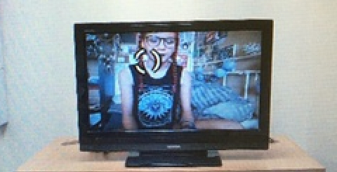
Figure 3. Example screenshot of a fixation. This figure illustrates a fixation that was borderline ‘looking at client’s face’ / ‘looking at client’.

Limitations of the study.

One of the main limitations of our study was that we did not include a non-active control comparison group. Control groups are used to reduce threats to internal validity, as any post-intervention improvements in the active group that are not observed in the control group can be attributed to the intervention itself (Kendall, Butcher & Holmbeck, 1999). However, Öst (2008) suggests using an active treatment as a comparison, and preferably one that has been shown to be effective for the problem in question. Therefore, in this case, we chose to compare ACT with CBT which is known to be effective in treating anxiety (Arch et al., 2012; Lappalainen et al., 2007).
In this pilot study, both interventions were delivered by the same researcher. In future studies it would be appropriate to either use 2 or more researchers to deliver the interventions, or to monitor the researcher whilst delivering the interventions (Becker, Bohnenkamp, Domitrovich, Keperling & Ialongo, 2014). This would allow consistency checks to be carried out to ensure the interventions are always delivered in the same way, as this could affect the reliability of results.
As the study involved student participants, we unfortunately cannot generalise our findings to professional therapists working in clinical settings. Surprisingly, very few (n = 3) participants had previous personal experience of self-harm or suicide. This variable was added as a covariate in the first MANCOVA analysis as we predicted that individuals who have experience of self-harm or suicide may find the video more difficult to watch as it may remind them of past experiences. However, in this case, the confounding effect of this variable may have been too weak to impact upon the results. Only 2 participants stated that they had received some therapy training, but the level of training still remained inferior to professionals. However, according to Hersoug et al. (2009), high levels of professional training have been associated with a poorer therapeutic alliance, as rated by the therapists themselves. Furthermore, therapist level and type of training have been shown to be unattributable to variance in therapy outcomes (Anderson et al., 2009; Okiishi et al., 2003).
Although we obtained scores of psychological flexibility for participants by reverse coding the AAQ-II questionnaire (Bond et al., 2011) scores prior to the intervention, we did not ask participants to complete the questionnaire again after the intervention and/or the video. Consequently, we are unable to infer whether the intervention itself improved psychological flexibility, which in turn may improve a participant’s ability to cope with the uncomfortable video scenario. Additionally, the internal consistency for the AAQ-II in our sample (α = .833) was high (Cronbach, 1951), demonstrating that the items in the questionnaire all measure the same construct. However, more recently, it has been suggested that for clinical application, a minimum value of α = .90 may be required (Bland & Altman, 1997). There are alternative measures of psychological flexibility, for example the 15-item Brief Experiential Avoidance Questionnaire (BEAQ; Gámez et al., 2014) that could be tested. Wolgast (2014) discusses that the questionable discriminant validity of the AAQ-II in terms of an overlap between measures of experiential avoidance/psychological flexibility, and suggests that the BEAQ may be the more appropriate measure for assessing psychological flexibility. However, both the AAQ-II and BEAQ are self-report measures and therefore may be subject to social desirability bias (Anderson, Crowley et al., 2016; Keane, 2014; Scherr et al., 2015). As a result, research has more recently begun focusing on implicit measures of experiential avoidance to eliminate bias (e.g., Drake, Timko & Luoma, 2016), and it may be interesting to test these alternative measures of psychological flexibility in follow-up studies.

Suggestions for future work

One area to explore is the dosage of the intervention required to produce effects. This pilot study involved a brief, high intensity package, in which the participant practiced the techniques in a single 2-hour session. Mindfulness studies with therapists have shown that more frequent practice is related to more robust, long-lasting results in terms of clinical skill development and stress reduction (Gockel et al., 2013). Keane (2014) states that embodying mindfulness can be challenging, and is well beyond brief interventions used in clinical training. Although mindfulness practices have been shown to improve therapists’ skills in general, 18% of participants in Keane’s (2014) study discuss challenges associated with mindfulness practice. For example, participants felt more intensely aware of a client’s pain, and a deeper feeling of self-awareness resulted in feelings of inadequacy (Keane, 2014). Further research is evidently needed into how mindfulness exercises can be delivered to ensure maximum efficacy, and to reduce the negative experiences outlined above. It may therefore be necessary to test delivery and supervised practice of the exercises in the interventions across multiple sessions.
Although eye tracking methods are a novel approach to measuring attentional control (Ellis et al., 2014), some of the participants found the eye tracker used in this study to be uncomfortable, especially as it was worn constantly for almost 30 minutes. Nyström et al. (2013) suggest that different eye tracker hardware, such as tower- or head-mounted systems instead of the remote system used in this experiment may help to improve precision. Alternatively, mobile eye trackers which have higher ecological validity could be tested (Canosa, 2009; Vidal, Turner, Bulling & Gellersen, 2012).
There are additional data that were collected during the study that have not been analysed in this report. Two areas that warrant further investigation are the questions the participant asked the client during the scenario, and the amount and duration of blinks of the participant whilst watching the video. With regards to the questions asked during the video, analysis of the language used could reveal whether the participant felt anxious about their performance, and may have resorted to use of complex terminology to hide their discomfort (Hayes et al., 1999). According to Chapman and Rosenthal (2016), therapists should avoid using too much medical jargon during discussions with clients, as it may be interpreted as intimidating. An effective therapist with excellent listening skills should be able to paraphrase what the client has just discussed, and by repeating this back to the client, as well as reflecting back feelings, can help to ensure the therapist has correctly understood what has been said (Hawton et al., 1989). It would also be interesting to see how many questions each participant asked, and the topics they discussed, as these data could also show how much attention the participant paid to the scenario. ACT encourages therapists to be present, which should prevent mind wandering (Luoma et al., 2007), so it may be predicted that participants in the ACT group would ask more relevant questions. Currently, there is limited research into blink frequency and blink patterns, but it is evident that inter-individual differences exist (Cummins, 2012). It would be interesting to investigate further the data collected for blinking in this experiment, as blinking has been suggested to modulate trade-offs between attending to internal thoughts due to mind-wandering and distractions, and attending to ongoing task stimuli (Smilek, Carriere & Cheyne, 2010). Although the eye tracking software calculated the number of blinks, we are only able to view the number of blinks for the entire recording (the 4 video clips plus the time in between clips when participants were focused on answering the questions displayed onscreen). As blink rate may be task-specific (Cummins, 2012), we are unable to infer any conclusions using the data as they stand without further analysis.
It is hoped that a fully-powered study will soon be carried out once improvements have been made to this experimental design. However, before findings can be generalised, it will be important to conduct controlled studies at national and international levels as verbal and non-verbal communication methods can vary significantly between cultures (Alelwani & Ahmed, 2014). It will also be necessary to study therapist effects in clinical practice settings, as variability in therapist competence in the general population is predicted to be larger than that among therapists involved in research studies (Anderson et al., 2009; Blow et al., 2007).

Conclusion

The findings from this pilot study contribute to the currently under-researched area of improving therapist engagement with clients during uncomfortable discussions. Although our results demonstrate no significant findings, the data suggest that an ACT-based intervention may help to improve therapist psychological flexibility, and may in turn be more effective in improving therapist attention and engagement with clients than a CBT-based intervention. The pilot study was significantly underpowered, and so a fully-powered study with modifications to experimental design as suggested in this report will help to further contribute to our understanding of how to improve therapist behaviours.

References

Alelwani, S. M., & Ahmed, Y. A. (2014). Medical training for communication of bad news: A literature review. Journal of Education and Health Promotion, 3, 1-5. http://dx.doi.org/10.4103/2277-9531.134737
Anderson, T., Crowley, M. E. J., Himawan, L., Holmberg, J. K., & Uhlin, B. D. (2016). Therapist facilitative interpersonal skills and training status: A randomized clinical trial on alliance and outcome. Psychotherapy Research, 26(5), 511-529. http://dx.doi.org/10.1080/10503307.2015.1049671
Anderson, T., McClintock, A. S., Himawan, L., Song, X., & Patterson, C. L. (2016). A prospective study of therapist facilitative interpersonal skills as a predictor of treatment outcome. Journal of Consulting and Clinical Psychology, 84(1), 57-66. http://dx.doi.org/10.1037/ccp0000060
Anderson, T., Ogles, B. M., Patterson, C. L., Lambert, M. J., & Vermeersch, D. A. (2009). Therapist effects: Facilitative interpersonal skills as a predictor of therapist success. Journal of Clinical Psychology, 65(7), 755-768. http://dx.doi.org/10.1002/jclp.20583
Arch, J. J., Eifert, G. H., Davies, C., Plumb Vilardaga, J. C., Rose, R. D., & Craske, M. G. (2012). Randomized clinical trial of cognitive behavioral therapy (CBT) versus acceptance and commitment therapy (ACT) for mixed anxiety disorders. Journal of Consulting and Clinical Psychology, 80(5), 750-765. http://dx.doi.org/10.1037/a0028310
Becker, K. D., Bohnenkamp, J., Domitrovich, C., Keperling, J. P., & Ialongo, N. S. (2014). Online training for teachers delivering evidence-based preventive interventions. School Mental Health, 6(4), 225-236. http://dx.doi.org/10.1007/s12310-014-9124-x
Bengtsson, J., Nordin, S., & Carlbring, P. (2015). Therapists’ experiences of conducting cognitive behavioural therapy online vis-à-vis face-to-face. Cognitive Behaviour Therapy, 44(6), 470-479. http://dx.doi.org/10.1080/16506073.2015.1053408
Bland, J. M., & Altman, D. G. (1997). Statistics notes: Cronbach’s alpha. BMJ, 314(7080), 572. http://dx.doi.org/10.1136/bmj.314.7080.572
Blow, A. J., Sprenkle, D, H., & Davis, S. D. (2007). Is who delivers the treatment more important than the treatment itself? The role of the therapist in common factors. Journal of Marital and Family Therapy, 33(3), 298-317. http://dx.doi.org/10.1111/j.1752-0606.2007.00029.x
Blow, A. J., Timm, T. M., & Cox, R. (2008). The role of therapist in therapeutic change: Does therapist gender matter? Journal of Feminist Family Therapy, 20(1), 66-86. http://dx.doi.org/10.1080/0895280801907150
Bond, F. W., Hayes, S. C., Baer, R. A., Carpenter, K. M., Guenole, N., Orcutt, H. K., … Zettle, R. D. (2011). Preliminary psychometric properties of the Acceptance and Action Questionnaire-II: A revised measure of psychological inflexibility and experiential avoidance. Behavior Therapy, 42(4), 676-688. http://dx.doi.org/10.1016/j.beth.2011.03.007
Bull, S. J. (1991). Sport psychology: A self-help guide. Marlborough, United Kingdom: Crowood Press.
Cañadas, E., & Lupiáñez, J. (2012). Spatial interference between gaze direction and gaze location: A study on the eye contact effect. The Quarterly Journal of Experimental Psychology, 65(8), 1586-1598. http://dx.doi.org/10.1080/17470218.2012.659190
Canosa, R. L. (2009). Real-world vision: Selective perception and task. ACM Transactions on Applied Perception, 6(2), 1-34. http://dx.doi.org/10.1145/1498700.1498705
Chapman, A. L., & Rosenthal, M. Z. (2016). Managing Therapy-Interfering Behavior: Strategies from dialectical behavior therapy (pp. 235-255). Washington, D.C.: American Psychological Association. http://dx.doi.org/10.1037/14752-012
Clark-Carter, D. (2010). Quantitative psychological research: The complete student’s companion. (3rd ed.). Hove, United Kingdom: Psychology Press.
Cohen, J. (1988). Statistical power analysis for behavioral sciences. (2nd ed.). Hillsdale, NJ: Lawrence Erlbaum Associates.
Cohen, J. (1992). A power primer. Psychological Bulletin, 112(1), 155-159. http://dx.doi.org/10.1037/0033-2909.112.1.155
Cronbach, L. J. (1951). Coefficient alpha and the internal structure of tests. Psychometrika, 16(3), 297-334. http://dx.doi.org/10.1007/BF02310555
Cummins, F. (2012). Gaze and blinking in dyadic conversation: A study in coordinated behaviour among individuals. Language and Cognitive Processes, 27(10), 1525-1549. http://dx.doi.org/10.1080/01690965.2011.615220
Davey, G. (2014). Psychopathology: Research, assessment and treatment in clinical psychology. (2nd ed.). Chichester, United Kingdom: Wiley.
Dinger, U., Strack, M., Leichsenring, F., Wilmers, F., & Schauenburg, H. (2008). Therapist effects on outcome and alliance in inpatient psychotherapy. Journal of Clinical Psychology, 64(3), 344-354. http://dx.doi.org/10.1002/jclp.20443
Dowell, N. M., & Berman, J. S. (2013). Therapist nonverbal behavior and perceptions of empathy, alliance, and treatment credibility. Journal of Psychotherapy Integration, 23(2), 158-165. http://dx.doi.org/10.1037/a0031421
Drake, C. E., Timko, C. A., & Luoma, J. B. (2016). Exploring an implicit measure of acceptance and experiential avoidance of anxiety [Abstract]. The Psychological Record, 66(3), 463-475. http://dx.doi.org/10.1007/s40732-016-0186-z
Egan, G. (2014). The skilled helper: A problem-management and opportunity-development approach to helping. (10th ed.). San Francisco, CA: Brooks/Cole.
Ellis, A. J., Wells, T. T., Vanderlind, W. M., & Beevers, C. G. (2014). The role of controlled attention on recall in major depression. Cognition and Emotion, 28(3), 520-529. http://dx.doi.org/10.1080/02699931.2013.832153
Fairburn, C. G., & Cooper, Z. (2011). Therapist competence, therapy quality, and therapist training. Behaviour Research and Therapy, 49(6), 373-378. http://dx.doi.org/10.1016/j.brat.2011.03.005
Field, A. (2013). Discovering statistics using IBM SPSS statistics: And sex and drugs and rock ‘n’ roll. (4th ed.). London, United Kingdom: SAGE.
Gámez, W., Chmielewski, M., Kotov, R., Ruggero, C., Suzuki, N., & Watson, D. (2014). The Brief Experiential Avoidance Questionnaire: Development and initial validation. Psychological Assessment, 26(1), 35-45. http://dx.doi.org/10.1037/a0034473
Gockel, A., Burton, D., James, A., & Bryer, E. (2013). Introducing mindfulness as a self-care and clinical training strategy for beginning social work students. Mindfulness, 4(4), 343-353. http://dx.doi.org/10.1007/s12671-012-0134-1
Greenberger, D., & Padesky, C. A. (1995). Mind over mood: Change how you feel by changing the way you think. New York, NY: Guilford.
Gwon, S. Y., Cho, C. W., Lee, H. C., Lee, W. O., & Park, K. R. (2014). Gaze tracking system for user wearing glasses. Sensors, 14(2), 2110-2134. http://dx.doi.org/10.3390/s140202110
Hacker, T., Stone, P., & MacBeth, A. (2016). Acceptance and commitment therapy – Do we know enough? Cumulative and sequential meta-analyses of randomized controlled trials. Journal of Affective Disorders, 190, 551-565. http://dx.doi.org/10.1016/j.jad.2015.10.053
Hall, E. T. (1969). The hidden dimension: Man’s use of space in public and private. London, United Kingdom: The Bodley Head.
Harris, R. (2009). ACT made simple: An easy-to-read primer on acceptance and commitment therapy. Oakland, CA: New Harbinger.
Hawton, K., Salkovskis, P. M., Kirk, J., & Clark, D. M. (1989). Cognitive behaviour therapy for psychiatric problems: A practical guide. Oxford, United Kingdom: Oxford University Press.
Hayes, S. C., Bissett, R., Roget, N., Padilla, M., Kohlenberg, B. S., Fisher, G., … Niccolls, R. (2004). The impact of acceptance and commitment training and multicultural training on the stigmatizing attitudes and professional burnout of substance abuse counselors. Behavior Therapy, 35(4), 821-835. http://dx.doi.org/10.1016/S0005-7894(04)80022-4
Hayes, S. C., Luoma, J. B., Bond, F. W., Masuda, A., & Lillis, J. (2006). Acceptance and commitment therapy: Model, processes and outcomes. Behaviour Research and Therapy, 44(1), 1-25. http://dx.doi.org/10.1016/j.brat.2005.06.006
Hayes, S. C., Strosahl, K. D., & Wilson, K. G. (1999). Acceptance and commitment therapy: An experiential approach to behavior change. New York, NY: Guilford Press.
Health and Social Care Information Centre. (2015). Health Survey for England 2014: Health, social care and lifestyles. Retrieved from http://digital.nhs.uk/catalogue/PUB19295/HSE2014-Sum-bklet.pdf
Hedman, E. (2014). Therapist guided internet delivered cognitive behavioural therapy. BMJ, 348, g1977. http://dx.doi.org/10.1136/bmj.g1977
Hersoug, A. G., Høglend, P., Havik, O., von der Lippe, A., & Monsen, J. (2009). Therapist characteristics influencing the quality of alliance in long-term psychotherapy. Clinical Psychology and Psychotherapy, 16(2), 100-110. http://dx.doi.org/10.1002/cpp.605
Hertel, P. T., Benbow, A. A., & Geraerts, E. (2012). Brooding deficits in memory: Focusing attention improves subsequent recall. Cognition and Emotion, 26(8), 1516-1525. http://dx.doi.org/10.1080/02699931.2012.668852
Hietanen, J. K., Myllyneva, A., Helminen, T. M., & Lyyra, P. (2016). The effects of genuine eye contact on visuospatial and selective attention. Journal of Experimental Psychology: General, 145(9), 1102-1106. http://dx.doi.org/10.1037/xge0000199
Holmqvist, K., Nyström, N., Andersson, R., Dewhurst, R., Jarodzka, H., & van de Weijer, J. (Eds.). (2011). Eye tracking: A comprehensive guide to methods and measures. Oxford, United Kingdom: Oxford University Press.
Jacobson, L., Fox, J., Bell, H., Zeligman, M., & Graham, J. (2015). Survivors with dissociative identity disorder: Perspectives on the counseling process. Journal of Mental Health Counseling, 37(4), 308-322. http://dx.doi.org/10.17744/mehc.37.4.03
Jacobson, N. S., & Truax, P. (1991). Clinical significance: A statistical approach to defining meaningful change in psychotherapy research. Journal of Consulting and Clinical Psychology, 59(1), 12-19. http://dx.doi.org/10.1037/0022-006x.59.1.12
Jarick, M., & Kingstone, A. (2015). The duality of gaze: Eyes extract and signal social information during sustained cooperative and competitive dyadic gaze. Frontiers in Psychology, 6(1423), 1-7. http://dx.doi.org/10.3389/fpsyg.2015.01423
Joormann, J., & Gotlib, I. H. (2008). Updating the contents of working memory in depression: Interference from irrelevant negative material. Journal of Abnormal Psychology, 117(1), 182-192. http://dx.doi.org/10.1037/0021-843X.117.1.182
Kahn, M. (2001). Between therapist and client: The new relationship. (2nd ed.). New York, NY: Holt.
Keane, A. (2014). The influence of therapist mindfulness practice on psychotherapeutic work: A mixed-methods study. Mindfulness, 5(6), 689-703. http://dx.doi.org/10.1007/s12671-013-0223-9
Kendall, P. C., Butcher, J. N., & Holmbeck, G. N. (1999). Handbook of research methods in clinical psychology. (2nd ed.). Chichester, United Kingdom: John Wiley & Sons.
Lancaster, G. A., Dodd, S., & Williamson, P. R. (2004). Design and analysis of pilot studies: Recommendations for good practice. Journal of Evaluation in Clinical Practice, 10(2), 307-312. http://dx.doi.org/10.1111/j..2002.384.doc.x
Lappalainen, R., Lehtonen, T., Skarp, E., Taubert, E., Ojanen, M., & Hayes, S. C. (2007). The impact of CBT and ACT models using psychology trainee therapists. Behavior Modification, 31(4), 488-511. http://dx.doi.org/10.1177/0145445506298436
Lindgren, L., Folkesson, P., & Almqvist, K. (2010). On the importance of the therapist in psychotherapy: A summary of current research. International Forum of Psychoanalysis, 19(4), 224-229. http://dx.doi.org/10.1080/08037060903536047
Luoma, J. B., Hayes, S. C., & Walser, R. D. (2007). Learning ACT: An acceptance & commitment therapy skills-training manual for therapists. Oakland, CA: New Harbinger
Marschner, L., Pannasch, S., Schulz, J., & Graupner, S. (2015). Social communication with virtual agents: The effects of body and gaze direction on attention and emotional responding in human observers. International Journal of Psychophysiology, 97(2), 85-92. http://dx.doi.org/10.1016/j.ijpsycho.2015.05.007
Masuda, A., Hayes, S. C., Fletcher, L. B., Seignourel, P. J., Bunting, K., Herbst, S. A., … Lillis, J. (2007). Impact of acceptance and commitment therapy versus education on stigma toward people with psychological disorders. Behaviour Research and Therapy, 45(11), 2764-2772. http://dx.doi.org/10.1016/j.brat.2007.05.008
McCollum, E. E., & Gehart, D. R. (2010). Using mindfulness meditation to teach beginning therapists therapeutic presence: A qualitative study. Journal of Marital & Family Therapy, 36(3), 347-360. http://dx.doi.org/10.1111/j.1752-0606.2010.00214.x
McIlveen, R., Higgins, L. T., Wadeley, A., & Humphreys, P. (1992). BPS Manual of psychology practicals: Experiment, observation and correlation. Leicester, United Kingdom: BPS Books.
Mental Health Foundation. (2015). Fundamental facts about mental health 2015. Retrieved from https://www.mentalhealth.org.uk/publications/fundamental-facts-about-mental-health-2015
Moorey, S. (2013). ‘I know they are distressed. What do I do now?’ Psycho-oncology, 22(9), 1946-1952. http://dx.doi.org/10.1002/pon.3297
Moorey, S., Cort, E., Kapari, M., Monroe, B., Hansford, P., Mannix, K., … Hotopf, M. (2009). A cluster randomized controlled trial of cognitive behaviour therapy for common mental disorders in patients with advanced cancer. Psychological Medicine, 39(5), 713-723. http://dx.doi.org/10.1017/S0033291708004169
Moreno-Agostino, D., Galván-Domínguez, N., & Álvarez-Iglesias, A. (2015). Relationship between the client’s adaptive verbalizations and the therapist’s verbal behaviour in the clinic context. Clínica y Salud, 26(3), 131-139. http://dx.doi.org/10.1016/j.clysa.2015.07.001
Nolan, P. (2012). Therapist and client: A relational approach to psychotherapy. Chichester, United Kingdom: Wiley-Blackwell.
Norgaard, J. M. (2016). 5,4,3,2,1 method to reduce anxiety. Retrieved October 9, 2016 from http://www.hope-therapy-center.com/single-post/2016/04/06/54321-Method-to-Reduce-Anxiety
Nyström, M., Andersson, R., Holmqvist, K., & van de Weijer, J. (2013). The influence of calibration method and eye physiology on eyetracking data quality. Behavior Research Methods, 45, 272-288. http://dx.doi.org/10.3758/s13428-012-0247-4
Office for National Statistics. (2016). Suicides in the United Kingdom: 2014 registrations. Retrieved from http://www.ons.gov.uk/peoplepopulationandcommunity/birthsdeathsandmarriages/deaths/bulletins/suicidesintheunitedkingdom/2014registrations
Okiishi, J., Lambert, M. J., Nielsen, S. L., & Ogles, B. M. (2003). Waiting for supershrink: An empirical analysis of therapist effects. Clinical Psychology and Psychotherapy, 10(6), 361-373. http://dx.doi.org/10.1002/cpp.383
Öst, L. (2008). Efficacy of the third wave of behavioral therapies: A systematic review and meta-analysis. Behaviour Research and Therapy, 46(3), 296-321. http://dx.doi.org/10.1016/j.brat.2007.12.005
Palmer, S., & Whybrow, A. (Eds.). (2007). Handbook of coaching psychology: A guide for practitioners. Hove, United Kingdom: Routledge.
Peirce, J. W. (2007). PsychoPy – Psychophysics software in Python. Journal of Neuroscience Methods, 162, 8-13. http://dx.doi.org/10.1016/j.jneumeth.2006.11.017
Sandhu, S., Arcidiacono, E., Aguglia, E., & Priebe, S. (2015). Reciprocity in therapeutic relationships: A conceptual review. International Journal of Mental Health Nursing, 24, 460-470. http://dx.doi.org/10.1111/inm.12160
Scherr, S. R., Herbert, J. D., & Forman, E. M. (2015). The role of therapist experiential avoidance in predicting therapist preference for exposure treatment for OCD. Journal of Contextual Behavioral Science, 4(1), 21-29. http://dx.doi.org/10.1016/j.jcbs.2014.12.002
Schneier, F. R., Rodebaugh, T. L., Blanco, C., Lewin, H., & Liebowitz, M. R. (2011). Fear and avoidance of eye contact in social anxiety disorder. Comprehensive Psychiatry, 52(1), 81-87. http://dx.doi.org/10.1016/j.comppsych.2010.04.006
Sharpley, C. F. & Sagris, A. (1995). Does eye contact increase counsellor-client rapport? Counselling Psychology Quarterly, 8(2), 145-155. http://dx.doi.org/10.1080/09515079508256332
Slavin-Mulford, J. (2016). Therapist characteristics that impact outcome. Retrieved from http://www.societyforpsychotherapy.org/therapist-characteristics-that-impact-outcome
Smilek, D., Carriere, J. S. A., & Cheyne, J. A. (2010). Out of mind, out of sight: Eye blinking as an indicator and embodiment of mind wandering. Psychological Science, 21(6), 786-789. http://dx.doi.org/10.1177/0956797610368063
Souza, A. S., Rerko, L., Lin, H., & Oberauer, K. (2014). Focused attention improves working memory: Implications for flexible-resource and discrete-capacity models. Attention, Perception & Psychophysics, 76(7), 2080-2102. http://dx.doi.org/10.3758/s13414-014-0687-2
Tolin, D. F. (2010). Is cognitive-behavioral therapy more effective than other therapies?: A meta-analytic review. Clinical Psychology Review, 30(6), 710-720. http://dx.doi.org/10.1016/j.cpr.2010.05.003
Vidal, M., Turner, J., Bulling, A., & Gellersen, H. (2012). Wearable eye tracking for mental health monitoring. Computer Communications, 35(11), 1306-1311. http://dx.doi.org/10.1016/j.comcom.2011.11.002
Von Ranson, K. M., Wallace, L. M., & Stevenson, A. (2013). Psychotherapies provided for eating disorders by community clinicians: Infrequent use of evidence-based treatment. Psychotherapy Research, 23(3), 333-343. http://dx.doi.org/10.1080/10503307.2012.735377
Wampold, B. E. (2001). The great psychotherapy debate: Models, methods, and findings. New Jersey, NJ: Lawrence Erlbaum Associates.
Wampold, B. E., & Brown, G. S. (2005). Estimating variability in outcomes attributable to therapists: A naturalistic study of outcomes in managed care. Journal of Consulting and Clinical Psychology, 73(5), 914-923. http://dx.doi.org/10.1037/0022-006X.73.5.914
Wolgast, M. (2014). What does the Acceptance and Action Questionnaire (AAQ-II) really measure? Behavior Therapy, 45(6), 831-839. http://dx.doi.org/10.1016/j.beth.2014.07.002
Yu, E., & Wright, S. M. (2015). “Beginning with the end in mind”: Imagining personal retirement speeches to promote professionalism. Academic Medicine, 90(6), 790-793. http://dx.doi.org/10.1097/ACM.0000000000000690

Appendix A

Application for ethical approval

[Not included].

This research received ethical approval from the Department of Psychology Ethics Committee on 22/04/2016, DOPEC code AGKH220416.

Appendix B

Application for ethical approval amendment form

[Not included].

This research received ethical approval from the Department of Psychology Ethics Committee on 22/04/2016, DOPEC code AGKH220416.

Appendix C

Acceptance and Action Questionnaire-II (AAQ-II) (Bond et al., 2011)

Appendix E

Recall questionnaire with answers

Appendix F

CBT intervention booklet


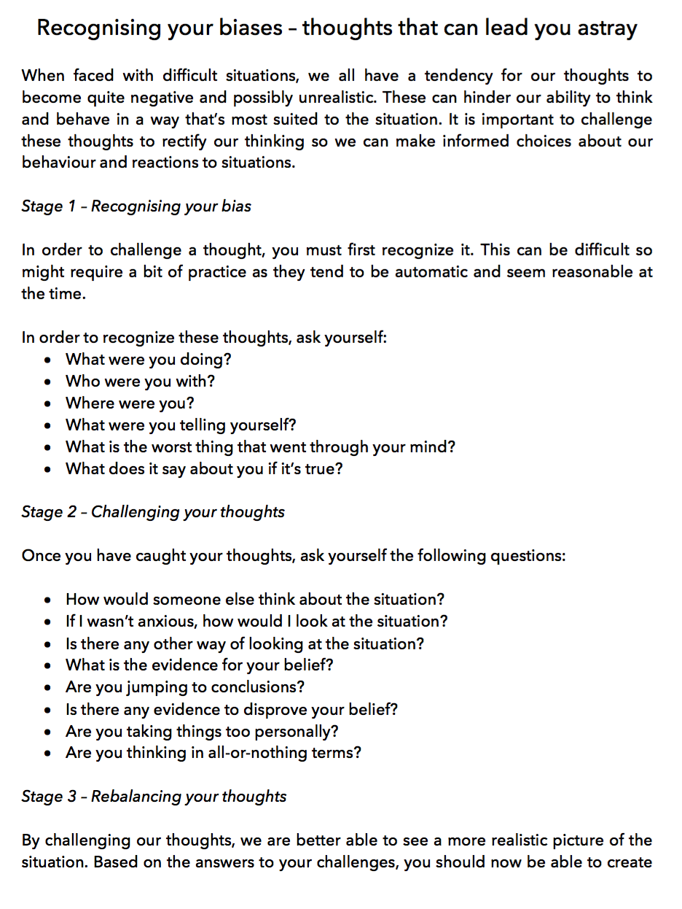

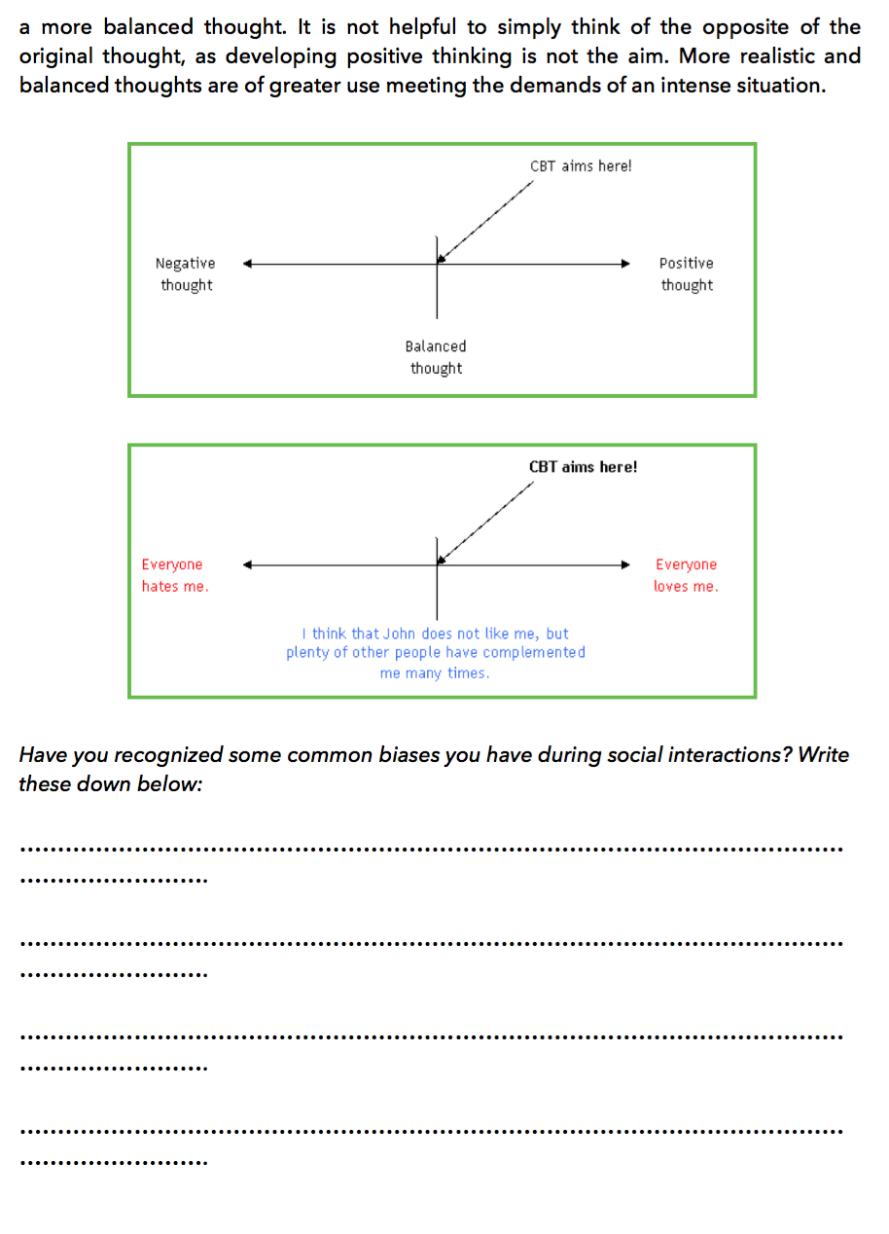



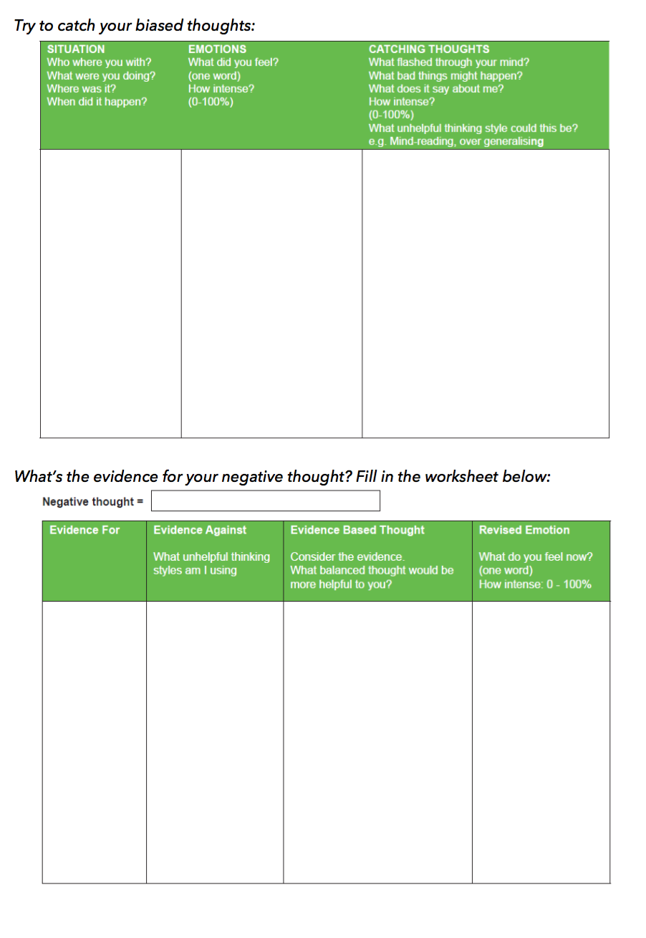

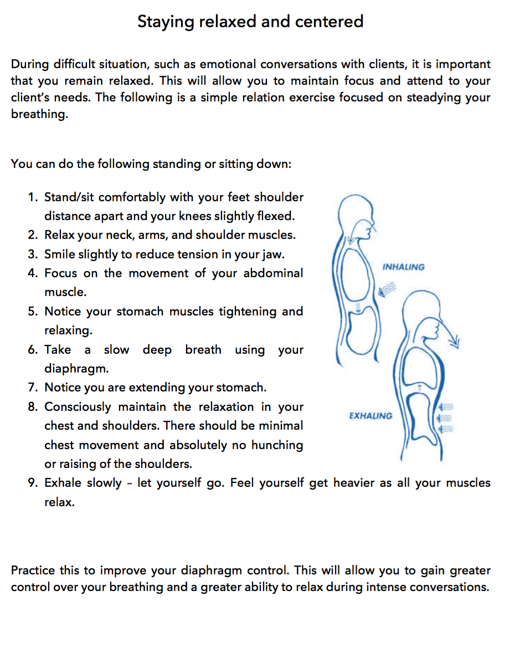





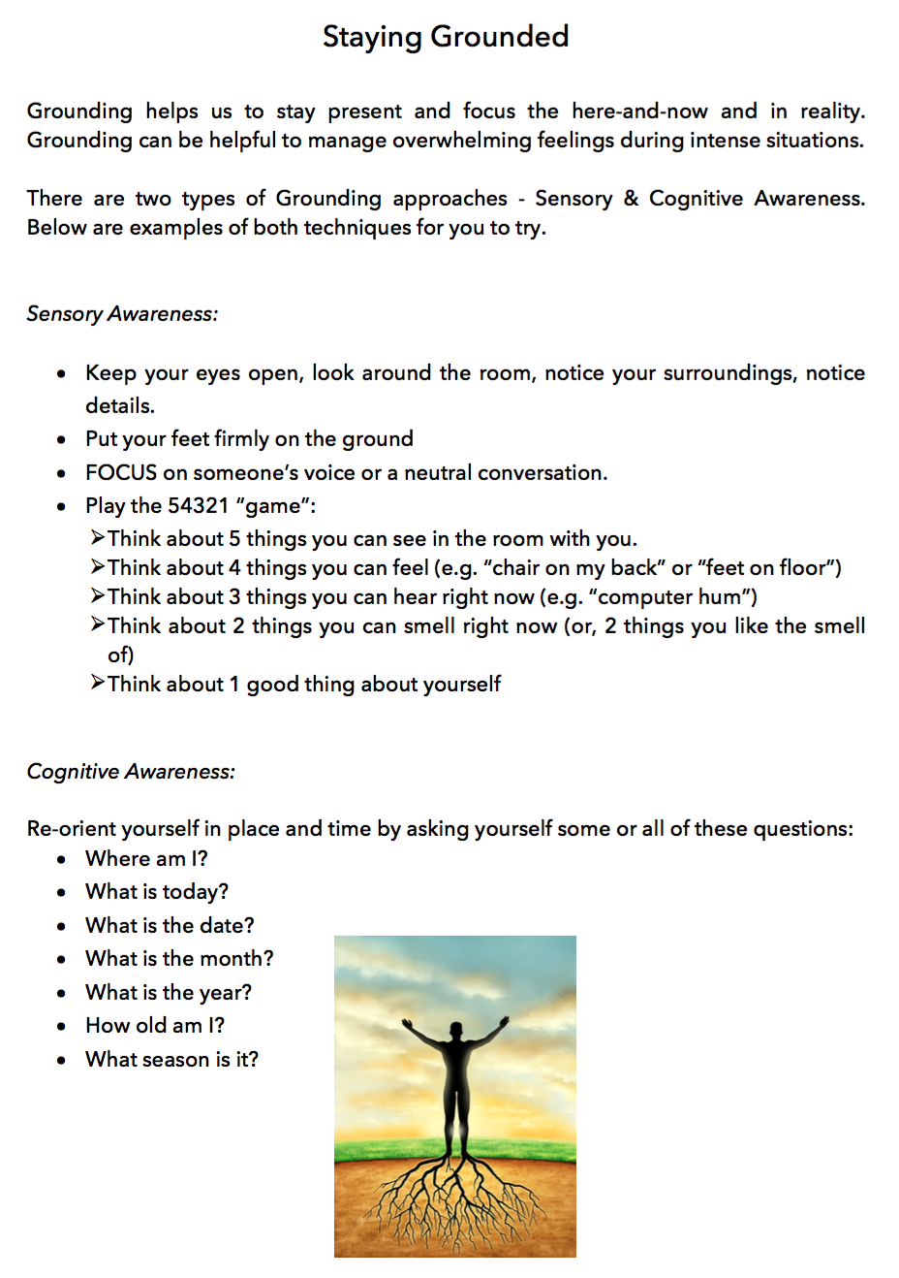

Appendix G

ACT intervention booklet








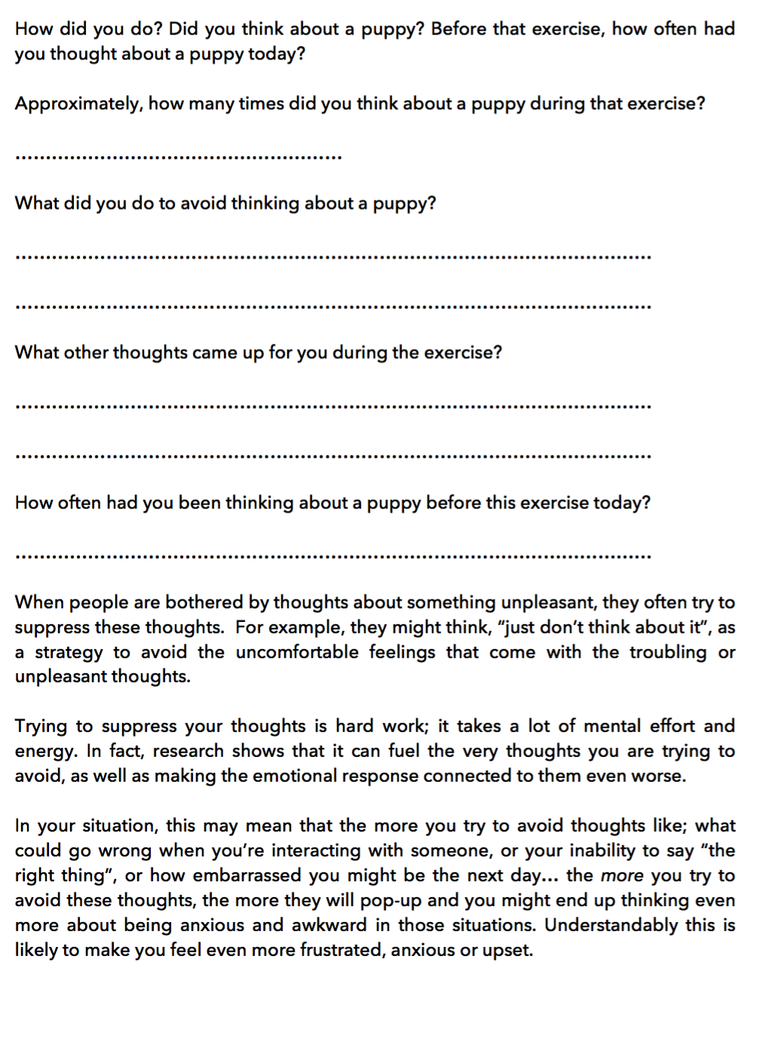

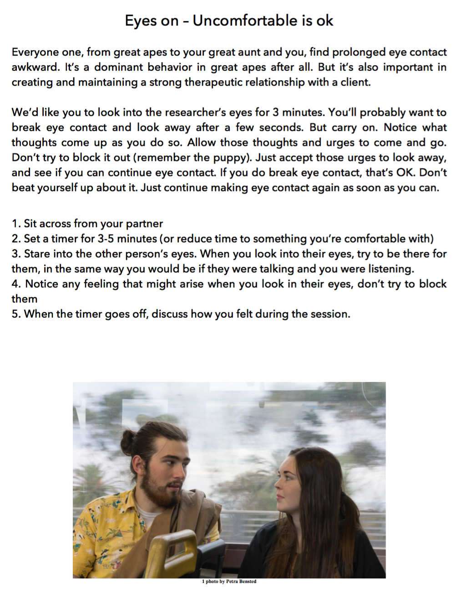

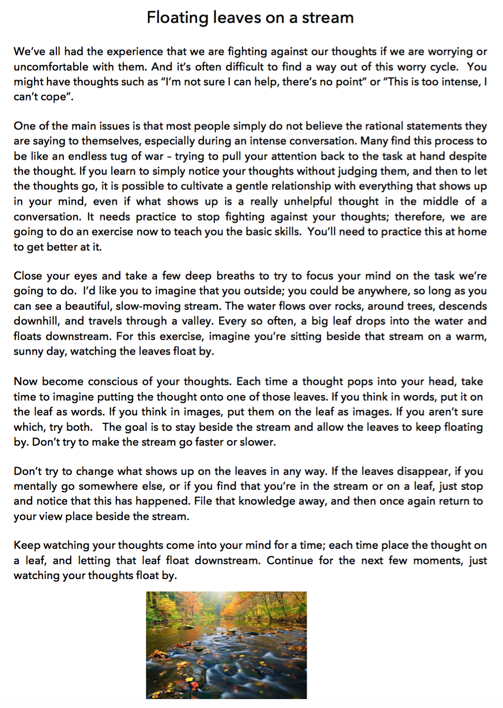

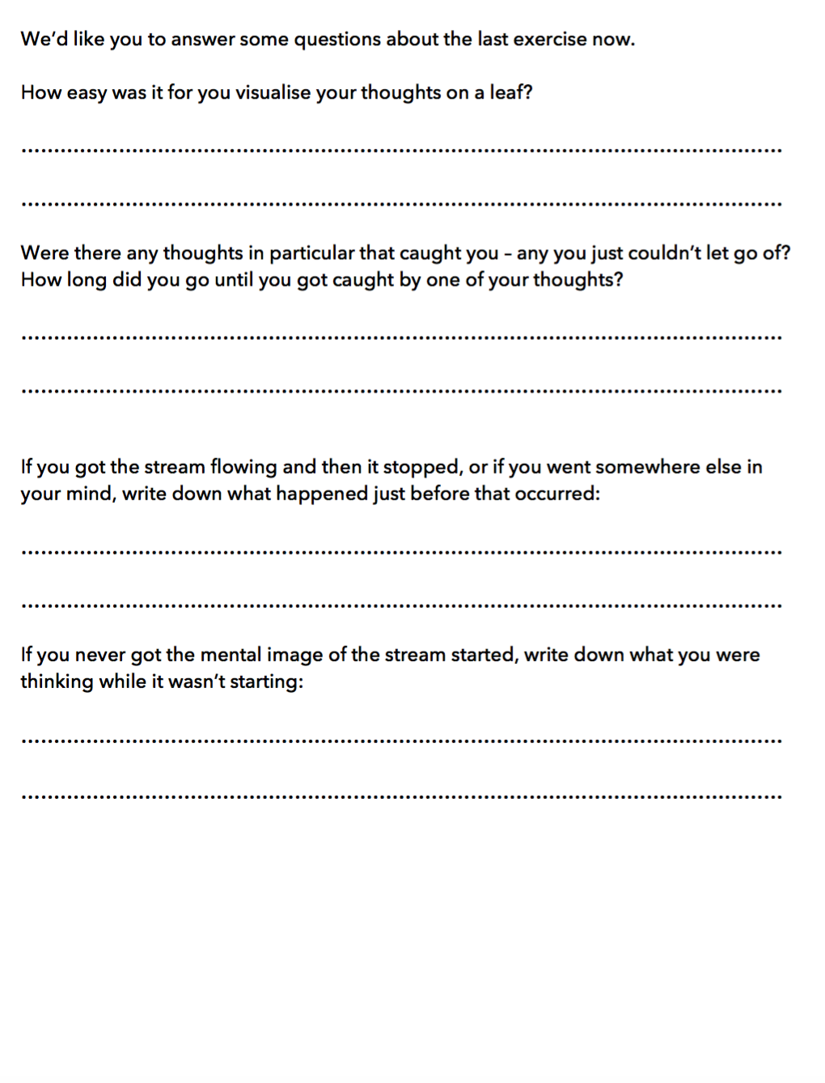
Appendix H

Study protocol

