Sculpture and Place: a biographical approach to recontextualising Cheshire’s early medieval stone sculpture

Thesis submitted in accordance with the requirements of the University of Chester for the degree of Doctor of Philosophy

By Joanne Elizabeth Kirton
18/02/2016

ABSTRACT

SCULPTURE AND PLACE: A BIOGRAPHICAL APPROACH TO EARLY MEDIEVAL STONE SCULPTURE IN CHESHIRE

JOANNE ELIZABETH KIRTON

Researching early medieval stone sculpture has long been enabled and constrained by approaches devised and subsequently honed over the last century focusing on form and ornamentation. These approaches largely prioritise the physical appearance of sculptural fragments, often distancing them from the physical and cognitive contexts in which they operated from their creation to the present
This thesis brings together popular strands of research from other areas of archaeology - landscape, biography, materiality and monumentality - to explore how early medieval stone sculpture operated in place and time, from their construction through processes of use and reuse. The study recognises that sculpture did not function independent of physical location or the socio-political context with which it was connected and that many sculptures have life-histories which can be charted through individual monuments, assemblages of sculpture, and regional patterns.
Using a tenth-/eleventh-century assemblage from Cheshire, the biographies of the county’s early medieval monuments and architectural fragments are explored in relation to their physical location and the local historical frameworks with which they are connected. Through this original and distinctive approach, Cheshire's corpus of early medieval stone sculpture is both revisited and reinterpreted to emphasis the power of place and the biographies of stone sculpture.

TABLE OF CONTENTS

CHAPTER ONE
INTRODUCTION 1
AIM 5
THESIS STRUCTURE 8
TERMINOLOGY 8

CHAPTER TWO
EARLY MEDIEVAL STONE SCULPTURE: 11
APPRAISING PAST AND CURRENT APPROACHES TO THE STUDY OF EARLY MEDIEVAL INSCRIBED AND SCULPTED STONES 11
INTRODUCTION 11
THE STUDY OF EARLY MEDIEVAL STONE SCULPTURE: A BRIEF OVERVIEW 14
HISTORIOGRAPHY SUMMARY 19
ART-HISTORY VERSUS ARCHAEOLOGY: THE EARLY BEGINNINGS 21
THE IMPACT OF ART-HISTORY 28
SCULPTURE STUDIES IN THE SECOND HALF OF THE TWENTIETH CENTURY 38
RECENT APPROACHES TO SCULPTURE STUDIES 47
CONCLUSION 69

CHAPTER THREE
THE DATA SET, OBJECTIVES AND METHODOLOGY 72
THE DATA SET 72
OBJECTIVES 6
METHODOLOGY 82

CHAPTER FOUR
REUSE OF EARLY MEDIEVAL STONE SCULPTURE IN CHESHIRE: WHEN, HOW AND WHY? 90
INTRODUCTION 90
PRELIMINARY ANALYSIS 91
CHESHIRE REUSE 104
CONCLUSION 133
CHANGING ATTITUDES TOWARDS EARLY MEDIEVAL STONE SCULPTURE IN THE POST-CONQUEST PERIOD 134
THE CHESHIRE EVIDENCE 143
CONCLUSION 162

CHAPTER FIVE
THE ASSEMBLAGE OF EARLY MEDIEVAL STONE SCULPTURE AT ST JOHN THE BAPTIST CHURCH, CHESTER: GROUPED ASSEMBLAGES IN A SETTLEMENT CONTEXT 164
INTRODUCTION 164
THE SCULPTURAL ASSEMBLAGE 165
RE-CONTEXTUALISING MONUMENTS 184
LOCATION 193
THE MONUMENTAL ASSEMBLAGE: FUNCTION AND INFLUENCE 196
WHO RAISED THE ST JOHN’S MONUMENTS? 221
CONCLUSION 238

CHAPTER SIX
MONUMENTS, LOCATION AND ORCHESTRATED AUDIENCE ENGAGEMENT AS A TOOL IN THE CREATION OF PLACE 242
INTRODUCTION 242
THE ROUND-SHAFTS OF CHESHIRE 246
THE CLEULOW CROSS LANDSCAPE 251
MOUND AND MONUMENT 271
COMPARATIVE MATERIAL 284
MOUND AND MONUMENT: BIOGRAPHY AND FUNCTION 288
CONCLUSION 304

CHAPTER SEVEN
CONCLUSION: A BIOGRAPHICAL APPROACH TO RECONTEXTUALISING EARLY MEDIEVAL STONE SCULPTURE 306
INTRODUCTION 306
SUMMARY OF RESULTS 306
THEMATIC APPROACHES 312
THE CHESHIRE ASSEMBLAGE: NEW INTERPRETATIONS 320
FUTURE RESEARCH 323
CONCLUSION 327

BIBLIOGRAPHY 329

APPENDIX A 358

APPENDIX B 363

LIST OF FIGURES
Fig. 1. Heaton 1, Cheshire (© Joanne Kirton) 2
Fig. 2. Early medieval cross located in All Saints Churchyard, Bakewell (© Joanne Kirton) 60

Fig. 3. Whitford F12, Flintshire also known as the Maen Achwyfan cross (© Joanne Kirton) 62

Fig. 4. The Pillar of Eliseg, Denbighshire as viewed from the top of the mound (© Joanne Kirton) 64

Fig. 5. Percentage of known fragments of early medieval sculpture in Cheshire pertaining to the Anglian or Viking Period 75

Fig. 6. Distribution of early medieval stone sculpture in the pre-1974 County of Cheshire 77

Fig. 7. Distribution of Viking period stone sculpture from the pre-1974 County of Cheshire 92

Fig. 8. Solid geology of Cheshire and Lancashire, with the distribution of stone types used for Anglo-Saxon sculptures in Cheshire and Lancashire (© Corpus of Anglo-Saxon Stone Sculpture) 94

Fig. 9. Natural topography of Cheshire (Place-name evidence after Phillips and Phillips (2001, 26). Base Map: Ordnance Survey 2015 [Crown Copyright/database right 2015. An Ordnance Survey/Edina supplied service]). 96

Fig. 10. Relief Map of Cheshire and Stone Sculpture Distribution. Base Map: Ordnance Survey 2015 [Crown Copyright/database right 2015. An Ordnance Survey/Edina supplied service]). 98

Fig. 11. Percentage of sculpture associated with church fabric, foundations or churchyards in east and west Cheshire 100

Fig. 12. Percentage of sculpture associated with church fabric, foundations or churchyards in Cheshire and surrounding counties* 101

Fig. 13. Line drawing of the two types of round-shaft derivatives (After Cramp 1984, xv) 105

Fig. 14. Distribution of round-shaft derivatives in the pre-1974 counties of Cheshire, Derbyshire and Staffordshire 108

Fig. 15. Percentage of round-shaft derivatives associated with church structures 109
Fig. 16. Percentage of sculptures associated with church fabric, foundations or churchyards 110

Fig. 17. Composite monument at Disley, Lyme Handley known as the ‘Bowstones’ (© Joanne Kirton) 112

Fig. 18. Percentage of early medieval stone sculpture reused in the fabric or foundations of churches in surrounding counties 124

Fig. 19. Astbury 1A, Cheshire (©Corpus of Anglo-Saxon Stone Sculpture, photographers K. Jukes and D. Craig) 128

Fig. 20. Leek, Staffordshire (© Joanne Kirton) 129

Fig. 21. Wincle 1, Cheshire (© Joanne Kirton) 129

Fig. 22. The Lichfield Angel (© Joanne Kirton) 139

Fig. 23. Reuse percentage of monuments with a known provenance 150

Fig. 24. Overchurch 1A, Cheshire (©Corpus of Anglo-Saxon Stone Sculpture, photographers K. Jukes and D. Craig) 151

Fig. 25. Shocklach 1, Cheshire (© Joanne Kirton) 153

Fig. 26. Bruera 1, Cheshire (© Corpus of Anglo-Saxon Stone Sculpture, photographers K. Jukes and S. Craig) 154

Fig. 27. Frodsham 1, Cheshire (© Corpus of Anglo-Saxon Stone Sculpture, photographers K. Jukes and D. Craig) 154

Fig. 28. Panoramic view of St. Edith’s highlighting the location of the stone carving in the northern wall (© Joanne Kirton) 156

Fig. 29. Original screenshot of 3D data set obtained by laser scanning of the Shocklach carving (National Museums Liverpool, March 2010) 157

Fig. 30. Screenshot of 3D data set obtained by laser scanning with re-working highlighted in black (After National Museum of Liverpool) 158

Fig. 31. Carved anthropomorphic corbel stone in the exterior wall of St Edith’s, Shocklach (© Joanne Kirton) 159

Fig. 32. St John’s as it appeared in AD 1875 shortly after restoration work uncovered the Anglo-Saxon sculpture (© Crown Copyright and Landmark Information Group Limited (2016) All rights reserved (1856-1908). 167

Fig. 33. Gilcrux 1A, Cumberland (© Corpus of Anglo-Saxon Stone Sculpture, photographer T. Middlemass) 169

Fig. 34. Chester St John 2a-bA, Cheshire (© Corpus of Anglo-Saxon Stone Sculpture, photographers K. Jukes and D. Craig) 170

Fig. 35. Typical features of a Cheshire circle-headed cross (© Joanne Kirton) 171

Fig. 36. St John’s 8a (© Corpus of Anglo-Saxon Stone Sculpture. Original photographs supplied by the British Museum). 172

Fig. 37. Distribution of circle-headed crosses in-and-around the county of Cheshire (Base Map: Ordnance Survey 2015 [Crown Copyright/database right 2015. An Ordnance Survey/Edina supplied service]). 177

Fig. 38. Distribution of early medieval stone sculpture found in Cheshire with a known provenance (© Crown Copyright and Database Right 2016. Ordnance Survey (Digimap Licence). 179

Fig. 39. Chester Unknown Provenance 1A, Cheshire (© Corpus of Anglo-Saxon Stone Sculpture, photographers K. Jukes and D. Craig) 181

Fig. 40. Chester unknown Provenance 2E and A, Cheshire (© Corpus of Anglo-Saxon Stone Sculpture, photographers K. Jukes and D. Craig) 182

Fig. 41. West Kirby 4A, Cheshire (© Corpus of Anglo-Saxon Stone Sculpture) 185

Fig. 42. Comparisons of forms – (L-R) Sutton 2B and St John’s 1a-bA, Cheshire (©Corpus of Anglo-Saxon Stone Sculpture, photographers K. Jukes and D. Craig) 189

Fig. 43. Neston 2C (© Corpus of Anglo-Saxon Stone Sculpture, photographers K. Jukes and S. Craig) 198

Fig. 44. Neston 3C (© Corpus of Anglo-Saxon Stone Sculpture, photographers K. Jukes and S. Craig) 199

Fig. 45. Estimated parish space c. AD 907 (after Allridge 1981, 8) 205

Fig. 46. St John’s’ land within the interior of the burh by Domesday as noted in red (After Alldridge 1981, 24) 206
Fig. 47. Substantial, probable medieval, linear ditch running on a north-south alignment in Grosvenor Park (© Simon Ward). 219

Fig. 48. Map of early medieval activity in Chester dating from the tenth and eleventh centuries (© Crown Copyright and Database Right 2016. Ordnance Survey (Digimap Licence). 227

Fig. 49. Map of parish authority for St Bridget’s and St Olave’s (After Allridge 1981, 18) 233

Fig. 50. Wincle 1, Cheshire. Also known as the Cleulow Cross (© Joanne Kirton) 250

Fig. 51. Map demonstrating study area around the Cleulow Cross and mound (Base Map: Ordnance Survey 2015 [Crown Copyright/database right 2015. An Ordnance Survey/Edina supplied service]). 252

Fig. 52. Map demonstrating the pre-1974 county boundaries, hundredal boundaries and the Parish of Prestbury (after Williams 2015). 254

Fig. 53. Population density of Cheshire in 1086 based on Domesday Survey after Phillips and Phillips 2001, 31 (© Phillips and Phillips). 256

Fig. 54. Woodland density of Cheshire in 1086 based on Domesday Survey after Phillips and Phillips 2001, 31 (© Phillips and Phillips). 257

Fig. 55. Distribution of place-names dated to prior AD 1400 (Dodgson 1970) (Base Map: Ordnance Survey 2015 [Crown Copyright/database right 2015. An Ordnance Survey/Edina supplied service]). 258

Fig. 56. Local Landscape Character Assessment designations after Cheshire County Council, 2008 261

Fig. 57. Map demonstrating road network around the Cleulow Cross and Wincle Mound (Base Map: Ordnance Survey 2015 [Crown Copyright/database right 2015. An Ordnance Survey/Edina supplied service]). 264

Fig. 58. Roman road network and associated occupational evidence in Cheshire and surrounding areas (after McCormick 2013, Talbot 2000 & Phillips and Phillips 2001, 29). 265

Fig. 59. Early turnpike system and place-names associated with routeways (after Phillips and Phillips 2001, 55) 266

Fig. 60. Map of known monuments, earthworks and find spots around the Cleulow Cross, Wincle (Base Map: Ordnance Survey 2015 [Crown Copyright/database right 2015. An Ordnance Survey/Edina supplied service]). 268

Fig. 61. Bullstones (© Joanne Kirton) 269

Fig. 62. Sutton Wayside Cross (© Joanne Kirton) 270

Fig. 63. The Mound as viewed from the east (© Joanne Kirton) 272

Fig. 64. Map illustrating topographic features and relief within the study area (Base Map: Ordnance Survey 2015 [Crown Copyright/database right 2015. An Ordnance Survey/Edina supplied service]). 273

Fig. 65. Viewshed from Wincle mound (Base Map: Ordnance Survey 2015 [Crown Copyright/database right 2015. An Ordnance Survey/Edina supplied service]). 279

Fig. 66. Rowsley mound as viewed from the north and Rowsley cross-head (© Joanne Kirton) 285

Fig. 67. Viewshed from the Bowstones, Disley Lyme Handley (Base Map: Ordnance Survey 2015 [Crown Copyright/database right 2015. An Ordnance Survey/Edina supplied service]). 287

Fig. 68. Map demonstrating Higham’s (1993, 175-6) proposed pre-tenth century land unit and the location of the Cleulow Cross and mound (after Williams 2015). 297

Fig. 69. Brailsford round-shaft (© Joanne Kirton) 300

Fig. 70. Close up of Brailsford round-shaft with carved warrior holding sword (© Joanne Kirton) 301

LIST OF TABLES
Table 1. Table of all known round-shaft derivatives in Cheshire, Derbyshire and Staffordshire 107
Table 2. Table of all known possible round-shaft derivatives in Cheshire, Derbyshire and Staffordshire 107
Table 3. Percentage of early medieval stone sculpture reused in the fabric or foundations of churches in surrounding counties 123
Table 4.. West Cheshire reuse 125
Table 5. East Cheshire reuse associated with churches 127
Table 6. Table noting all place-names dated prior to AD 1400 (Dodgson 1970), their meaning and date of first reference. 259
ACKNOWLEDGMENTS

I would like to thank the following people for their support and advice throughout my doctoral research. Firstly, my supervisors Dr Meggen Gondek and Professor Howard Williams for their unwavering encouragement and understanding. Secondly, the staff of the History and Archaeology Department, University of Chester, particularly Dr Keith McLay, Brenda Davies and Maxine Reed. I also owe a huge debt of thanks to Rod Cox, who generously sponsored my doctoral research.
There have been many others along the way who have given me their time, support and access to their research: Dr Derek Craig, Dr Phil Sidebottom, Professor Nancy Edwards, Liz Royles, Dr Jane Hawkes and the late Dr John Doran deserve particular mention. Many more projects have provided the training and experience invaluable in the completion of the thesis, including the Bamburgh Research Project, Project Eliseg, The Runes, Monuments and Memorial Carvings Network and Big Heritage C.I.C.
Finally, I would like to thank my family and friends who have stuck with me through thick and thin, believing in me when I could not. A particular thank you to Gary Duckers for supporting and helping me through the final stages of the submission and his advice on all things maps. Thank you!

CHAPTER ONE

INTRODUCTION

The early medieval period in England (AD 400-1100) has left a varied legacy of material cultures which include ceramics, glass, metal, cloth, ivory, manuscripts and stone (e.g. Clegg-Hyer and Owen-Crocker 2013; Hamerow et al. 2011). However, the stone sculpture from this period is the only surviving assemblage that can be considered monumental. The very material and size of these sculptures have ensured their longevity: rarely unscathed, but commonly found outside archaeological excavation in churches and churchyards, built into walls and used as decorative ornaments.
England’s early medieval lithic heritage is a blessing and a curse for archaeological enquiry. Even today, it is often perceived as the preserve of the art-historian rather than the archaeologist. Surviving early medieval carved stones might be considered problematic, as most examples have largely been distanced from their original locations and associated archaeological assemblages, which makes it difficult for those who wish to study their dates and their original contexts of commissioning, designing, creation and use. For example, Heaton 1 (see Fig. 1) was brought to Staffordshire after the Second World War and moved to its current location in Cheshire in 1966 (Hill and Seddon 1998, 145-9). However, its earlier provenance is not known. Whilst its form and decoration indicate that it most closely resembles round-shaft derivatives from Cheshire (Bailey 2010, 154), there is nothing to tie the monument to a location either physically or through documentary records.
Yet the complex life-histories of early medieval stone sculpture can offer opportunities for archaeological investigation as well as challenges. Largely because sculptures have born witness to, and been subject to, treatments by many changing events and perceptions, sometimes evident on their surviving surfaces. For example, the Hilton of Cadboll cross from the Tarbat Peninsula in Scotland was seemingly defaced and its cross was erased. Attempts were also made to remove the whole monument after the Reformation, possibly because it was perceived as idolatrous (Foster and Jones 2008, 221). At a later date (AD c.1676) the monument was appropriated and turned into a memorial, acquiring new carvings and an inscription.This occurred at a time when the Scottish church had banned burial in the interior of church buildings and many were looking for monumental alternatives for memorialisation (Foster and Jones 2008, 222). This possibly indicates why the monument was appropriated in this way (see Foster and Jones 2008, 215-223). The perception and function of this, and other early medieval stone monuments, demonstrably changed over time and, as such, they can provide data beyond the period of their erection and initial use. Hence the cultural biographies of individual pieces, assemblages and places can be explored as signals of changing social and cultural attitudes.
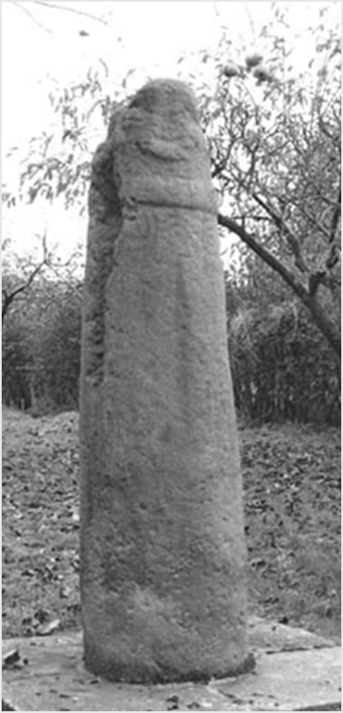
Fig. 1. Heaton 1, Cheshire (© Joanne Kirton)
In most past studies, the lack of original context and their fragmentary state has ensured that this data set has not been fully utilised. Scholars have focussed on the appearance of these monuments: their style, form, decorative repertoires and distribution patterns serving as primary points for discussion, linked loosely to broad historical narratives. These avenues of research do not require an investigation of the physical context at the point of creation, initial use or throughout the entirety of their existence. They also do not require an understanding of a monument’s biography and how this might be tied to the historical and/or modern biography of place.
The distancing of stone sculpture from context has had a major impact on its survival, research agendas and display of the data set in England and throughout the British Isles. Over a decade ago, Sally Foster (Foster et al. 2003 and Foster 2005a and b) set out an agenda for researching and conserving the early medieval stone sculpture of Scotland, taking into account the current academic climate, public interest and resources available. Time and again her discussion returned inevitably to the same point: early medieval stone sculpture can only be understood and interpreted through its connection to place: its physical context. Stone sculpture, whether a monument or architectural fragment, was created with a particular location and associated function in mind. Moreover, its survival after its initial use was and is dependent on location and the interactions with individuals and groups that this relationship inadvertently encourages. In order to understand and subsequently interpret and present stone sculpture, recognition of the relationship between sculpture and place throughout the entirety of a sculptures existence is essential. Martin Carver (2005, 13-5) elaborates on this stance, breaking this approach into three areas: social context, intellectual context and local legacy. Each area fundamentally relies on the relationship between stone sculpture and place. "Without an understanding of these, and their interrelationship, our understanding and appreciation of early medieval sculpture is severely diminished" (Foster 2005a, 7).
At the commencement of my doctoral research, I was still largely unaware of the fundamental depths of disconnection between early medieval stone sculpture and contextual studies, as outlined above. In the north west of England, early medieval archaeology is rarely encountered beyond late Anglo-Saxon burhs (Mason 2007; Newman 2006, 96) and the linear earthworks of Wat’s Dyke and Offa’s Dyke (Griffiths 2010, 20; Hill and Worthington 2002). Occupational sites are also rare with exceptions such as Tatton (Griffiths 2010, 71; Higham 2004, 308-9; Newman 2006, 98), Irby (Philpott and Adams 2011; Newman 2006, 98) and Meols (Griffiths, Philpott and Egan 2007). Likewise, burial sites attributed to the period are rare too, but for exceptional finds such as the reputed battle burial at Heronbridge on the outskirts of Chester (Mason 2007, 43-56). Small-finds are also sparse, when compared with other regions, and hoards are rare, although they do exist. Obvious examples include the tenth century Castle Esplanade hoard from Chester (Webster et al. 1953, 22-32) and the Huxley hoard found south east of the city (Graham-Campbell and Philpott 2009). Consequently, sculpture has an especially important contribution to make to this region (Newman 2006, 102-5). However, at the commencement of the preliminary research on Cheshire's early medieval archaeology, focusing upon its stone sculpture, it was a struggle to find an opportunity to expand on the basic information provided in the recently published Corpus of Anglo-Saxon Stone Sculpture (hereafter referred to as CASSS) volume, which covered the county of Cheshire (Bailey 2010). It was particularly striking how problematic it was to find monuments or architectural fragments in situ or demonstrably in close proximity to their original location. It was necessary to revaluate if it was possible to compose an original thesis about stone sculpture in the landscape when almost the entire study area was devoid of such examples and the archaeological context and historical detail that might suggest where they had come from.
I looked to others who had studied early medieval stone sculpture for inspiration and whilst the distancing of stone sculpture from context had been recognised and a lack of methods and theories to tackle this problem had been noted, there still seemed very little concerted effort to truly tackle these issues. That is not to say there was not inspired work being undertaken, only that much of it seemed to have been embarked upon on an ad hoc basis in relation to an explicit agenda to combine the spatial and temporal dimensions of stone monuments (e.g. Andreef 2012, 129-212; Buström 1996, 21-40; Driscoll et al. 2005, 135-58; Edwards 2001, 15-39 and 2009, 1-35; Griffiths 2006, 143-62; Orton 2006, 31-66; Sidebottom 2000, 213-35; Stocker 2000, 179-212 and Turner 2006) (see Chapter Two for an in depth discussion of historical and modern early medieval stone sculpture research).
This search for an approach lead beyond the confines of the discipline, encouraging an investigation of how monuments were theorised and explored in prehistoric studies. This highlighted the longevity of landscapes and interactions with monuments (Bradley 1997 and 2000; Bender et al. 2008; Conneller 2011; O’Connor et al. 2009; Parker Pearson and Ramilisonina 1998, 308-326; Pollard and Gillings 2010, 7-11; Pollard and Reynolds 2002; Scarre 2010, 91-6 and Tilley 1994 and 2012) and it became apparent how a relationship between monument and place might be formed over hundreds, sometimes over thousands, of years. It also demonstrated that a biographical approach enabled an exploration of modern social groups encountering monuments, as advocated for stone sculpture elsewhere, but notably in Scotland (James et al. 2008; Jones 2004 and Hall 2005, 343-52 and 2012, 85-102). It became clear that the relationship between monument, biography and place are key to studying early medieval stone sculpture. The information that a monument or architectural fragment can offer is not confined to its original location or function but can contribute to interpretations at any point during the life of the sculpture. This realisation offered the gateway to exploring early medieval stone sculpture within their landscape location - it can be any place, any location and any type of sculpture, providing there is some record of provenance.

AIM
Based on these observations, this thesis will explore individual sculptures and assemblages, whilst investigating them as part of larger local and regional collections. Biography will be a key element, not simply the biography of a particular monument or assemblage but the biography of sculpture and place, exploring how the two might inform one another. Consequently, the primary aim of this thesis is to contextualise both individual fragments and geographically concentrated assemblages of early medieval stone sculpture from the county of Cheshire, using data derived from their location and current state of survival. This data is then used to explore trends in historical and modern biographies across geographical areas. Where this is possible, new understandings may be generated for the sculpture and their current location. Furthermore, it is intended that the approaches developed in the thesis are not exclusively relevant to Cheshire. Instead, the aim is to develop approaches which will be suitable for other regions with sculptural assemblages that might be more intensively studied in conventional terms, but still lack the approach adopted here. Indeed, future research in other regions will provide greater comparative material and a more focussed understanding of early medieval stone sculpture in England and the British Isles.
To meet the aims of the thesis and help shape the methodology, a series of objectives have been identified which fall into the three themes of biography, landscape and materiality.

OBJECTIVES
- Biography
1.1. Analyse the different forms of reuse evident within a regional assemblage of early medieval stone sculpture.
1.1.1. Compare this across the chosen study area to determine local trends.
1.1.2. Compare this with surrounding areas to determine regional and broader trends.

1.2. Attempt to establish a timescale for monument reuse that might then be linked to archaeological or historical evidence in the region. This may provide impetus for the destruction and/or reuse of the monument, architectural fragment or assemblage.
1.3. Consider how the presence of the monument or architectural fragment and its developing biography might have influenced the morphology and perception of its location and the monument itself.

- Landscape
2.1. Consider how the appearance of an early medieval monument (or monuments) or architectural fragment (or fragments) might be used to establish the original functions and landscape location(s) and, conversely, consider how location may affect the design, appearance and use of stone sculpture.

2.2. Explore how the location of an individual monument or assemblage affects survival in the archaeological record.

2.3. For sculptural assemblages and individual monuments, explore how they informed the creation and transformation of place. Moreover, use the place of their erection to understand the impetus for the monuments erection, appearance and function.
2.4. Consider how the wider topography of the landscape might have been important in locating monuments and how this might affect function.

- Materiality
3.1. Consider how the local topography and geology of the area affects or influences monument production and materiality.
  - Consider how materiality informs the biographical and landscape dimensions of the study.

THESIS STRUCTURE
The thesis begins with an extended overview of the history of early medieval stone sculpture studies in Chapter Two, exploring how the relationship between art history and archaeology has shaped research agendas that direct and influence how the data set is perceived. It concludes with recent studies that have moved beyond the traditional approaches and from which inspiration has been drawn for the thesis approach. In Chapter Three the Cheshire assemblage is reviewed, the objectives for the research established and the methodology outlined. The following three chapters explore different methodological approaches to the data set, as set out in Chapter Three. Chapter Four will investigate the varying biographies of early medieval stone sculpture and attempt to establish how monument biographies are connected and shaped by location, using the entire Cheshire corpus and comparison with surrounding counties. Chapters Five and Six will build on this by exploring the relationship between individual and monumental assemblages and their landscape location at the time of their erection, using different monuments/architectural fragments and assemblages to explore how variability in the types of sculpture, landscapes and survival might be investigated. In Chapter Seven the results of the study are summarised and discussed, concluding with suggestions for future research.

TERMINOLOGY
Finally, two key terms need defining before proceeding to the main discussion. The first is ‘reuse’ or ‘reused’. Sculptures that are deemed to have been moved from their original location and reworked into a later structure are considered reused. They are not deemed to be reused if they have been broken and dumped/buried. Sculptures are also considered reused if their form or decoration has been re-worked. For example, if the decoration has been altered or added to, or certain iconographic scenes have been preserved, they are considered reused.
The locations where sculptural reuse might occur can be largely divided into two groups both of which will be explored: one considers reuse within and around buildings used for Christian worship, including buildings that are no longer upstanding, but which have a record of their existence and location. The criteria for association with a Christian building are as follows: it includes the fabric and foundations for the buildings and the interior of the churchyard, above and below the ground surface. The second group explores sculptures that were seemingly situated away from buildings used for Christian worship - anything outside the historic churchyard boundary. Invariably, there will be monuments that do not fall easily into either of these groups and these will be discussed independently: for example, monuments that are situated outside the churchyard boundary but sit on a road leading to and from the church of any period. This basic categorisation of early medieval stone sculptures reuse in Cheshire will form the basis for further exploration across the county and comparison with surrounding counties.
The second term that needs defining is ‘place’, particularly when considered alongside ‘space’, as the two are often used to describe a specific geographical area and/or conceptual construct. However, there is no one definition for place (Casey 1996, 13-18; Cresswell 2004, 1), so it is wise to outline what it means when it is discussed in the remainder of the thesis.
Places are physical locations, which hold meaning. This may be a fixed point that can be noted on a map, such as a building. On occasion, a place can be mobile, on a ship or a room on a train for example (Cresswell 1996, 5-6). An area takes on the mantle of place when it acquires meaning, which therefore necessitates a connection between a person and place. It is something that can be physically created by a person or conceptually perceived (Creswell 2004, 1-3). Moreover, because place relies on meaning, that meaning can develop and change over time, consequently place is not static. A place can also have many layers of meaning and activity associated with it. Place when discussed in this thesis is a particular location, which can be a monument, natural feature, structure or portion of land that has a particular meaningful connection to a person or group of people, which does not necessary have a defined boundary. It is instead a known spot, remembered and/or marked by natural or anthropogenic activity.
Places can be part of spaces but the two are perceived and experienced differently. Cresswell (2004, 8-9) suggests that anyone can move around a space but not everyone will encounter a place within that space, as to experience place there must be a meaningful connection to it. Space, on the other hand, is a realm without meaning. When meaning is attached to space it becomes a place. Tuan (1977, 6) defines this further, suggesting that a place is a location and space is the gaps between.
‘The ideas of ‘space’ and ‘place’ require each other for definition…..If we think of space as that which allows movement, then place is pause; each pause in movement makes it possible for location to be transformed into place’.
Here Tuan both defines the difference between place and space and outlines the fundamental shift in perspective required to create place from space.

CHAPTER TWO

EARLY MEDIEVAL STONE SCULPTURE:

APPRAISING PAST AND CURRENT APPROACHES TO THE STUDY OF EARLY MEDIEVAL INSCRIBED AND SCULPTED STONES

INTRODUCTION
‘The circumscribed traditional specializations [within the minor Anglo-Saxon arts] have provided us with basic typologies and a fairly secure cultural and chronological anchorage; but there is also a sense in which they have served as a constraint, inhibiting a wider and deeper questioning.’ (Webster 2003, 11).

‘Theoretically and methodologically [the approach to Anglo-Saxon stone sculpture]….is committed to seeing and describing similarities of form (monument type), decorative elements or ornamentation (motifs, patterns), techniques of carving (modelled, humped, grooved, incised), and with tabulating those similarities according to an obvious and universal mode. I argued that though this work was enabling of knowledge in so far as it permitted the visibility of an object to pass into discourse, it also inhibited the production of knowledge because it tended to restrict what could be seen and named and described…..it established a recognized way of seeing and saying….. corpus scholarship has become paradigmatic’ (Orton 2003, 66).
These two quotes, the first from Leslie Webster and the second from Fred Orton, serve three purposes. Firstly, they highlight the traditional focus of early medieval stone sculpture studies (where the term sculpture is used in the text it pertains to early medieval inscribed and sculpted stones): the development of typologies and chronologies, the identification of cultural links and the distribution of monuments. Second, they also note a climate that has arisen in which many scholars feel this highly focussed methodology has also limited the types of questions asked of the data set. Third, both quotes were written over ten years ago and stem from a period when scholars were beginning to critique the standard methodologies, and attempting to step beyond the confines of particular sets of questions and approaches, best highlighted by the CASSS (see below).
Today, the discipline largely continues to depend on the visible, quantifiable attributes of early medieval stone sculpture just like regional and national sculptural studies from earlier decades (Allen and Anderson 1903; Collingwood 1907 and 1927; and Nash-Williams 1950). These influential early corpora have long dominated thinking and approaches towards sculpture, potentially to the detriment of further, expansive study of sculpture within its spatial settings and the shifting temporal contexts in which individual and groups of sculpture operated over time, and the properties of stone itself as a medium for production and use. Hence, recent work is still primarily approached in the same broad intellectual terms as those explored in the early and mid-twentieth century (Hawkes 1999, 204; Orton 1999, 219-222). Work on spatial context, materiality or biography remains relatively rare and in many cases subsumed within existing frameworks of examining individual monuments or fragments. This highlights a persistent shortfall in the potential of existing approaches in sculpture studies to fully and adequately be explored as material culture created in, and operating within, early medieval socio-economic, political and religious life.
The focus on the appearance and distribution of monuments is justified to some degree. The data set does not easily lend itself to other forms of exploration, particularly exploration of spatial context. This is due to the way many sculpted stones have survived in the archaeological record; they are most frequently found having been moved, reused and/or transformed over time and away from their original contexts of production and use. The lack of primary contexts and their habitually fragmented state ensures that exploring sculptures as functioning monuments within a particular place or broader landscape is especially difficult. Still, this study argues that attention to context, whilst challenging, has continued to escape detailed theoretical and methodological appraisal and the aim of early medieval sculpture studies going forward should be an attempt to develop a theoretical and methodological framework with which to explore the relationship between monument and context. Therefore, any investigation of sculpture must surmount the limitations imposed by the loss of immediate context and explore them not in terms of their materiality and interwoven biographies alone, but how these monuments relate spatially to their environments on a number of scales.
In order to establish a theoretical context and focus for this thesis, this chapter explores the development of early medieval stone sculpture studies in the British Isles from the late nineteenth century to the present day. This highlights a discord in approach that is best described as a division that has grown between art-historical and archaeological methodologies in recent decades. This had ramifications that limit and direct how sculptures have been approached within their spatial context. The following chapter will consider how the distancing of monuments from context, both physically and in the academic literature seeking to describe and interpret them, impacted and shaped the discourse on early medieval sculpture. It will highlight approaches that have attempted to move beyond the traditional. It will consider what new methodologies and theoretical frameworks have been developed and/or appropriated to help advance the subject along fresh avenues of research. Using these new studies as inspiration, Chapter Three will set out a methodology that seeks to explore several key themes that are essential for studying sculptures as monuments within a broader context: these will be landscape, biography and materiality. The core of the thesis will then build on these research directions to identify new questions and explore new methodologies for investigating the relationship between monuments and the landscapes for which they were intended. This chapter will also consider how this relationship developed. Interweaving landscape and biographical approaches to explore the biography of the monument but also the developing relationship between individual monuments or assemblages in relation to place and landscape.

THE STUDY OF EARLY MEDIEVAL STONE SCULPTURE: A BRIEF OVERVIEW
Before embarking on a detailed discussion of how the discipline developed and the direction it is now taking, a brief outline of the subject will help situate the reader as they progress through the discussion.
Prior to the nineteenth century, little was written on the topic of early medieval stone sculpture. Whilst extant examples were sometimes noted in texts in the seventeenth and eighteenth centuries (Cramp 2010, 1), they were often wrongly associated with the Romans or ‘Celts’ (Hawkes forthcoming). It was only in the nineteenth century, with the extensive refurbishment/rebuilds of many churches throughout the country, that this data set began to make an impact on the conscious of antiquarians, primarily due to the sheer quantity of material emerging (for further discussion of this process please see Chapter Four).
At the beginning of the twentieth century, publications documenting significant regional collections began to be compiled. Most notably the monuments of Scotland were published by J. Romilly Allen and J. Anderson in 1903 and W. G. Collingwood (1907, 1909, 1911 and 1916) began publishing regional assemblages from Yorkshire, England. These works were very similar in their approach, focusing on a descriptive and typological methodology that sought to determine the date, chronology and stylistic development of the sculptural collection by categorising and comparing their various decorative attributes (Hawkes 2007, 150-1 and Reed 2011, 1). Collingwood (1907, 268-9) wrote that it was necessary ‘to compare the forms….before us, and to study their materials and technic; then to examine their subject-matters, figures, animals and ornament; and finally, to suggest a grouping of the remains in accordance with our analysis. This approach was later to find new proponents at the close of the Second World War, as the Welsh and Irish material was analysed and presented in a very similar format in 1950 by Victor Nash-Williams and François Henry in 1964.
Whilst this methodology and style of presentation was clearly popular it was not the sole means of assessing the data and the later works of Henry and Nash-Williams also incorporated the work of Baldwin-Brown (1937) who favoured a less formulaic approach. His approach recognised the individuality of monuments and pushed for sculpture to be studied not as part of a prescribed craft but as monuments or architectural fragments influenced by specific circumstances dependent on the social, political and economic context in which they were erected. Baldwin-Brown also championed the idea of their individualism, which was often lost by classification and typological methodologies that favoured the study of groups of monuments (Reed 2011, 2). His work was an early attempt to establish the initial biography of these monuments and architectural fragments. Despite Baldwin-Brown's aim to develop an approach which favoured contextualisation of sculptures and the view that they were more than pieces of art to be compared and contrasted, the favoured avenue for research continued to be primarily focused on the approaches implemented by Collingwood.
In the 1970s, a number of individuals, namely Rosemary Cramp (1977), James Lang (1973 and 1978) and Richard Bailey (1978), began working on Anglo-Scandinavian material, particularly in northern England. This research built on the work of Collingwood and used his methodology to inform their own studies. Their collective research encouraged a greater interest in stone sculpture studies. Like the earlier work of Collingwood, their outputs were largely descriptive and based on typological methodologies. However, there were elements whereby sculptures were linked to potential cultural stimuli, such as Rosemary Cramp’s 1977 chapter ‘Schools of Mercian Sculpture’ that attempted to establish links to particular production centres (see Chapter Four for further discussion).
In 1977, the first volume of the Corpus of Anglo-Saxon Stone Sculpture (CASSS) was authored by Rosemary Cramp, later volumes would be co-authored with, and authored by Bailey (1988 and 2010) and also by James Lang (1991 and 2002) amongst others. The CASSS series has subsequently become the most influential publication on England's early medieval stone sculpture to date. The content and presentation is based on the earlier corpuses for England, Wales, Ireland and Scotland and it is still adhered to today (further discussion of CASSS and its impact can be found below). The initial 1977 publication was the culmination of the approach developed by W. G. Collingwood in the early twentieth century and the continued interest and revival by the likes of Cramp, Bailey and Lang. Accompanying this series is Rosemary Cramp's 'Grammar of Anglo-Saxon Ornament' published in 1984. This work is possibly the best demonstration of the very particular and formulaic way in which sculpture was viewed and described at this point in time, as it categorises the visual aspects of sculpture. Below is a list of the chapter headings demonstrating the particular ways in which sculpture was evaluated:
- Classification of Forms and Shapes
- Techniques of Carving
- Classification of Ornament
- Dating Methods

With the commencement of the CASSS series and supporting material there was now a universal way to view and describe sculpture. However, it is this prescribed language which Fred Orton (2003), in his introductory quote at the beginning of this chapter, criticises for stagnating and inhibiting the way in which scholars approach, perceive and discuss early medieval stone sculpture.
Whilst the CASSS volumes provide the basic catalogue for regional assemblages, the mid to late 1990s saw scholars working with early medieval stone sculpture, begin to question the lack of theoretical approaches and the absence of inter-disciplinary work that would help inform and generate new types of data. This was largely inspired by the broader theorisation of archaeology as a discipline (again, see below for further discussion). For example, the 1998 IMC session titled 'Theorising Anglo-Saxon Stone Sculpture' organised by Catherine E. Karkov was first, a clear recognition that early medieval sculpture could and needed to be considered more theoretically. Second, it was an attempt to move away from standard methodologies and provide an impetus to develop a theoretical framework. The fact that such seminars existed in the late 1990s demonstrates awareness from within the subject that a theoretical framework was largely missing from approaches to early medieval stone sculpture. Others were seeking to inform the discipline by looking to other fields of study. For example, Richard Bailey's 1997 volume 'England's Earliest Sculptors' was a clear step toward inter-disciplinary work, as he used data sets and approaches from other areas of Anglo-Saxon art, such as manuscripts and metalwork, to help hone chronologies.
It was also around the same time that other areas of archaeology began to use sculpture studies to inform their research. For example, the 2000 volume 'Cultures in Contact' edited by Dawn Hadley and Julian Richards, uses sculpture alongside a range of other categories of archaeological, historical and onomastic data from the Viking Age to explore the Danelaw. They make a deliberate effort to bring together multiple research strands to compare and contrast the various methodologies, evidence and outcomes of recent debate. On a very basic level the collective voice of the volume views stone sculpture as one product of Danish ethnicity and identity. Whether one agrees with the assessment, studies such as this moved sculpture away from a sub-discipline focused on chronologies, distribution and classification and began to incorporate the data into wider arguments for the first time. This in-turn generated new questions of the data set, challenging past assumptions and forcing scholars to consider new approaches by returning to the data and looking at it afresh.
The desire to look beyond one’s own subject strand also meant that scholars of early medieval stone sculpture were beginning to pay attention to work outside the discipline and others, from other subject strands, were beginning to apply approaches and methodologies to sculptural assemblages. For example, John Moreland (1999), traditionally working with prehistoric data sets produced a paper exploring the biography of an early medieval monument from Bradbourne in Derbyshire. The appearance of the monument factored little in the discussion, instead its location, the condition of the sculpture and its changing function were the focus of the paper. Whilst this study will be discussed in detail below, the paper exemplifies what can happen when a different approach/different questions are asked of the data set, as it demonstrated how and why the monument was found in its current state, whilst providing evidence for changing social and religious attitudes throughout the last 1000 years.
Whilst new studies abound, and will be discussed further below, there are several points to note before moving onto the broader discussion. First, whilst there has been much effort to move away from and/or develop the traditional approaches spear-headed by Collingwood, many recent studies still rely heavily on discussion of style, iconography and form, based on categorisation and typological sequences. This is despite numerous publications which call into question the validity of this approach, including Rosemary Cramp herself (2010). For example, Cramp (2010, 6) states that seeking meaning for the production of sculptures is satisfactory if it helps date the monuments – the focus on chronology is still seemingly the primary goal. Secondly, there is still little consensus on how to theorise sculpture. There are no universal methodologies and few studies that expound a strong theoretical approach.
The final point to note is that studies that explore early medieval sculpture have yet to fully utilise the concept of contextualising monuments. Whilst there are numerous studies that explore the social, economic and/or political background in which sculptures were erected and a growing collection that explore the biography of monuments (see below), few endeavour to explore monuments within their physical situation - the physical place of their erection, destruction, re-erection, reuse and/or burial with exceptions such as Orton’s (2006) exploration of the Bewcastle cross. The physical environment is an often overlooked and under-appreciated source of information within early medieval sculpture studies but one that is crucial in developing the subject further. Why this relationship has been neglected in favour of the approaches outlined above will be explored further in this chapter and the following.

HISTORIOGRAPHY SUMMARY
Bruce Trigger (2001, 377) has stated that an understanding of one’s discipline may enable the recognition of gaps in understandings and develop new methodologies in reaction. It provides ‘…. a matrix for evaluating established theories’. Like many areas of archaeology today, sculpture studies and the broader discipline of early medieval archaeology have begun to reflect, in a limited way, how previous approaches have affected how stone sculpture from the early medieval period has been studied and how this affected the way in which it is viewed (e.g. Bailey 2003; Cramp 2010; and Reed 2011). However, most reflections on previous studies focus on who was working on the material (Hawkes 2007) and the history of the sculptures discovery and recording.
The recent CASSS series and the Welsh Corpus volumes that have been inspired by, and serve as extensions of, the English corpus, present a history of research for their particular geographical coverage. For example, Bailey’s (2010) Cheshire and Lancashire CASSS volume notes how church restoration encouraged increased antiquarian interest in stone sculpture in the region, firstly focussed on individual monuments, followed by more comprehensive surveys in local journals (Bailey 2010, 1-2). What the study, and others like it, primarily demonstrate is how local factors impact upon study of regional assemblages. These overviews highlight that the level of interest in early medieval sculpture is often dependent on types of evidence available in a region. In some areas of the British Isles, they are the primary early medieval field monument type, in other areas, they are rare or limited to the confines of churches or churchyards, subsequently viewed as part of the church makeup rather than independent monuments. They are often found as footnotes to the broader description of the church fittings. For example, the monuments recovered from St Bridget’s at West Kirby are simply noted for their presence by Richards (1973, 348), when other later monuments and memorials are discussed and described in detail.
However, at no point does Bailey attempt to discuss how the study of sculptures in Cheshire and Lancashire fits within the broader development of the subject and he certainly does not attempt to discuss where this research might fit within the development of a methodological and/or theoretical framework. Instead, what we have is a history of discovery and a list of those individuals who wrote about the various assemblages in Cheshire and Lancashire. Bailey is not unusual in this sense – his work is symptomatic of a broader practice of simply recounting the details of discovery rather than attempting to discuss the methodological and theoretical implications of the history of the subject in any one particular region or explore the broader theoretical paradigms or the socio-economic/ideological contexts in which monuments are erected, destroyed and sometimes reused.
Few have attempted to move beyond this custom and provide a critique of the discipline and discussion of ways to move the discipline forward. There are recent exceptions that attempt aspects of a critical historiography, notably Rosemary Cramp (2010) who discusses and critiques current theoretical output through current research and M. J. Reed (2011) who summarises the methodological and theoretical development of early medieval stone sculpture studies. However, these recent reviews of the discipline do not offer suggestions about ways to move the subject forward. Moreover, they do not consider theoretical paradigms from outside the subject that might offer a means to explore sculpture differently. As yet, there is no published comprehensive discussion that draws together the history of the subject, identifying shifts in approach, theoretical input and inter-disciplinary influences and how these have and continue to affect the subject.
The following section will explore the emergence of early medieval stone sculpture studies, highlighting the problems of early studies and how these have shaped the way sculpture is analysed, spoken about and how it has impacted how surviving early medieval sculptures are viewed. By identifying areas that are under-researched and considering recent publications it will also highlight potential avenues for the thesis to investigate. This discussion explores both archaeological and art-historical methodologies, as they have been instrumental in the progression of the subject. This duality of approach means the discussion cannot follow a linear path as both subjects did not always work in tandem and develop at a similar pace. Instead this is a critical discussion of art-historical methodologies and how the development of archaeology allowed these methodologies to impact and lead archaeological practice in the field of early medieval stone sculpture studies.

ART-HISTORY VERSUS ARCHAEOLOGY: THE EARLY BEGINNINGS
The relationship between art-history and archaeology has been a defining one in terms of early medieval sculpture studies. In archaeology, stone sculpture falls under the remit of ‘Insular Art’. The Insular Arts cover manuscripts, metalwork and stone sculptures that were created during the early medieval period in the British Isles (Farrell 1997, 1). Within art-history they fall within the ‘Minor Arts’, which includes all of the above with the addition of glass and ivory objects (Wicker 1999, 162). As academic disciplines, archaeology and art-history, therefore, have a clear fundamental commonality: the investigation of objects bearing particular characteristic motifs (Wicker 1999, 161) – in this case artefacts with decorative repertoires from the early medieval period. The common bond of the object has invariably ensured that both disciplines have, to some degree, influenced each other’s methodologies as they have developed. For example, the use of typology is pivotal in both disciplines (Wicker 1999, 164). Typology is the sequencing of objects/styles according to the developments and changes of their appearance, which can potentially provide hypothetical chronologies (Trigger 2003, 202-5). W. G. Collingwood, who began life as an art-historian at the turn of the twentieth century used typology, particularly the work of the archaeologist Oscar Montelius, to classify and date sculptures from the early medieval periods in parts of England. Collingwood used typology within a framework of art-historical observations based on appearance (Hawkes 2007, 151; Townend 2009, 140). Jane Hawkes (2007, 150 and 152) argues that he was the individual who first developed a methodology that enabled early medieval stone sculpture to be studied not simply as pieces of art work (art-historical approach) but as a particular type of material culture that should be studied as a corpus (archaeological approach). Collingwood’s work demonstrates just how clearly the two disciplines merged but their relationship has not been one of equals. Rather archaeology has been subservient to art-historical methodologies since the early twentieth century. This is, in part, due to two primary factors – its inclusion within the broader ‘Insular Arts and the way archaeology developed in the early years of its growth as an academic subject.

The Insular Arts
The Insular Art tradition dates to approximately the years AD 550-850, and can be found across the British Isles and Ireland (Cramp 1997, 284-88). The legacy of Insular Art differs from region to region in the British Isles and there is an element of ‘survival and subsequent revival’ of the motifs, which means that chronologies and recognising influences is very rarely straightforward (Lang 1997, 63-78). Insular Art can be found on a number of materials such as vellum, stone, metal, ivory, wood and textiles, most of which are portable objects such as brooches and books. Because stone sculpture has fallen under the banner of Insular Art, it has been approached in a similar manner to other Insular Art artefacts. However, sculpture poses a genuine dilemma; is it an artefact or is it a monument? This ambiguity in nature, particularly for those pieces of sculpture that are free-standing, as opposed to architectural fragments, can be seen in how people react to them.
This dilemma is well illustrated in Scotland during the 1880s, where a conflict arose between those who believed that sculptures should remain in situ, as monuments within a landscape, and those who believed that sculptures belonged in a museum with other artefacts. This was a clash of opinions headed by General Pitt Rivers and Joseph Anderson respectively. It was fundamentally an argument based on how different people perceived sculpture (i.e. monument or artefact) and where the value of the material lay. Is sculpture more valuable in an easily accessible museum, as part of a large comparable assemblage, or does its value lie in its relationship to its landscape context (Foster 2005a, 4)? In the present these problems of perception are not resolved. It still affects how they are displayed to the public, their general care and preservation (Foster 2005a, 1-12). The outcome of the monument/artefact debate significantly affected how sculptures were and are approached, primarily being considered as decorative objects and, therefore, more easily aligned with art-historical methodologies.
Hodder’s (2000) exploration of reflexive archaeology has highlighted how the personalities and backgrounds of those conducting investigations can shape the questions, methodology and results of archaeological investigation. This is based on the concept that before an individual can begin to analyse anything they must first make a number of decisions about what it is they are analysing, which is affected by their prior knowledge and expectations. Based on these decisions they then begin to form the questions they wish to ask of the evidence. These questions will shape the type of answers available and inevitably lead to a specific type of outcome. We see this within archaeology all the time. A metal brooch may be analysed through its mineral composition in order to understand the manufacturing process and/or its provenance. Alternatively, one may examine the archaeological context in which it was found in order to understand something of its reason for deposition and function. Within the Insular Art tradition sculptures have primarily been approached and understood as artefacts or even a pieces of art, not as monuments, which has invariably affected the type of questions asked of this data set. This is not unexpected as much of the sculpture from this period is fragmented and moved and, therefore, they do not present themselves as a monument in the landscape. Secondly, the types of methodologies that have developed (as will be discussed below) often focus on specific aspects of the sculpture, instead of the object as part of a bigger monument or structure.
Focussing on sculpture as an artefact, often means that an entire area of investigation is overlooked. As a monument, sculpture has the potential to be explored in terms of its impact and use within the wider landscape; at the time of its initial construction and in subsequent centuries (Carver 2005, 13-36; Foster 2005b, 315-324). For example, some sculptures, such as the ninth-century Pillar of Eliseg in Denbighshire, Wales, became a tourist attraction in the nineteenth century as part of a planned estate landscape, thus creating a place to visit (Edwards 2009, 7). Furthermore, sculpturse must be understood in terms of the whole, in order to recognise the message they were trying to convey. Exploring individual images or shapes of particular parts must be one part of a larger study, as sculptures were intended as monuments with a particular message or as pieces of architecture tied to structures. Investigations of fragments or individual motifs are more appropriate when exploring encounters with later generations, who may have been reacting and reusing individual motifs. However, even in these circumstances the monument or fragment would not have been devoid of context.
It is also important to recognise that early medieval stone sculpture should not always be approached in the same terms as other Insular Art objects, which commonly focus on chronological and stylistic analysis. Unlike many metal, ivory or bone objects for instance, stone sculpture is not commonly found in contemporaneous contexts. This is due to its potential function and its size. It does not appear as though it was originally intended for intentional deposition or use in the home, so we cannot normally expect to see it in contemporaneous archaeological contexts like occupation layers, or interred with burials related to the period of its construction. Therefore, it rarely forms part of surviving larger material culture assemblages, meaning it is difficult to provide absolute dates for them or tie them into wider dates for assemblages or archaeological contexts (Wilson 1984, 70).
The umbrella of Insular Art studies has confined the growth of sculptural research because of the myopic way in which the subject has been perceived by art-historians and archaeologists alike. The methodologies that worked for metalwork or ivories for example, do not work as well for sculptures because of their fundamental difference in use and deposition.
Secondly, the way archaeology developed shifted the balance of power towards art-historical approaches. Early medieval sculpture studies, from their early beginnings, have had to rely on an art-historical foundation for two main reasons. Firstly, medieval archaeology, for many decades, was practiced without a coherent or even consciously sought theoretical agenda; instead focusing on methods of recovering data rather than its analysis (Trigger 2001, 364; Gerrard 2003, 83-9); a practice that only really began to be remedied in the 1960s with the theorisation of the subject. Emphasis was primarily placed on ‘discovering new facts or new knowledge’ (Gerrard 2003, 83). Crawford (1921, xI) summarised the view of many archaeologists in the 1920s by stating that the only role of archaeology was to help history ‘by confirming or contradicting its facts’. Early reflections on archaeology encouraged the belief that archaeology was primarily, at its core, a discipline that collected data and that interpretation was based on personal opinion (Trigger 2001, 364). For medieval archaeology, technical and stylistic attributes were the main method of understanding the data (Gerrard 2003, 85). For example, the Museum of London Catalogue published in 1940 classified, through typology, a wide variety of material culture from the medieval period, as well as providing illustrations and distributions of the objects. It did not provide broader interpretations; yet it became the standard reference for over 35 years (Gerrard 2003, 74). From a methodological standpoint, chronological and geographical patterning was the primary outcome of most medieval studies (Gerrard 2003, 66-75). Trigger (2003, 4) describes the progression of archaeology as follows: ‘Speculative, Classificatory-Descriptive, Classificatory-Historical, and Explanatory, the last of which began in 1960’. Trigger (2003, 4) goes on to describe the progression of the subject as ‘archaeology in the western hemisphere experienced a long-gestation during which descriptive and classificatory objectives predominated, prior to developing significant theories to explain the data’.
However, whilst no clear theoretical approaches developed which created paradigm shifts in the discipline, E. H. Carr in 1967 noted that when any study determines what is relevant and is not relevant there must be some sort of theory underpinning the decision – therefore theory must be present in some limited way in any study that makes value judgements of its data set (Carr 1967, 3-35). Furthermore, Alison Wylie (1982, 42) cautioned against describing early archaeological studies as simply neutral observations with a prescribed vocabulary, suggesting instead that theory was present in many works whose primary aim was to describe and classify objects and sites, only the theoretical ideas were not sign-posted or even recognised/consciously understood by their authors. In stone sculpture studies, this value judgement can be seen in terms of what was deemed relevant, for example the appearance of the sculpture, its form, decoration and carving techniques. The location of the monument, how it survived in the archaeological record and its biography were not important and, therefore, not discussed beyond the history of a monuments/architectural fragments discovery.
The standardised approach to describing and interpreting sculpture demonstrates a methodological consensus. However, within the literature there is no evidence that there was a consensus or even a desire to expand the remit of sculpture studies by developing a theoretical framework from which archaeologists could draw methodologies that would eventually develop into a research paradigm (Trigger 2003, 5). This was not unusual as Clarke (1968, xiii) remarked that archaeology was a ‘disconnected bundle of inadequate sub-theories’. It is not surprising then, considering the fragmentary nature of the data set and lack of robust, established approaches from within archaeology that scholars instead turned to other disciplines with more rigorous and tested approaches to begin exploring decorative objects.
The second reason early medieval sculpture studies had to rely on art-historical techniques stems from the fact that sculptures commonly lack excavated archaeological contexts and the related stratigraphy and associated material culture. Without an archaeological context and stratigraphy, it is very difficult to accurately suggest a dating sequence, function or the origin of individual monuments. They are, therefore, distanced from everything that makes them an artefact/monument – a product of a particular time affected by particular events. Without a deliberate effort to establish methodologies that sought to deal with this issue there was no impetus to look beyond the aesthetic qualities of these monuments and architectural fragments. It was, therefore, easiest to view them as pieces of art, which would then naturally lead to them being studied as examples of art, within developed and developing art-historical theoretical frameworks. Consequently, investigation of stone sculpture became dependent on the information that could be gained from their decoration and form.
The dominance of art-history in early medieval sculpture studies until the 1970s was the result of medieval archaeology not developing its own methodologies and theoretical constructs that could challenge the popular approaches to the data set that had their roots in the work of prominent art-historical works devised between the late nineteenth and early twentieth centuries. Prior to the late 1970s medieval archaeology was not yet striving for ‘conceptual and methodological identity but still seeking basic facts, improvements in record keeping and standards of core activities’ (Gerrard 2003, 132). It was only in the late ’70s and early ’80s that archaeologists such as Martin Carver (1981), Roger Leech (1981) and Philip Rahtz (1981) began to argue that medieval archaeology could and should seek to provide interpretations and synthesis of data that was not beholden to historical frameworks but developed from archaeological data, using objective more science-based approaches favoured by processual archaeologists. Gerrard (2003, 172-173) argues that medieval archaeology was not an academic subject until the 1970s, when it began to develop its own investigative techniques and theoretical frameworks, largely as a result of the growing popularity of processual archaeology, which began life in the US in the 1950s and ’60s. The movement sought to emphasise long-term societal processes rather than individualistic biographies of sites or objects (Gerrard 2003, 173; Trigger 2003, 303-12). Systems theory (the establishment of laws/systems that governed human behaviour by breaking down society into components that could be compared and contrasted) was a driving concept and led to the establishment of methodologies dependent on empirical archaeological and scientific data and quantitative techniques (Trigger 2003, 296). Gerrard (2003, 131) suggests that innovation, until then, was not possible and the introduction of new ideas and techniques came from outside the discipline, particularly geography.
Whilst medieval archaeology began to vigorously debate the types of methodologies and approaches that should be applied to the various archaeological material from the period, this movement and desire to explore archaeological material in a more theoretical, holistic and interpretative manner seems to have had little or no impact on stone sculpture studies from the same period (as will be discussed below). This is despite the introduction of post-processual and/or interpretative studies such as Pam Graves’ (1989) exploration of space in churches or Harold Mytum’s work on theoretical approaches to monastic archaeology also published in 1989, art-history on the other-hand, had been using theoretical, conceptual frameworks in order to critically assess artwork and its own methodologies since the nineteenth century and as such, was in a much stronger position to approach the artwork of the Insular world, including early medieval stone sculpture. What follows is a discussion of the impact these art-historical methodologies had on sculpture studies.

THE IMPACT OF ART-HISTORY
Stone sculpture and inscribed stones in the British Isles have long generated interest. They are mentioned in the works of early antiquarians and art-historians; for example, the Pillar of Eliseg was recorded by Barrington in 1773 and presented at the Society of Antiquaries of London the same year (Edwards 2009, 6). This indicates that stone sculpture was, and is, a prominent and identifiable part of the past and present landscape. During the nineteenth and early twentieth centuries, the exploration of early medieval sculpture was dominated by European art-historical approaches. This was, in part, due to the foundation of many nineteenth-century scientific and historical societies, and the upsurge in antiquarian activities, making it easier for groups of intellectuals to share their research (Fernie 1999, 13). The coming together of scientific and historical methodologies resulted in several new art-historical movements such as the connoisseurs and formalists that made use of various paradigms that were in circulation. The ideas and methodologies generated by these movements influenced the way early medieval Insular Art was, and still is, studied. Past studies have used elements of different art-historical concepts to investigate the chronology, provenance, style and meaning of objects and monuments created in the early medieval period.
Art-history has not progressed in a linear fashion, instead most of the art-historical approaches (which will be discussed below) continued to be used by later art-historians (Hatt and Klonk 2006, 11-20), and some were influential in forming the key concepts of other movements, if only through opposition and reaction (Hatt and Klonk 2006, 5). Consequently, discussing the influence of art-historical approaches within an early medieval framework is difficult as the lines between methodologies are blurred. No one movement is usually solely responsible for the investigation of early medieval sculpture. Archaeology on the other hand, had very little input during the late nineteenth century, although the concept of typology, as discussed above, did influence some movements such as the formalists who used it to develop a methodology based on their own concepts of progression within art. Art-history, as will be shown, left an enduring legacy within early medieval studies.
The connoisseur art-movement, which developed during the first quarter of the nineteenth century, was heavily influential in the study and progression of early medieval sculpture. The aim of the connoisseur was to produce quantifiable information, as opposed to subjective theories based on art’s relationship to the society and culture in which it was produced (Hatt and Klonk 2006, 40). The movement worked on the pretence that art was individualistic; any change in art and subsequently culture, was inspired by the ideas and expression of individuals (Hatt and Klonk 2006, 40-41). As such, connoisseurs focused on recognising the different styles/attributes of individual artists; their primary concern was visual appearance as opposed to the potential meaning of the art. This manifested itself in characterisations of specific styles, decoration and manner of production (Hatt and Klonk 2006, 40-64). Consequently, proponents of the connoisseur movement (e.g. Berenson and Morelli) were the first to develop a recognisable methodology, based on the empirical information inherent in art; such as identifying authorship, provenance and stylistic character (Harris 2006, 63-64). Despite seeking to view art as individualistic, devoid of any evidence for wider societal change, the connoisseurs could not completely escape history and culture in their studies. They required an understanding of the different periods of history, to recognise the subject matter and techniques employed.
This general trend only reached fruition in the closing decades of the nineteenth century. Romilly Allen’s Celtic Art in Christian Times (1904) is an early example of work based on the visible decorative attributes of objects, and analysis of technical characteristics, fundamental aspects of the connoisseur movement. The book explores where art-styles came from, the progression of the decoration and the study ends by categorising the decoration into specific, identifiable groups. The focus of this approach is primarily placed on describing the visible attributes of the objects (stone sculptures, manuscripts, and metal work) and defining them in terms of their similarities and differences. However, Romilly Allen also explored these objects in light of the culture in which they were produced; focusing on the origin of ‘Celtic’ art during the Christian period in the British Isles. An approach more attuned to Hegelian art-theory and thus demonstrating how sculpture studies and the broader Insular Arts combined methodologies from art-historical approaches.
Hegelian art-theory, which also emerged at the beginning of the nineteenth century, was an approach that viewed art as an expression of the society that produced it. The approach argued that by seeking and understanding the progression of artwork through its aesthetic qualities, one could contribute to the understanding of the historical and social development of that society and age, consequently making the artwork specific to a time and people. Furthermore, Hegel argued that because art was a social expression, changes in art reflected changes in society (Hatt and Klonk 2006, 21-39). This concept encouraged early medieval sculpture to be understood in terms of its aesthetic qualities, being viewed as ornamental objects tied to a specific place and time (Hawkes 2007, 148). These approaches were used by Collingwood in the early twentieth century; although, he would not necessarily have recognised them as such (Hawkes 2007, 142-152).
Both Collingwood (and his mentor Ruskin) ‘privileged a sense of progression and the spiritual’ (Hawkes 2007, 403). These are fundamental cornerstones of the Hegelian art-movement. Collingwood’s work identified groups of sculptures related by their shape and decoration. He also postulated which sculptural characteristics belonged to which period (Anglian/Viking) and which cultural groups were responsible, if not directly, for the development of particular styles and forms (e.g. British, Anglo-Saxons, Norse or Danes). A similar approach was taken by the aforementioned Romilly Allen and Joseph Andersen who compiled a classified, descriptive, and illustrated inventory of all known Scottish stones entitled The Early Christian Monuments of Scotland (1903). These stones, like their southern counter-parts were classified by their visible attributes; divided into three groups dependent on the presence and/or absence of Pictish symbols.
Formalism emerged in the late nineteenth century and it too had an impact on sculpture studies. It developed from, and in response to, Hegelian art-theory and connoisseurship. Formalism, as suggested by the name, focuses on form: the basic shapes that make up a piece of art. Formalists, such as Wölfflin (1864–1945) and Riegel (1858–1905) argued that shapes are originally inspired from nature and then change as they are reproduced time and again. Collingwood had something of a negative view of this, postulating that art went from ‘masterly naturalism to debased conventionalism’ (Townsend 2009, 254). Romilly Allen takes a different path, suggesting that decoration begins as representation of an idea, but through repetition they become stereo-typed forms: moving beyond naturalisation to ‘abstract thought’ (1887, 1). This idea manifests itself in an approach based on ‘technical radicalism’ – seeking to understand where an object sits within the ‘progressive development’ of art by comparing and contrasting the forms of the object (Riegel 1893). Formalists believe that this change is traceable as each new object/piece of artwork builds on what has gone before. The observer is, in theory, able to build a progressive sequence. This approach developed within the same academic climate as the development of typology by Oscar Montelius in the 1880s, which would have invariably have had an impact on the main proponents of formalism. Furthermore, Darwin’s Theory of Evolution was also circulating at this time and would have complemented this concept of progression and development (Trigger 2003, 94).
Another key concept for the formalists is the idea that progression in form is brought about by a change in an individual’s perception. They argued that everybody’s perception is slightly different; dependent upon their location, past experiences and their own intuition. Consequently, individuals produce different art works, explaining why art changes over time. This focus on the individual would not take firm root in archaeology till the arrival of the post-processualist movement around the beginning of the 1980s (e.g. Hodder 2000; Barrett 2001; Tilley 1994). Within archaeology the proponents that made up this movement privileged the individual and their subjective experience, a concept that has only become main stream in archaeology in the last 30 years. It has taken even longer for meaningful research of the individual to develop in early medieval studies (see below) (Gerrard 2003, 219-220; Johnson 1999, 98-115). However, because art is based on people’s perceptions of the world, it is also symptomatic of the period in which it was produced, because the world around them shapes how they think and perceive it (Hatt and Klonk 2006, 65-95). Therefore, art is both individualistic and tied to the wider world, a concept that Hegelian art-theory and connoisseurship could not merge. Romilly Allen (1887, 40) independently suggested a complementary theory: stating that as cultural groups’ ideas about the world progressed, modifications to motifs and symbols occurred. A very famous example of this transpired in Germany between the First and Second World Wars. When the Nazi Party rose to power they appropriated ancient Germanic symbols as their own; drawing a link between themselves and the traditional Germanic ancestors. For example, the double lightning bolt of the SS (Hitler’s Secret Service) was taken from a Germanic rune (Arnold 1990, 469). The Nazi party were attempting to legitimise their right to the lands they were invading by claiming they were the rightful heirs. Archaeology is often used to support nationalistic agendas and identities in this way (Johnson 1999, 29). For example, the Book of Durrow has been subject to nationalist agendas in the nineteenth and early twentieth centuries, as it became entwined with the ‘cultural aspirations’ of the antiquarians who worked on, and published it (Netzer 1999, 315). This was based on the long-standing cultural divisions between England and Ireland. Irish scholars attempted to prove that their ancestors were not the barbarian’s portrayed in the English literature of the medieval period. They did this by prolifically publishing volumes of Irish artwork and literature from the period, such as the Book of Durrow. In contrast, the English refused to acknowledge the impact Ireland had on the development of the country, instead favouring a Germanic connection. However, at the turn of the twentieth century, Salin identified Anglo-Saxon motifs on the Book of Durrow, similar to those found in Northumbrian art, which sparked a debate amongst scholars as to the origin of the manuscript. These debates were fuelled by ‘racially motivated discrimination’ (Netzer 1999, 318-20).
Formalism sought over-arching systems based on style in a specific era and place. They identified style as the characteristic of an epoch or culture, in which changing interpretations of style subsequently manifested itself in a change in society and culture. In some studies, such as G. K. Anderson’s The Literature of the Anglo-Saxons (1949) style is used as means of creating a chronological sequence, based on the wider changes apparent in society and the way they approached their artwork. Within sculpture studies scholars sought to place objects within a set, progressive sequence dependent on visible attributes like style and form. It is an approach that was initially absent in Collingwood’s early work, but one that he came to depend upon after observing the work on style by Montelius in 1899 and Salin’s work on Germanic animal ornament published in 1904. These studies sought to refine existing work on typologies in order to establish relationships between regional chronologies and cultures (Hawkes 2009, 400). They fundamentally altered the way Collingwood approached sculpture: he now looked at monuments as part of a group, a ‘corpus’ (Hawkes 2007, 150). Collingwood (1907, 268-269) states that it is necessary ‘…..to compare the forms.... before us, and to study their materials and technique; then to examine their subject-matter, figures, animals and ornament; and finally, to suggest a grouping of the remains in accordance with our analysis’. This approach has encouraged the development of set typologies within the British Isles, fixed to a broad time frame. These typological sequences based on style developed by Collingwood have been heavily pervasive in early medieval sculpture studies. They have been added to and refined as more examples have been discovered and other regions investigated. Rarely has the methodology come under sustained attack by either archaeologists or art-historians, instead they have preferred to expand and manipulate the methodology to incorporate wider investigations of distributions, local groupings and iconography.
However, the idea that style and form provide chronological, progressive sequences is not universally accepted. Meyer Schapiro argued (1953) that style was not necessarily linear; it is not a model for evolution. He claimed that he could see a duality in early English art which suggested multiple, contemporaneous styles. This is an idea postulated by Clapham (1934, 43–57), when he describes a revival and re-introduction of Celtic/La Tène art in Anglo-Saxon England and parts of Ireland, dependent on the socio-political situation of the time (1934, 43–57). It was not, he argued, continually used but re-introduced via the Picts raiding in the south during the fourth and fifth centuries and re-introduced to Ireland via Irish missionaries. In summing up Schapiro’s work Howe (1997, 174) states ‘.....the style of Anglo-Saxon art is made up of complementary though divergent modes or forms’. Later work by Lloyd Laing (1975, 340) argued the same point, suggesting that similarities between objects can only indicate a shared heritage. Style cannot date an object or prove the origin. This is an argument that has not been reconciled within Insular Art studies.
This methodology has largely proven popular within stone sculpture studies. One of the most overt syntheses of this technique is Cramp’s Grammar of Anglo-Saxon ornament: a general introduction to the Corpus of Anglo-Saxon stone sculpture (1984 and 1991) discussed above. This work was the accumulation of a generation of scholars who had refined Collingwood’s original ideas within their own studies. Scholars such as Kendrick, Lang, Cramp and Bailey all wrote about local and regional groups, specific forms and styles before the CASSS compilation. For example, Kendrick (1938 and 1949) wrote about regional groups such as the round-shafts of northern Mercia; in terms of their form, style, ornament and date. He also placed these discussions within a wider body of work examining Anglo-Saxon art, including metal-work, ivories and manuscripts. It is now possible to recognise the style of a sculpture and where this sits within the broader CASSS typological sequence. This is used to provide a date and potential form based on similarities and differences to other pieces. In turn, this information has been used to recognise potential cultural influences and even the stone schools and/or artisans that produced them. For example, Richard Bailey (1980, 238-255) identifies possible schools based on similarities of form and decoration at places like Chester and York. He is also able to recognise where the same templates have been used to mark-out decorative elements on pieces of sculpture, some from the same site and others from further afield. This methodology, also employed elsewhere for other Insular Arts such as metalwork and manuscripts, has allowed these other outputs to inform and be informed, thus helping refine the identification and synthesis of the Anglo-Saxon stone sculpture corpus. For example, a grave-cover from Gloucestershire, Bibury 1, has decoration similar to examples found on other stone sculptures, metalwork and manuscripts. The plant decoration is similar to examples found on manuscripts, such as the early eleventh-century Bury Gospel (MS Harley 76); the beast heads on the Bibury stone are similar in design and execution to the beast on the eleventh-century grave-cover at St Paul’s, London (Tweddle et al. 1995, 226-8); the character of the beasts on the fragment appear to stem from metalwork, such as the eleventh-century Heggen vane (Bryant 2012, 135). The ability to explore and compare the decorative elements of multiple art forms, which fall within the Insular Arts, enables the identification of the art-style and date. In the case of Bibury 1, this monument is dated to the first-half of the eleventh century and the decorative style suggests that it is ‘an English design vaguely altered in the direction of the fluttering disorder of the Ringerike art’ (Kendrick 1949, 102-3).
In summary, it is a method that attributes individual or groups of sculpture to specific places and/or peoples. By its very nature this approach seeks to view sculpture as part of a wider network of skills, ideas and manufacture. It is based on the progression of sculpture’s visual qualities and it has been the bedrock for many subsequent investigations.
The work undertaken in England was not occurring in isolation. In 1950 Nash-Williams published his work on the Welsh corpus. An endeavour built on the foundations of almost a century of antiquarian and archaeological discovery and recording (e.g. Romilly-Allen 1899; Hughes 1932; Radford and Williams 1937). The Welsh corpus was divided into four groups based on their form, decoration, inscriptions and date. Each fragment was commonly given a short description of its appearance, location, potential date and dimensions with some accompanied by drawings and/or black and white photographs. The introductory chapters explore the four groups of sculpture, with discussion focusing on distribution, description of decorative elements and forms, as well as their potential origin and influences. This study fits within the broader repertoire of sculpture studies during the post-war era and undoubtedly influenced the work of the later English corpus (Nash-Williams, 1950).
One final area that requires closer attention is the use of iconography in early medieval sculpture studies, a movement which emerged in the early twentieth century. The iconographer believes that art is an expression of the mind conceptualising the world. It is the subjective objectified. Iconography identifies “the formal and symbolic elements in visual representation” (Harris 2006, 148). It seeks to understand the particular knowledge that is being conveyed by an object, recognising that art is particular to the culture and society from which it is envisioned. It argues that by understanding the symbolic significance of art, access is gained to the thoughts of its creator and its relationship to other intellectual activities. Panofsky argues that a change in style, form and/or decoration reflects a change in context or what the artwork is conveying: it reflects a change in how people conceptualised their world (Hatt and Klonk 2006, 96-119). He suggested that one should approach art in three stages: by exploring the form and composition of the physical elements; identify the symbolic and narrative elements of the artwork; then examine this information in-light of the culture in which it was produced (Harris 2006, 148). This approach is evident throughout Insular Art studies, such as George Henderson’s work exploring Insular manuscripts (1987). The Book of Durrow is explored in light of its design; including form, style and comparison to other objects such as the Sutton Hoo hanging bowl and the St Andrews sarcophagus (Panofsky’s Stage 1) (1987, 20 and 25). Henderson then endeavours to set the manuscript within its historical context (Stage 3), followed by an exploration of the iconography portrayed on its pages (Stage 2). This information is then used to help provide a speculative date and provenance. Roger Stalley’s (1997, 115-135) exploration of the Tower Cross at Kells follows a similar path. It provides a description of the cross based on its style, technique and form, followed by an examination of the iconography; concluding with an attempt to tie it into the culture and political situation of Ireland at the time of its erection.
The decoration on many pieces of sculpture, and the inscriptions that they bear, indicate a complex series of ideas carved into these monuments. We know that the motifs represented transform over time, and that these transformations appear to coincide with changes occurring within society. For example, with the introduction of Scandinavian influences to Britain, we see an upsurge in secular imagery and the inclusion of more Germanic myths, such as Wayland the Smith on pieces of sculpture (See the Leeds cross for an example) (Lang 1976). Many of the Christian motifs that appear on the sculpture can be found in some form all across the Christian world. We know that their meaning is often recognisable to those with a Christian schema. For example, the portrayal of the four Evangelists is a common theme in Christian decoration. Mark, Matthew, Luke and John each have a traditional image associated with them (lion, man, ox and eagle respectively) (Backhouse 1981, 33-57). In some representations, like the Lindisfarne Gospels, the evangelists are drawn at work with their associated imagery in the background (folio 26b, 94b, 138b, 210b). However, in the Book of Kells they are represented by their associated symbols (f.2.). They also appear in the Lichfield Gospels and the Book of Durrow. Interestingly, in the Book of Durrow, John appears as a lion, which demonstrates that motifs had to first become established and/or could be subject to change. The point being, none are exactly the same but their meaning is conveyed by the repetition of similar decorative elements. For example, in western Mercia, particularly focussed on Gloucestershire, two figural decorations predominate: the crucifixion and the Harrowing of Hell (Bryant 2012, 87-9). The crucifixion scene is present on multiple tenth- and eleventh-century monuments from the region. The same elements predominate: the figure of a haloed Christ on a cross. Christ is covered with a loin cloth, has long hair and his feet are depicted side-by-side. However, despite the repetition of the basic components, their execution is often different. For example, Dalingworth 1 and 2 show Christ on the cross, seemingly without pain, demonstrating heavenly power. However, both carvings, whilst representing the same biblical scene and projecting a particular ideal of Christ have differences: on Dalingworth 2 Christ is flanked by Stephaton and Longinius whereas on Dalingworth 1 Christ is alone on the cross (Bryant 2012, 154-7). The repetition of particular motifs on stone sculptures conveys knowledge to those who understand the material, for example the crucifixion scene. However, subtle differences abound within the imagery and may represent the desire to emphasise particular points to a specific audience.
As an artistic medium, sculpture lends itself very well to the articulation of ideas and concepts through imagery. They are monuments or architectural fragments that are meant to be seen. They are often large, durable objects placed within the landscape; perfect repositories for articulating ideas to a largely illiterate audience. It is, therefore, no surprise that iconography has fared well within early medieval sculpture studies. However, in other areas of the British Isles, an iconographical approach is difficult to implement. Those artworks that display forms and decoration without identifiable narratives and known symbolic conventions remain ambiguous (Harris 2006, 148). Early medieval sculpture studies have found many followers of the iconographic approach (e.g. Hawkes 2001, 2002 and 2003a, Karkov and Orton 2003, Thompson 2003 and 2011) and it remains one of the primary ways of working with sculptures from this period. However, the approach remains embedded in the more general idea that these carvings should be considered via their visible, aesthetic, human-made attributes; seeking the similarities and differences between different fragments.
The art-historical concepts discussed in this section, and the contributions from archaeology, set the foundation for future studies exploring Insular Art in the British Isles for most of the twentieth century. Many of the main corpus publications during this period have used some of these ideas and methodologies almost to the exclusion of all else.

SCULPTURE STUDIES IN THE SECOND HALF OF THE TWENTIETH CENTURY
Early medieval sculpture studies have struggled to break free of their original methodologies, as art-historians and archaeologists have found it difficult to change their perceptions of these objects in line with the new paradigms developing in their respective disciplines (Hawkes 2007, 142). For example, within archaeology, the emergence of the post-processualists in the 1980’s encouraged a sea-change in the way people approached archaeological data. Key themes sought to emphasise the role of the individual (both past and present), the importance of context, the relationship between material and ideas to name but a few (Gerrard 2003, 217-20; Johnson 1999, 107; Trigger 2003, 348-66). It encouraged archaeology to accept the role of the active individual within society, to explore the subjective and the ‘lived world’, moving away from the empirical methodologies and grand narratives of the processualists (Gerrard 2003, 217). Experience became a key theme. How would past peoples have experienced the world around them, both the natural and the man-made? This approach stresses the material attributes of objects, monuments and structures within their environments, as well as exploring their impact on the cognitive landscape in which they operate. Post-processualism attempted to move away from the rigid approaches based on classification and description, instead focusing on concepts such as materiality, phenomenology and biography. This is reflected in the type of investigations that have been undertaken.
The idea of multiple meanings and functions is another major theme running through the work of post-processualist archaeologists (Tabaczyński 1993, 1-14). This theme is based on the idea that landscapes, buildings, artefacts and other material traces of the past are ‘meaningfully constituted’ by society and consequently have potential meaning beyond the functional (e.g. Bradley 1984; Driscoll 1984; Shanks and Tilley 1987; Tilley 1993). The impact of this idea on archaeology has been fundamental, as it is now recognising that material culture has both functional and symbolic meaning, and that meanings are context-dependent and shifting. The separation of human existence between areas such as economy and ritual, demarcated by specific material culture is no longer viable. Semiotics is an art-historical movement that came to the fore in the 1960s with the work of Meyer Schapiro and helped devise a theoretical framework in which these ideas could be explored (Harris 2006, 284). It demonstrated that material culture could have specific meanings based on the common understanding of a group of people. If one is immersed within this particular cognitive framework, then material culture can be read like a text which conveys meaning. If one can recognise the different meanings, one is able to access the subjective, cognitive worlds of past peoples (Tabaczyński 1993, 4-6). Martin Carver (2001, 1) suggests that the monuments of the early medieval period, a term he uses to cover burial mounds, churches, illuminated manuscripts and sculptures, are like texts to be read. He claims that they are the ‘vocabulary of a political language, fossilised versions of arguments’. He supports this idea by arguing that the Anglo-Saxons were not eclectic but chose certain subjects, materials and styles, therefore, there must be meaning behind these choices (Carver 2001, 3).
Semiotics also suggested that material culture and places could have multiple meanings as they can function within multiple frameworks, for example, between different cultural groups. Furthermore, when we recognise changes in the archaeological record, it suggests there must also have been a change in the connotations and meaning conveyed, which is potentially indicative of wider societal changes (Harris 2006, 283–85; Hatt and Klonk 2006, 200-22). Semiotics consequently favours a receptionist approach to material culture (including art). This is fundamentally different to many art-historical movements that primarily endeavour to seek out ‘the’ meaning of art; what the author was trying to convey (Hatt and Klonk 2006, 200-22). A receptionist approach suggests that the meanings of material culture change depending on who is observing them. For example, Cramp (2010, 13) indicates that sculptures with Christian motifs can have different meanings depending on the depth of biblical knowledge the viewer has, which highlights the importance of recognising individuals and individual experience within the archaeological record, a key post-processual idea. Semiotics has demonstrated that objects have multiple connotations, and therefore, multiple uses, both functional and symbolic. Within archaeology, the role of material culture within society and its uses in forming, maintaining and changing human relationships has been recognised. This idea has moved the emphasis on objects away from dating, typologies, their decorative influences or more recently their economic value, towards a more social explanation for changes and differences in the archaeological record (Gerrard 2003, 225). For example, these concepts have been particularly well received in early medieval funerary archaeology. It is evident that objects from this period found in furnished burials are highly ambiguous in terms of function. Often they have both practical and symbolic uses, although not necessarily at the same time. Howard Williams (2003, 89-128) argues that bone combs and other components of toilet sets, once involved in the funerary ritual, took on a secondary, mnemonic use. The bone comb became a form of social remembrance, as part of a process of reconstituting the dead. Some objects may begin life as functional (like the comb) and take on a symbolic element, others may have been produced with the intention of never being used in a practical way (Crawford 2004, 87-101; Fontojn 2002). This is supported by the fact that objects are often found in ‘special deposits’ such as those found in the funerary arena, settlement deposits - at the bottom of wells, post-holes and in pits, as well as deposition in wet places to name but a few (Hamerow 2006, 1-30), suggesting a purpose beyond the functional.
Art-history has also progressed, moving away from an emphasis on ‘visual supremacy’ expounded by connoisseurship and formalism (as seen with semiotics). Wicker suggests, based on the work of Grabar (1994, 397), that the art-historian should look at the ‘pre-history of an object (everything that goes into its manufacture and the moment of presentation) and post-history (everything that happens afterwards). In this way one can separate out the aesthetic qualities of an object from the art-historical information that subsequently develops once the object is produced. Exploring the transformation of objects in this way is a useful tool for understanding how they were perceived and used. However, to suggest that the aesthetics of an object are not intertwined with things like conception, and production is short sighted. Wicker (1999, 168-69) argues that this enables one to move towards viewing art as objects within a wider sphere of understanding, over a prolonged period of time, which is reminiscent of the more recent debates in archaeological theory. However, Wicker (1999, 167) states that this concept and the new approaches generated (semiotics, deconstructionism) ‘.....has not been widely noticed by archaeologists’. This is by no means an unfounded criticism, as it does appear that Anglo-Saxon sculpture studies and other closely related fields have been left behind, failing to fully grasp and use the approaches modern art-historians and archaeologists have to offer. The need for an inter-disciplinary approach towards studying sculpture and a lack of enthusiasm to actively collaborate with each other is the probable root cause of this apparent apathy in sculpture studies. Even as early as 1887, Margaret Stokes (1887, 25) stated that to fully explore the sculpture of the early medieval period one needed to employ both art-historical and archaeological methodologies and ideas to fully utilise and understand this resource. Unfortunately, early medieval sculpture studies now have a fragmented approach, which is manifested as a pre-disposition towards either an art-historical or archaeological background, which will be demonstrated below.
After the post-war era, studies generally follow two paths, both are still fundamentally rooted in the early methodologies of the twentieth century based on the aesthetic qualities of these objects, such as form and style (Hawkes 2003b, 5-30). The first explores early medieval sculpture as a series of decorative images and motifs, focusing primarily on typologies and chronology, brought together by the form of the stone. This can be an exploration of an individual sculpture or a series of images grouped together because of their date, style or subject (e.g. Hawkes 2002; Newman and Walsh 2007; Ó Carragáin 2003, 131-87). This is not a surprising outcome when one recognises that many sculptures, particularly in England, have been removed from their original position, which has resulted in a lack of focus on the monuments themselves and a strong concentration on the iconographic information that can be gained (Jeffery 2005, 357). This group of work is based heavily on art-historical approaches that seek to examine the aesthetic qualities of the artwork, without exploring its wider context. It is based on elements of the formalist, connoisseur and iconographic approaches and its methodology owes much to the likes of Collingwood, Calverley and Kendrick. Shirley Alexander’s (1997, 100) exploration of Daniel themes on High Irish crosses is a good example of this type of work in recent decades. She explores these monuments in terms of their connecting motifs based on the story of Daniel from the Bible, seeking out connections between the crosses and imagery from further afield, in countries like Italy and Gaul. Her primary outcome from this research is that although the Daniel theme is present on many Irish High crosses their purpose and meaning is often very different depending on the composition of the motif and the position on the cross. Daniel is variously associated with patience, humility, obedience, fortitude in suffering and the power of prayer, so the immediate message is not overt. Alexander makes the point that the Bible can be interpreted on different levels depending on the sophistication of the reader, which may also be true for sculpture indicating that the message conveyed from this imagery is decided upon by the viewer – a receptionist viewpoint. This would support the concept that the decoration and form of a sculpture could have multiple meanings dependent on the observer (Alexander 1997, 107–112). This study concentrates on a number of sculptures considered together because of their form and the presence of a specific motif. It explores the meaning of the motif and its place amongst the other images. However, as with the vast majority of studies in this era, this chapter does not explore the physical location of sculptures, their distribution or biography and, therefore, still falls within the remit of methodologies developed in the first half of the twentieth century. What is more, this type of approach commonly disassociates monuments from their surroundings, focusing only on the decorative attributes of the sculptures. Leslie Webster (2003, 12) is highly critical of these types of methodologies within archaeology and Insular Art studies, suggesting that those who research in this field are limited by the scope of their work; focusing only on specific areas within the wider body of evidence. For example, she suggests that metalwork studies have focused on origins, classification and chronology, as opposed to content and meaning. This is a point re-iterated in several recent publications by authors who are attempting to move beyond these confines in medieval archaeology (Ó Floinn 2001, 1-14). It is also a point echoed by prehistorians, such as Richard Bradley, whose review on rock art suggests a similar phenomenon. Bradley’s (1997) critique of rock-art studies illustrates how research has focused on the symbols and images, which has had the result of divorcing them from their landscape setting. Furthermore, he writes ‘The carvings, and in some cases the paintings, are detached from the surfaces on which they were created and reproduced on the printed page in exactly the same manner as portable artefacts’ (Bradley 1997, 7). He concludes that rock art can only find value if it is linked directly with archaeological investigation (Bradley 1997, 8). These endeavours were not undertaken in a void of context, so to understand anything of them, one must consider them within their wider setting.
The second approach that has developed in the post-war era takes a more archaeological direction, as it looks at distribution based on local groups and schools. This can include form, subject matter, style and so forth, in a similar way to the first. Examples of this kind of work include Cramp’s Schools of Mercian Sculpture (1977), Lang’s The Hogback: A Viking Colonial Monument (1984). Both examples link particular geographically distinct groups of monuments with localised social groups. These studies often look for common factors to explain their aesthetic similarities, such as cultural groups, topography, place-names or templates. The Ryedale group in Eastern Yorkshire are classed as a ‘group’ based on their design, ornamental repertoire and form. However, research by James Lang (1991, 40) indicates that they were undertaken by different hands and their differences therefore, suggest ‘local idiosyncrasies in taste’. Lang also uses their form to propose people movement and cultural influence in this area of Yorkshire. He concludes by suggesting that local artisans were operating in workshops that were very restricted in their stylistic output. He also suggests that their presence and location indicate the structure of local land-holding (Lang 1991, 41). This example illustrates several themes that tend to come to the fore in recent sculpture studies, namely: cultural influence, distribution and schools connected by form, style or ornament. However, the methodologies are still based on similarities of motifs and form just like their art-historical counter-parts.
Eric Cambridge (1984, 65-82 and 1989, 367-86) used the sculptural assemblages of Northumbria, County Durham and North Yorkshire as one facet of larger studies that, as a by-product, provided a broader context for the counties early medieval stone sculpture. By using a combination of surviving historical, architectural, topographic and sculptural data his research considers why known ecclesiastical centres were settled and how they developed. For example, he combined all these data sets in an attempt to understand why the Community of St Cuthbert came to settle in Chester-le-Street in AD 883 (Cambridge 1989, 367-86). His methodology largely explored the commonality of multiple physical data sets at particular locations and considered these in terms of their broader distributions and dates to understand the movement and development of land-holdings for the Northumbrian church at particular points in time. The sculptures, in both his 1983 and 1989 study, are primarily compared and contrasted stylistically to provide suggestions of networks and realms of influence that might indicate how particular communities migrated, settled, developed and influenced one another in an area. The approach is not unlike the work of Cramp and Lang discussed above. However, unlike Cramp and Lang the investigation of the sculpture was not the primary purpose of the work, and as such, Cambridge was able to bypass much of the data necessary to understand these monuments in terms of their function, biographies, materialities or even how they operated within the landscape in which he was investigating, as he only opted to explore the stylistic similarities, or lack off, the date of these monuments and their distribution. That withstanding, his approach, one that combines numerous data sets, should be brought to bear on individual monuments and assemblages in order to better understand how they were conceived and functioned within the particular contexts in which they operated.
The approaches of Cramp, Lang and Cambridge are reflected in one of the most prolific studies of early medieval stone sculpture to date; the continuing publication of regional sculptural corpora by the CASSS. It has, in many respects combined the two branches of sculpture studies, as outlined above, into one volume. The CASSS was the first to set about a modern systematic recording of all of England’s early medieval sculpture. As noted, Rosemary Cramp’s general introduction to the series as a whole outlines the terminology and format to which all subsequent volumes were to conform. The Corpus’ main intention was, and is ‘...to identify record and publish in a consistent format, the earliest English sculpture dating from the seventh to the eleventh centuries’ (CASSS website, 2010). The CASSS’s publication provides a catalogue detailing the provenance, description, discussion, photographs, geographic data and references for each monument. The choices of the data included in the corpus owe much to the art-historical methods discussed above such as formalism and iconography and the methodologies of individuals such as Allen (1903), Collingwood (1927) and Nash-Williams (1950). The description of the objects is based on their form, ornamentation and the meaning of the decoration, which draws its inspiration from the formalist and iconographic movements. The discussion element consists of comparisons with other material culture in order to provide a date and possible influence, again drawing on formalist and connoisseur techniques. This dependence on other material culture, as discussed above, stems from the fact that sculpture is poorly dated and heavily dependent on typological sequencing. However, the work of individuals such as Lang, Bailey and Cramp in the second half of the twentieth century is apparent in the type of chapters, and the discussion, in the preliminary section of these books. The type of information included in this section has changed very little in CASSS’s 35 years. The introductory chapters commonly include overviews of the historical background and past research of each region, the different sculptural periods, production, chronologies and distribution. Furthermore, the depth of discussion for each monument is largely based on previous research. For example, the Sandbach Crosses in Cheshire have received in-depth exploration, such as Hawkes’ 2002 publication. This interest in the crosses is reflected in the length of discussion given to each monument in the Cheshire and Lancashire CASSS volume. Monuments with equally interesting iconography, but which have received little scholarly interest prior to the CASSS publication, do not receive the same treatment and subsequently the balance of information remains skewed.
As the CASSS has progressed, the introductory chapters, dependent on the authors, have expanded what they discuss. For example, the introduction of a geological survey of the monuments is a useful addition which began with the publication of the York and Eastern Yorkshire volume in 1991 (Lang). It is now more common to have a section devoted to the archaeological investigation of monuments from a particular region (Stocker and Everson 1990; Bryant 2012). Although this is not always the case (e.g. Bailey 2010) and others are subsumed within historical narratives (Coatsworth 2008). The inclusion of geology and archaeology chapters is significant, as it demonstrates a change in the approach to sculpture, whereby the monuments and architectural pieces are beginning to be more frequently associated with their physical contexts.
Despite steps, in some volumes, to progress the discussion and consider context, the volumes are still primarily based on what they can add to ideas about set typologies established by the CASSS in the 1984 publication. The main areas of exploration are based on similarities of style, iconography and form (e.g. Cramp, 1984; Bailey and Cramp, 1988; Lang, 1991).

RECENT APPROACHES TO SCULPTURE STUDIES
Anglo-Saxon sculpture studies have generated debate amongst medieval scholars who question why the approaches outlined in the previous section, which primarily concern themselves with using visible attributes to focus on typologies, chronology, distributions and groups, still remain dominant (Hawkes 2007, 142). The art-historian Fred Orton states that the emphasis on typologies, described within a fixed dialogue, has meant that stone sculptures have been predominantly viewed in one particular way, as part of a series of forms or series of images. He states, in response to CASSS, that it is ‘….committed to seeing and describing similarities of form, decorative elements and ornamentation.’ (2003, 66). Orton is claiming that by limiting the study of sculpture to description, one potentially restricts the way people think about these objects because it defines what they see and look for. Webster (2003, 11-30) states that Collingwood’s and Cramp’s view of sculpture has ‘…provided us with basic typologies and a fairly secure cultural and chronological anchorage; but there is also a sense in which they have served as a constraint, inhibiting a wider and deeper questioning’. This is a critique echoed in other studies such as David Stocker’s (2000, 179) exploration of monuments and merchants in Lincolnshire, in which he stresses the point that most Viking sculpture studies have focused on the ‘style-critical assessment of details’. Phil Sidebottom (1999 and 2000) has repeatedly criticised this type of approach in several publications, claiming that scholars need to go beyond the ‘impasse’ of these monuments and begin exploring them afresh. However, Cramp (2010, 4) has recently stated in response to some of these criticisms that any work with ‘value judgements’ must depend ‘…on a reliable and consistent record of the material such as the CASSS is attempting to provide’. Bailey (2003, 66-92), in direct response to Orton’s 2003 critique of ‘corpus scholarship’ attempted to defend CASSS’s methodology. He states that ‘The function of the corpus is primarily to describe and illustrate’ (Bailey 2003, 96). He makes no apology for its focus on the form and decorative qualities of the material and argues by describing and illustrating the sculpture the CASSS volumes make the material available to other scholars. Bailey argues that CASSS is a platform from which further research might be undertaken. However, he seems to miss the point that Orton is suggesting more can and should be done with the material and by presenting the material in a prescribed and somewhat simplistic fashion, it can inhibit how people respond to the data set. Bailey fails to recognise that other forms of information are equally important for understanding these monuments, such as spatial data, biographical background and associated archaeological material. The CASSS volumes could provide a platform for research that is more flexible and aware of sculptures as individual monuments/architectural fragments with biographies, as demonstrated by the recent three volume publication of Wales’ early medieval sculptural assemblage.
The Welsh Corpus ‘A Corpus of Early Medieval Inscribed Stones and Stone Sculpture in Wales’ (Edwards 2007 and 2012 and Redknap and Lewis 2007) is a prime example of how new approaches in sculpture studies can explore multiple approaches when considering individual monuments. The volumes rely heavily on the layout and methodologies of previous corpus publications, like CASSS, for its catalogue but it is also making valuable contributions to other areas such as biography.
Its production has a long history: the corpus was first envisioned in the 1970s, but work abruptly halted after the death of its main instigator and author, Gwyn Jones. Furthermore, Wales already had a corpus publication compiled by Nash-Williams and published in 1950. In the 1990s the work began afresh, based on new scholarly ideas and the work of CASSS, which offered ‘…a new model of what was now required’ (Redknap and Lewis 2007, vii). However, the Welsh volumes, whilst including the information outlined in the discussion of CASSS, are more encompassing of wider archaeological debates, allowing for a greater scope of ideas and avenues of research. For example, the individual biographies and situation of each monument are discussed at length, including associated folklore, antiquarian investigations and reuse of the stone. For example, the discussion of the cross at Llandough in Glamorgan is accompanied by several antiquarian drawings and later photographs of the monument’s re-erection in 1934. There are also colour photographs of a painted replica, all of which add to the biography of this monument. The photographs from 1934 indicate why the sculpture is found in its present location and in its somewhat altered state (Redknap and Lewis 2007, 329-37). Furthermore, folklore can also demonstrate why monuments might be interacted with in a particular manner. For example, the cross found at Merthyr Mawr in Glamorgan in Wales had a reputation as the ‘Goblin Stone’. The field in which it was erected was also haunted by a ghost ‘…. who forced the hands and feet of any passers-by it managed to catch through the openings between the arms of the cross and ‘made him pray’. (Redknap and Lewis 2007, 472). The differences demonstrate a fundamental distinction in their approaches. CASSS examines the sculptural fragments as parts of a larger group, seeking similarities in style, form and decoration. Much discussion is given towards regional groups and distributions, which it has inherited from scholars such as Collingwood. The Welsh corpus places emphasis on the individuality of each stone fragment. It explores some of the biography of the sculptures and places greater emphasis on their location and provenance. The Welsh corpus volumes exemplify what can be achieved when approaches to sculpture are multi-faceted and favour the individual monument above its decorative and formal aspects. The volumes pull together several strands that have been developing in sculpture studies in the last twenty years, which will be explored in greater depth below.

Iconographic and Receptionist Approaches
Smaller scale studies have also attempted to move beyond the prosaic descriptive work discussed above, including art-historical approaches. Individuals, such as Hawkes and Orton, have proposed fresh ways of exploring sculpture. Hawkes’ (1999) approach seeks to investigate the significance of the monument for those who commissioned it, and the subsequent audience. Her work exploring the figural decoration on several pieces of sculpture from Northumbria has indicated that although these pieces of sculpture are similar in style and draw on the same kind of motifs, their composition and choice of subject matter provide different messages to those who would have viewed the individual monuments. For example, the Masham, Hovingham and Cundall monuments had different messages of salvation, redemption and/or resurrection, despite baring stylistic similarities and sharing common motifs (Hawkes 1999, 204-215). Hawkes’ work indicates that an individualistic approach to sculpture is useful and an exploration of the decoration as part of a wider monument is necessary. In this way, Hawkes is able to move away from viewing these sculptures as part of a group and explore them as individual monuments with a specific purpose/message. Iconographic studies have begun to explore the purpose of monuments and the perception of monuments, which is something that has generally been lacking in much work of this genre.
Another art-historian, Orton (2003) has also proposed a methodology that begins to bridge the gap between object and monument. It is also a methodology based upon viewing sculptures as individual monuments. It is, in many respects, a methodology born in direct reaction to the CASSS, as he seeks to ‘free’ sculpture from the rigid characterisation imposed on the data set by the Corpus. Moving away from a methodology focused on seeking chronology and typologies based on similarities of style. He states:
‘The study of Anglo-Saxon sculpture progresses within a disciplinary matrix composed of symbolic generalisations, shared beliefs and values and exemplars that tell a community of practitioners how their object of study is to be approached and characterised, and how that characterisation relates to some of the world’ (1999, 220).
Orton argues that this has stunted the way people can use sculpture, as they no longer view it as an independent piece of artwork; it only has meaning when placed alongside others. Instead Orton seeks to understand the purpose of these monuments by exploring their differences, as they have usually been considered in terms of their stylistic similarities. His work focuses upon two primary monuments; the Bewcastle Cross and the Ruthwell Cross (Orton 2003, 65-92). Like Hawkes’ study, Orton highlights the fact that although they are stylistically similar, their compositions, motifs and so forth, are different. This approach has allowed Orton to access their possible functions. In fact, he suggests that the Ruthwell monument is predominantly ecclesiastical in character and that Bewcastle had a more pronounced secular programme, which indicates that it was a commemorative monument. He concludes by suggesting that the next step would then be to consider what the differences mean and then compare and contrast with the wider assemblage. Both Orton’s and Hawkes’ methodologies begin to bridge the gap between object and monument, author and audience and art-history and archaeology. However, both do not use the information that can be gained from other aspects of the sculpture such as its location and condition.
Within archaeology, perceptions are changing and there is an endeavour by some to explore monuments in new ways – by exploring their biographies (e.g. Jones 2004; Moreland 1999; Stocker with Everson 1990), landscape location (e.g. Andreef 2012; Sidebottom 1999 and 2000; Williams 2011) and materiality (e.g. Gondek 2006; Williams 2015). What all these studies have in common is a methodology that treats early medieval stone sculptures as monuments or architectural fragments intended for specific locations. In turn, contextualisation of the sculpture within historical frameworks and physical contexts comes to the fore as the primary means of expanding the approaches applied to the data set.

Biography
One of the key areas in which stone sculptures have been explored is that of biography, as highlighted by the work of Grabar (1994). As touched upon briefly, biography is the exploration of a monument from its construction to its destruction and often its reuse. It is a methodology which focuses on function and the relationship between audience and monument. The research concentrates not on the empirical data that can be gathered from the monument (i.e. its form, size, decorative elements), but on the subjective and changing meaning of these monuments (Moreland 1999, 194-213). There are two key ways in which this has been approached within sculpture studies. The most popular route explores what happens to a monument after it is removed from its original location. The second approach considers how a monument’s role during its initial use may have changed over time - this is harder to determine and has subsequently received less attention. By exploring the biography of a monument it is sometimes possible to understand why it has survived in the archaeological record in a particular way. For example, it may explain why the monument only has certain decorative elements surviving or why it was reused in a building. If a timescale for the destruction or reuse of a monument can be determined then it might be possible to link this with societal changes, which may tell us something about the social group operating in and around a particular monument or monumental assemblage.
Two key studies that consider the historical biographies of monuments are worth considering here. Stocker with Everson (1990, 83-101) published a key text on the subject which explored the early medieval stone sculpture assemblage from Lincolnshire. They explored reuse patterns in the county, demonstrating different motivations and chronologies for early medieval stone sculpture reuse. They divided the types of reuse into three areas:
- Casual - sculpture that is reused for purposes other than its original functional, i.e. reuse of stone sculpture within foundations and walls.
- Functional - sculpture that is reused for its original purpose, i.e. reused doorways, lintels.
- Iconic - sculpture that is reused because it has a perceived symbolic value.

Firstly, this early study of monument biography demonstrated that reuse was not simply practical. Instead there is frequent evidence for symbolic reuse, some of which dates to the early medieval period itself and others that occur throughout the post-Conquest period. The study also established how important context was for understanding how monuments survived in the archaeological record.
Whilst this study clearly establishes the importance of recognising reuse and establishing context, it is overly simplistic. The study largely focusses on categorising the various stone sculpture fragments into easily defined reuse groups, as set out above. In this respect it still attempts a methodology that is more akin to the groupings set out in CASSS rather than an investigation of why individual monuments or groups of monuments were reused in a particular way at a particular time. By creating reuse categories, once again the monuments are being considered as a group, distancing them from their individual circumstances. Furthermore, as Orton has noted, by creating prescribed descriptive language (casual, functional, symbolic) this limits the way in which reuse can be understood. The rigid categorisation makes no provision for those monuments that may have hidden symbolic messages that are no longer evident. For example, a monument may be built into a wall and the decoration turned-in so it is no longer visible. Using Stocker’s criteria this monument would be considered casually reused. But what if this monument had been incorporated into the building because it still held some sort of symbolic significance, such as a link to previous Christian activity on the site? Its inclusion in the fabric of the building may have been seen as a means of augmenting the power or prestige of the building. Alternatively, its inclusion as building fabric may symbolise the end of the previous patron’s power (i.e. those who created the monument), as the monument was destroyed, broken and seemingly used as unimportant building material – a sign of the new patron’s power over the old. The variety of possible interpretations demonstrates that monument reuse is far more complex and reuse more diverse than Stocker’s methodology allows for. Instead monuments should be explored on an individual basis, unless directly associated with others in the same context, considering what state is it in; where was it found; what does the context tell us about the reuse; what happened at that particular site and when? These are just some of the many questions that should be asked of the monument/architectural fragment before one tries to compare and contrast it with others.
The second study by John Moreland, mentioned briefly before, does just this – exploring the individual biography of a particular monument within a particular physical context affected by multiple societal shifts. Moreland (1999) explored the ‘life’ of the Bradborne cross, Derbyshire. It was destroyed in the Reformation, subsequently built into the porch of the church, turned into a Roman altar by an antiquary and re-erected in the nineteenth century as part of the Reformationist movement (for a greater discussion see Chapter Four). This individual monument demonstrates that it continued to play an important role in events beyond the immediate centuries after its erection, being re-appropriated and re-contextualised over many generations (Moreland 1999, 194-293). This study also demonstrates the importance of looking beyond physical evidence for reuse and instead explores the impetus for reuse. Furthermore, Moreland links the physical changes to the local social and political landscapes; what was occurring in Bradbourne at this particular moment in time that may account for the monument being moved, re-erected, reused and so forth, and how do these events tie into the broader social changes being witnessed nationally? By exploring these ideas, we are able to see that the monument has been used to control and direct human relationships and actions well past its initial erection and function. Moreover, Moreland clearly demonstrates that exploring individual monuments and their evolving biographies is a far more fruitful process than simply categorising the type of reuse apparent.
Another consideration for biographical studies of monuments is how they are currently interacted with and understood. Sian Jones' (2005, 37-54) work with the Hilton of Cadboll cross has explored the modern relationship between a monument and community, noting how the excavation of a portion of cross base in 2001 brought forth a strong sense of community and place from the local inhabitants. The recent biography of the monument is complex and specific to a time and place. The monument that survived above ground was removed from its original location and taken to the British Museum in the early twentieth century. Following a national outcry, it was later removed to the National Museum at Edinburgh (Jones 2005, 41). There was a strong sense of grievance after the stone was removed because local inhabitants felt it belonged firstly in Scotland and secondly, at Hilton of Cadboll, a dispute which was rekindled with the excavation of the remaining lower portion. The 2001 excavation created a discord between local inhabitants and heritage bodies as both groups envisioned a different future for the monument. The local community wished it to remain with them, the heritage bodies wished to display it in a museum to allow greater access (Jones 2005, 40).
Jones' work demonstrates, on a fundamental level, that the biography of a monument is never concluded until it is completely eradicated from people’s memory. The Hilton of Cadboll monument is still highly significant to the local populace, despite being erected approximately 1200 hundred years earlier. It is also highly significant on a national level, as it now forms one of the main attractions for the Early People exhibition in the Museum of Scotland (Jones 2005, 40). It demonstrates how monuments can take on new meanings and become part of new social discourses and agendas. What has happened with the Hilton of Cadboll monument is specific to a community, to a place and to a particular set of social and economic backgrounds. The same will also be true of places, communities and time periods where monuments were present.
Those studying early medieval stone sculpture should attempt to access these biographies in order to understand the function of a monument, how this might have affected its later function and survival and how its function/appearance/location may also have impacted on the relationships between particular social groups and/or individuals. In summary, without biographically contextualising stone sculpture from the early medieval period, scholars are seriously hampering their understanding of how a monument functioned, how that function developed/became redundant, how the monument was shaped and perceived based on its location and how it survived in the archaeological record. There is a clear need to shift researcher’s perspective away from simply seeing a monument in terms of its appearance and recognising that many more factors have played a role in getting that particular monument to that particular location in that specific state of survival.

Landscape
Part of understanding the biography of a monument must invariably be linked to location – where are these monuments situated both geographically and topographically? How might these change over time and what impact does all of this have on the biography of these monuments? As noted previously, the approaches that have focussed on appearance typically distance sculpture from the fact that it was either a monument or architectural fragment situated in a particular location. Instead the decoration has been mapped in terms of its distribution, noting local or regional concentrations of particular motifs, forms and so forth. For example, Bailey (1980, 153 and 179) maps the distribution of particular Christian scenes on monuments around North Yorkshire and County Durham and circle-headed crosses around the Irish Sea. Few studies have sought to move away from this myopic approach. Certainly, there have been few archaeological explorations of extant sculptures or broader investigations of the landscapes in which they are found, unlike prehistory where they are the bread and butter of prehistorians. For example, the work of Parker Pearson and Ramilisonina (1998, 308-326) at Stonehenge and on the wider Salisbury Plain has used the materiality of stone and wood to understand the potential meaning of monuments made from these materials and the relationships between them during the Neolithic and early Bronze Age. They examined societies from across the world, both ancient and modern, and argued that most traditional societies partook in some form of ancestor worship. Using examples from modern cultures, primarily from Madagascar, they proposed that the material traits of stone; durability, hardness, solidity and weight could potentially lend itself to representing the dead in monumental form. Furthermore, they offered that wood, in opposition to stone, could therefore represent the living. They supported their arguments by looking at the close association between stone and the dead in southern Britain. For example, the use of burying the physical remains of the dead within or around stone monuments. Parker-Pearson and Ramilisonina looked at the monuments on Salisbury Plain in Wiltshire with particular interest. They used this demarcation of stone and wood to suggest realms of the living, ancestors and physical dead. Whereby, Stonehenge represented the ancestors, Durrington Walls; the living and the peripheral Bronze Age Cairns; the physical dead (1998, 317-18). The material culture excavated from Durrington Walls and Stonehenge indicated that the latter had little evidence for occupation and use, whereas Durrington Walls had lots of ‘litter’, which they argue suggests the presence of the living, in comparison to an absence at Stonehenge. They take this work further by suggesting that those monuments, like Stonehenge, that have phases of wooden structures followed by stone were potentially being transformed from a place of the living to a place of the dead, symbolised by this change in material (1998, 321; Pollard and Gillings 2010, 38). A phenomena noted in other Neolithic landscapes like that on Bodmin Moor, where Bender et al. (2008, 200) suggest that houses once used by the living were commonly turned into the houses of the dead in later periods. This study of Stonehenge focused on the meaning of the monument, its developing biography in conjunction with other monuments and its broader landscape, it was not viewed as a static monument devoid of context.
Where investigations of sculptural landscapes have been undertaken they have been productive and suggest that these monuments were not raised ad hoc but were in fact placed at particular important locations, some practical and others symbolic – often both at once. By studying the biography of the landscapes in conjunction with the biography of a monument a greater understanding of both is a likely outcome.
Exploring the landscapes of sculptures should involve multiple levels: the immediate setting of the monument; the area that surrounds the monument; its wider local landscape setting; regional distribution and association with other monuments and/or assemblages. However, this requires different approaches. Regional approaches have successfully been implemented when exploring the relationship between monuments and socio-political and ideological boundaries and sacred landscapes (e.g. Edwards 2001; Gondek 2006 and 2007; Turner 2006). Sometimes these wider landscape discussions result in spatial considerations of ‘schools’ or groups of monuments (e.g. Driscoll et al. 2005; Sidebottom 1999 and 2000), which emphasise the collective power of monuments to promote particular concepts across considerable distances. Phil Sidebottom (1999 and 2000), through an exploration of regional groups with similar ‘design elements’, which seemingly correspond to secular land units, has attempted to date sculptures and suggest a possible purpose for their erection. He identifies regional iconographic groups within the Peak District that he argues corresponds to secular land division and is also indicative, by way of the quality of the sculptures, of different cultural groups. These groups are dubbed primary, those who are long settled in an area, and secondary, those who have moved into the area and have had to settle for the peripheral, less productive land. It is a similar concept to Fellows-Jenson’s (1972, 175) place-name summations, which suggest that -by names are primary settlements and -thorpe are secondary, peripheral settlements. Sidebottom also suggests that the designs of these monuments were not based on fashion, but were used to signify political affiliations.
Sidebottom’s research is very different to most sculptural research currently undertaken, as it seeks to tie the monuments to the landscape in which they were placed. They form an integral part of a group’s identity and claim to the land. Through his work he is attempting to explore their function, the information they can provide about the political landscape in certain periods and supply a new methodology, or at least a supporting methodology, that can help to date monuments. There are problems with Sidebottom’s methodology, as his demarcations of areas are partly based on the distribution of certain types of sculpture. He fails to factor in that a) many sculptures are not found in their original position and it is wise to assume that many have not survived into the present period and b) although sculptures may have similar motifs, Orton and Hawkes have demonstrated that they do not necessarily carry the same message and purpose.
There are also those studies that have considered specific monuments and then sought ways of tying them to the local landscape and power networks. Meggen Gondek’s (2007, 69-90) work in Scotland seeks to explore sculpture in an innovative way, arguing for a change in the way individuals approach their study. She argues that sculpture studies should emphasise the role of the monument, as opposed to the role of the decoration on the surface of the stone and the form it takes. In addition, she argues that a sculpture should be seen primarily as a monument, with its importance coming from its actual presence within a specific setting, which allows for an investigation of things like function and location. Her research in early medieval Scotland explores the investment that went into the production of these sculptures. She argues that monuments are symbols of power through their production. This appears to be born from the idea that the ‘...economy was embedded in society and that social actions as well as products had an economic value and worth’ (2006, 107). Furthermore, a monument’s appearance and location was dependent on a number of (power) relationships. The end product is the culmination of a number of ‘socially loaded processes’ and as such, there are varying levels of power invested in different monuments (Gondek 2006, 107-9). Gondek devised a methodology that allowed her to rank the investment for each sculpture, thereby enabling a hierarchy of sites to be devised. This is aimed at identifying the emergence of power centres, shifts in their productivity and different methods of displaying power. Her work demonstrates that these power pockets are often small and fluid, both ecclesiastical and secular. The production of stone monuments was a sign of wealth, which can potentially offer a means of understanding power structures (Gondek 2006, 105-42). For sculpture studies it suggests that there is variability in the way people approached and used this medium. By exploring sculpture as an economic and social investment, one is potentially in the position to recognise networks of established, emerging and diminishing power. Gondek’s work steps away from exploring the meaning of decoration and form on sculpturea. Instead she embarks on a study that measures the importance of human relationships and the impact these relationships have on the landscape. Sculpture provides the tool by which she can access these relationships, map them and analyse their import. Gondek’s work has demonstrated that a sculpture can be viewed not just as a piece of artwork but as a commodity, which functioned within an economic network built on the perceived value in its production.
The relationship between a stone sculpture from the early medieval period and its immediate setting and surrounding topography has been explored in a variety of ways, as will be discussed below but rarely have these investigations woven multiple strands of research together to provide a comprehensive analysis of the relationship between monument and landscape and the biographies of both. Strands such as topographic analysis, place-name evidence, archaeology, settlement archaeology and historical documentation can all add to our understanding of extant monuments both in situ and re-erected.
Excavation around the base of upstanding stone sculpture is one of the most obvious types of exploration. Establishing a physical relationship with its place of erection is important. Excavation can, for example, indicate if a monument is in its original location or suggest a date when it was re-erected. This is key to understanding its biography and that of the place in which it is erected. Furthermore, the associated archaeology, when present, can suggest why the monument was located there in the first instance - it was located on a boundary, route way or next to other extant or buried archaeology. It may also suggest the function of the monument initially or how the perception/function of the monument has changed over time.
Recent projects have used archaeological methodologies and recording to explore the immediate situations of extant sculptures, which highlight how this approach can add to the understanding of a monuments function and/or biography. For example, excavation within Bakewell's All Saints Church in Derbyshire (See Fig. 2), conducted by Archaeological Research Services Ltd in 2012, demonstrated that one of the churchyard monuments had been moved to the site in the post-Conquest period, as stratigraphic material below the cross, including human remains dated to the eleventh to twelfth centuries, was of a later date than the monument (Moro-Ottomano 2012). This raises the question of why the monument was moved and where was it moved from.
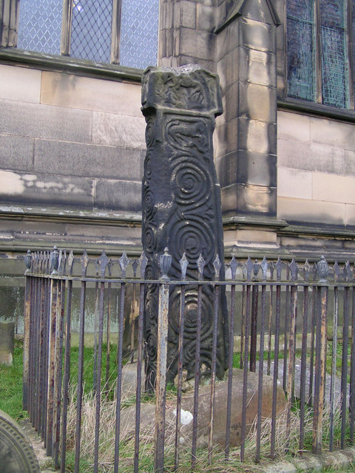
Fig. 2. Early medieval cross located in All Saints Churchyard, Bakewell (© Joanne Kirton)
In Gotland, Sweden, Alexander Andreef (2012, 129-212) has conducted a number of excavations around picture stones. Andreef found these monuments to be in situ. Located amongst artefacts and human remains, seemingly deposited at what appears to be the picture stones moment of erection. For example, the Fröjel Stenstugu stone was placed amongst a round stack of smaller limestone and granite stones, amid which were cremated remains and artefacts of iron, bronze and glass (Andreef 2012, 132). The association of such material suggests that the erection of this particular monument was imbued with symbolic significance, it was not simply a decorative marker.
However, excavation of a monument’s immediate setting can go beyond the examples discussed above, particularly when links to the immediate surroundings can be made either physically or through broader research strategies. Andreef (2012) was able to physically link the picture stones in Gotland to the broader topography by identifying relationships between the stones and roads. His work, therefore, was able to demonstrate that these monuments were not simply sited ad hoc amongst the landscape but placed alongside communication routes (Andreef 2012, 133). He was, therefore, able to link them to the wider topography and mobile audiences. He also notes how these roads were used to demarcate boundaries between farms and sometimes communities, which suggests a function, i.e. demarcation of land.
After the initial investigation, the cross explored within the churchyard at Bakewell in 2012 was also the focus for a wider landscape study. However, unlike the picture stones explored by Andreef, this research was not based on physical evidence uncovered during excavation. Instead, documentary research that focussed on place-name evidence and historical documents for the wider area was used alongside the surviving topography to suggest the original location of the church cross. This research was able to suggest where the monument may have originally stood and excavation in 2012 unearthed a possible base for the cross (Moro-Ottomano 2012, 8). A similar outcome was achieved using non-invasive techniques in North Wales by David Griffiths (2006) at the tenth-century Maen Achwyfan cross (Whitford F12), near Whitford, Flintshire, which is situated in a field in North Wales (Edwards 1999 and 2013; Griffiths 2006) (See Fig. 3).
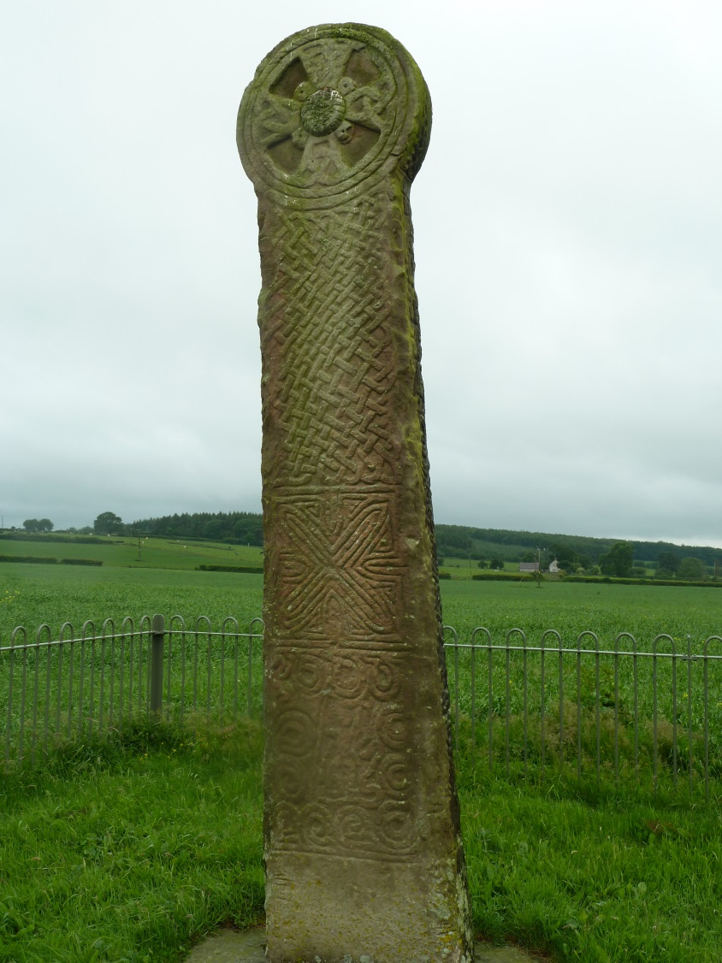
Fig. 3. Whitford F12, Flintshire also known as the Maen Achwyfan cross (© Joanne Kirton)

The Maen Achwyfan cross is seemingly located in its original situation. Non-invasive fieldwork has suggested that it might have once stood beside a chapel, located near or on a boundary, beside a road, and was possibly raised to commemorate the donation of land to the church at Dyserth (Edwards 2013, 370; Griffiths 2006). Furthermore, the cross is surrounded by prehistoric monuments six burial mounds, most likely dating to the Bronze Age. Clearly, the landscape around the monument was not devoid of activity, which indicates that the monument may have been erected due to this activity and/or impacted on activity in the area at a later date.
The three examples given here, Maen Achwyfen, the Bakewell Cross and the Gotlandic picture stones,- have all been better understood through an exploration of their immediate contexts through both invasive and non-invasive techniques. They clearly demonstrate that there is much to be gained by contextualising these monuments within their landscapes and with their associated archaeology, where possible. However, all are small-scale investigations into much broader topographies, which is not unusual as few investigations of early medieval monuments explore the broader topography and only a few projects explore monuments in terms of both their immediate and broader landscapes. Furthermore, there are few investigations of monuments that pull together the different landscape scales highlighted at the beginning of this section and few that combine this information with a biographical approach to monument and place. However, the research surrounding the Pillar of Eliseg in North Wales conducted by Nancy Edwards, Gary Robinson, Howard Williams and Dai Morgan-Evans is currently attempting such an approach.
The Pillar of Eliseg is a ninth-century round-shafted cross situated on a prehistoric mound (see Fig. 4) located within a valley bottom that links the settlement of Llangollen to the Horse Shoe Pass (Edwards 2013, 322-37). If one was to consider the pillar in terms of its appearance there would be limited information to take from it, as its decoration is largely weathered away and the cross-head is lost. All that remains are the round shaft and swag at the juncture between the shaft and the cross-head. It might be possible to provide a broad date and decorative influence, comparing it to other sculptures with similar decorative elements but how does this further our understanding of the monument, the landscape, the people who erected it and those who altered it? Put simply, it does not. Only by exploring the relationship between monument and landscape might we understand its function, what happened to it, why this particular location was important and so forth. Understanding the monuments biography is invariably tied with understanding its physical context.
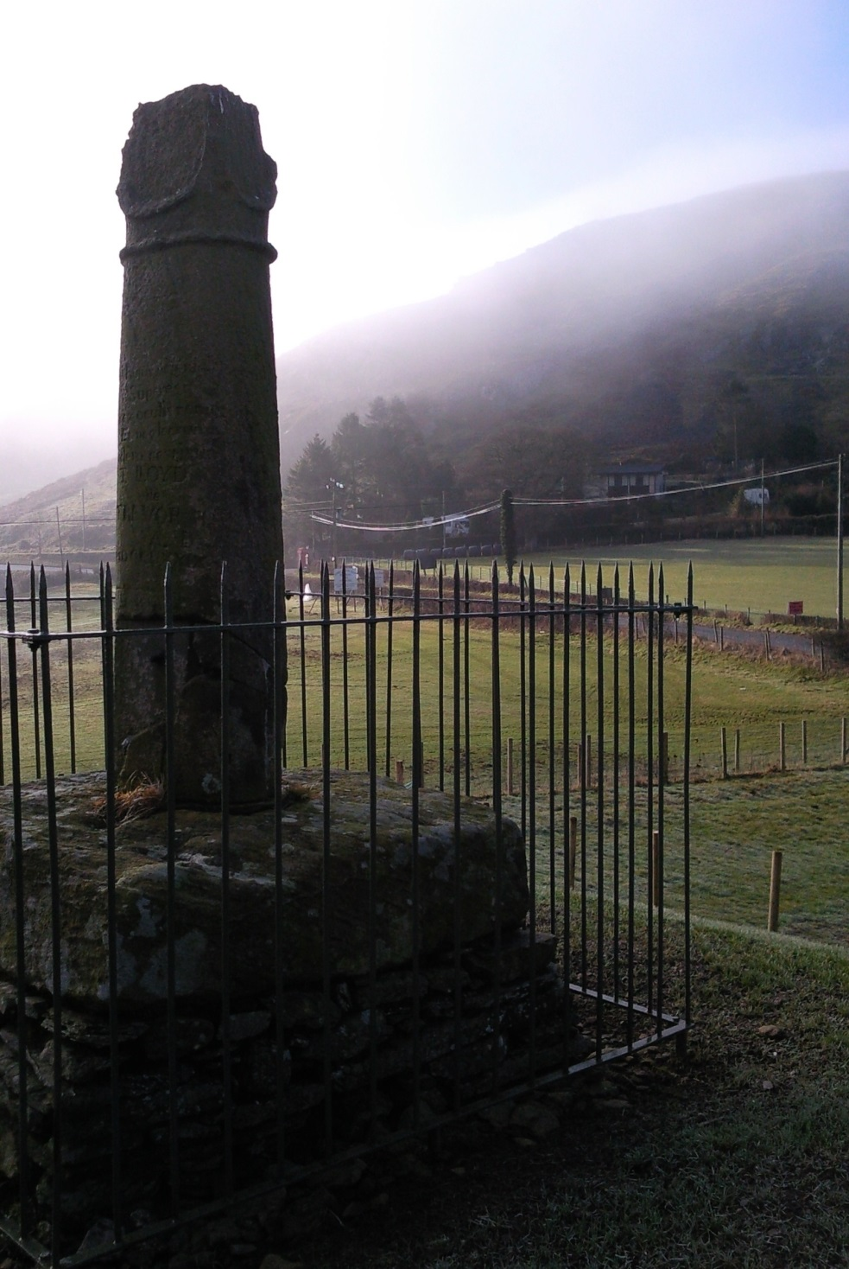
Fig. 4. The Pillar of Eliseg, Denbighshire as viewed from the top of the mound (© Joanne Kirton)

Early research by Nancy Edwards (2009, 143-177) took a biographical approach to the monument, noting how the cross-shaft had been recorded through history. Notably the valley in which is sits takes its name from the cross ‘Valle Crucis’ and the Cistercian Abbey 400m north west of the cross bares the same name (founded in 1201). This suggests that the cross was present in the valley for at least 800 years, supporting the notion that it remains in situ (although re-erected in the eighteenth century). In 2009, Edwards’ paper clearly establishes that the monuments location is key to understanding its function, location and biography. Much of this argument is based on the now lost inscription that once covered the shafts surface. (For a full discussion of its discovery and content see Edwards 2009, 155-168).
- Edwards is able to link the information in the inscription to larger socio-political activity in this area of Wales during the ninth century. This gives us a possible impetus for the monuments erection, the content of the inscription but also the choice of location. Edwards (2009, 168-170) argues that the monument was erected at a time when the ruling dynasty of Powys felt threatened and was used to send a number of messages to its audience.
- Its geographical location was seemingly chosen to celebrate the defeat of the English by Powys on land that had once been English - both a symbol of victory and land ownership. Its topographical location, atop a prehistoric mound, was chosen to visualise the mythical links to the ancient past described in the inscription, both of which served to highlight the ancient line of Concenn (the monuments patron) and his ancestral ties to the land, thus legitimising his land ownership.
- She also speculates that the mound, marked with the cross-shaft, could have served as an assembly place based on the importance of the site and its morphology.

Having established the importance of context for understanding the monument, both the historical biography and the landscape location, the next step was to explore the area around the pillar, beginning with its immediate locale. In this case the mound on which it is situated. Non-invasive investigation of the monuments immediate locale was undertaken by Durham University, suggesting potential targets around and within the mound (Edwards 2009, 9). These were investigated during excavation of the mound conducted from 2010-2012. Excavation established that the monument had been raised on a multi-phased Bronze Age kerbed cairn. Just below the ground surface secondary Bronze Age cist burials had been inserted (Edwards et al. 2012, 5-8). However, no physical connection to the early medieval period, beyond the presence of the pillar, could be established archaeologically.
Howard Williams (2011; 2013) has taken the exploration of the monument and mound further by considering the surrounding topography. He has suggested that the location of the monument was ideal for visibility, both of the monument or from the monument, having being situated on the apparent route way linking both ends of the valley. Its location atop the mound, on a spur of land evident through topographic survey, would have also created a visible and striking location that foregrounded the monument, serving as an easy place to gather and communicate to large groups of people.
A new project, Topographies of Memory which forms part of the broader The Past in its Place: Histories of Memory in English and Welsh Locales, although still in its early stages, is now working to explore the broader topography of the area, including the relationship of other extant prehistoric monuments. This is important, as it situates the Pillar of Eliseg and the mound within its broader topography, enabling us to better understand why this particular location was chosen as the site for the monument and the possible activities that may have played out there. It is an interdisciplinary approach that seeks to use the monument and others associated with it, to explore a landscape over a longer period of time than its original use. This is a different way of approaching sculpture, as it is used here to inform other areas of research, which in turn inform research into the monuments biography. It is an approach that draws early medieval stone sculpture into mainstream research, contextualising it amongst other data sets, over prolonged periods of time. It is, in this sense, a more fully integrated and contextualised monument within its landscape. It is this type of multi-strand, landscape approach that is required to contextualise and understand the biography of individual stone sculpture from the early medieval period.

Materiality
The final area that should be considered more within sculpture studies is the concept of materiality, particularly as it relates strongly to both reuse and physical location. Material is a fundamental aspect of any work of art, structure and/or object, as it affects the shape, style, form and decoration that one can use, plus the function of the end product (Conneller 2011, 24-48). Materiality is also a topic that explores the physicality of a monument, object or landscape and how this might be used, intentionally or unintentionally, to impact individual/group behaviour and experience. This concept has primarily been explored in relation to prehistoric material (see below for examples) with little direct engagement within early medieval stone sculpture studies.
Within prehistoric studies, the concept that material may mean something to the craftsmen, the patrons and the larger audience has come to the fore as a method of trying to understand meaning. Individuals such as Bradley (1993, 1-21), Parker Pearson and Ramilisonina (1998, 308-326), O'Connor and Cooney (2009) and Conneller (2011) have argued that the choice of material has symbolic significance that goes beyond the functional considerations, suggesting that these associations maybe captured in the monuments construction. For example, Richard Bradley's (2009, 3) exploration of Swedish chambered tombs suggests that certain colours were important in the construction of these monuments, for example, white and red stones being placed in alternative arrangements. He considers whether certain substances hold intrinsic properties and if this importance is foregrounded by their particular contexts: two key concepts for understanding the importance of materiality. These types of ideas have rarely been broached within early medieval stone sculpture studies but they have the potential to further our knowledge of a monuments function and the choice of location.
One obvious consideration for stone sculpture studies is the geology of the sculptures. As noted already the CASSS and other corpora now provide discussion of the geology of each monument. This can suggest the provenance of the stone, which in turn can enable discussions based on the source of the material - was it significant? It also raises questions about the distance travelled - what might this tell us about the resources required in terms of physical labour and time? Furthermore, what type of experience might the movement of these large blocks of stone have generated?
These types of questions have proved fruitful when directed at prehistoric data sets. For example, within several chambered and unchambered mounds in the Avebury region the presence of oolite stone to drystone wall the interiors of these chambers suggests a symbolic significance, as these stones had to travel some 35km to the site, bypassing equally appropriate material (Pollard and Reynolds 2002, 73). Thomas (1999, 208) suggests that this importation of stone built a link between the locale and far-off places. Thomas' idea would complement Jones (2007, 215-19) concept of 'prescensing' the landscape through rock art images of places. Whereby, he argues that the depictions of landscapes in rock art, brings distant places into the present, allowing people to experience and remember them. Finally, Chris Scarre's work on Jersey has demonstrated that the megalithic tomb of Mont de la Ville was built with stones from various locations in the landscape such as outcrops and the foreshore, all of which were lifted from the visible landscape. He uses ethnological comparisons to suggest that many prominent landscape features were often invested with specific meanings, which he suggests may have been gathered into one place to make the stone monument, enabling its builders to appropriate the power of these stones. He suggests that by leaving the stones unworked, the builders were drawing a direct visual link, a form of citation, to their original sources and the ideas associated with them (Scarre 2010, 12). By exploring the geology of early medieval monuments, where they may have been sourced and worked, plus how they might have moved through the landscape, we might be better able to understand why they were erected and how they functioned.
Secondly, the idea of citation, whereby the material from which a monument was made cites a particular place, as suggested by Scarre (2010), is also a line of inquiry worth considering when a monument is reused. As already discussed in the biography section, the reuse of a monument may have a symbolic meaning. Reuse in some cases may be a form of citation. For example, the presence of a sculpture reused in a church structure maybe placed there to represent the place/person with which it was once associated. Therefore, investigating provenance as part of a monuments biography is potentially essential for understanding its original function and possibly its reuse. Jane Hawkes (2003, 69-99) has argued that stonework in the seventh century would have been a rare occurrence and its use was, therefore, a deliberate and considered act. Much of the stonework used in the construction of churches was reused Roman masonry, commonly taken from surviving structures such as forts. This created a direct link between Rome, the home of the Catholic Church, and the churches of Northumbria. Hawkes (2003c, 71-2) argues that the use of stone, reused or carved anew, was a citation of this relationship and the antiquity of an areas link to Rome. However, the use of the stone was not the only link Hawkes identified. She noted that the churches copied the style of the Roman architecture and appropriated places associated with key figures and events, such as the creation of a cathedral in York on the reputed location where Constantine was proclaimed emperor in AD 306 (Hawkes 2003, 75). Carved stone sculptures and the stone churches of Northumbria were a direct citation of this ancient relationship with which the seventh century Northumbrian church could draw power and prestige.

CONCLUSION
The preceding discussion has demonstrated how the study of early medieval stone sculpture has progressed as a discipline. Clearly it is not a simple progression. This is due to the complex nature of stone sculpture from this period and its ambiguity as an object. Many of the criticisms that have been directed at past studies stem from the fact that they do not approach sculpture in a multifaceted way, instead preferring to compartmentalise and dissect the individual elements. Consequently, these studies do not have the breadth to grasp the intricacy and the multi-dimensional nature of these carved stones.
The studies discussed in the closing section of this chapter demonstrate that there is much to be gained by exploring the idea that a series of decorative images formed a single monument (although monuments can also be devoid of these), that these monuments had individual biographies and that they were intrinsically linked to the landscape and the people who erected, and used them. However, at present there is clearly no coherent methodology that brings together biographical and landscape studies to explore early medieval sculpture. Nevertheless, establishing context and exploring the physical location of monuments is clearly a fundamental requirement for furthering the discipline.
Martin Carver (2005, 1336) sets out a three-fold approach which brings together the many different perceptions of stone sculpture. Carver states that monuments can be understood as an artefact or site, as communal or individual. They also have multiple meanings; for those who made them, first saw them and for those who came after. Therefore, approaches towards sculpture must be varied and ‘multi-dimensional’. He separates his approaches into three categories: firstly, social context which explores the physical and cognitive landscape in which sculpture is erected; secondly, the intellectual context, which uses the art-historical methodologies to gain insight through decoration: finally, local legacy which is based on the biography of the monuments and the value the monument has to different generations (Carver 2005, 13-5). In this way, Carver attempts to provide the means by which stone sculpture can be approached in a multi-dimensional way. Not all sculpture will fit these criteria but a general awareness of the multi-faceted way in which stone sculptures functioned and the awareness of different approaches may just broaden the study area of scholars.
In the following chapters the ideas and approaches discussed here will form the basis for an exploration of a regional assemblage using a multi-scalar methodology developed with the intention of being able to explore monuments both in situ and moved, complete and fragmentary, reused and/or destroyed, decorated or plain, architectural or free-standing.

CHAPTER THREE

THE DATA SET, OBJECTIVES AND METHODOLOGY

THE DATA SET
In order to achieve the aim of the thesis and the objectives listed below, a data set with a variety of monuments, landscape locations and biographies is required. The sculptural assemblage from the county of Cheshire, based on the pre-1974 county boundary, has been chosen for its variability in all of these areas.

Justification
The Cheshire assemblage offered an opportunity to explore multiple approaches – biography, landscape and materiality - as the county is diverse both culturally and topographically. It also provides the variability in the sculptural assemblage required to meet the primary aim of the thesis.
Firstly, the data set spans a county that is divided by its topography, the Cheshire Plain. This is reflected in the distribution of sculptures from the county (see Fig. 6). Furthermore, the county is also bordered by significant topographic features, such as the rising hills of the Peak District to the east, along the county boundaries with Staffordshire and Derbyshire, and the Irish Sea to the North West with maritime links clearly evident around the Wirral and Chester (Mason 2007, 133). There are also significant cognitive boundaries, particularly the border with modern-day Wales, which likely developed based on its topographic qualities. ‘The Welsh border landscape is one the most richly varied in the whole of Britain. Within a relatively small area is plain, upland and mountain and it is precisely this close juxtaposition of high and low land that has made the region a political and cultural boundary area for the last 2000 years at least’ (Rowley 2001, 12). The presence of Offa's Dyke, which loosely follows the modern boundary between England and Wales for approximately 129km demonstrates that this was a border region since at least the early medieval period, although specific dating has proved inconclusive (Hill and Worthington 2002, 47-102).
The Anglo-Saxon kingdoms of Northumbria and Mercia also bordered in this region. The presence of these two kingdoms, combined with that of the Irish Sea and the Welsh kingdoms of Powys and Gwynedd, would have made Cheshire (particularly in the ninth, tenth and eleventh centuries) a hotbed of probable competing cultural influences, all of which could have potentially impacted on the appearance, function and reuse of the early medieval stone sculpture of the region. This variety in the counties topography and its regional situation places it within an area of multiple influences both culturally and naturally, raising the possibility that the data set may demonstrate evidence for different responses to cultural influences, topography and geology.
Secondly, the Cheshire data set offered an opportunity to explore monuments that were found alone and within a larger assemblage, as there are multiple examples of both. Many of the monuments situated on the edge of the Peak District in the east of Cheshire were found alone, such as sites at Disley Lyme Handley, Rainow and Upton. Others, primarily in the west of the county, were found as part of large assemblages, such as Bromborough, St John's Chester and Neston. This variety allows for an exploration of how our understanding of early medieval stone sculpture might be affected by considering monuments individually and as part of a group.
Thirdly, the location of the Cheshire monuments - those in situ and those reused - is incredibly diverse. There are examples set alone on remote uplands, next to routeways, within churches and churchyards, built into ecclesiastical and secular structures and others found during excavation. This allows for an exploration of different landscape locations; how these might have influenced appearance, situation, function and their later biographies.
Finally, the preservation of the assemblage is highly variable. It has largely been moved and reused with a few exceptions that appear to be in situ and a handful of monuments that have been destroyed and/or discarded. In particular, the high level of reuse offers the opportunity to explore the biography of a great many monuments within this group. This provides the opportunity to compare reuse practices amongst east and west Cheshire, amongst grouped monuments and individual monuments, amongst monuments located in settlements and others without and so forth. The chance to compare and contrast such a variable data set may enable the identification of particular biographical and geographical trends across the county. Combined, the diversity of the data set allows the study to consider a wide variety of approaches, including monument biography and its relationship with landscape, set to the backdrop of a region that was culturally and topographically diverse.
Another aspect to consider is the history of study in the area, as the Cheshire assemblage is a little studied data set within a region of under-researched material. At the commencement of this thesis, the Cheshire material had only just been published by Richard Bailey (2010), which paved the way for new research in the region. However, no other surrounding counties had been published at this time. The publication of the Cheshire corpus was, therefore, the first step to opening this area to greater scrutiny. The publication provided the opportunity to comment on the significance of the sculptural fragments and assemblages, their location and function, whilst adding to an understanding of the wider regional activities being undertaken at the time of their erection and in later periods.
Furthermore, whilst the Cheshire and Lancashire volume was coming to publication the CASSS were commissioning volumes for the surrounding counties, such as the Western Midlands volume (Bryant 2012) and the Derbyshire and Staffordshire volumes (Hawkes and Sidebottom forthcoming). Nancy Edwards (2013) was also compiling the third, and final, volume of the Welsh corpus, which focuses on Northern Wales. Combined, there was a clear impetus to drive forward the study of early medieval stone sculpture in this region of the UK.
During the course of this research the Western Midlands CASSS volume and the North Wales volume have been published and work is ongoing with the Derbyshire and Staffordshire volume. Consequently, all of these data sets have been accessed for comparative purposes, allowing for a broader regional perspective and the breaking down of the superficial barriers imposed by county based publication. Subsequently, the thesis is the first study to attempt both a local and regional exploration of the material, which will offer new perspectives on the regions sculptural collection.

Assemblage Overview
According to Richard Bailey’s (2010) CASSS volume, which covers the county of Cheshire, there are eighty-nine fragments of sculpture from the early medieval period. Where multiple fragments are known from the same monument (excluding socket stones) they are classed as one monument. In this thesis, sculptures with sockets stones are also classed as one monument. There are a further thirteen fragments from the Saxo-Norman or Norman period. Of those fragments dated to the early medieval period, ten belong to the Anglian period (c. seventh to eighth century) and seventy-six belong to the Viking period (c. ninth century to 1066) (see Fig. 5).

Fig. 5. Percentage of known fragments of early medieval sculpture in Cheshire pertaining to the Anglian or Viking Period
The fragments dating to the early medieval period were found in thirty-one different locations. At Chester, Disley and Sandbach, multiple settings are noted within each settlement. A further three sites, Shocklach, Swettenham and Woodchurch are associated with Saxo-Norman material. Other sites, including Bromborough and West Kirby, have both pre-Conquest and Saxo-Norman fragments (Fig. 6).
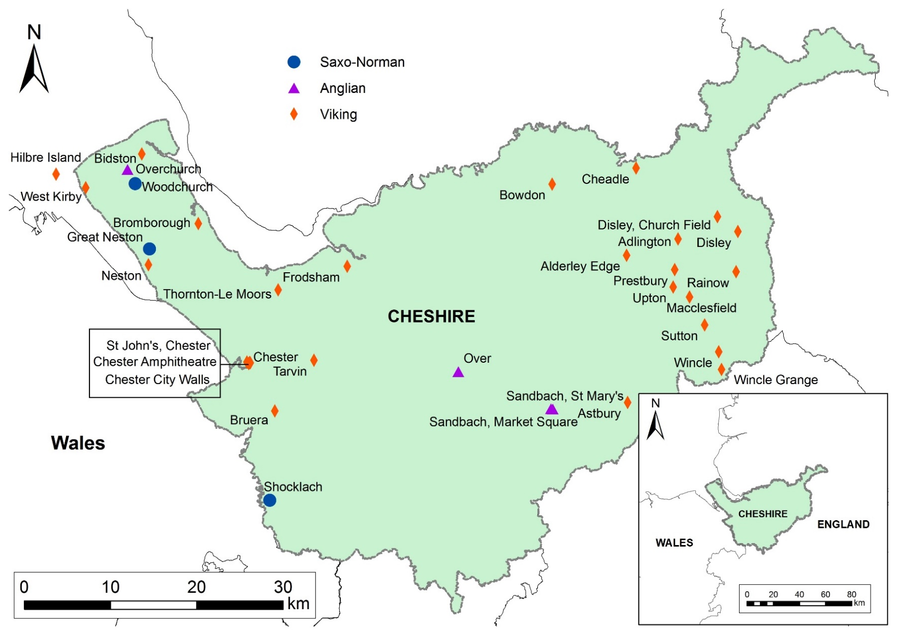
Fig. 6. Distribution of early medieval stone sculpture in the pre-1974 County of Cheshire

As noted above, the collection is mainly composed of Viking Period sculptures with only four sites - Over, Overchurch, Sandbach Market Square and Sandbach St Mary's - known to have monuments dating to the Anglian Period (see Fig. 6). The thesis will focus primarily on the Viking Period monuments rather than the Anglian examples, as the latter monuments have a potentially different early biography to the majority of the later collection. For example, the people producing stone sculpture, the quality of the workmanship and the locations in which they are found are often notably different to sculptures carved and erected in the Viking period (Bailey 2010, 27), all of which indicates that these monuments and architectural fragments were used and perceived in contrasting ways at different times during the early medieval period. This, in itself, is not a challenge to the inclusion of the Anglian period sculpture and potentially provides useful comparative discussion. However, the limited and eclectic collection of Anglian period sculpture in Cheshire does not provide a large enough body of material for comparative purposes. Moreover, the link to particular locations for almost all of the monuments is tenuous. For example, at Over the evidence for discovery is unknown and at Overchurch one monument is missing and the other has travelled between locations and its situation upon discovery is not known (Bailey 2010, 90-1). As much of the discussion will be focused on biography and observable trends linked to particular geographical locations and areas at specific times, the inclusion of Anglian period monuments with potentially different (lost) locations and functions has the capacity to skew these observations as the data set is so small. However, their later biographies, particularly the evidence for reuse, is very similar, probably because they would have appeared alike in appearance and function to those moving and reusing them, so they will be considered further as part of reuse discussions for comparative purposes.

Summary
As outlined in Chapter One the primary aim of this thesis is to contextualise both individual fragments and geographically concentrated assemblages of early medieval stone sculpture from the county of Cheshire, using data derived from their location and current state of survival. However, clearly there are a number of hurdles and challenges that must be overcome, as identified in Chapters One and Two, in order for this to take place. In addition, the Cheshire corpus presents specific challenges as a data set, as outlined above. Therefore, a secondary aim of the thesis is to develop a coherent methodology that can deal with the challenges of early medieval stone sculpture and, specifically, those of the Cheshire corpus.
The purpose of contextualising sculpture is to understand their original function and how they were experienced at the time of their erection and in subsequent periods. Given the fragmentary nature of the Cheshire material (and the English corpus as a whole) and the amount of fragments that have been moved around, a methodology is necessary that can draw out as much information as possible from this sculptural collection in order to make this possible. The principal agenda is to understand the way early medieval sculpture, individual monuments or groups, were used and experienced in their original settings and how their materiality impacted upon their original and subsequent agency, the audiences that experienced them and the settings in which they were located. However, at present no such methodology has been applied to the Cheshire material.

Overview of Earlier Research
Research regarding the monuments of Cheshire began in the early nineteenth century. Individuals such as Ormerod (1819) and Whitaker (1823) made note of the presence and appearance of several fragments. However, as little comparative material was available, their discussions were largely speculative regarding date and function.
Scholarly research was encouraged by the many fragments of sculpture recovered during extensive refurbishment of church structures throughout the county in the middle to late nineteenth century (see Chapter Four for further discussion). Many of these new discoveries were recorded in the local regional journals accompanied by illustrations, such as the discovery of the Overchurch fragment noted in the Journal of the Chester Archaeological and Historical Society in 1890 (Dallow 1890, 185-91). Once again, these were largely notes on their discovery and descriptions of their appearance. However, the abundance of new material encouraged the production of a corpus of the Cheshire (and Lancashire) material by J. Romilly Allen (1894 and 1895). For the first time the material was contextualised within the broader assemblage and wider national collection. The publication referred to each fragments discovery (where known), appearance and similarity to other examples within Cheshire and further afield, being accompanied by illustrations.
Throughout the twentieth century, the monuments from Cheshire were discussed sporadically as part of larger bodies of work, such as Collingwood's seminal 1927 publication Northumbrian Crosses of the Pre-Norman Age. However, rarely were they discussed on their own merit. One notable exception was J. D. Bu'lock's (1959, 1-11) discussion of regional groupings in the county, such as the circle-headed crosses found at Chester and throughout the Wirral. He offered suggestions regarding their cultural influences and potential locations for production centres.
In 1987, Alan Thacker produced a gazetteer of all the known monuments from the county but again this was largely noting their location and date. New discoveries have continued to be unearthed, such as the Tarvin cross discovered in 2006 as part of archaeological works (Bailey 2010, 128) and the Bidston hogback recovered from a residential garden in 1994 (Bailey 2010, 49; Bailey and Whalley 2006). In 2010, the publication of the Cheshire and Lancashire CASSS volume brought together all the known sculptures from the region, providing information on each monuments decoration, form, discovery and location, accompanied by photographic illustrations. It also provided information on the geology, historical background of the county and broader discussions regarding the appearance of the monuments.
Only two recent publications have attempted to explore Cheshire monuments in any depth. The first, by Jane Hawkes in 2002, considered the Sandbach crosses in east Cheshire, providing an in-depth exploration of each monuments iconography and form. Hawkes also provides a summary of their history of discovery and recent biography, which clearly explains why these monuments appear in their current location and state of survival, which in-turn shines light on how they were perceived from the seventeenth century onward. However, little is made of their landscape location, which might suggest something of their earlier biographies and functions. Hawkes focuses on what can be observed of the monuments in their current location, state of survival and most specifically on their decorative repertoires and forms.
The second study by Dan Robinson (2003-4), focused on the recently re-discovered Shocklach rider located in the church of St Edith's in the south-west of the county. It is the only example of recent work in Cheshire which attempts to link a monument to its surrounding landscape, as a means to understand its location and iconography. Robinson explores other forms of evidence that might suggest a Viking presence on Wirral and in Cheshire to support his notion that the image depicts the eight-legged horse Sleipnir and its rider Odin from Norse mythology (incidentally, laser-scanning has disproved this theory - the horse has four legs, which have been recut (see Kirton, in prep.). He considers the archaeology and place-name evidence, suggesting a Scandinavian cultural influence in the region that would then support the idea of Scandinavian decoration and iconographic themes. Whilst the interpretation of the image is flawed (undertaken prior to laser-scanning), Robinson does attempt to contextualise the sculpture within a broader socio-political landscape. In this respect, both Robinson's and Hawkes' research stands alone, as both attempted to go beyond the typical categorisation and descriptive work undertaken in the county.
No other modern study of Cheshire's early medieval stone sculpture has looked to explore individual monuments in terms of their biography, location or materiality. Nor have they sought to explore the wider assemblage with these concepts in mind. Instead, the legacy of scholarly work on the corpus is largely based on the history of discovery and discussion of comparable decoration and form, suggestive of cultural influence and date.

Summary
The remainder of this chapter sets out a multi-strand methodology developed around the concept of object biographies, but shaped to meet the challenges of understanding early medieval stone sculpture as a monument in its contemporary context, which is often removed from its original purpose and setting.

METHODOLOGY
Early medieval stone sculpture, whilst commonly fragmented, remains difficult to move due to its size and weight in most instances. Consequently, an object biography approach, as discussed in Chapter Two, simply will not suffice to explore sculpture, as it does not account for the impact place can have upon this long-lived monument type. The agency and experience of those individuals and groups engaging with the sculpture cannot be the same as those interacting with an object that is moveable. The place in which it is located influences the way an individual or group can view, approach, move around, physically touch and interact with the sculpture. Instead, a combination of methodologies is required that allows for an approach that explores both monument biography and the biography of place, considering the symbiotic relationship between the two. Only through this approach can a monument be contextualised, from the time of its erection to the moment of its destruction.
Whilst the need to explore early medieval stone sculpture in relation to place is evident, there are a number of challenges which make this particularly difficult, especially so in Cheshire.
- Often early medieval stone sculpture is large, frequently moved and reused. This is particularly true of the Cheshire corpus, as 77.9% has clear evidence of reuse (as defined in Chapter One).
- There is often little in the way of evidence for original location. There are no contemporary documents that note Cheshire sculptures in situ.
- Little is understood about the sourcing and manufacture of these monuments;
- Dating is almost wholly relative and style-based, as very few are found in secure early medieval archaeological contexts. No sculptures from the Cheshire corpus have been recovered from known early medieval stratigraphy.
- Whilst we know that monuments stood alone and as groups, we know little about how they were experienced singly and as an assemblage.
- ‘Experience’ is largely explored through detailed analysis of the iconography and form but not their current and previous (where known) locations.
- The Cheshire corpus also has additional challenges, including the variability of monument location and the lack of monuments in situ that can be compared and contrasted with the reused examples.

In order to meet these challenges and the limitations posed by the data set a multi-strand methodology has been devised, based on the exploration of work on sculptures, monuments and monumental settings from a raft of periods, as discussed and explored in Chapter Two. This will allow for a fluid approach that will be able to tackle the variety of monuments, locations and biographies present amongst the collections of early medieval stone sculpture seen across Cheshire and indeed elsewhere. It is an approach that will also allow for the variety of survival seen in the archaeological record; the different physical and spatial locations in which the material is found; the potential different early biographies of individual monuments and/or assemblages; and the variable survival of the supporting data, such as landscape topography, historical documentation and toponymic data. This approach has enabled the development of a multi-scalar landscape perspective for the Cheshire corpus and the creation of three primary methodological strands.

Strand One: Broad Landscape Distribution
Many pieces of sculpture are fragmented, moved and reused, as noted in Chapter Two. The Cheshire assemblage is no exception, as very few remain in situ and reuse is high and widespread. The challenge is to recontextualise these monuments by exploring their biographies through their materiality and relationship with their setting and broader landscape. Unfortunately, much of Cheshire’s sculpture lacks an early provenance and is badly damaged, so exploring such ideas with individual fragments is often fruitless. Instead, a comparative study that uses some of the county’s better documented and understood monuments as anchors for the whole assemblage will potentially enable a more refined and coherent study of all the county’s sculpture.
A county-wide assessment of the early medieval sculptures location, condition and the current setting has been identified as a means of exploring why sculptures were destroyed and/or reused, often multiple times. The assemblage will be analysed in terms of the evidence for their destruction, reuse, reworking, movement, location and, where possible, dates will be assigned to this activity. This will be rooted in an investigation of provenance. Once each piece of sculpture has been assessed in this way, the information will be collated to question if any local or county-wide trends are evident at particular periods in time. By establishing period or geographically specific local and regional trends it will be possible to examine and question local and regional socio-political developments and events, which may have directly or inadvertently impacted how individuals and/or groups viewed early medieval sculpture and/or the places with which they are associated. In turn, these may have led to alterations to the sculptures and/or their settings, providing a context for use, reuse and perception at particular times in the sculpture’s history. In addition, the same assessment will be undertaken for the surrounding counties of Derbyshire, Flintshire, Lancashire and Shropshire. This will help ascertain regional trends, whilst highlighting any unusual activity in Cheshire. This will prevent the corpus being explored in isolation and allow for the identification of larger patterns and future research opportunities. If trends are evident there is the possibility that they can then serve as an index for socio-political change in the county and beyond.
A county-wide assessment of the different locations in which monuments were/are found (churchyard, boundaries and roadsides for example) will also be undertaken. This will allow for an exploration of how a monument might be affected by its particular setting and hinterland. Does a churchyard location, for example, provide a greater likelihood for survival or is it more likely that a churchyard monument will suffer destruction or be reused? Assessing the assemblage as a whole will allow for such trends to be identified, which might pertain to specific events or the activities of particular social groups. In turn, such an approach will also allow a consideration of how a sculpture might impact on a place over a long period of time.
Finally, a county-wide assessment will also enable a discussion of the sculptures materiality. The reuse of sculptural fragments largely depended on the fact that they are made of stone and can easily be reused in later stone built structures. There are several avenues to pursue that may shed light on the significance of a monuments materiality. For example, does the availability of stone in an area affect reuse? A consideration of the geology and topography will aid with this discussion. Moreover, the surfaces of the monuments often dictated the way in which they were used – some being chosen because they could have their decoration hidden and others reused because certain surfaces were attractive for a variety of reasons. Is there a particular prevalence for this in a specific area and, if so, why? Consequently, there is scope to explore how the materiality of the monuments impacted and encouraged different forms of reuse.
This methodological strand will address the objectives 1.1, 1.2, 1.3 and 3.2, as set above.

Strand Two: In situ Collections in Settlement Zones
Early medieval sculpture is commonly found as individual fragments or as a part of a larger assemblage. In Cheshire many examples in the west of the county occur in core collections, often in urban environments. The challenge, when this occurs, is to explore what this means in terms of their creation, function, perception, reuse and how this impacted their setting. How does been part of an urban, geographically concentrated assemblage contribute and shape our understanding of the individual sculptures, the assemblage and the location in which they are found? In order to explore this element of the data set, a single large collection of free-standing monuments from St John’s, Chester, considered to derive from its current location or from the hinterlands of the current location will be explored in depth.
The St John’s collection is closely related, both spatially and decoratively. The first consideration will be to examine what the decoration and form may suggest about the groups function and how multiple monuments may contribute to understanding how they operated. Furthermore, is it possible to establish if the monumental assemblage at St John’s was specifically created to operate within the particular confines of the St John’s precinct, based on an exploration of the similarity of decoration and form? Here a phenomenological approach will be applied to consider interaction and experience, based on visibility, directionality and movement. The initial observations from this research will then be applied to the specific setting of St John’s and its environs. What might the relationship between the appearance, quantity of monuments and their setting suggest about their function and survival in later periods and how might this contribute to our general understanding of sculptures from comparable settings and/or in a similar state of survival? Such an approach will achieve objectives 2.1, 2.2. 2.3 and 2.5.
The early provenance of this collection at St John’s and the churches longevity, first mentioned in contemporary sources in the tenth century, will also allow for an exploration of how a monuments current survival is impacted by its location. Here monument biography and the biography of place will be explored in tandem. What can this relationship tell us about the impact setting and broader location had on a particular group of monuments? Can events at St John’s be linked to apparent destruction, reuse and re-display of the sculptural assemblage? This will be explored through a consideration of the known archaeological material, documentary evidence and morphology of the site and hinterland.
The assemblage also has clear evidence of destruction and reuse, which is supported by reasonably well-documented evidence of discovery, providing a stratigraphic sequence for its reuse. The urban setting of St John's in the pre- and post-Conquest period, provides an opportunity to explore the impetus for monument erection and destruction by considering the development of the city over several hundred years until their deposition in the twelfth and fourteenth centuries. A comparable approach to that outlined above will be undertaken for the wider cityscape, providing a city-wide context for St John’s and its sculptural assemblage. Consequently, this may elucidate possible activities at St John's and its relationship with Chester, as the city developed in the early medieval and medieval period. This will contribute to fulfilling objectives 2.2, 2.3 and 2.5.
This approach contrasts with the county-wide exploration by considering sculptures in a specific urban environment, in this instance Chester. The cities archaeological material and documentary evidence spans the lifetime of the sculptural assemblage, offering an opportunity to consider the biographical relationship between monuments and place in relation to the urban development of a regionally significant city.

Strand Three: Immediate and Hinterland Context of Individual Monuments
Whilst it is common to encounter groups of monuments, particularly associated with church locations, many examples of early medieval stone sculpture are found alone. This is not, seemingly, due to later destructive practices, as many extant sculptures stand alone. Individual sculptures have been noted across Cheshire with a particular concentration in the east of the county. Secondly, few early medieval stone sculptures are found in situ. When a monuments original context can be established and it is in reasonably good condition, a whole raft of new questions maybe posed and ideas explored. Few examples exist like this in Cheshire. However, one example from Wincle, bordering the Cheshire, Derbyshire and Staffordshire borders provides a singular avenue for such discussion in the county.
Firstly, the Wincle cross offers contrast to the St John’s assemblage, being a single monument, situated in a rural, upland area of the county. A consideration of its form and appearance will be used to question if its function and its relationship to its setting has shaped its appearance. This will follow a comparable approach to the St John’s collection, as outlined in Strand Two. If both the St John’s assemblage and the cross at Wincle have been shaped by their setting this can be used to interpret the function of monuments that have lost their original context. This contrast and discussion will fulfil objectives 1.2, 1.3 and 2.4.
The remainder of this exploration is an assessment of an example of a single monument in its original landscape context and consideration in relation to comparable monuments and contexts. This approach uses a retrogressive analysis on a single site basis to explore ways in which monuments and their original locations can be identified and function established.
The Wincle monument is a free-standing round-shaft cross, one of several in the county. It offers the opportunity to explore the unique nature of this sculptural group, located primarily across east Cheshire, Derbyshire and Staffordshire, as they stand distinct from the remainder of the Cheshire corpus. GIS and standard mapping techniques are employed here, first to assess the long durée of activity in the vicinity of the monument, visibility to and from the monument, travel and movement in its immediate environs, and to help visualise for the reader, the landscape on which this exploration depends. The experiential import of the setting is explored and contrasted with similarly sited round-shaft monuments.
This landscape exploration is supplemented with an exploration of the documentary evidence for the area, limited though it is, considered as a means of interrogating the reasons for the setting of this prominent landmark and the broader assemblage. Notably, the round-shaft assemblage has been largely damaged, moved and reused. By establishing a probable early function at Wincle and understanding the choices that led to its erection at that particular location, it is possible to explore the biography of this sculptural group and how it was impacted by the particular settings in which they were situated, fulfilling objectives 1.2, 1.3 and 2.2.
Finally, the presence of an in situ monument allows for a consideration of materiality. For example, how far has the stone travelled, where has it travelled from, how might this journey influence the cognitive landscape around the monument? This discussion will fulfil objective 3.1.

Summary
Combined, the three methodology strands outlined above will provide a multi-scalar perspective of Cheshire’s monuments and associated settings at different points in time. The approach set out above has been designed to accommodate a variety of monuments and architectural fragments that have different physical appearances, functions, locations and reuse histories. It is also designed to recognise that different locations also have variable biographies and associated data that can aid in their contextualisation (i.e. historical records, topographies and previous research histories). By adopting a flexible approach, it is hoped that individual monuments and architectural fragments, some associated with geographically concentrated assemblages, might be better contextualised and subsequently interpreted.
This multi-strand, multi-scalar approach will determine the best method for exploring monument biographies and landscape contexts. It will also explore how the data for Cheshire compares and contrasts between assemblages and individual monuments, identifying the best approaches for each. At the conclusion of the work the thesis will be able to demonstrate the different types of information that can be garnered from exploring monuments that have been reused and those that remain in situ, which should ensure that specific monuments and collections can be researched in a way most appropriate to them. More broadly speaking, developing a more comprehensive approach to regional collections will allow for the identification of links between monument erection, destruction and reuse and socio-political developments to be more easily identified and explored.

CHAPTER FOUR

REUSE OF EARLY MEDIEVAL STONE SCULPTURE IN CHESHIRE: WHEN, HOW AND WHY?

INTRODUCTION
This chapter aims to understand why the monuments in Cheshire are fragmentary, when and if reuse occurred, and the impetus for reuse (possibly multiple reuses). Initially, this can offer insight into particular monuments. However, considering them as a group will also enable the identification of broader patterns that can, at best, highlight important cultural and societal shifts in the region.
To achieve these aims the chapter will investigate the evidence for reuse across the county of Cheshire. Like many other regions of England, Cheshire has an early medieval stone sculpture collection that is largely fragmentary and disassociated from its original location or place of erection. Instead, these sculptures are commonly discovered as damaged, reused material. Of the eighty surviving fragments with a known provenance, sixty-seven (77.9%) have a clearly recognisable reuse. An approach that foregrounds reuse inevitably requires an exploration of context; to understand the biography of a sculpture one must understand something of the place in which it is situated. The relationship between the two means that each has the power to affect the other. Some sculptures and landscapes may stay similar for long durations but others will invariably change significantly and often multiple times. By exploring alterations to the sculpture alongside changes that might occur to the place in which it is located – these can be physical alterations or changes to the groups who inhabit the place – it is possible to explore the impetus for these developments. Combined, sculpture and place enable one to investigate the biography of a monument or architectural fragment from the present day, in some rare instances back to its very construction (in some rare instances), allowing one to unravel how they were perceived and used over time. Moreover, considering the biographies of multiple monuments within a concentrated area, such as Cheshire, can offer further information about local and regional patterns of reuse. These patterns, where evident, might represent wider societal changes at numerous points in history that had a direct impact on the survival, form, decoration and function of a sculpture. This in turn can help us understand why they are discovered in a variety of secondary contexts in many different states of survival.
The early medieval stone sculpture of Cheshire has been considered here as a regional grouping based on proximity, excluding the pre-tenth-century examples, as these are outside the remit of the broader thesis. Statistical analysis on a number of attributes, such as their location of discovery, evidence for reuse and type of reuse, has been generated to aid the forthcoming discussion (See Appendix A for the data). To avoid creating a wholly Cheshire focus, the neighbouring Welsh county of Flintshire and the English counties of Shropshire, Derbyshire and Lancashire have also been subject to the same statistical analysis to establish comparative material that allows for a broader regional perspective (see Appendix A). These counties have been chosen for their physical proximity to Cheshire and the availability of the published material. All, with the exception of Derbyshire, have been published in regional CASSS volumes. The Derbyshire corpus is currently being compiled and the author was kindly given access to the material by CASSS author Phil Sidebottom (Hawkes and Sidebottom forthcoming). The decision to use data from areas that are physically adjacent to Chester was based on the assumption that they would have been subject to similar political, social and economic influences and might, therefore, provide better comparative material than distant counties.

PRELIMINARY ANALYSIS
A quick glance at the counties sculptural distribution for the tenth to eleventh centuries clearly demonstrates a significant geographical divide between east and west Cheshire, particularly when the pre-tenth-century monuments are removed at Sandbach and Over (see Fig. 7). There are a number of elements that appear to have contributed to this distinct distribution.
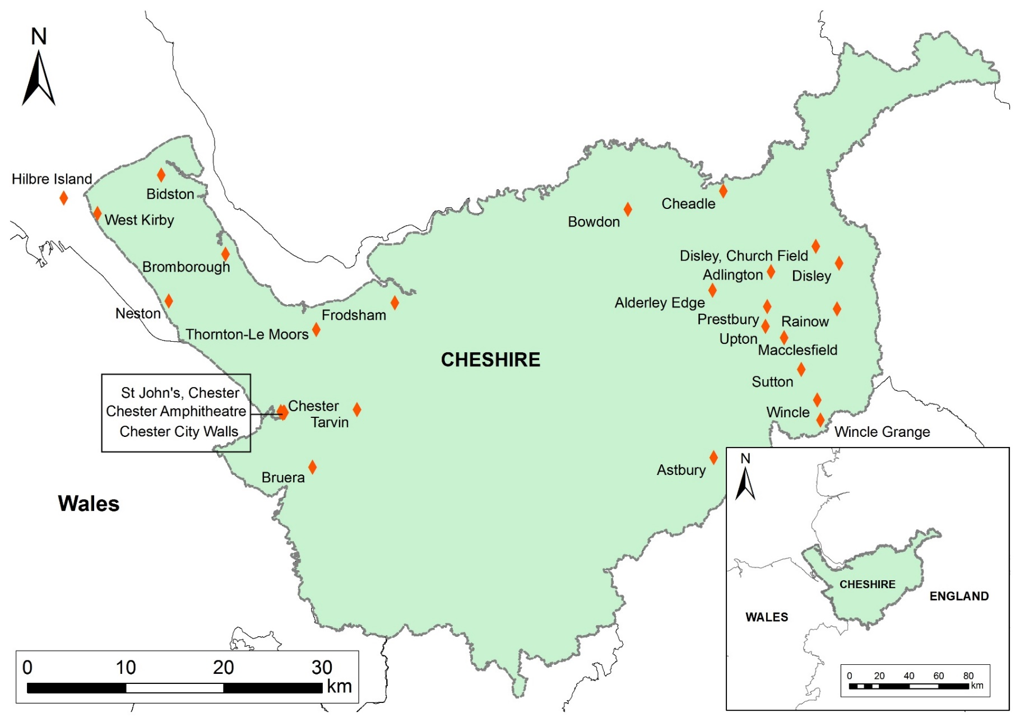
Fig. 7. Distribution of Viking period stone sculpture from the pre-1974 County of Cheshire

Geology
The CASSS, as part of its exploration of Cheshire’s sculptural assemblage, conducted a geological survey that examined each stone fragment in regard to its geological makeup and potential origin (see Bristow 2010, 10-7). The survey demonstrated that the underlying and drift geology of Cheshire ensured that stone sculpture production was easier in some areas due to the prevalence of workable stone (See Fig. 8). The lack of sculpture in the interior of the county, particularly in the tenth and eleventh centuries, is best explained by a lack of raw material for their production.
To the west the sculptural collection is almost wholly derived from Sherwood Sandstone, using both the Helsby Sandstone and Chester Pebble Bed formations. To the east the solid geology is comprised of Coal Measure, Millstone Grit and Sherwood Sandstone, the latter two being used for the sculpture in the region. Separating the two sculptural distributions is an area of Mercian Mudstone, which is a poor material to create sculpture from (Bristow 2010, 10-3). In the Anglian period, stone from the Sherwood Sandstone and Millstone Grit areas was transported into the interior at sites such as Over and Sandbach. Why the interior (with the exception of Overchurch) was seemingly the only area to produce Anglian period sculpture, particularly when this material had to be transported, remains unclear. However, in the Viking period the creation and transportation of sculpture into the county’s interior appears to cease, as there is no evidence for sculpture in the area during this period.

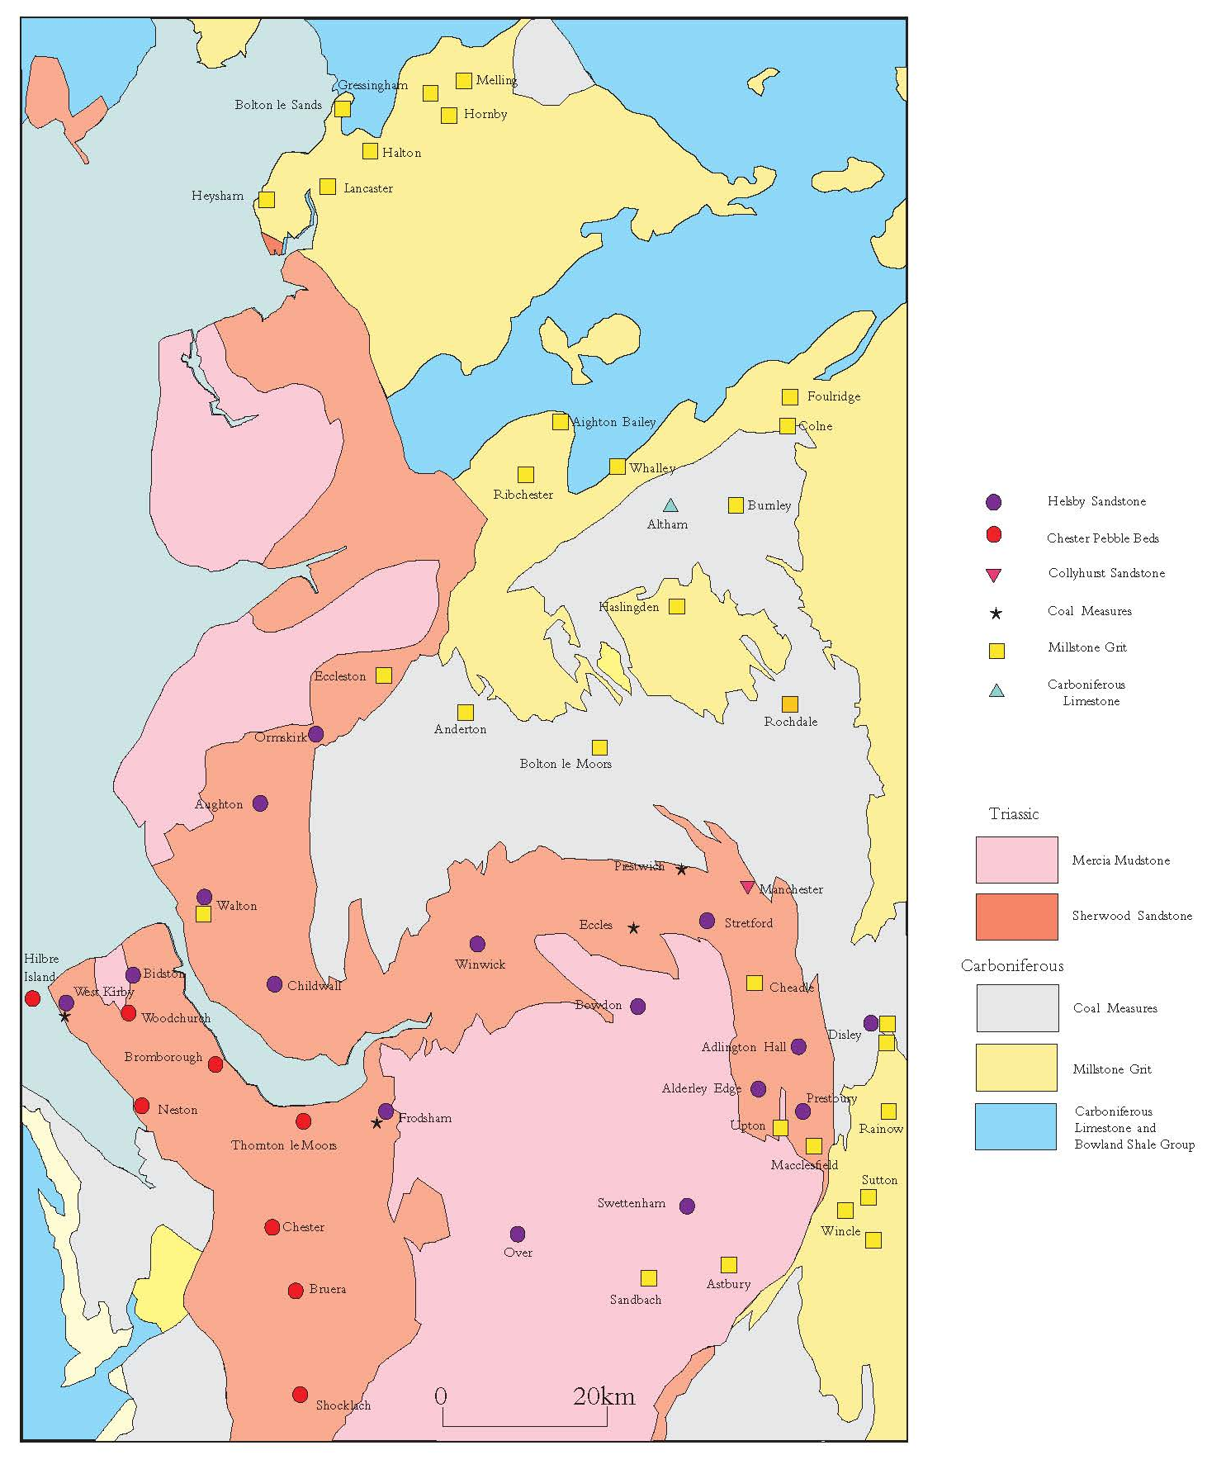
Fig. 8. Solid geology of Cheshire and Lancashire, with the distribution of stone types used for Anglo-Saxon sculptures in Cheshire and Lancashire (© Corpus of Anglo-Saxon Stone Sculpture)
The distribution of workable stone for the creation of carved stone monuments evidently factored in the distribution of stone sculpture in the tenth and eleventh centuries. A further consideration must be the topography of the region.

Topography

A lack of historical documentation for Cheshire for the early medieval period, means a reliance on place-name evidence in order to establish some basic understanding of the natural topography of the county besides that which can be gained from observation, for example upland/lowland distinctions (See Fig. 10).
Phillips and Phillips (2001, 26) mapped all known townships with names indicative of a woodland landscape, such as –leah and –lyme. The distribution established that woodland place-names were evenly distributed across the county. However, notable clusters were found in the north-east and south Cheshire. At Domesday, this distribution appears to have been maintained (Darby and Maxwell 1962, 356). When mapped alongside the early medieval sculptural assemblage no pattern can be discerned, as sculpture appears in both wooded and cleared areas (See Fig. 9).

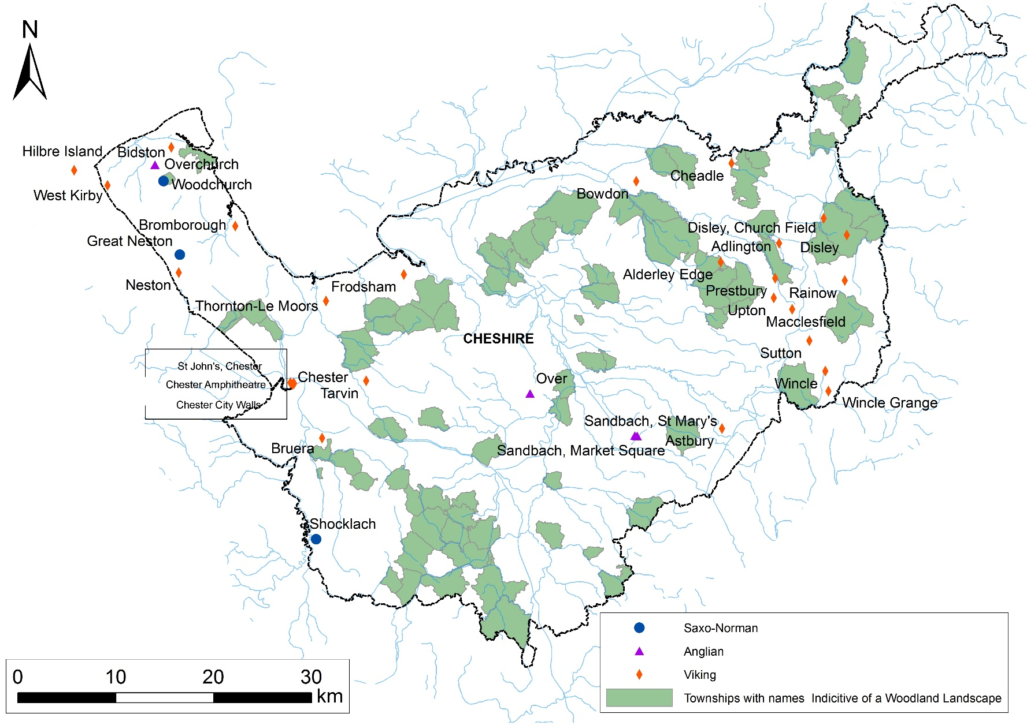
Fig. 9. Natural topography of Cheshire (Place-name evidence after Phillips and Phillips (2001, 26). Base Map: Ordnance Survey 2015 [Crown Copyright/database right 2015. An Ordnance Survey/Edina supplied service]).

In addition, as a county assemblage there is also no apparent preference for lowland or highland, riverine, coastal or inland locations. However, this generalisation masks the difference between the geographical clusters to the east and west. When explored separately, rather than as a county collection, it is evident that some groupings do prefer certain topographies. For example, those monuments in the east of the county are found on high ground, avoiding the valley bottoms and the Cheshire Plain (see Chapter Six for further discussion).
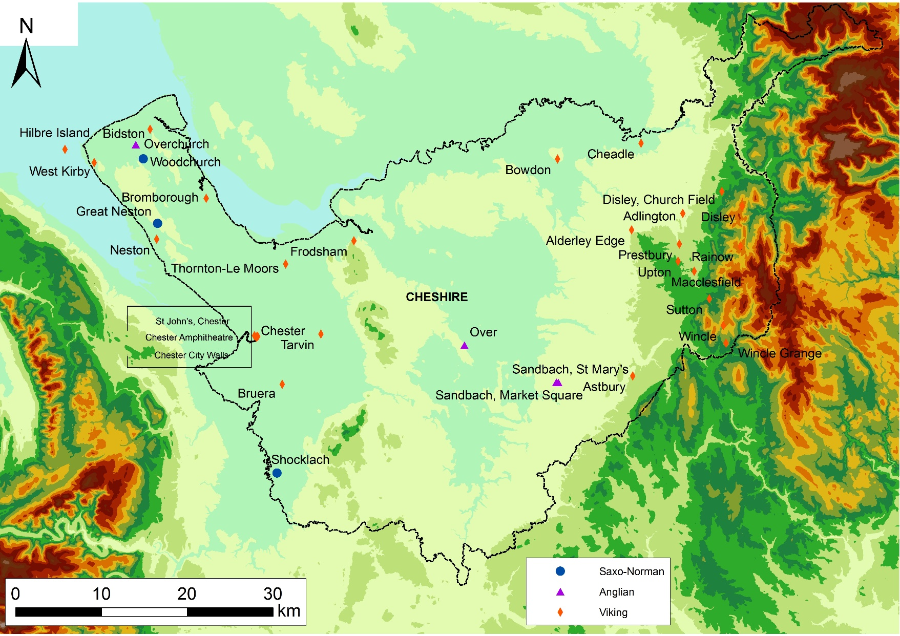
Fig. 10. Relief Map of Cheshire and Stone Sculpture Distribution. Base Map: Ordnance Survey 2015 [Crown Copyright/database right 2015. An Ordnance Survey/Edina supplied service]).

Localised preferences for certain topographic situations suggests that there is more to monument distribution than the availability of appropriate raw materials. This notion is supported by the distinct appearance of the western and eastern assemblages, as the geographic divide can be seen mirrored in the distinctive physical attributes of the groups of sculptures found in the east and west of the county. Their form, size and decorative carvings are coherent within their localised grouping but distinct from their counterparts at the opposite side of the county (See Chapter Five for further discussion). Whilst geology clearly had an impact on the distribution of stone sculpture in the county, it cannot account for the difference in the appearance between the east and west Cheshire assemblages. The difference in physical attributes indicates that a cultural divide was also present within the county. How this transpired is difficult to establish. Whatever the reason, the divide appears to have impacted the appearance of monuments, their locations, possibly their functions and the subsequent interactions that were fundamental in shaping how they survived as monuments.
The difference in physical appearance is also mirrored in an apparent difference in reuse patterns, indicating that the geographical divide is not arbitrary. In west Cheshire forty (88.9%) fragments are associated with church structures compared to only eight (22.9%) in east Cheshire (see Fig. 11).

Fig. 11. Percentage of sculpture associated with church fabric, foundations or churchyards in east and west Cheshire

Whilst Cheshire as a whole falls within the normal range of church association in the region (see Fig. 12), comparatively the east Cheshire percentage is much lower, indicating that something unusual is potentially occurring here.

Fig. 12. Percentage of sculpture associated with church fabric, foundations or churchyards in Cheshire and surrounding counties*
*Based on fragments - where two fragments are known to be from the same monument they are counted as one. Monuments with an unknown provenance have been excluded (see Appendix A for detailed summary).

In west Cheshire, as with much of England, restoration work in the nineteenth and early twentieth century is responsible for a large proportion of the monuments discovered in church fabric or church foundations (see Appendix B). In west Cheshire thirty-nine (86.7%) fragments of sculpture, with known evidence for discovery, were found in this way compared to only eight (22.9%) in east Cheshire. The first step in the exploration of reuse must be to establish how reliable these figures are by comparing restoration practices on both sides of the county. This will indicate if attitudes towards church restoration differed and if this has contributed to the obvious difference in reuse patterns between east and west Cheshire.

Patterns of Reuse across Cheshire
Using the architectural information provided by Richards (1973) and Hartwell and Hyde (2011) all the surviving churches within the pre-1974 county of Cheshire have been explored in terms of their architectural sequences. Those churches that were built prior to 1700 and that have known surviving elements of architecture from before this period have been listed (see Appendix B). Each listing notes the evident changes to the buildings fabric —remodelling, extension, restoration, rebuilds — and the period in which this occurred. Restoration or rebuilds AD 1800–1935 have been given particular attention, as it was during this period that a large proportion of Chester’s sculpture was recovered and recorded. The more recent work to the buildings has been better described, so in many instances the date of the works and the people responsible for it can be discerned.
In total eighty-six surviving churches were identified. Thirty-one from East Cheshire and fifty-five from West Cheshire. Despite the disparity in church numbers between east and west Cheshire the level of restoration and/or rebuilds is of a comparable level: 90% and 92.7% respectively.
This result clearly indicates that recovery due to restoration and rebuilding practices was not responsible for the high level of early medieval stone sculpture recovered in West Cheshire during this period. In addition, there is no evidence to suggest that particular individuals, responsible for restoring or rebuilding specific churches, had an approach that was conducive to recovering early medieval sculpture over others. Thirteen different individuals are noted to have been involved in the restoration and/or rebuilds of the twelve different churches where sculpture was recovered. There is also no difference in prevalence of monuments evident between restored churches and those that were rebuilt.
Another trend is evident based on the quantitative data compiled in Appendix A. The monuments associated with church structures are commonly found in areas of occupation: modern villages, towns or cities. These monuments are highly fragmentary, suggesting they have been broken up to serve as building material or fragmented to serve symbolically within buildings as a form of appropriation and citation (a concept that will be discussed further below). Those monuments that are found outside modern centres of occupation survive in much better condition, as they are far less fragmentary, often only missing their fragile cross-heads. This implies that these monuments were less likely to be appropriated for reuse in buildings, either for practical or symbolic reuse, probably because they were harder to access and/or move.
These initial observations suggest that the county of Cheshire was operating along an east-west divide, which determined how monuments survived in the archaeological record and how they were later reused. This divide between east and west may have begun in the early medieval period (or before) and affected the types of monuments being erected and the locations in which they were raised. If this is the case, then the reuse patterns may primarily be dictated by the monuments original location and function. However, it may have been the political, economic and/or social climate after their initial erection and use that determined which monuments would be destroyed and/or reused. The same may be true of monuments that survived intact into later periods, only to be reused at a later date. However, it is not clear which of these suggestions is more likely based on this initial assessment.
Using the data described above it is clear that an in-depth exploration of the distribution of monuments in the county and their reuse is required. Whilst investigations of monument distribution or reuse on a county scale is not unusual (Stocker and Everson 1990), combining spatial data with biographical data to generate information about a place and a monument/group of monuments is an altogether different and fruitful approach, and is clearly required to understand a variety of aspects of early medieval stone sculpture of Cheshire.
By exploring the monuments of the entire county in terms of their primary contexts (where possible), the contexts in which they were discovered and how they were reused, alongside the evidence for wider changes to the economy, society and politics throughout various periods, from a national and local standpoint, it may be possible to determine when monuments were taken down, destroyed and/or reused. By establishing a timescale for these various activities, it might also be possible to understand the motivations for the destruction and/or reuse of a monument, often multiple times, which in-turn may shed light on wider local and national cultural shifts. Lastly, by pulling all this information together it might be possible to determine why we see such an obvious divide in the sculptural distribution and reuse between the east and west of the county.

CHESHIRE REUSE
Within the Cheshire corpus, the majority of the monuments have provenance, meaning they have been found within a specific location that has been recorded. Monuments with provenance will be explored in this chapter. Those without provenance; Alderley Edge 1, Bowdon 1, Chester Unknown Provenance 1 and 2 and Disley Lyme Hall 3 are not discussed any further. Furthermore, monuments at Cheadle (Cheadle 1) and Disley Lyme Hall (Disley Hall 1 and 2) have multiple and competing stories of discovery, which means their provenance is unreliable. These too will be excluded from the discussion. This leaves 92% of the counties sculpture to work with.

East Cheshire: Reuse Not Associated with Church Structures
A large proportion of monuments in the east of Cheshire are of a particular type referred to as ‘round-shaft derivatives’. More importantly, this type of monument is not found elsewhere in Cheshire and is more commonly found alone, at sites distant from centres of occupation. They are the only type of monuments found in east Cheshire that are not associated with church structures.

Round-shaft Derivatives
Within the east side of Cheshire there is a concentration of fourteen tenth- or eleventh-century round-shaft monuments. These are part of a larger concentration that also covers the counties of Staffordshire and Derbyshire. The monuments are defined by Cramp (1984, xv) as having two distinct sections to the shaft. The bottom section is rounded or sub-rectangular and the upper part is angular. The two sections are divided by a collar and/or a swag (see Fig. 13). Of the examples that survive in Cheshire, Derbyshire and Staffordshire with this terminal intact, all have collars and some have both the collar and swag, for example Sutton Ridge Hall 2 and Wincle Grange 1 (Bailey 2010, 127 and 138).

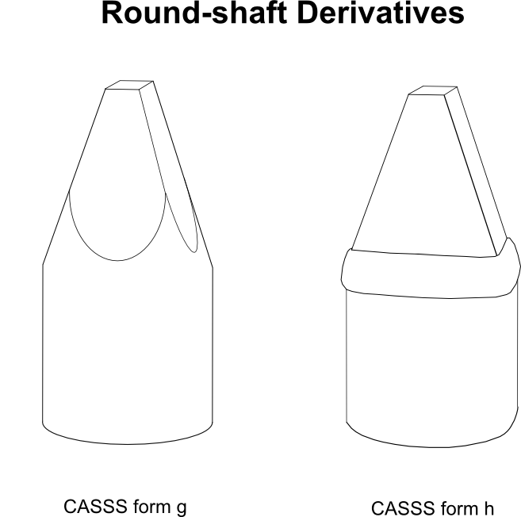
Fig. 13. Line drawing of the two types of round-shaft derivatives (After Cramp 1984, xv)

Whilst round-shaft derivatives from the early medieval period can be identified at other sites across England, such as at Beckermet St Bridget 2 in Cumbria (Bailey and Cramp 1988, 56-7) and Gilling West 2 in North Yorkshire (Lang 2001, 114), such a geographically concentrated group as the Cheshire-Derbyshire-Staffordshire area exists nowhere else. Within these three adjoining counties there is a minimum of twenty-seven known examples with the possibility of at least four more and one with an unknown provenance (currently located at Heaton, Staffordshire). There are five identified in Derbyshire, eight in Staffordshire but the majority are found within Cheshire, which has fourteen examples and four further possibilities (see Tables 1 and 2 and Fig. 14). Despite their close proximity and similarity of form they are not a homogenous stylistic group. They vary in their decorative choices and the types of locations in which they were erected

COUNTY | SITE | CITATION
Cheshire | Adlington 1 | Bailey 2010, 45
 | Adlington 2 | Bailey 2010, 45-6
 | Astbury 1 | Bailey 2010, 47
 | Disley Church Field | Bailey 2010, 73-4
 | Disley Lyme Handley - Composite | Bailey 2010, 78-80
 | Macclesfield 3 | Bailey 2010, 83-4
 | Macclesfield 4 | Bailey 2010, 84
 | Rainow | Bailey 2010, 98-9
 | Sutton 1 | Bailey 2010, 126
 | Sutton 2 | Bailey 2010, 127
 | Sutton 3 | Bailey 2010, 127-8
 | Upton | Bailey 2010, 132-3
 | Wincle | Bailey 2010, 137-8
 | Wincle Grange | Bailey 2010, 138
Staffordshire | Alstonefield 1 | Pape 1946, 29-31
 | Alstonefield 2 | Pape 1946, 29-31
 | Alstonefield 3 | Pape 1946, 29-31
 | Alstonefield 4 | Pape 1946, 29-31
 | Alstonefield 5 | Pape 1946, 29-31
 | Chebsey | Pape 1946, 31-2
 | Ilam | Pape 1946, 33-4
 | Leek | Pape 1946, 34-5
Derbyshire | Bakewell 25 | Sidebottom 1994, 224-5
 | Bakewell 27 | Sidebottom 1994, 225
 | Brailsford | Sidebottom 1994, 231
 | Fernilee | Sidebottom 1994, 249-50
 | Glossop | Sidebottom pers. comm.

Table 1. Table of all known round-shaft derivatives in Cheshire, Derbyshire and Staffordshire

COUNTY | SITE | CITATION
Cheshire | Cheadle | Bailey 2010, 60-62
 | Disley Lyme Hall 1 | Bailey 2010, 74-6
 | Disley Lyme Hall 2 | Bailey 2010, 76-7
 | Alderley Edge | Bailey 2010, 46-7

Table 2. Table of all known possible round-shaft derivatives in Cheshire, Derbyshire and Staffordshire
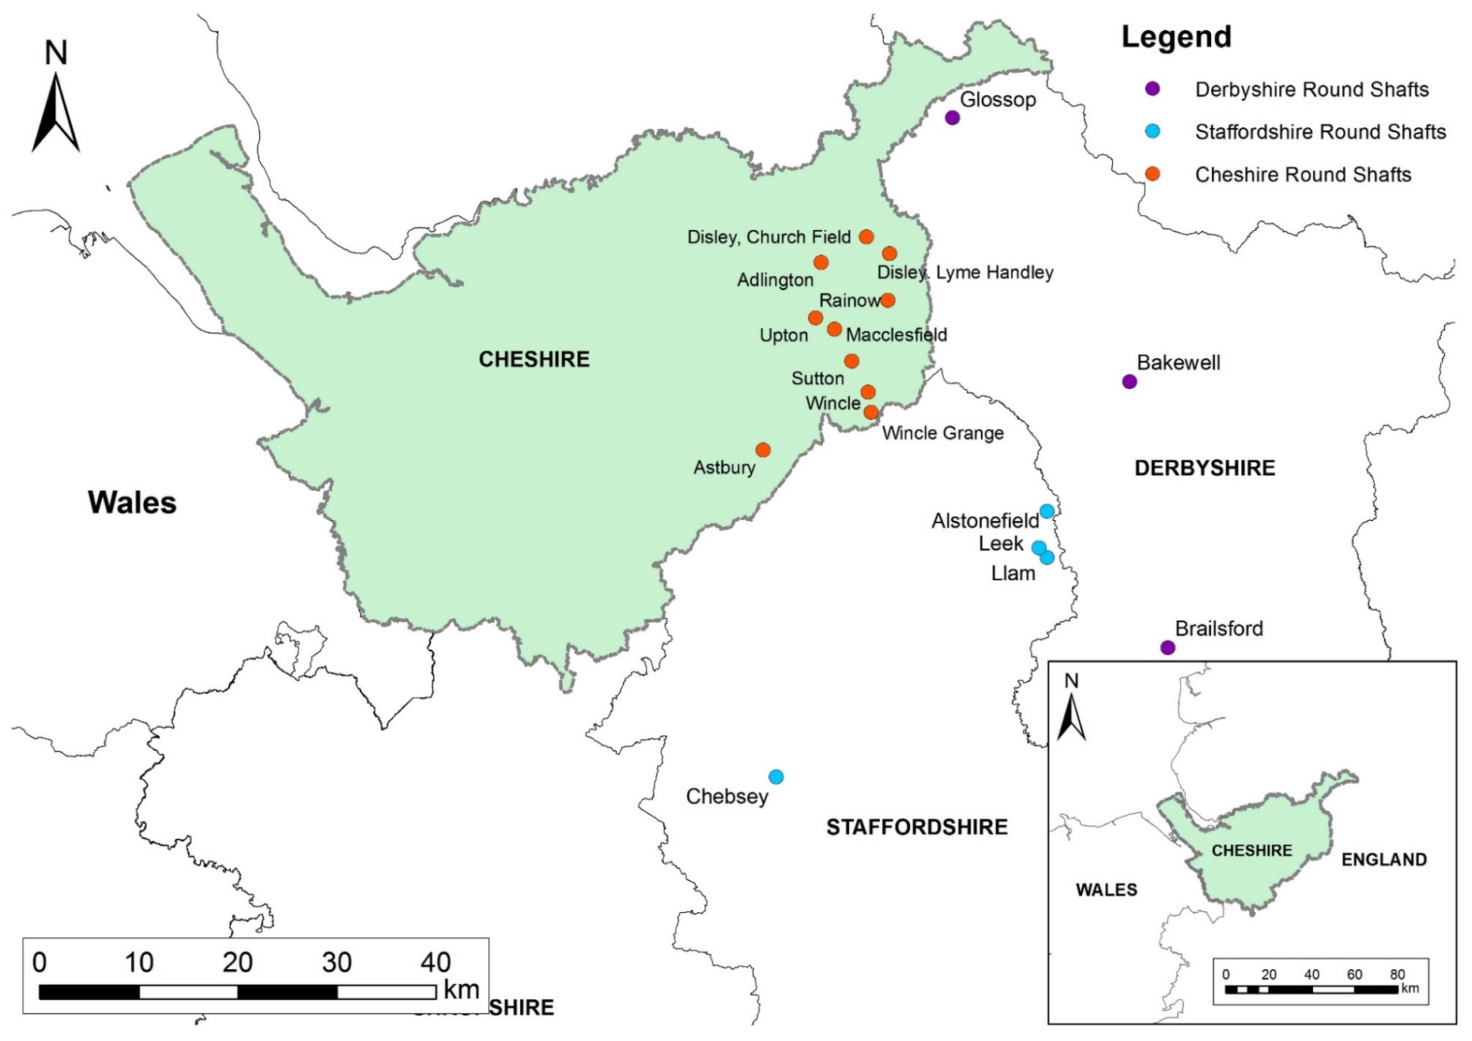
Fig. 14. Distribution of round-shaft derivatives in the pre-1974 counties of Cheshire, Derbyshire and Staffordshire

Round-shaft Locations
The Cheshire examples vary quite considerably to their Staffordshire and Derbyshire counterparts, as they are frequently found in areas not associated with church structures – for example, not found located in the fabric or foundations and not located within the modern churchyard boundaries. Of the fourteen examples identified from Cheshire only three (21.4%) can be associated with church structures (Astbury, Macclesfield 3 and 4), two of which have no definitive ‘evidence of discovery’ in the church fabric or grounds. In Derbyshire 60% of round-shafts are associated with church structures and in Staffordshire 100% are associated with church structures, a marked difference to the east Cheshire group (see Fig. 15).

Fig. 15. Percentage of round-shaft derivatives associated with church structures

Clearly the round-shafts of east Cheshire had a use or reuse that sets them apart from the majority of their Derbyshire and Staffordshire counterparts. Outside the study area, other round-shaft derivatives from tenth-/eleventh-century England are also all found in churchyard/church settings (within the fabric and foundations of churches or within the modern churchyard boundaries) (Bailey and Cramp 1998, 56-7; Lang 2001, 114), which compounds how unusual the east Cheshire examples are. The east Cheshire round-shafts’ unusual situation is highlighted further if we look at all the sculpture from Cheshire. If we compare the round-shaft group with the counties sculpture as a whole, there is a stark difference (see Fig. 16).

Fig. 16. Percentage of sculptures associated with church fabric, foundations or churchyards

The division between counties is an arbitrary one, and only exists based on the tradition of publishing regional assemblages by county, as seen in the publication of material by CASSS, but there is a clear indication that the occurrence of round-shafts at sites not associated with church structures is dominant in east Cheshire, as all of the examples of non-ecclesiastical settings can be found here with the exception of two outliers at Fernilee on the Cheshire/Derbyshire border and Glossop in north Derbyshire (whose nearest round-shafts are actually those in the north of Cheshire). The remaining round-shafts occur in Staffordshire and mid- to south Derbyshire, which appear to form a secondary group, focused around church settings.
Round-shafts Monuments in Non-ecclesiastical Settings
Eleven (78.6%) of all round-shafts in Cheshire were found outside church structures and churchyards. Several common factors are evident in the group and suggest that the trend for round-shafts away from churches was deliberate and was directly responsible for the types of reuse and survival we see in the area today (round-shafts associated with church structures will be discussed below).
The round-shafts of east Cheshire are found in two types of locations. Wincle, Wincle Grange, Sutton 1, 2 and 3, Disley Lyme Handley and Rainow are found outside centres of modern occupation up on the borders of the Peak District, at least 1km from a village or town, normally near or on upland pasture. Some like, the Sutton examples and Wincle Grange 1 are no longer in their original locations but there is a strong possibility that Wincle (also known as the Cluelow Cross) and the composite monument at Disley Lyme Handley (also known as the Bowstones) remain in their original settings. This is because, whilst there are no records of any of these monuments from the early medieval period, they are mentioned relatively early. The cross at Wincle is mentioned as a location in a will dating to AD 1538 (Bailey 2010, 137) and the 'Bowstones', referred to here as Disley Lyme Handley (see Fig. 17), was mentioned in a 1465 document as 'le Borestone' in the location in which the composite monument is currently located (Bailey 2010, 78). Whilst some have argued that the ‘Bowstones’ of today is not the same monument (Marshall 1975) due to the singular nature of the name in 1465 (the monument has two round-shafts set into a double socket stone), Bailey has convincingly argued that the monument is a composite and was likely seen as a singular monument. Secondly, a stone monument stood on this location in 1465. Its name referring to something that is a 'thing in a conspicuous position: prominent object’ (Parsons et al 1997, 126-7). Finally, Ormerod, writing in 1882, refers to it in the singular as the ‘Bow Stone’ (1882, 540), demonstrating that the current monument was known by the singular name. Based on this evidence there is no reason to assume that this monument is not the same one mentioned in the 1465 document.
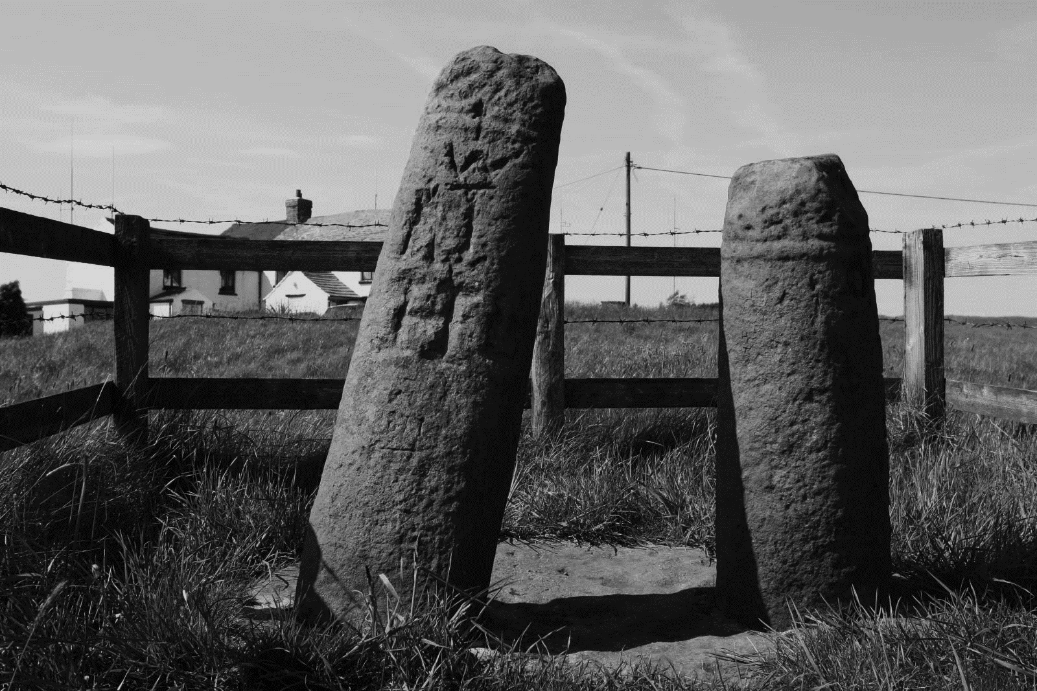
Fig. 17. Composite monument at Disley, Lyme Handley known as the ‘Bowstones’ (© Corpus of Anglo-Saxon Stone Sculpture, photographers K. Jukes and D. Craig)

Both Wincle and Disley Lyme Handley are situated in comparable settings. They are located on the tops of valleys, with significant viewsheds, next to natural passages through the rugged terrain (to see more discussion on this please see Chapter Six). The similarity of their situations supports the argument that they remain in their original setting. The rest of the monuments, whilst not in their original locations, are situated in comparable landscapes.
The remaining monuments, Adlington 1 and 2, Disley Church Field and Upton require further thought, as these are located in close proximity to modern settlements. The two Adlington monuments were first recorded within the grounds of Adlington Hall, one of which has been converted into a sundial. It is very likely that both examples were brought to the Hall at a date prior to 1876 when Adlington 1 was first recorded (Renaud 1876, 73). It is probable that these two monuments may have been brought from to the Hall during the creation of the pleasure park around the hall in the 1740s and ‘50s, as part of the many follies, such as the Temple of Diana, the Chinese Summerhouse and Mock Castle built during this period (HER 1582/2/0). The double socket stone unearthed at Disley Church field, like Adlington 1 and 2, is a clear example of a monument that becomes associated with a building later in its biography. It cannot be linked to any known building prior to St Mary's church, which was only founded in 1558, as a chantry chapel (Richards 1973, 143). Finally, the round-shaft at Upton was built into the wall off the high road in Upton, which also formed the township boundary (Ormerod 1882, 704). In its current location, Upton like many of the more remote monuments, is located on a roadside (for further discussion about the importance of roadside monuments see Chapters Five and Six). Like Adlington 1 and 2 and Disley Church field, it is also not associated with a particular building, which leaves little room for understanding the setting for this particular monument. Its location on a township boundary could suggest that it has remained in situ for some time, preserved because it helped demarcate the boundary but it is not evident if the monument was used to help determine the township border or if it was moved to its location to help demarcate the townships extent. However, no other early medieval Cheshire stone monuments have been found located on boundaries: township, parish or county. Without any comparative material from the county, particularly within the round-shaft group, determining if its original function was linked to its location on a boundary is impossible.
Based on this overview, Adlington 1 and 2 were probably moved to their current locations and Disley Church Field was already present when St Mary's was built. Upton remains problematic in terms of its association with a settlement, but it is possible that it developed a function strongly associated with settlement sometime after its erection. More broadly speaking, with the exception of Disley Church Field and Upton, these monuments are strongly associated with remote locations on the edge of the Peak District. This is very significant for understanding reuse in later periods, as their remoteness is the crucial aspect of their largely intact survival and the key to understanding how and why they were reused in later periods.

The Impact of Location on Survival
In Cheshire, because the round-shafts are located in remoter situations than the rest of the counties assemblage, their audience was limited to travelers and the rural population who worked the land around them. Whilst highly visible, the physical distance between monument and audience may have ensured that their impact on a person was lessened and the utilitarian nature of the movement around them might have provoked less of a memorable encounter. Conversely, in any one of the Cheshire churchyards monuments would have been experienced at close quarters when visiting the church for religious ceremonies, including Sunday service, baptisms (or similar), marriages and funerals. The proximity of the monuments and impetus for movement around them would have generated a very different experience, whereby the monument was physically presenced and tied to specific communal events. This would have ensured that monuments in churchyards, commonly associated with settlements, would have been easier to access and more likely to provoke reactions which might lead to reuse. For example, John Moreland’s (1999, 194-213) discussion of the Bradbourne cross in Derbyshire provides an example of a churchyard monument (a space regularly frequented) that attracted attention time again, resulting in multiple interpretations and interactions with different groups spurred on by the social climate of the time. For example, in the nineteenth century, the Rev. G. F. Browne, Bishop of Bristol, reinterpreted and re-erected the monument at Bradbourne as an example of a monument demonstrating the antique ‘genius and later corruption’ of the native British Church by the Roman Catholic Church (Moreland 1999, 208). It was a statement made at a time when there was increasing pressure for re-unification of the Catholic and Protestant Churches, a move that Bishop Browne was vehemently against. He used the Bradbourne monument to symbolise his rejection of the Roman Catholic Church. In the east of Cheshire there is no evidence for reuse. It appears that the round-shafts have survived in better shape than the majority of the west Cheshire examples and those monuments (round-shafts and others) associated with church settings and/or settlements in the east of Cheshire. For example, the monuments at Wincle, Wincle Grange, Sutton 1, 2 and 3 all have a large proportion of their shafts surviving intact with the majority only missing their cross-heads. Those more closely associated with ecclesiastical centres such as Astbury, and Macclesfield (which will be discussed below) are in a more fragmentary state. Clearly, the people inhabiting tenth- and eleventh-century east and west Cheshire were using different types of stone sculpture but the very different location in which monuments were found, between east and west Cheshire, was key to how they survived in the archaeological record.

Round-shaft Reuse
The location of monuments, whilst clearly having an impact on their survival, is also likely to have had an impact on their reuse in later periods.
As prominent monuments in a landscape of hills, valley bottoms and few settlements, the Cheshire round-shaft crosses likely served as landmarks. Their proximity to multiple roads would also have facilitated and encouraged this. Several of the Cheshire round-shafts are located on or near roads of potential antiquity. For example, the monument at Rainow sits on a Roman road (see Chapter Six)
There are also descriptions of monuments that were used as stopping places on processional routes and sometimes as meeting places in the medieval period, so they were maintained and not moved for centuries. In Cheshire we have an account from the Star Chamber Proceedings, James I (bundle 21, No.6) in 1613 printed in the Cheshire Sheaf (1923, 100-101) that discusses the role of standing crosses in the county. We learn that they were:
‘....good directions for travelers and places appointed for the payment of certain rents and for the other lawful meetings.
The Wincle and Upton crosses were, according to folklore, used as places where provisions were left during the Plague (Ormerod 1882, 540). The High Cross at Chester was the ‘scene of all great civic functions’ within the city according to the Archdeacon of Chester (Barber 1910, 207). Royalty was received there, important proclamations were made and the Mystery Plays were undertaken here. Whilst the antiquity of these functions is not known, the fact that they developed at all impacted on their survival in later periods (see below). There are also glimpses of the crosses more ritualistic significance in the medieval period:
‘an ordynarie custome of sundry supersticious persons that in carrienge corpses to the buryall in theire parishe churches by the highe wayes did use to sett downe the same corpses at or neare to suche crosses as stoode in the same wayes, and did usually there kneele downe and make or recyte certaine superstitious prayers.
Their roles as both civic and religious monuments ensured their survival:
"nowe and for a longe tyme hath bene usually frequented and extraordinarily preserved, defended and advanced by sundry.....and have bene superstitiously and idolterously worshiped and adored".
The combination of possible religious and civic significance, plus the round-shafts remote location, probably ensured their survival until they were actively sought out by the iconoclasts in the early decades of the seventeenth century and later the landed gentry in search of novelties for the new gardens and parks in the eighteenth century.

Iconoclasm
The English Reformation had a huge impact on the survival of pre- and post-conquest free-standing crosses across England. The Reformation was in part a direct response to the break from Rome instigated by Henry VIII. The English Church under its new leader, sought to justify its actions from a theological stand-point despite a primarily political motivation for the break. One such justification was that the Catholic Church had become corrupt and idolatrous and, therefore, the newly established English Church was returning to the purity of earlier periods. Its main tenets for reform were a denial of purgatory and the power of the saints to intercede for the living, plus rejection of the power of images, which manifested itself in the obsessive following of the second commandment 'Thou shalt not make unto thee any graven image' Exodus 20:4 (Duffy 2005, 377-424). In the reign of Edward VI (1547-1553) we see a concerted effort to remove all trace of Catholic decoration. The 28th Royal Injunction of 1547 tells the people of England and Wales to ‘take away, utterly extinct and destroy all shrines.....pictures, paintings and all other monuments of feigned miracles, pilgrimages, idolatry and superstition; so that there remain no memory of the same’ (Duffy 2005, 451). In Cheshire the destruction of crosses was taking place shortly before and after the Royal Injunction. In AD 1543 a receipt survives that states that the local stone mason was paid for two days’ work taking down and removing the cross at St Mary’s-on-the-Hill in Chester (Barber 1910, 209-10). In AD 1577 the Archbishop instructs the Sheriff of Chester to pull down various crosses throughout the city (Barber 1910, 209).
Early medieval stone sculpture, particularly the highly decorative kind, was an obvious affront to the reformists with the crucifix and cross serving as a particular focal point for their attentions (Aston 2002, 253-72). Those crosses that were deemed to encourage superstitious behavior, like that described in the Star Chambers account above, were particularly frowned upon, as there are many references throughout the period of people banning such activity. For example, Bishop Bentham at Coventry and Lichfield in AD 1565, and Archbishop Grindal of York six years later prohibited the setting down of corpses at wayside crosses and saying of the De profundi or pater noster for the dead (Aston 2002, 265). In AD 1607 Tobie Matthew, Archbishop of York wanted to know if any of his parishioners had been praying for the dead at a cross or places where crosses used to be (Aston 2002, 266). It is also noted how more common day-to-day actions were prohibited, such as curtsying to the cross, the bowing of knees or removal of a hat, when one passed by (Aston 2002, 264 and 266). These accounts clearly demonstrate that such practices were widespread and represent enduring practices rather than a single wave of monument destruction.
The tension between reformers and those who still worshipped at crosses can be seen in the documentary evidence from the period and explains why we see some monuments surviving in better condition than others. For example, two men from Yorkshire were charged and imprisoned in AD 1571 for burying a cross without first defacing it (Aston 2002, 263), indicating that whilst they were following instructions they were reluctant to actually harm the monument. Specific parts of the decoration might be removed from much larger scenes, suggesting a reluctance to destroy the whole monument. For example, the monumental slab from Woodwray, Angus had only its central cross chiseled off, the remainder of the decoration was left intact (Fraser 2005, 61). It was the cross that was perceived to cause particular offence in that instance. Sometimes whole scenes were eradicated, like the carefully removed panel from St Orland's Stone, Angus. Foster (2005, 59) suggesting that rather than a fervor of mindless iconoclasm, crosses were subject to the 'careful editing' of the iconography.
John Moreland (1999, 201) has noted similar activity in Derbyshire, whereby the clergy were instructed to remove crosses from their churches and churchyards but were also instructed not to destroy them but hide them and note their location, implying a reluctance to harm the monuments and suggesting that they still retained some significance.
Aston (2002, 259) suggests that some of the monuments and other objects that found their way into the fabric of buildings, may have done so to hide them until they could be brought back again, such as the complete painting of the Virgin and Child being venerated by the magi unearthed under the floor boards of a church in Long Melford and a figure of the Virgin Mary boarded up in the niche in which it stood at St Mary's Stamford (Duffy 2005, 490). During the short reign of Queen Mary (AD 1553-1558) such an opportunity presented itself, as Catholicism was once again permitted in England and Wales. During her reign many of the church decorations that were supposed to have been destroyed were returned to parish churches by the parishioners (Duffy 2005, 489-90).
By the 1640s the reformist zeal supported by both the church and various Royal Injunctions was set into law for the first time. In AD 1644 all depictions of crosses were officially condemned (Woolf 1992, 12). This law covered crosses in secular and ecclesiastical spaces, in private and public places.
The easiest way of adhering to this legislation was to cut the head off the cross. In this way the monuments could retain any civic roles they had without being classed as idolatrous (Aston 2002, 266). In Cheshire, of the round-shafts with their circular part of the shaft surviving (nine), all have lost their cross-heads strongly indicating that these were deliberately removed. The Archdeacon of Chester stated: ‘That the demolition of the crosses was usually achieved by removing the cross-head and shortening the shaft’ (Barber 1910, 209). The account from the Star Chambers in AD 1613 provides a context for this sort of activity in Cheshire. It describes how a group of individuals went about the county destroying wayside and churchyard crosses with crow bars because they deemed them idolatrous and unlawful:
‘....terming themselves to be the only true professors of the Gospel, [they] took upon themselves to destroy said crosses by way of a reformation of abuses and superstitions. They designed to destroy every cross in the county and city.
The defendants in the case claimed that they were 'leaving the foundation [of the crosses] as sufficient for any civil use'. This remarkable account demonstrates the reasons why monuments in this period were being destroyed, how they had been used prior to the Reformation and how they continued to be used for civic purposes after their partial destruction. This account from Cheshire provides strong circumstantial evidence that suggests the round-shafts missing their cross-heads probably suffered a similar fate. The lack of decoration on their shafts also probably ensured that they survived in better shape than those that were fully decorated. However, as noted above, the adherence to these rules was not uniformly practiced and there is evidence in Cheshire that some monuments retained their religious import for some time after the AD 1644 legislation was passed. The composite monument at Disley Lyme Handley (The Bowstones), for example, was used as a place of burial in the mid-seventeenth century, for those who were denied burial in churchyards during the various plague years of the seventeenth century (Ormerod 1882, 540). One grave marker reads:

John Hampson and his wife
And three children left this life
1646
(Ormerod 1882, 540)

Another major issue that has been touched upon already is the possibility that individuals (usually landed gentry) were moving monuments from their remote situations to become curios for private and public display, like the examples at Adlington Hall discussed above. Three other sites can be linked to such reuse activity in Cheshire. Sutton, Ridge Hall farm had three monuments. One was found on a rubbish pile and the other two were being used as gateposts. In c. AD 1858 these monuments along with the Upton stone were removed and re-erected in Macclesfield Park as curiosities. Upton was subsequently taken back to its original location but the other three remained (Bailey 2010, 126 and 132). The monument from Wincle Grange was also removed in 1874 by the squire of Swythamley Hall in Staffordshire and re-erected in the grounds with a new cross-head (Bailey 2010, 138). Drawing upon such instances, Phil Sidebottom (1994, 153) has argued that the east Cheshire round-shafts are located away from church sites due to their movement by local gentry. However, this does not explain why monuments such as Wincle and Disley Lyme Handley have a long association with their current locations. Wincle is first mentioned in AD 1538 and the Bowstones in AD 1465 (see above for more info). It also does not explain why this activity would only be confined to east Cheshire. Why is there no evidence in Staffordshire and mid-south Derbyshire for comparable activity? The appropriation of round-shafts in east Cheshire by the gentry class as curios is actually further evidence that these monuments were originally located away from church structures. Those monuments in Staffordshire and mid-south Derbyshire are all associated with churchyards and, therefore, under the protection/ownership of the local church. As such, the local gentry were less likely to be able to have them removed for their own personal interests. Conversely, those round-shafts in east Cheshire that had no protection from the church environs were easily removed and re-erected once their religious and civic significance had diminished. With the growth of antiquarianism these monuments would have been recognised by some as historical curiosities that were not out of place alongside the follies of the Country House gardens.

West Cheshire: Reuse Not Associated with Church Structures
There are three monuments that fall within this category within the west of Cheshire, none of which are round-shafts, two of which are situated in Chester city centre. Chester City Walls 1 was found in the fabric of the medieval city walls in the south-east angle tower (Newstead 1948, 157). Its form and decoration are very closely linked with the sculptural assemblage from St John the Baptist, Chester, strongly suggesting that this monument was once part of this collection (particularly considering the proximity for the SE angle tower) or a comparable one connected to one of the churches in the city. Consequently, this particular monument does not easily belong to either reuse group.
The second monument from Chester was found during excavation for a road within the Roman Amphitheatre in Chester in AD 1935 (Newstead 1948, 157). It was found in the topsoil, suggesting that it was recently deposited there. Its decoration and form does not suggest a stylistic link to the St John’s assemblage but its proximity to the church, less than 20m north-west of St John’s, means an ecclesiastical connection cannot be ruled out.
The third monument, a cross-head and a small fragment of shaft from Tarvin, is very different, having been found during archaeological excavation in 2006 (Bailey 2010, 128). Its fragmentary state and disposal in a seventeenth-century ditch is strongly indicative of deliberate destruction during this period. Further clues are available from the Star Chambers document of AD 1613, discussed earlier, which explicitly states that the 'Tarvyn Crosse' was destroyed by iconoclasts sometime after the 1st of February AD 1613 using crowbars (Cheshire Sheaf 1923, 100-1). Whilst it is impossible to definitively say that the cross fragments from the ditch and the Tarvyn Crosse in the Star Chambers report are one and the same, it is nevertheless a strong possibility. If this is the case, it appears to have suffered a comparable fate to the east Cheshire round-shafts. Tarvin 1 was also the only monument not associated with a church structure to be situated outside a settlement. This suggests why it appears to have survived intact into the seventeenth century, while many others were destroyed much earlier (see below).

Summary
Those monuments not associated with church structures confirm the trends evident in the preliminary assessment of the data. Firstly, there is a clearly an east/west divide in the types of locations in which monuments are found: in the east they are predominantly found outside settlements, in the west they are commonly found within settlements. Those monuments situated outside settlements appear to have survived largely intact compared to those found in settlements, the latter being highly fragmented. The key aim here was to use this data to understand why these trends developed. The first point to note is that the location of a monument prior to reuse clearly had an impact on their survival in the archaeological record, in terms of when they were reused and how they were reused. What is more, by exploring the physical context in which these monuments were recovered or survived, plus the type of reuse evident, it was possible to identify a timescale for their reuse. Where trends were strong, links to societal changes could be identified, such as the iconoclasm of the seventeenth century that was seemingly responsible for round-shafts of east Cheshire and the Tarvin cross in west Cheshire losing their cross-heads. The fate of Chester City Walls 1 and Chester Amphitheatre 1 is harder to determine, as both are highly fragmentary and appear to be loosely associated with their most recent contexts. In the following section monuments associated with church structures will be approached in a similar manner and the trends identified above will be explored further.

West Cheshire: Reuse Associated with Church Structures
The west of Cheshire provides ample examples of early medieval stone sculpture reused in church structures. Of the fourteen sites in west Cheshire with a known provenance, nine of the sites produced early medieval stone sculpture reused in church fabric or foundations. In terms of individual sculptural fragments this works out at 86.7% of all sculpture in the west of the county with a known provenance. This is a significant percentage and the largest in the region (see Table 3).

COUNTY | TOTAL* | CHURCH REUSE | PERCENTAGE
DERBYSHIRE | 102 | 81 | 79.4%
FLINTSHIRE | 10 | 3 | 30%
LANCASHIRE | 77 | 37 | 48%
SHROPSHIRE | 11 | 7 | 63.6%

Table 3. Percentage of early medieval stone sculpture reused in the fabric or foundations of churches in surrounding counties

Fig. 18. Percentage of early medieval stone sculpture reused in the fabric or foundations of churches in surrounding counties

SITE | TOTAL FRAGMENTS | CHURCH REUSE | EARLIEST PHYSICAL EVIDENCE FOR CHURCH STRUCTURE RECORDED  (Richards 1973)
Bidston | 1 | No evidence | Mid-12th century
Bromborough | 11 | Church Foundation | Pre-Conquest
Bruera | 6 | Church Fabric | AD 1100-1150
St John’s Chester | 9 | Church foundations | Late 11th century
Frodsham | 1 | Church Fabric | AD c.1170
Hilbre Island | 2 | No Evidence | N/A
Neston | 5 | Church Foundations | AD c.1170
Shocklach | 1 | Church Fabric | AD c.1150
Thornton le Moors | 1 | Church Foundations | Pre-Conquest
West Kirby | 6 | Church Foundations (one found in graveyard) | AD 1150-1160

Table 4. West Cheshire reuse

The strong correlation between church structures and early medieval stone sculpture is well attested across England (Bailey 1980, 81). The relationship between early medieval stone sculpture and churches from the same period will be discussed further in Chapter Five. Of the nine churches in west Cheshire with early medieval stone sculpture incorporated into their fabric, four (St Barnabas’, Bromborough, St Mary's, Bruera, St John’s, Chester and St Mary's, Thornton le Moors) have Saxon foundations (Richards 1973) and a further two others (St Lawrence’s, Frodsham and St Mary's and St Helen's, Neston) are mentioned in Domesday by AD 1086. This strongly suggests that these early medieval monuments were associated with church structures prior to the Norman Conquest. However, determining when these monuments were pulled down and reused requires an exploration of context, which might allow these monuments to be situated within a stratigraphic sequence or dated by association with radiocarbon dates or other material culture. Moreover, by understanding when they were incorporated into a building allows one to explore these monuments in regard to the contemporary political, economic and social climate of the period and/or localised activities, allowing the opportunity to identify possible causes for their destruction and understand something of why they might be incorporated into a later building. As was seen with the east Cheshire round-shafts, certain ideologies can greatly affect the survival and reuse of these monuments.
To establish when these monuments entered the fabric of the building requires specific investigation of the contexts in which they were found. Unfortunately, due to the fact that the west Cheshire examples were primarily uncovered during nineteenth-century restoration work, none were excavated or recorded using modern archaeological techniques, a very common situation across the British Isles (Eaton 2000, 70 and 75). Consequently, it is difficult to establish when they were incorporated into the church structure, foundations or churchyards. There are limited descriptions of some locations, such as those monuments unearthed at St John's, Chester, which were incorporated by the twelfth (one assemblage) and fourteenth (second assemblage) centuries (See Chapter Five for an in-depth discussion), based on their stratigraphic relationship with the building. Other sites such as Shocklach and Bruera have sculpture still situated in the fabric of standing churches, which can also be dated to the twelfth to fourteenth centuries respectively, based on the date of the church fabric in which they are situated, determined by Raymond Richmond’s architectural examination of all the ancient churches of Cheshire (1973). Based on the foundation dates of these stone buildings, acquired through Richards’ architectural analysis, and the limited contextual evidence for the monuments’ recovery, it is probable that most of these monuments were incorporated into the present buildings by the fourteenth century. Most appear to have been incorporated into stone churches erected in the twelfth century (77.8%), many of which underwent multiple restorations. This dates correlate with wider patterns across England (see O’Sullivan 2011 for an overview).
Stocker and Everson's (1990, 87) exploration of reuse in Lincolnshire demonstrated a comparable pattern: of the thirty-six 'late-pre-Conquest' sculptural fragments from the county thirteen were used in eleventh- to twelfth-century fabrics, seventeen in thirteenth-century fabrics and six in fourteenth-century fabrics, suggesting comparable reuse to the Cheshire group. Whilst we have limited evidence in Cheshire for early Norman reuse, such as that evident at St John’s, Chester (Bailey 2010, 62), other counties provide evidence that this was a common practice after the Conquest. For example, several architectural fragments and free-standing monuments were unearthed during excavation at St Oswald's Priory, Gloucester found in eleventh- and twelfth-century deposits (Bryant 2012, 107). The same is true of Worcester Cathedral where multiple sculptural fragments were discovered in the early Norman foundations (Bryant 2012, 111). Evidence is also forthcoming for small parish churches such as St Ricarius’s, Aberford and St Mary's, Kippax both in West Yorkshire, which have sculptural fragments found during restoration work of the eleventh to twelfth-century churches (Coatsworth 2008, 87 and 182). Broadly speaking, the evidence clearly indicates that the early medieval sculptural fragments from west Cheshire had a strong relationship with churches founded after the Norman Conquest (or earlier) and that this relationship was established some time prior to the end of the fourteenth century.

East Cheshire: Reuse Associated with Church Structures
In East Cheshire only three sites have early medieval sculptures unearthed in their fabric and/or foundations. These are St Mary's, Astbury, St Michael's, Macclesfield and St Peter's, Prestbury. This makes up only 24.2% of all sculpture in the east of the county with a known provenance (see Table 5).
SITE | TOTAL FRAGMENTS | CHURCH REUSE | EARLIEST PHYSICAL EVIDENCE FOR CHURCH STRUCTURE RECORDED  (Richards 1973)
Astbury | 3 | Church Fabric | Pre-Conquest
Macclesfield | 4 | Church Fabric x2  Unclear x2 | AD 1279
Prestbury | 3 | Church Fabric | Early 12th century

Table 5. East Cheshire reuse associated with churches

The first point to note about this group, is that they contain three highly fragmented round-shafts (Astbury 1 and Macclesfield 3 and 4). Based on the round-shaft discussion above, a consideration of why these three monuments are associated with a church structure is needed, particularly as it sheds further light on the trends being discussed.

Round-shaft Monuments in Church Settings
As stated above, few Cheshire round-shafts are found in church settings. Astbury 1 (see Fig. 19) was built into the north porch of St Mary’s church in 1892 (Pullinger 1892, 39). When the monument was first incorporated into the building is difficult to surmise, but the building as a whole was rebuilt over the original Saxon church in the fourteenth century with additions in the fifteenth (Richards 1973, 25). Whilst reuse in church structures (fabric or foundation) is unusual for round-shafts in Cheshire, its location away from the main Cheshire cluster suggests that it may in fact belong to the Staffordshire grouping, being almost equidistant between the two distributions. Given its decorative collar, the Astbury fragments stylistic influences are more closely aligned with the monument found at Leek, Staffordshire (see Fig. 20) rather than its nearest Cheshire counter-parts at Wincle (see Fig. 21) and Wincle Grange.
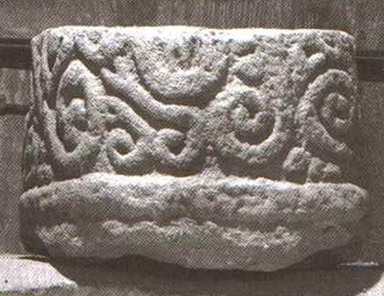
Fig. 19. Astbury 1A, Cheshire (©Corpus of Anglo-Saxon Stone Sculpture, photographers K. Jukes and D. Craig)
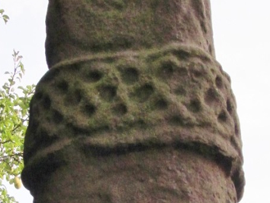
Fig. 20. Leek, Staffordshire (© Joanne Kirton)
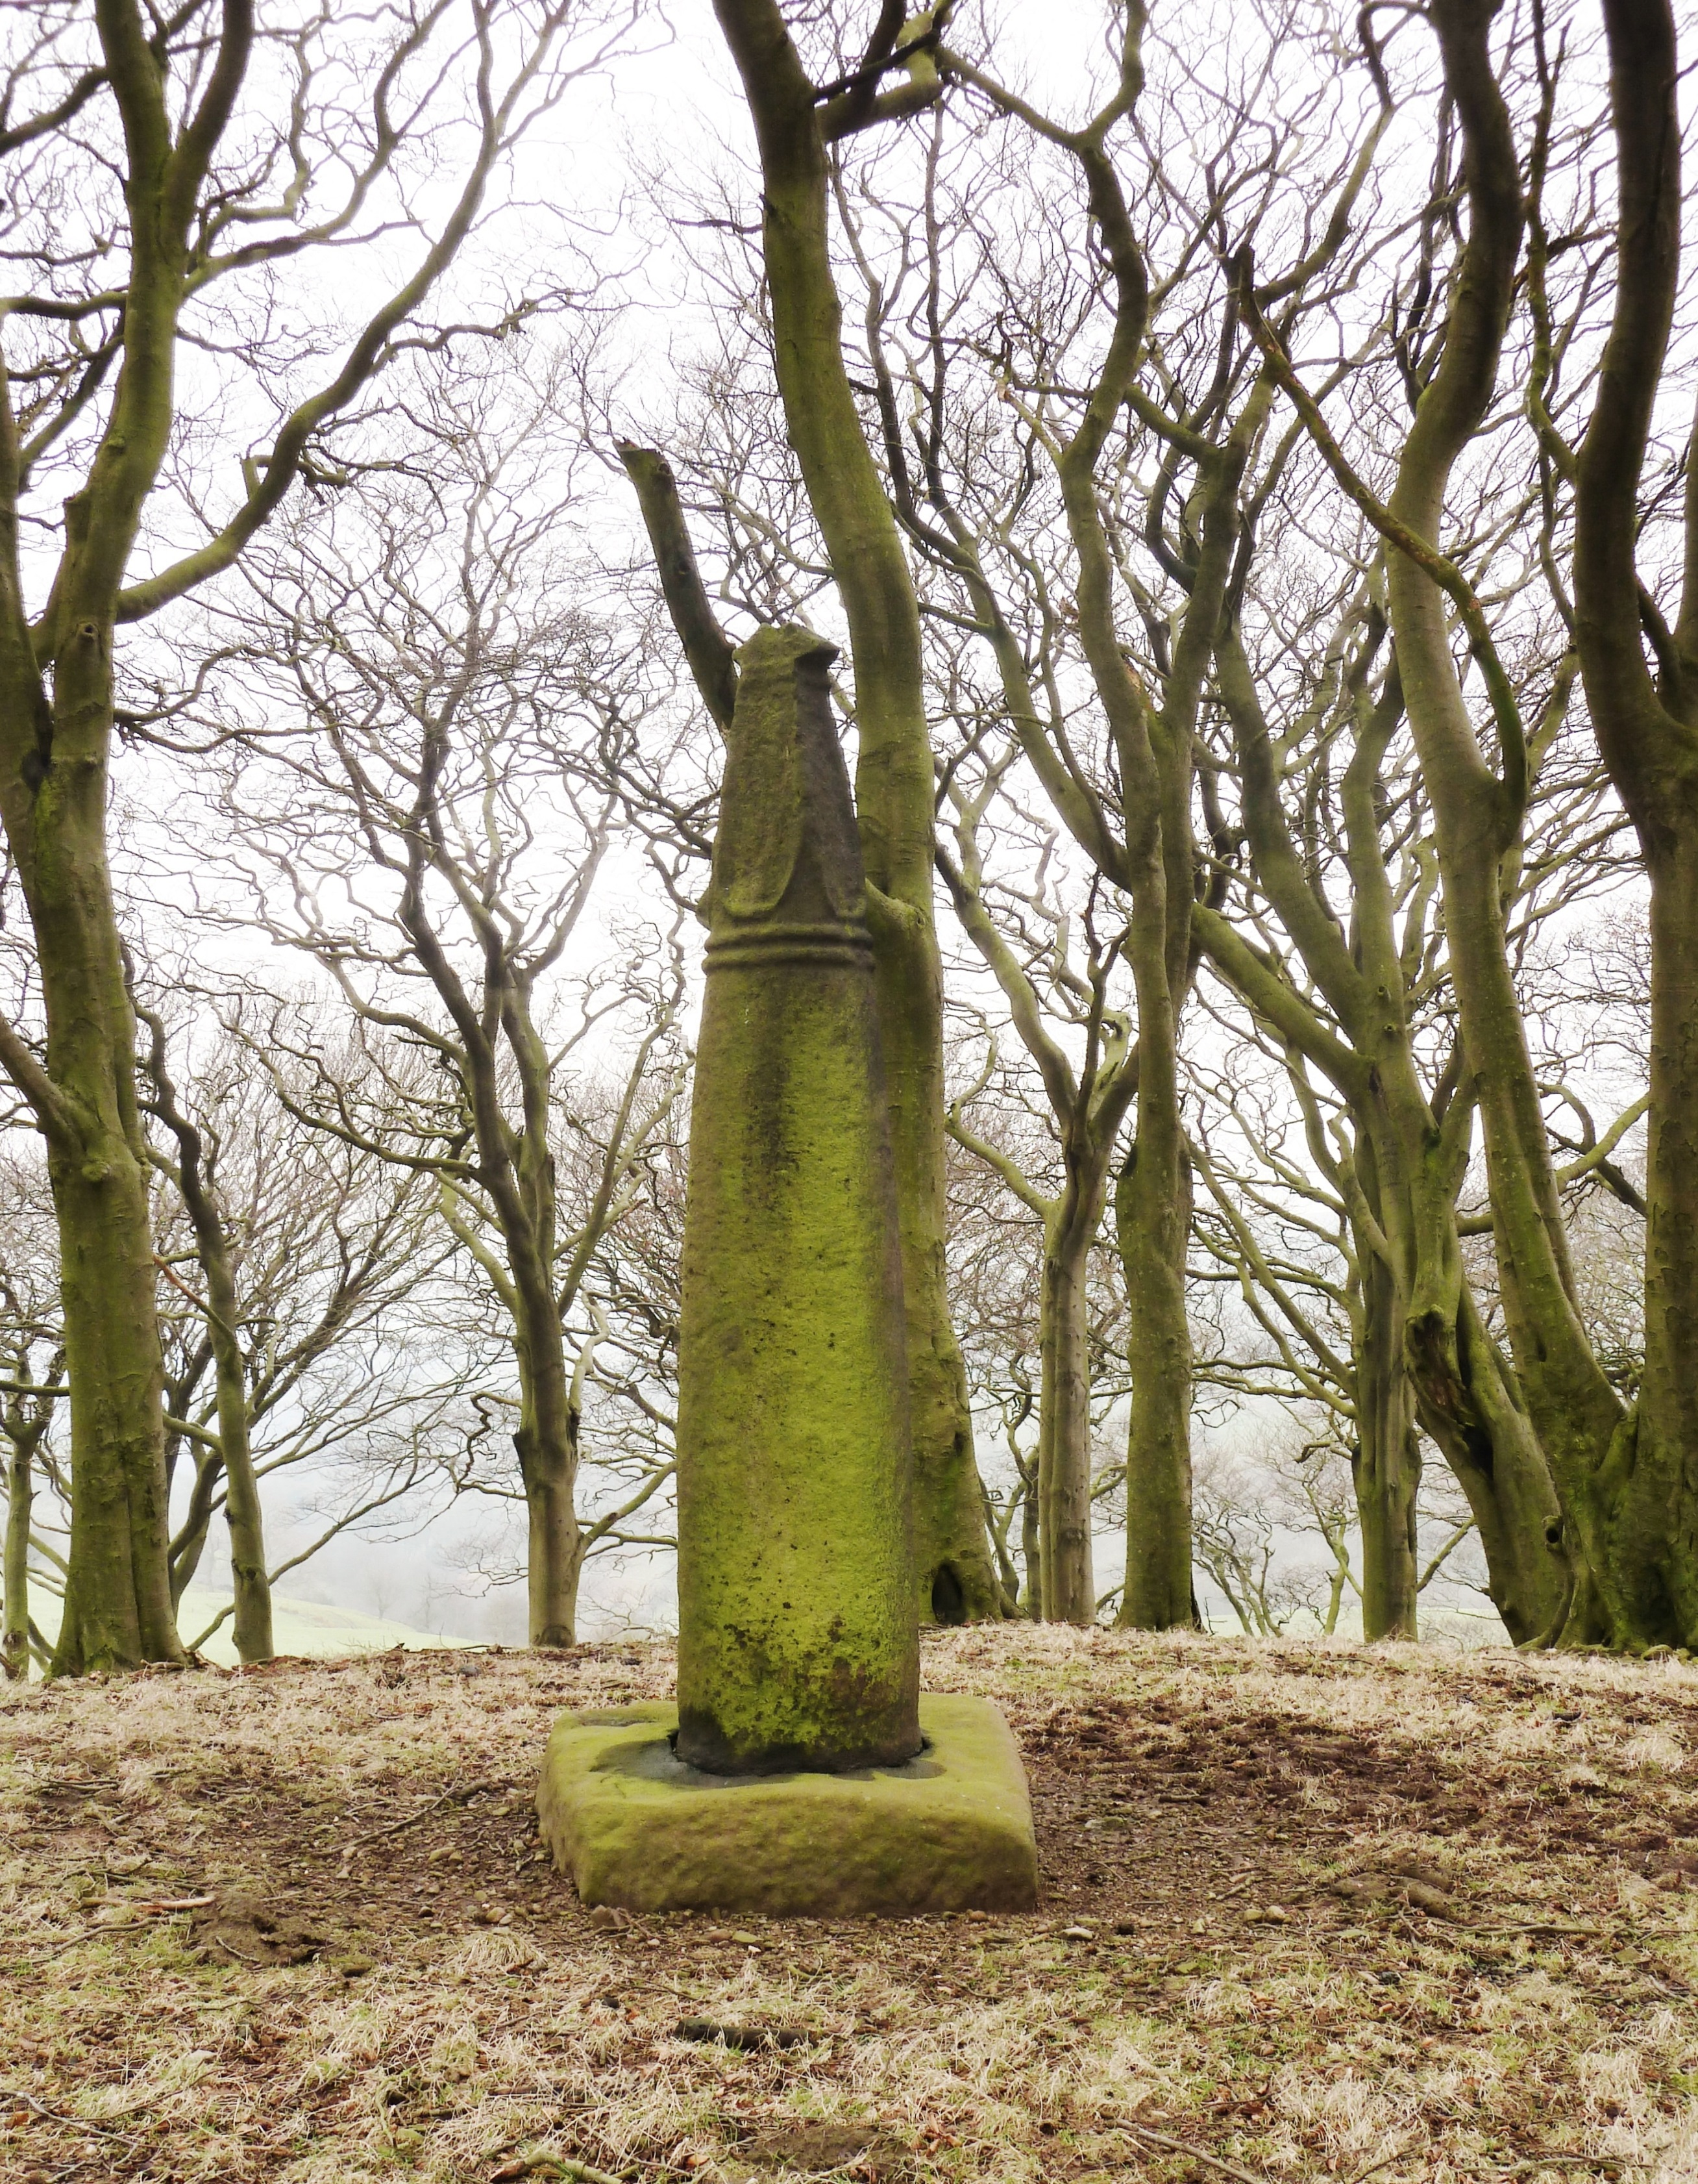
Fig.*. Astbury 1A, Cheshire. Copyright Corpus of Anglo-Saxon Stone Sculpture, photographers K. Jukes and D. Craig.

Fig 21. Wincle 1, Cheshire (© Joanne Kirton)

The other two examples from St Michael’s (formerly All Saints) in Macclesfield are only tentatively associated with the church structure, which was founded by Queen Eleanor in AD 1279 (Richards 1973, 205). These are believed to be part of ‘remains of an Anglo-Saxon cross’ found during alterations in AD 1882 (Aston 1904, 169). However, there is no description of this cross, so it is difficult to pinpoint which monument of the two it refers to or even if it refers to them at all, making it difficult to confidently establish recent provenance. Furthermore, there is no evidence of a church at this site prior to the thirteenth century, so it is impossible to determine if these monuments were associated with an earlier unrecorded church or brought to the site at a later date. This group is too small to draw any firm conclusions but all three fragments from St Mary’s, Astbury and St Michael’s, Macclesfield are highly fragmentary, particularly when compared to the rest of the group. The Astbury example was used as building material and it is probable that the Macclesfield examples, considering their fragmentary state, were also used in a similar manner.
Returning to the group as a whole, the assemblage appears to have been incorporated into the church fabric at a later date than their west Cheshire counterparts. Astbury 1 was noted in AD 1892 as a support for a beam in the north chancel, built between the fourteenth and fifteenth centuries (Pullinger 1892, 39). The monument was not fixed within the church structure, so its incorporation into the fabric of the building is not secure. The other two fragments from the church are also found loose within the interior and have no earlier provenance than a photograph taken in AD 1915 (Bailey 2010, 47). At Macclesfield, fragments 1 and 2 have a better context, being used as foundations below the Legh Chapel, which dates from either its original construction in c. AD 1422 or the later restoration of AD 1620: it is not made clear which by Boyd (1901, 17). Fragments 3 and 4, as discussed, are tentatively associated with a discovery of a 'Saxon cross' noted in AD 1882 (Aston 1904, 169). However, no description survives to securely link these carvings to the discovery or a description of their discovery. Finally, the site of Prestbury houses four carved fragments. Fragments 1 and 2 are thought to originate from the churchyard cross that was taken down in AD 1576-80 and were later incorporated into the fabric of the building in one of its many building phases that post-dates this action (Bailey 2010, 95). Prestbury 3, now lost, appears to have been found built into the fourteenth-century walls of the chancel in AD 1841 (Renaud 1876, 74) and is, therefore, the only fragment securely dated to the medieval reuse witnessed in the west of Cheshire. As has already been established in the round-shaft section, the east and west of Cheshire underwent comparable restoration work, so this discovery is not the outcome of differential restoration practices. Instead, it would appear that those few fragments with a direct provenance (Astbury 1, Macclesfield 1 and 2, Prestbury 1, 2 and 3) had a final stage of reuse that is later in date than the west Cheshire examples, with the exception of Prestbury 3.
It is not immediately evident why low-level reuse would occur during this later period. A variety of circumstantial evidence might explain the data. After the county was laid waste, in AD 1069-70, the Norman landowners focused their attention primarily on the west of the county, with Chester being the main location for their activities. They initially focused their estates at Frodsham, Weaverham, Aldford, Eastham and Macclesfield (Higham 1993, 208). Only the latter falls within the east of the county. They also built castles at Chester, Malpas, Halton, Aldford and Bowdon (Higham 1993, 209). Again, only Bowdon falls within the east of the county. As well as the impact the secular elite had on the focal areas for activity in Cheshire, the church also played a significant role, despite not being a rich religious house, compared to others in England (Husian 1973, 125) Of the seven early religious foundations that the Norman's initiated (two in Chester, one each in Norton, Combermere, Poulton, Stanlow and Mobberly) (Husain 1973, 125), only the latter was in the east of the county. This demonstrates that the east of the county bears a notable scarcity of castles, estates and monastic foundations, which indicates a limited interest in the area by the highest echelons of Anglo-Norman society.
This is further highlighted when the Domesday geography of Cheshire is mapped. In AD 1086 the plough-teams documented for Cheshire compared to the availability of workable land indicates that the east of Cheshire was underused (Darby and Maxwell 1962, 341). For example, in Macclesfield there was sufficient land to host ten plough-teams but only one was noted. However, in west Cheshire at Farndon and Fulk Stapleford for example, there were more plough-teams noted than land available, suggesting a disparity in how the east and west of the county was inhabited and exploited at the time of Domesday (Darby and Maxwell 1962, 342). This regional difference is also reflected in population densities (see Darby and Maxwell 1962, 348-9), whereby the east of Cheshire has a significantly smaller population to the west of the county. Darby and Maxwell (1962, 354) state:
‘Of the five recurring standard formulae, those relating to plough-teams and population are most likely to reflect something of the distribution of wealth and prosperity throughout the county in the eleventh century…..Broadly speaking, the main contrast in the county was between the richer west, with population densities of 3 to 4 per square mile and plough-team densities of about one over, and the poorer east, with densities of only one up to one-quarter of these’.
Both Darby and Maxwell (1962, 354) and Phillips and Phillips (2001, 28) suggest that the eastern part of the county recovered more slowly from the harrying of 1070. The western part of the county was the powerhouse providing the largest liability for the county, as the hundreds of Chester, Dudeston and Willaston provided over half of the counties taxable wealth (Phillips and Phillips 2001, 30).
Aleksandra McClain's (2011, 151-184) study of local churches after the Norman Conquest explores what changes and continuity can be observed in areas of Northumbria (North Yorkshire, County Durham and Northumberland). She makes an important observation in her study area: the evidence for church re-builds and the destruction and reuse of early medieval stone sculpture in the eleventh and twelfth centuries was not standardised across the region. Instead, it is evident that the Norman influence on church structures and monuments is stronger in areas of primary settlement, which are well connected and populous. In peripheral areas where Norman rule is restricted there is strong evidence of continuity of style and decoration. There is also less evidence for re-building and new builds of churches. This is particularly evident in Northumberland and County Durham, where a strong English presence was retained long after the Norman Conquest (McClain 2011, 170, for further discussion see below).
The difference in Norman interest between east and west Cheshire, as outlined above, may explain why we see less evidence of early reuse in the east. As noted by McClain (2011, 162-165) those areas in Northumbria that were peripheral were less likely to begin rebuilding immediately after the Conquest. In terms of Cheshire, the east appears to be of peripheral interest and based on McClain’s observations in the North East of England, it is not unexpected that activity in the form of rebuilds and sculptural reuse was limited and delayed when compared to the west of the county. Furthermore, evidence of continuity of practices is stronger in these areas, which might explain why monuments, such as the churchyard sculpture found at Prestbury, were still standing in the sixteenth century. The peripheral eastern areas of the county would be the places most likely to demonstrate continuity of practice. For example, they retained their early medieval stone sculpture and possibly their churches until a later date. One or both factors may have contributed to this delayed reuse in east Cheshire churches, as monuments may have continued to remain standing longer and been incorporated at later dates.

Summary
By considering the locations in which these monuments were found, the fabric or foundations of churches or their surrounding churchyards, it was possible to determine an approximate date for their incorporation into buildings. Monuments in west Cheshire were being incorporated into structures between the twelfth and fourteenth centuries. In the east of Cheshire this process began much later between the fourteenth and fifteenth centuries, supporting this notion of a divide between the counties east and west. By establishing a timescale for reuse it was then possible to explore what may have been happening in the county that accounts for this disparity.

CONCLUSION
This section has presented and worked through the evidence for reuse in Cheshire. It has firmly established a difference in reuse practices between the east and west of the county. It has argued that these differences are based on the monuments original location and the disparity based in how the east and west of the county developed politically and socially in the centuries after the Norman Conquest. This observation would not have been possible without a regional approach that explores biography and distribution simultaneously. In the following sections this data set and the observations made here will be used to explore why monuments were pulled down and reused in the first instance.

CHANGING ATTITUDES TOWARDS EARLY MEDIEVAL STONE SCULPTURE IN THE POST-CONQUEST PERIOD

Why ignore or destroy them?
Reuse in Cheshire appears to have occurred between the twelfth and fifteenth centuries. Something during this period encouraged their removal and sometimes their destruction. As was demonstrated with the iconoclasm of the seventeenth century, these types of widespread changes were usually brought about by wider social change. The Norman Conquest of AD 1066 created great upheaval for the Anglo-Saxon/Anglo-Scandinavian elites and church (Allen-Brown 2000, 178- 88; Thomas 2008, 101-5) and this had a demonstrable impact on the survival of early medieval stone sculpture, as so much is incorporated into Norman structures. However, it is unlikely that reactions to early medieval stone sculpture in the post-Conquest period were consistent and motivated by the same concerns, so we cannot rely on one explanation. Instead, a consideration of a variety of factors is required, informed by the contexts of each fragment, the broader archaeology of the area and historical accounts.
Deirdre O'Sullivan (2011, 163-191) identifies several factors that might lead to the destruction of early medieval stone sculpture in post-Conquest England. Firstly, she suggests that some sculptures simply lost their social and religious import: a form of 'liturgical and cultural redundancy', which manifested itself commonly in practical reuse in places like walls, foundations and drains. She suggests that the move toward burial of elites within churches rather than churchyard burial at this time, as outlined by Nigel Saul (2009, 24-35), drew emphasis away from the outside of the church and into the interior, where a new form of monumentalisation became popular, for example the trend for effigy tombs. This monumentalisation also encouraged the creation of new churches or the re-building of wooden pre-Conquest churches, in part to house these burials. An outcome of this re-building was sometimes the destruction and re-modeling of graveyards. Monuments that were in the way were either removed or built over. This is particularly true of monastic and episcopal sites, where there was a predetermined, claustral ground plan that had to be followed (O'Sullivan 2011, 186). These new plans provided no room to build around monuments and/or churchyards. For example, the new Norman Cathedral at Durham was built over, and cut through, the earlier Anglo-Saxon cathedral’s burial ground (Rollason 2000, 211 and 255). At York, tenth- and eleventh-century fragments of sculpture, some still in situ, were unearthed beneath the Minster, which had been constructed over the graveyard (Phillips and Heywood 1995, 33-169 and Lang 1995, 433-67). Many more examples were found incorporated into the fabric of the building, demonstrating that both methods of reuse were equally acceptable (O'Sullivan 2011, 174). So monuments may have been removed for practical reasons, such as space or re-shaping the churchyard layout.
Another practical consideration, is how well they complemented the decorative repertoires of the new buildings, particularly when we consider that the only major churches not rebuilt after the conquest were those at Waltham and Westminster, which had copied Norman styles from the continent. The rest were knocked down and rebuilt (Brown 1984, 89; O'Sullivan 2011, 165; McClain 2011, 152). Deirdre O'Sullivan (2011, 165) suggests that the destruction of many Anglo-Saxon churches was based on the Norman preference for a simpler aesthetic. One that appealed to contemporary monastic reformers and, as such, was largely acceptable to the native ecclesiastical community. Importantly, rebuilding was not simply a Norman practice introduced after the Conquest but one that was already established in England and was simply accelerated by the Norman invasion and settlement. The primary difference before and after the Conquest was that prior to it the Anglo-Saxons/Anglo-Scandinavians worked to improve existing buildings, whereas Norman architects preferred to start afresh (O’Sullivan 2011, 165-6).
However, as both O'Sullivan (2011) and Aleksandra McClain (2011) acknowledge, there were also symbolic considerations that affected church building and their associated pre-existing stone monuments. McClain (2011, 154-5) states that the production of stone churches and commemorative monuments began prior to the Norman Conquest and it was a visual vocabulary of authority. John Blair (2005, 411) notes how rebuilding in stone really began around AD 1000 and was simply intensified after the Norman Conquest. These earlier rebuilds were constructed primarily from mortared rubble with arched doorways, windows and chancel arches, using dressed stone for corners, openings and arches. He calls this shift a 'cultural horizon' (Blair 2005, 414). This demonstrates that the Anglo-Scandinavian communities used the systems already in place and manipulated them to suite their own needs. This can be seen again during the aftermath of the Norman Conquest and well into the twelfth century. The newly established Norman elites actively used this developed visual vocabulary to mark their new positions within society by accelerating the construction of new stone churches and monuments. It was an 'active manipulation' of recognisable material culture associated with authority. ‘Material expression and display were integral means through which people adapted and dealt with turbulent events, and reinforced or changed social, cultural and individual identities’ (McClain 2011, 152). Churches and their monuments were signs of temporal power and legitimised authority. Churches had increasingly become patronised by the secular elite prior to the Norman Conquest. Large estates were broken up, which created a larger manorial elite and in turn they founded new churches and chapels on their land (McClain 2011, 154). They also created many stone monuments that make up the majority of the Cheshire assemblage today. However, it was not solely the remit of the new Norman overlords but was also practiced by those English elite who survived the Conquest or who were promoted after it. Two of the most elaborate churches constructed quickly after the Conquest, at Milborne Port (Somerset) and Langford (Oxon.), were commissioned by English men, Regenbald and Aelfsige of Faringdon (Blair 2005, 416). This demonstrates that this practice was not a form of Norman control but one developed prior to the Conquest and used by all those who sought to maintain power and control after it. Nevertheless, it is also evident that whilst the Norman Conquest did not start the rebuild of churches and the removal of monuments, it intensified it and introduced new architectural styles and decoration, which expedited the loss of significance and interest in some early medieval stone sculpture, which found its way into the fabric, foundations or buried in churchyards of Norman churches and monasteries.
The other factor that O'Sullivan (2011, 163 and 183) considers is the 'active demolition' of early medieval stone sculpture. She argues that many of the Anglian and Anglo-Scandinavian sculptures found in eleventh- and twelfth-century contexts are highly fragmented but very crisp, indicating that these monuments were removed when in a good condition and deliberately destroyed and buried for symbolic reasons rather than practical considerations. O’Sullivan questions the motive for this by exploring the physical context in which the sculpture is located and the social and political climate at the time. Her primary question is: to what extent did early medieval stone sculpture, in the eleventh and twelfth centuries, serve 'as tangible links with earlier power structures' and how this potential link might affect their destruction and survival. This is quite different to the previous point, as instead of being redundant/unimportant, it suggests that some monuments may have taken on a new or revived symbolic role in the post-Conquest period, possibly one of association with past ruling groups and, as such, developing negative connotations for the new hierarchy – a form of citation. She suggests that there was a deliberate process of 'Normanisation' where earlier symbols of Anglo-Saxon/Anglo-Scandinavian groups were deliberately targeted for destruction because they retained some symbolic import to those individuals/groups that could potentially threaten/undermine the new ruling hierarchy (O’Sullivan 2011, 183).
As well as exploring the impetus for the removal and/or destruction of monuments it is also important to consider why particular monuments were reused in the county. There are a number of probable reasons, which closely mirror the reasons for their destruction: they were reused for practical purposes or for symbolic reasons. This second group can be considered in two ways: a monument may be reused because it had positive symbolic connotation(s), which individuals wished to appropriate for their own reasons or the monument had negative symbolic connotation(s) and the reuse was a means of either controlling the power of the monument or an act of deliberate forgetting. However, exploring the impetus for reuse is difficult, as much of the monuments contextual data has been lost and remains the major drawback with this data set

Symbolic Reuse
Evidence of monuments being reused for symbolic reasons, whether negative or positive, is incredibly difficult to discern, primarily because most were poorly recorded when they were discovered and few have undergone archaeological investigation in situ. However, where this has been possible the results clearly demonstrate that symbolic reuse was undertaken in post-Conquest England.
The Lichfield Angel, discovered under Lichfield Cathedral’s Gothic nave in 2003, is one such example. The fragment of sculpture depicts the figure of an angel on Ancaster Limestone, which forms one part-face of a boxlike structure with a coped lid. Rodwell et al. (2008, 55) state that it was part of shrine chest, possibly part of the original St Chad’s shrine, which was housed in the Anglo-Saxon timber framed church of St Peter, as described by Bede in AD 731. The fragment of carving was buried sometime before or during the tenth century, based on the archaeological material surrounding and covering it (Rodwell et al. 2008, 56). The fragment is in very good condition with paint surviving on its surface (see Fig. 22).

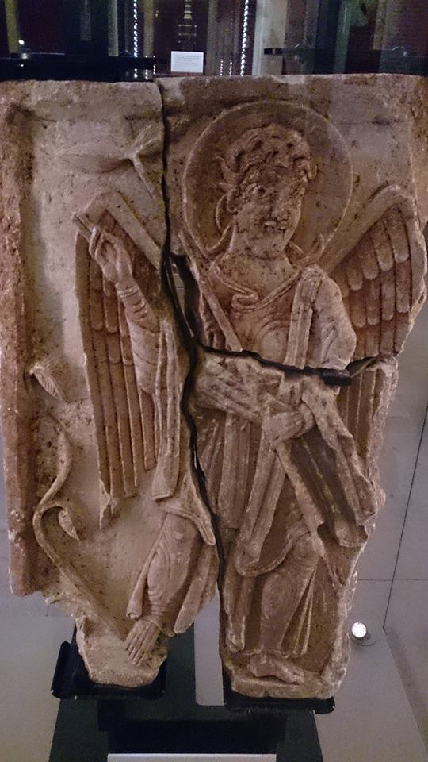
Fig. 22. The Lichfield Angel (© Joanne Kirton)

The deposition of this carving was a deliberate act, as it was found within its own pit with stone packing. The pit was located next to a larger timber-lined pit found on the central axis of the cathedral and believed to be the location of the original St Chad’s shrine with a possible crypt (Rodwell et al. 2008, 53-55). Whilst we know the burial of this carving was intentional, it is the condition of the carving, its location and surrounding archaeology that provides us with insight about the impetus for deposition.
Firstly, despite being found in three fragments the carving is in very good condition. It has been deliberately cut away on its right side, so its removal from its original location was a deliberate act. Rodwell et al. (2008, 59) suggest that the fragmented nature of the carving may have occurred during its removal. As the carving is only partial, it can be argued that the angel alone was deliberately chosen for deposition. However, Rodwell et al. (2008, 59) suggest that other pits containing other parts of the box shrine may have been placed around this location. The choice of a specific image and its remarkable condition suggest that the incorporation of this monument into the foundations of the cathedral was not an act of vandalism.
The context in which it was unearthed provides further clues. The creation of a pit to house the carving on its own and packing stones to keep it in place indicate that much care was taken over its burial. Furthermore, its location below a crypt or burial chamber possibly associated with the shrine of St Chad - one of the most important sites within the cathedral - suggests that this carving was significant and remained so after it had been removed from its original location. Finally, the activity undertaken after the burial of the carving is also very telling. The new Norman cathedral was focused on this space, indicating that this area was of great import in the post-Conquest period, being remembered and acknowledged, as the space was venerated well after the deposition of the carving. What is more, the discovery of well-appointed canons’ burials circling the area where the carving and timber-lined pit was found, dating from the late thirteenth and early fourteenth centuries (Rodwell et al. 2008, 55), demonstrates that this space continued to be venerated for hundreds of years after the deposition of the Lichfield Angel. Whilst the memory of the carving's burial may have faded with time, the reverence offered this particular space demonstrates that the Lichfield Angel was situated within an incredibly important space within the church. Clearly, the burial and reuse of this carving was one of commemoration and respect – a positive act of reuse. The burial was used to augment the new Cathedral, rather than simply forget the previous structure.
Conversely, a group of monuments reused in a church structure at Sockburn in County Durham, suggests symbolic reuse as a means of deliberate forgetting and appropriation of a space. The examples at Sockburn were removed and reused for very different reasons: a thirteenth-century chapel was constructed over the remains of an earlier chapel probably dating to the eleventh or twelfth century. Within the chancel of this earlier chapel were the remains of some twenty-three pre-Conquest monuments. Notably these monuments have secular iconography with probable elements pertaining to Scandinavian mythology (Cramp 1977, 191-233). The property was acquired by a Norman family, the Conyers, sometime between 1099 and 1128 (O'Sullivan 2011, 182). The removal and reuse of these pre-Conquest monuments during this period suggests that a change of ownership was likely responsible for their removal and incorporation into a new building, whereby the new owners were eradicating any visible trace of the earlier incumbents.
These two examples demonstrate two types of reuse, one where the reuse of these monuments was used to augment a structure another where it appears the reuse was a deliberate attempt to forget the previous activity on the site. Both processes lead to the same outcome in this instance, in this case the burial/reuse of sculpture. However, whilst the Lichfield Angel was clearly a form of positive reuse, its burial meant that no one was able to see it. Reuse in this way, in any situation, must also be a form of deliberate forgetting, as only those who knew what had happened to the monument would remember and within a few generations those who had seen the sculpture prior to burial would all be dead. Had the monument meant to be remembered and commemorated by future generations it would need to be visible. This was not the case and we must assume burial was a deliberate act to both augment the new building by an association to a saint (the tomb of which the sculpture was likely to have adorned) whilst forgetting the structure. Therefore, reuse where a monument is no longer visible must be considered a form of deliberate forgetting.
The interpretation of the Lichfield Angel and the examples found at Sockburn suggest that early medieval stone sculpture was being reused for symbolic reasons. However, the discovery of the Lichfield Angel also highlights another issue, the value of discovering early medieval stone sculpture within undisturbed archaeological layers. Without the specific context for this sculpture, revealed through archaeological excavation and recording, it would have been impossible to understand the significance of the reuse and the strong influence its presence had on activities within the church and the impact on burial traditions. No monuments in Cheshire, with the exception of the Tarvin Cross and Chester Amphitheatre 1, were recovered during archaeological excavation, which severely impacts our understanding of reuse in the county. Of those that were excavated, Tarvin appears to have been dumped after being deliberately destroyed with no evidence for reuse and Chester Amphitheatre 1 was poorly recorded and no link to sealed archaeological contexts was evident (Bailey 2010, 128 and 70).
The round-shafts of east Cheshire appeared to develop other symbolic uses, not because they were removed or destroyed but because they appeared to have endured in the landscape for centuries, even after they were apparently mutilated in the seventeenth century. Like the Lichfield Angel, context is crucial for understanding why these monuments survived to develop other functions, such as civil uses and markers for burial, as discussed earlier in the chapter. In the case of round-shafts it is the landscape context, rather than their situation within an archaeological sequence, that allows for an understanding of their biographies, but the notion is the same. Had the Bowstones or Wincle 1, as examples, been removed from their original settings and deposited elsewhere, it would be incredibly difficult to understand how they had developed different functions over time and why they came to lose their cross-heads.
A large proportion of reused monuments suffer from a loss of context, particularly those that were removed during restoration work or the demolition of church structures. In Cheshire, of those monuments with a known provenance, 60% were found in this way, which makes discerning the impetus behind reuse problematic.

THE CHESHIRE EVIDENCE
The preceding discussion has considered the possible impetus for destruction and reuse of early medieval stone sculpture after the Norman Conquest. In the final section evidence for the deliberate destruction and reuse of Cheshire monuments will be sought and discussed in light of changes occurring across the county. The discussion will also consider how the survival of the data set and the recording of their contexts has impacted our ability to interpret the data.

Removal and Destruction in Cheshire
Cheshire rebelled after the Conquest, as part of the Mercian uprising and many who supported Cheshire’s Earl Edwin joined the rebellion (Higham 1993, 190). The rebellion forced William the Conqueror to march his army north and lay waste to the area between AD 1069-70 (Higham 1993, 190). Following the unsuccessful rebellion William’s forces built castles in the Mercian centres of Chester, Stafford and Shrewsbury (Higham 1993, 191), leaving a garrison at each – a very visible symbol of his authority over the area. Despite the clear unrest in the county it appears that William and his forces established a strong presence in Chester and he gifted the land to Hugh de Avranches (Hugh Lupus), creating a new regional elite. As part of this reorganisation of power and land control there may have been a desire to forget, to some degree, the previous ruling elite. One way of doing this might have been to remove and sometimes destroy visual representations of their authority, such as the monuments they patronised and those that were erected to commemorate particular individuals. Some stone sculptures appear to have been strongly related to ruling pre-Conquest groups who were themselves using these monuments to emphasise their own import and collective group identity, such as the mercantile Anglo-Scandinavian groups in Lincolnshire and Yorkshire identified by Stocker (2000, 206-7) (See Chapter Five for further discussion of the evidence). By removing monuments from their original settings, sometimes destroying them and/or incorporating them unseen into later structures, the new ruling elite were potentially trying to either eradicate particular memories of the past or harnessing any positive associations these monuments may have held, subsequently, taking control of them. For example, several pre-Conquest monuments were unearthed beneath Durham Cathedral in 1891 (O'Sullivan 2011, 169). One of which was a fine coped grave-cover, which Rosemary Cramp (1980, 8-9) suggests could have belonged to the Ealdhun (d. 1018), who was the founder of the Anglo-Saxon cathedral, which was later demolished to make way for the new Norman cathedral begun in 1093. Even without the link to Ealdhun, the cover clearly belonged to a significant Anglo-Saxon or Anglo-Scandinavian, as did the other monuments found at the site. Their destruction and burial in the foundations of the new cathedral could have been a deliberate act of memory destruction or appropriation, particularly if the grave-cover had belonged to the founder of the previous cathedral (see also the discussion of the Lichfield Angel).
Alternatively, if the old ruling families were no longer living in the area then there may have been no one to care for or remember the graves and/or monuments, and in time they were forgotten. Zoë Devlin (2011, 37-9) notes that some monuments survived longer because they remained relevant to the local community. Devlin (2007, 77-8) has also noted how considering the location of graves through monuments, wooden staffs and/or mounds was important to Anglo-Saxon communities in terms of remembering their dead and their links to kin and the wider community. However, only a small number of individuals within a cemetery group were given special markers such as stone monuments, indicating that they were particularly significant to the community and were likely linked to important communal commemorative practices (Devlin 2007, 78). Devlin argues that once stone monuments were reused, this is evidence that the memory of the individual(s) and their ties to a specific kin/social group have been dissolved and/or forgotten. In turn, this would have weakened the collective social memory of local groups (Devlin 2007, 55-7). A new ruling elite would find this particularly beneficial.
Tim Eaton (2000, 100) has argued that the reuse of Roman monuments such as altars in early medieval churches could also be a form of deliberate destruction whereby monuments that had previously been worshiped and may have retained some ritual import were removed and 'entombed' within new churches as a way of 'neutralising' their power and/or harnessing their associations for the new buildings. For example, he argues that the inclusion of altars as parts of doorways in religious buildings, such as the seventh-century crypt at Hexham, was a form of harnessing the altar’s ritual significance as a means of protecting the doorway. He notes how doorways have had enduring social meanings. They were 'weak points in the fight against superstition and the spirit world’ (Eaton 2000, 109) that needed special protection. Whilst not definitively proven, this hypothesis provides convincing evidence for the appropriation of association for later buildings. Furthermore, he also argues that the reuse of monumental blocks within church structures was a form of citation, whereby, their reuse was literally building a link to the might and power of Rome, which, in the seventh century, was the heart of Christianity. It was also a form of aggrandising the new buildings (Eaton 2000, 126-7). Bidwell (2010, 131-134) suggests that the reuse of large masonry blocks, whilst clearly having a practical advantage also demonstrated that the stonemasons and builders were able to build in the Roman style, which in itself was an accomplishment. A further consideration, is that Wilfrid was signaling that his ability to work in stone and wield massive Roman masonry as the Romans had before him, in a landscape sparsely populated with early medieval stone buildings, was evidence of his and the churches legitimate inheritance of authority from Rome.
Active demolition and/or a general disregard for religious structures, monuments and decorations also led to the plundering of churches for spoils. For example, at the monastery at Abingdon a Norman monk melted down its chandelier worth £40 and sent the proceeds back to Normandy. At Ely, various figurines were stripped of their precious metal and gems (Thomas 2008, 120). It is not a stretch to imagine that stone sculpture was treated with as little reverence as the figurines at Ely and the chandelier at Abingdon. Those stone monuments that were highly decorated with metal fittings and inset with gemstones, such as the Sandbach crosses (Hawkes 2002, 146) may have drawn particular attention. For the new hierarchy an active dislike of pre-Conquest stone sculptures or a simple disregard for them would likely have ensured that during the rebuild/foundation of many Norman churches in the later eleventh and twelfth centuries, they were pulled down, plundered and/or removed. Combined, these factors provide several reasons why we might expect to see early medieval stone sculptures removed and sometimes destroyed. Clearly, there was a variety of motives at work. Some based on the redundancy of the monuments, others on an active dislike encouraged by societal and political changes occurring across the country.
In Cheshire, none of the contexts in which the monuments were unearthed provide enough information to identify if any were removed simply because they were no longer important or were in the way of later buildings. However, the appearance of monuments within Norman structures, as at St John’s, suggests that these monuments may have been removed to make way for new constructions. The round-shaft monuments and Tarvin Cross discussed earlier demonstrate that monuments were deliberately mutilated based on changes to people’s perceptions and understanding of what they believed and understood to be right. However, earlier evidence pertaining to the centuries after the Norman Conquest is less forthcoming. The deliberate destruction of decoration like that found on the Woodwray cross-slab, Angus, as discussed above, is scarce. The only monument that may have had decoration removed is West Kirby 3, which appears to have had its central boss chiseled off (Bailey 2010, 134), which is not uncommon, see Cawthorne 2 in West Yorkshire for a similar occurrence (Coatsworth 2008, 115). However, it is hard to argue that the central boss would have caused particular offence on this monument. It is more likely that it was removed to level the surface of the fragment for reuse in St Bridget's Church.
The evidence for the complete removal of monuments motivated by symbolic factors is harder to determine. The only surviving evidence comes from the Star Chamber's account of AD 1613, which lists three churchyards monuments in west Cheshire - Barrow, Christleton and Ecclestone - that were completely destroyed by the iconoclasts: their fragments were scattered amongst their respective churchyards (Cheshire Sheaf 1923, 100-1; Bailey 2010, 150). There is no way of knowing if these monuments were of an early medieval date but the account clearly demonstrates that church monuments, where they survived intact into later periods, were being destroyed (not simply mutilated) in the seventeenth century for religious and social reasons. Those monuments that were reused in the twelfth to fourteenth centuries are heavily fragmented reducing the likelihood of spotting purposeful mutilation or evidence that they were deliberately removed and/or broken up. Moreover, the reasons for removing specific monuments from their original locations (and the subsequent reuse) is almost impossible to establish, as it is not clear which were deliberately taken down and reused and which fell down and were later reused. However, it is evident that many of the monuments within Cheshire have evidence of being deliberately re-shaped (Astbury 1, 2 and 3, Bromborough 1, Chester St John 1, Disley Lyme Hall 3, Macclesfield 2, 3 and 4, Neston 4, Overchurch 1 and West Kirby 2), presumably for reuse in the church structures that they were found in (Bailey 2010).
It is possible, as was demonstrated above, to determine the latest date that they were re-shaped, based on their association with specific building phases within their associated churches architecture. For example, we can deduce that the cutting away of the base of Chester St John 1 occurred during or before the fourteenth century and that Neston 4 was likely re-shaped before AD 1170 and placed in the church foundations, as was West Kirby 4, based on their locations within the architectural sequence of the respective structures to which they belong.
So whilst there is much circumstantial evidence to suggest that the loss of standing stone sculpture and architectural fragments associated with church buildings from the early medieval period was a deliberate act brought about by wider social change, the assemblage in Cheshire provides only limited evidence. This problem is compounded by the fact that much of Cheshire is poorly recorded after the Conquest, so establishing links between the biographies of particular monuments and particular social, economic and/or political changes is difficult. It is only possible to determine overall changes to the county that coincide with trends evident in the Cheshire assemblage. Events such as the wasting of Cheshire by William the Conqueror between AD 1069 and 1070 and Earl Edwin’s subsequent demise, cannot have failed to have had an impact on Cheshire. The Domesday Book indicates that Cheshire was one of the poorest counties in England by AD 1086, largely due to the limited settlement growth and the economic prosperity that often went hand-in-hand. This was probably a result of low population density, the destruction of many settlements during the harrying and the heavy bias towards Chester and its hinterlands by its new Norman overlords. For example, the county was very slow to develop nucleated settlements, instead preferring the small church hamlets, manorial holdings and scattered farmsteads that had predominated prior to the Norman invasion (Higham 1993, 202-4). Only Chester and its surrounding areas appear to have prospered during this period. It follows then that west Cheshire churches were more likely to be the focus for rebuilds during the twelfth century as the attention, power and money was focused there with little if no attention directed towards the distant hamlets of east Cheshire and its remote hilltops (as highlighted by the lack of castles, estate centres and religious foundations noted earlier), where many of the round-shafts were erected. The west of Cheshire had also been the focus for the county prior to the Conquest, so there was likely more evidence, in the way of people, structures, monuments and place-names, that reminded people of the past, prior to the Conquest. It is, therefore, more likely that this area would also be the focus of rapid change, as the new ruling groups sought to establish themselves in their new positions within a particular area by appropriating and/or eradicating evidence of previous important individuals, kin or social groups. Whilst specific links between monuments and the actions of post-Conquest individuals or groups is not forthcoming, the links between regional trends for monument reuse in Cheshire and the social, political and economic changes occurring in the county, largely fit with broader patterns of destruction and reuse, and timescales noted by O'Sullivan (2011) and McClain (2011) in other areas of the country, suggesting comparable activity in Cheshire is likely.
As is clearly the case based on the evidence set out above, the biography of the fragments of early medieval stone sculpture did not stop when they were removed from their original locations and from their original purpose. Instead, many find their way into the fabric of later buildings and others remain in situ but take on new meanings and functions. The trends evident in the assemblage suggest that this was not occurring on an ad hoc basis – reuse was based in broader social, economic and/or political events occurring in the region.

Reuse in Cheshire
The preceding discussion has explored the evidence for reuse in Cheshire, identifying various trends and considering why monuments may have been moved from their original locations and sometimes destroyed. The final discussion will consider why particular monuments were reused in the county. There are a number of probable reasons, which closely mirror the reasons for their destruction i.e. they were reused for practical purposes or for symbolic reasons. This second group can be considered in two ways: a monument may be reused because it had positive symbolic connotation(s), which individuals wished to appropriate for their own reasons or the monument had negative symbolic connotation(s) and the reuse was a means of either controlling the power of the monument or an act of deliberate forgetting. However, exploring the impetus for reuse is difficult, as much of the monuments contextual data has been lost and remains the major problem with this data set

Symbolic or practical reuse in Cheshire
Where the type of reuse is clearly evident in Cheshire (77.4 % of those with a known provenance), the majority appear to have been reused for practical reasons. This largely appears to be reuse within the fabric or foundations of church structures or as building material for secular constructs. The group of monuments reused in church structures consists of forty-seven fragments.

Fig. 23. Reuse percentage of monuments with a known provenance

Of these forty-seven fragments only eight remain embedded in church structures. The rest have been removed from walls, foundations and the exterior ground surface (see Fig. 23). Of those monuments that have been removed, all are fragmented and there is no evidence that any particular part of the monuments decoration was respected, subsequently, providing no obvious evidence for symbolic reuse. The only early medieval stone sculpture from Cheshire that potentially falls into this category is a fragment of a monument that dates to the late ninth century; the Overchurch runic stone (see Fig. 24). Whilst not within the date range of the thesis, this monument was reused at a comparable time to the tenth-/eleventh-century monuments under discussion and was subject to the same reuse practices. It is particularly worthy of note, as it is the only example of a monument removed from a church setting that might fall into this category.
The monument is unique within Cheshire as it is the only monument with a runic inscription, found at Overchurch on the Wirral (Bailey 2010, 91-4). The Overchurch runic stone, whilst possibly only a quarter of its original size, appears to have been deliberately preserved; namely, the block appears to have been cut to size to respect and preserve the runic inscription, which is almost wholly intact apart from weathering on its corners, whilst the imagery was crudely cut through and chiseled off.

Fig. 24. Overchurch 1A, Cheshire (©Corpus of Anglo-Saxon Stone Sculpture, photographers K. Jukes and D. Craig)

The impetus behind this is unclear but the remarkable survival of the runic inscription suggests the message, rather than the whole monument, retained/developed significance enough for it to be specially preserved and built into the Norman church at Overchurch. Close inspection of the entire corpus suggests that no other monument was subject to such a clear endeavor to preserve a particular part of the decoration.
The architectural sequence in which the tenth-/eleventh-century monuments were discovered and the way they had been reused in the structures suggests no evidence of symbolic reuse. The sculpture at Prestbury, for example, was found in four fragments; at least two of these belonged to the same monument. Whilst weathered and fragmented, they were not seemingly damaged. Moreover, the ad hoc way they were incorporated into the church walls, away from each other, does suggest that they were being used as building material not specially deposited to preserve them or provide significance to a specific area like the Lichfield Angel. However, the lack of any indicators of symbolic reuse does not mean this was absent, only that the contextual information provides limited evidence. A further five: Bidston 1, City Walls Chester 1, Hilbre Island 1 and two of three monuments from Sutton (it is not known which), were used in a comparable manner, as building material, in secular contexts: shed and city walls or as gateposts, for example.
Despite the appearance of practical reuse within church structures, it is impossible to definitively state that all these monuments were deposited in this way purely as building material. Some of the deposition may have been undertaken for symbolic reasons that are no longer evident because the biography of particular sculpture is lost or the context in which they were discovered was not recorded. However, in Cheshire there are a few instances where monuments survive, incorporated in the fabric of church buildings, which means their context is readily available for discussion. These examples, at Shocklach, Frodsham and Bruera (all in the west of Cheshire), provide an opportunity to explore reuse associated with church structures and symbolic practice.

Shocklach, Frodsham and Bruera – Visible Reuse
Of the eighty fragments with a known provenance in the county, only eight (10%) remain situated within church structures. Each of these fragments is visible within a church today. The choice to make the decorative faces of these monuments visible, rather than turning them in (a practice identified by Stocker and Everson (1990) common with practical reuse), suggests that there may have been an element of symbolic reuse, dated to the late thirteenth or fourteenth centuries, based on their location within the architectural sequence of the church buildings in which they are situated. This time period coincides with a flurry of activity in west Cheshire, as at least six (of nine) churches with sculpture reused in their fabric, underwent renovation or refurbishment of one kind or another during these centuries. Understanding why some monuments were used decoratively and others hidden within walls and foundations is difficult to determine. Stocker and Everson’s (1990) criteria for reuse; ‘iconic’, ‘functional’ and ‘casual’ is not adequate and can hamper interpretation of reuse practices, as some monuments may have more than one possible reason for reuse, as will be demonstrated below.
The Shocklach example (Fig. 25) is situated in the northern nave wall dating to the late thirteenth to fourteenth centuries. The Frodsham fragment (Fig. 27) is built into the fourteenth-century tower and the six Bruera fragments are located above and around the exterior doorway situated in the fourteenth-century southern wall of the church (Fig. 26).

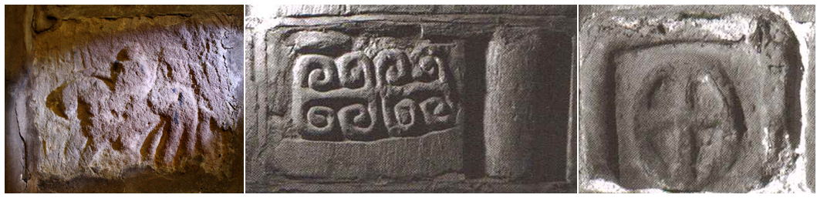
Fig. 25. Shocklach 1, Cheshire (© Joanne Kirton)

Fig. 26. Bruera 1, Cheshire (© Corpus of Anglo-Saxon Stone Sculpture, photographers K. Jukes and S. Craig)

Fig. 27. Frodsham 1, Cheshire (© Corpus of Anglo-Saxon Stone Sculpture, photographers K. Jukes and D. Craig)

Whilst clearly more visible than the monuments built within walls and used as foundation stones, it is questionable just how visible these monuments were within these churches. Firstly, it must considered that these fragments may have been covered by lime wash at some point during their history, particularly the Shocklach and Frodsham examples, as they are situated within the interior of the churches. However, a number of observations hint that these monuments were not simply lime washed over. Firstly, the Shocklach example has clearly been re-worked to emphasise the decoration after heavy weathering (see below for full discussion), suggesting that the decoration was important. The monument has also been re-shaped to focus on the horse-and-rider motif, again emphasising the importance of this specific decoration. Had the re-working of the decoration been undertaken at the monuments original location and only subsequently reused for building material, it would be anticipated that there would be weathering on the most recent tool marks – this is not the case upon close examination, indicating that this reworking was undertaken once the monument had been removed from its original location. Combined, these factors suggest that the horse-and-rider motif was re-carved and cut to shape for visible incorporation within the thirteenth-century phase of the Norman Church (see Fig. 27).
Frodsham is slightly different, as the monuments incorporation into the wall appears to have been undertaken after the walls construction. This suggests that a particular effort was made to incorporate the fragment, as it does not naturally fit within the stone coursing of the wall. The effort required and the slightly haphazard insertion into the wall suggests that the monument was specifically chosen for integration at a later date than the walls construction, indicating that a symbolic reason outweighed practical considerations. It would then seem odd to cover the fragment.
Finally, the Bruera fragments are located on the exterior of the church structure, so were less likely to have been whitewashed. Their concentration around the entranceway to the church is the strongest indicator that they were meant to be seen. Had they been intended only for building material, spreading them throughout the material of the building, to lessen their visual impact, would have made sense. However, if the builders wished to make a feature of them, concentrating them together in one area, particularly the highly visible entranceway would have made them noticeable. These observations about the locations and/or the way in which they have been incorporated into their respective church structures suggest that more than practical considerations may have been at work when these decorated fragments were chosen for integration into their respective buildings.
As noted already, to make a decorative feature prominent, the choice of location is essential. Doorways, porches, windows and around the altar are places that draw people's vision as they serve as focal points in the church, which a person move towards and through. Bidwell (2012, 128) has suggested that the crypt at Hexham emphasised particular areas based on their visability, as people moved through the passages. These areas – walls entrances, niches – were emphasised using lighting. Many of these locations also played a signicant role in liturgical practices. A significant proportion of the Gotlandic picture stones, are reused in church structures with a clear symbolic use and appropriation of their decorations. For example, they can be found built into the floors next to altars, used as the bases for fonts and one example at Sproge Church, was used as a piscina (Buström 1996, 28-9), suggesting a link liturgical practice.
Bruera makes an obvious feature of the sculpture, incorporating it into the wall around the church door within the porch. This does not suggest a link to liturgical practices but it does suggest they were intended to be visible to all who entered the chruch. The fragments do not fit with the coursing of the wall, being incorporated in a haphazard way, intentionally creating an obvious fault in symmetry of the wall. This indicates, firstly that their value lay in their meaning or age and not in their decorative qualities and secondly, suggesting some sort of symbolic value. Shocklach’s example is hidden away in the NW corner of the wall, a shadowy place where the congregation would have had their back to it, is almost impossible to see. Consequently, it went un-detected by church goers until 2001 (Bailey 2010, 142).
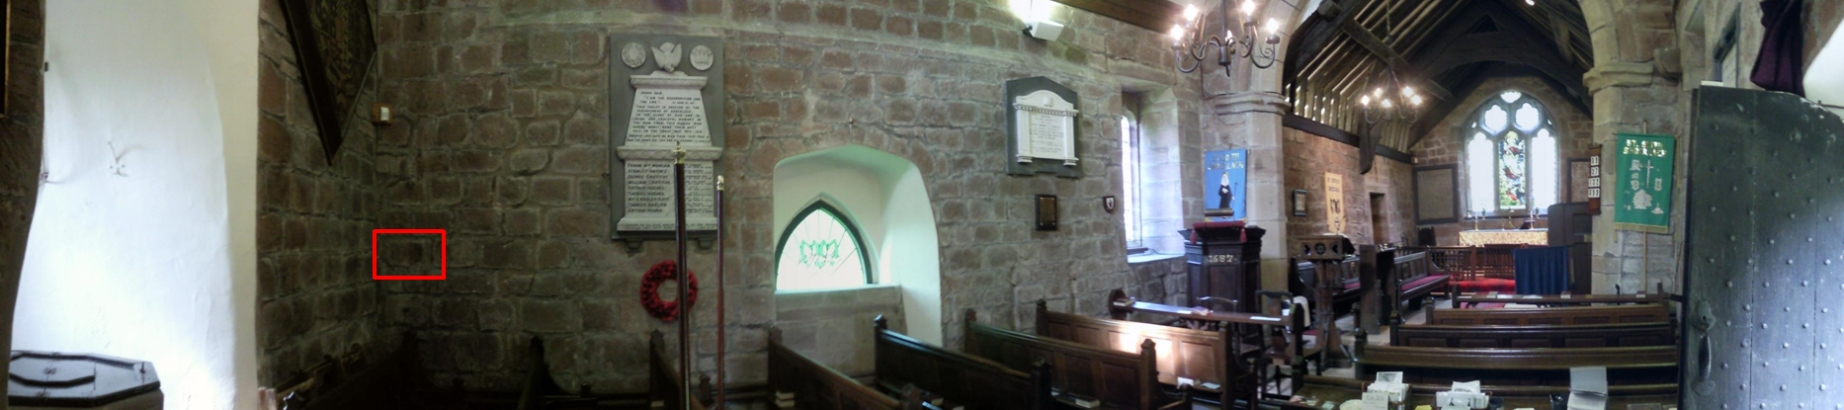
Fig. 28. Panoramic view of St. Edith’s highlighting the location of the stone carving in the northern wall (© Joanne Kirton)

The example from Frodsham, whilst much more obvious to the naked eye in the church tower, is not in a frequently encountered location, as one moves through the church. Yet an effort was made to incorporate these fragments into the fabric of these church structures. Nowhere is this more evident than the example at Shocklach, which had considerable alterations made to its shape and decoration. Firstly, it has been cut to size. It appears that it was once part of a bigger decorative scene, as additional carving can be identified to the rear of the horse and behind the rider (Bailey 2010, 143). Secondly, the image has been re-worked to re-emphasise the horses head and legs that have suffered due to extensive weathering. On 3D scans undertaken by National Museums Liverpool the new chisel marks (10-15mm) are clearly evident (see Figs. 29 and 30), as is the original outline of the horse’s head. Someone, at some point, has deemed this particular image of enough import to rescue it from the elements, re-cut the stone and re-work the image. This is not a simple case of casual reuse.

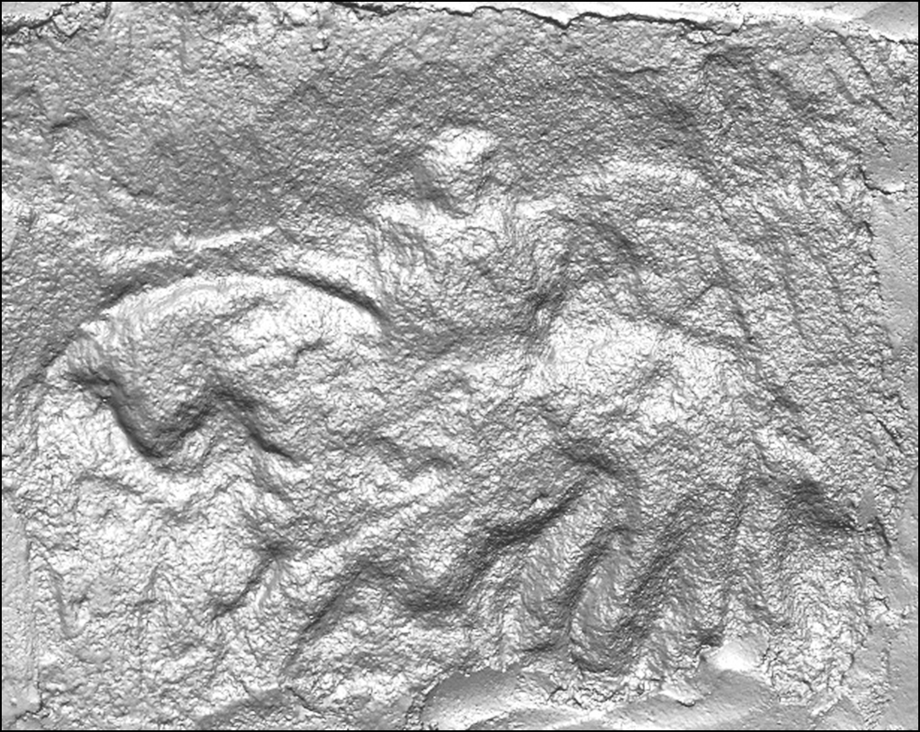
Fig. 29. Original screenshot of 3D data set obtained by laser scanning of the Shocklach carving (© National Museums Liverpool, March 2010)

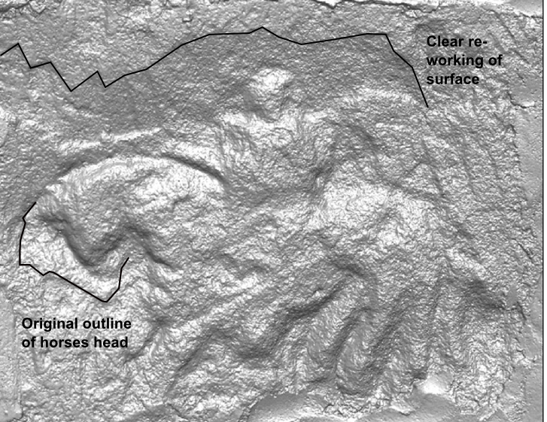
Fig. 30. Screenshot of 3D data set obtained by laser scanning with re-working highlighted in black (After National Museum of Liverpool)

Based on the fact that the Shocklach and Frodsham fragments are not located in prominent visual positions or areas of common interaction, but have been clearly incorporated into the fabric of these buildings with some effort, it can be assumed that they had some form of symbolic meaning that is now lost to us. One possible explanation for the Shocklach rider's incorporation into St Edith's might have been apotropaic. Eaton (2000, 91) argues that the inclusion of anthropomorphic figures without obvious Christian connotations into the fabric of churches may have been used as a means to ward off evil and harm, thus protecting the church and its people. Carved monuments such as the Sheela-na-gig and Hunky Punky carvings that decorate churches primarily in Britain and Ireland are common examples of this phenomenon. Whilst we cannot know if this was the case with the Shocklach rider it does provide one such possibility, which is further supported by the reuse of a corbel stone depicting a beast with male genitalia built into the exterior of the north wall (see Fig. 31) (the Shocklach rider is in the interior of the north wall).
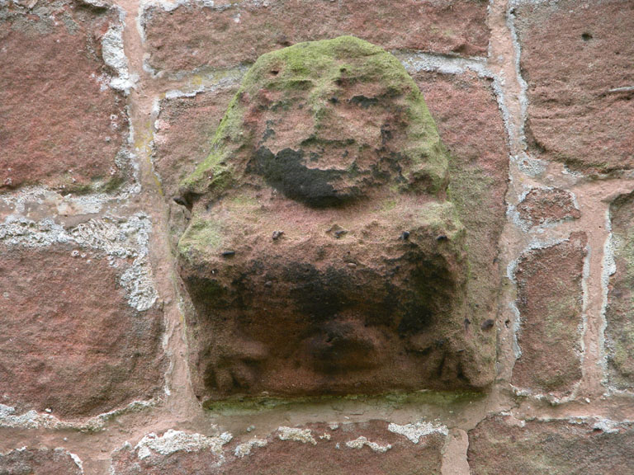
Fig. 31. Carved anthropomorphic corbel stone in the exterior wall of St Edith’s, Shocklach (© Joanne Kirton)

Champion (2012) argues that some types of medieval graffiti, within the interiors of churches, were created for particular symbolic reasons. He uses their location within the church to suggest that particular areas were focal points for graffiti and, therefore, that these clusters of graffiti signal areas of particular import in the church. He suggests that the graffiti could be apotropaic, ritual or votive in its nature. The idea that areas of the church might be informally altered by the congregation for symbolic meaning, does suggest that the Shocklach rider and the other examples noted above, might also have been used and viewed in a similar manner.
The lack of obvious visibility may have been deliberate, simply knowing that these decorative fragments were in the church structure may have been more important than seeing and physically interacting with them on a regular basis. Gondek (2015, 87-113) has noted how a proportion of Class 1 Pictish symbol stones have been incorporated into secular structures across Northern Britain. The symbols are found turned-in, so they are not visible. She argues that their location in prominent areas, that structure particular types of movement, demonstrates that these carved stones were placed within structures and deliberately hidden from view - not because they were symbolically redundant and were now serving a functional use, but because they were being used to signal to an unseen world. Her use of the word 'hidden' implies a deliberate act of concealment from public view, which suggests that knowing the stone with symbols is there is more important than actually viewing it. It may be the case that this knowledge is limited to a few members of a community at any one time and thus became a source of empowerment. Gondek (2015, 87-113) also suggests that this practice was about 'reworking their relationship with the otherworld within new material cultural practices and technologies of remembrance'. The 'reworking of relationships' through material culture seems to be a prevalent theme in post-Conquest England as well, whereby the material culture of the Anglo-Saxons/-Scandinavians had to be dealt with by the new hierarchy but also by those who had created and venerated it prior to the Conquest. The reuse of sculptures/carvings/monuments in buildings is one way of reworking their relationship. However, Gondek's work suggests that the early medieval sculptures found incorporated into structures may have had a symbolic use rather than a practical one, as was also demonstrated with the Lichfield Angel. This was based on a need to reinvent/rework relationships with the sculptures that was possibly deemed inappropriate/obsolete by some sections of society but not by others, in a comparable way to peoples’ reactions during the surge of iconoclasm in the sixteenth and seventeenth centuries. However, determining if this type of deposition was a positive or negative act is often difficult to identify. For, example, O'Sullivan (2001, 186) highlights the reuse of a stone monument at Lindisfarne, which was split and reused to support the crossing arch built to honour St Cuthbert. She argues that the monument was 'transferred into the ground where it both physically and symbolically supported the new building' - a form of structured deposition with definite symbolic reuse. However, it is not clear if the monument was reused because it was deemed significant because of its age and association or because it was associated with a past, redundant elite. Clearly, even where contextual information survives it is not always possible to understand impetus.
It is quite possible then that the reuse evident in many church structures is also a form of citation, whereby the builders are incorporating monuments into the fabric of church structures because they remain symbolically potent - they are affectively building meaning into the structure. The fragments incorporated into the structures at Bruera, Frodsham and Shocklach may have been chosen not for their decorative appeal but for what they symbolised – a visual connection to a particular idea.

Summary
Reuse of early medieval stone sculpture can be varied in terms of location, reuse type and the impetus for reuse, as was demonstrated above. In many cases the impetus for reuse is not clear, nor does it always fit within the reuse categories established by Stocker and Everson in 1990. It is clear, based on the evidence and ideas set out above, that contextual information is required to understand something of why a monument becomes reused. Inclusion in the fabric of a wall or the foundation of a building does not necessarily mean that a monument or fragment of a monument was simply reused for practical purposes. Indicators include, where in the fabric or foundations a monument is discovered, visibility in an important location or association with other material. These are key questions and ones that can only be properly answered when thorough contextual information is forthcoming. Unfortunately, few monuments in Cheshire were well recorded when they were discovered. Instead we must rely largely on an exploration of the condition they were found in when they were first discovered.
The monuments reused within churches in Cheshire suggest both casual and practical reuse. However, the lack of context impeded interpretation. The monuments that remain in situ at Bruera, Frodsham and Shocklach, suggest symbolic reuse but they do not provide information for impetus. The subject matter on each of these stones and the Overchurch Runic stone shows no similarity in design or subject, which might have indicated a particular preference for preservation.

CONCLUSION
This chapter has explored the evidence for reuse across the county. It has determined that a large proportion of the early medieval stone sculpture collection in Cheshire was reused in some manner after the Norman Conquest. It has also demonstrated that the type of reuse was heavily dependent on their original location, for example, in settlements or located in remote areas. This observation demonstrates that location is key to understanding why a monument or architectural fragment survives in a particular way in the archaeological record. Moreover, this suggests that a sculptures original function and possibly appearance is dictated by its intended location. Therefore, the key to understanding monuments in the early medieval period lies in an exploration of their landscape location. For example, what type of place or space were they located within: what features are the monuments associated with; how did they impact on the choice of location for the monument, its function and appearance; how might the contemporary local political, social and economic activities have contributed to the monuments location and function?
Another important observation made in this chapter is the divide between east and west Cheshire observed in several reuse trends, which clearly highlights the need for an approach that looks at spatial and biographical data. This divide also appears to impact on location, as most of the east Cheshire monuments are located in remote areas, whereas the west Cheshire monuments are almost all located in relation to church structures. Consequently, it is logical to explore monuments that are situated on either side of the county, particularly, as it would appear that the economic, political and social climate was aligned along the same division. The localised landscapes of monuments in east and west Cheshire is also vastly different and deserves separate discussion to fully understand how these sculptures operated. This will provide an opportunity to explore different approaches to tackling the problem of contextualising early medieval stone sculpture in order to establish function and information about the groups who were erecting and interacting with them in very different environments.
The Cheshire material has provided an opportunity to explore a regional group and identify localised patterns of reuse associated with particular monument types. It clearly demonstrates that the broad reuse patterns witnessed in other counties, such as Derbyshire, Shropshire and Lancashire will need further unpicking if a true understanding of their reuse patterns is to emerge. This breaking down of barriers between county assemblages is essential in order to identify the extent of these patterns and then tie them to particular historical and archaeological activity. In turn, these trends may also contribute to understanding the geographical extent/impact of socio-political activities at any given time.
The following chapters will investigate particular sites in Cheshire with the intention of exploring different approaches but with the single aim of (re)contextualising monuments within their early medieval landscape location.

CHAPTER FIVE

THE ASSEMBLAGE OF EARLY MEDIEVAL STONE SCULPTURE AT ST JOHN THE BAPTIST CHURCH, CHESTER: GROUPED ASSEMBLAGES IN A SETTLEMENT CONTEXT

INTRODUCTION
A group of tenth- and eleventh-century monuments that have been removed from their original location and reused during the post-Conquest period provides the focus of this chapter. This group, located within the city of Chester, has a strong provenance to a bounded space. They were discovered during the second-half of the nineteenth century in the modern precinct of St John the Baptist Church (NGR: SJ 40919 66138). It is one of the largest surviving collections in Cheshire and is principally comprised of monuments that share a strong similarity in terms of their decoration and form. There is no stratigraphic evidence to directly link the monuments to early medieval activity at this site. Consequently, the approach here must establish the context in which these monuments were first commissioned and deployed based on their appearance, size, reuse, current location and comparable data available from similar sites and monuments.
This chapter utilises the three-fold methodology explained in Chapter Three a discussion of form and decoration (the materiality of a monument) and its implications, an exploration of the biography of a monument or monuments including creation as well as reuse and its implications and an investigation of the relationship between monuments and place and/or a broader landscape. Within this three-fold methodology, however, different datasets and monuments require different approaches and techniques to tease out the narratives and meanings of the sculpture. For example, viewshed analyses are not particularly effective for the St John’s collection of monuments as their original settings are unknown. The first task of this chapter is, therefore, to re-contextualise the St John’s monuments by examining form and decoration and their object biographies.
What follows is a discussion of how the appearance of monuments (their form and decoration) is directly influenced by the setting they were intended for. By considering how the monuments look it is possible to establish what type of environment they were initially erected. Their later reuse and location can add further information to this picture. This, in turn, can suggest function, particularly when considered alongside other examples of early medieval stone sculpture, their uses and settings. Finally, this chapter will seek to explore the space in which these monuments were erected within the much larger urban setting of Chester in the tenth and eleventh centuries, which can shed further insight on their impetus for erection and function.
In summary, this chapter will demonstrate how an approach that considers appearance, setting, the broader landscape, reuse, recent provenance, the historical background and comparable material can establish a context and function for a single monument or group of monuments that currently lack one or both. It also foregrounds place as the key to interpreting a monuments function and decorative choices.

THE SCULPTURAL ASSEMBLAGE

Discovery at St John’s
The collection of early medieval stone sculpture unearthed within the modern precinct of St John's comprises thirteen fragments representing a minimum of six separate monuments, as suggested by the presence of six circle-heads. None were found in their original location (Bailey 2010, 62-69). The fragments were discovered during restoration work in the nineteenth century. There are three recorded finds spots. The first area to produce sculpture was the old foundation of the south church wall (see Fig. 32: area 1), where the top of a circle-headed cross and a 'flat-stone….covered with curious interlace' were found in AD 1861 (Parker 1864, 402). According to Parker (1864, 400-3), a short time after this, another circle-headed cross head was unearthed during excavation for a drain along the south-eastern boundary of the churchyard (see Fig. 32: area 2). In AD 1871, the derelict choir area at the eastern end of the church was cleared of accumulated debris and silt, caused by the collapse of the tower in AD 1470 and subsequent neglect. During this work the remnants of the fourteenth-century Lady Chapel and more tenth- and eleventh-century sculptures were unearthed (see Fig. 32: area 3) and stored in the chapter house (Scott 1892, 241). These were illustrated by J. Romilly Allen in the 1890s (Allen 1892-5). However, it is not clear which specific pieces of sculpture are referred to in each of these accounts.
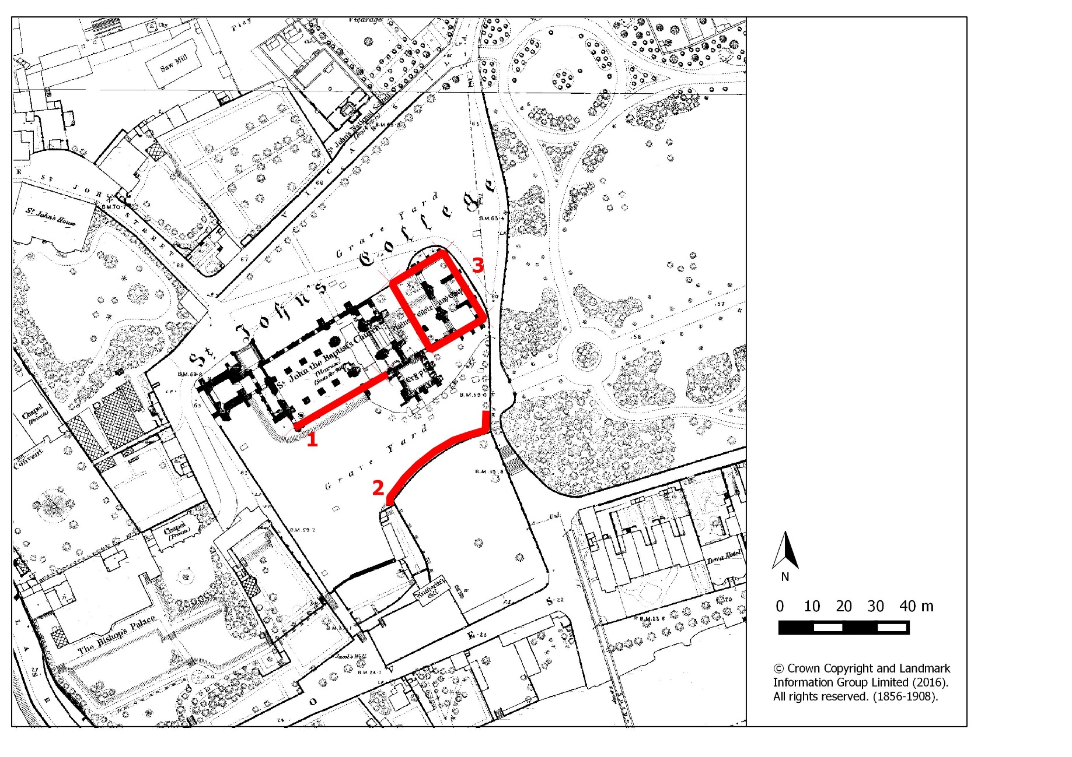
Fig. 32. St John’s as it appeared in AD 1875 shortly after restoration work uncovered the Anglo-Saxon sculpture (© Crown Copyright and Landmark Information Group Limited (2016) All rights reserved (1856-1908).

Monument Form and Decoration
The monuments of St John’s consist of four circle-headed crosses, two disc-headed crosses, three shafts and one possible cross-head fragment. Bailey (2010, 62-69) has dated this group to the tenth to eleventh centuries based on form, style and decoration: using typology to place them in a relative sequence. No examples from this group have been archaeologically recovered from early medieval contexts (see below), so these dates are based on comparison with other monuments attributed to this period.
The circle-headed crosses comprise the largest group, with two associated shafts (1a-b, 2a-b, 3, 4 and 5a-b) (Bailey 2010, 31). The circle-headed crosses are decorated with a continuous circle, with the arms of the head behind and often protruding beyond it (Cramp 1984, xiv). This style of monument is predominant on the eastern seaboard of the Irish Sea with clusters in the Lune Valley in Lancashire, Chester, North Wales and Wirral (see Figs. 33 and 34). The Cheshire examples are similar in terms of their style, as they generally have pellets or meander patterns decorating the circle with un-pierced spandrels between the arms of the cross head. This sets them apart from the Cumbrian group, which is typified by continuous plaitwork decorating the circle and pierced spandrels (see Fig. 35)

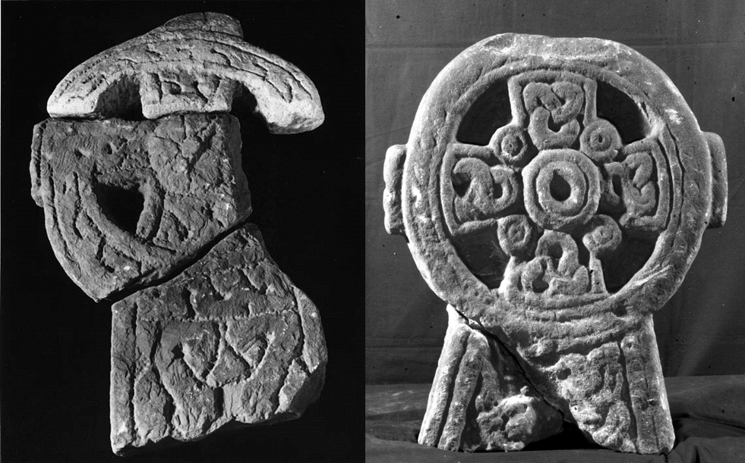
Fig. 33. Gilcrux 1A, Cumberland (© Corpus of Anglo-Saxon Stone Sculpture, photographer T. Middlemass)

Fig. 34. Chester St John 2a-bA, Cheshire (© Corpus of Anglo-Saxon Stone Sculpture, photographers K. Jukes and D. Craig)

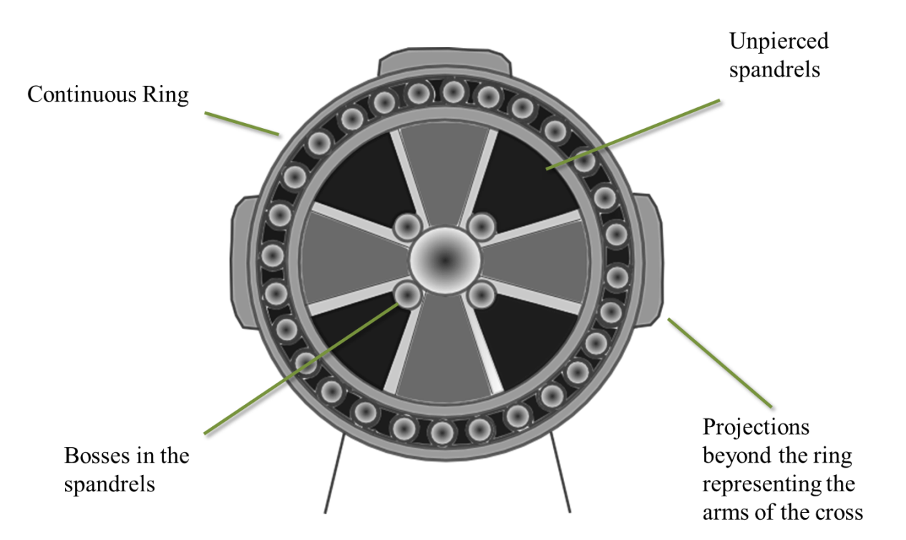
Fig. 35. Typical features of a Cheshire circle-headed cross (© Joanne Kirton)

The style is attributed to the tenth and eleventh centuries, which follows and coincides with a period of Hiberno-Norse settlement around the Irish Sea (Griffiths 2010, 48-60). It is believed that this decorative form was brought to England by Hiberno-Norse settlers in the early tenth century (Bailey 1980, 177-182 and 2010, 31; Bu'lock 1959, 2; Collingwood 1926, 322-331). Collingwood (1927 137-139) suggested that the style originated on the Isle of Man and radiated along lines of Viking communication and travel. However, Bailey (1980, 71) disputes this based on form and shape, preferring an origin in either Ireland or the west coast of Scotland. Whilst this debate is unlikely to be resolved with current evidence it does indicate that the Irish Sea region was a dynamic area during this period with people and ideas moving through trade and ecclesiastical networks.
The two disc-headed crosses (CASSS 6 and 7a-b) are comparable in style having wedge-shaped cross arms superimposed onto the outer circle with a central boss. Whilst some of the decoration is unparalleled in the Cheshire region, for example, the spandrel bosses placed at the centre of the unpierced area, there are examples around the Solway Firth, Wales and Isle of Man (Bailey 2010, 67). As with the circle-headed crosses, their stylistic influence appears to look seaward.
St John’s 8, which is a fragment of a shaft, is very different to the rest of the assemblage as it is the only piece of the collection with figural decoration, with the remnants of an arm, hand and drapery still surviving (Bailey 2010, 68).

Fig. 36. St John’s 8a (© Corpus of Anglo-Saxon Stone Sculpture. Original photographs supplied by the British Museum).

Figural scenes in the west of Cheshire are very rare during the tenth and eleventh centuries only discovered at Neston and Thornton le Moors. The latter has knotwork influences that derive from the west coast of Cumbria and the figural scene is most closely paralleled with the Book of Kells (Bailey 2010, 130). Further examples of figural decoration can be found on circle-headed crosses in North Wales, such as Whitford F12 (Edwards 2013, 366-71). The decorative parallels in Cheshire and North Wales indicate that this monument, which on first inspection may look out of place, was indeed part of the wider Cheshire/North Wales grouping that largely looked towards the Irish Sea region for its decorative influence and form.
With regard to their form, the St John’s assemblage is comprised of free-standing monuments and all appear to be part of crosses. The surviving shafts at St John’s and comparable collections, such as Neston, indicate that these monuments were short and squat compared to their North Wales counterparts.

The St John’s ‘School’ and the Church’s Riverine Location
The similarity in style, decoration and form of the St John’s cross-heads and other comparable collections at Neston, West Kirby and Hilbre Island, has led to the suggestion that they were made by the same 'school of artisans’ based at St John’s producing monuments of a similar style and form (Bu’lock 1959, 5). However, the term ‘school of artisans’ is ambiguous and needs further clarification before moving on. Firstly, at St John’s and across England it has not been possible to identify a particular monument or group of monuments with an actual named carver or group of carvers (Cramp 2010, 6; Driscoll, O’Grady and Forsyth 2005, 141). Here the term is used to denote: ‘…attribution to ‘schools’ which imply time/place divisions not linked to known individuals’ (Cramp 1977, 191). In this case the time would be the tenth and eleventh centuries and the place would be St John’s. The common attributes would be circle-headed crosses and disc-headed crosses on short, squat shafts with particular decorative choices such as unpierced spandrels. The notion of ‘affiliation’ can sometimes go further to denote particular links to a political, social or religious groups, such as Mercian or Northumbrian, Anglo-Saxon or Hiberno-Norse. Cramp (1977, 192) suggests that political power can create individual responses that are localised and identifiable: namely distinct groups of sculpture connected to a particular focal point or area. She pinpoints individual monastic houses, diocesan organisations or royal patronage as the obvious origin for the creation of focal points of power and influence. Whilst evidence is scarce, both physical and documentary, it is argued that St John’s was an important ecclesiastical centre in the tenth and eleventh centuries, plus a place of aristocratic patronage and a church visited by kings (see below for further details). Following Cramp’s criteria, St John’s would be an obvious place for sculpture to be located but also a site with far-reaching influence. However, Bu’lock’s suggestion of a ‘school of artisans’ takes this argument a step further and suggests that the sculpture was being produced on site, rather than St John’s simply influencing the use and style of the monuments within the wider region.
There is no physical evidence for a mason’s yard or documentary evidence to support the argument for a ‘school of artisans’. Instead, this suggestion is based on a number of observations. Firstly, the quantity and decorative similarity of the sculpture at the site suggests control of design and output. At St John’s, as with other churchyards with collections of sculpture with a similar appearance, the similarity in style may have been a reflection of local patronage and itinerant sculptors with a preference for a particular decorative style and form rather than evidence for a workshop and artisan group on the site.
The second observation is the proximity of an undated stone quarry just south of the current church. Quarries were prolific around Chester in the Roman period. One quarry across the river from St John’s in Handbridge still retains its Roman shrine (Ward 2009, 14). These Roman quarries could have provided the stone needed for the creation of these monuments. Geologically, the stones from St John’s are all made from the same Sherwood Sandstone found at the riverine quarries but as the sandstone outcrop covers much of western Cheshire, Wirral and southern Lancashire, this is neither unexpected nor useful for pinpointing the source of the stone (Bristow 2010, 10), so no definitive connection can be made between the monuments and a particular quarry.
Finally, the presence of a possible unfinished piece of tenth- or eleventh-century sculpture (St John’s 6) found within the modern precinct of St John’s has indicated that a workshop may have been located nearby. The suggestion that St John’s 6 is unfinished is based on its limited and simplistic decoration, plus the apparent ‘outlining’ of the design, which looks as if it might simply be the guideline for further work (Bailey 2010, 67). Whilst this is the strongest evidence to date for the presence of a stone mason on site, there is nothing to suggest that monuments were not finished in or near their final resting place by a single itinerant craftsman. Individually, none of these arguments can be used to argue for a ‘school of artisans’ working out of St John’s. Together they form a stronger argument but one that is still based on supposition.
The concentration of sculpture at St John’s, Chester’s apparent importance in the tenth and eleventh centuries (discussed below), its proximity to a quarry and the river has led to the suggestion that St John’s may have also been responsible for the production of similarly shaped monuments throughout the west of Cheshire, Wirral and possibly North Wales (Bu’Lock 1959, 5). A similar argument has been put forth for other sites, such as Whithorn in Galloway (Derek 1991) and Govan in Strathclyde (Driscoll, O’Grady and Forsyth 2005, 135-148), which also have large collections similar in form and decoration. Its dependent churches also have comparable smaller collections, which has led to the suggestions of a ‘school’ based at Whithorn, supplying the dependent churches with sculpture (Collingwood 1923, 217-27). Derek Craig (1991, 53) suggests that the churches that housed this particular style of sculpture would, in the tenth and eleventh centuries, become a single administrative unit centred on Whithorn. Furthermore, he notes that this area with sculpture was also the area with the best arable land, which supports the notion that sculpture was created by wealthy patrons, as a sign of status and wealth. He argues that the power of Whithorn, as an ecclesiastical and political hub supported and/or governed by wealthy patrons, is as important for disseminating ideas, in this case sculpture, as the housing of a ‘school of artisans’. In theory, an ecclesiastical hub like Whithorn or St John’s could be responsible for the spread of a particular sculptural style without housing the artisans themselves but instead, by encouraging the production of stone sculptures that looked a certain way. Bailey (2010, 33) has rightly argued that whilst St John’s may have had a resident artisan or group of artisans, there is enough variability within the wider west Cheshire, Wirral and North Wales assemblage to strongly suggest that there was more than one group working on similar styles within the region. Consequently, it is worth considering that it was St John’s influence, both ecclesiastical and political, that encouraged this particular style of monument to flourish in the region rather than simply arguing for one workshop producing monuments for the region. St John’s location would certainly facilitate the movement of ideas, as well as sculpture around the North West and North Wales.
St John the Baptist church is situated on a major communication route in the North West of England. In Chester, the Roodee served as the most important port and dock in North West England during the Roman period and was one of the primary ports in western England until it began silting up in the sixteenth century (Ward 1994, 122). The port and access to navigable waterways that could easily access the Irish Sea was the primary reason for locating the Roman fort at this site (Mason 2007, 65). There were also riverside jetties along the Dee, most notably downstream of the Old Dee Bridge (Mason 2007, 133). In addition, Chester also sat on the important York-Dublin axis, which was of great importance in the tenth century (Forte et al. 2005, 101-2); Chester provided a port for travel between the two major Scandinavian holdings. This situation ensured that Chester would have been a place where many influences would converge.
The proximity of St John’s to the River Dee would have undoubtedly had an impact on its ability to influence sculptural styles. Conversely, its location also placed it in a position to be strongly affected by outside forces. As was demonstrated above, the stylistic and decorative influences of the sculpture at St John’s (and others within the broader group) principally looks westward towards the Irish Sea Region for its inspiration. No doubt, because Chester was inhabited by people and objects from this region, brought in by sea trade (see below), it also ensured that ideas and objects could spread from Chester to/from other areas quickly and frequently.
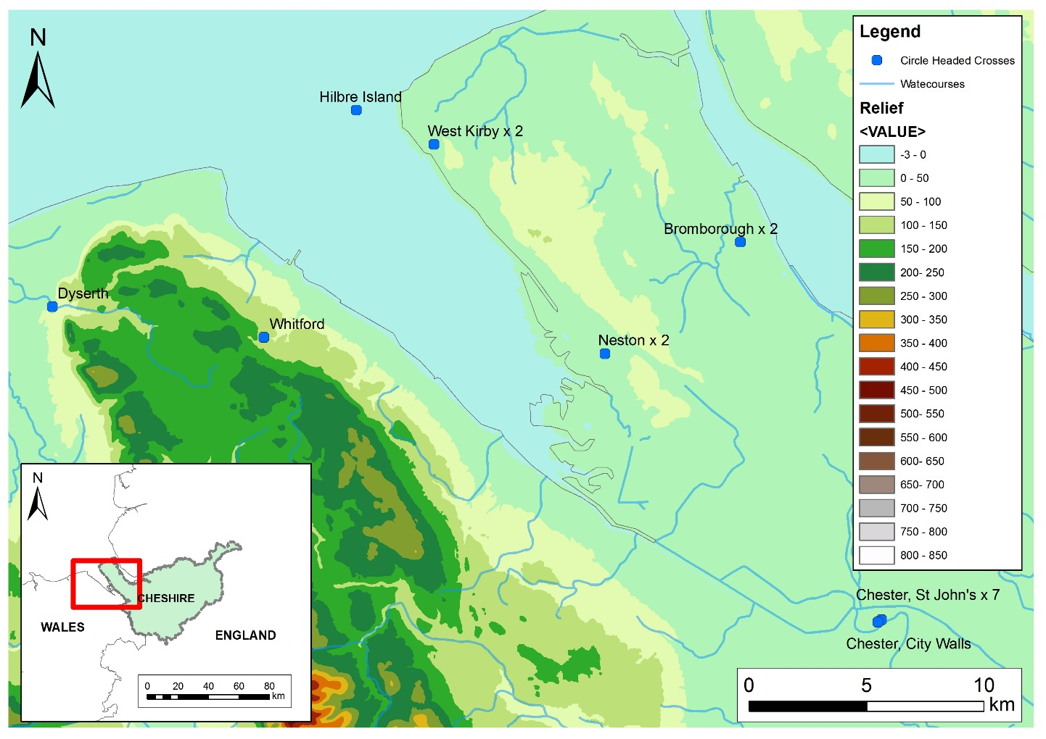
Fig. 37. Distribution of circle-headed crosses in-and-around the county of Cheshire (Base Map: Ordnance Survey 2015 [Crown Copyright/database right 2015. An Ordnance Survey/Edina supplied service]).

The distribution of this sculptural assemblage supports the notion of an active network during the tenth and eleventh centuries centred on the Irish Sea. The distribution map (see Fig. 37) demonstrates that no other examples of this form from Cheshire have been found inland (i.e. beyond 2km from the nearest navigable waterway), suggesting that St John’s and possibly a ‘school of artisans’ working in-and-around the vicinity of modern day St John's, demonstrably projected their influence seaward and/or moved around coastal and riverine sites. Other areas, such as Whitford and Dyserth in North Wales, which are further inland (approx. 3km and 5km respectively), are still within half a day’s walk.

Other Chester Monuments
The St John’s assemblage is the largest in Chester, but there are a number of other fragments from the city that are indicative of a more diverse sculptural tradition than that represented within the modern St John’s precinct.
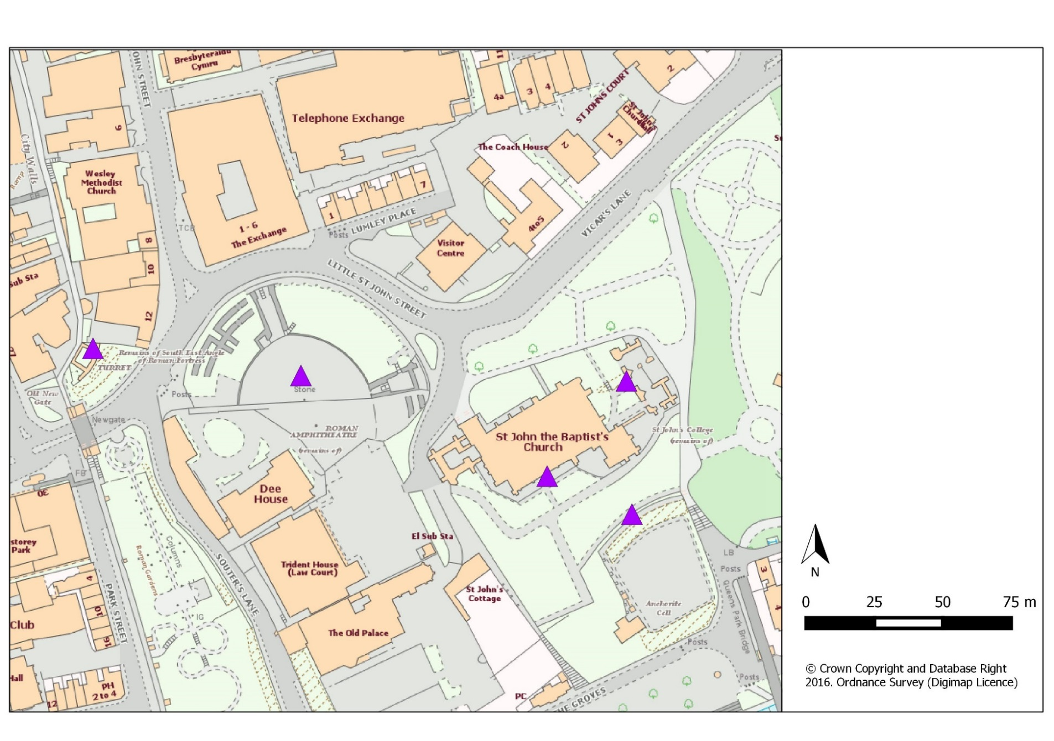
Fig. 38. Distribution of early medieval stone sculpture found in Cheshire with a known provenance (© Crown Copyright and Database Right 2016. Ordnance Survey (Digimap Licence).
A fragment of cross-head, which is a small part of a circle-headed cross like those from St John’s, was found in the south-west angle tower of the city walls. Where it originally came from is unknown, but its form certainly suggests that it might have connections to St John’s. Another fragment was found in the topsoil of the amphitheatre and two more have an unknown provenance (Bailey 2010). The amphitheatre fragment is different to any others found in Chester, as it has a circle-headed cross motif carved into the surface of a rectangular cross-slab, which has closer parallels with ornament from Ireland and Western Scotland than any other examples in Chester or the wider county (Bailey 2010, 70). The two unprovenanced examples, now residing in the British Museum, are tenth-century in date based on the similarity of certain decorative choices to other monuments dated to this century (see Bailey 2010, 70-73 for a fuller discussion). The first appears to be part of a recumbent slab, as it is only ornamented on one side. The second fragment probably stood erect, as all its sides are decorated. Bailey (2010, 70-73) suggests that they may have functioned as grave-markers based on their form. Both fragments look to southern and western Mercia for style and decorative motifs (see Bailey 2010, 70-73 for broader discussion). The difference in style, decoration and form of these monuments demonstrates that these were not seemingly part of the St John’s repertoire.
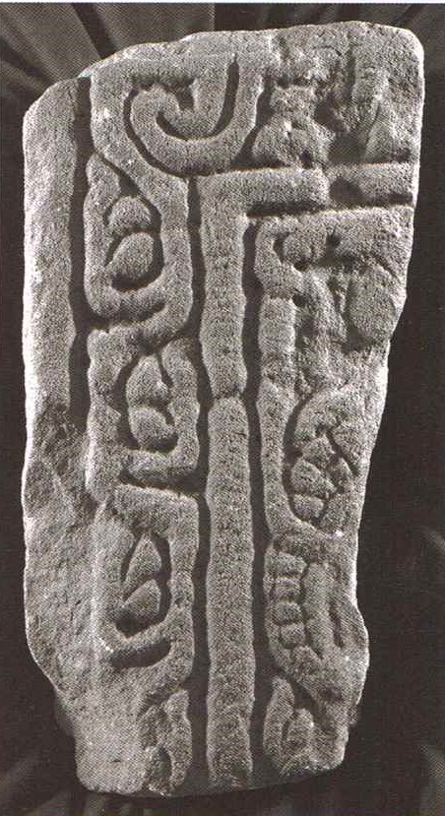
Fig. 39. Chester Unknown Provenance 1A, Cheshire (© Corpus of Anglo-Saxon Stone Sculpture, photographers K. Jukes and D. Craig)

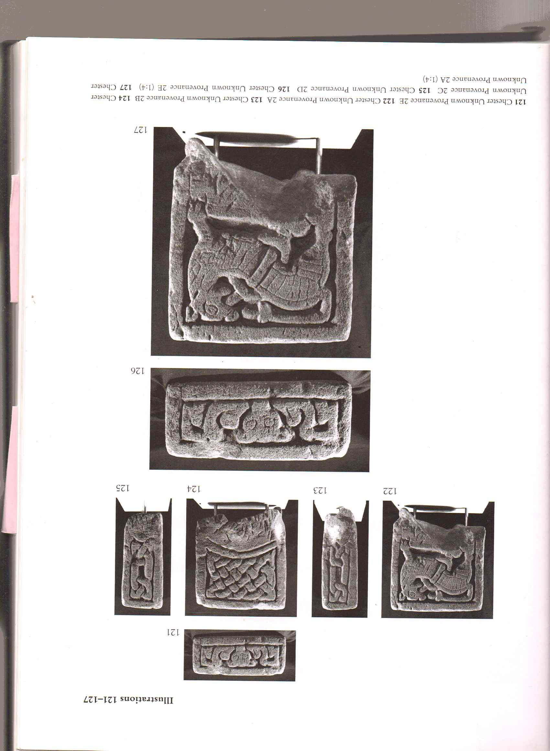
Fig. 40. Chester unknown Provenance 2E and A, Cheshire (© Corpus of Anglo-Saxon Stone Sculpture, photographers K. Jukes and D. Craig)

No other ecclesiastical sites in Chester have evidence for early medieval sculpture, which is unusual considering the age and status of some of the churches (see below). Nevertheless, it is possible that some could have come from St Werburgh’s within the interior of the old Roman fortress. A description from the Historic Society of Cheshire and Lancashire’s Journal notes how ‘an important angle of superstructure was found based upon a number of beautifully-carved Anglo-Saxon crosses’ (Smith 1874-5, 93-94). Whilst this statement is far from conclusive, it does raise the possibility of other sculptures coming from areas outside the St John’s precinct, particularly if those monuments are notably different to the St John’s group. The one that was apparently removed at this time does not bear decorative similarities or proportions to the unprovenanced sculpture described above. However, the description does note, like the amphitheatre example, that the monument had a carved cross within a circular recess.
When examined together, the various miscellaneous sculptures from Chester, the unprovenanced pieces now housed in the British Museum, the fragment from the amphitheatre and the missing stone from St Werburgh’s, all have one thing in common: they are all inscribed into slabs, as opposed to carved circle-heads. What is more, they are all notably different from the group found at St John’s. If inscribed stones were part of the collection, alongside the circle- and disc-heads, it is notable that none were found associated with the church, which suggests that they might have formed a second assemblage associated with another location, possibly modern day St Werburgh’s.
The monuments found around St John’s and scattered across Chester are clearly not in situ, but they are closely associated with religious structures and/or an urban landscape. The group found at St John’s can be explored in terms of their relationship with the settlement centre, the church and how the development of Chester may have affected when, how and why these monuments were erected.
The following discussion will first explore how size, form and decoration are indicative of function, even when removed from their original location. This will aid the exploration of how the St John’s monuments may have been used. It will also explore how groups of monuments may have functioned differently to lone examples, whilst considering how monuments may have helped define space and how this may have affected perception of it. Secondly, the discussion will consider how the growth of early medieval Chester shaped the creation and function of these monuments.

RE-CONTEXTUALISING MONUMENTS
Monuments are commonly defined as grave-markers, waymarkers, liturgical devices and so forth, primarily because the evidence suggests as much. However, without a clear context for each monument and no in-depth exploration of each monument, these suggestions are little more than educated guess-work. Furthermore, by exploring the relationship between location, reuse and appearance it is possible to establish a better understanding of why a monument(s) was erected, how it functioned, why it was located in a particular place, how this might affect its appearance and how all of these factors may have contributed to how the monument survived in the archaeological record.
As the monumental collection from St John's was found within the churchyard and within elements of the post-Conquest building it is easy to assume that they belonged to a pre-Conquest church and were used as some sort of marker. However, it is not clear just by looking at them and knowing their recent provenance if these 'markers' were used for graves, directing movement around the churchyard, within the church or signaling outside the churchyard boundaries. The following discussion aims to consider these different options, whilst establishing the likelihood of these monuments belonging to an ecclesiastical setting. It is also the intention to demonstrate an approach that can be applied to other monuments and/or monumental groups.

Using Form and Decoration to Ascertain Function
As noted, the St John’s assemblage was uncovered in post-Conquest deposits in a fragmentary state. Clearly these monuments were no longer in their original contexts or being used for their original purpose. As discussed in the previous chapter, this is a very common situation in Cheshire, which poses major problems for interpreting the function of these monuments and their original settings. One way of studying the St John’s assemblage is to compare them to other examples both in terms of their appearance and current setting. This can provide insight into function and how they may have been used within certain types of landscapes and spaces. Firstly, the form of a monument and the decoration on the surface can be indicative of purpose. A monument that is tall, such as the Whitford Cross (F12) (Edwards 2013, 366-71) or the Sandbach crosses, have the potential (based on their landscape location) to be seen at a considerable distance. However, if a monument is small or low-lying, its capacity to convey messages across space is limited. For example, hogback monuments cannot have been intended for long-distance viewing, as they are often large but they are also generally low-lying, making them difficult to spot from a distance if situated alone. The example below is the type h hogback West Kirby 4A from St Bridget’s, West Kirby, on the Wirral peninsula, which broadly dates to the same period as the St John’s circle- and disc-heads.
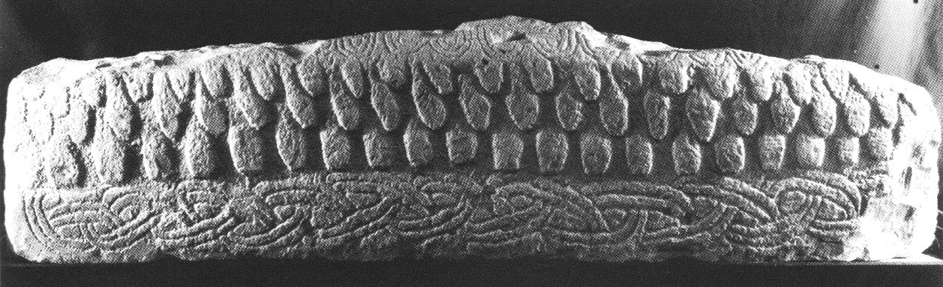
Fig. 41. West Kirby 4A, Cheshire (© Corpus of Anglo-Saxon Stone Sculpture, photographers K. Jukes and D. Craig)

If a monument has a distinctive form, this enables it to convey a message or symbolise an idea across space. The most obvious examples are cross-heads such as Cheadle 1, Tarvin 1 and Bolton le Moors 1a-c (Bailey 2010, 60-62, 128-129 and 164-166), which are cross-shaped and, therefore, can be easily recognised as Christian monuments from a distance. However, if the shape is indistinct, the audience will have to move closer to better understand the purpose of the monument: these monuments draw people to them.
In some cases, the purpose of the monument is conveyed or augmented by surface carvings or painting. Subsequently, the presence or lack of decoration can further illuminate possible function and be indicative of the space in which they were intended to operate based on the required proximity needed for the viewer to observe the decoration. Christopher Tilley (2012, 15-52) has recently stressed how important surface decoration can be in terms of impacting bodily interaction and movement around rock art, demonstrating how decoration can affect how a person approaches, experiences and subsequently understands the medium. For example, he questions whether a person sees the whole decoration at once; must they move around or over the rock surface to see it all? Is the decoration obvious or must it be sought out? Are there groupings of carvings on a single rock face or multiple carvings that people have to move between? He argues that a focus on the carvings alone suggests that the human conscience produces meaning, but a consideration of how the body interacts with monuments/carving through the senses is a more rounded approach, as perception is generated by the senses and cannot be understood without first understanding how these perceptions are generated by embodied interaction (Tilley 2012, 18-19). Understanding how the body engages and moves around or over rock art can also be applied to early medieval stone sculpture, possibly indicating the type of space they were situated in and how people may have encountered them. For example, a monument that has several undecorated faces, such as Chester Unprovenanced 1, only requires interaction with the decorated sides. This indicates that the monument would be experienced from the visible sides and access was not required to the entirety of the monument. In the case of Chester Unprovenanced 1, the lack of decoration on all sides, bar one, suggests that it was likely set up against a wall or flat on the ground. This link between decorative choices and function is seen elsewhere, for example Lythe 34 in North Yorkshire (Lang 2001, 166) and Little Ouseburn 1 in West Yorkshire (Coatsworth 2008, 208). This is a particularly useful approach when a monument has been removed from its original situation.
Those monuments with little or no intended surface decoration do not require the immediate physical presence of an audience to convey a message/purpose, as this can be achieved at a distance (this is the fundamental difference between rock art and early medieval upstanding stone sculpture, as rock art is carved onto the earth’s surface and its form is, therefore, less distinct and often less visible from a distance). However, this is not to say people were not drawn to these monuments to experience them up close, only that their message could be conveyed without being immediately present. Defining which monuments were accessible and allowed movement to them is possible, but takes careful landscape analysis of in situ monuments. Those monuments that are highly decorated require an audience in reasonably close proximity, so the carvings and/or paintwork is visible and (in conjunction with the form and material) able to fully transmit its message. Here, we might consider Tilley’s approach further, and ask how the decoration may affect how an individual will interact with the monument on which it is carved. Tilley argues that the rock faces on which carvings can be found are the canvas for this art form. In order to view the carvings people often have to walk up to, over and around ‘the canvas’ (Tilley 2012, 38). This affects how they experience and remember the carving, affecting how they will understand its meaning. He argues that observation of modern day encounters with rock art can direct people in a comparable manner and whilst the meaning of the carvings may not be understood, the sensory experience of them can be reproduced and used to illuminate how meaning might be directed and generated. Furthermore, it might be possible to observe if the carvings are all easily visible from a single viewing point or must people move their body to observe them? The monuments at St John’s for example, are highly decorated on all surfaces. In order to view the monument, a person has to move around it, suggesting that the monument was situated in a space with 360° access. The process of moving around the monument would have encouraged secondary engagement, as the individual felt the movement in their body, as well as experiencing the monument through sight and possibly smells and sounds associated with the surrounding space.
There are, of course, examples that are both large and highly decorated, which clearly indicate that these monuments had multiple purposes and were able to function on a number of spatial levels. In Cheshire, the only surviving monuments that fall within this category within the tenth and eleventh century is possibly Prestbury 1a-b. The rest are either short and highly decorated or tall with limited decoration.
The decoration on monuments rarely suggests a specific way in which they should be read, unlike the Bayeux Tapestry for example, which should clearly be read from left to right. Sculptural decoration is less directional and more thematic, potentially creating an iconographic theme, as discussed in Chapter Two, when considering Jane Hawkes’ (1999, 204-15) observations of the Masham, Hovingham and Cundall monuments, which had different messages: salvation, redemption and resurrection. Because there is rarely an obvious starting point for observing the imagery on monuments, it cannot be used to suggest how they might be approached and moved around, which is the case with the St John’s crosses. Instead, the approach to the monuments was likely dictated by the surrounding topography and the decoration geared towards a more meditative experience.
Based on the discussion above, the size, form and presence of decorative carvings or paintwork can suggest on what spatial scale these monuments were intended to operate and how they might be approached and encountered. At St John’s the monuments are short and highly decorated on all sides, suggesting that they had to be encountered within a close distance, as they were unable to convey messages across large distances. Their all-round decoration indicates they were situated in a space that was accessible from all sides, although the decorative repertoire gives no indication of directionality or a strong thematic message, so it is not possible to suggest how they were approached and encountered. From these deductions it is possible to begin looking for spaces that were accessible and open to house the sculpture – although the space need not be large.
Monuments that survive in situ can help provide examples of landscapes in which monuments might operate. For example, the round-shafts of east Cheshire generally survive to over 2m tall. Those in situ are placed in prominent topographical areas, particularly the Wincle cross. They have limited decoration and a distinctive cross-head form, which all indicate that these were monuments meant to be seen from a distance and they did not require the immediate presence of an audience to convey their meaning, as this could be observed from afar. The group unearthed at St John’s and comparable monuments found on Hilbre Island and at Neston on the Wirral, are the antithesis of this, as they are small and highly decorated (see Fig. 42).
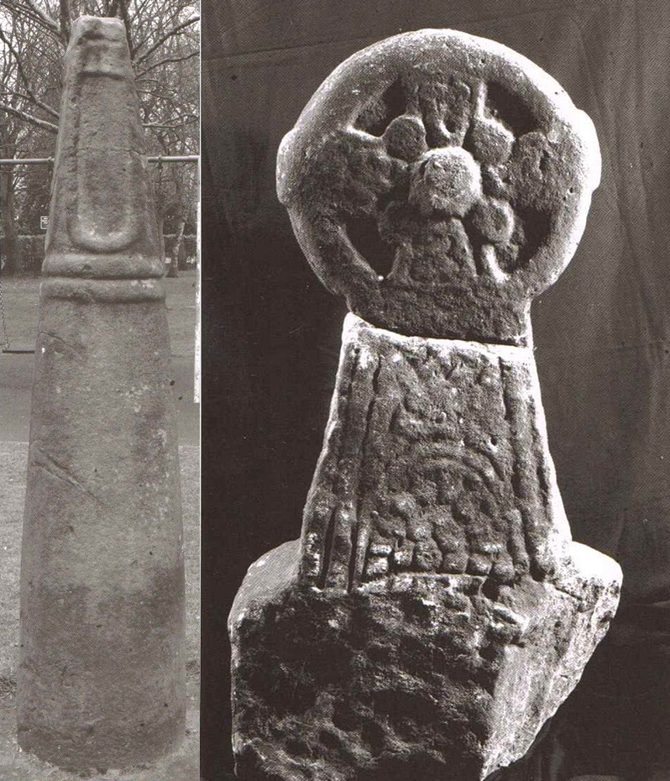
Fig. 42. Comparisons of forms – (L-R) Sutton 2B and St John’s 1a-bA, Cheshire (©Corpus of Anglo-Saxon Stone Sculpture, photographers K. Jukes and D. Craig)

When compared to monuments like the round-shafts, it is apparent that they are impractical for long distance viewing. Certainly, if these monuments were to act as beacons within a landscape they would need to be taller. However, they could still be used to mark roads, rivers and shorelines, as people would already be moving along/through these areas and the monuments would not be reliant on attracting attention from afar: they would have a ready-made audience. The size of these monuments suggests that they were not used to draw people along roads or rivers, but they could have signalled information once a traveller had approached them, possibly signalling they were on the correct route, the distance they had travelled/had to travel, as common sign-posts do today and Roman milestones were known to do (Bishop 2014, 31). Alternatively, they could have been used to mark a particular space or place, as boundary markers or grave markers for example. Furthermore, the decoration on the St John’s monuments is such that a person needs to be within reasonably close proximity to interpret their meaning. Therefore, a gradation of interaction between monument and audience, based on degrees of proximity, was required for them to convey their messages in full. This suggests that the assemblage found at St John’s, and others like it, was created to have most impact within a limited space.

Grouped Monuments and Function
The occurrence of multiple monuments with a comparable form and decoration at St John’s provides another avenue for exploration. It is important to consider whether each monument’s impact would have depended on their spatial and/or decorative relationship with others in the group. Certainly, if the intention was to mark a space, five monuments would be far more effective and impressive than one; relying on their physicality to convey the limits of space rather than one monument conceptually symbolising the space. A group of monuments demarcating space is more readily understood in terms of physical boundaries than a single monument, because they themselves create, as well as demarcate the boundary. A single monument’s meaning must be known to a person or group if its function as (a) a marker of space is to be recognised and (b) the actual extent of the space is to be understood, except where they mark an entrance point or threshold. The presence of single and grouped monuments, therefore, requires one to consider the different types of people using boundary stones and the space within. A single stone, raised to symbolise space suggests communal/shared knowledge: the purpose of the space is understood by those who encounter and access it, and either the boundaries of that space are also understood in the same way or the space has no boundaries to begin with. Space demarcated by multiple monuments, can be understood by strangers and locals alike, although their understanding of the space may vary considerably.
As suggested, some monument or monuments may have been used to guide a person or group along a certain path, either by land or sea. Crumlin-Pedersen (2010, 142-3) has suggested that place-names with the element kors (cross), along the Danish coast correlate with narrow entrances to fjords and inlets, suggests they served as warning markers to seafarers. Others are found at islands, which provided save anchorage. Both of which suggest that these potential crosses were serving as guides to those navigating the seas. However, he also suggests that they may have had a dual purpose whereby they signalled ownership of the area and the trading activities that were invariably linked to the sea. Fjords, inlets and anchorage sites would make an obvious place to mark territory and rights, as they would be the first port of contact for incoming travellers. This practice also appears to be mirrored across the Tarbat Peninsula in Scotland, where numerous crosses stand on or over the few sandy beaches that were safe to anchor at. Martin Carver’s (2005, 26) work at Portmahomack demonstrated that the monastery owned the beaches and suggested the crosses were a way of marking their control over the beach and those who used it to land and trade goods.
It has been established that the monuments at St John’s are too small to visually draw people over long distances. This then suggests two possibilities if they served as waymarkers:
- travellers had foreknowledge of the route to be undertaken and these monuments were used to convey information i.e. to reassure travellers they are going the right way, convey knowledge about distance, location and access like those used by the Roman’s and the many medieval milestones that still proliferate. Groups of monuments might more easily convey and compound the idea that people are on a route that will bring them to an important space, a single monument can indicate the same information but its impact would be comparatively limited. These routeways may be understood and augmented through multiple monuments and distinctive topographic locations.

- these monuments were marking routeways commonly used by the populace and it was these routeways that were used to bring people to and past the monuments. In this case, the route itself is not important but simply the means to make the monument or monuments accessible to a mobile audience who may undertake specific actions once they arrive at a particular monument or destination.

In both scenarios the monuments rely on a degree of foreknowledge to bring their audience to them.
Based on an exploration of form and decoration, plus the association with a distinctive, geographically concentrated group within the Cheshire corpus; a number of conclusions can be drawn for the sculptural assemblage unearthed at St John’s. Firstly, these were monuments that functioned within a limited area. They were not used to signal/symbolise space over large distances and were not expected to be viewed beyond a short distance (certainly less than 100m). Therefore, they required an audience to be within a specific distance of their setting to fully communicate the purpose for which they were erected. Consequently, channelling attention through movement, towards the monument or monument(s) was essential, as they had limited capacity to draw an audience. This channelling may have been undertaken by creating paths and route ways towards the monument. Another possibility is that the monument was situated at a particularly significant place or within a specific space. It was the place/space that drew people’s attention in the first instance, and the monument which helped convey the meaning of the place/space and possibly encourage particular actions once people were present.
The St John’s monuments also form a group, which in itself cannot be devoid of meaning. It suggests that their function may have been dependent on, or at least augmented by, their proximity to one another, which is supported by their concentration around modern day St John’s and their similarity in appearance. The next step is to establish what type of place these monuments were originally located in, which will also aid in determining their function.

LOCATION

Structure, Space and a Monumental Assemblage
The logical starting point to begin this exploration is the location in which the assemblage was discovered - within the modern precinct of St John the Baptist church in Chester. Several fragments (it is not clear which from the records) were directly associated with the church structure. The first group found was unearthed in the foundations of the south wall (Parker 1864, 346), which was erected in the twelfth century (Richards 1973, Plate 119). A second group was found in the foundations of the fourteenth-century choir and lady-chapel, which survived under the rubble of the tower, which collapsed in AD 1470 (Scott 1892, 19). Based on stratigraphic evidence, they were found below characteristic twelfth- and fourteenth-century architecture, it is possible to establish the presence of the St John’s sculptural assemblage at the site from at least the twelfth century onward. However, based on the stylistic attributes of the St John’s assemblage, it has been established that these monuments were raised sometime during the tenth or eleventh centuries and, therefore, may have been present on the site earlier than their stratigraphic relationship suggests.
Two historical documents refer to a pre-Conquest St John’s in existence by the tenth century (and will be discussed further below). However, the reliability of these accounts is problematic as both were written after the Norman Conquest and are not contemporary. However, firmer archaeological evidence has been recovered in the form of two tenth-century burials, discovered during trench evaluation prior to development just to the west of the church (Ainsworth et al. 2005, 15). No direct link has been established with any structure but, as St John’s was the only known church at Domesday that buried outside the city walls, it is likely that these burials belong to an associated graveyard, indicating that St John’s was in all likelihood in existence by the tenth century.
Establishing a physical connection between possible early medieval activity at the St John’s site and the sculptural assemblage under discussion is almost impossible without further excavation or accidental discoveries. Instead, less direct means are required to explore the possible relationship between these monuments and the St John’s locale in the centuries preceding the Norman Conquest.
Some ecclesiastical sites have a clear stratigraphic sequence of destruction and reuse that begins in the pre-Conquest period, demonstrating clearly that early medieval sculpture was linked to pre-Conquest ecclesiastical buildings in some instances. Durham Cathedral and York Minster, as discussed in the previous chapter, both provide a clear link between pre- and post-Conquest ecclesiastical activity, as early medieval stone sculpture was left in situ under the Norman builds and others were reused in the Norman structures (Lang 1995, 433-67; Phillips and Heywood 1995, 33-169; Rollason 2000, 211 and 255 and O’Sullivan 2011). It is rarer to find evidence of early medieval sculpture in situ in early medieval ecclesiastical contexts. The discovery of in situ monuments from an eleventh-century graveyard under York Minster, for example, was exceptionally rare. Whilst the monuments were largely tenth-century in date, indicating they had been reused in the eleventh-century cemetery, their relationship with burials clearly indicated that they were used as grave-markers during this period (Lang 1991). It is even harder to find evidence in smaller churches because few churchyards have been excavated to early medieval depths and those that have, are often heavily disturbed by later burials and/or buildings. However, examples of excavated early medieval churchyards do exist and provide strong evidence to support the relationship between churchyards/churches and stone sculpture from the same period, offering supportive evidence to link early medieval St John’s with the sculpture. Sadly, no such investigations have been documented in the Cheshire region; instead an exploration of sites outside the counties borders is required to further the discussion.
St Mark’s in Lincolnshire was excavated prior to commercial development. The church was erected and burial appears to have begun by the tenth century. Fourteen stone grave-markers and/or covers are attributable to the mid⁻tenth to eleventh centuries and four to the mid⁻tenth to thirteenth centuries (Devlin 2011, 34). These were found reused in the foundations of the later medieval church or in the later Victorian church (Stocker and Everson 1999, 198-210). However, one free standing sculptural example was found apparently in situ, above the grave of a man aged 25-35 years of age (Gilmour and Stocker 1986, 63-4; Stocker and Everson 1999, 209-10). This is incredibly important as it demonstrates stratigraphically that these monuments were definitely associated with an early medieval graveyard and church. There is also clear evidence of function, a grave marker in this instance. Another example, from Raunds Furnell in Northamptonshire, provided evidence of both stone and wooden grave markers. The chapel was erected in the late ninth or early tenth century with an associated 40m by 30m boundary, encompassing the graveyard (Boddington 1996). Amongst the early medieval burials at least seven graves were marked by wooden posts and several stones markers were found in situ above graves. There were two grave-covers, thirteen graves covered with rough stones and one marked by a stone cross. Further examples of stone sculpture, two crosses and one slab, were found built into later associated buildings (Devlin 2011, 38). Both sites provide stratigraphic evidence that ties early medieval stone sculpture to early medieval cemeteries of the tenth and eleventh centuries associated with a church, the latter with a clearly defined boundary.
The large collection of early medieval sculpture located at St John’s from at least the twelfth century has strong parallels with other sites in the British Isles. Whilst a stratigraphic relationship with a pre-Conquest church and/or site cannot be established, there is robust evidence from other sites that sculpture was associated with pre-Conquest churches and churchyards. When combined, the concentration of groups of sculptures found around St John’s, plus their similarity in appearance, provides a persuasive argument to suggest that these monuments belonged to a pre-Conquest church. The presence of a church and associated graveyard would have provided the ideal setting for the St John’s monuments to convey their message: the church and the deceased would have provided the draw required to bring an audience to the monuments. Furthermore, the monuments were small and highly decorated on all sides, so they needed to be encountered up close. The churchyard could provide the limited arena in which people could move about, possibly directed by paths or routes through the graves and around the church, as was demonstrated to have existed at St Mark’s, Lincoln (Devlin 2011, 35).
These interpretations combine to indicate the type of setting that the St John’s crosses belonged to at the time of their original erection. It builds a strong sense of how these monuments were designed to be encountered. However, it is not yet clear exactly what their function may have been. They could have been grave markers, liturgical devices or boundary/way markers around St John’s, possibly within a defined bounded area surrounding the church. A closer exploration of the political, social and religious environment in Chester during the tenth and eleventh centuries may suggest why these monuments were erected, how they functioned and who erected them.

THE MONUMENTAL ASSEMBLAGE: FUNCTION AND INFLUENCE
As noted at the beginning of this discussion Steven (1904) listed the various probable functions of carved stone sculptures, a list that has changed little in the past 100 years. This static interpretative situation is largely due to the fact that recognising the function of early medieval stone sculpture still remains problematic due a lack of associated archaeological contexts. Understanding the purpose of the St John’s collections is challenging for this very reason. The preceding discussion has established that these monuments were in all likelihood linked to pre-Conquest St John’s even if their precise location and function remains tentative.
By exploring the stones’ physical appearance, their decoration and form, it was demonstrated that their ability to signal and convey information visually was constrained by distance, indicating that the monuments were either placed on known routes, where they would be encountered as people moved through the area or that they were located within a known space that people would visit and move around. In addition, the uniformity of the collection also suggests that they served a similar purpose, possibly created to function as a group. What then, might this function be?
It is quite possible that the sculptures found at St John’s had a dual function. Firstly, as monuments placed to create, signal space and/or guide movement around a space. In terms of St John’s this was likely to be within the churchyard or a broader precinct. Their second purpose may have been to convey specific messages based on decoration and form. This may have been an affiliation to a religion, group or location, possibly serving as grave-markers, memorial stones or in a purely ornamental role. Exploring the historical evidence for the period might provide further insight into their function, which can then be considered in light of the documentary and archaeological evidence for tenth and eleventh century St John’s and Chester.

Churchyard Monuments
In northern England, the tenth and eleventh centuries see a proliferation of stone carved monuments. More specific trends are also evident. Firstly, there is a definite increase in monuments used specifically as individual grave markers within Christian graveyards (Hadley 2002, 224-5). Stocker (2000, 180) argues that this is a clear indicator of a shift in sculptural function from communal commemorative monuments to private and personal ones. Secondly, this proliferation also coincides with the increase of secular iconography in northern England represented on stone carved sculpture (Hadley 2008, 270-84), such as the fighting scene on Neston 2C and the mounted warriors on Neston 3C (see Figs. 44 and 45).

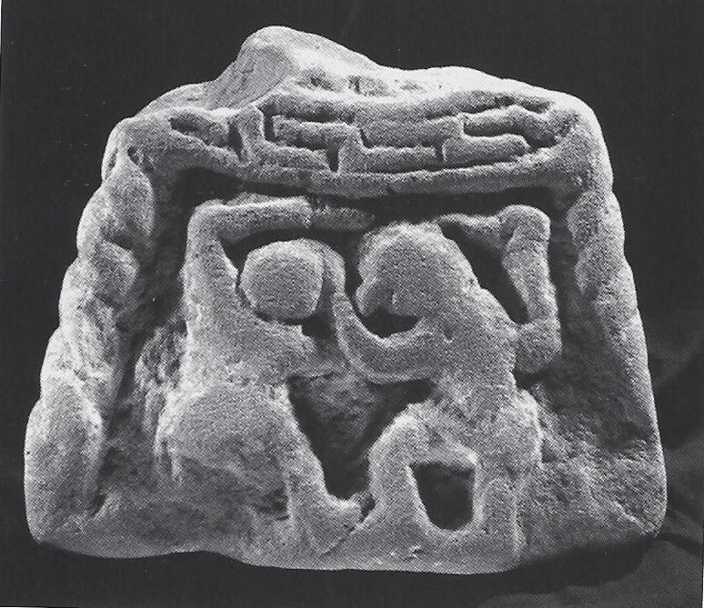
Fig. 43. Neston 2C (© Corpus of Anglo-Saxon Stone Sculpture, photographers K. Jukes and S. Craig)
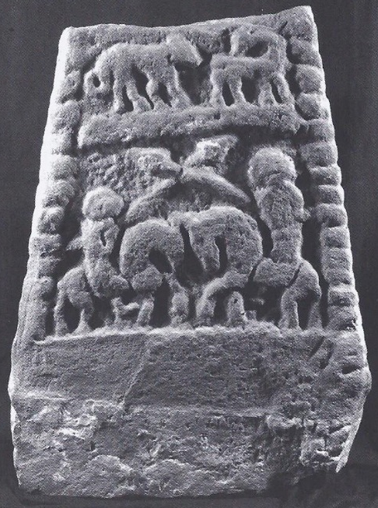
Fig. 44. Neston 3C (© Corpus of Anglo-Saxon Stone Sculpture, photographers K. Jukes and S. Craig)

Thirdly, this increase in grave markers and secular imagery also coincides with the greater use of churchyards as burial places (Blair 2005, 305-6; 309-10). These factors combined, suggest that there is a marked desire to emphasise specific graves or specific spaces within cemeteries associated with Christian graveyards and it would seem that stone carved sculpture was a popular device to mark graves of certain individuals, whom Stocker (2000, 181) believes must have been elite based on the cost of the material, carving and transport. At St John's, the dating of the monuments based on typological chronologies, fits perfectly with this move to mark space within Christian graveyards, often associated with church structures in the tenth and eleventh centuries, suggesting that the monuments unearthed within the modern precinct of St John’s may well have been grave markers.
Stocker (2000, 182) suggests that the increase of stone sculpture in Christian graveyards is linked to the growing trend of direct patronage of parish churches by a growing local elite. Stocker (2000, 129-212) argues that in the tenth and eleventh centuries in Lincolnshire, Nottinghamshire and Yorkshire there was a deliberate attempt by an emerging Anglo-Scandinavian elite to mark their positions by (re)building local parochial churches and burying their kin in their associated cemeteries with distinguishing markers that noted their importance within the community. The move toward monumentalising graves within a Christian churchyard may have been a desire to encourage long-term memory of the individual and their associated kin. Zoë Devlin (2007, 49 and 2011, 34) argues that graveside display of the fifth to seventh centuries, in the form of elaborate burial with furnishings, was replaced by monumental graves by the tenth and eleventh centuries as a means of projecting memory forward with the expectation that people would come to the churchyard and interact with the upstanding structures and, therefore, engage in long-term remembrance and prayer.

Pre-Conquest St John’s
The contemporary documentary evidence noted above, coupled with the sculptural collection of the same date, indicate that St John's was in existence by the tenth century. However, the church has a reputed early foundation date of AD 689 (Mason 2007, 63). It is subsequently suggested, based on the lost works of Gerald of Wales, a twelfth-century Welsh chronicler and reiterated in various works, that St John’s is a seventh century royal foundation endowed by King Æthelred in AD 689 (Thacker 1982, 2000 and 2005, 125). However, except for this one lost twelfth-century source there is neither textual nor archaeological evidence to suggest St John’s existed before the tenth century (Thacker 2000, 16-7; Ward 2001, 164).
However, there has been some discussion about how and why St John’s may have been established prior to the tenth century. Ward (1994, 119) suggests that St John’s location outside the burh may have been due to the fact that it was once at the centre of a seventh- to eighth-century Saxon settlement that began to decline after the creation of the burh when the settlement seemingly moved inside. Similar movement has been noted at Canterbury, Lincoln and London. Whilst there is no conclusive archaeological evidence to support Ward’s theory, recent work by English Heritage at Chester’s Roman amphitheatre has generated new interest in the area around St John’s and indeed the relationship between the two structures.
It is regularly suggested that the amphitheatre might have been the site of execution for Christian martyrs during the Roman period and this association may have provided the impetus to build the earliest version of St John’s in such close proximity to the site (Ainsworth and Wilmott 2005, 7-8; Wilmott et al. 2006, 13). However, there is no documentary or archaeological dating evidence to support this idea and at present is based on nothing but supposition. Nevertheless, the earliest evidence of early medieval occupation comes from this area of Chester. Re-interpretation of the material unearthed in the amphitheatre excavations, particularly the 1960s excavation, has led to the suggestion that part of the amphitheatre may have been actively used in the sixth and seventh centuries (Matthews 2003-4, 17). There is certainly evidence that two of the entrances were closed off, which Ainsworth and Willmott (2005, 7-8) suggest may indicate that this site was used defensibly based on similar examples from Europe. Matthews (2003-4, 17) also suggests parallels with Cirencester, which was seemingly fortified in the fifth and sixth centuries with an exterior ditch and narrowing of the entrances. Within the arena a large timbered building, based on the presence surviving post-holes, was also erected (Watcher 1974, 314). Secondly, the discovery of a timber structure within the interior further supports the notion of a possible hall building, which may have served as the foci for this defensive area (Matthews 2003-4, 18; Ainsworth and Wilmott 2005, 9; Wilmott et al. 2006, 13). Finally, the east gate into the arena, nearest St John’s, shows evidence of reuse, whereby the stones on the upper courses have been turned inwards, possibly to create an arched roof. This evidence has been used to suggest that this part of the amphitheatre may have been reused as a crypt for an earlier church, possibly the original St John’s (Matthews 2003-4, 22-3). However, once again no evidence exists to link this to an earlier ecclesiastical building. Whilst the archaeological evidence provides only hints of what might have been happening on the site prior to the tenth century, it does indicate the potential for an area of activity before St John’s comes to prominence in the literature. In AD 907, with the creation of the burh, the extant Roman walls provided an obvious defensible location. The interior of the fort also probably offered less resistance in terms of the local populace who were already seemingly established without. The new military and administration attached to the burh could occupy the interior without physically displacing the groups who had already settled around Chester.
Equally, St Werburgh’s, named as St Peter and St Paul’s prior to the tenth century (Richards 1973, 93), is similarly lacking in textual or archaeological evidence to illuminate its history and development until the tenth century. Discussion of activity earlier than this period, for both establishments, is largely speculative until further archaeological or textual evidence comes to light.
However, this has not dissuaded individuals from trying. Thacker (1982, 206 following Tait 1936, 44-5), for example, considers the possibility that St Werburgh’s, previously known as St Peter’s and St Paul’s prior to the re-foundation of the church by Æthelflæd in the early tenth century, was the mother church for the whole of Chester and its surrounding areas. Thacker (1982, 206) quotes Bradshaw, a sixteenth-century Chester monk, who claimed that the minster of St Peter and St Paul was the mother church of Chester, principal to all the city and it possessed burial rights within and for a radius of seven miles around. If this were the case, then St John’s parish would have been carved out of St Peter and St Paul’s own jurisdiction or possibly that of St Werburgh’s if the split occurred after the re-foundation. Whilst there is no evidence to suggest that this is the case in Chester, comparable activity at other Mercian centres, at Gloucester and Shrewsbury, adds credence to this idea and suggests how and when this might have occurred in Chester.
Gloucester, like Chester, was an old Roman fort town. Prior to the tenth century Gloucester was under the jurisdiction of a single seventh-century minster, St Peter’s, which had a large parish encompassing the settlement. However, in the early tenth century, this parish was split and the ancient minster’s jurisdiction was divided (although not evenly) and shared with a smaller institution outside the Roman walls (Thacker 1982, 210). This activity occurred under the governance of Æthelflæd and her husband who turned the old Roman fort into a burh, much like Chester. Moreover, a Mercian saint (St Oswald) was also brought to reside in the re-built minster. The creation of a burh in an old Roman fort, the (re-founding of a minster and the translation of a Mercian saint into the heart of the settlement has strong parallels with Chester in the early tenth century (see below). In addition, on a basic level the ecclesiastical jurisdiction seems comparable, although when and how this occurred in Chester remains obscure and Thacker (1982, 206) concedes that knowing when the ‘unitary parish’ was split between St Werburgh’s and St John’s is unknowable on current evidence
Exploring the documentary and archaeological evidence of both minsters in the tenth century, their relationship with one another and the impact the settlements topography had on their relationships may help indicate why St John’s acquired a large collection of sculpture at this time.

Exterior v. Interior
The creation of the burh in AD 907 signalled a sea-change for Chester’s fortunes but also an important turning point for St John’s, which was largely due to its location. The old Roman walls were reused to create the burh’s primary defence and it appears that the perimeter wall was likely extended towards the River Dee, with the river providing the southern defensive limit to the burh (Ward 1994, 121). The enclosure of this area encouraged the re-population of the fortress interior testified by the emergence of multiple buildings and artefacts pertaining to that period (Thacker 2000, 17-9). Of more importance to St John’s, it affectively placed the church and its associated lands of Redcliffe outside the defences of the burh, in affect creating a separate suburb by the time of the Norman Conquest. The impetus to leave St John’s outside the defensive perimeter is an interesting one and might have multiple motives. Firstly, it may simply have been easier to build a defensive line directly down from the Roman walls to the river, rather than trying to incorporate the precinct of St John’s. There may also have been an element of wanting to define the space between secular and ecclesiastical rule; however, this seems unlikely considering the presence of St Werburgh’s within the interior. Yet, this might also be the real clue to this odd situation – the relationship between St John’s and the re-founded St Werburgh’s. By excluding St John’s from the burh’s interior, it is possible that this was done intentionally to signify the new power of St Werburgh’s and its Mercian patrons within the city and reduce, by exclusion, St John’s influence.
Tradition, based on the work of Bradshaw, states that Æthelflæd and her brother Edward the Elder founded the minster of St Werburgh after the burh’s fortification (Lewis 2001, 114; Thacker 2000, 19)). Bradshaw also extrapolated that St Werburgh’s relics were translated to Chester in 875. However, more recent scholarship (Thacker 2005, 19 and 1982 204-5) has attributed the move to Æthelflæd, much like the events in Gloucester outlined above.
By the mid-tenth century St Werburgh’s had a saint and a re-established royal patron(s). This link to the Mercian royal household was to continue well into the tenth century and would ensure the wealth and power of St Werburgh’s only grew. A register of Chester Abbey’s charters, created in the fourteenth century, notes a royal charter from the reign of King Edgar the Peaceful (AD 943-75), written in AD 958 in which he bestows on the abbey 16 estates, totalling 17 hides of land spread throughout the west of Cheshire, providing a stake in half the hundreds of the county (Lewis 2001, 111; Thacker 1982, 204). This charter, if genuine, demonstrates that King Edgar was pivotal in the development of St Werburgh’s power and prosperity. The charter ‘…reaffirmed royal patronage, secured any existing estates, and extended them with lavish new grants’ (Lewis 2001, 115). Certainly, by the Norman Conquest, St Werburgh’s had fared better than St John’s. ‘At the time of Domesday Survey St John’s was the smaller and much the less wealthy of Chester’s two minsters’ (Thacker 1982, 201). In addition, St John’s parish space within the interior of the city by Domesday was small compared to the rest of the division of space for religious houses situated in the interior (Allridge 1981, 24) (see Figs. 45 and 46).
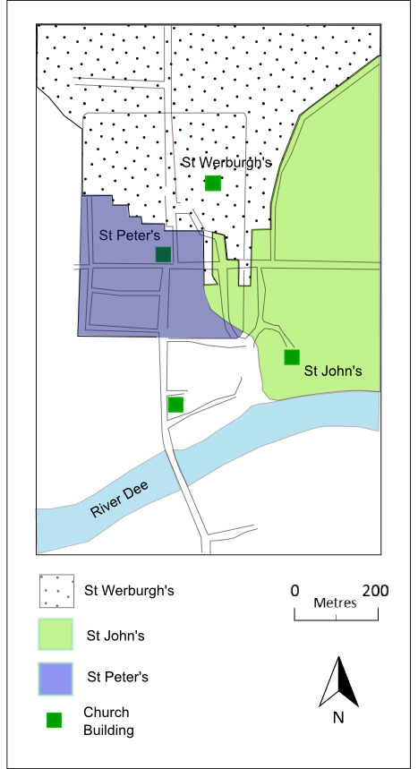
Fig. 45. Estimated parish space c. AD 907 (after Allridge 1981, 8)
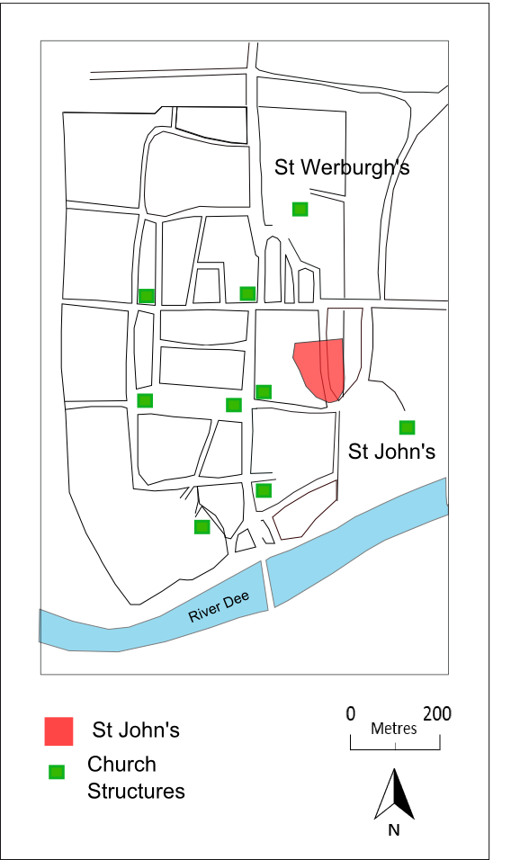
Fig. 46. St John’s’ land within the interior of the burh by Domesday as noted in red (After Alldridge 1981, 24)

However, historians have often noted that St John’s was also significant during the tenth century, as it is often claimed that the West Saxon king, Edgar the Peaceful, visited St John’s in AD 973 as part of an elaborate ceremony, where the kings of Britain and the Isles gave their submission and swore their allegiance on land and sea to him. This visit has been used as evidence for the existence of St John’s by the second half of the tenth century and to suggest that it was of enough import to welcome the king of Wessex (Thacker 2005, 125). Unfortunately, an exploration of the source material does not support this claim.
Firstly, contemporary references to Edgar’s visit to Chester in AD 973 are rare. In the Anglo-Saxon Chronicle, of which nine copies of the manuscript exist, only three versions, D – the Worcester Chronicle, E – The Laud Chronicle (sometimes referred to as the Peterborough Chronicle) and F - The Bilingual Canterbury Epitome, collectively known as the ‘Northern Recension’, mention this visit (Thornton 2001, 50). In all instances St John’s is not mentioned.

‘And immediately after that the king took his whole fleet to Chester, and there six kings came to him, and all gave him pledges that they would be his allies (lit. fellow workers) on sea and on land’. (Thornton 2001, 50)

There is another set of texts that allude to this event without mentioning it directly, such as the Life of Swithun written by Ælfric and the Ely Charter (Thornton 2001, 52-4). However, these texts are written in praise of Edgar and do not mention Chester, the date of the visit or the king visiting St John’s.
There is, therefore, no known reference to a visit to St John’s in the pre-Conquest material. This only occurs in the post-Conquest period, in one twelfth-century account appearing in the Chronicon ex chronicis, believed to have been written by John of Worcester in the early twelfth century (Barrow 2001, 90). This chronicle was largely based on the eleventh-century Marianus’ Chronicon completed before AD 1082, with additions from Bede’s Historia Ecclesiastica, Eadmer of Canterbury’s Historia Novorum and the Anglo-Saxon Chronicle (Darlington and McGurk 1995). In this account, Edgar is rowed down the Dee to St John’s by eight named kings who offered their loyalty and swore allegiance to him. Leaving St John’s, they then headed to Edgar’s Palace (Thornton 2001, 58). A similar account was written by William of Malmesbury in the Gesta regum. However, this fails to mention St John’s (Thornton 2001, 59). Thornton (2001, 75) notes a number of additional inconsistencies between the two accounts, suggesting that either their sources differed or they elaborated the story for a particular purpose. Thus, of all the pre- and early post-Conquest accounts only one, the Chronicon ex chronicis, mentions a visit to St John’s.
Of the pre-Conquest accounts, those that allude to the visit to Chester were all written by Benedictine Monks in praise of Edgar. He had become the patron and something of a hero to the Benedictines. They praised him for his revival of monasticism and extolled him as a great king (Barrow 2001, 91). Barrow (2001 81-93), Lewis (2008, 104-23) and Thornton (2001, 49-79) have all argued that the pre-conquest texts that allude to this event (excluding the direct reference- in the versions of the Anglo-Saxon Chronicle), were created to elevate the role and importance of Edgar and that the varying accounts of the event were described in a way that best suited the agenda of the Benedictine Reform Movement. ‘Edgar was a figure around whom legend developed very quickly, so one must question to what extent the allusions may be regarded as reliable witnesses to the events of 973’ (Thornton 2001, 77). Lewis (2008, 105) states that ‘…its protagonists [of the Benedictine Reform movement] did not resist the temptation to rewrite the 950s in light of later developments and current concerns’. If the history of Edgar was being rewritten shortly after his death (AD 975) it is not difficult to extrapolate that much of what we know from twelfth-century sources is likely fictional.
The post-Conquest sources also had their own agendas according to Barrow (2001, 90). She argues that both John of Worcester and William of Malmesbury were attempting to ‘rescue and justify’ some of the Anglo-Saxon past after the Norman Conquest. For example, John of Worcester was attempting to highlight the role that certain kings had in forming the kingdom of the English, particularly to highlight the English supremacy over the Scots (Williams 2004, 229-43). Both Barrow (2001) and Lewis (2008) argue that the history of King Edgar’s rule appears to have been elaborated and partially rewritten in the twelfth century to reflect the interests and agendas of the periods historians and commentators, a process that had begun shortly after Edgar’s death in AD 975. Williams (2004 229-43) takes this further and suggests that the texts created by John of Worcester and William of Malmesbury may have been created as forgeries in an ongoing legal dispute (for further discussions see Williams 2004, 229-43).
The foregoing discussions sets out the documentary evidence for this event. It relies solely on one known twelfth-century account. In addition, Lewis, Barrow and Williams have all suggested that the documentary material pertaining to King Edgar was subjected to change and elaboration in the pre- and post-Conquest periods, indicating that the account by John of Worcester is unreliable at best.
Furthermore, returning to the earlier discussion regarding the foundation of St Werburgh’s minster and the probable translation of a Mercian saints remains in the early tenth century by Edgar’s ancestor’s and the royal charter issued in AD 958, these events provide strong evidence for a familial and Mercian connection to St Werburgh’s. Based on these ties, it seems odd that St Werburgh’s would be ignored in favour of St John’s during Edgar’s visit in AD 973. The only reason St John’s might be preferred over St Werburgh’s, based on the evidence to date, is the churches proximity to the River Dee (although it is not clear if the rowing on the Dee actually occurred or was a later elaboration). It is, therefore, difficult to argue that St John’s was of more import to the West Saxon rulers during the tenth century and that the visit to St John’s, so often cited as evidence of the minsters import, is either reliable or likely. If St Werburgh’s began to eclipse St John’s in the tenth century, as seems likely based on the royal Mercian interest discussed above and its eminent location within the burh, we must consider how this might affect St John’s in this period.

The Graveyard: Experience and Remembrance
If it is accepted that the early medieval stone sculpture assemblage was associated with St John’s and that individually they functioned as markers within the graveyard – not necessarily only marking graves – then an exploration of the church graveyard as a place to visit, move through and around, and a place to undertake specific activities, is required to fully understand how these monuments may have functioned within this particular space. Zoë Devlin’s (2007 and 2011) exploration of Christian graveyard layout and experience, in particular her 2011 study of the tenth- to twelfth-century graveyards and churches at St Mark’s Wigford, Lincoln (Lincolnshire) and Raunds Furnell (Northamptonshire), provides a useful example of a discussion into how early medieval stone sculpture from the tenth and eleventh centuries, and the space in which they were located, may have been used and interacted with. Devlin focuses on the idea that individuals, kin groups and communities wanted to be remembered after death and to infer power and prestige on those living kin associated with the dead. This is a concept prevalent throughout studies of early medieval funerary practices (e.g. Innes 2001, 17-35; Thompson 2003, 215-26; Williams 1997, 1-31; 2001, 35-71 and 2006; Zadora-Rio 2003, 1-20) but one that has rarely used early medieval stone sculpture to explore particular spaces. In order to be remembered, the dead needed to be visible to the living (Devlin 2011, 34-5): a desire true of both pagan and Christian groups in pre-Conquest England. However, how this was achieved changed over time and varied between cemeteries.
The development of Christianity in England from the seventh to eleventh centuries was a period renowned for its variability in practices. Evidence presented by Hadley (2007, 194-203), from cemeteries across England, demonstrates that the changes occurring to cemeteries during the middle to late Saxon period, were far from standardised and occurred at different rates across the Anglo-Saxon kingdoms, providing evidence for a gradual change throughout. Furthermore, Hadley (2007, 194-203) identifies a number of patterns for the creation and abandonment of cemeteries such as those; associated with ecclesiastical communities (Ripon, North Yorkshire and Repton, Derbyshire); church creation after cemetery formation (Raunds, Nottinghamshire and Trowbridge, Wiltshire); cemetery formation with no evidence for associated churches (Templecombe, Dorset and Riccall, North Yorkshire) and execution cemeteries (Staines, London). Thus, indicating that the introduction of churchyard burial did not prevent the creation of new cemeteries away from ecclesiastical structures: a pattern mirrored in seventh- to eighth-century Merovingian France (Zidora-Rio 2003, 8). Indeed, there is no evidence to suggest that during the eighth to ninth centuries this form of burial was exclusive or regulated, or even encouraged (Blair 2005, 228; Gittos 2002, 202; Hadley 2007, 194-203; Thompson 2004, 30; Zadora-Rio 2003, 2). Nevertheless, it proved increasingly popular and by the end of the tenth century it was common practice to be buried in a churchyard or within the church itself depending on your status (Blair 2005, 244; Gittos 2013, 19-54).
It is not surprising then that during the creation of sanctified and/or bounded Christian cemeteries associated with places of Christian worship, different ways of burying and commemorating the dead developed over time and space. It is this variability that offers some clues to the local attitudes to religion and patronage during this period. Broadly speaking, the primary mechanism for long-term remembrance within a Christian cemetery setting appears to be the creation of a memorable marker (again not a novel concept), which was augmented by its particular location within the churchyard space. However, the use of carved stone sculptures to mark individual graves or kin groups was largely a new development in the tenth century and one that can be used to explore Christian cemetery development, the evolving function of stone sculpture and what this signifies for the groups and individuals using the cemeteries and creating sculptures.
Devlin (2011, 32-41) has demonstrated how churchyards could be manipulated through their layout and topography to generate specific experiences for the living, a practice that can be seen in other early medieval burial locations, such as Capel Eithin on Anglesey. At this cemetery an early grave with a rectangular roofed structure became the focus for later activity and burial (Williams 2006, 151-3). Firstly, there were focal points within the cemetery – namely the graves themselves, which might be marked by earthen mounds, grave covers, standing stone sculptures, wooden sculpture/poles or monumental structures, as suggested by the survival of post-holes at sites like Raunds Furnell. However, not all graves would have been marked with permanent markers if at all, some would naturally disappear as the ground settled and the body decomposed. These were physical reminders of individual graves or family plots. Some, like several grouped graves at St Mark’s in Lincoln, appear to be clustered together, to form a larger more prominent focal point (Devlin 2011, 33). Others, like the possible founder grave at Raunds Furnell, Northamptonshire may have been notable for their apparent seclusion. Devlin (2011, 38) suggests that this might, in part, be based on how the graveyards were originally conceived. St Mark’s at Lincoln is believed to have been founded by and serviced a wealthy mercantile trading community (Stocker 2000) and was, therefore, used by multiple wealthy families, which would explain the clustered burial groups with an associated marker. Raunds Furnell, on the other hand, is considered a small parish church linked to the local lordly manor. The secluded ‘founder’ burial, which is not encroached upon and belongs to no discernible rows of burials, would then fit well with the founder of the church or someone closely linked to them, surrounded by the local community over which this particular individual and his family governed. This is supported by the fact that at Raunds there appears to be a greater control over burial based on the regimented layout of the burial plots, which suggests very specific management of the space. This variability is common across England in the tenth and eleventh centuries and appears to reflect the preference of those who founded and used the space (Devlin 2007, 53). Whilst no evidence survives above ground at St John’s, the multiple monument forms, the circle-heads and disc-heads, might indicate more than one important individual or kin group using St John’s in the tenth and eleventh centuries, or possibly the marking of multiple defined burial plots.
Whilst individual monuments probably reflected individual people or groups, collectively the St John’s assemblage’s similarity in style, form and decoration – with Scandinavian influences – may also have signalled the power of this social group and their connection to this space. The monuments were symbolic of both the dead and the living as they were raised for the dead by the living, creating a physical link between the two. The choice of material, form and decoration was undoubtedly a reaction to particular social situations, possibly emphasising their origins, community, affiliations and/or their wealth and power.
The other methods for manipulating experience within the graveyard, noted by Devlin (2011, 38-9), was a preference for high ground or proximity to paths, which would have made the graves more visible and accessible. This suggests that there was probably a hierarchy of burial space within the graveyard dependent on visibility and proximity to visible areas. At St Mark’s, Lincoln there appears to be a particular preference for the space nearest the entrance to the road – the primary point of access into the churchyard (Devlin 2011, 35). At Raunds, there is little evidence for paths to access certain burial areas. Devlin (2011, 38) suggests that this might be because there was less emphasis or accommodation for family burial plots, so less focal areas to move around and towards. Instead the primary focus remained the secluded ‘founder’s grave’. Graves that were close to paths and/or on high/visible ground augmented with some sort of standing marker would have naturally heightened the visibility of the grave or an important location worthy of notice.
It is also worth considering that if markers were decorated – like the St John’s examples – then the decoration may have physically drawn people to the grave-side. Creating objects that drew the attention of the living and provoked a memory or simply an acknowledgement of an individual or kin group would have been a useful and desired tool for remembrance. Here, it is evident how the physical interior of a graveyard may have been manipulated and augmented to service the needs of both the living and dead by creating highly visible and accessible monuments within a particular space.
The creation of markers in the churchyard around St John’s fits with the broad burial trends seen across England during the tenth and eleventh centuries but it is not the only explanation for the creation and raising of stone sculptures around St John’s. Crosses were also being raised to mark locations not associated with burial.
Blair (2005) notes that there are carved stone crosses located well away from ecclesiastical centres. He describes how crosses, when raised outside the ecclesiastical bounds are found in elevated locations, at nodal points in the landscape or along important roads and streams. They were not, however, used to denote boundaries, as too few are recorded in the documentary evidence (Blair 2005, 479-81 and 488). The Cornish parish of St Buryan, for example, has forty-two surviving crosses (not all have definitive dates), only one is located on a boundary, the rest are found on tracks, at intersections or on streams (Blair 2005, 478). This is a trend mirrored across Cornwall. Blair (2005 479-80) argues that these monuments, and others like them, were used to mark routes and were to be viewed as people moved through the landscape. They were not positioned to signal bounded space. Similar positioning and function is noted in Chapter Six, which explores the east Cheshire round-shafts: no round-shafts are found on known boundaries but many are found in elevated positions, at nodal points and/or on significant routes through the landscape (see next chapter for further discussion).
Blair (2005, 471) also suggests that many of these crosses, found at topographically significant locations in the landscape, may have first been placed to supersede earlier cultic activity and then became part of a larger sacred landscape linked to particular ecclesiastical buildings and/or spaces by the act of movement (for further discussion see Blair 2005, 471-481). These sites could be sacred wells and springs, barrows and mounds, Roman sites or even rocks and trees. Blair argues that rather than eradicate sites that still held significance for local people, it was easier to assimilate them into the new religious landscape. He noted that the easiest way to assimilate these sites was to build a cross that would draw the focus for worship.
Hagiographies — accounts of saint’s lives and the journeys they took and recounting miracles and occurrences that were commonly marked in the landscape — provide complementary motives for raising monuments (crosses) outside ecclesiastical spaces. For example, St Cuthmann’s trail across west Sussex marks particular events in the saint’s life and a post-conquest account of the life of St Aldhelm and his funeral procession in AD 709 along the Fosse Way notes that a series of stone crosses were raised at the stopping points of the funeral procession (Blair 2005, 480). True or not, the various traditions surrounding hagiographies indicates a link between religious events and wayside crosses. Blair (2005, 481) suggests that attaching religious stories and events to sites, and sometimes monuments, was means of appropriating previously significant cultic locations or even landscapes. The appropriation of earlier cultic sites, possibly through the erection of carved stone (or wooden) crosses, would have expanded the reach of the church far beyond the confines of its ecclesiastical complexes. Significantly, these sites and their associated monuments were interacting with people as they traversed the landscape. Movement, therefore, was key to interaction and engagement with them.
The practice of rogation appears particularly bound with the concept of worship through movement. Rogation first appears in Francia in the fifth century and is first referenced in England in the eighth century (Neuman de Vegvar 2007, 420). The Rogationtide Liturgy was largely based on pagan weather magic according to Blair (2005, 486-89) and Neuman de Vegvar (2007, 420), whereby people moved through the landscape and prayed for good weather to grow their crops (Blair 2005, 486). However, this custom was seemingly assimilated into Christian practice, much like the cultic sites described above, and developed into a movement of Christian worshippers progressing around significant religious places and monuments. Intermittently worshippers would stop at ‘stations’ to submit prayer, offerings and ask forgiveness.
What the ‘stations’ were is rarely noted but natural places such as pools, wells and springs, the same places that acquired crosses as part of the churches appropriation of cultic sites, have been mooted as potential locations (Blair 2005, 487). Neuman de Vegvar (2007, 424) notes how similar processions were undertaken in Rome to bless the fields and pray for a good crop. Here, a link to crosses is more overtly noted, as the clergy and secular of Rome carried crosses to various ‘stations’, including an oratory dedicated to the ‘One Cross’, thus emphasising the importance that the cross had in this ceremony. In AD 747 the Synod of Cloves outlined how rogation was to be performed in England based on that conducted by the pre-Reformation Catholic Church in Rome, which strongly suggests that the cross was to play a significant part in the practice of rogation in England from this date onward.
The Rogationtide Liturgy linked disparate places, potentially marked by crosses, through movement and prescribed actions. They became part of a broader symbolic landscape, linked by the prescribed routes they would take. Neuman de Vegvar (2007, 424-5) argues that the cross became bound with this practice: ‘Stone crosses set-up in the Anglo-Saxon countryside could extend and make permanent this association of the cross with Rogationtide; they could ‘…….mark out predetermined stopping points for rogation prayers…..bringing the land as well as its inhabitants permanently under the mantle and protection of the faith’ (Neuman de Vegvar 2007, 424-5). However, Blair (2005, 487) stresses that these movements and routeways were not the same as ‘beating the bounds’ to mark the boundaries of estates, either secular or ecclesiastical, and the crosses being discussed here should not be confused as boundary markers.
If the St John crosses were erected as stations on a rogation route, that would explain the uniformity of the decoration and form, as they served a common purpose. It would also fit well with the idea that these monuments had to be on a known route and/or within a space that would draw people to it.
The religious precinct of St John’s known as the ‘Bishop’s Borough’, by the twelfth century, contained not only St John’s but the basilica of St Mary’s, the chapel of St James and the bishop’s residence (Thacker 2000, 19 and 2005, 126) (for further discussion of the Bishop’s Borough, see below). It may well be that these monuments were located around the land and buildings held by the church. Certainly, by the twelfth century such processional activity was documented within the bounds of St John’s precinct, as choral processions from St John’s to St Mary’s were undertaken on Sundays and on holy days (Thacker 2005, 126) (see below for further discussion of the St John’s precinct). Whilst the St John’s crosses were unlikely to have been used specifically as boundary markers, based on Blair’s observations, their presence at potentially significant locations around St John’s could have served to signal the ecclesiastical and sacred nature of the area around them. The fact that there was more than one monument, possibly in view of each other, may have created a de-facto boundary or a type of buffer zone.
Whilst the uniformity of style, decoration and form has been noted as a possible clue as to the function of these monuments, the meaning of the decoration also offers a further point for discussion. Kitzinger (1993, 3-7) has argued that knotwork, the same as that found decorating the St John’s assemblage, may have apotropaic elements. He suggests that knotwork, on various different mediums, is commonly seen as a means of keeping the evil spirits at bay by confusing and ensnaring those who would do harm (Kitzinger 1993, 3). He does not suggest that all knotwork on early medieval sculpture is apotropaic but suggests that context can offer hints that objects and sculptures were apotropaic in nature. For example, he suggests that knotwork at the entrances to buildings is an example of apotropaic intent by creating a guard-like structure and/or decoration. Kitzinger (1993, 4) suggests that the entrance to St Peter’s porch at Monkwearmoth, decorated with two intertwined beasts with knotwork-like bodies, were located there to guard the entrance to the church and prevent evil spirits entering the sacred space. Neuman de Vegvar (2007, 424-5) has also suggested that certain crosses may have taken on apotropaic element seeded in earlier cultic activity. If the St John’s monuments were used as signifiers of sacred space than an apotropaic element to the decoration would be appropriate in this context, serving as both signal and guardians of the space.
The foregoing discussion has argued that these monuments belonged to St John’s and that they were located outside the building in land held by the church. It was St John’s itself, and the activities associated with it, that brought people to view the monuments. It is less clear what the specific purpose of the monuments was. Their date certainly fits with the rise of secular burial and the monumentalising of graves. However, their decoration and similarity suggest that they may have had a more symbiotic relationship and purpose, possibly related to movement around St John’s land and the signification of the lands purpose. However, to develop these ideas further an exploration of St John’s and its relationship with the broader settlement, through documentary and archaeological evidence, may suggest which function is more likely.

The ‘Bishop’s Borough’
The exclusion of St John's from the interior of the burh and the later medieval walled town seems to have ensured that St John's and the area around it developed differently, which is reflected in the Domesday entry, which notes the whole space as a suburb of Chester by AD 1086 (Mason 2007, 123). That separateness is also evident today, as the area remains largely free of encroaching structures compared to the rest of the city, indicating that St John's and its associated lands were able to maintain their autonomy right through to the modern era. Certainly, St John's was a clearly recognised distinct space in the legal documents of the time, as the land on which St John's was situated had its own name, the ‘Bishop’s Borough’ (Thacker 2005, 126-7) with a ditch, the ‘Bishop’s Ditch’ physically demarcating the space by AD 1066 (Thacker 2000, 19). A pre-sixteenth century boundary ditch has recently been unearthed to the east of the church in the Grosvenor Park, this has provisionally been identified as the medieval boundary for the St John’s precinct (Simon Ward pers. comm.) and may well have its origins as the Bishop’s Ditch in the early medieval period (Fig. 47)
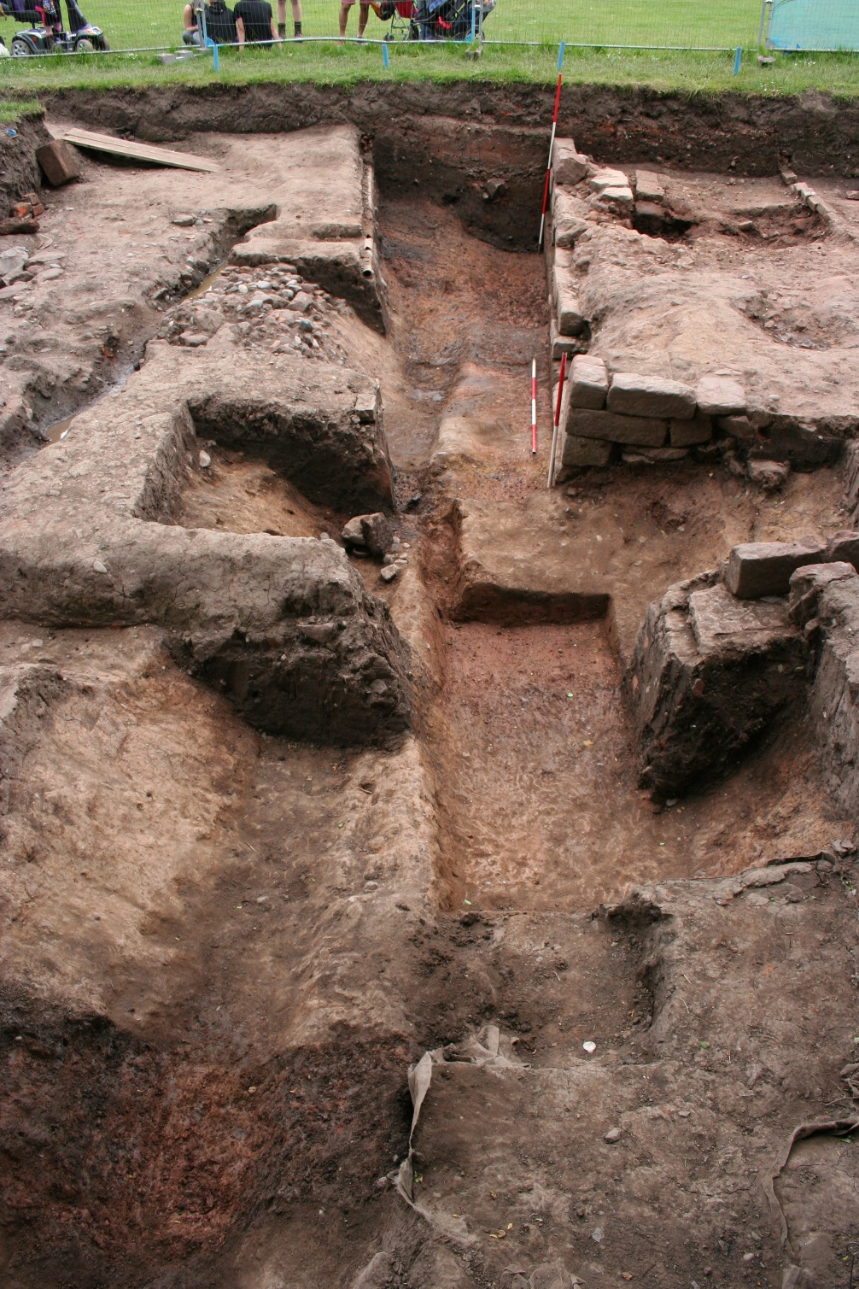
Fig. 47. Substantial, probable medieval, linear ditch running on a north-south alignment in Grosvenor Park (© Simon Ward).

Several burials have also been recovered within the western periphery of the Park, indicating that the graveyard extended further east than at present, which ties with the boundary ditch evidence (Simon Ward pers. comm.), and demonstrates that the church was physically demarcated in the post-Conquest period.
When considering the apparent influx of people to the burh in the tenth century, as evidenced by its repopulation, plus the arrival and settlement of Scandinavians (see below for further discussion) in the tenth century, the need to demarcate land must have significantly intensified, for fear of physical and legal encroachment of property. It is not surprising then that St John's developed, not only as an extra-mural religious space but also a legal land and property owner within a distinctive, demarcated space called the 'Bishops Borough'. This area was owned by the Bishop of Lichfield, alongside the manor of 'Redcliff' and 56 houses as noted in Domesday, which were free of tax (Thacker 2000, 24). The fact that this land was free of tax and had a name to distinguish it, clearly indicates that this space had a known boundary recognised by law.
It is not unreasonable to suggest that the sculptural collection found at St John’s may have stood within or around this space. The assemblage at St John’s may well have been created to mark special locations or symbolise land belonging to St John’s, particularly if the area was being created from the holdings of St Werburgh’s or diminished to make way for St Werburgh’s in the late ninth or early tenth century. It seems less likely that the monuments were raised to mark the boundary of its churchyard or a larger religious precinct associated with it, as the space was marked by a boundary ditch. However, this possibility should not be ruled out, as the monuments may have stood along the ditch as an enhancement to the boundary or were possibly an earlier version of the boundary prior to the ditch being excavated. Either scenario would ensure that the land around St John’s was visually distinct and potentially conveying messages to those who moved and used the space.

WHO RAISED THE ST JOHN’S MONUMENTS?
The question still remains: who raised the St John’s monuments? The two styles of sculpture evident in Chester, the Scandinavian influenced circle-heads from St John's and the unprovenanced pieces that look to Mercia and the south, possibly associated with St Werburgh's, are indicative of two artistic styles, possibly representing two sets of patrons or social groups creating sculptures in the city. This, in itself, demonstrates that there were different considerations and choices involved in raising monuments. Moreover, the large collection at St John’s suggests something unique was happening at the site that sets it apart from the other pre-Conquest churches in and around Chester. By exploring the location of monumental assemblages and the prevalence of monuments at different sites, it is possible to begin to recognise who may have been responsible for their conception and production and the impetus for their erection, all of which is informed by an exploration of the broader local political, economic and social climate of the time.
David Stocker’s (2000, 179-212 and 2015 23-43 with Everson) work on collections of churchyard sculpture is a useful starting point, as he has noted similar disparity in the quantities of sculpture between churchyards in urban (and rural) settings. It is pertinent to expand and clarify Stocker’s argument here. He has proposed two types of sculptural collections evident in Christian churchyards in tenth- and eleventh-century Lincolnshire, Nottinghamshire and Yorkshire, plus Norfolk more recently. This division is based on the quantity of material at each site. The first category, usually includes one or two surviving monuments, which he argues represents local lordly patronage: possibly the founder grave of a Christian graveyard patronised by the local lordly family. The second group consist of larger collections of monuments, which he defines as ‘exceptional’, typically averaging five monuments or more, indicating that the normal pattern of elite burial was not followed at these sites. Here Stocker suggests that these assemblages may represent incoming groups or established communities wishing to emulate the new incoming groups: namely the influx of Scandinavian settlers after the taking of York by the Danes in 876.
Stocker's argument was formed using the Lincolnshire corpus (Stocker and Everson, 1999), which demonstrates strong patterns throughout the county, whereby local parish churches commonly have a few examples of stone sculpture surviving from the tenth and eleventh centuries. Raunds Furnell, Northamptonshire, is a good example of this phenomenon, as it has strong evidence to suggest one specific grave was of particular importance based on its central location, lack of encroaching burials (compared to other graves) and it was also the only grave to have early medieval stone sculpture associated with it. One was a grave-cover lying over the remains of a 35-45 year old male, the other was found at the head of the grave and was a fragmented free-standing stone cross (Cramp 1996, 102-12). The excavators (Boddington 1996) argued that this grave was the earliest from the cemetery and its location dictated how the rest of the cemetery was laid out. Furthermore, unlike other burials from the same phase, this plot was respected until the rebuilding of the church, which indicates that the plot and probably the grave cover (which was heavily weathered, suggesting prolonged exposure outside) was visible for the duration of Phase 1 (Boddington 1996, 11, 51 and 67). These types of individual or small grouped burials with sculpture are interpreted as ‘founder graves’ belonging to the local elite who built and patronised the parish churches on their land. Other counties have comparable examples. In Yorkshire, Blair (2005, 470) also identifies a plot of three remains with eleventh-century upstanding grave markers associated with the Phase II church at Wharram Percy, as potential founder graves. He suggests that these individuals marked by stone-carved crosses and/or grave-covers are the founders of the church and associated cemetery. Dawn Hadley (2002, 224-5) has made similar observations; noting that burials with small collections of stone sculpture dating to the tenth and eleventh centuries, mark the 'seigneurial foundations' of the churches and burial space. The monuments at St John’s were likely used to mark graves or important space within the churchyard. However, their quantity suggests that we are not dealing with the type of churchyard founded in the tenth or eleventh centuries by a powerful local kin group, as suggested by the likely founder grave from Raunds Furnell. Although large collections of stones from eighth- and ninth-century minster and monastic sites from Northern England are known, as at Heysham in Lancashire and Monkwearmouth and Jarrow in County Durham. St John’s currently fits a different scenario more akin (but not the same) to that outlined by Stocker (2000). St John’s history, its sculptural assemblage and location suggest something altogether different occurring at this site during the tenth and eleventh centuries.

Monuments and Communities
Parochial churches with one or two examples of stone carved sculpture from the tenth or eleventh centuries (as outlined above), whilst the most common, are not the only sites to house sculpture. Some churches, like St John's in Chester, have a much larger collection and are classed as 'exceptional' within Stocker's (2000) framework.
The following discussion will consider the archaeological evidence associated with St John’s and its ‘exceptional’ sculptural collection in the tenth century and broader historical evidence available for Chester in this period. It will begin with an exploration of the physical evidence and what this might mean in terms of the community who raised the monuments and how this collection and St John’s was linked with the broader settlement of Chester.

Lincoln
Very little exploration of tenth century Chester and the sculptural collection from St John’s has been undertaken. Comparing the assemblage and the settlement of Chester in the tenth- and eleventh-centuries with similar-sized assemblages from other urban sites offers an opportunity to shed light on who raised these monuments and why. For example, the city of Lincoln, its churches, sculptures and morphology, provides a useful comparison to Chester and a platform from which to consider the development of St Johns and its relationship with the city.
Lincoln was an ancient ecclesiastical site. By the twelfth century some 32 churches were in existence with many churches associated with the town after the withdrawal of the Roman Army (Stocker 2013, 119-21; Blair 2005, 405). The Lincoln Archaeological Research Assessment (LARA) characterised the archaeology of the city and identified different 'zones' of activity, which included data for the foundations of pre-Conquest churches. It identified four different broad categories of church locations (Stocker 2013, 122): strip plots; junctions of streets and lanes; churchyards located within public open space of markets; churchyards located within religious precincts. Primarily, these churches were established between AD c. 875 and 1110 but a handful, such as St Paul-in-the Bail, were established prior to the Viking Period (Stocker 2013, 134).
Stocker's study, by exploring the topography of each of the churches in Lincoln, was able to identify the probable specific functions that led to the foundation of churches (Stocker 2013, 139). The evidence for Lincoln suggests that churches were often established to serve the feudal lords who owned the land. For example, he suggests that the area known as the Bail was occupied by a small number of high-status dwellings and he argues that the four churches that also occupied this area may have belonged to the four principle lords that held land and property at the time of the Conquest (Stocker 2013, 136-7).
However, there are other churches that suggest a broader community involvement, whereby strips of land were given over for the creation of churches for the tenants of the surrounding burgage plots. For example, the settlement to the south of the walled city along the east bank of the River Witham called Wigford, appears to have developed rapidly after c. 875. On this strip of land there are 12 known churches from this period, surrounded by numerous burgage plots. Amongst this new settlement were two churches, St Mary-le-Wigford and St Mark’s, both of which are associated with 'exceptional' collections of early medieval stone sculpture, situated in close proximity on opposite sides of the main north to south road leading through the settlement.
Stocker (2000) argues that the churches of Mary-le-Wigford and St Mark’s, situated outside the city walls, were founded in the tenth and eleventh centuries by new communities of incoming Scandinavians (referring here to those individuals or groups of individuals with a cultural heritage that stems from Northern Europe, primarily from Sweden, Denmark and Norway). This connection between the church and Scandinavian influence primarily relies on the decorative aspects of the monuments found at each church site. The concentration of early medieval sculpture with a strong Scandinavian influence suggests that a particular group or two groups, in close proximity to one another, were burying and monumentalising their dead at these two churches. Based on Stocker's observations of Lincoln as a whole, the evidence suggests that this group were settling on burgage plots in a concentrated area in Wigford and two plots (in both cases these were at the juncture of a road or street) were given over to the establishment of two churches to service the community (Stocker 2013, 139-40).
Stocker (2000 187–89) argues that it is the location of the settlement that explains why there are so many stone sculpture monuments at these churches when compared to the rest of the city: the River Fossdyke was cleared sometime in the tenth century to provide a navigable water route, which created a new harbour just south of the walled city where the Fossdyke and River Witham met at Brayford Pool (Vince 2003, 235-42). Stocker argues that these two churches must have serviced mercantile families located just east of the harbour, who were trading and possibly manufacturing on the banks of the River Witham (Stocker 2000, 186-191).
In summary, the presence of a group of people with a Scandinavian identity concentrated east of Brayford Pool is strongly suggested by the quantity of early medieval stone sculpture with Scandinavian influenced decorative designs and forms. That this group was wealthy is also clear from the level of stone sculpture production. However, the evidence for them being merchants is limited to the location of the settlement, as there is no physical evidence unearthed at present to definitively link the two. So whilst the suggestion seems a sensible one it has yet to be proven through archaeological excavation.

Chester
Comparing tenth- and eleventh-century Chester with Lincoln, a number of similarities can be identified. At the beginning of the tenth century, in AD 907, Chester was re-fortified as a burh by Æthelflæd, using the extant Roman walls as the basis for the re-fortification (Mason 2007, 36), which meant that St John's was situated outside the burh's walls, like St Mark's and Mary-le-Wigford. The interior churches, most notably St Werburgh's, have no known 'exceptional' collections of early medieval sculpture, as was the case with the interior churches at Lincoln. Furthermore, Stocker (2000) argues that the churches with 'exceptional' sculptural collections in Lincolnshire and Yorkshire were serving particular social groups: mercantile Anglo-Scandinavian traders. By exploring the archaeological evidence for activity in the tenth and eleventh centuries in Chester there is enough evidence to suggest the possibility of distinctive groups operating within localised areas largely based on an exterior/ interior divide.
The archaeological evidence to the south of the Roman walls, between the extant walls and River Dee (including St John’s) suggests occupation from the early tenth century (see Fig. 48).
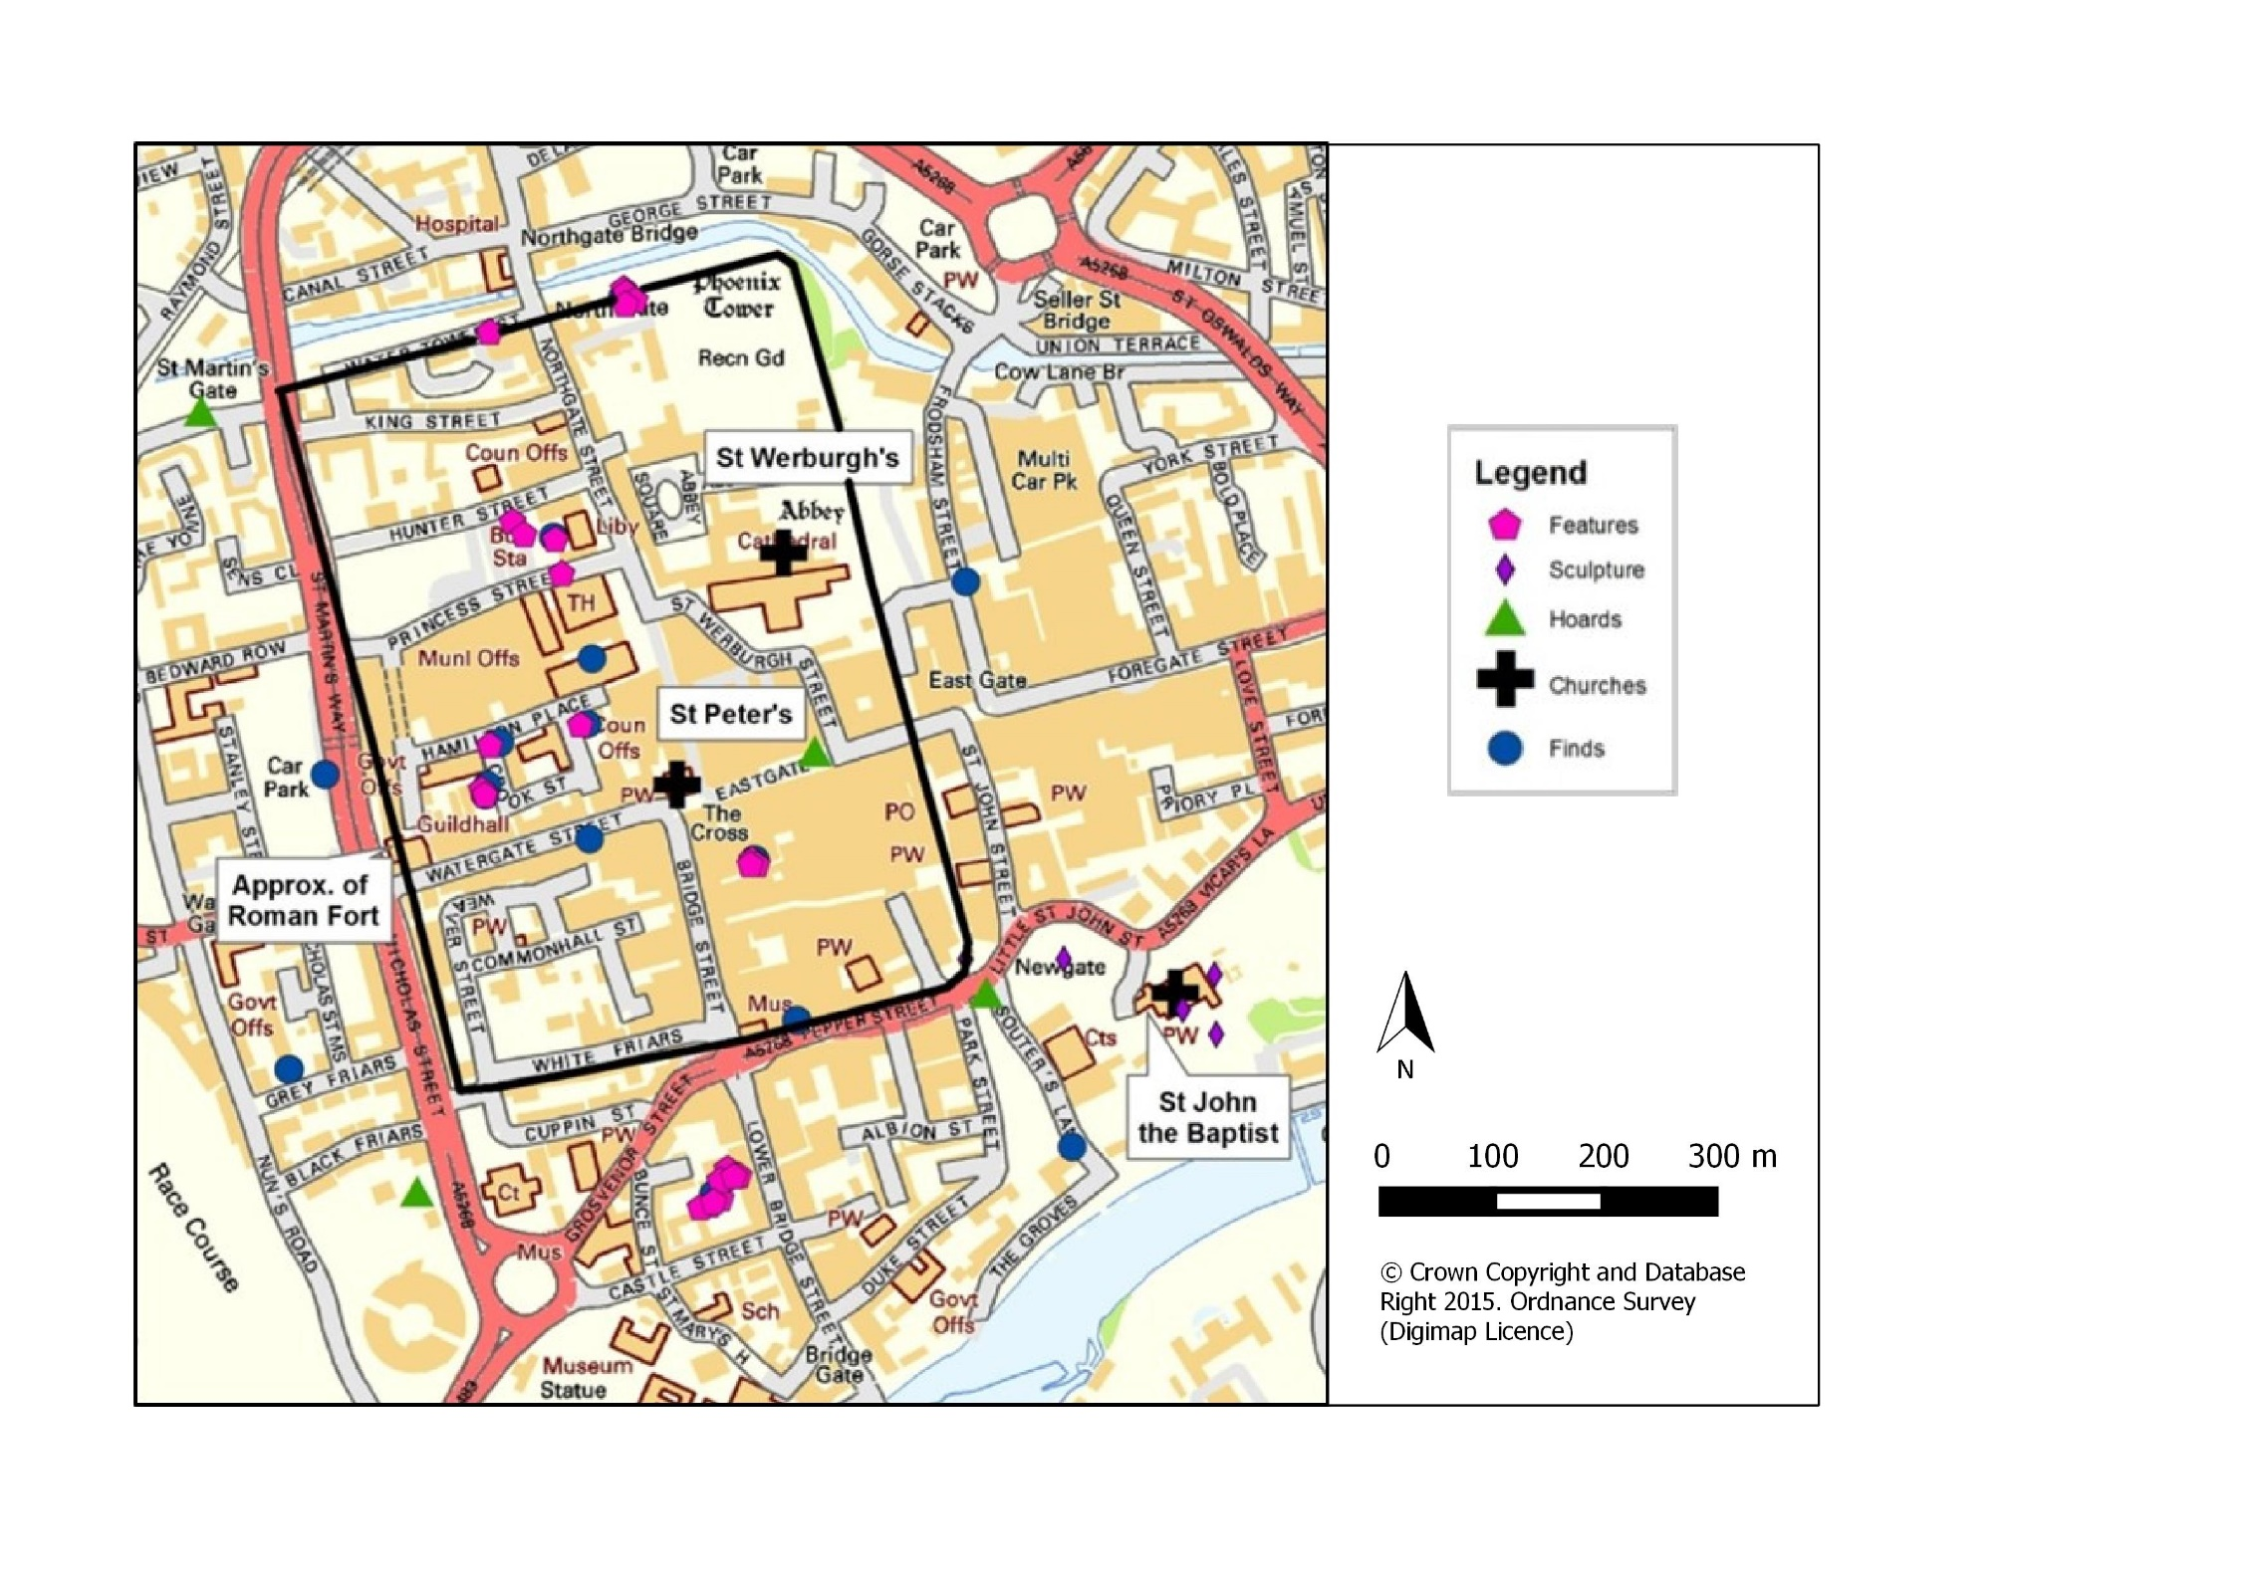
Fig. 48. Map of early medieval activity in Chester dating from the tenth and eleventh centuries (© Crown Copyright and Database Right 2016. Ordnance Survey (Digimap Licence).

Around St John's the evidence for activity pertaining to this period is predominantly artefactual, primarily the early medieval sculptures already noted and a coin hoard from the reign of Edward the Elder (AD 899-924) found just west of the current St John's building (Mason 2007, 126). As noted previously, just to the west of the church two tenth-century burials were also discovered during trench evaluation prior to development (Ainsworth et al. 2005, 15), which belonged to the St John’s graveyard, indicating that the extent of the graveyard is either different or larger than the current one, or they were part of a larger ecclesiastical complex of which we know nothing about.
To the west of St John's, around the site of Lower Bridge Street, occupational evidence has been unearthed dating to the tenth and eleventh centuries. Five rectangular timber buildings dating to the first half of the tenth century based on stratigraphic sequences and associated material culture, on what appears to be a planned system of development, were excavated in the 1970s (Mason 2007, 100-107; Griffiths 2010, 132-3). These were of a standard ground plan and size. Three had full cellars cut into bedrock and another was semi-sunken; the fifth was too badly damaged to get a clear understanding of its construction. These buildings were constructed with at least two floors (a cellar and ground floor). Mason (2007, 102) suggests they may have had an additional second floor. The presence of a cellar, accessed externally to the ground floor, indicates a need for storage associated with these properties. The morphology of these buildings suggests they were not simply used for dwellings but may have served as workshops and storage spaces. In terms of artefactual evidence from Lower Bridge Street, little survived. A stone mould for silver ingots was retrieved from building four. The stone had travelled from the western Highlands of Scotland and the mould would have produced ingots similar to the types found in numerous tenth-century hoards, including the Castle Esplanade hoard from Chester itself (Griffiths 2010, 105-8). This is the only artefactual clue as to the activities being undertaken here, but it does suggest manufacture of precious metal ingots, used in manufacturing and trade. This evidence, when combined, suggests that the residents of these buildings were involved in the manufacture, storage and/or trade of goods in Chester during the tenth century, which is supported by comparable evidence from other towns (see below), which indicates that these buildings represent reasonably wealthy tradespeople with the cellars providing ample space for the storage of goods.
The buildings of Lower Bridge Street also hint at an Irish Sea Zone connection. These types of structures are commonly associated with tenth to eleventh century Irish Sea Zone settlements with Scandinavian influences, particularly towns in the East of Ireland. For instance, examples were found in Dublin (Dublin Type 4), four at Winetavern Street and a single example at Fishamble Street. Others have been found in Manchester and Waterford, although the latter were slightly later dating to the eleventh century (Griffiths 2010). Mason (2007, 105) also notes that the buildings at Lower Bridge Street were slightly bowed, which is a Scandinavian building trait.
The artefactual evidence from Chester as a whole also suggests a Scandinavian presence after the burh’s foundation. Objects associated with clothes are particularly evident. Many examples of hooked tags, a Scandinavian dress accessory used as a cloths fastener, have been found both inside and outside the walls (Ward 1994, 36, 67, 101 and 104). Comparable examples were found at Lincoln, Dublin and York, all of which have a known Scandinavian presence (Mason 2007, 114). Ring-headed pins, which originated in Ireland but were adopted by Scandinavian settlers, have also been unearthed in Chester, suggesting a Hiberno-Norse influence (Ward 1994, 27, 53 and 104; Griffiths 2010, 127). Two brooches have also been recovered: one was found at the Lower Bridge Street excavations and dates to the second half of the ninth century. However, Mason (2007, 114) argues that it may have been in circulation far longer than its date of production based on the amount of weathering on its surface, suggesting that it might have been lost well into the tenth century or beyond. Both brooches are covered in Scandinavian zoomorphic designs, again suggesting a Scandinavian influence at Chester (Ward 1994, 67). Comparable examples have been found in Sweden, Denmark, Dublin and Iceland. In summary, the structural evidence and material culture focused primarily between the southern burh wall and the River Dee suggests a strong link to the Irish Sea Zone and Danelaw settlements such as York and Lincoln, facilitated no doubt by movement by river and sea. This is not unexpected considering Chester’s strong links to places like Ireland. David Griffiths (2010, 130) notes ‘Chester……..was in economic terms the most important town connected to Ireland in the tenth and early eleventh centuries’.
Proof of trade around Chester, whilst limited, does suggest the movement of people and goods around the Irish Sea and across land to places like York, indicating Chester’s growing import during the tenth and eleventh centuries. The documentary evidence for trade during the early medieval period is limited to several eleventh-century regulations that describe how ships, their crew and cargo should be dealt with in terms of taxes and laws. Only one mentions any particular type of commodity: pelts from Ireland (Ward 1994, 124). The archaeological evidence, whilst not abundunt, does suggest the movement of goods and coinage. For example, the discovery of Red-burnished Ware dating to the eighth to ninth centuries was found in disturbed contexts at Lower Bridge Street. The rarity of this ceramic from Northern France, suggests Chester may have been an important port, as it has only been found at Hamwic and Ipswich in England, both of which were major trading centres during this period (Mason 2007, 68). The appearence of Chester-type Ware in Ireland and other Mercian burhs during the tenth century suggests the movement of goods over sea and land (Ward 1994, 125). Limited evidence for metal goods such as the Irish ring-headed pins found across Chester also suggest trade with Ireland (Ward 1994, 125). Probably the most prolific evidence for trade in Chester, the cities links with the Irish Sea Zone and individuals with a Scandinavian heritage is the appearance of many coins minted in Chester, in many major settlements in Britain and around the Irish Sea Zone, including Dublin. Of the 28 Chester moneyers recorded between AD 924-939, six of them had Scandinavian names, one of which meant ‘Ireland Journeyer’ (Griffiths 2010, 102). This evidence clearly suggests that a Scandinavian influence, if not a proven presence was active in the city during the first half of the tenth century. Furthermore, several hoards found in the city also consisted of coinage from other areas of the British Isles, indicating that the flow of goods went both ways. The probable beach market at Meols on the tip of the Wirral boasts comparable material culture to Chester, such as the Irish ring-headed brooches (Griffiths 2010, 112). The site has been interpretated as a site of Scandinavian trade, possibly outside the jurisidiction of Chester, although it had been active as a trading site from at least the Roman period (Griffiths 2010, 111-5). Based on the evidence set out above, Chester was clearly part of the Irish Sea trade network and pivotel in the York-Dublin axis, based on the movement of goods, people and ideas by river, sea and land. Furthermore, the evidence around Lower Bridge Street suggests the presence of a mercantile community that were certainly storing and exchanging goods for trade, if not producing them.
The sculptural evidence strongly supports a connection to Scandinavian/Hiberno-Norse influenced groups in Chester operating near or around St John’s in the tenth century. The surviving sculptures from St John's looks to the Irish Sea and other areas associated with Scandinavian activity for its form, style and decoration. For example, on St John 1, the shaft appears to depict a tegulated roof pattern, similar to the types seen on some hogback monuments (see Fig. 41) (Bu’lock 1959, 6 and Bailey 2010, 63). Bu’lock argued that this was a strong indicator of the monument’s connection to Scandinavian groups, probably from Ireland. Furthermore, a cross depicted on the circle-head, on-top of a building (i.e. the depiction of the tegulated roof tiles on the shaft of St John 1) draws parallels with the ‘Doorty Cross’ at Kilfenora in County Clare, Ireland. This monument depicts a cross and an Anastasis structure, which relates to the resurrection of Christ. Bailey (2010, 63) suggests that this iconography may be behind both the Irish and Cheshire motifs. Parallels with the form and decoration outside the Cheshire/Wirral/North Wales group are all found within areas of Scandinavian activity, such as Yorkshire, the Isle of Man and the Solway area, suggesting that they take their influence from Scandinavian, specifically Hiberno-Norse culture.
The lack of secular imagery at St John's might be deemed problematic, as its occurrence is often linked to the incoming of new groups from Scandinavia and Ireland. However, it is not unexpected within the context of Chester and St John’s. Dawn Hadley (2013, 103-118) has noted that secular imagery in the tenth and eleventh centuries is rare within urban settings, instead focused at rural, parochial churches - the types founded and patronised by local elites - with only a few stone monuments to mark the founder’s graves. Hadley’s argument supports Stocker's idea that some churches with exceptional amounts of sculpture were serving a specific mercantile/trading community rather than all secular patrons. He calls these types of churches 'collaborative group foundations' - churches founded by a specific community, such as the churches of St Mark's and St Mary-le-Wigford in Lincoln (Stocker 2013, 138). Because these churches were servicing traders and possibly craftsmen rather than lords or warriors, there was less interest in depicting marshal prowess and power. Subsequently, there is little if no evidence of this in those churches associated with Scandinavian trading settlements.
Clearly, the archaeological evidence demonstrates a Scandinavian influence at work in Chester during the tenth and eleventh centuries, largely concentrated outside the city walls to the south of the old Roman fortress. However, as Simon Ward (1994, 121) has noted, multiple artefactual finds of a Scandinavian type, plus one possible Scandinavian type building at Hamilton Place and one at Hunter Street School, have been noted within the interior, which indicates that the groups operating in and around Chester may have been more fluid than is generally accepted. Nevertheless, the concentration of Scandinavian artefacts, monuments with Scandinavian influences and possible Scandinavian-type buildings is indicative of a focus outside the Roman walls to the south and south-east along the River Dee.
The area to the south of the Roman Fortress and the River Dee appears to continue to be significant in terms of Scandinavian activity into the eleventh century, as two churches with apparent Scandinavian dedications, St Bridget's and St Olave's, had parish limits that stretched from within the southern limits of the Roman walls to the River Dee (see Fig. 49).
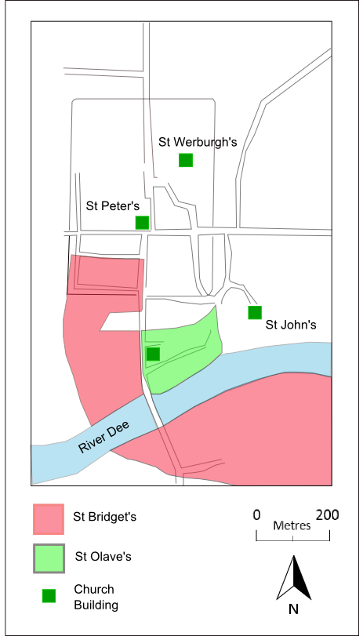
Fig. 49. Map of parish authority for St Bridget’s and St Olave’s (After Allridge 1981, 18)

The foundation dates of these churches are unknown, but they may well be pre-Conquest. St Bridget's parish boundary appears to have been encroached upon by St Mary's, which was founded during the Norman period (Alldridge 1981, 17-21; Lewis and Thacker 2005, 19), indicating that St Bridget's is earlier than St Mary's. St Olave's is dedicated to the Olaf who died in AD 1030, so must date after this time (Alldridge 1981, 19; Ward 1994, 121; Thacker and Lewis 2005, 19). It would, therefore, appear as though these churches were probably founded around the eleventh century, notably after St John's. Furthermore, the land granted to the Parish of St Bridget’s across the river on the southern bank is also measured in Domesday by ‘carucates’, which is a Danish measurement in an area that was largely hidated (Allridge 1981, 19), suggesting Scandinavian influence within the parish of St Bridget’s. So, in one respect these churches support the argument for a Scandinavian presence to the south of the city walls and also demonstrate the obvious importance of the community to have been granted such an extensive area for their churches. However, they also raise the question of why monuments, like those from St John's, were not found at these churches, which have a clearer Scandinavian connection and physical proximity. The likely answer lies in their date. If these churches were not erected until the eleventh century, the need to monumentalise graves may have faded. It may also, in part, be due to the decline that Chester suffered, as Ward (1994, 116) notes how the closing years of the tenth century and the eleventh century was a period of decline for Chester brought about by Viking Raids in AD 980. If the prosperity of Chester's people declined for a time, so too might their ability to raise monuments to themselves.
The notion that Scandinavian’s were active in and around Chester, based on the physical evidence, is no great surprise as documentary material indicates that this area was historically significant in the tenth and eleventh centuries. Emphasis has commonly been placed on the Hiberno-Norse link, based on the proximity to the Irish Sea Region and the documentary evidence of settlement by a Hiberno-Norse group in the area (see below). However, the make-up and origins of the areas Scandinavian settlers is more varied and indicates that Chester’s geographic and topographic location ensured that it was a hub for the movement of people, material culture and ideas.

The Hiberno-Norse in Chester
In AD 902 the ‘Norse’ were expelled from Dublin (Downham 2007, 83; Forte et al. 2005, 101; Griffiths 2004, 127; Jesch 2000, 2), as noted in the Annals of Ireland, Three Fragments (Wainwright 2000, 20). The Norse groups, although it is unlikely they were all of Norse origin, fanned across the Irish Sea Region (Downham 2007, 83). This event has been seen as the main catalyst for Viking settlement in the north-west of England and south-west Scotland (Griffiths 2004, 127).
Most famous of these groups was Ingimund and his followers. In the account from Annals of Ireland, Three Fragments Ingimund attacked and was repelled from Anglesey in AD 902. He then travelled to Chester and established holdings on the outskirts of the settlement with the consent of Æthelflæd (Wainwright 2000, 21-3). Chester was subsequently attacked by the newly settled Vikings. In response, Downham (2007, 83-4) suggests that Æthelflæd likely established the burh at Chester in 907 and others in the area to protect Mercian interests from the Viking raiders and settlers. Furthermore, Smyth (1979, 77-8) suggests that the creation of burhs at Chester, Eddisbury and Runcorn, guarding the low-lying coastal corner of north-west Mercia, clearly indicates that the threat from the Irish Sea Region between AD 909 and 918 was substantial.
Whilst the account, as first noted by Wainwright in 1948, has many fanciful elements, the core narrative seems probable based on the physical evidence set out above and the place-name evidence, which suggests a concentration of Scandinavian place-names on Wirral, primarily of Old Norse origin (Jesch 2000, 3-4 and Wainwright 2000, 35-42). However, it would be wrong to simply assume that the expulsion of the ‘Norse’ from Dublin in AD 902 was directly or wholly responsible for the settlement on Wirral and around west Cheshire, particularly around Chester or that it describes the ethnic make-up of these settlers. This is a rather simplified argument and does not take into account the broader events affecting the Irish Sea Region and mainland England in the tenth century. Greater in-depth analysis by Downham (2007, 121) and summarised by Jesch (2000, 3-4) indicates that those settling in these areas were of Norse, Danish and Irish origin, arriving in the area via the Irish Sea and overland.
In the tenth century, the links between Dublin and York were at times very strong, with leaders from Dublin ruling both settlements. For example, in AD 919 Sigtrygg ruled both York and Dublin and is noted as plundering Cheshire as he moved between them (Forte et al. 2005, 103). At other times that relationship was strained and sometimes none-existent. During these periods there appears to have been a retreat west towards the Irish Sea and overland from the inhabitants of the Danelaw. For example, the collapse of Danish York in AD 954 drove out the Danes with the remaining residents accepting Eadred, King of Wessex and Mercia, as their king. This acceptance of Eadred appears to have encouraged the departure of some leading figures from eastern England (Downham 2007, 120), encouraging individuals to ‘develop power-bases in the west in compensation for the loss of York’ (Downham 2007, 122). This is supported by the place-name evidence, which suggests variability with Irish (Irby) and Danish (Denhall) place-names present amongst the distribution (Jesch 2000, 3). Indeed, in the account of Ingimund’s settlement around Chester it is noted that ‘Afterwards Hingamund came to the leaders of the Norsemen and the Danes’ (Wainright 2000, 21), indicating that the settlers were of a mixed heritage. Based on the complexity of the place-names in the region, Fellows-Jensen (1983, 37-52) and Gelling (1995, 187-94) have both argued, albeit from different angles, that the evidence indicates that a mixture of Scandinavian groups were settling in and around the coastal area of Cheshire, Lancashire and North Wales coming from the Irish Sea region and the Danelaw, largely in the tenth century, arriving here by a variety of means and routes.
The historical evidence, as outlined above, indicates the presence of individuals or groups with a Scandinavian heritage in-and-around Chester and supports the notion that these groups were active and settling in the area in the tenth century. The importance of movement around the Irish Sea Region is noted but it was not the only significant point of contact and feeder for settlers to Chester and its hinterlands. As such, the material culture identified in Chester as Scandinavian in either origins or influence, cannot be assumed to only represent Hiberno-Norse individuals and/or groups but maybe representative of a more mixed Scandinavian heritage. This may also be the case for the sculptural assemblage at St John’s.

Discussion
Who then, raised the monuments at St John’s? The evidence outlined above suggests that Scandinavian influences evident in the decorative designs and forms of the monuments at St John’s is reflected in the material culture and buildings discovered in some areas of Chester. This evidence is particularly concentrated along Lower Bridge Street, heading toward the River Dee. The two areas are linked by the river and share a similar topographic location, particularly as both were situated outside the walls of the old Roman Fort. David Mason (2007 99-100) notes how the area around St John’s and the along the river front were also likely connected by the old Roman road network that had developed due to the areas commercial potential during the lifetime of the Roman occupation. This similarity and proximity suggests a potential group with whom the assemblage can be associated with. Why then, might St John’s be connected with this group of Scandinavian settlers from the late to early tenth century?
If the fortunes of St John’s were limited or even in decline due to the new-found popularity of St Werburgh’s in the early tenth century, then encouraging a potentially wealthy group of individuals to bury and possibly patronise St John’s may have been a means of maintaining or even garnering power within the city. Certainly, the proximity of the church to the concentrations of Scandinavian material culture found in Chester to date suggests that this link is a viable one. Unlike Stocker’s (2000, 179-212) mercantile model, St John’s was unlikely to have been established by mercantile Anglo-Scandinavian settlers. However, there are several similarities in terms of settlement morphology, material culture and sculptural assemblages in areas of Yorkshire, Lincolnshire, Norfolk and Nottinghamshire that cannot simply be ignored. Whilst there is no overwhelming evidence to suggest that these churches were directly linked to mercantile activity, as Stocker would argue, they certainly suggest a link between Scandinavian settlement activity and exceptional collections of early medieval stone sculpture in the tenth century and are seemingly comparable to activity evident in Chester at the same time. If Scandinavian settlers were attending St John’s and seeking burial, then acknowledging this connection through decorative choices may have strengthened and/or symbolised the relationship between the church and its congregation. If the monuments were associated with burial, they may have been raised by Scandinavian’s to commemorate their dead. If they were raised to mark significant locations or signify space, as discussed above, then they may have been commissioned by individuals or groups who had a Scandinavian heritage. Whatever their initial use was, the assemblage suggests a connection between St John’s and the Scandinavian settlers of the late ninth and early tenth centuries. The decoration suggests that these settlers were, at least in part, of Hiberno-Norse origin or identified as such.

CONCLUSION
The approach taken above has systematically attempted to establish that the early medieval stone sculpture unearthed at St John’s in the nineteenth century did belong to the pre-Conquest St John the Baptist church documented in various sources. This was a twofold approach: one that looked at the appearance of the various monuments, their form, decoration and style, and one that explored other Christian graveyards for evidence of stone sculpture stratigraphically linked to early medieval contexts, both methods proved fruitful. A particularly useful avenue was the consideration of what appearance might suggest about the situation these monuments were intended to operate within. In the case of the St John’s monuments, which are highly decorated, short and squat, they were clearly made to be viewed at a short distance. They were certainly not used to draw people long distances. This in turn indicated that it was either the reputation of the space in which they were raised or other visible structures that were attracting people’s attention in the first instance and that the monuments augmented the space and/or structures that they belonged to. This observation, combined with the archaeological evidence that demonstrated that sculptures from the tenth and eleventh centuries were commonly associated with Christian churchyards, strongly suggests that the St John’s group belonged within a churchyard setting: the church structure and the dead providing the initial draw to the space in which the monuments were erected. Whilst there is no physical evidence to tie the group to St John’s in the pre-Conquest period, a consideration of where the monumental fragments were discovered in the nineteenth century, within the foundations and ruins of the twelfth-century church and fourteenth-century Lady Chapel, demonstrate a long association with the site, which supports the notion that these monuments belonged to the pre-Conquest St John’s. Whilst the use for the monuments recovered from the modern precinct of St John’s in the nineteenth century is uncertain, their connection to the building and its locale is strong. They could have been used as burial and/or commemorative monuments, as was becoming increasingly common in the tenth century. However, their uniformity in style and form suggests a common purpose, indicating that they were erected to symbolise or demarcate the space around St John’s, either the churchyard itself or the broader Bishop’s Borough.
Contextualising the monuments within a particular space, a Christian churchyard with a church, on a known site in the tenth and eleventh centuries, allowed the approach to expand beyond the monuments to consider how they and the church operated within the wider setting of Chester during a time of great upheaval, which changed many aspects of the settlement, including its economic prosperity, cultural and religious make-up and the settlements morphology.
The creation of a burh in AD 907, plus the re-foundation of St Werburgh’s and patronage of the West Saxon royal family throughout the tenth century, undoubtedly impacted how St John’s developed and how it was used. Competition between the two ecclesiastical foundations may have led to a desire to demarcate land and seek wealthy patronage. This may have been dependent on the proximity of different groups within the city. Seemingly, St Werburgh’s had a hold on the interior of the burh and strong support from the Mercian royal family. St John’s situated outside the burh may have sought new profitable relationships based on its proximity to the River Dee and the groups operating in that area. The creation of the sculptural assemblage may have been a symbol of the churches wealth and prestige in Chester at a time of competition for land and power but also a reference to the social groups operating within the settlement. On a rudimentary level the evidence, though limited, suggests that St John’s was being utilised in the tenth century by a group of people that were using churches and churchyards differently to those groups within the interior of the city, much like the evidence suggests for Lincoln. Based on the decorative repertoire of the sculptural assemblage at St John’s and the similarities between St John’s, Chester and sites identified by Stocker (2000 and 2015), this group was likely of a Scandinavian heritage or had a desire to identify as Scandinavian, possibly predominantly originating in Ireland. The material culture recovered from areas of Chester, particularly around the riverside south of the old Roman fort walls, indicates that Chester was indeed home to multiple individuals whose activities have left physical clues as to their cultural affiliations, comparable to those identified with the St John’s assemblage. This is also supported by textual and toponymic evidence that suggests Scandinavian groups were moving and settling in the area.
The approach undertaken above has allowed a group of monuments removed from their original context to be recontextualised and explored within their probable setting: a Christian churchyard and precinct, which in-turn has allowed an exploration of their probable function within that space. In addition, their stylistic influences have encouraged an exploration of comparable archaeological material within Chester and suggested links to a particular group with a focal point within the city. The link between the monuments, the community based between the southern wall of the Roman fort and the river front and St John’s in the tenth century has also facilitated an exploration of how the morphology of the city developed based on choices made during this formative period.
Like many examples in west Cheshire and a limited collection in east Cheshire, proximity to a settlement clearly had an impact on how they survived - fragmentary and reused. Therefore, understanding the history of that settlement (Chester in this instance) is absolutely key to understanding the biography of these monuments from their erection to the current day. Moreover, when an assemblage survives, like the St John's group, it is far easier to establish a reason for their erection and their function than standalone monuments, as one is able to recognise trends in their decoration and form that might suggest function.
Overall, this chapter has demonstrated an approach that considers all the evidence associated with these monuments; their decoration, form, size, evidence for reuse, recent provenance, historical background to the sites and comparable material to establish a context and function. It is an approach that foregrounds place as the key to interpreting a monuments function and decorative choices. Place is also the key that allows one to begin to trace the biography of a monument back from its present situation and function. We only need to look at the unprovenanced examples from Chester to see how limited our understanding of them is, primarily because we cannot establish a relationship between them and a particular place. Any approach that distances monument from location by focusing solely on their appearance and/or distribution is invariably limited.

CHAPTER SIX

MONUMENTS, LOCATION AND ORCHESTRATED AUDIENCE ENGAGEMENT AS A TOOL IN THE CREATION OF PLACE

INTRODUCTION
In the previous chapter, a group of monuments removed from their original contexts was discussed in terms of what their appearance could suggest about their initial location and function. By re-contextualising the monuments, it was also possible to establish who might have erected them and how their creation was linked to wider changes across an urban settlement. It was clearly demonstrated that considering monuments within their landscape location can offer a wealth of information not available by simply exploring their decorative choices and styles.

The following chapter will apply a distinct but related approach to a very different sculpture with a very different landscape situation and reuse history. This will have a number of benefits. Firstly, it will highlight how useful the approach is for all early medieval sculpture. It will also demonstrate the different types of discussion that can be generated when different evidence, locations and sculptures are available for investigation, as the next site is situated in a remote location and represents those monuments, primarily in the east of Cheshire situated away from settlements. This sculpture, whilst having many comparable examples, is located alone rather than in a physically concentrated group. Possibly the most important factor that differs from the St John’s assemblage addressed in Chapter Five is the fact that the monument is thought to be in situ, so its biography and reuse history is very different to the St John’s assemblage and the vast majority of early medieval sculpture from the British Isles. All these factors should ensure that whilst a comparable approach is applied to the monument the discussion will be different and generate different information.

As was established in Chapter Four, east and west Cheshire has very different sculptural collections and had very different economic, political and social development. By comparing the most prolific types of sculpture in west Cheshire against the most prolific types of sculpture in east Cheshire and comparing the most common locations for west Cheshire monuments and east Cheshire monuments, a greater understanding of what was happening locally during the early medieval period and beyond might be possible.
The case study for this chapter will be a striking early medieval stone cross-shaft seemingly positioned in its original location: the Cleulow cross (Wincle 1), located in the far east of Cheshire. As well as the approaches set out above, the exploration of this in situ monument also allows for an in-depth exploration of early medieval stone sculpture’s role in creating or augmenting existing landscapes, as the topography is seemingly largely unaffected by subsequent habitation and building, unlike the St John’s group. The surviving landscape topography offers an opportunity to explore how people may have experienced the monument during their journeying through and dwelling in the landscape. For example, the visibility of the Wincle monument within the landscape, albeit hampered by the lack of detailed micro-environmental reconstructions, does allow us to explore how the monument may have viewed the landscape around it and been viewed by those moving through its surroundings (see also Williams 1999; Brookes 2007). Exploring the way the body is able to move and interact with an early medieval monument, however, takes us far beyond the study of viewsheds. It is about considering the perceptions and experiences of the human body in relation to monuments, and while individual experience might not be readily reconstructed, monuments can be viewed as tools created to consciously manipulate these bodily experiences (Tilley 2012). Hence, an early medieval stone monument is first a landmark around which engagement with the landscape occurs. It is a visual signal that requires the embodied, multi-sensory presence of individuals and groups to observe it and remember it (see also Gondek 2010; Williams 2011). In some situations, this experience can be enhanced by a physical encounter with the monument, where an individual is able to walk around and touch it (Tilley 2012). In this regard, the study builds on the previous chapter but focuses on visibility, degrees of proximity and access, as themes to explore how early medieval sculpted stone monuments constructed particular embodied experiences in the landscape.

It is generally accepted that early medieval stone sculpture served as visual aids: as waymarkers on journeys, visual indicators of cognitive boundaries and signals of land ownership through complex commemorative practices (reviewed by Williams 2011, 16), as touched upon in the previous chapters. However, research has rarely been undertaken to understand how the topography of the area, the associated archaeology and the cognitive aspects, such as nonphysical boundaries and place-names, are connected to an early medieval sculpture’s location, appearance and use.

When factors, such as associated archaeology and place-names, are considered in relation to early medieval stone sculpture, the results provide additional clues as to the function of the monuments, why particular locations were chosen and the broader changes occurring within society that may have spurred on the creation of such monuments. As noted earlier, Jane Hawkes (2003c, 69–99) argued that the use of stone in church constructions and the raising of monuments in the early medieval period was at times a direct citation of Rome and the Roman church. By referencing Rome in the creation of buildings and monuments, those groups associated with these new constructions were able to appropriate the power, antiquity and prestige of the ancient Roman church. Many stone churches incorporated romanesque features into the architecture and stone sculpture copied Roman columns like the examples of decorated columns at Masham and Wolverhampton (Hawkes 2003, 78). Furthermore, Hawkes (2003c, 69-99) and later Semple (2013, 134) have noted how churches and/or stone sculptures in the early medieval period were sited on or close to partially extant Roman earthworks or structures, such as forts. For example, Hawkes (2003b, 78-1) suggests the cross at Bewcastle is a take on a Roman column and Orton (2006, 62-3) has discussed how the siting of the monument at the fort is significant because of its location within the fort walls, its visibility within and via the major access points, plus its proximity to important Roman buildings.
Hawkes (2003b 69, 99), Orton (2006, 29-66) and Semple (2013, 131 -136) were able to demonstrate that exploring the associated cultural and natural topography in which a monument is erected provides a context in which early medieval sculpture was raised. Their work illustrates how the location of the monument was impacted by the surrounding cultural topography (e.g. extant buildings, road networks, lines of site), and its physical appearance in order to project and appropriate a particular set of associations. Sarah Semple (2013, 132-136) has addressed more broadly, how surviving prehistoric and Roman cultural landscapes can impact upon how monuments are used, where they are sited and what they look like. She emphasises how important it is to explore the micro-topographies and broader locales of monuments in terms of their specific topography and local identities, indicating that these can affect how groups use stone sculpture and suggesting that these factors are responsible for the variations in practice, locations and appearance:

‘The intellectual agenda for monument building could be the locality itself and the physical remains of the past therein and the local sense of identity shaped by the landscape (Semple 2013, 135).

Orton (2006, 29-66) demonstrated that the relationship between the cultural and natural topography worked together at Bewcastle to shape broader landscape and create a ‘place’ that would become the focus for activity over many generations.

The natural and cultural topography discussed above can be carefully orchestrated, or at least drawn upon to aid in the creation of a particular experience over time, to manipulate the experience of individuals by controlling how and what they see, when they see it, from what distance and direction they are expected and allowed to experience it. Williams (1999, 57-86) has noted a similar phenomenon for high-status late sixth to seventh century Anglo-Saxon burials, whereby locations that could draw on multiple topographic features, such as physical links to the ancient past, elevated areas and proximity to route ways, were particularly popular. Whilst these topographic features were not created specifically for the burial, they were clearly important in the choice of location for burial, as they are present repeatedly. These orchestrations of experience combine to generate specific knowledge of a place and a memorable encounter, although there is room for an individual to act outside these parameters and generate an experience outside the norm. Using in situ monuments allows for an exploration of this orchestrated environment.

This chapter is an in-depth exploration of the Cleulow Cross from this perspective. It argues that the monument’s appearance is likely dictated by its location and its function is augmented and publicised by both its immediate landscape and broader situation. Combining the regional information discussed above with a more intuitive localised exploration of the monument and its relationship with the landscape, allows a discussion that both considers how the monument is affected by its particular environment and how it affects the environment. Moreover, it also demonstrates how broader regional trends and activities may have impacted on this relationship. Exploring a monuments location at different scales prevents it being studied in isolation whilst also preventing a discussion based on broad generalisations observed across a particular geographical area (for a similar methodology that uses a ‘multi-scaler’ approach see Williams et al. 2010, 1-21).

THE ROUND-SHAFTS OF CHESHIRE
As discussed in Chapter Four, in the east of Cheshire there is a well-recognised group of round-shafted crosses with limited surviving decoration. The group is comprised of twelve single-shaft monuments, one composite monument with two shafts and a double socket stone with two missing shafts. A further four monuments could be round-shafts but their fragmentary state makes a definitive identification impossible. They are dated by CASSS (Bailey 2010, 33-38) to the tenth and eleventh centuries based on their form and decoration. All have lost their cross-heads and the only decoration that survives is the moulding and swag at the juncture between the shaft and the cross-head, with occasional fragments of relief decoration on monuments such as Rainow and Sutton 1, predominantly limited to the tapering shaft between the swag and cross-head (Bailey 2010, 98, 126-128). They are found in a closely bound geographical area along the eastern extent of Cheshire, bordering Derbyshire and Staffordshire (See Fig. 14).

Of the ten known sites, three are associated with parish churches (Astbury, Disley Church Field and Macclesfield). However, as demonstrated in Chapter Four, the evidence suggests that these sites developed as churches after the Norman Conquest of AD 1066. This, combined with the fact that the rest of the group were situated away from centres of occupation, suggests that the monuments have been moved to the churches at a later date. Therefore, their locations suggest few were immediately connected to contemporary early medieval ecclesiastical structures (Bailey 2010, 36), although it remains possible that further examples have been lost; those located in closer proximity to settlements might have less readily survived as landmarks.

The remaining seven of this group are found on moorland, beside trackways or at crossroads. This grouping is part of a wider distribution of round-shafted crosses focusing on the Peak District, across Derbyshire and Staffordshire (Routh 1937, 1-42; Pape 1945-46, 25-49; Bailey 2010). Their locations have been repeatedly used to interpret their probable function, commonly believed by historians and archaeologists to be landmarks and aids to devotion (Thacker 1987, 280; Bailey 2010, 5-10). Descriptions of these monuments tend to focus on their comparable stylistic qualities and rarely explore individual monuments and their context (Sidebottom 1999, 206; 2000, 213-217). The body of work pertaining to round-shafts in Cheshire (and the surrounding counties) is limited and largely confined to discussions regarding appearance and dating (see Bailey 2010, 33-7 for an overview). Only a few explore the assemblages function based on their geographical/and or topographical location. Early discussion (Andrew 1905, 201-14 and Cox, 1904, 56-8) largely concentrates on the Derbyshire monuments and makes assumptions about the Cheshire material being comparable in location and function. Andrew and Cox for example, having worked on the material together, both conclude that the round-shafts are ecclesiastical or secular land boundary markers from the latter end of the early medieval period. However, there is no round-shaft monument in Cheshire that has a secure provenance on any boundary. It is, therefore, difficult to conclude that this was their purpose. Radford (1961, 209-10) also reiterates this idea, specifying their possible function as parish boundary stones. However, all but three monuments were found within the ancient parish of Prestbury and none are on or near the Parish boundary (see Fig. 52). Whilst it is not wise to dismiss the notion that the round-shafts functioned as boundary markers (secular or ecclesiastical), the level of detail and investigation is simply not present in these discussions to present a convincing argument that can be explored in detail. The most recent attempt to explore round-shafts, based on their distribution, was undertaken by Phil Sidebottom (1999 and 2000). Sidebottom attempted to identify who was raising the round-shafts and why. Whilst problematic (see Chapter Two for an overview and discussion of his arguments), Sidebottom has come the closest to mobilising the landscape context to understand something of the assemblages function and appearance. However, there was little in the way of exploration of place or the specifics of environments for each monument. The monuments were never considered alone and the possibility never raised that they might have functioned individually as well as, or instead of, collectively.
By considering a monuments individually (and then comparatively) within its own locale, this chapter will bring a level of detail and understanding to the fore that can then be explored and used to inform the broader historical and iconographic detail that has been discussed elsewhere. This chapter will use multiple data sets and observations to explore function, appearance and distribution, considering an in situ monument in context, in order to develop a better understanding of the monuments relationship with its immediate location, environs and broader hinterland. The chapter will also explore how round shafts could have functioned, possibly as visual way markers, markers for assembly (formal and informal), if the sculpture was possibly used to signal territorial, political, ecclesiastical power and/or identity, and how this might be identified through the surviving evidence. The best opportunity the Cheshire corpus provides to explore these ideas, within the round-shaft assemblage and also more broadly, is the Cleulow Cross at Wincle (Fig. 50). Within the Cheshire corpus, of the thirty-one sites associated with early medieval sculpture in the county, only the round shaft of the Cleulow Cross at Wincle, is likely to be in its original location. The name ‘Cleulow Cross’ is first mentioned in a will dated AD 1538 as the location of a debtor. In the seventeenth century, its geographical position is first noted, in that it appears on a map (Bailey 2010, 136). The early date of the will certainly indicates that it survived the iconoclasts who are known to have destroyed many early medieval sculptures in Cheshire, as discussed in Chapter Four (Stewart-Brown 1923, 100-102). The argument for the Cleulow Cross being in its original location is further enhanced by the presence of the stone’s original base, the sheer size of the monument, and its relative completeness. Its survival in its probable intended situation allows consideration of its original topographic, geographical and archaeological context.

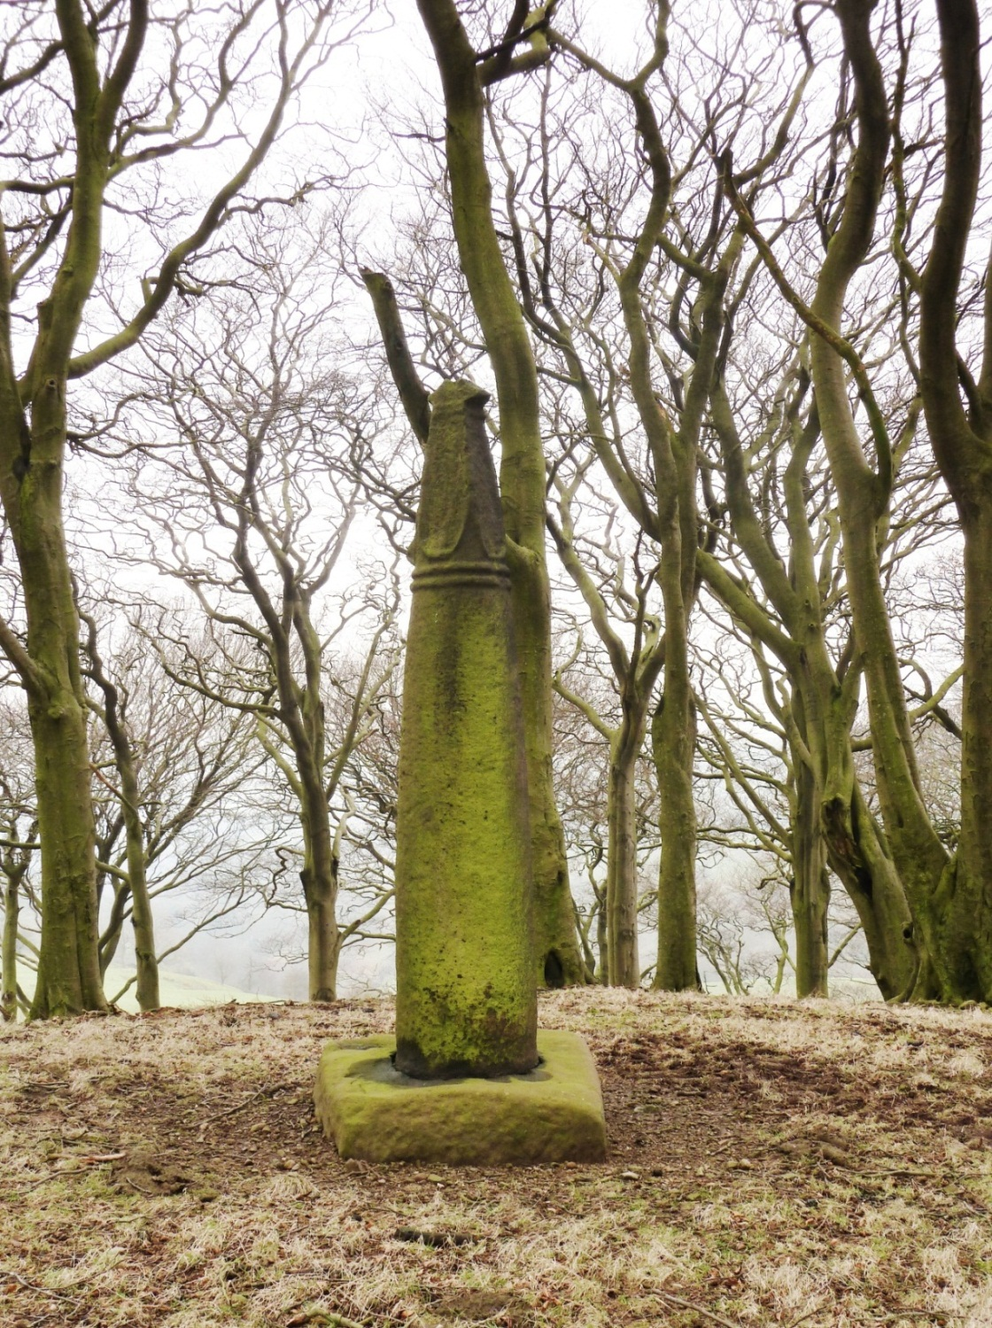
Fig. 50. Wincle 1, Cheshire. Also known as the Cleulow Cross (© Joanne Kirton)

Two other sites (with round-shaft monuments), Disley Lyme Handley and Rainow, provide compelling evidence for only localised movement (within 300m of the original find-spot). Though scarce, examples like the Cleulow Cross at Wincle provide excellent opportunities to explore the function and meaning of free-standing stone crosses through their landscape situation comparable to the ongoing research investigating the Pillar of Eliseg, Denbighshire (Edwards 2009; Williams 2011). However, it seems that round-shafted monuments in Cheshire have escaped in-depth enquiry because they do not bear either highly decorative motifs or an inscription, the likes of which have made monuments such as the Sandbach crosses and the Pillar of Eliseg, the focus of intense study (e.g. Hawkes 2002; Edwards, 2009, 1-35). The Cleulow Cross at Wincle only becomes worthy of an in-depth study when we consider it as a monument within a landscape.

THE CLEULOW CROSS LANDSCAPE
A number of observations made during several visits to the mound and traverses of the surrounding landscape suggest that the patron(s) actively chose to make the Cleulow Cross visible, memorable and available to a mobile audience. The strategy was seemingly dependent on movement, which suggests that the monument had a significant symbolic message to convey to those who passed by. The surrounding topography and archaeology, the form and size of the monument itself, and the geographical location are all part of this strategy. Furthermore, its immediate topography is boggy and undulating, suggesting that the significance of the monument may have been enhanced by the control and access of space via natural approaches and barriers. By investigating this strategy, employed within the early medieval landscape, it is possible to explore ideas about monumentality, memory and embodied experience.

To begin this investigation of the Cleulow cross and mound, an exploration of what the monuments hinterland may have looked like and how it may have been used and understood prior to the crosses creation, will provide the context in which to explore how and why this monument might have been conceived and how it may have functioned once raised on the summit of the mound in the tenth or eleventh century. The mound and monument will form the foci for a 4x4 km² study area (Centroid: 395201, 367401), in which topographic, archaeological, toponymic and documentary sources will be used to build a picture of the landscape in which the Cleulow Cross was raised (Fig. 51).

Fig. 51. Map demonstrating study area around the Cleulow Cross and mound (Base Map: Ordnance Survey 2015 [Crown Copyright/database right 2015. An Ordnance Survey/Edina supplied service]).

The early medieval landscape: land use and administration
The first element of this exploration will be to try understand how the landscape may have appeared at the time the monument was conceived and subsequently erected and to explore the cognitive aspects, such as boundaries, that affected how people used and understood the landscape. Unfortunately, the data available to reconstruct the landscape in the latter Anglo-Saxon period is incredibly poor. The hundredal boundaries, as mapped below, are derived by aggregating evidence from nineteenth-century administrative boundaries and the Alectro Domesday (Thorn 1992). Collectively, the hundredal boundaries delimit the county of Chester. Prestbury Parish is also derived from the same nineteenth-century boundaries. However, Kain and Oliver (2001) argue that there is little evidence of either new parishes being created or existing ones being divided after c. AD 1500. Consequently, the antiquity of the parish boundary likely dates to at least AD 1500.

Fig. 52. Map demonstrating the pre-1974 county boundaries, hundredal boundaries and the Parish of Prestbury (after Williams 2015).

The major land unit at the time of the Cleulow Cross’s creation was the shire, a system of land units created in the first half of the tenth century, probably between 920 and 923 (Higham 1993, 115). The shire covering modern day Chester was called Legeceaster scir. The shire name is first referenced in 980 in the Anglo-Saxon Chronicle (Dodgson 1970, 1). The Cleulow Cross was located within the far south-east corner. The shire was divided further into twelve hundreds. Hamestan Hundred (largely equating to the later Macclesfield Hundred), was located at the eastern extent of the shire, bordering Derbyshire, Lancashire and Staffordshire, containing the Cleulow Cross and the research area. The first known reference to the hundred is made in Domesday Book (Dodgson 1970, 42). The monument and mound are located within the ancient parish of Prestbury, first noted in c. 1170-1182 (Dodgson 1970, 212). The Cleulow Cross is situated 2.17 km from the modern county boundary, which also serves as the parish and township boundaries in this area. The Cleulow Cross is not situated on any of these known borders, nor are any other of the Cheshire round-shaft assemblage.

Beyond this broad detail, the area is poorly documented. The Domesday Book provides no specifics about activity in and around the Cleulow Cross. Higham (1993, 171) states that there are ‘exceptional problems confronting an analysis of pre-Conquest organisation in Hamestan Hundred, the poorest and least hospitable of any part of the region’, indicating that establishing what the landscape looked like and understanding how it was used within the hundred is particularly problematic compared to other hundreds in the county and beyond. The discussion is, therefore, restricted to inference from areas that do appear in the Domesday survey of AD 1086 within the hundred and an exploration of place-name evidence, both of which provide hints of what the landscape was like and used for around the time the monument was erected. This information is supported by recent landscape characterisation of the natural topography and the regional historic landscape characterisation.

From the list of locations that were noted in Hamestan Hundred in the Domesday survey, twenty-seven in total, indicates that the hundred was sparsely populated, the least so of all hundreds in Cheshire, particularly in comparison with the west of the county. The population consisted of villeins, smallholders, ploughman, riders and a small percentage of knights, no priests (or churches) are recorded (Phillips and Phillips, 2001, 28-31).

Fig. 53. Population density of Cheshire in 1086 based on Domesday Survey after Phillips and Phillips 2001, 31 (© Phillips and Phillips).

Within the study area no settlements are noted in the Domesday survey. The nearest recorded settlement to the Cleulow Cross is at Bosley, approximately 4km to the south-west. The description notes woodland two leagues long by half a league wide. However, the area was waste at the time of the Domesday survey but had the capacity for four plough teams (Folio 266v, Williams and Martin 2003, 729). Using Bosley, and other documented sites, to document the wooded areas, this distribution indicates a high concentration of woodland in close proximity and infers that Wincle was comparable but unrecorded.

Fig. 54. Woodland density of Cheshire in 1086 based on Domesday Survey after Phillips and Phillips 2001, 31 (© Phillips and Phillips).

In AD 1066 Bosley was held by Godric, who also appears to have held twelve other settlements at this time in the east of the county, primarily within the Hamestan and Middlewich Hundreds (Williams and Martin 2003, 716-740). By AD 1086 the land was in the possession of Hugh, who held the land from Earl Hugh (Folio 266v, Williams and Martin 2003, 729). There is no evidence to indicate who held the land on which the mound and Cleulow Cross sat, but the proximity of Bosley and distribution of their other landholdings can suggest potential landowners in the pre- and post-Conquest periods.

The place-name evidence pertaining to the study area (taken from Dodgson 1970, 148-72) is limited and the antiquity of the names difficult to establish. No names are documented prior to the twelfth century. However, eleven names are dated prior to AD 1400 and are best placed to offer insight into land use in this area (Fig. 55 and Table 6).
Fig. 55. Distribution of place-names dated to prior AD 1400 (Dodgson 1970) (Base Map: Ordnance Survey 2015 [Crown Copyright/database right 2015. An Ordnance Survey/Edina supplied service]).

Name | Meaning | First Reference (AD)
Buttlerlands | Rich pasture land (good for butter) | 1286
Cleulow* | Ball/round mound | 1382
Dane Bridge | Bridge over River Dane | 1357
Greasley | Badger clearing | 1350
Hammerton | Maimed/mutilated hill | 1347
Hollinset | Holly-tree fold | 1285
Oakenclough | Dell growing with oak trees | 1347
River Dane | Slow river | 1270
Shellbrook (Valley)* | Sheep/noisy brook | 1270
Wincle* | Nook/corner hill | 1190
(Wincle) Grange | Pasture estate | 1190

*denotes a place-name where the meaning is not certain. See Dodgson (1970) for full discussion. Cleulow also has additional discussion below.

Table 6. Table noting all place-names dated prior to AD 1400 (Dodgson 1970), their meaning and date of first reference.

Two names indicate settlement. The first, Wincle Grange, was a pasture estate first mentioned in AD 1190. However, the presence of a round-shaft at the site indicates that the settlement may have an earlier origin. The second is Hammerton to the north of the mound and cross, ton denoting a ‘homestead’ or ‘enclosure’ in OE. Two names suggest a form of land use or impact on the landscape: the latter element –ley in Greasley refers to lēah OE for woodland clearing. However, it is difficult to tell if the clearing was natural or anthropogenic, but it does demonstrate that there were areas of wooded land in the study area. Two other place-names refer to wooded areas, Oakenclough, which means ‘dell growing with oak trees’ and Hollinset, meaning ‘holly-tree fold’. The second name indicating land use is Butterlands, which translates as ‘rich pasture land (good for butter)’. No place-names are indicative of seasonal activity in the study area and notably, none of the place-names that can be dated prior to AD 1400 have elements derived from personal names, which may be indicative of the low population density noted in the Domesday survey. In summary, the place-name evidence suggests that the research area around the Cleulow Cross was sparsely settled, wooded in places and used for pasture in others.

The evidence provided by the Domesday survey and place-names recorded before AD 1400 is limited. Setting this information within a broader landscape assessment offers an opportunity to explore the landscape now and in the past. The Local Landscape Character Assessment (Cheshire County Council, 2008) identifies three different designations within the study area; Upland Footslopes (USF2 and USF5) Upland Fringe (UF1 and UF4) and Moorland Plateau (MP2). The core of the research area focuses on USF2 and UF1 (Fig. 56).

Fig. 56. Local Landscape Character Assessment designations after Cheshire County Council, 2008

The Upland Fringe area, UF1, is characteristically largely upland enclosed moor. The landscape is open and expansive with long panoramic views providing the most characteristic feature. Woodland cover is low and largely confined to the steep valley slopes (Cheshire County Council 2008, 133-5). Settlement in this area is characteristically low in density, mainly constituting dispersed farms in the valley bottoms. ‘The inhospitable and exposed nature of the character type makes is particularly inappropriate for settlement, hence the predomination of dispersed farms on lower margins’ (Cheshire County Council 2008, 135). To the south and west are the Upland Footslopes, which are characterised by areas of dense wooded, steep-sided valleys, with river and stream networks. It is a transitional landscape between steep-sloping ground and the urban settlements below (Cheshire County Council, 2008, 105-6). In this part of the study area, designated UFS2, there is a mixture of woodland and pasture, with woodland mainly focussed around the River Dane and its tributaries. The higher ground in the north of the designated area is predominantly used for pasture (Cheshire County Council 2008, 113). This area also has low population density with settlements largely focussed in the valley bottoms.

The characterisations outlined above are based on modern observations but they do suggest the type of activity that might have been possible during earlier periods. The Cheshire Historic Landscape Characterisation completed in 2007 (Edwards 2007) has explored the same area in terms of evidence for historic land use, and can be used to supplement the information provided above. The land that falls within the research area is characterised as an area of post medieval (AD 1600 onward) enclosure of heathland and moorland (Edwards 2007, 117-8). Some medieval field systems do survive in the area, west of the mound and monument, at Bosley Minn (NGR 393910 366647). Here heathland and moorland was also enclosed in small field systems (Cheshire County Council 2008, 137-8). The historic characterisation seems to support the modern land use characterisations outlined above: the area around the Cleulow cross and north of it, to the extent of the research area, was open heath- and moorland, possibly used for pasturing animals. Moving south toward Wincle and Danebridge, the land is a mixture of high, open ground, transitioning to steep valley slopes and bottoms, on which more wooded areas were present. Throughout the study area the landscape was sparsely populated and settlement dispersed due to its inhospitable nature. The field-name evidence supports this description, being limited in settlement names and broader land use indictors. This too is reflected in the limited evidence available for the area in Domesday Book.

Whilst none of the information presented above is contemporary with the Cleulow Cross, it does all form a coherent picture of how the land would likely have been used in the past based on its topography and natural resources. Whilst enclosure of moor- and heathland occurred in the post medieval period (Cheshire County Council 2008, 138-8), it appears that this area has remained largely static in terms of land use and settlement density.

Routeways and Road Networks
An exploration of the historic routes across Cheshire, and specifically the study area, provides an opportunity to understand how people may have moved through the landscape and how this impacted its appearance and use over time. When monuments, earthworks and/or structures can be associated with routeways and roads, physically or by simple proximity, there is also an opportunity to explore how audiences may have accessed and viewed such sites. This is particularly pertinent to the Cleulow Cross, as it sits at the heart of a modern road network (see Fig. 57), which appears on the 1871 1st Edition OS map (1:2500). At first glance the road network makes the monument and mound incredibly accessible. However, the age of this road network is difficult to establish due to a lack of historical detail.

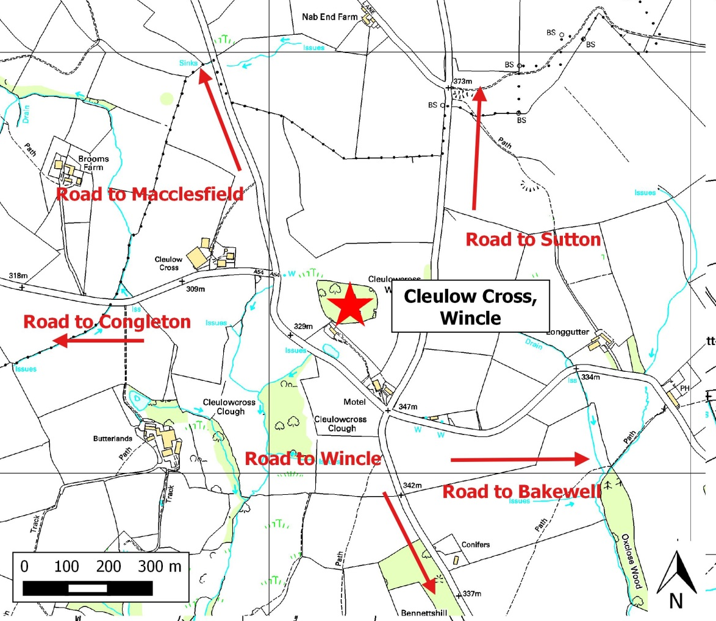
Fig. 57. Map demonstrating road network around the Cleulow Cross and Wincle Mound (Base Map: Ordnance Survey 2015 [Crown Copyright/database right 2015. An Ordnance Survey/Edina supplied service]).

Whilst a number of Roman finds have been noted within the study area (see below for further discussion), no known Roman route ways have been identified (See Fig. 58).

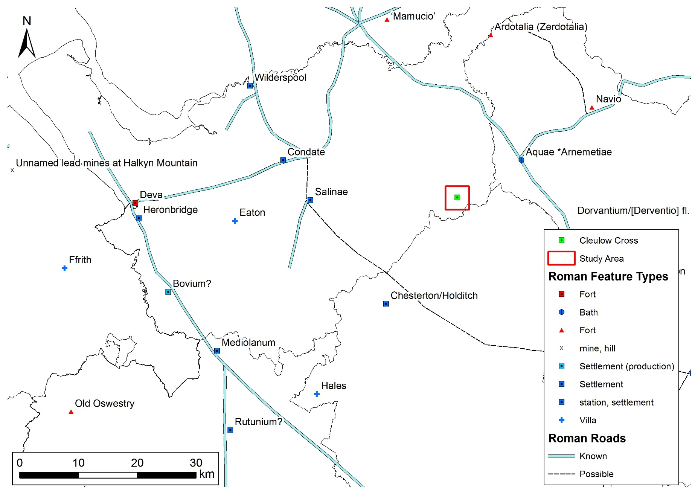
Fig. 58. Roman road network and associated occupational evidence in Cheshire and surrounding areas (after McCormick 2013, Talbot 2000 & Phillips and Phillips 2001, 29).

Furthermore, there are no place-names denoting routes within the study area that precede Bryant’s 1831 map of the county. However, Dodgson (1970, 46) identified one route that passed by the Cleulow Cross, dubbed the Earlswaie, noted in 1593 as a route between Congleton and Buxton (see Fig. 59). This appears to follow the later turnpike running between the same settlements, which suggests that this route has been in existence since at least the sixteenth century. Unfortunately, no other turnpike roads are noted in the research area that might be indicative of earlier routeways (see Fig. 59).

Fig. 59. Early turnpike system and place-names associated with routeways (after Phillips and Phillips 2001, 55)

Based on the current evidence the road network around the Cleulow Cross cannot be dated earlier than AD 1760-1789, except for the road passing just to the south below the mound and cross, connecting Congleton and Buxton. However, all the roads surrounding the mound and monument may well be much earlier. The lack of precise dating is a challenge faced across the British Isles (Taylor 1979, x). However, Taylor (1979, 90) notes that establishing dates for the surrounding settlements with which the tracks are associated is the best option for establishing provisional dates for the tracks themselves. The sites of Macclesfield, Congleton and Bakewell were all in use during the early medieval period, as their situations before the Norman Conquest are described in Domesday. Wincle and Sutton do not appear in Domesday but the presence of tenth- to eleventh-century stone sculpture (Bailey 2010) is indicative of activity in each of these areas during this period. Therefore, whilst we cannot date the routes, we do know they were linked to early medieval settlements or areas associated with activity from this period. Furthermore, a consideration of the surrounding topography suggests that these routes generally follow the easiest passage through the rugged terrain: primarily the tops and bottoms of the valleys, avoiding the peaks of hills. Stuart Brookes (2007, 146-7) has demonstrated a correlation between least-cost pathways generated using GIS and transport geography in the early medieval period, suggesting that routes commonly follow the easiest overland trajectory, as is suggested by the Wincle evidence.

In summary, whilst the road network cannot be dated earlier than the post-medieval period, the early medieval dates of the settlements linked by the roads indicates that movement was likely between these locations. This is supported by the concentration of monuments around these routeways dating from prehistory into the medieval period (see below for further discussion).

A monumental landscape: from prehistory to the Norman Conquest
A range of monuments and find-spots around the mound are indicative of activity from the Neolithic to the early medieval period (Fig. 60). Their concentration within the study area would have ensured that anyone traversing the landscape around the Cleulow Cross and mound, an area designated as largely open moor- and heathland (Cheshire County Council 2008), would have encountered a monumentalised landscape. It also suggests the movement of people through the landscape, in order to construct and subsequently visit the monuments.
Fig. 60. Map of known monuments, earthworks and find spots around the Cleulow Cross, Wincle (Base Map: Ordnance Survey 2015 [Crown Copyright/database right 2015. An Ordnance Survey/Edina supplied service]).

There are a number of different monument types surviving from prehistory. For example, to the south-west of the mound, on the opposing side of the valley, stand two prehistoric standing stones (at a distance of c. 1.67 km) (SMR 1645 and SMR 1646). To the north-east there is a Bronze Age round barrow (at a distance of c. 1 km) (SMR 1523) and a Bronze Age stone circle and burial site known as the Bullstones (c. 0.4 km distant) (SMR 1522; Wilson 2011, 43-53).

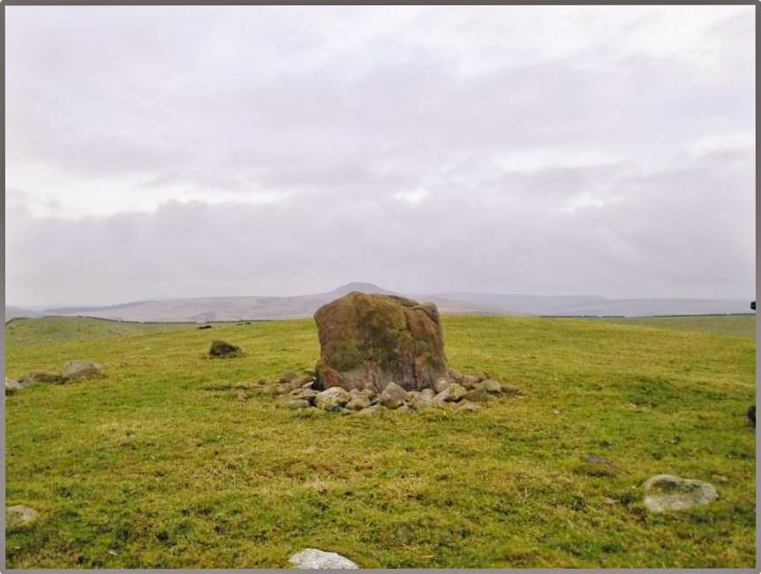
Fig. 61. Bullstones (© Joanne Kirton)

Although there is no evidence to directly link the mound with prehistoric and Roman activity, the surviving Bronze Age burials and Neolithic standing stones indicate that this was a landscape with visible monuments surviving from prehistory. Furthermore, the Cheshire antiquarian Dr J. D. Sainter made reference to a possible prehistoric settlement or cemetery in the field directly west of the Cleulow Cross and mound (Sainter 1878, 36). However, this no longer appears visible and only further survey would provide a clearer interpretation.

The addition of early medieval monuments in the study area is also indicative of people being active in the landscape at the time of the Cleulow Cross’s construction. The Sutton Cross (see Fig. 62), a probable early medieval wayfaring standing stone with a carved cross on both faces (Bailey 2010, 143-4), sits to the north (c. 1.7km) on the road between Sutton and Wincle, leading to Wildboarclough Village (SMR 1519). The road passes along the steep edge of the Shell Brook Valley and commands views down the valley to the north and Shutlingsloe Hill (the third tallest in the Peak District) dominates the horizon to the east.

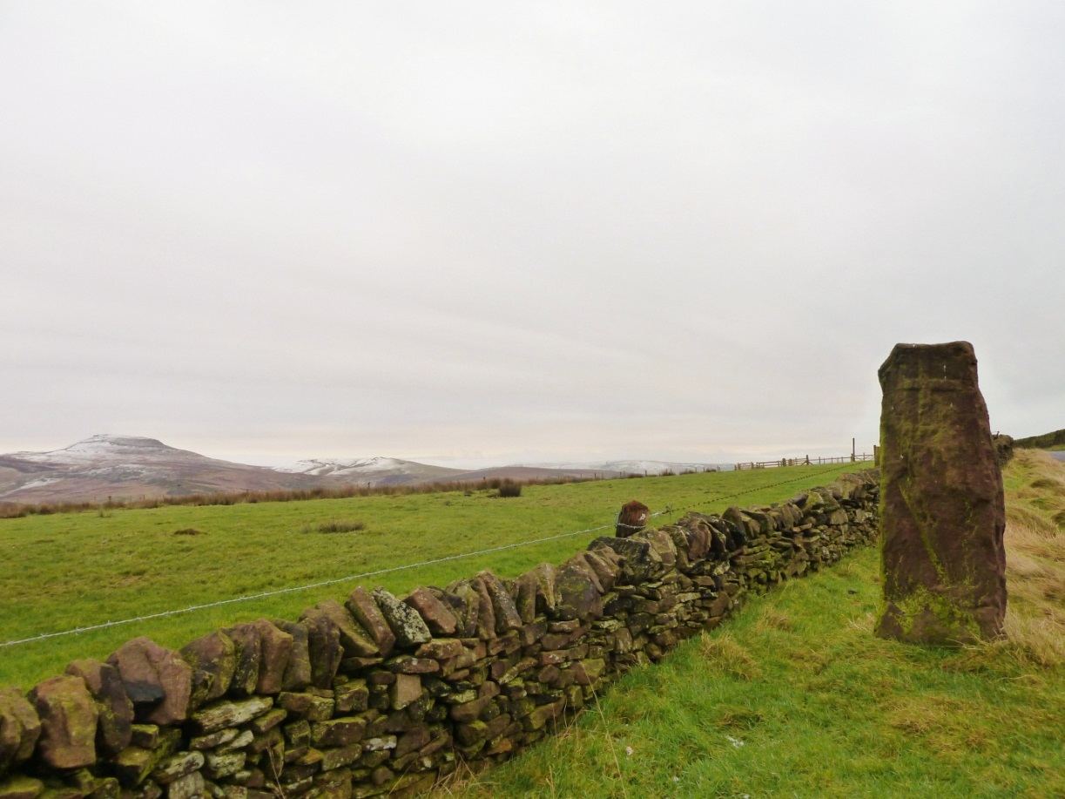
Fig. 62. Sutton Wayside Cross (© Joanne Kirton)

Another round-shafted cross can be found at Wincle Grange in the south (c. 2.5 km) although its exact location within this area is unknown (Bailey 2010, 138). Another three examples were moved from Ridge Hall farm to the north (c. 3.33 km) and now reside in West Park, Macclesfield (Bailey 2010, 126), although there is some suggestion that two of these came from elsewhere, supported by the fact that one of them is notably different in form and decoration. Finally, a now lost ‘Blayklow Cross’ is marked on a seventeenth-century map just south of the Wincle mound on a water route (c. 0.4 km) (SMR 2210) (see Fig. 60).

The significance of this prehistoric monumental landscape and the additions made in the early medieval period, including the Cleulow Cross, will be discussed below. However, for now, having constructed a probable hinterland, in terms of land use, appearance and access, the next step is to explore the mound as a place within the landscape and how it may have been perceived and/or used, followed by an exploration of the relationship between particular places and their associated monuments.

MOUND AND MONUMENT
The mound on which the Cleulow Cross is situated is a natural mound of glacial drift material, which may have played a significant role in the landscape before the monument was erected in the early medieval period. The mound at Wincle is certainly visually striking and unusual in the broader topography: a place that naturally draws ones attention whether covered with trees as at present or cleared of vegetation (Fig. 63).

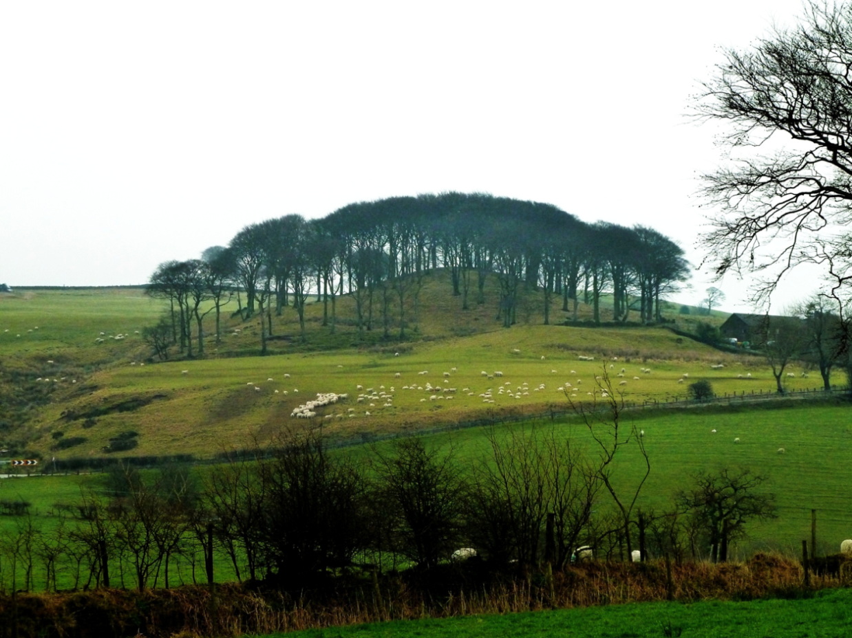
Fig. 63. The Mound as viewed from the east (© Joanne Kirton)

Natural features, such as peaks, prominent stones and trees, could appear special in the landscape and these were sometimes augmented in later periods by monuments or considered as significant places (Bradley 2000, 97-113; Hooke 2010), an argument made specifically for early medieval Britain by Sanmark (2010, 171-2) and Semple (2010, 27-9). The link between natural places/features and assembly sites has been highlighted by Pantos (2004, 155-70), who has clearly demonstrated they were popular choices for assembly gathering. The place-name evidence derived from the hundreds of Cheshire prior to the Norman Conquest indicates that natural places were given significance in the region during this period, as four of the twelve hundreds in the county bear names associated with natural places, usually prefixed with a personal name. For example, Tunendune, which is OE personal name Tuna and OE dun meaning ‘hill down’ (Anderson 1934, 149) and Warmundestrou, which is the OE personal name Wermund and treo ‘tree’ (Anderson 1934, 150). Four other names refer to a ‘stone’, for example Dudestan, which uses the OE personal name Duda and OE Stan ‘stone’. The use of natural features for important sites in the landscape was clearly a feature of the early medieval Cheshire landscape.

There are no trees or natural stones with associated surviving folklore in the area, nor marshes present that may have taken on special connotations. There is, however, a spring just at the base of the mound to the North West. However, a broader exploration of springs within the study area and the areas around monuments thought to be close to their original sites of erection demonstrate no correlation between these monuments and springs (Fig. 64).

Fig. 64. Map illustrating topographic features and relief within the study area (Base Map: Ordnance Survey 2015 [Crown Copyright/database right 2015. An Ordnance Survey/Edina supplied service]).

As discussed previously, the area has a number of significant landscape features that are visually dominating, such as Shutlingsloe Hill. However, the primary topographic feature in close proximity to the Cleulow Cross is the mound itself.
One way of recognising natural places that may have developed significance is by the evidence for human activity associated with these sites (Bradley 2000, 35). The mound at Wincle and the Cleulow Cross on its summit are situated amongst several surviving prehistoric and early medieval monuments. Reynolds and Langlands (2011, 417) argue that the clustering of monuments from several time periods is evidence for ‘deep time signatures of key landscape features’ and Semple (2007) argues that certain surviving place-names elements such as OE Hearg, represent sites of long-lived ‘cultic’ practice from the prehistoric to the early medieval period. The Wincle mound, surrounded by multiple prehistoric monuments, suggests that this area was indeed a focal point for a long, probably intermittent, period of time. Whilst these monuments and earthworks are not particularly exceptional within British prehistoric landscapes, their clustering around the Wincle mound and along the valley with which it associated, suggests that the natural topography may have held significance prior to the erection of the monument on the mounds summit.

Mound and Monument: cultural topography
Understanding the reasons why the specific mound was chosen as the site for the Cleulow Cross in the early medieval period requires a twofold approach: one that considers both the significance of the cultural landscape and how the natural topography would have aided the patrons in conveying their message(s).

Recent sculpture studies have argued that the creation of early medieval stone sculpture was a way of marking new and/or developing identities by physically creating a link between a people and their landscape. It is a process that drew upon past memories embedded in a landscape (memories real or imagined) and one that facilitated the creation of new memories, as part of group activity and cohesion. Natural features, such as hilltops, which may already have had import, were drawn upon to aid this endeavour (Semple 2010, 21-4).

The monumental landscape may have appealed to the patrons of the cross, as it signalled that this place had been important before. The concept of reusing or appropriating past landscapes and monuments is drawn from the broader paradigm of ‘the past in the past’ whose main proponents, working with early medieval material, (e.g. Bell 2005; Williams 2006; Semple 2010, 21-5) have been successful in demonstrating how groups reused ancient landscape features, such as funerary monuments, to draw a link between the past and the present. Semple (2011, 743) notes how the

‘... act of raising new monuments and using old monuments, drawing on the power of the ancient and the natural, is conceived as an active process of physical myth-making, with the landscape both adopted and used afresh to add emphasis to the legends and beliefs of communities’.

The apparent connection between round-shafts and prehistoric monuments in the east of Cheshire could be a symbolic appropriation of space by creating a physical marker linking living individuals, ancient monuments and their associated ancestral groups. The link could be a perceived connection to their ancestors or a physical sign of the appropriation of the land by a community. Williams (2006, 145-214) has demonstrated that groups from the early medieval period often buried their dead within or around prehistoric monuments, as a means of making a physical connection with the past and as a way of appropriating the landscape. Perhaps, rather than burying their dead in the Wincle landscape, the patrons of the Cleulow Cross, and others like Rainow and Disley Lyme Handley, could have used its construction and placement to symbolise their association with the land and with those who went before. As noted in Chapter Five, monuments of the tenth and eleventh centuries were increasingly being used as grave markers and commemorative markers. As these monuments became synonymous with the dead, remembrance and/or symbols of the peoples who erected them it is easy to see how they might have been used to mark this relationship in remoter areas. This would have enabled them to appropriate this landscape, including the mound, as their own and symbolise this appropriation to a wide, mobile audience and contribute to their own developing group identities. Whilst it is almost impossible to prove this in an area with very limited historical documents and even less archaeological investigation, the cultural topography surrounding a monument can be indicative why the location was chosen and suggest probable function.

Mound and Monument: natural topography
The natural topography is equally important for understanding early medieval sculpture, as it dictates how the monument will be engaged with and subsequently how it will be remembered.

Form, Decoration and Landscape Location
The Cleulow Cross as it stands now remains significant in its height: the shaft and base are just over 3m in height. Before it lost its cross-head, it is likely that this monument stood in the region of 4m tall, implying that it was intended to be seen from some distance. Comparisons with other round-shafts that appear largely intact, such as the Wincle Grange (2.03m) example and the three examples from Sutton (1.9 - 2.16m), suggest that the shafts of these monuments (without base or cross-head) were generally over 2m tall. Even with the skyline now obscured by a plantation of large trees, the monument at Wincle is visible from the other side of the valley (1.7 km) and southwards in the direction of the River Dane. It is possible that its visibility was further enhanced by the application of paint, a known practice from this period (e.g. Rodwell et al. 2008, 48-108). The lack of decoration on the shaft, separated from the rectangular head with swag decoration (Bailey 2010, 137), may be explained by the use of paint, rather than carving, as the primary form of decoration. However, considering this monument was highly exposed the decorative painted images would have been short-lived and their impact in such an open space would have been highly limited. Furthermore, any decoration on the monument, painted or carved would have been impossible to see even when on the mound due to its steeps sides – only when on top of the mound would the surface decoration have been evident. It is far more likely that this monument was primarily meant to be viewed from a distance and, therefore, did not require the intricate decorative programme of a cross that was intended to be seen at close quarters, within a churchyard or church for example. The Wincle monument, standing alone in a seemingly large open space, required a different form and decorative consideration to engage its audience at various scales. It is possible that decoration would have hampered the functionality of the monument by drawing people too close to it, thereby losing the imposing visual impact created by its landscape location. Based on these observations it appears that the form and decoration of the Wincle monument is seemingly influenced by its immediate topography.

A Cross to See From and be Seen At
Engagement with the mound and Cleulow Cross, like form and decoration, was dictated by the surrounding topography. To the north and east, after the immediate drop of the mound, the land begins to steadily rise and areas of higher ground can be found. However, there is good reason why this more prominent area was not chosen for monumentalisation. Firstly, in order to be seen the Cleulow Cross needs to be situated in a visible location. Its location at the head of the valley, on a spur of land, makes the mound on which the monument is situated, far more visible over the longer distances than those high-points could obtain, as these high-points are obscured by the gently rising topography that surrounds them. This situation ensures that the higher points in the area do not hold commanding views over the valley and/or they are not visible from the valley itself. Secondly, the mound is the most visually dramatic in the locale. It is a natural spectacle which draws the eye and engages the traveller by its shear physicality. It provides an obvious stage for anyone wishing to draw attention and foreground a monument.

However, the ease at which the monument can be viewed is juxtaposed with the difficulty of the immediate terrain. To the south and west there are sharp drops into the Shell Brook Valley and to the east the ground is boggy and undulating. The local antiquarian, J. D. Sainter (1878, 39) referred to this area as an ‘extensive morass’. This would have created a visual and physical barrier, serving to discourage people just wandering up to the mound, naturally aiding in controlling access and potentially symbolising a divide between the people who accessed the mound and those that were excluded. Whilst the mound was not inaccessible, it would have required careful, considered movement to and from it. In other words, a special effort was needed to reach it. There may even have been a designated path to follow. Currently, the best approach to the mound is from the north, along the valley top, as it is less boggy.

The immediate topography, geographical location and the form and size of the Cleulow Cross indicate that this was a monument designed to be seen from afar. This approach was dependent on controlled encounter founded on visibility and varying degrees of controlled proximity, possibly based on natural directionality. Hence, the monument's creators were able to orchestrate a situation that provided a visible platform in a location that is problematic to access from certain directions.

However, its visibility from a distance was just one reason why this mound became significant. The views from the mound were equally important. The mound sits alone at the head of the Shell Brook Valley, with views stretching to the Cheshire Plain in the north-west and the River Dane in the south, which forms the county boundary between Staffordshire and Cheshire. The viewshed from the mound would have provided an excellent vantage point from which to observe the landscape to the south and north, plus the passage of people along the valley (see Fig. 65).

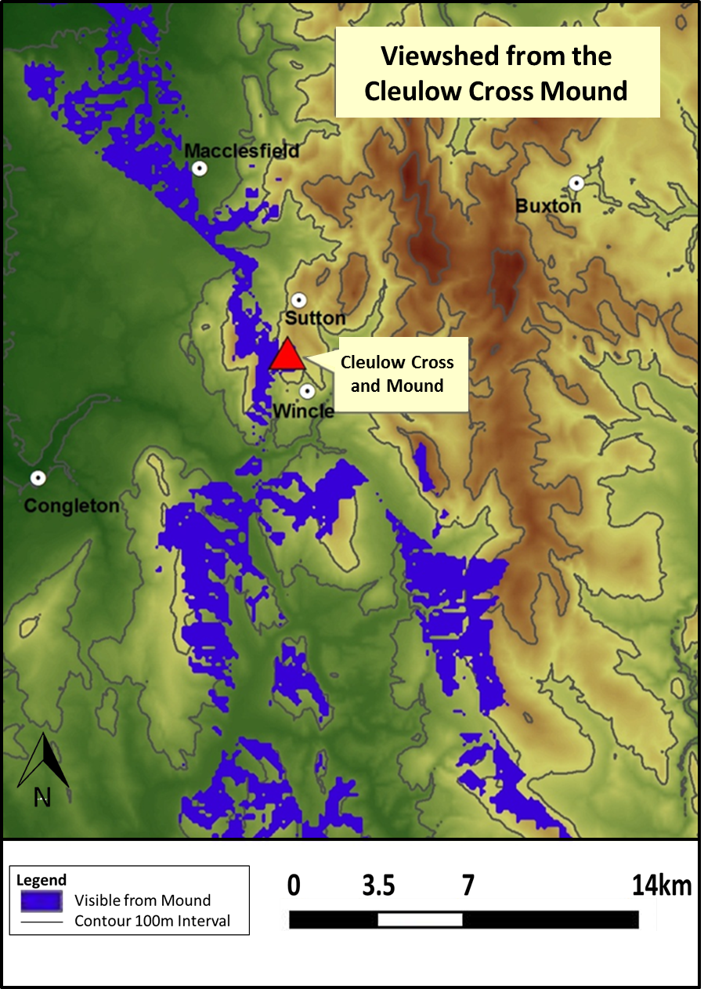
Fig. 65. Viewshed from Wincle mound (Base Map: Ordnance Survey 2015 [Crown Copyright/database right 2015. An Ordnance Survey/Edina supplied service]).

Fig. 65 is a viewshed created in ArcGIS as a tool to help visualise the distances and areas visible from the mound. The viewshed demonstrates the vast views available from the mound to the north and south, which stretches beyond the limits of the computer generated viewshed. Furthermore, it also demonstrates how the whole of the valley, which sits to the west, is visible from the mound. This viewshed suggests two scales of view. The first, is focussed on the valley itself - the mounds immediate topography. The second is the broader view to the north and south beyond the valley. The vast views serve to situate the mound and valley within the broader topography, offering a much broader sense of place.

The mound itself is situated in a location that allows interaction (visually and/or by sound) with a number of the significant high points along the valley, as it sits at its head. If the valley was under observation from the various highpoints along its way (offering good but limited views of certain areas) the mounds close interplay with these other potential viewing areas would make it the natural foci for the relaying of information. This would allow those who controlled the valley to make use of the wider topography. For those moving through the valley, particularly if they were aware of being observed, they would be entering a trusted space, whereby they would have to trust those controlling and observing the valley. This would be highly significant if the mound were to serve as a place to gather and meet, which will be discussed further below.

The exploration of early medieval cemeteries in comparable locations (elevated, topographically distinct) has certainly demonstrated that a viewshed that encompasses large swathes of the surrounding topography or particular vast views in one direction, as well as earlier monuments, was a common consideration when choosing a burial location and consequently had a bearing on the creation and/or continuation of symbolic sites in the landscape (Lucy 1998; Williams 1999; Brookes, 2007, 143-53). Whilst further viewshed analysis of early medieval round-shafts in the east of Cheshire is difficult because so many have been moved around, those that have localised movement (Rainow and Disley Lyme Handley) also boast significant viewsheds, suggesting that being seen and affording places with extensive views was a particular consideration for those raising monuments in the area. This preference for a significant viewshed also ensured that they were situated in elevated, often topographically distinct locations.

The place-name evidence also supports this preference for elevated, topographically distinct locations. Of those monuments that can be linked to a specific topography rather than those reused in buildings, six of the seven have place-name elements related to this specific type of topography. For example, Rainow, ‘Ravens hill-spur’ is derived from OE hræfh meaning a raven and OE hōh meaning a heel or sharp projecting piece of ground. The meaning of Disley is a little more obscure but worth pursuing. The second element OE lēah meaning wood clearing is straight forward. The first element is more unusual but probably comes from OE dystels and means mound – something thrown up in heap, giving it the overall meaning of ‘mound with wood clearing’. Finally, Lyme Handley means ‘at the high wood clearing’ and is derived from the OE hēah meaning high, lēah meaning wood and the Lyme element is British lemano meaning Elm-wood (see below for an explanation of the Cleulow Name). The place-names associated with the Cheshire round-shafts, therefore, provide strong support for a link between this group of monuments and their high/prominent locations.
In summary, it is apparent that the mound at Wincle has strategic, practical advantages for observing large swathes of the landscape, including major navigable routes. To the north-east the view extends to the Peak District (c. 7.41 km). To the north-west the Mersey estuary is visible (c. 70.6 km) and to the south the distinctive Roaches and Hen Cloud stone outcrops, near the Staffordshire border, sit on the horizon (c. 7.7 km). These dominant, visual features may have been used to help orientate an individual or group within the landscape. When on the mound they would have helped to relate and order movement through the landscape, as one or more of the features are commonly visible as you traverse the area. This would have been essential in the early medieval period when the only means by which the landscape could have been understood would have been by way of passage through it and observation of it, from high ground, as well as word of mouth directions described in terms of features in the surroundings. Reynolds and Langlands (2011, 413) have suggested that Anglo-Saxon inhabitants relied on ‘mental-maps’ to help them journey through the landscape. Specifically, the embodied experience of the landscape, through movement and visibility, was key to its perception and the ordering of it and mounds like that at Wincle and eventually the Cleulow Cross on its summit, as destinations and points of embarkation, were positioned to configure such practical maps for those traversing the landscape.

Move and be Moved
The importance of this specific type of topography and the use of the Wincle mound as a viewing platform is further enhanced by the clear importance of movement. If the area was sparsely inhabited, as suggested by the Domesday data discussed earlier (Phillips and Phillips 2001, 29), then individuals and groups would need to traverse the landscape in order encounter the monument. Whilst dating the routeways around the mound has proved problematic, the early medieval activity assigned to the settlements associated with these routes indicates that they may well date to at least this period.

The proximity of multiple routes is not unexpected, as many examples of early medieval stone monuments are associated with such arteries of communication in the documentary evidence and through archaeological investigation (e.g. Griffiths 2006, 143-62; Turner 2006, 166-9; Reynolds and Langlands 2011, 420; Andreeff 2012, 129-44).

Whilst the natural landscape facilitates access along certain routes, the proximity of the monuments described above, from any period, would have enhanced the experience of the traveller and aided those journeying through the landscape. Monuments, such as round barrows and standing stones, may begin as symbolic representations of ideas and messages but they commonly develop utilitarian uses, such as obvious waymarkers. They come to facilitate the ordering and remembering of the physical landscape, enabling individuals to navigate their way across it.
The distribution of monuments and the distinctive topography of the Wincle area may well have facilitated a confluence of movement around the Cleulow Cross and mound, a sort of early medieval highway led by ease of passage and visible signs along the valley tops. Reynolds and Langlands (2011, 413-4) suggest this natural ‘funnelling’ of movement created ‘locations in the landscape ripe for the monumental expression of power, belief and identity’. The creation of other early medieval monuments, in close proximity, would have encouraged this concentration of movement (see Fig. 60). Monuments such as the Sutton Cross, the round-shaft at Wincle Grange and the now lost Blayklow Cross.

Despite the disturbance of the later monuments around the Cleulow Cross, the evidence does indicate that this was a landscape populated by post-Roman monuments, as well as the prehistoric examples discussed above. These examples may have been used by the patrons of the crosses to create points to visit, to mark and order the land, so that passers-by and locals alike had points of reference. Later references to the crosses of Cheshire suggest that they served as waymarkers and places that people deliberately sought to move past, as part of processional activity, see Chapter Four for the Star Chambers (1613) account of how these monuments were used as part of processional ways. It is possible that processions of this nature were also undertaken in the early medieval period along the routes surrounding the Cleulow Cross mound. Certainly the landscape topography offers itself to controlled movement, access and visibility, plus the monumental landscape would have provided notable features to direct movement.

In summary, the mound forms a natural viewing platform from which an individual or group can observe both the landscape and passage through it via the valley bottom and tops. It is situated in a location that encouraged the movement of people around the mound from various directions. Reynolds and Langlands (2011, 414) identified a similar situation along the Icknield Way, where travellers heading north pass through a series of topographically distinct places to emerge in an elevated location, on top of a barrow, to panoramic views. They also suggest that the proximity to navigable routes meant that these locations were ‘…. perfectly placed to take advantage of concentrated traffic and to communicate meaning to those passing by’ (Reynolds and Langlands 2011, 414). The mound at Wincle, and others like it, would have helped orientate movement within the broader landscape. The mound's location and views would have made it a suitable place to discuss topics such as land ownership, boundaries, movement and access – a real-world map in the sense that one can use the views from the mound as a visual aid, offering a practical, if informal location for such discussions. It may be the significance of this site, as a site of potential observation and its proximity to numerous passages, which gave it its initial import as a ‘place’ within the early medieval landscape. Its importance, in part, was derived from its ability to help process the experiences generated through movement in the landscape, which would help individuals and groups order the world around them and make sense of their interaction with it. In addition, the proximity of the monuments from all different time periods suggests that this area attracted attention, probably intermittently, for thousands of years. The Cleulow Cross was likely situated on the Wincle mound due to the clear advantages provided by the natural topography, which in turn dictated its appearance, and the proximity of a prehistoric monumental landscape.

COMPARATIVE MATERIAL
The Cleulow Cross and mound are a distinctive place in the east Cheshire landscape, this is augmented by the surrounding natural and cultural topography. However, comparable places can be found elsewhere. As discussed previously, topographically distinct locations draw monumentality, reuse and augmentation of older landscapes. A similar natural, topographically distinct mound, which is remarkably similar in terms of appearance to the Wincle mound, can be found just across the border in Rowsley, Derbyshire on the same ancient road that links Congleton to Buxton (see Fig. 66). This is significant, as it too, appears to have been the foci for various activities, some of which provisionally date from the early medieval period. The Historic Environment Record cites a number of discoveries around the mound known locally as Peak Tor.

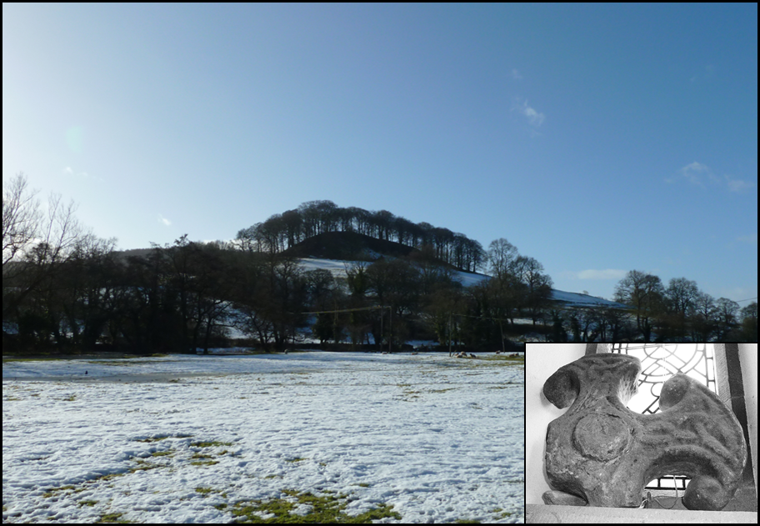
Fig. 66. Rowsley mound as viewed from the north and Rowsley cross-head (© Joanne Kirton)

The mound is situated next to a burial ground with graves orientated north-west (HER: 12204), an earthwork bank and ditch runs along the north and west sides of the mound, tentatively identified as ‘Anglo-Danish’ (HER: 12203) and two un-investigated rectangular crop marks are also visible. Most significant of the HER records was the discovery of a tenth- or eleventh-century cross head found in the River Wye that runs east to west along the north side of the mound (HER: 12202; Tudor 1932, 98-9). The exact location is not given but the proximity of such a monument to Peak Tor is suggestive of a comparable situation to Wincle, particularly as there is no recorded church in the area during this period.

The similarity to the Wincle mound, in terms of Peak Tor’s natural morphology and topographic distinctiveness, combined with the numerous archaeological features and finds associated with the mound spanning several time periods, suggests that it is not unreasonable to argue that the Wincle mound could have attracted interest, even accrued symbolic significance, before the erection of the Cleulow Cross and that the monumental landscape around Wincle may have inspired the erection of a monumental stone cross on the mounds summit.

Further comparisons can be drawn between specific round-shaft monuments and their natural and cultural topography. Two sites with round-shafts, Rainow and Disley Lyme Handley (monuments which appear to be located near to their original settings), are also situated in monumentalised prehistoric landscapes. The monument at Disley Lyme Handley (the Bowstones discussed in Chapter Four) comprises a double socket stone and two shafts. The monument is first referred to in AD 1465 (Bailey, 2010, 78), which is comparable to the earliest accounts of the Cleulow Cross and suggests it too survived the sixteenth- and seventeenth-century iconoclasts. The landscape in which it is situated is dotted with seven Bronze Age barrows. The monument at Rainow was found in the field opposite its current location, marked on the 1875 OS map as ‘cross’ (OS c. 1875 Copyright © Landmark Information Group). This alone does not suggest that the monument remains in its original locale. However, the similarity of its situation to other round-shaft landscapes does support this notion. Like the Cleulow Cross and Bowstones, it has prehistoric monuments in close proximity, as it shares the field in which it is located with the three round barrows (SMR: 1601). The landscape around Rainow is also dotted with natural knolls which have Bronze Age monuments situated on their summits at sites like Yearns Low (SMR: 1600) and Little and Big Low (SMR: 1605); natural mounds mistaken for their man-made counterparts. The proximity of surviving prehistoric landscapes, at both Disley Lyme Handley and Rainow, is comparable to the Cleulow Cross, particularly the association between round-shaft monuments and prehistoric round barrows. It appears that those groups who inhabited the early medieval landscape were attracted to some of the same locations as the Bronze Age communities who created these barrows. In this case upland areas with distinctive topography (knolls and mounds) and distant, encompassing viewsheds (discussed below).

The monument at Rainow is comparable to the elevated and visible situation noted at Wincle, being situated approximately 285m from the highest spot in the immediate vicinity. Consequently, its location provides views of the major topographical features in the area, although not apparently located on the highest point in the area (like the Cleulow Cross). The Bowstones are also located in a similarly elevated position, approximately 197m away from the highest point in the area, which forms a physically imposing platform that looks over the valley to the east, providing an imposing view of the eastern edge of the valley, as is demonstrated by the viewshed analysis (see Fig. 67).

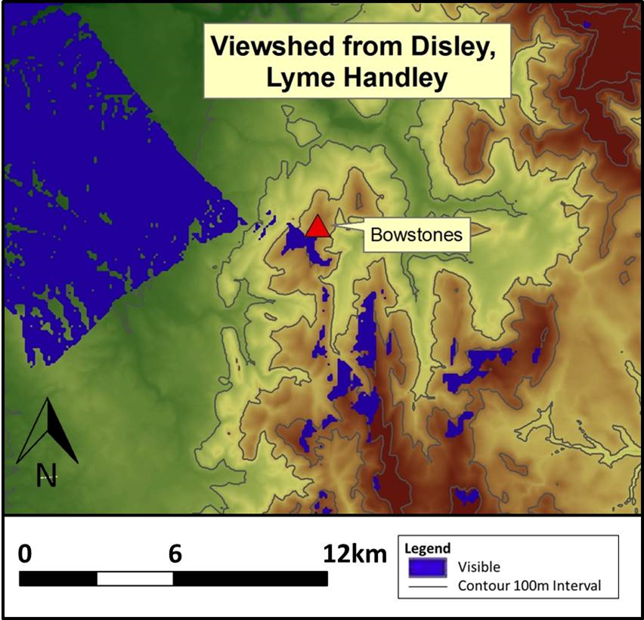
Fig. 67. Viewshed from the Bowstones, Disley Lyme Handley (Base Map: Ordnance Survey 2015 [Crown Copyright/database right 2015. An Ordnance Survey/Edina supplied service]).

Whilst the locations of the Bowstones and Rainow monuments do not provide the island-type setting evident at Wincle and Rowsley, their situations do offer unparalled views, a dominating setting and a monumentalised landscape; supporting the theory that there appears to be a strong link between round-shaft monuments and imposing settings and viewsheds. Furthermore, their comparable topographic locations indicate that these monuments, like the Cleulow Cross, were made with this remote upland landscape in mind, which is reflected in their appearance, both form and decoration. The proximity to monumental prehistoric monuments also hints that the round-shafts were chosen to stand alongside traces of past peoples and perhaps, the round-shafts were imbued with additional significance through their proximity. In addition, the significance of the monuments and the message which they were created to convey appears to have been dependent on the visibility of the crosses and the ability for people to move and be mobile through the surrounding landscapes, as the areas in which they were located were seemingly sparsely inhabited. The round-shafts proximity to routeways, although this cannot be dated beyond the 1st Edition OS map, supports this notion. This, in turn, reinforces the observations made in and around the Cleulow Cross and its hinterland.

MOUND AND MONUMENT: BIOGRAPHY AND FUNCTION
The foregoing discussion of the Cleulow Cross’ form and setting has demonstrated that the monument was conceived with its landscape location in mind. When combined, the form and setting enhanced a landscape that already encouraged and orchestrated movement through and around it. More broadly speaking, visibility, monumentality and topography (natural and cultural) were clearly important factors that worked together to generate special places that could be used to convey particular messages and encourage particular behaviour. The result of this research is an opportunity to develop an interpretation of the Cleulow Cross's function and meaning based on its relationship with its surroundings rather than on its aesthetic qualities.

Mnemonic Device: production as a form of memory making
The link between the monument and the landscape began the moment the sculpture was conceived and the material chosen. This is clear from the impact location had on the form and decoration of the monument. Consequently, we are able to consider the early biography of this monument afresh. The movement of the stone, carved, un-carved or partially carved, through the landscape to the Wincle mound created a memory that tied the monument, the people associated with it, the route to the mound, the mound and its landscape setting together in one memorable event. The creation of such memories would have changed the perception of the monument's locale, making it synonymous with this event and the monument itself. The creation of such a large, heavy monument as the Cleulow Cross and its passage through the landscape to the Wincle mound would undoubtedly have been a remarkable and memorable sight, immediately contributing to the mental palimpsest around the mound; firstly for those who were there to experience its erection, and thereafter for all those who experienced the monument in situ. The monument would serve as a reminder of this journey, connected to the monuments and topography which it passed and traversed, drawing them together in a mental palimpsest, which is both remembered and experienced afresh. In this sense it is part of, and a reminder of, this particular landscape imbued with memories, stories and experiences.

The carving of this monument and its movement to its final resting place would have been a physical and mental endeavour, which affected how the monument was experienced and remembered. Bristow’s (2010, 11-17) overview of the region’s geology indicates that the stone from which the Cleulow cross was fashioned was not immediate to the vicinity. The mound and surrounding area is composed of glacial drift debris. The millstone grit outcrops were at least 2 km away from the Wincle mound and, therefore, quarrying at these sites would have ensured that the monument had to travel at least 2 km, predominantly uphill, to reach the summit of the mound. Whilst this may not seem far, it would have been a time-consuming and difficult venture due to the weight (approx. 13 tonnes without the surviving cross head, based on surviving proportions and known weight of Millstone Grit sandstone) and shape of the stone, and to the difficult terrain through which it had to be moved, all of which meant that the venture was fraught with the possibility of breakage. Furthermore, the monument is carved from a single block of stone. It is probable that the fragile head of the cross was completed once it had reached the top of the mound, so the monument was likely to have been heavier prior to its erection. Whilst the movement of monumental blocks of stone and the possible in situ carving may not have been an uncommon event, it was probably not an everyday occurrence and, as such, would have been a powerful memory-inducing episode for all involved, including passers-by. Gondek (2006, 107) argues that monuments are symbols of power through their production. The end product was the culmination of a number of memorable ‘socially loaded processes’ (Gondek 2006, 107–109). Furthermore, the act of moving objects, and the movement required by the people involved may have generated its own meanings or contributed to wider social relationships. Colin Richards (2009, 57) proposes that the movement of monoliths on Orkney (and elsewhere) would have ‘…necessarily involved the negotiation and reproduction of an extensive network of social relationships’. He is suggesting that this process was a social one, requiring the motivation of a body of people. He also suggests that the construction of these monuments helped groups reproduce their social worlds by their involvement in sourcing and extracting the material, moving and erecting the stone, plus the making of the tools required for this process to be undertaken – all these processes relied on the interaction of people and the relationships between them. He refers to this network as ‘projects of stone’ and suggests that they have the agency by which social groups order their world and remember their social ties and obligations (Richards 2009, 57).

The creation of the Wincle monument would have required an investment of wealth and power, dependent on a number of social relationships within a group. These relationships, as well as the visual spectacle of the monument and hinterland, would have encouraged group memories, although the event would have been experienced differently depending on an individual’s role within the scenario.

A landscape of local power and administration
The monumentalising of the mound with the cross suggests the mound takes on a more defined symbolic role in the tenth and eleventh centuries: Bailey’s (2010, 137-138) proposed date for the cross's erection. Its situation away from centres of occupation and any known boundaries mean there is little evidence for known function. However, the creation of such a monument, combined with its topographically significant location and morphologically distinct situation, raises the possibility that it may have served as a place to gather in the tenth and/or eleventh centuries. Certainly the immediate morphology of the landscape at the Cleulow Cross mound closely correlates with the criteria for formal assembly sites: a mound close to several roads and route-ways, a large mound with a stone monument, a significant viewshed across major land boundaries and features and set within a palimpsest of ancient monuments (Meaney 1995; Pantos 2004; Sanmark and Semple 2008). Meaney (1995, 36) states that ‘The mound is an archetypal assembly point because it gives good opportunities for announcements, for speech-making, and for impressing inferiors’. Whilst no examples of assembly sites have been archaeologically proven in Cheshire, the place-name evidence for the hundreds suggests that mounds were known, significant places in the Cheshire region, for example Bochelau (Bucca’s Mound) in Bochelau Hundred (Higham 1993, 163). Indeed, the Cleulow name appears to be derived from the mound. The name was first recorded in AD 1371 and presents a number of interpretive possibilities, which support the importance of the mound's topographic significance, particularly the link between visibility and prominence. Dodgson (1970, 166) suggests that the clu element came from the ME clywe derived from OE clīwen and states ‘... which means a clew, a ball (of thread, yarn etc.)’ which might be used here figuratively in the sense ‘... a clue, a guiding line (as through a labyrinth etc.)’. He suggests that this may refer to a landmark, which marked the landscape in order to help remember and direct passage through the moorland. This would certainly fit with the argument outlined above. However, more convincing arguments have been presented. The clu element could be derived from the English clifu or clud and the low element from OE hlaw meaning mound, which would give us 'cliff-mound' or 'hill-mound' (Breeze pers. comm.). Breeze (pers. comm.) provides an interesting alternative, suggesting that the clu element of Cleulow relates to clue or clow – swift, lively, as argued by Thomas (1938, 183-4) – and suggests that this was probably the old name for the Shell Brook Valley – a fast-running stream. When combined with the hlaw (low) name, this would suggest a topographic name referring to the mound's location on the edge of the Shell Brook Valley. Certainly, the clu element of the name, whichever interpretation we consider, seems to draw its emphasis from its prominent topographic location and its relationship to the valley which may support the importance of crosses as place-making and memory-making devices.

The low element of the Cleulow name is more closely associated with assembly sites, as it denotes a mound, mounds often appearing to have served as the foci for these gatherings. Della Hooke (2010, 172) has noted how hundreds (or wapentakes) commonly took their names from the landmark at their meeting place, as Bucklow Hundred took its name from the meeting place at Bochelau or Bucklow Hill (Higham 1993, 163).

The Wincle mound would have been suitable for large assemblies, although its accessibility naturally limits how many people can approach at any given time, providing a notable location in which groups could gather. Assembly sites, as demonstrated by Pantos (2004) Sanmark and Semple (2008), Semple and Sanmark (2013, 533) are not all similar. There are differences in morphology, biography and use. Certainly the location of the Wincle mound at the centre of a network of routes, its viewshed and visibility were ideal for discussing land-related topics and may have given the mound import before or during the early medieval period, as discussed previously. The raising of a monument at this site may have been a means of generating importance and providing formalisation in a place lacking the same ‘meaning’ as sites built on ancestral mounds. Nancy Edwards (2009, 169) suggests that the choice of a cross form to mark places of meeting may be indicative of the symbolic growth of the church's influence in secular affairs, such as the use of God as a legal witness. If we accept that the mound had some formal purpose that encouraged the gathering of people, the cross may represent the presence of the church or even God himself at these gatherings. This would add symbolic significance to any formal activity conducted on the mound, which in-turn would have generated stronger, significant memories for those involved in formal activities (swearing of oaths for example), and for those who served as witnesses. Potentially, the presence of the cross also paved the way for an element of ritual to enter the proceedings in the first instance. The cross form may have provided the ‘cultic’ element missing from these new mounds, by presencing God. As suggested by Warner (2004, 32), assembly mounds in Ireland were deemed to be places where people could engage with the supernatural world and Semple (2004, 150-51) suggests that the Anglo-Saxon reuse of prehistoric monuments is a sign of similar practice in England. Presencing God at later assembly mounds may have been a Christian take on this practice. The relationship between mound, monument and God may have begun during the actual conveyance of the cross through the landscape. The visual tableau could not fail to raise parallels with the procession of Christ and his cross to the hill of Golgotha outside Jerusalem. This may have been a primary symbolic act of bringing Christ/God/the church to the mound, to serve as a witness to the activities planned for the mound. Both Williams (2011, 23) and Edwards (2009, 170) when discussing the Pillar of Eliseg, have noted how the spectacle of the Pillar and its Christian associations may have drawn on perceived links to the Holy Land, as part of the monuments message and power.

The preceding discussion has established that the mound and monument on its summit has the potential to be a meeting place in the tenth and eleventh centuries. The question now is why was this particular location chosen at this time? The likely answer lies in its associated cultural and natural topography, its potential previous use and its geographical location.

Sanmark and Semple (2008, 245-59) suggest a two-phase chronology for the formation of assembly sites in Britain and on the Continent and the Cluelow cross and mound seemingly fit into the latter phase. They argue that early cultic assembly sites, such as Gamla Uppsala in Sweden, developed as central places for gathering due to their wider social import, and they were actually part of a much broader spectrum of assembly site types. In later periods assembly sites were purposely created for meetings and these were less likely to involve elements of the cultic or earlier activity, such as burial. ‘New sites were established for meetings. Some were newly created. These new meeting-sites were set out according to a topographic plan related more to access, visibility and magnate/royal prestige than ancient cultic and ritual origins and importance. A physical signature – monumentality that drew inspiration from the past – was necessary however to give the site credibility’ (Sanmark and Semple 2008, 256). Semple and Sanmark (2013, 531-2) suggest that those sites with visible links to the past were also powerful places to create memories, identities and a sense of place by linking people to their immediate landscape. The assembly sites themselves would then be the mediator between the past and the present, a place to ‘harness’ the power of the ancestral past and use it to help and manage new group and/or individual agendas. The Cleulow Cross and the Wincle mound specifically (and not its surrounding topography) has no evidence to suggest that it has been augmented to build on its natural features, although the mound has undergone no archaeological investigation, indicating that the mound itself was not chosen for its visual association with prior activity, such as burial (although it was situated within a broader landscape of burial activity). It does, however, have evidence to suggest that the mound, and the cross on its summit, was comparable to one of the later meeting places, centred on a natural mound in a prominent topographic location, with a prehistoric monumental landscape to provide ‘credibility’ and additional meaning through remembered or appropriated associations.

Sanmark and Semple (2008, 245-259) also suggest that local groups were choosing sites of topographic importance which visually echoed their predecessors, such as the ninth-century Pillar of Eliseg. The Pillar of Eliseg is a ninth-century round-shafted cross, which sits on a prehistoric mound. The monument sits in the base of the Nant Eglwyseg Valley (Edwards 2009, 16) and was in close proximity to a natural route-way as the route past the pillar is the major route-way that connects the Vale of Llangollen and the upland district of Iâl via the Horseshoe Pass. Williams (2011, 16-18) suggests that the monument was not a boundary marker but a purposely prominent route marker ‘... geared to specific routes of movement into and out of the territories, serving to protect and commemorate the land given by the kings to the church’. Its form and proximity to a major route bears a similarity to the Cleulow Cross. Edwards (2009, 26-27) has proposed that the Pillar of Eliseg and its barrow may have been an assembly site, potentially an inauguration place for the Kings of Powys, having being directly related to kings through its lengthy inscription. Its location also serves as a natural gathering place, as the valley sides and the river to the west create a sense of enclosure (Williams 2011, 18); this is further augmented by the acoustics of the space, which ensure that anyone speaking from the mound would be amplified down the valley. However, this does not necessitate a direct link between the Cleulow Cross and the Pillar of Eliseg, it suggests only that there may have been earlier examples comparable to the Pillar of Eliseg in the territories of the kingdoms of Powys, Mercia and Northumbria from which the Cleulow Cross patrons took their inspiration.

Sanmark and Semple have clearly established that assembly sites were created and utilised in different time periods, drawing influence from comparable landscapes and monuments, all of which suggests variability in use and morphology. Aliki Pantos (2001, 124) likewise considers how assembly sites may have been utilised and this too can offer insight into how the Wincle mound and Cleulow Cross may have operated. She demonstrates that assembly sites could operate on different scales, the most significant could be used by the whole hundred for example, whereas others could be used by particular communities or individuals, serving a smaller area. This type of meeting place is dubbed ‘sub-hundredal’ by Pantos (2001, 128). Pantos (2001, 128) has stressed that there may be ‘numerous assembly sites varying in origins, function and antiquity’. Therefore, it is wise to explore assembly sites as varied and dynamic places that can shift in their importance and their geographical significance.

The creation of a monument on the Wincle mound in the tenth and eleventh centuries strongly indicates that a change in the mounds use/ownership and how it was perceived occurred at this time. The evidence presented above also indicates that this change would fall within the broader assembly site trends noted by Sanmark and Semple (2008, 245-59). There are, however, clues that suggest where earlier import for the mound (not the monument) might have derived from and who might have been using it prior to the erection of the monument on its summit.

The Cleulow Cross’s location within Hamestan Hundred is peripheral, as discussed above, being situated in the hundreds south-east corner. However, the mound may have been far more centrally located within an earlier administrative unit. Nick Higham (1993, 175-6; later Phillips and Phillips 2001, 24) has proposed that Cheshire’s Hamestan Hundred, in which the Cleulow Cross is located, once formed part of a larger Mercian Hundred of the same name. His initial suggestion is based on the presence of Hamston Hundred across the border in Derbyshire, which he suggests once formed one larger unit with Cheshire’s Hamestan Hundred. His suggestion is based primarily on the similarity of the name and their proximity with one another. This land unit broadly covers the area deemed to have belonged to the Pecsaete – the people of the peak - recorded in this area in the Tribal Hidage (Higham 1993, 70 and 77). Higham (1993, 175-6) suggests that if Totmonslow Hundred in Staffordshire was also added to this earlier hundred, this would then encompass all the furnished Pecsaete burials of sixth-/seventh-century date recorded in this area, forming a discrete land unit belonging to a specific recorded community. He suggests that this land unit was subsequently likely divided ‘either during the Danish land-grab of the late ninth, or the English re-conquest and reorganisation of the tenth century’ (Higham 1993, 176).

When these three hundreds are combined as one, the mound and Cleulow Cross suddenly becomes very central within this purposed earlier administrative unit (see Fig. 68).

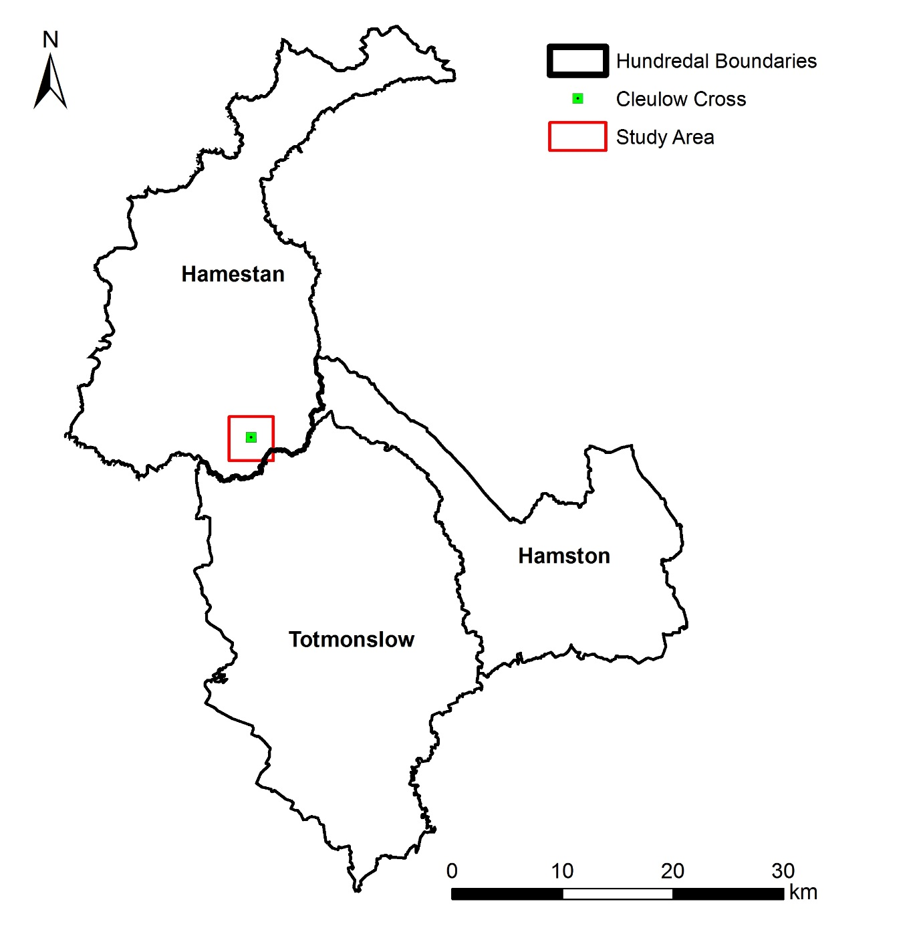
Fig. 68. Map demonstrating Higham’s (1993, 175-6) proposed pre-tenth century land unit and the location of the Cleulow Cross and mound (after Williams 2015).

The monument, based on current accepted dating, cannot be associated with this earlier proposed land unit. The mound, however, can. It is, therefore, possible that the mound at Wincle may well have served as a significant location, potentially for assembly, during an earlier period, possibly for the group known as the Pecsaete, as described in the Tribal Hidage (Higham 1993, 70). The Cleulow Cross would then be associated with a site of earlier importance and possibly gathering. The later creation of a monument on its summit denotes a new phase in its use. It could, as discussed earlier, have served as a sub-hundredal assembly site during the tenth and eleventh centuries. However, Pantos (2001, 124) offers a compelling alternative by suggesting that assembly sites that sit at or close to the juncture of several county boundaries could have served as meeting places for the counties that dealt with issues that went beyond their boundaries (see Pantos 2001, 124 for an in-depth discussion). Notably, the Wincle mound is situated directly 5.5 km west of the modern Three Shires Head, where the modern counties of Cheshire, Derbyshire and Staffordshire meet. Other such assembly mounds (with sculpture) are noted in comparable locations. For example, the site of Knightslow in Warwickshire is a known post-conquest assembly site for the collection of the ship-soke for the Domesday Hundreds of Brinklow, Marton and Stoneleigh. The site comprises of a mound and cross-base on its summit (Pantos 2001, 442-443) but the loss of the upstanding stone and lack of decoration on the base means the monument has proven difficult to date. However, the site's morphology and the later activity recorded at the site make it a strong contender for an early medieval assembly site and comparable to the mound and cross at Wincle.

The political climate during the tenth and eleventh centuries provides a plausible scenario in which this type of site may have been utilised and transformed. The Peak District was a border region between the West Saxons and the Anglo-Scandinavian Kingdom centred at York, particularly in the early tenth century (Crosby 1996, 30; Sidebottom 1999, 207). It was also a period when the Hundred of Hamestan, in which the Cleulow Cross is found, underwent major reorganisation (Higham 1993, 174). Fluctuating borders and changes in power centres may have encouraged greater localised control over land use and demarcation, visualised by monuments. This would have affected both secular and ecclesiastical groups.

Ecclesiastical Patronage
Understanding function requires an exploration of both the secular and ecclesiastical groups operating within the locale of the Wincle mound, as the cross clearly draws some power from its association with Christianity based on its form. However, establishing a firmer link between this group of carved stone sculptures and the ecclesiastical groups operating in and around Hamestan Hundred in the tenth and eleventh century is near impossible based on the lack of documentary material and physical links to places known to have been associated with the church. For example, no churches are recorded in Domesday in the Hamestan Hundred (Phillips and Phillips 2001, 28). Only with new source material and/or archaeological excavation may this link, or lack of it, be more firmly explored. Nevertheless, the link to Christianity can be further considered in terms of ecclesiastical patronage.

There is little to suggest that the round-shafts were linked to a specific ecclesiastical group or individual in the tenth or eleventh centuries. Firstly, except for their form, the crosses bare no discernible decoration or inscriptions that would suggest a link to the church. The only decorative clue available across the Cheshire, Derbyshire and Staffordshire assemblages, beyond broad stylistic influences, is found at Brailsford in the form of a warrior holding a sword carved onto the shaft of the cross (Figs. 69 and 70). The inclusion of this image suggests that at least some of the round-shafts were associated with secular individuals and it is, therefore, not unreasonable to suggest that others in the group could have been patronised by groups/individuals of a similar secular standing.

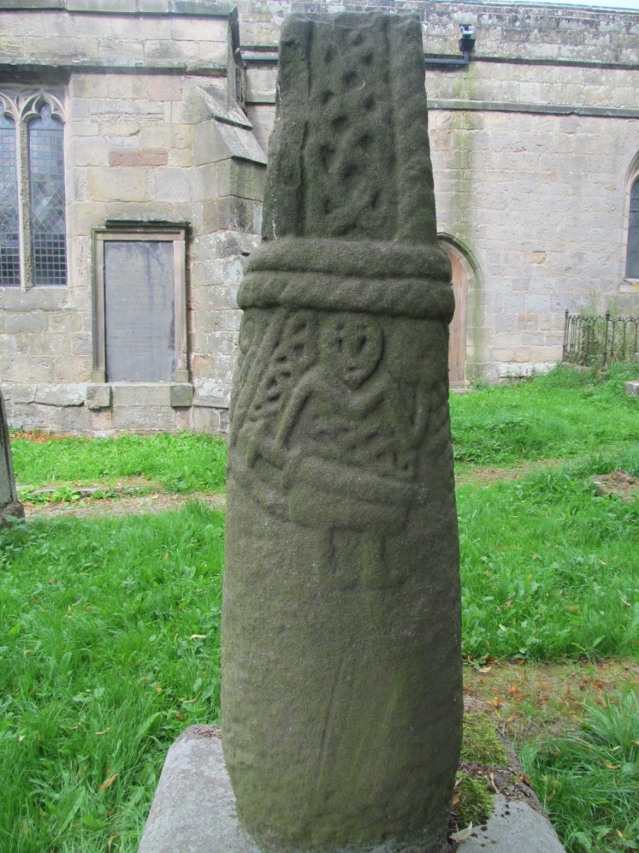
Fig. 69. Brailsford round-shaft (© Joanne Kirton)

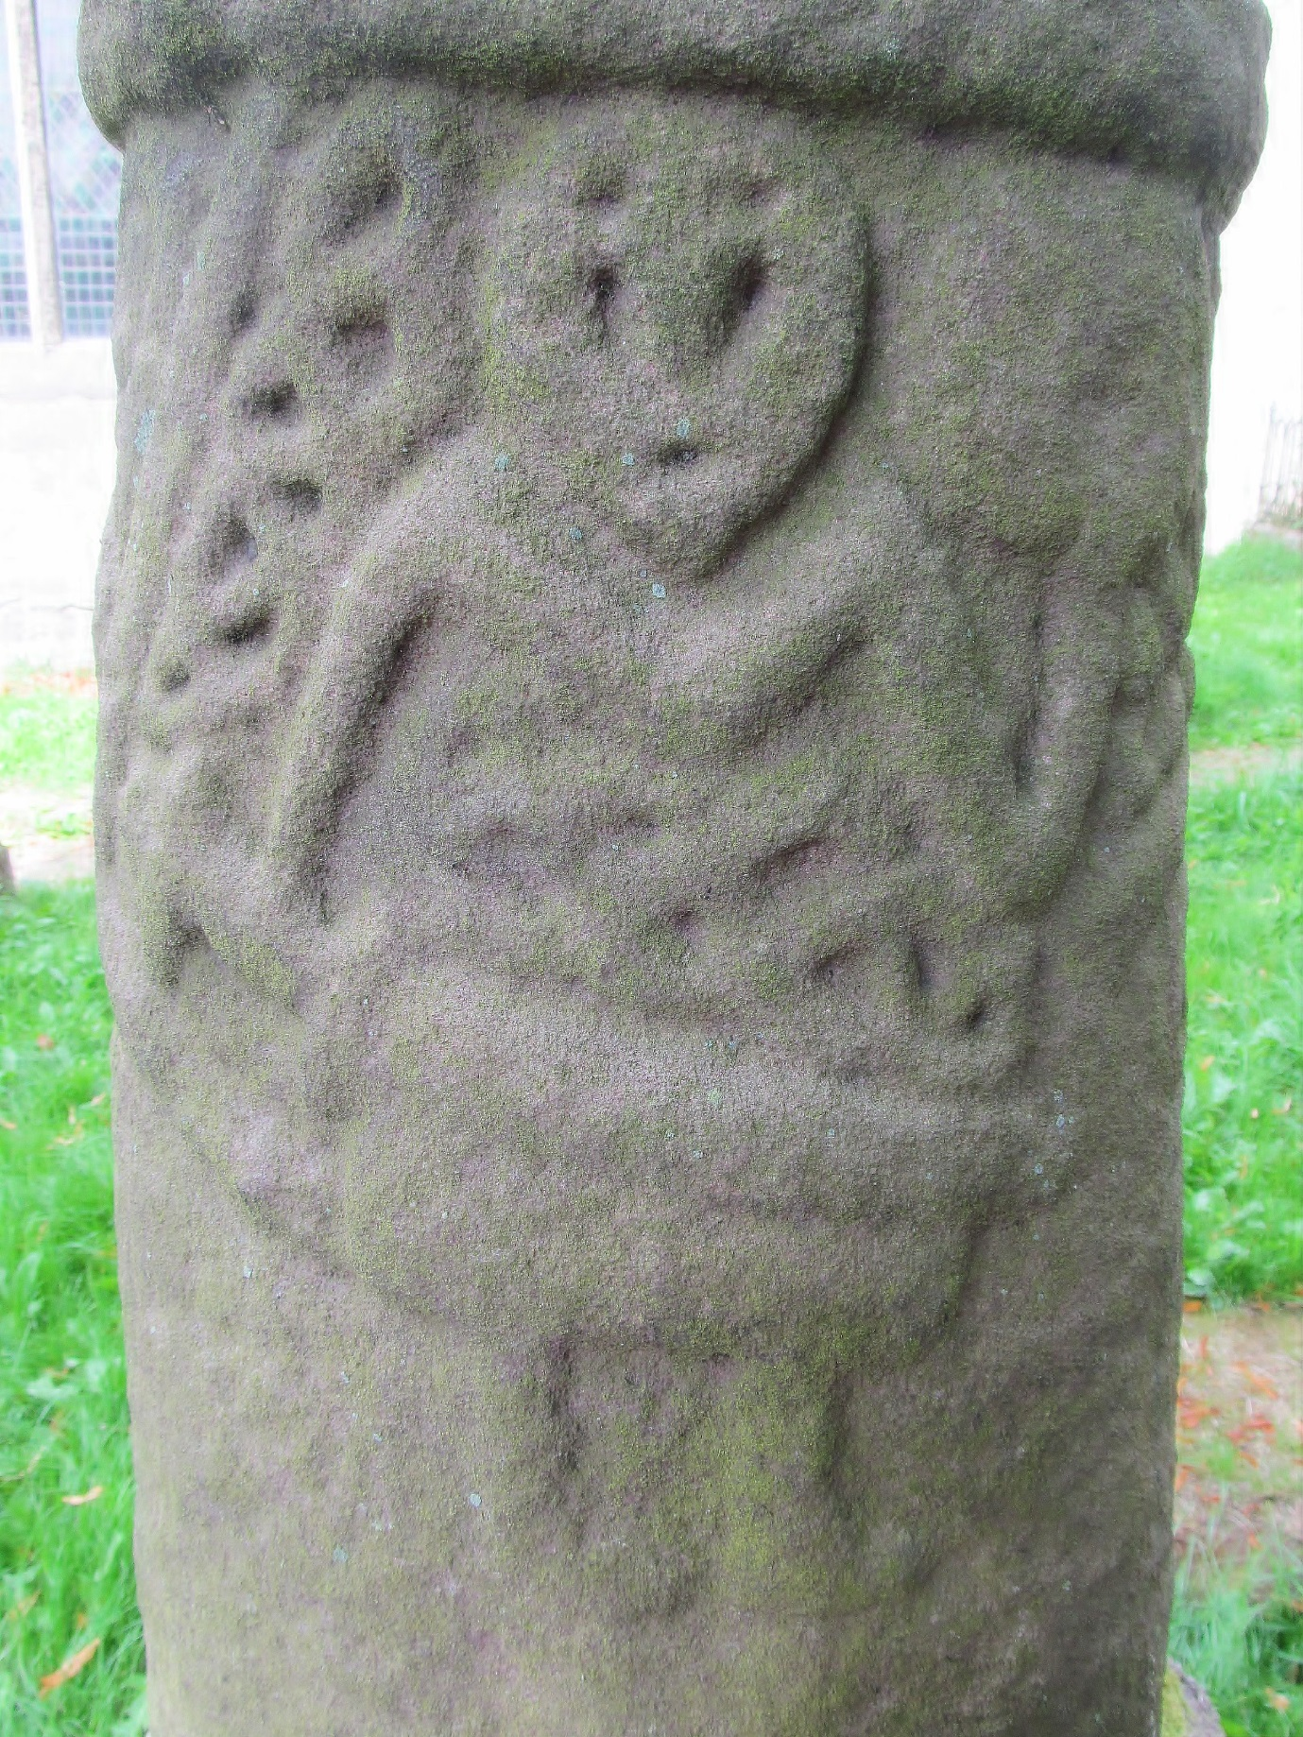
Fig. 70. Close up of Brailsford round-shaft with carved warrior holding sword (© Joanne Kirton)

The geographic location is also worth considering in terms of an ecclesiastical link, as a large percentage of the east Cheshire monuments are situated within Prestbury Parish but few are associated with ecclesiastical buildings, as discussed in Chapter Four. Those that are, at Macclesfield and Astbury, provide no evidence to suggest that this relationship has any longevity (see Chapter Four for further discussion). The only monument within the Hamestan Hundred that has a proven church provenance is that found at St Peter’s in Prestbury. This is a large, highly decorated tenth- to eleventh-century monument that was found embedded within the fabric of the church in AD 1884 (Bailey 2010, 95). However, an ‘ancient’ church cross was recorded as standing in the churchyard between AD 1576-80, when it was pulled down (Bailey 2010, 98). It is highly likely, considering the evidence for reuse across the county (see Chapter Four) that the monument noted in the account is the same as that built into the church walls. The earliest part of the church dates to the thirteenth century (See Appendix B) but Prestbury was likely home to the hundreds mother church in the pre-Conquest period (Bailey 2010, 29), and its name, the ‘Priests Manor’ indicates a religious association from at least AD 1170-1182 when the first reference is made to the settlement (Dodgson 1970, 212). Consequently, this monument has a strong link to a place with a pre-Conquest ecclesiastical association. No other piece of sculpture from Hamestan Hundred has the same association.

This is particularly important when the Prestbury cross is compared to the round-shaft collection, as it is also aesthetically different. It is distinct in its form, the quantity and quality of the decoration and its iconographic repertoire; the cross fragments depict the crucifixion, a possible scene with martyrs and a probable carving of the Tree of Life (Bailey 2010, 95-7). When compared to the rest of the assemblage in the parish (the round-shafts), none bare carvings depicting religious scenes and none are of a comparable form or decorative quality. This suggests a difference in function and/or patronage. As the Prestbury monument has a clear ecclesiastical association through its location and decorative choices, it likely performed an ecclesiastical function and/or operated within an ecclesiastical space. The same cannot be said for the round-shaft crosses in terms of location and decoration, indicating that their purpose and/or patron(s) was not overtly ecclesiastical in nature.
The remoteness of the round-shaft group and their distribution throughout Prestbury Parish means rogation practices, like those discussed in Chapter Five, but on a much larger scale, cannot be excluded. However, the distances between monuments suggests that this would be a mammoth undertaking if the monuments were collectively traversed. There is no evidence to date to suggest that this was the case. However, the round-shafts may have had multiple purposes and may not have been used collectively but instead incorporated into more localised processional routeways and/or created to denote significant locations on localised routes. This was certainly the case for some roadside monuments by the early seventeenth century, as noted in the Star Chambers account of AD 1613 (see Chapter Four for further discussion).

It is possible that the form was not specific to particular practice but simply used as a tool to denote a place of importance within a landscape inhabited by Christians. The variability in the size, decoration and location of the wider assemblage (across all three sites) would lend itself to this interpretation. As suggested above, the cross could be the visual signal of the presence of God at important locations in the landscape, some given over to rogation (prayers, offerings for examples) and others for assembly, where the swearing of oaths and making of laws required the presence of God to add credibility to the proceedings. Other uses cannot be excluded, such as burial and simple waymarkers.

In summary, the Cleulow Cross, as discussed already, is comparable in appearance to many others in the east of Cheshire. Many of these seem to be located in similar landscapes, although sadly most have been moved, some more so than others. Consequently, establishing how each monument relates to another and the broader group is problematic. Certainly, their appearance and the seeming preference for remote, elevated and topographically distinct locations, combined with a visible, distinct form suggest that they were required to operate across long distances in order to convey their particular message. However, it is not clear that these crosses all served the same purpose, at the same time. Instead the variability in their decoration and immediate locales suggests that the style and form was popular within a specific cultural group and/or geographic area, but their function may have varied dependent on their patrons and/or need.

CONCLUSION
Despite limitations and challenges, it remains profitable to approach the early medieval landscape from an experiential perspective. We may approach this period using aerial photographs, maps and manuscripts, but early medieval people daily and seasonal movements and engagements, sensitive to settlements, topography, vegetation, boundaries, routes and existing monumental landmarks, were the principal means by which they engaged with their environments.

People moving and interacting with the early medieval landscape ensured an appreciation of place and the mechanisms by which these places could be enhanced for personal and social gain. Movement and visibility were key means by which landscape was ordered and controlled and it is in this context that we can understand the locational qualities of the Cleulow Cross. The monument conveyed social messages through its creation and location, as a landmark and mnemonic device. Its production was a deliberate form of memory-making and its monumental presence in situ demarcating the landscape and direct passage through it. It is also apparent that the medieval landscape relied heavily on movement to convey, reproduce and validate meaning.

The choice of monument location and the spectacle of its movement and raising was a form of deliberate memory making, designed to heighten the importance of the monument, its locale and the wider landscape. At Wincle we see a monument that uses all the available mechanisms to make it memorable: location, topography, size and movement. The mound and monument at Wincle were important in facilitating the ordering of the landscape and the monument, in-part, is the symbolic recognition of the particularities of landscape and movement here. The Cleulow Cross was implicated in a web of meanings and memories attached to place and encountered through movement.

It is proposed that the Cleulow Cross was initially conceived of as a means of formalising the mound as a place of import and adding gravitas to the human actions that played out there, potentially within the orchestrated arena of an assembly site. In future work, stone sculpture of this period that remains in situ should be experienced as monuments within a landscape in which their very form, size, location and survival are inter-dependent.

CHAPTER SEVEN

CONCLUSION: A BIOGRAPHICAL APPROACH TO RECONTEXTUALISING EARLY MEDIEVAL STONE SCULPTURE

INTRODUCTION
In the following discussion, the results of the multi-strand methodology set out in Chapter Three will be explored, whilst considering the success of the overall approach. Furthermore, Cheshire’s early medieval sculptural corpus, which has served as the focus for this research and the new discoveries generated throughout the course of the study, will be summarised. It is also prudent to explore what additional avenues of research might be investigated to further the understanding of the county’s collection of early medieval stone sculpture and how this might encompass cross-border assemblages and regional studies.

SUMMARY OF RESULTS
The primary aim of thesis, as set out in Chapter One, was to contextualise both individual fragments and geographically concentrated assemblages of early medieval stone sculpture from the county of Cheshire, using data derived from their location and current state of survival. Chapter Two considered how monuments had been contextualised in previous studies and identified a disengagement between the physical surroundings of monuments and their biographical history. The chapter explored the reasons for this and established that this was a symptom of the data sets often poor survival, being fragmented and moved, and its frequent reuse for different purposes in a variety of contexts. It also demonstrated how a lack of a theoretical agenda for early medieval stone sculpture, and medieval archaeology more broadly, had constrained how researchers approached, perceived and even described the sculpture they were investigating. This established an over-emphasis on the visual appearance of monuments and consequently, created a disconnect in the literature between sculpture and context. The chapter concluded by exploring recent research, considering new sculpture studies and research agendas, whilst investigating concepts and methodologies outside the discipline, particularly prehistoric approaches to landscapes and monuments.
Chapter Three identified the specific challenges posed by the Cheshire assemblage, in light of broader sculptural research issues noted in Chapter Two, and discussed current sculptural research in the county. As the Cheshire assemblage is highly fragmented and rarely remains in situ a secondary aim was identified: the need for a coherent methodology that can deal with the challenges of early medieval stone sculpture and, specifically, those of the Cheshire corpus. A multi-strand methodology was devised, based on the exploration of work on sculpture, monuments and monumental settings from a raft of periods, as discussed and explored in Chapter Two. This fluid approach enabled me to appropriately analyse the variety of monuments, locations and biographies present amongst the collections of early medieval stone sculpture seen across Cheshire and discussed throughout Chapters Four, Five and Six. Three distinct strands were established using a multi-scalar landscape perspective: broad landscape distribution, in situ collections in settlement zones and immediate hinterland and context of individual monuments. This allowed for variability in monument survival; the different physical and spatial locations in which early medieval stone sculpture is found; the potential different early biographies of individual monuments and/or assemblages; and the variable survival of the supporting data, such as landscape topography, historical documentation and toponymic data.
Chapter Four explored the first methodological strand. It firmly established a difference in survival and reuse practices between the east and west of the county, which was only made possible by a simultaneous exploration of both county-wide monumental biographies and distribution. Research focused on establishing why this marked trend had developed. Whilst the geology of the county clearly impacted the distribution of sculpture across Cheshire, there was no obvious explanation for the difference in reuse and survival seen between east and west Cheshire. It was also noted that the sculpture was significantly different in appearance and location, and there was a notable lack of grouped assemblages in the east of the county. The chapter successfully established that these differences were based on societal factors and proceeded to demonstrate specific links between later activity and its impact on stone sculpture, such as iconoclasm in Cheshire in the early sixteenth century. The chapter also demonstrated that these impacts could be geographically specific. Neither observation would have been possible without a county-wide assessment of reuse practices, provenance and context. The discoveries of Chapter Four provided a suitable platform for Chapter’s Five and Six, establishing which monuments, collections and locations to explore using the second and third methodological strands.
Chapter Five employed the second methodological approach, investigating in situ collections of early medieval stone sculpture in settlement zones. A collection of sculpture from St John’s in the city of Chester formed the research focus for this chapter. The provenance of the collection from St John’s in Chester was first established, which then allowed a simultaneous exploration of monument biography and the biography of place to be undertaken. Exploring this symbiotic relationship demonstrated the wealth of information that could be garnered by taking a multi-disciplinary approach; one that explored biography, landscape and materiality of monument and place.
This investigation began with a phenomenological, experientially based exploration of the assemblage’s material characteristics and how this was potentially shaped by place. This was supported by a discussion of how function and perception of a monument might be altered by the proximity of other similar-looking monuments, as found at St John’s. The phenomenological investigation demonstrated that the St John’s collection was created to operate within a particular known space, cognitively and possibly physically bounded. The physical extents of which are most likely the St John’s precinct or the Bishop’s Borough, based on the provenance of the sculpture. Their decoration, form and size suggested they did not have the capacity to transmit information or draw an audience over a long distance, instead relying on the place with which they are associated to attract their audience. This was indicative of their probable function, which was seemingly dependent on their proximity to one another. Studying these monuments in isolation from one another and their landscape setting, would have prevented an understanding of function and the reasoning behind the choice of decorative styles and form. Establishing a clear link between monument(s) and place allows for a more nuanced contextual study. It also allows for a multi-scalar approach, as monuments and place can be explored in terms of their wider connection to settlements and natural features, which was a key approach in the remainder of Chapter Five and Chapter Six.
St John’s has a long documented history with the broader settlement of Chester, a key theme of the second methodological strand. This link was explored in detail using documentary and archaeological evidence to consider the impetus for monument creation and how the relationship between monument and place impacted the assemblage’s survival. It has contextually tied the collection to a place with a long biography but also the broader cityscape, which in turn has provided a broader context for the sculptural assemblage, both at the time of its erection and in later periods. This study of the monument biography and the biography of place considered what historical events may have been responsible for the creation of the sculptural collection at St John’s and what role St John’s may have played in pre-Conquest Chester, particularly in light of the other sculptural influences evident in the city and the developing morphology of the city in the tenth and eleventh centuries, set to the backdrop of huge social and political upheaval across England. This also built upon the first methodological strand, which had demonstrated that particular social and/or political events can impact sculptural survival, but in addition, demonstrated that it can also be the impetus for its creation and appearance, not simply its destruction and reuse as largely discussed in Chapter Four. It also demonstrated how these changes can be specific to a particular place, as the relationship between St John’s and Chester, (for example, its association with other ecclesiastical organisations, social groups in the settlement and its particular location with the city), had specific impacts on the monumental collection.
Overall, this chapter clearly demonstrated an approach that considers all the evidence associated with these monuments; their decoration, form, size, evidence for reuse, recent provenance, place, historical background and associated archaeological material to establish a context and function that has significant research value. It is an approach that foregrounds place as the key to interpreting a monuments function and decorative choices.
Chapter Six used the third methodological strand, exploring the immediate hinterland and context of individual monuments, specifically the Cleulow Cross at Wincle. This monument is thought to be still in situ and, therefore, offered a unique opportunity within Cheshire to explore how a single monument was shaped by its particular location and how that location may have been orchestrated to create place.
Like the St John’s assemblage in Chapter Five, it was established that the monument at Wincle was conceived with its landscape location in mind. The monuments form, size and decorative choices were clearly based on its intended location and partly accounts for the difference in monument form, size and decoration between east and west Cheshire, as the east and west of the county were erecting monuments in very different locations, for seemingly different purposes. This, in turn, supports the findings of the broader county-wide approach established in Chapter Four.
The remainder of the chapter used a retrogressive landscape approach, particularly focussed on GIS visualisations and standard mapping techniques, to explore the early biography and materiality of the Wincle cross and assess the long durée of activity in the vicinity of the monument. The monuments appearance, location and immediate hinterland was explored from an experiential perspective, which suggested that the mound was probably of particular significance prior to the raising of the Cleulow Cross, possibly as a pre-tenth century hundredal meeting place. The landscape is also littered with earlier evidence of human activity, indicating that the valley tops had been significant for thousands of years. It suggested that the broader landscape held importance at particular periods of time and the activities undertaken on the mound could have appropriated import from the surrounding topography. This investigation of the hinterland of the monument suggested that the natural and cultural topography of the surrounding area was a significant factor in the choice of monument location. Clearly demonstrating specific factors were considered important for raising monuments and in the creation of significant places in the landscape in the tenth and eleventh centuries. More broadly, it demonstrated once again that interpreting impetus for erection, function and reuse is intrinsically linked to place. Place should also be explored on different scales: the immediate location, which in turn should be investigated alongside the immediate and broader hinterland.
In addition, Chapter Six established the importance of comparative single monument studies that explored sculptures from a multi-scalar landscape perspective. A consideration of other round-shaft sites demonstrated how comparative studies can highlight the importance of particular cultural and natural topographic features in siting early medieval sculpture. This comparison suggested that proximity to other anthropogenic topography, or at least topography that was perceived as such (i.e. natural mounds that looked like barrows), was a preferred feature of the immediate landscape, indicating that the ancient past may have been deemed significant for appropriation or reuse. Notably, the landscape locations suggested that the purpose of the monument was significantly different to those of west Cheshire (and limited east Cheshire) examples found located within or below ecclesiastical structures. This approach provides potential context to those round-shafts that have been heavily fragmented and/or moved.
Chapter Six also established that a multi-scalar landscape perspective was a viable approach to early medieval sculpture studies. Each level of investigation informing the next. Moreover, the Wincle cross was explored in terms of its appearance, the choice of location, impetus for erection and historical background. As a result, this exploration allowed for characterisation of the landscape over thousands of years. It shed light on activity prior to the crosses erection and considered how place was impacted by the presence of the Cleulow Cross.
In summary, Chapters Four, Five and Six employed the multi-strand methodology set out in Chapter Three. This allowed for a multi-scalar landscape perspective, one that began on a county-wide basis, exploring the whole assemblage and ended with the immediate location of a single monument. However, each chapter also moved between landscape scales, demonstrating a flexibility and fluidity in the approach to studying these monuments but always exploring the relationship between monument and place. None of the methodological strands would have succeeded in producing new interpretative data had they not explored place through monuments and monuments through place. The approach allowed for the variability noted in the Cheshire assemblage, in terms of their appearance, locations and functions at the time of their erection, and in regard to their later biographies, which explored their movement, reuse and/or destruction. The discussion generated from these studies can be applied to other Cheshire monuments and this is particularly important for those sculptures that lack a secure provenance, function and so forth, as there is now a chance to re-contextualise these monuments using the observations and conclusions noted above.
Throughout the study the thematic themes of biography, landscape and materiality have been consistent, providing nuanced research questions tackled via the multi-strand, multi-perspective approach outlined above. Below is further analysis and discussion of how these thematic approaches have been used and how they have surfaced throughout the thesis.

THEMATIC APPROACHES
Three key thematic approaches were identified in Chapter Two and used to establish a set of clear objectives for the thesis. Having explored and developed these themes throughout the previous three chapters it is now time to reflect on their impact. Before discussing individual approaches, a number of broader observations should be noted. First, it is impossible to divide the discussion between biographical, landscape and materiality approaches, as these themes are interwoven. This is a positive observation, as it demonstrates an opportunity to move away from compartmentalising the way we study sculpture and link all of the many avenues of research, including the form, style and decoration, into one larger collaborative investigation rooted in context. Naturally, not all approaches will be equally useful depending on individual fragments but an attempt to bring contrasting methodologies to bear on a particular site and individual pieces of stone sculpture should be the key implication for future research derived from this study. The exploration of the Wincle cross and the St John’s assemblage demonstrated that even when the same approaches are used, the differences in the character and quantity of the sculpture, plus the landscapes and biographies of place and sculpture can result in very different conclusions
Second, a monument must be considered on multiple scales: as an individual monument (or architectural fragment), within its immediate assemblage (if it has one) and on a local and regional scale for comparative purposes. A multi-strand, multi-scalar methodology is, therefore, key to facilitating this. However, this multi-scalar approach is not simply to facilitate comparison of decoration or form, as is normally the case, but a comparison of locations, biographies and (changing) functions. Applying this approach can help identify trends in the carved stone monuments of early medieval Cheshire that can be linked to broader historical events, thus providing potential impetus for erection, movement and/or destruction.

A Biographical Approach
A core outcome of this study is the recognition that monument biographies must be explored in relation to the biography of place, which in turn can be set against local and regional historical frameworks to provide contextual information for sculpture. This approach is integral to any understanding of a sculptures function, appearance and survival. Historical frameworks can provide the clues to trends in function and reuse. Therefore, distancing monuments from place, both archaeologically (physically and contextually) and cognitively can only serve to limit the interpretation of early medieval stone sculpture.
Foregrounding biography and linking it to a particular place and/or landscape, whether it is a modern or historical link, provides an immediate context in which the sculpture can be explored and, therefore, contextualised despite its state of survival. Emphasising the importance of recording and investigating monuments through archaeological investigation cannot be stressed enough, as they invariably yield biographical information, as demonstrated by the Lichfield Angel (Rodwell et al. 2008, 48-108).
The influence of the relationship between biography and place is illustrated by looking at the difference in sculptural survival in Cheshire. Those monuments most frequently and easily encountered were more likely to be subject to movement and destruction/reuse. High levels of fragmentation and movement were noted within the vicinity of medieval and modern settlements compared to sculptures found in more remote locations, demonstrating that location had a direct impact on monument survival. The Cheshire data set clearly demonstrates the need for such an approach, as all the monuments in the county have either been moved, reused and/or altered in some way. To try to understand this data set in terms of function and how people interacted with the stones in the early medieval period, without first understanding their biographical context, is counterproductive faced with such high levels of destruction, reuse and/or movement. Importantly, this approach is demonstrably applicable to any early medieval stone sculpture with a known history of discovery.

Place and Landscape
The location of a monument has already been identified as a key component for understanding monument biography. Landscape location is also an important factor for understanding monument function, appearance and, crucially, for interpreting the landscape before, during and sometimes after a monument was situated within it. However, as noted in Chapter Two, the landscape location has rarely been given consideration beyond sculptural distribution and proximity to other monuments. The benefits of such an approach are still being explored and are not yet the standard in sculpture studies. In Chapter Six, the Wincle cross-shaft was explored in terms of its landscape location. However, this exploration of place and the wider landscape, began with the landscape setting in the time before the monument was erected, as I have argued that interactions with the natural topography that preceded the cross-shafts erection may have been pivotal in creating a place suitable for such a monument. This exploration indicated that the mound and surrounding landscape at Wincle had been significant before the monuments erection, suggesting the presence of the sculpture augmented and even appropriated the importance of the place. At Wincle the monument added to the biography of a place, a key consideration for further studies.
The opportunity that early medieval sculpture provides to explore particular places and wider landscapes was also a significant factor when discussing the St John's assemblage based in Chester. The presence of these monuments, their probable association with a pre-Conquest church and the Scandinavian decorative elements on the fragments themselves, provided an opportunity to explore their wider connection to a settlement, including a discussion of how Chester developed, the different cultural influences at work and the different activities taking place within and around the hinterlands of the city. Whilst the investigation of the Wincle monument and the St John's assemblage explored different avenues for discussion, the basic approach, contextualising monuments within their wider surroundings, was fundamentally identical. The type of linked evidence that was explored, namely topography, archaeology and historical data was also similar in terms of category and scope. By exploring these monuments at a particular place and how that particular place relates to the broader landscape, it has been possible to suggest why this specific location was chosen as the site for the sculpture and how the monument may have operated within that space.

An Experiential Approach
Another key consideration for both Chapter Five and Chapter Six was how the physical presence of a monument might impact upon human experience through interaction and movement. Linked to this was how the landscape, both the natural and cultural topography, might be used to orchestrate particular experiences of the monument.
In Chapters Five and Six, and to a lesser extent Chapter Four, movement was highlighted as a key consideration for understanding early medieval stone sculpture, as past people, whether traversing for other reasons or upon specific processions, moved towards, around or away from sculpture. This movement might be deliberate, as people wished to visit or see the monument; other interactions may have been due simply to proximity, as people passed by. How one interacts with a monument, intentionally or unintentionally, will impact upon how it is understood and remembered, which in turn affects its ability to function in the manner it was intended for. Consequently, considering how people interacted with early medieval stone sculpture is crucial to understanding function. It is also key to understanding survival and reuse. Exploring access, directionality and proximity of routes when moving around a landscape can reveal how a person or group might have experienced a monument. Therefore, exploring topography is an essential element of investigating the impetus for monument erection, its function and the choice of monument location. This landscape approach works for open areas like the hills of the Peak District or bounded churchyards. Where monuments are no longer in situ, if links to a particular place can be established, an exploration of how place relates to the wider landscape is a valid alternative for establishing context.
Whilst much work about dwelling and experience in the landscape has been undertaken for prehistoric monuments little has been attempted for early medieval stone sculpture, possibly because they are not fundamentally approached as landscape monuments and secondly, because few remain in situ. Clearly early medieval stone sculpture could and did direct bodily movement and affected the senses, as demonstrated by the likely interactions between the Wincle cross-shaft and those moving or travelling in its surroundings. Foregrounding a more experiential approach to monuments and their landscapes can add another layer of context, which can suggest function but also inform us about how the wider landscape was used and possibly perceived at the time of the monuments erection.
Chapter Six tackled a further theme: memorialisation and remembrance through the deliberate generation of memories encouraged by the erection of a monument. The act of creating a monument, in this case the Cleulow Cross, and placing it within a landscape, was in itself a memory-making event that linked monument with place and potentially the wider landscape through movement. This exploration specifically focused on an understudied element of monument biography, the production stage, indicating that this moment in the 'life' of a monument was crucial in creating a special place of significance and imbuing the sculpture with importance. It was also argued that the early biography might be tied to specific landscapes, places and routes that were used as a form of citation to imbue import on the monument. For example, a monument might pass significant places, possibly encompassing views to other significant locations. Moreover, the material may come from a notable place. By citing important locations through materiality and/or movement, the monument is linked to the landscape and serves as a mnemonic device.
This concept was generated by exploring the landscape and materiality of the Cleulow Cross and related examples. Although limited to the round-shaft assemblage, this does underline the value of moving outside the confines of conventional sculpture studies, and using methodologies and approaches from other strands of archaeology or disciplines. When new monuments are discovered and old monuments become the focus for new investigation, ideas like this may inform research strategies that might in turn generate the information required to explore concepts of citation, memorialisation and phenomenology.

Form and Decoration: a new direction
A significant approach developed and explored in the thesis is the relationship between a monuments appearance, location and function. Both Chapter Five and Chapter Six explored this idea in depth.
Physical location, at the time of the monuments conception and erection, determines its form and decoration. The appearance of the monument - the type and quantity of the decoration, the size and shape of a monument, for example - can suggest function, as discussed in Chapter Five. The appearance of the monument and probable function can, in turn, suggest what type of place a monument might have been initially located in and/or within. This is a useful approach when a monument is no longer in situ. Conversely, appearance and location might suggest function, as was argued with the St John's assemblage in Chapter Five. In Chapter Six appearance and location were used to consider the function of a cross-shaft at Wincle. The fact that this monument remains in situ also offered the opportunity to explore how the particularities of a location affected appearance. In the case of the Wincle cross it meant the form had to be distinctive and the surface decoration was basic and limited due to the distances at which the sculpture could have been viewed. This approach has demonstrated that sculptures were not planned and created devoid of context, they were intended for specific locations. Therefore, to discuss their decoration, form, size and even their geology without considering physical context is short-sighted and limiting.
The relationship between appearance and location is also important for understanding sculptural survival. There are certain iconographic schemes and forms that might have drawn positive and negative attention towards sculpture. Attitudes towards these would change over time depending on the socio-political climate in a particular region or even a particular place. For example, an inscription to an Anglo-Saxon aristocratic patron may have been viewed negatively by the new incoming Norman rulers in the twelfth century or a carved cross or cross head may have been seen as blasphemous during the Reformation. By considering appearance, alongside monument survival and within a historical framework, it is possible to piece together the monuments biography whilst illuminating attitudes and highlighting particular actions at a specific place and time.

Limitations
Throughout the thesis, there have been multiple avenues of research and a variety of questions asked of the data set with the wider intention of approaching the material in the most flexible manner possible in order to provide some form of context for each fragment. This was undertaken in the full awareness that not all approaches would be applicable to all sculptural fragments and, as such, acknowledging that some approaches will work better than others depending on the monument and the supporting contextual information. The development of a multi-strand methodology largely mitigated this issue. However, there remains limitations to the approach based on a variety of factors affecting each fragment or assemblage.
Being aware of the limitations of an approach provides an opportunity to consider why this might be and what, if anything, can be done to resolve the issue(s). In the case of early medieval stone sculpture an obvious shortcoming of the methodology, but one that cannot be overcome, is its dependence on reliable and descriptive accounts of a fragments discovery and also any evidence for purposeful mutilation to alter its function. Without at least some evidence for either, it is nearly impossible to offer meaningful contextual discussion and instead must rely on comparative data.
Another common problem is a lack of historical detail because an area is poorly documented and/or poorly archaeologically investigated, such as the landscape around Wincle. One remedy would be to conduct non-invasive and invasive archaeological investigation to augment future interpretation but this is not always feasible due to issues such as cost and/or access. Therefore, some areas and some assemblages are better than others for identifying and understanding reuse.

Summary
The overview of the approaches attempted throughout the thesis demonstrate the real variability and opportunity that there is to explore early medieval stone sculpture. The multi-strand methodology based on a multi-scalar landscape perspective is one that takes into consideration visual elements, such as decoration, style and form, but situates this information within a contextual framework based on the cultural and natural landscapes that surround monuments and architectural fragments. Combined with a knowledge of the associated archaeology and history of a particular area, these approaches can be used to understand and unravel the biography of these monuments from their very conception. In addition, these approaches should not be attempted independent of one another as they significantly contribute to the interpretation of monuments and architectural fragments from the early medieval period.

THE CHESHIRE ASSEMBLAGE: NEW INTERPRETATIONS
The Cheshire assemblage has provided the material that has enabled the variable approaches discussed above to be explored and evaluated. Consequently, a number of fresh observations have been made, which in turn offer new avenues of research within the county and comparable discussions with other regional assemblages.
Firstly, there are different types of reuse evident between east and west Cheshire. West Cheshire’s reuse primarily occurs in and around church structures and east Cheshire reuse primarily occurs away from church structures. Secondly, survival of monuments differs between the east and west of the county. In west Cheshire, the sculpture survives in a more fragmentary state than in the east. Together, these two observations indicate that activity in east and west Cheshire differed at some point after the erection of the counties sculpture in the early medieval period.
This observation led to the argument that the choice of monument location differed in the early medieval period between the east and west of the county, with west Cheshire preferring locations within and around settlements and east Cheshire preferring locations outside settlement centres. The correlations between the types of location sculptures were found in and their fragmentary state strongly indicates that location directly impacted how a monument survived in the archaeological record.
- In west Cheshire, they were removed, moved and/or reused at an earlier date within ecclesiastical settings.
- In east Cheshire, they were reused slightly later, if at all, largely outside ecclesiastical settings

Using historical documents it was possible to situate these trends within a historical framework, which suggested that interest in the county was unequally balanced in the post-Conquest period. West Cheshire, based on the population statistics from Domesday (see Chapter Five), was seemingly of much greater import than east Cheshire, which appears to have formed something of a peripheral area in the county. Consequently, east Cheshire's sculpture was reused at a later date. This suggests that east and west Cheshire were socially and/or politically distinct from one another in the post-Conquest period. This observation clearly demonstrates the importance of exploring biography in terms of location in order to consider local historical frameworks that can then be compared to facilitate comparison and interpretation of the data.
Moreover, the type of sculptures created on each side of the county indicates that this social and/or political divide stems from before the Conquest, as the west Cheshire examples largely look to the Irish Sea for their decorative influences and form. In east Cheshire, comparable decoration and forms can be found across the Peak District, notably in Staffordshire and Derbyshire. This is an important observation from a methodological standpoint, as it clearly demonstrates that sculpture studies should not be defined simply by counties, as this can inhibit the understanding of these monuments. As a result this thesis explored the surrounding counties for comparable sculpture, landscapes and historical frameworks, providing a broader regional context.
The recognition of the counties divide (and the trends associated with it) was incorporated into the structure of the multi-strand methodology. St John's is located in west Cheshire. It had typical sculpture from the western half of the county: it was highly fragmented; associated with settlement and an ecclesiastical setting; it had comparable form and decoration to many other monuments in the area. Whereas the Wincle cross was typical of monuments found in the east of the county: largely intact; away from settlement; also having a comparable form and decoration to other monuments in the area. These case studies allowed an in depth exploration of a particular site and monument type, whilst shedding light on the broader grouping to which they belonged.
Chapter Five explores how the political situation in Chester in the tenth century lead to competing ecclesiastical groups in the city, as suggested by the shifting division of parish space. The material culture from tenth and eleventh century Chester also indicates that there were different cultural groups operating in the city, which is represented by the different styles of surviving early medieval sculpture. One of these groups was operating in close proximity to St John’s and is linked to the site by stylistic affiliations noted in the St John’s sculptural assemblage, namely persons with a Scandinavian heritage, possibly Hiberno-Norse. The sculptural assemblage seems representative of the shifting cultural makeup of the city, as well the developing morphology of Chester’s cityscape. Once the burh was created in AD 907, St John’s was affectively excluded from the interior of city and possibly looked to other areas to build links and encourage patronage, in this case the settlement outside the city walls, alongside the River Dee. This indicates that the development of the city’s morphology directly impacted how St John’s developed, it cultural affiliations and the impact these had on the areas topography.
Chapter Six used the Wincle cross to explore a remote upland region in the east of the county on the edge of the Peak District. This was the polar opposite of the St John's assemblage geographically and in regard to the character of the sculpture under investigation. The exploration provided insight into an ancient landscape that had been the focus of activity, probably intermittently, for thousands of years. It demonstrated that the choice of location for the round-shaft derivatives was not random but one based on visibility of the monument itself but also the landscape from the monument. This was suggested by the surrounding topography and the proximity to route ways, which would facilitate a mobile audience.
The Wincle cross was explored in terms of its function, considering how the topography and the monuments appearance may suggest purpose. This was difficult to discern, as the historical data for this area of Cheshire before and after the Conquest is sparse. Instead, the discussion relied upon comparative exploration of topography and monuments, such as the ninth-century Pillar of Eliseg, as well as an experiential approach that considered how interaction with the monument might shape experience and perception of it. Both the comparative study and landscape analysis lead to the suggestion that the site may have been a meeting place and later an assembly site, with the cross-shaft symbolising and augmenting the activities that might have been undertaken there. Notably, the place-name evidence suggested that the Hamestan Hundred, in which the Cleulow cross is located, may have been part of larger land unit, which would locate the mound centrally at a topographically significant location between three tenth century hundreds. This discovery prompted discussion of the possibility that the Wincle mound may have served as a significant gathering place for the larger pre-tenth century hundred and the people associated with it.
Here, the discussion moved from largely data based toward a more theoretical discussion. It demonstrated an alternative method of interpreting and attempting to contextualise a monument. Where a more comprehensive historical framework exists, a monument that has undergone excavation, and/or a wider archaeological exploration (invasive and/or non-invasive) of the surrounding micro-topography, these approaches and considerations may yield further insights. .
In summary, the multi-strand, multi-scalar methodology outlined in Chapter Three was successful in identifying a number of local and regional trends using biographical and landscape methods. These observations did not simply rely on comparison with decorative repertoires and form, or even location, but were rooted firmly in the physical and historical context. Below further research areas are highlighted that augment the data already gathered.

FUTURE RESEARCH
Whilst the thesis outcomes outlined above have shed new light on Cheshire's early medieval stone sculpture assemblage there are still multiple research avenues to pursue, adding to our understanding of the data set, as well as new investigation that can be directed based on the trends and conclusions summarised so far.
- Firstly, there is more scope to explore the Cheshire data set on a monument-by-monument basis, particularly as they will offer different information based on the variable locations and states of survival. The explorations of the St John’s assemblage and the Cleulow Cross clearly demonstrate that single monuments or groups of monuments can provide the platform from which to explore much larger themes, which can spawn further research questions that can greatly further current research agendas. Undertaking such comprehensive studies was beyond the word count and time frame of the thesis but should be considered for all monuments in Cheshire and elsewhere. Naturally, some will be more productive than others based on context and provenance.

- By exploring other monuments, architectural fragments and assemblages in this manner the varied approaches can be honed and trends in sculptural function, location and biography more readily identified. Furthermore, as was demonstrated in Chapters Five and Six, an exploration of a monument/architectural fragment or assemblage’s context also means an exploration of place. By investigating the individual locations of sculpture, the approach also facilitates the exploration of multiple sites and associated landscapes, both rural and urban. This, in turn, can offer a wealth of material that may provide insight into settlements and/or places at particular points in time, which can then be set to the backdrop of historical frameworks allowing for a greater understanding of how Cheshire developed socially and politically, since the erection of the stone sculpture. This may prove particularly productive for understanding the clear divide between the east and west of the county during the early medieval and post-Conquest period.

- The geology of the county has provided a viable reason why the interior is devoid of sculpture in the tenth and eleventh century’s. However, it does not explain why this area has all the Anglian period materil centred within it, with the exception of the Overchurch 1 stone: Sandbach Market Square, Sandbach St Mary's and Over. What was happening in this area to encourage the importation and erection of highly decorative stone sculptures and why were stone rich areas producing no sculptures? A closer exploration of the small concentration of Anglian Period sculpture in central Cheshire may shed further light on the pre-Conquest period in the county and the distributional shift that seemingly occurred in the tenth and eleventh centuries.

- As noted previously, the types of sculpture differ in east and west Cheshire. In west Cheshire the circle-headed crosses, like those found at St John's, predominate and the round-shaft derivatives, (like the Wincle cross-shaft) cluster along the Cheshire/Staffordshire/Derbyshire border. These monuments, grouped by style, form and decoration, have been considered (e.g. Sidebottom 2000, 213-35). If the approach set out in this thesis is applied to the other monuments within these groupings it maybe be possible to identify probable impetus for erection, movement and destruction, which might then suggest stimulus for site location and/or activity that encouraged the monuments creation. However, as has been noted throughout the discussion, the distribution of particular groups of monuments that can be linked stylistically are not bound by modern county boundaries, so it is an approach that can and should be brought to bear in the surrounding counties to help establish a broader sense of the regional activity in the early medieval period and through to modern times.

- Future research in Cheshire should also consist of documenting new sculpture as it is recovered. Whilst typically interest has largely been focused on date, appearance, form and function, the most crucial aspect of any new discovery, in the early stages, is documenting how the monument was recovered and exploring the location to establish context. As has been demonstrated in Chapter Four, once the details of discovery are lost, the level of information that can be generated from a monument or architectural fragment is severely degraded. As highlighted in Chapter Three, Cheshire and the surrounding counties have received little attention from scholars of early medieval stone sculpture, compared to other areas of the England, such as Yorkshire and the north east. With the publication of Richard Bailey's 2010 CASSS volume, which covered the counties of Cheshire and Lancashire, the opportunity to explore this region was made easier. Following this volume, other publications including the North Wales volume by Nancy Edwards (2013) and the Western Midlands CASSS volume (including Shropshire) by Richard Bryant (2012) have provided further insight on these areas and helped contextualise the monuments within each volume. The ongoing compilation of the Staffordshire and Derbyshire volume by Jane Hawkes and Phil Sidebottom is further enabling this process. This is incredibly important for moving forward the study of the regions stone sculpture and pushing approaches that contextualise monuments and architectural fragments based on biographical approaches linked to place, landscapes and historical frameworks, all of which are influenced by activities that go beyond the confines of particular places or county boundaries.

- The material from each of these regions has comparable examples in terms of their decoration, form and style. For example, the circle-headed crosses that proliferate in the west of Cheshire can also be found in Flintshire and Denbighshire, North Wales (see Fig. 37). There is opportunity, therefore, to use the same approaches outlined above to explore monuments, places and landscapes outside of Cheshire to contextualise the counties monuments, whilst also providing further data on regional groups. This, in turn, may shed light on particular activity in the surrounding counties, subsequently providing data on both the early medieval stone sculpture and the landscapes associated with them.

- Investigating individual monuments using the same approaches employed for the Wincle cross-shaft and the St John's assemblage would be particularly useful for exploring the round-shaft derivatives in east Cheshire, as this is an area of the county that is poorly understood in terms of historical data and insufficiently investigated archaeologically. These monuments, which remain largely intact, may provide insight into the early medieval landscape and how it changed over time. However, to fully grasp the significance of this regional assemblage, this exploration should be extended to cover the examples from Staffordshire and Derbyshire. Whilst the distribution suggests that these monuments do not cluster together and, therefore, represent a distinctive grouping, comparison with the various sites in Derbyshire and Staffordshire might offer further insight into their original function and explain why they survive differently in the archaeological record (e.g. 100% of the Staffordshire examples are found associated with church structures). Whilst attempts were made to contextualise these monuments within the broader region, a study that has the scope to explore many monuments at a wider scale would be beneficial. Broadening the study area and breaking down the county boundaries that so often limit the study of early medieval sculpture is a welcome and necessary outcome of broader sculptural studies rooted in landscape and context. This would be particularly useful when considering the possible morphology of the pre-tenth century Hamestan Hundred, as discussed in Chapter Six.

CONCLUSION
This study has undoubtedly demonstrated that early medieval stone sculpture, as a durable object and a monument or architectural fragment, is able to span many research agendas and inform many different types of investigations. Consequently, early medieval stone sculpture should be more widely acknowledged and used across multiple disciplines and time periods as a nodal point for future research into monuments, structures, places, landscapes, biographies and materialities.
It required a multi-strand methodology to tackle the challenges in studying early medieval stone sculpture, and one that could deal with the specific challenges of the Cheshire assemblage. The multi-strand methodology employed a multi-scalar landscape perspective combining new theories with focused and refined methodologies. This was applied to a variety of sculptures and assemblages from an array of locales in Cheshire. The variability and quantity of new data derived from this study clearly demonstrates that the methodology works and sign-posts how future studies of the material should proceed, in respect to stone sculpture and the exploration of places with stone sculpture. As a consequence of developing multiple approaches, the data and discussion generated throughout the thesis poses many new questions and opens new avenues for research within and beyond the county. As more studies of this kind are conducted, the potential generation of comparative data can only expand our knowledge of sculpture and place in the early medieval period. Going forward, the next step will to be expand the quantity of single monument investigations using a multi-scalar landscape perspective and to expand the geographical focus of the multi-strand methodology beyond the confines of the county to provide a broader and inclusive platform for understanding monument biography and the biography of place.

BIBLIOGRAPHY
Ainsworth, S. and Wilmott, T. 2005. Chester Amphitheatre: from gladiators to gardens, Dorchester: Henry Ling
Alexander, S. 1997. Daniel themes on the Irish high crosses, in C. E. Karkov, R. T. Farrell and M. Ryan (eds) The Insular Tradition, 99-114, New York: New York Press
Allen, J. R. 1887. Early Christian Symbolism in Great Britain and Ireland before the Thirteenth Century: the Rhind lectures in archaeology for 1885, London: Whiting
Allen, J. R. 1889. The Monumental History of the Early British Church, London: SPCK
Allen, J. R. 1892-5. The early Christian Monuments of Lancashire and Cheshire, Transactions of the Historical Society of Lancashire and Cheshire, Series 2, IV, 34-51
Allen, J. R. 1894. The early Christian monuments of Lancashire and Cheshire, Transactions of the Historical and Society of Lancashire and Cheshire, Series 2, XLV, 1-32
Allen, J. R. 1904. Celtic Art in Pagan Christian Times, London: Methuen
Allen, J. R. and Anderson, J. 1903. The Early Christian Monuments of Scotland, Edinburgh: Neill
Allen–Brown, R. 2000. The Normans and the Norman Conquest, Woodbridge: Boydell and Brewer
Allridge, N. J. 1981. Aspects of the topography of early medieval Chester, Journal of the Chester Archaeological Society 64, 5-31
Anderson, G. K. 1949. The Literature of the Anglo-Saxons, Princeton: Princeton University Press
Anderson, O. S. 1934. The English Hundred Names, Lund: Hakan Ohlsson
Andreef, A. 2012. Archaeological excavations of picture stone sites, in M. H. Kamell (ed.) Gotland’s Picture Stones: bearers of an enigmatic legacy, 129-212, Visby: Fornsalen Publishing
Andrew, W. J. 1905. The Shall-cross: a pre-Norman cross now at Fernilee Hall, Journal of the Derbyshire Archaeology and Natural History Society 27, 201-14
Arnold, B. 1990. The past as propaganda: totalitarian archaeology in Nazi Germany, Antiquity 16(64), 464-78
Aston, M. 2002. Cross and crucifix in the English Reformation, Historische Zeitschrift. Beihefte, New Series, 33, 253-272
Aston, W. 1904. Notes on the antiquarian discoveries in Macclesfield, Transactions of the Lancashire and Cheshire Antiquarian Society 22, 164-9
Backhouse, J. 1981. The Lindisfarne Gospels, Oxford: Phaidon
Bailey, R. N. 1978. The chronology of Viking-age sculpture in Northumbria, in J. Lang (ed.) Anglo-Saxon and Viking Age Sculpture and its Context, add page numbers, Oxford: British Archaeological Report British Series 49
Bailey, R. N. 1980. Viking Age Sculpture in Northern England, London: Collins
Bailey, R. N. 1997. England’s Earliest Sculptors, Publications of the Dictionary of Old English 5, Toronto: Pontifical Institute of Mediaeval Studies
Bailey, R. N. 2003. Introduction, in C. E. Karvov and F. Orton (eds) Theorizing Anglo-Saxon Stone Sculpture, 1-4, Morgantown: West Virginia University Press
Bailey, R. N. 2010. Corpus of Anglo-Saxon Stone Sculpture: Volume IX. Cheshire and Lancashire, Oxford: Oxford University Press
Bailey, R. N. and Cramp, R. 1988. Corpus of Anglo-Saxon Stone Sculpture: Volume II Cumberland and Westmorland and Lancashire North-of-the-Sands, Oxford: Oxford University Press
Bailey, R. N. and Whalley, J. 2006. A miniature Viking-age hogback from Wirral, Antiquaries Journal 86, 345-56
Baldwin-Brown, G. 1937. The Arts in Early England, Volume VI Part ii: Anglo-Saxon sculpture, London: John Murray
Barber, E. 1910. Some Cheshire crosses, in E. Barber and P. H. Ditchfield (eds) Memorials of Cheshire, London: George and Allen
Barrett, J. 2001. Agency, the duality of structure, and the problem of the archaeological record, in I. Hodder (ed.) Archaeological Theory Today, 141-164, Oxford: Blackwell Publishers
Barrow, J. 2001. Chester’s Earliest Regatta?: Edgar’s Dee-rowing revisited, Early Medieval Europe 10, 81-93
Bell, T. 2005. The Religious Reuse of Roman Structures in Early Medieval England, Oxford: British Archaeological Report British Series 390
Bender, B., Hamilton, S. and Tilley, C. 2008. Stone Worlds: narrative and reflexivity in landscape archaeology, California: Left Coast Press
Bidwell, P. 2012, A survey of the Anglo-Saxon crypt at Hexham and its reused Roman stonework, Archaeologia Aeliana, 5th Series, 39, 53-145
Bishop, M. C. 2014. The Secret History of the Roman Roads of Britain, Barnsley: Pen and Sword Military
Blair, J. 2005. The Church in Anglo-Saxon Society, Oxford: Oxford University Press
Boddington, A. 1996. Raunds Furnell: the Anglo-Saxon church and churchyard, London: English Heritage Archaeological Report 7
Boyd, S. 1901. The History, Antiquities and Present Restoration of Macclesfield Parish Church, Manchester: Sherratt and Hughes
Bradley, R. (ed.) 1984. Neolithic Studies: a review of some current research, Oxford: British Archaeological Reports British Series 133
Bradley, R. 1993. Altering the Earth, Edinburgh: Society of Antiquaries of Scotland
Bradley, R. 1997. Rock Art and the Prehistory of Atlantic Europe: signing the land, London: Routledge
Bradley, R. 2000. An Archaeology of Natural Places, London: Routledge
Bradley, R. 2009. Dead stone and living rock, in B. O'Connor, G. Cooney and J. Chapman (eds) Materialitas: working stone, carving identity, Prehistoric Society Research Paper 3, 1-8, Oxford: Oxbow Books
Bristow, C. R. 2010. Regional geology, in R. N. Bailey, Corpus of Anglo-Saxon Stone Sculpture: Volume IX Cheshire and Lancashire, 11-18, Oxford: Oxford University Press
Brookes, S. 2007. Walking with Anglo-Saxons: landscapes of the dead in early Anglo-Saxon Kent, in S. Semple and H. Williams (eds) Anglo-Saxon Studies in Archaeology and History 14, 143-153, Oxford: Oxbow
Brown, R. A. 1984. The Norman Conquest, Woodbridge: Boydell and Brewer
Bryant, R. 2012. Corpus of Anglo-Saxon Stone Sculpture: Volume X Western Midlands, Oxford: Oxford University Press
Bu’lock, J. D. 1959. The pre-Norman crosses of west Cheshire and the Norse settlements around the Irish Sea, Transactions of the Lancashire and Cheshire Antiquarian Society 68, 1-11
Buström, M. 1996. Other generation’s interpretation and use of the past: the case of the Picture Stones on Gotland, Current Swedish Archaeology 4, 21-40
Cambridge, E. 1984. The early church in County Durham: a reassessment, Journal of the British Archaeological Association 137, 65-82
Cambridge, E. 1989. Why did the community of St. Cuthbert settle at Chester-le-Street?, in G. Bonner, D. Rollason and C. Stancliffe (eds), St. Cuthbert, his Cult and his Community, 367-86, Woodbridge: Boydell
Carr, E. H. 1967. What is History? New York: Vintage
Carver, M. O. H 2005. Sculpture in action: the early medieval cross-slabs on the Tarbat Peninsula, Easter Ross, in S. M. Foster and M. Cross (eds) Able Minds and Practised Hands: Scotland’s Early Medieval Sculpture in the 21st Century, The Society of Medieval Archaeology Monograph 23, 55-68, Leeds: Maney
Carver, M. O. H. 1981. Sampling towns: an optimistic strategy, in P. Clark and S. Haselgrove (eds) Approaches to the Past. Occasional Paper No. 2, 65-92, Durham: Durham University
Carver. M. O. H 2001. Why that? Why there? Why then? The politics of early medieval monumentality, in H. Hamerow and A. MacGregor (eds) Image and Power: in the archaeology of early medieval Britain, Essays in Honour of Rosemary Cramp, 1-22, Oxford: Oxbow books
Casey, E. S. 1996. How to get from space to place in a fairly short stretch of time, in S. Feld and K. H. Basso (eds) Senses of Place, 13-52, Sante Fe: School of American Research Press
Champion, M. 2012. The Medium is the Message: votive devotional imagery and gift giving amongst the commonality in the late medieval parish, Peregrinations: Journal of Medieval Art and Architecture 3(4), 103-23
Cheshire County Council. 2008. The Cheshire Landscape Characterisation Assessment, cheshireWestandchester.gov.uk (accessed 08/08/2015).
Clapham, A. W. 1934. Notes on the origin of Hiberno-Saxon art, Antiquity 8(29), 43-57.
Clarke, D. L. 1968. Analytical Archaeology, London: Metheun
Clegg-Hyer, M. and Owen-Crocker, G. R. (eds) 2013. The Material Culture of Daily Living in the Anglo-Saxon World, Liverpool: Liverpool University Press
Coatsworth, E. 2008. Corpus of Anglo-Saxon Stone Sculpture: Volume XIII Western Yorkshire, Oxford: Oxford University Press
Collingwood, W. G. 1907. Anglian and Anglo-Danish Sculpture in the North Riding of Yorkshire, Yorkshire Archaeological Journal 14, 267-413
Collingwood, W. G. 1909. Anglian and Anglo-Danish sculpture at York, Yorkshire Archaeological Journal 20, 149-213
Collingwood, W. G. 1911. Anglian and Anglo-Danish sculpture in the East Riding, Yorkshire Archaeological Journal 21, 254-302
Collingwood, W. G. 1916. The Ruthwell Cross in its relation to other monuments of the early Christian Age, Transactions of the Dumfriesshire and Galloway Natural History and Antiquarian Society, Series 3, 5, 34-84
Collingwood, W. G. 1923. The early crosses of Galloway, Transactions of the Dumfriesshire and Galloway Natural History and Antiquarian Society, Series III, 17, 205-31
Collingwood, W. G. 1926. The Dispersion of the Wheel-Cross, Yorkshire Archaeological Journal 28, 322-31
Collingwood, W. G. 1927. Northumbrian Crosses of the Pre-Norman Age, London: Faber and Gwyer
Conneller, C. 2011. An Archaeology of Materials: substantial transformations on early prehistoric Europe, New York: Routledge
Cox, J. C. 1904. Early crosses in the High Peak, The Athenaeum 4002, 56-8
Cramp, R. 1977. Schools of Mercian sculpture, in A. Dornier (ed) Mercian Studies, 191-233, Leicester: University of Leicester Press
Cramp, R. 1984. Grammar of Anglo-Saxon Ornament: a general introduction to the Corpus of Anglo-Saxon Stone Sculpture, Oxford: Oxford University Press
Cramp, R. 1996. The monumental sculpture, in A. Boddington, Raunds Furnell: the Anglo-Saxon church and churchyard, 101-112, London: English Heritage Archaeological Report 7
Cramp, R. J. 1980. The pre-Conquest sculptural tradition in Durham, in P. Draper and N. Coldstream (eds), Medieval Art and Architecture at Durham Cathedral, British Architectural and Archaeological Associations Transactions for 1977, 1–10
Cramp. R. 1997. The Insular Tradition: an overview, in C. E. Karkov, R. T. Farrell and M. Ryan (eds) The Insular Tradition, 283-300, Albany: State University of New York Press
Cramp. R. 2010. New directions in the study of Anglo-Saxon Sculpture, Transactions of Leicestershire Archaeology and History Society 84, 1-25.
Crawford, O. G .S. 1921. Man and his Past, London: Oxford University Press
Crawford, S. 2004. Votive deposition, religion and Anglo-Saxon furnished burial ritual, World Archaeology 36(1), 87-102
Cresswell, T. 2004. Place: a short introduction, Oxford: Blackwell
Crosby, A. 1996. A History of Cheshire, Chichester: Phillimore
Crumlin-Pederson, O. 2010. Archaeology of the Sea in Scandinavia and Britain: a personal account, Oslo: Viking Ship Museum
Dallow, W, 1890. Notes on the Overchurch runic inscription, Journal of the Chester Archaeological and Historical Society, Series 2, III, 185-91
Darby, H. C. and Maxwell, I. S. 1962. The Domesday Geography of Northern England, Cambridge: Cambridge University Press
Darlington, R. R. and P. McGurk. 1995. The Chronicle of John of Worcester. 3 vols. Oxford Medieval Texts, Oxford: Clarendon
Derek, C. 1991. Pre-Norman sculpture in Galloway: some territorial implications, in R. D. Oram and G.P. Stell (eds) Galloway: land and lordship, 45-62, Edinburgh: Scottish Society for Northern Studies
Devlin, Z. 2007. Remembering the Dead in Anglo-Saxon England: memory theory in archaeology and history, Oxford: British Archaeological Report British Series 446
Devlin, Z. 2011. Putting memory in its place: sculpture, cemetery topography and commemoration, in M. F. Reed (ed.) New Voices in Early Medieval Sculpture in Britain and Ireland, Oxford: British Archaeological Report British Series 542
Dodgson, J. McN. 1970. The Place-Names of Cheshire, Part 1, Cambridge: Cambridge University Press
Downham, C. 2007. Viking Kings of Britain and Ireland: the dynasty of Ivarr to AD 104, London: Dunedin Academic Press
Driscoll, S. T. 1984. The New Medieval Archaeology: theory vs history, Scottish Archaeological Review 3(2), 104-9
Driscoll, S. T., O' Grady, O. and Forsyth, K. 2005. The Govan School revisited: searching for meaning in the early medieval sculpture of Strathclyde, in S. M. Foster and M. Cross, (eds) Able Minds and Practised Hands: Scotland's early medieval sculpture in the 21st Century, The Society for Medieval Archaeology Monograph 23, 135-158, Leeds: Maney
Duffy, E. 2005. The Stripping of the Alters: traditional religion in England 1400-1580, 2nd Edition, Yale: Yale University Press
Eaton, T. 2000. Plundering the Past: Roman stonework in Medieval Britain, Oxford: Tempus
Edwards, N. 1999. Viking-influenced Sculpture in North Wales: its ornament and context, Church Archaeology 3, 5-16
Edwards, N. 2001. Early medieval inscribed stones and stone sculpture in Wales: context and function, Medieval Archaeology 45, 15-39
Edwards, N. 2007. A Corpus of Early Medieval Inscribed Stones and Stone Sculpture in Wales: Volume II, South-West Wales, Cardiff: University of Wales Press
Edwards, N. 2009. Rethinking the Pillar of Eliseg, Antiquaries Journal 89, 1-35
Edwards, N. 2012. A Corpus of Early Medieval Inscribed Stones and Stone Sculpture in Wales, Volume III, North Wales, Cardiff: University of Wales Press
Edwards, N. Robinson, G. and Williams, H. 2012. Excavations at the pillar of Eliseg,
Edwards, R. 2007. The Cheshire Historic Landscape Characterisation, Cheshire County Council and English Heritage
Farrell, R. T. 1997. Introduction, in C. E. Karkov, R. T. Farrell and M. Ryan (eds) The Insular Tradition, Albany: State University of New York Press
Fellows-Jenson, G. 1972. Scandinavian Settlement Names in Yorkshire, Copenhagen: I Kommission hos Akademisk Forlag
Fellows-Jenson, G. 1983. Scandinavian Settlement in the Isle of the Man and Northwest England: the place-name evidence, in C. Fell (eds) The Viking Age in the Isle of Man, 37-52, London: Viking Society for Northern England
Fernie, E. 1999. Art-history and its Methods, London: Phaidon
Forte, A. D. M., Oram, R. D. and Pedersen, F. 2005. Viking Empires, Cambridge: Cambridge University Press
Fraser, I. 2005. ‘Just an ald steen’: reverence, reuse, revulsion and rediscovery, in S. M. Foster and M. Cross (eds) Able Minds and Practised Hands: Scotland’s early medieval sculpture in the 21st century, The Society for Medieval Archaeology Monograph 23, 55-68, Leeds: Maney
Foster, S and Jones, S. 2008. Recovering the biography of the Hilton of Cadboll Pictish cross-slab, in H. James, I. Henderson, S. Foster and S. Jones (eds) A Fragmented Masterpiece: recovering the biography of the Hilton of Cadboll Cross-slab, 205-84, Edinburgh: Society of Antiquaries of Scotland
Foster, S. 2005a. Introduction. Able Minds and Practised Hands: historical fact, 21st-century aspiration, in S. M. Foster and M. Cross (eds) Able Minds and Practised Hands: Scotland’s early medieval sculpture in the 21st century, The Society for Medieval Archaeology Monograph 23, 1-12, Leeds: Maney Publishing
Foster, S. 2005b. Know your properties, recognise the possibilities: Historic Scotland’s strategy for the interpretation of early medieval sculpture in its care, in S. M. Foster and M. Cross (eds) Able Minds and Practised Hands: Scotland’s early medieval sculpture in the 21st century, The Society for Medieval Archaeology Monograph 23, 315-24, Leeds: Maney Publishing
Foster, S. M. with Bridgland, N, Carver, E., Fry, M., Grove, D., Tabraham, C., Teoman, P. and Welander, R. 2003. Early Medieval Carved Stones in Historic Scotland’s Care, unpublished
Gelling, M. 1995. Scandinavian settlement in Cheshire: the evidence of place-names, in B. E. Crawford (ed) Scandinavian Settlement in Northern Britain, 187-94, New Jersey: Fairleigh Dickinson University Press
Gerrard, C. 2003. Medieval Archaeology: understanding traditions and contemporary approaches, London: Routledge
Gilmour, B. J. J. and Stocker, D. A. 1986. St Mark’s Church and Cemetery, Council for British Archaeology, London
Gittos, H. 2002. Resting in peace: churchyard consecration and sacred spaces in Anglo-Saxon England, in A. Reynolds and S. Lucy (eds) Burial in Early Medieval England and Wales, Society for Medieval Archaeology Monograph 17, 195-208, Leeds: Maney
Gittos, H. 2013. Liturgy and Architecture in Anglo-Saxon England, Medieval History and Archaeology Series, Oxford: Oxford University Press
Gondek, M. 2006. Investing in sculpture: power in early-historic Scotland, Medieval Archaeology 50, 105-142
Gondek, M. 2007. Pictish symbol stones: caught between prehistory and history, in A. Mazel, G. Nash, & C. Waddington (eds) Art as Metaphor: the Prehistoric Rock-art of Britain, 69-89, Archaeopress: Oxford
Gondek, M. 2010. Constructing sacred space – soil, stone, water and symbols: early medieval carved stone monuments from Tillytarmot, Aberdeenshire, in A. George, D. D. Hawley, G. Nash, J. Swann and L. Waite (eds) Early Medieval Enquiries, 318-333, Bristol: Clifton Antiquarian Club
Gondek, M. 2015. Building blocks: structural contexts and carved stones, in H. Williams, J. Kirton and M. Gondek, Early Medieval Stone Monuments: materiality, biography, landscape, 87-113, Woodbridge: Boydell and Brewer
Grabar, O. 1994. Different but compatible ends, Art Bulletin 76, 397
Graham-Campbell, J. and Philpott, R. 2009. The Huxley Viking Hoard: Scandinavian settlement in the North West, Liverpool: National Museums Liverpool
Graves, P. 1989. Social space in the English parish church, Economy and Society 18(3), 297-322
Griffiths, D. 2004. Settlement and Acculturation in the Irish Sea Region, in J. Hines, A. Lane and M. Redknap (eds) Land Sea and Home, Society for Medieval Archaeology Monograph Series 20, 125-38
Griffiths, D. 2006. Maen Achwyfan and the context of Viking settlement in north-east Wales, Archaeologia Cambrensis 155, 143–62
Griffiths, D. 2010. Vikings of the Irish Sea, Stroud: The History Press
Griffiths, D., Philpott, R. A. and Egan, G. 2007. Meols: the archaeology of the north Wirral coast: discoveries and observations in the 19th and 20th centuries with a catalogue of collections, Oxford: Oxford University School of Archaeology
Hadley, D. 2002. Burial practices in northern England in the later Anglo-Saxon period, in S. Lucy and A. Reynolds (eds) Burial in Early Medieval England and Wales, 209-28, London: Society for Medieval Archaeology
Hadley, D. 2007. The garden gives up its secret: the developing relationship between rural settlements and cemeteries, c. 800-1100, in S. Semple and H. Williams (eds) Anglo-Saxon Studies in Archaeology and History 14, 193-204, Oxford: Oxbow
Hadley, D. 2008. Warriors, heroes and companions: negotiating masculinity in Viking-Age England, in H. Hamerow and S. Crawford (eds) Anglo-Saxon Studies in Archaeology and History 15, 270-84, Oxford: Oxbow
Hadley, D. 2013. Whither the warrior in Viking-Age towns, in D. M. Hadley and L. Ten Harkel (eds) Everyday Life in Viking ‘Towns’: social approaches to Viking Age towns in Ireland and England c. 850-1100, 103-118, Oxford: Oxbow
Hadley, D. M. and Richards, J. 2000. Cultures in Contact: Scandinavian Settlement in England in the Ninth and Tenth Centuries, Turnhout: Brepols
Hall, M. 2005. A museum curator’s adventures in Pictland, in S. M. Foster and M. Cross (eds) Able Minds and Practised Hands: Scotland’s early medieval sculpture in the 21st century, The Society for Medieval Archaeology Monograph 23, 343-52, Leeds: Maney Publishing
Hall, M. 2012. Three stones, one landscape, many stories: cultural biography and the early medieval sculptures of Inchyra and St Madoes, Carse of Gowrie, Perthshire, Scotland, in S. H. Dudley, A. J. Barnes, J. Binnie, J. Petrov and J. Walklate (eds) Narrating Objects, Collecting Stories. Essays in Honour of Professor Susan M. Pearce, 85-102, London: Routledge
Hamerow, H. 2006. ‘Special deposits’ in Anglo-Saxon settlements, Medieval Archaeology 50, 1-30
Hamerow, H., Hinton, D. A. and Crawford, S. 2011 (eds) The Oxford Handbook of Anglo-Saxon Archaeology, Oxford: Oxford University Press
Harris, J. 2006. Art History: the key concepts, London: Routledge
Hartwell, C. and Hyde, M. 2011. The Buildings of England, Cheshire: Pevsner Architectural Guide, Yale: Yale University Press
Hatt, M. and Klonk, C. 2006. Art History: a critical introduction to its methods, Manchester: Manchester University Press
Hawkes, J. 1999. Anglo-Saxon Sculpture: questions of context, in J. Hawkes and S. Mills (eds) Northumbria’s Golden Age, 204-215, Stroud: Sutton Publishing
Hawkes, J. 2001. Constructing iconographies: questions of identity in Mercian sculpture, in M. P. Brown and C. A. Farr (eds) Mercia: an Anglo-Saxon Kingdom in Europe, London: Continuum
Hawkes, J. 2002. The Sandbach Crosses: sign and significance in Anglo-Saxon Sculpture, Dublin: Four Courts Press
Hawkes, J. 2003a. The plant-life of early Christian Anglo-Saxon art, in C. P. Biggin (ed.) From Earth to Art: the many aspects of the plant-world in Anglo-Saxon England, Costerus New Series, 148, 263-86, Amsterdam: Rodopi
Hawkes, J. 2003b. Reading stone, in C. E. Karkov and F. Orton (eds) Theorizing Anglo-Saxon Stone Sculpture, 5-30, Morgantown: West Virginia University Press
Hawkes, J. 2003c. Iuxta Morem Romanorum: stone and sculpture in Anglo-Saxon England, in C. E. Karkov and G. H. Brown (eds) Anglo-Saxon Styles, New York: State University
Hawkes, J. 2007. W. G. Collingwood and Anglo-Saxon sculpture: art-history or archaeology, in R. Moss (ed.) Making and Meaning in Insular Art, 259-275, Dublin: Four Courts Press
Hawkes, J. 2009. Studying early Christian sculpture in England and Ireland: the object of art-history or archaeology, in J. Graham-Campbell and M. Ryan (eds) Anglo-Saxon/Irish Relations before the Vikings, 397-408, London: British Academy
Hawkes, J. and Sidebottom, P. Forthcoming. Corpus of Anglo-Saxon Stone Sculpture: Derbyshire and Staffordshire, London: British Academy
Hawkes, J. In prep. Reviewing old stones: the Anglo-Saxon sculptural arts of the West Midlands
Henderson, G. 1987. From Durrow to Kells: the insular Gospel-books, 650-800, London: Thames & Hudson
Henry, F. 1964. Irish High Crosses, Dublin: The Three Candles
HER 12202, Derbyshire Historic Environment Record, Heritage Gateway, Saxon Cross-head – not in situ (Accessed 14/07/2013)
HER 12203, Derbyshire Historic Environment Record, Heritage Gateway, Earthwork, Bank and Ditch (Accessed 14/07/2013)
HER 12204, Derbyshire Historic Environment Record, Heritage Gateway, Burial Ground – inhumations (Accessed 14/07/2013)
Higham, N. 1993. The Origins of Cheshire, Manchester: Manchester University Press
Higham, N. 2004. Viking-age settlement in the north-western countryside: lifting the veil, in J. Hines, A. Lane and M. Redknap (eds) Land, Sea and Home: settlement in the Viking period, 297-311, Maney: Leeds
Hill, D. B. and Worthington, M. 2002. Offa’s Dyke: history and guide, Stroud: Tempus
Hill, D. H. and Seddon, D. 1998. An unrecorded Anglo-Saxon cross shaft, now at Blackden, Holmes Chapel, Cheshire SJ 790 707, Transactions of the Lancashire and Cheshire Antiquarian Society XCIV, 145-9
Hodder, I. 2000. Towards Reflexive Method in Archaeology: The Example at Çatalhöyük. McDonald Institute for Archaeological Research/British Institute of Archaeology at Ankara Monograph No. 28
Hooke, D. 2010. Trees in Anglo-Saxon England, Woodbridge: Boydell Press
Howe, N. 1997. What we talk about when we talk about style, in C. E. Karkov, R. T. Farrell and M. Ryan (eds) The Insular Tradition, 169-177, Albany: State University of New York Press
Hughes, H. H. 1932. An early crucifix-head at Llanfachreth, Archaeological Cambrensis 87, 397-9
Husain, B. M. 1973. Cheshire under the Norman Earls 1066-1237, Chester: Cheshire Community College
Innes, M. 2001. Keeping it in the family: women and aristocratic memory, 700-1200, in E. van Houts (ed.) Medieval Memories: men, women and the past, 700-1300, 17-35, London: Longman
James, H. F. Henderson, I. Foster, S. and Jones, J. 2008. A Fragmented Masterpiece: recovering the biography of the Hilton of Cadboll Cross-slab, Edinburgh: Society of Antiquaries of Scotland
Jeffrey, S. 2005. The missing dimension: future directions in digital recording of early medieval sculptured stone, in S. M. Foster and M. Cross (eds) Able Minds and Practised Hands: Scotland’s early medieval sculpture in the 21st century, The Society for Medieval Archaeology Monograph 23, 353-366, Leeds: Maney Publishing
Jesch, J. 2000. From Scandinavia to the the Wirral, in P. Cavill, S. E. Harding and J. Jesch (eds), Wirral and its Viking Heritage, Nottingham: English Place-name Society
Johnson, M. 1999. Archaeological Theory: an introduction, Oxford: Blackwell Publishing
Jones, A. M. 2007. Memory and Material Culture, Cambridge: Cambridge University Press
Jones, S. 2004. Early Medieval Sculpture and the Production of Meaning, Value and Place: the case of Hilton of Cadboll, Edinburgh: Historic Scotland
Jones, S. 2005. ‘That stone was born here and that’s where it belongs’: Hilton of Cadboll and the negotiations of identity, ownership and belonging, in S. M. Foster and M. Cross (eds) Able Minds and Practised Hands: Scotland’s early medieval sculpture in the 21st century, The Society for Medieval Archaeology Monograph 23, 37-54, Leeds: Maney Publishing
Kain, R. J. P. and Oliver, R. R. 2001. Historic Parishes of England and Wales: an electronic map of boundaries before 1850 with a Gazetteer and Metadata. UK Data Service. SN: 4348
Karkov, C. E. and Orton, F. 2003. Theorizing Anglo-Saxon Stone Sculpture, Morgantown: West Virginia University Press
Kendrick, T. D. 1938. Anglo-Saxon Art to A.D. 900, London: Methuen
Kendrick, T. D. 1949. Late Saxon and Viking Art, London: Metheun
Kirton, J. In Prep. The Shocklach Rider, Cheshire
Kitzinger, E. 1993. Interlace and Icons: form and function in Insular Arts, in R. Spearman and J. Higgitt (eds), The Age of Migrating Ideas, 3-15, Stroud: NMSE Publishing Ltd.
Laing, 1975. The Archaeology of Late Celtic Britain and Ireland c. 400-1200 AD, London, Metheun
Lang, J. 1973. Some late pre-Conquest crosses in Ryedale, Yorkshire: an appraisal, Journal of the British Archaeology Association, Series 3, 36, 16-25
Lang, J. 1976. Sigurd and Weland in pre-Conquest carving in Northern England, Yorkshire Archaeological Journal 68, 83-94
Lang, J. 1978. Anglo-Scandinavian sculpture in Yorkshire, in R. A. Hall (ed.) Viking Age York and the North, Council of British Archaeology Research Report 27, 11-20, London: Council of British Archaeology
Lang, J. 1984. The Hogback: a Viking colonial monument, in S. C. Hawkes, J. Campbell and D. Brown (eds) Anglo-Saxon Studies in Archaeology and History 3, 85-176, Oxford: Oxbow
Lang, J. 1991. Corpus of Anglo-Saxon Stone Sculpture: Volume III York and Eastern Yorkshire, Oxford: Oxford University Press
Lang, J. 1995. Pre-Conquest sculpture, in M. O. H. Carver (ed.) Excavations at York Minster, Volume 2, 433-67, London: H.M.S.O
Lang, J. 2001. Corpus of Anglo-Saxon Stone Sculpture: Volume VI Northern Yorkshire, Oxford: Oxford University Press
Lang, J. 2002. Corpus of Anglo-Saxon Stone Sculpture Volume VI: Northern Yorkshire, Oxford: Oxford University Press
Lang, J. T. 1997. Survival and revival in Insular Art: some principles, in C. E. Karkov, R. T. Farrell and M. Ryan (eds) The Insular Tradition, 63-78, New York: New York Press
Leech, R. H. 1981. Medieval urban archaeology in the northwest: problems and response, in P. Clack and S. Haselgrove (eds) Approaches to the Urban Past, Occasional Paper No. 2, 55-64, Durham: Durham University
Lewis, C. P. 2008. Edgar and the Kingdom of the Mercians, 957-959, in D. G. Scragg (ed) Edgar, king of the English, 959-975: new interpretations, 104-23, Woodbridge: Boydell
Lewis, C. P. and Thacker, A. T. (eds) 2005. A History of the County of Chester Volume V, Part 2: the city of Chester, Woodbridge: Boydell and Brewer
Lewis, C. P. Mitchell-Fox, P. and Dyer, C. 2001. Village, Hamlet and Field: Changing Medieval Settlements in Central England, Macclesfield: Windgather Press
Llangollen 2012: Interim Report, (Accessed 23/11/2014-http://www.projecteliseg.org/)
Lucy, S. 1998. The Anglo-Saxon Cemeteries of East Yorkshire: an analysis and reinterpretation, Oxford: British Archaeology Report British Series 272
Marshall, S. 1975. The Bow Stones of Lyme Handley, Cheshire, Transactions of the Lancashire and Cheshire Antiquarian Society 78, 65-74
Mason, D. 2007. Chester AD 400-1066: from Roman fortress to English town, Stroud: Tempus
Matthews, K. J. 2003-4. Chester’s Amphitheatre after Rome: a centre of Christian worship, Cheshire History XLIII, 12-27
McClain, A. 2010. Local churches and the conquest of the North: elite patronage and identity in Saxo-Norman Northumbria, in D. Petts and S. Turner (eds) Early Medieval Northumbria: kingdoms and communities, AD 450-1100. Brepols: Turnhout, 151-78
McCormick, M et al. (Cartographer). 2013. Roman Road Network (version 2008) [Shapefile]. Retrieved from https://docs.google.com/file/d/0B4KitLDpLpYfN3hKM3E2YWltWm8/edit?usp=sharing
Meaney, A. 1995. Pagan English sanctuaries, place-names and hundred meeting places, in D. Griffiths (ed.) Anglo-Saxon Studies in Archaeology and History 8, 29-42, Oxford: Oxbow
Moreland, J. 1999. World of the cross, World Archaeology 31(2), 194-213
Moro-Ottomano, A. 2012. Excavation at Hassop Road Roundabout, Bakewell, Derbyshire, ARS Ltd Report 2012/58, unpublished
Nash-Williams, V. E. 1950. The Early Christian Monuments of Wales, Cardiff: University of Wales Press
Netzer, N. 1999. The Book of Durrow: the Northumbrian connection, in J. Hawkes and S. Mills (eds) Northumbria’s Golden Age, 315-326, Stroud: Sutton Publishing
Neuman D Vegvar, C. 2007. Converting the Anglo-Saxon Landscape: crosses and their audiences, in A. Minnis and J. Roberts (eds), Text, Image, Interpretation: studies in Anglo-Saxon literature and its Insular context in honour of Eamonn O’ Carragain, 407-29, Brepols: Turnhout
Newman, C and Walsh, N. 2007. Iconographical analysis of the Marigold Stone, Cardonagh, Inishowen, Co. Donegal, in R. Moss (ed.) Making and Meaning in Insular Art, Page numbers, Dublin: Four Courts Press
Newman, R. 2006. The early medieval period: resource assessment, in M. Brennand, G. Chitty and M. Nevell (eds) The Archaeology of North West England: an archaeological research framework for north west England, Volume 1: resource assessment, 91-114, Manchester: Council for British Archaeology North West
Newstead, R. 1948. Records of archaeological finds, Journal of Chester North Wales Architectural, Archaeological and Historical Society, Series 2, 36, 49-172
Ó Floinn, R. 2001. Patrons and Politics: art, artefact and methodology, in M. Redknap, N. Edwards, S. Youngs, A. Lane and J. Knight (eds) Pattern and Purpose in Insular Art, 1-14, Oxford: Oxbow
O’Carragain, T. 2003. Between annunciation and visitation: spiritual birth and the cycles of the sun on the Ruthwell Cross: a response to Fred Orton, in C. E. Karkov and F. Orton (eds) Theorizing Anglo-Saxon Stone Sculpture, 131-87, Morgantown: West Virginia University Press
O’Connor, B. and Cooney, G. 2009. Introduction: materialitas and the significance of stone, in B. O’Connor, G. Cooney and J. Chapman (eds), Materialitas: working stone, carving identity, Prehistoric Society Research Paper 3, 1-9, Oxford: Oxbow
O’Sullivan, D. 2011. Normanising the North: the evidence of Anglo-Saxon and Anglo-Scandinavian sculpture, Medieval Archaeology 55, 163-191
Ordnance Survey c. 1875 Copyright © Landmark Information Group (Accessed via Cheshire Tithe Maps Online 26/03/2013. http://maps.cheshire.gov.uk/tithemaps/)
Ordnance Survey. 2015. OS Terrain 50 [Data]. Retrieved from https://www.ordnancesurvey.co.uk/business-and-government/products/terrain-50.html
Ormerod, G. 1819. The History of the County Palatine and City of Chester: incorporated with a republication of Kings Vale, Royal and Leycester’s Cheshire Antiquaries, Volume 3, London: Lackington, Hughes, Harding, Mavor and Jones
Ormerod, G. 1882. The History of the County Palatine and City of Chester, Volume 3, Second Edition, Ludgate Hill: George Routledge and Sons
Orton, F. 1999. Northumbrian Sculpture (the Ruthwell and Bewcastle monuments): questions of difference, in J. Hawkes and S. Mills (eds) Northumbria’s Golden Age, 216-226, Stroud: Sutton Publishing
Orton, F. 2006. At the Bewcastle monument, in place, in C. A. Lees and G. R. Overing (eds) A Place to Believe In: locating medieval landscapes, 31-66, Pennsylvania: Pennsylvania State University Press
Orton. 2003. Rethinking the Ruthwell and Bewcastle monuments, in C. E. Karkov, R. T. Farrell and M. Ryan (eds) The Insular Tradition, 65-92, New York: New York Press
Pantos, A. 2001. Assembly-Places in the Anglo-Saxon Period: aspects of form and location, Unpublished DPhil Thesis, University of Oxford
Pantos, A. 2004. The location and form of Anglo-Saxon assembly-places: some ‘moot points’, in A. Pantos and S. Semple (eds) Assembly Places and Practices in Medieval Europe, 155-180, Dublin: Four Courts Press
Pape, T. 1945-6. The round-shafted pre-Norman crosses of the north Staffordshire area, Transactions of the North Staffordshire Field Club 80, 20-51
Parker. J. H. 1864. The collegiate church of St John the Baptist, Journal of the Architectural, Archaeological and Historical Society of Chester, Series 1, 2(7), 329-46
Parker-Pearson, M. and Ramilisonina. 1998. Stonehenge for the ancestors: the stones pass on the messages, Antiquity 72(276), 308-326
Parsons, D. Styles, D. G., Styles, T. and Hough, C. A. 1997. The Vocabulary of Place-names: Facsimile 1, Nottingham: English Place-name Society
Phillips, A. D. M. and Phillips, C. B. 2001. A New Historical Atlas of Cheshire, Chester: Cheshire Community Council
Phillips, D. and Heywood, B. 1995. Excavations at York Minster I: From Roman Fortress to Norman Cathedral, London: RCHME
Philpott, R. A. and Adams, A. 2011. Irby, Wirral: excavations on a late prehistoric, Romano-British and medieval site, 1987-96, Liverpool: National Museums Liverpool
Pollard, J. and Reynolds, A. 2002. Avebury: the biography of a landscape, Stroud: Tempus Publishing
Pollard, J. and Gillings, M. 2010. Sarsen stories, in H. Lewis, and S. Semple (eds) Perspectives in Landscape Archaeology: papers presented at Oxford 2003-5, 7-11, Oxford: British Archaeological Reports
Pullinger, W. 1892. Architectural features of Astbury church, Transactions of the Lancashire and Cheshire Antiquarian Society 10, 33-45
Radford, C. A. and Williams, I. 1937. The early medieval period c. 400- c.1100, Royal Commission for Historical Monuments, Anglesey
Radford, C. A. R. 1961. Pre-Conquest sculpture in Derbyshire, Archaeological Journal 118, 209-10
Rahtz, P. A. 1981. The New Medieval Archaeology, Inaugural Lecture, University of York
Redknap, M. and Lewis, J. M. 2007. A Corpus of Early Medieval Inscribed Stones and Stone Sculpture in Wales: Volume 1, South-east Wales and the English border, Cardiff: University of Wales Press
Reed, M. F. 2011. New Voices on Early Medieval Sculpture in Britain and Scotland, Oxford: British Archaeological Report British Series 542
Renaud, F. 1876. Contributions towards a History of the Ancient Parish of Prestbury in Cheshire, Series 1, XCVII, Manchester: Chetham Society
Reynolds, A. and Langlands, A. 2011. Travel as communication: a consideration of overland journeys in Anglo-Saxon England, World Archaeology 43(3), 410-427
Richards, C. 2009. Building the great stone circles of the north, in B. O'Connor, G. Cooney and J. Chapman (eds) Materialitas: working stone, carving identity, Prehistoric Society Research Paper 3, 54-63, Oxford: Oxbow Books
Richards, R. 1973. Old Cheshire Churches: a survey of their history, fabric, furniture, with records of the older monuments, Third Edition, Manchester: E. J. Morten
Robinson, D. 2003-4. Scandinavian settlement in west Cheshire – stretching the boundaries, Cheshire History 43, 28-40
Rodwell, W., Hawkes, J., Howe, E. and Cramp, R. 2008. The Lichfield Angel: a spectacular Anglo-Saxon painted sculpture, Antiquaries Journal 88, 48-108
Rollason, D. 2000. Symeon of Durham. Libellus de exordio atque procursu istius hoc est Dunelmensis ecclesie (Church of Durham), Oxford: Oxford University Press
Routh, R. E. 1937. A corpus of the pre-Conquest carved stones of Derbyshire, with introduction by W. G. Clark-Maxwell, Archaeology Journal 94, 1-42
Rowley, T. 2001. The Welsh Border - archaeology, history and landscape, Stroud: The History Press
Sainter, J. D. 1878. The Jottings of Some Geological, Archaeological, Botanical, Ornithological and Zoological Rambles Round Macclesfield, Macclesfield: Swinnerton and Brown
Sanmark, A. 2010. Living on: ancestors and the soul, in M. Carver, A. Sanmark and S. Semple (eds) Signals of Belief in Early England: Anglo-Saxon paganism revisited, 158-180, Oxford: Oxbow
Sanmark, A. and Semple, S. 2008. Places of assembly: new discoveries in Sweden and England, Fornvännen 103(4), 245-259
Saul, N. 2009. English Church Monuments in the Middle Ages: history and representation, Oxford: Oxford University Press
Scarre, C. 2010. Megaliths, memory and the power of stones, in D. Calado, M. Baldia and M. Boulanger (eds) Monumental Questions: prehistoric megaliths, mounds, and enclosures, 91-96, Oxford: Archaeopress
Schapiro, M. 1953. Style, in A. L. Kroeber (ed.) Anthropology Today: an encyclopedic inventory, 287-312, Chicago: University of Chicago Press
Scott, S. C. 1892. Lectures on the History of St John the Baptist Church and Parish in the City of Chester, Manchester: E. J. Morton
Semple, S. 2004. Locations of assembly in early Anglo-Saxon England, in A. Pantos and S. Semple (eds) Assembly Places and Practices in Medieval Europe, 135-154, Dublin: Four Courts Press
Semple, S. 2007. Defining the OE Hearg: a preliminary archaeological and topographic examination of hearg place names and their hinterlands, Early Medieval Europe 15(4), 364-385
Semple, S. 2010. In the open air, in M. Carver, S. Semple and A. Sanmark (eds) Signals of Belief in Early England: Anglo-Saxon paganism revisited, 21-48, Oxford: Oxbow
Semple, S. 2011. Sacred spaces and places in pre-Christian and conversion period Anglo-Saxon England, in H. Hamerow, D. A. Hinton and S. Crawford (eds) The Oxford Handbook of Anglo-Saxon Archaeology, 742-763, Oxford: Oxford University Press
Semple, S. 2013. Perceptions of the Prehistoric, Oxford: Oxford University Press
Semple, S. and Sanmark, A. 2013. Assembly in North West Europe: collective concerns for early societies?, Journal of European Archaeology 16(3), 518-542
Shanks, M. and Tilley, C. 1987. Social Theory and Archaeology, Cambridge: Polity in association with Blackwell
Sidebottom, P. 1994. Schools of Anglo-Saxon Stone Sculpture in the North Midlands, Unpublished PhD thesis, University of Sheffield
Sidebottom, P. 1999. Stone crosses of the Peak District and the ‘sons of Eadwulf’, Derbyshire Archaeological Journal 119, 206 -219
Sidebottom, P. 2000. Viking Age stone monuments and social identity in Derbyshire, in D.M Hadley and J. D. Richards (eds) Cultures in Context: Scandinavian settlement in England in the ninth and tenth centuries, 213-235, Turnhout: Brepols
Smith, H. E. 1874-5. Archaeology in the Mersey District, and Liverpool notabilia in 1874, Transactions of the Historical Society of Lancashire and Cheshire, Series 3, 3, 85-108
SMR 1519, Cheshire Historic Environment Record, Heritage Gateway, Sutton Wayside Cross (Accessed 28/03/2013)
SMR 1522, Cheshire Historic Environment Record, Heritage Gateway, The Bullstones (Accessed 02/02/2012)
SMR 1523, Cheshire Historic Environment Record, Heritage Gateway, Cess Banks (Accessed 02/02/2012)
SMR 1600, Cheshire Historic Environment Record, Heritage Gateway, Yearns Low (Accessed 02/02/2012)
SMR 1601, Cheshire Historic Environment Record, Heritage Gateway, Bronze Age Round Barrows South of Blue Boar Farm (Accessed 02/02/2012)
SMR 1605, Cheshire Historic Environment Record, Heritage Gateway, Big Low (Accessed 02/02/2012)
SMR 1645, Cheshire Historic Environment Record, Heritage Gateway, Standing Stone (Accessed 28/03/2013)
SMR 1646, Cheshire Historic Environment Record, Heritage Gateway, Standing Stone (Accessed 28/03/2013)
SMR 2210, Cheshire Historic Environment Record, Heritage Gateway, Blayklow Cross (Accessed 02/02/2012)
Smyth, A. P. 1977. Scandinavian York and Dublin: the history and archaeology of the two related Viking kingdoms, Dublin
Stalley, R. 1997. The tower cross at Kells, in C E. Karkov, R. T. Farrell and M. Ryan (eds) The Insular Tradition, 115-142, New York: New York Press
Stewart-Brown, R. 1923. Wayside and churchyard crosses of Cheshire, in W. F. Ferguson and J. H. E. Bennett (eds), Cheshire Sheaf, XX, Item 4932, 100-101
Stocker, D and Everson, P. 1990. Rubbish recycled: a study of the re-use of stone in Lincolnshire, in D. Parsons (ed.) Stone Quarrying and Building in England AD 43-152, 83-101, Hampshire: Phillimore
Stocker, D. 2000. Monuments and merchants: irregularities in the distribution of stone sculpture in Lincolnshire and Yorkshire in the tenth century, in D. M. Hadley and J. D. Richards (eds) Cultures in Contact: Scandinavian settlement in England in the ninth and tenth centuries, 179-212, Turnhout: Brepols
Stocker, D. 2013. Aristocrats, burghers and their markets: patterns in the foundations of Lincoln’s urban churches, in D. M. Hadley and L. Ten Harkel (eds) Everyday Life in Viking ‘Towns’: social approaches to Viking Age Towns in Ireland and England c.850-1100, 119-143, Oxford: Oxbow
Stokes, M. 1887. The Early Christian Art of Ireland, London: Chapman and Hall
Tabaczyński, S. 1993. The relationship between history and archaeology: elements of the present debate, Medieval Archaeology 37, 1-14
Talbert, R. J. A. (ed.). 2000, Barrington Atlas of the Greek and Roman World, Princeton: Princeton University Press.
Taylor, C. 1979. Roads and Tracks of Britain, London: Dent and Sons
Thacker, A. 1982. Chester and Gloucester: early ecclesiastical organisation in two Mercian burhs, Northern History 18, 198-211
Thacker, A. 1987. Anglo-Saxon Cheshire, in B. E. Harris (ed.) A History of the County of Chester, Volume 1, 237-292, Oxford: Oxford University Press
Thacker, A. 2005. Early Medieval Chester and The Collegiate Church of St John, in C. P. Lewis and A. Thacker (eds), A History of the County of Cheshire, V, pt2, The City of Chester, 16-33 and 125-33.
Thomas, H. M. 2008. The Norman Conquest: England after William the Conqueror, Plymouth: Rowman and Littlefield Publishers
Thomas, J. 1999. Understanding the Neolithic, London: Routledge
Thomas, R. J. 1938. Names of Rivers and Streams in Wales, Cardiff: University of Wales Press
Thompson, V. 2003. Memory, salvation and ambiguity: a consideration of some Anglo-Scandinavian grave-stones from York, in H. Williams (ed.) Archaeologies of Remembrance: death and memory in past societies, 215-226, New York: Kluwer/Plenum
Thompson, V. 2004. Dying and Death in Later Anglo-Saxon England, Woodbridge: Boydell and Brewer
Thompson, V. 2011. A cross-Head from St Mary’s Castlegate, York, and its affiliations, in M. F. Reed (ed.) New Voices on Early Medieval Sculpture, Oxford: British Archaeological Report British Series 542
Thornton, D. E. 2001. Edgar and the Eight Kings, AD 973, Early Medieval Europe 10, 49-80
Tilley, C. 1993. Interpretative Archaeology, Oxford: Berg
Tilley, C. 1994. A Phenomenology of Landscape: places, paths and monuments, Oxford: Berg
Tilley, C. 2012. Body and Image: explorations in landscape phenomenology 2, California: Left Coat Press.
Townend, M. 2009. The Vikings and Victorian Lakeland: the Norse medievalism of W. G. Collingwood and his contemporaries, Kendal: Titus Wilson and Son
Trigger, B. 2001. Historiography, in T. Murray and C. Evans (eds) Histories of Archaeology: a reader in the history of archaeology, 360-377, Oxford: Oxford University Press
Trigger, B. 2003. A History of Archaeological Thought, Cambridge: Cambridge University Press
Tuan, Yi-Fu, 1977. Space and Place: the perspective of experience, Minneapolis: University of Minnesota
Tudor, T. L. 1932. Ancient cross-head discovered at Rowsley, Journal of the Derbyshire Archaeological and Natural History Society 53, 98-99
Turner, S. 2006. Medieval Devon and Cornwall: shaping and ancient countryside, Macclesfield: Windgather Press.
Tweddle, D., Biddle, M. and Kjølbye-Biddle, B. 1995. Corpus of Anglo-Saxon Stone Sculpture: Volume IV, South East England, Oxford: Oxford University Press
Vince, A. 2003. The new town: Lincoln in the high medieval era (c.850-c.1350): the archaeological account, in D. Stocker (ed.) The City by the Pool: assessing the archaeology of the City of Lincoln, 159-295, Oxford: Oxbow
Wainwright, F. T. 2000. North-West Mercia AD 871-924, in P. Cavill, S. E. Harding and J. Jesch (eds), Wirral and its Viking Heritage, Nottingham: English Place-name Society
Ward, S. 1994. Excavations at Chester: Saxon occupation within the Roman Fortress, Chester: Archaeological Services Excavation and Survey Report 7
Ward, S. 2001. Edward the Elder and the Re-Establishment of Chester, in N. J. Higham and D. H. Hill (ed) Edward the Elder 899-924, 160-6, London: Routledge
Ward, S. 2009. Chester: a history, Stroud: The History Press
Warner, R. 2004. Notes on the inception and early development of the royal mound in Ireland, in A. Pantos and S. Semple (eds), Assembly Places and Practices in Medieval Europe, 12-26, Dublin: Four Courts Press
Watcher, J. 1974. The Towns of Roman Britain, London: Batsford
Webster, G., Dolley, R. H. M. and Dunning, G. 1953. A Saxon treasure hoard found at Chester, Antiquaries Journal XXXIII, 22-32
Webster, L. 2003. Encrypted visions: style and sense in the Anglo-Saxon minor arts, A.D. 400—900, in C. E. Karkov and G. Hardin Brown (eds) Anglo-Saxon Styles, 11-30, Albany: State University of New York,
Whitaker, T. D. 1823. A History of Richmondshire in the North Riding of the County of York, London: Robinson and Hernamen
Wicker, N. 1999. Archaeology and art-history: common ground for the new millennium, Medieval Archaeology 43, 161-171
Williams, A. 2004. An Outing in the Dee: King Egdar at Chester AD 793, Mediaeval Scandinavia 14, 229-43
Williams, H. 1997. Ancient landscape and the dead: the reuse of prehistoric and Roman monuments as early Anglo-Saxon burial sites, Medieval Archaeology 41, 1-31
Williams, H. 1999. Placing the dead: investigating the location of wealthy barrow burials in seventh century England, in M. Rundkvist (ed.) Grave Matters: eight studies of burial data from the first millennium AD from Crimea, Scandinavia and England, 57-86, Oxford: British Archaeology Report International Series 781
Williams, H. 2003. Material culture as memory: combs and cremation in early medieval Britain, Early Medieval Europe 12(2), 89-128
Williams, H. 2006. Death and Memory in Early Medieval Britain, Cambridge: Cambridge University Press
Williams, H. 2011. Remembering elites: early medieval stone crosses as commemorative technologies, in L. Boye, P. Ethelberg, L. Heidemann Lutz, S. Kleingärtner, P. Kruse, L. Matthes and A. B. Sørensen (eds) Arkæologi i Slesvig/Archäologie in Schleswig. Sonderband ‘Det 61. Internationale Sachsensymposion 2010’ Haderslev, Denmark, 13-32, Neumünster: Wachholtz
Williams, H. 2013. Keynote speaker and public lecture: ‘Captive and Captivating Audiences’ at St John’s Priory, Chester. Part of the Runes, Monuments and Memorial Carvings International Research Network Workshop, University of Chester, 8th-9th April 2013
Williams, H. 2015. Hogback tombs: the materiality of solid spaces, in H. Williams, J. Kirton and M. Gondek, Early Medieval Stone Monuments: materiality, biography, landscape, 241-68, Woodbridge: Boydell and Brewer
Williams, H., Rundkvist, M. and Danielsson, A. 2010. The landscape of a Swedish boat-grave cemetery, Landscapes 11(1): 1-24
Williams, M. (Cartographer). 2015. Cheshire [Map]. Retrieved from http://www.ucl.ac.uk/archaeology/research/projects/assembly/ElectronicAnderson
Wilmott, T., Garner, D. and Ainsworth, S. 2006. The Roman Amphitheatre at Chester: an interim account, English Heritage Historical Review, Volume 1
Wilson, D. 2011. The Excavation of Five Early Bronze Age Burial Sites in South-East Cheshire, Wotton-under-Edge: Clarendon Press
Wilson, D. M. 1984. Anglo-Saxon Art: from the seventh century to the Norman Conquest, New York: The Overlook Press
Woolf, D. 1992, The dawn of the artifact: the antiquarian impulse in England, 1500-1730, in L. J. Workman (ed.) Medievalism in England, 5-35, Cambridge: D. S. Brewer
Wylie, M. A. 1982. Epistemological issues raised by a structuralist archaeology, in I. Hodder (ed.) Symbolic and Structural Archaeology, 39-46, Cambridge: Cambridge University Press
Zadora-Rio, E. 2003. The making of churchyards and parish territories in the early-medieval landscape of France and England in the 7th-12th centuries: a reconsideration, Medieval Archaeology 47, 1-19

APPENDIX A
The material referenced from Appendix A is based on the totals and percentages listed below.
This information has been compiled from the following sources:
- Cheshire (Bailey 2010)
- Derbyshire (Sidebottom 1994 and Hawkes and Sidebottom Forthcoming)
- Flintshire (Edwards 2012)
- Lancashire (Bailey 2010)
- Shropshire (Bryant 2012)

Notes on Column Titles
Fragments: where two or more fragments are known to be from the same monument they are counted as one.
Moved - Yes: sculpture is no longer in situ.
Moved - No: sculpture is known to be in situ.
Moved- Unclear: it is uncertain if the sculpture is in situ, due to a lack of archaeological investigation or documentary evidence.
Clearly Reused: fragments where the reuse function is clear.
No Provenance: history of discovery is lost.
Total Excluding Unprov.: total amount of sculptural fragments with a known provenance.
Associated with CS: sculptural fragments found in the fabric or foundations for church buildings or found within the interior of the churchyard, above and below the ground surface.
CS and CY Reuse: sculptural fragments clearly reused in a church building or churchyard.
Visible Reuse in CS: sculptural fragments reused in church structure in a visible location.
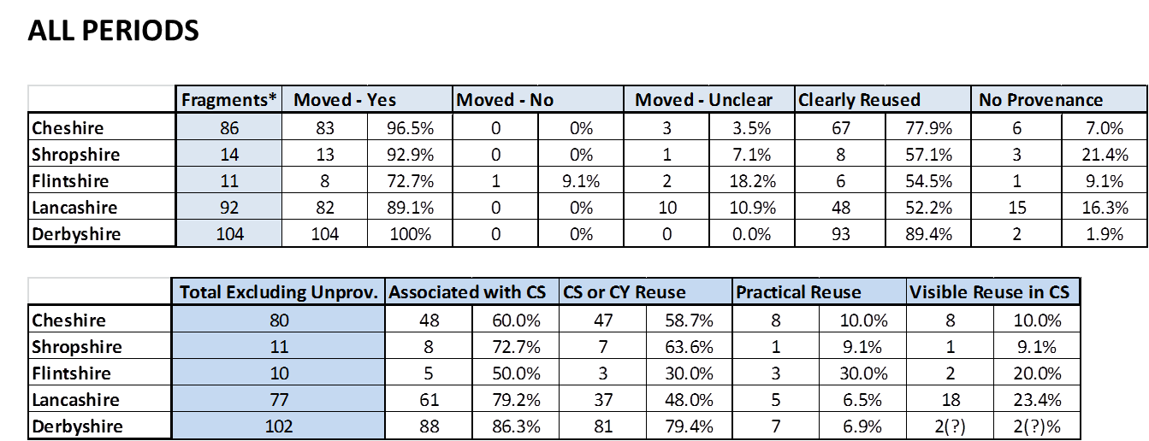

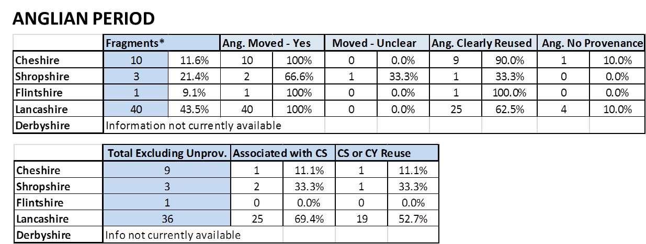

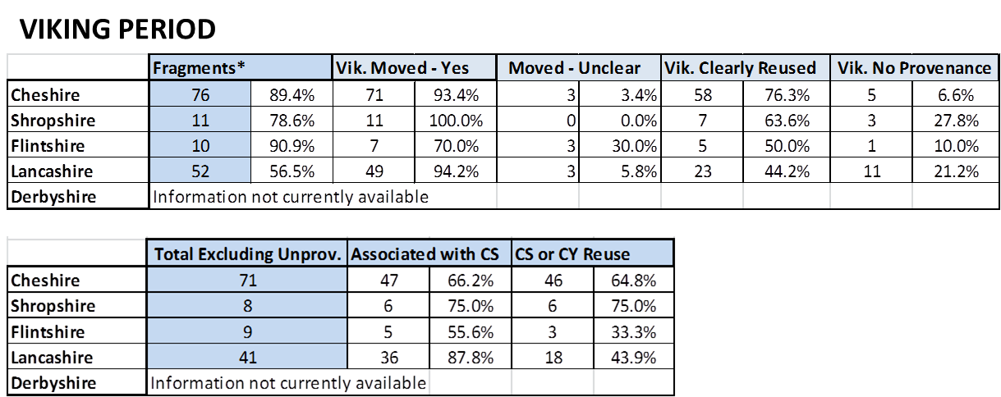

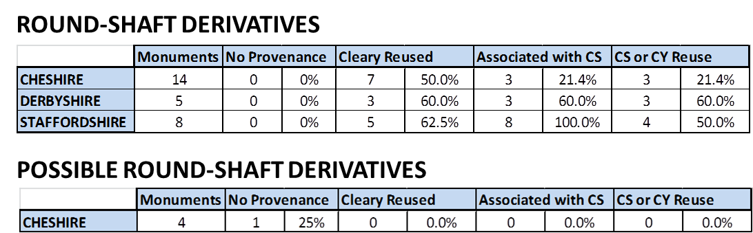
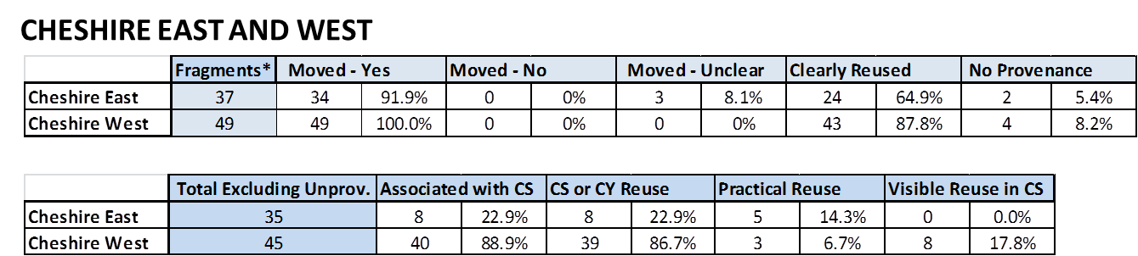

APPENDIX B
The material referenced from Appendix B is based on the totals and percentages listed below.
This information has been compiled from the following sources:
- Hartwell, C. and Hyde, M. 2011. The Buildings of England, Cheshire: Pevsner Architectural Guide, Yale: Yale University Press
- Richards, R. 1973. Old Cheshire Churches: a survey of their history, fabric, furniture, with records of the older monuments, Third Edition, Manchester: E. J. Morten

Notes on Column Titles
Rebuilt: The structure was built anew.
Remodelling: Changing the look and/or layout of the building without altering the exterior walls of the structure.
Extension: The current structure’s floor space and/or height was added to.
Restoration: The current structure was remodelled and/or extended.

EAST CHESHIRE CHURCHES
Place | Church | Earliest Architecture | Rebuilds/Restorations/Remodelling/Extension Evident (pre- 1800) | Restoration(s) 1800-1935 | Restorers | Early Medieval Sculpture
Astbury | St Mary | 13th century | Tower built in 14th century | 1857, 1862 | Salvin/G. G. Scott | 1 monument/2 architectural
Baddiley | St Michael | 14th century | 15-16th century remodelling | 1811 - Rebuild | Unknown | N/A
Barthomley | St Bertoline | 12th century | 15th century remodelling | 1852-4/1925-6 | Unknown/Austin and Paley | N/A
 |  |  | 16th century extension
Bosley | St Mary | 14th-16th century | 18th century remodelling | 1834 - Partial Rebuild | J. Green | N/A
Bowdon | St Mary | 16th century | remodelled in 16th century | 1858-60 - Rebuild | W. H. Brakspear | 1 monument
Brereton | St Oswald | 15th century | Rebuilt in 15th century | 19th century | Unknown | N/A
Cheadle | St Mary | 16th century | Not evident | 1859-61 and 1878-80 | J. Medland Taylor | N/A
Church Lawton | All Saints | 12th century | 16th century extension | 1803 - Rebuild | Unknown | N/A
Disley | St Mary | 16th century | Not evident | 1835 | S. Howard | N/A
Gasworth | St James | 15th century | Not evident | 1851 | Unknown | N/A
High Legh | St Mary | 16th century | Not evident | 1814 - Rebuild, 1893 -Rebuild | T. Harrison, E. Kirby | N/A
Holmes Chapel | St Luke | 15th century | 18th century remodelling | N/A | N/A | N/A
Lower Peover | St Oswald | 16th century | 17th century partial rebuild | 1852 | Salvin/G. G. Scott | N/A
Macclesfield | St Michael | 13th century | 15th century remodelling | 1882-Partial Rebuild | J. Stevens | 4 monuments
 |  |  | 17th century partial rebuild
 |  |  | 18th century rebuild
Macclesfield | Forest Chapel | 17th century | Not evident | 1834 - Rebuild | Unknown | N/A
Marton | St James and St Paul | 14th century | Not evident | 1850/1971 | Derrick/W. Butterfield | N/A
Middlewich | St Michael and All Angels | 12th century | 14th century rebuild | 1857-60 | J. Clarke | N/A
 |  |  | 15th century extension
 |  |  | 16th century extension
Mobberley | St Wilfrid | pre-Conquest | 13th century rebuild | 1889 | J. S. Crowther | N/A
 |  |  | Tower rebuilt in 16th century
Mottram-in-Longdendale | St Michael | 14th century | 15th century remodelling | 1854-5 | E. H. Shellard | N/A
Over Peover | St Lawrence | 15th century | 17th century extension | 1811- Partial Rebuild/1895 | Austin and Paley | N/A
Pott Shrigley | St Peter | 14th century | 15th century remodelling | N/A | N/A | N/A
Prestbury | St Peter | 13th century | 14th century extension | 1879-85 | G.G. and J.O. Scott | 3 monuments
 |  |  | 15th century extension
 |  |  | 17th century remodelling
 |  |  | 18th century remodelling
Rostherne | St Mary | 14th century | 16th century remodelling | 1888 | A. W. Blomfield | N/A
Sandbach | St Mary | 15th century | Not evident | 1847-9 - Partial Rebuild/1930 | G. G. Scott/Austin and Paley | 5 monuments
Swettenham | Unknown | 13th century | 18th century rebuild | 1846 | Unknown | N/A
Tabley | St peter | 18th century | Not evident | 1927-9 | C. Leicester | N/A
Tushingham | St Chad | 17th century | Not evident | N/A | N/A | N/A
Wilmslow |  | 13th century | 15th century remodelling | 1862-3/1877-8 | W. H. Brakspear/ J.S. Crowther | N/A
 |  |  | 16th century remodelling
Witton | St Helen | 14th century | 15th century remodelling | 1842 - Rebuild |  | N/A
 |  |  | 16th century remodelling
Wrenbury | St Margaret | 16th century | 18th century remodelling | 1865 | Unknown | N/A
Wybunbury | St Chad | 15th century | Not evident | 1893 | J. Brooks | N/A

WEST CHESHIRE CHURCHES

Place | Church | Earliest Architecture | Rebuilds/Restorations/Remodelling/Extension Evident (pre- 1800) | Restoration(s) 1800-1935 | Restorers | Early Medieval Sculpture
Acton | St Mary | 13th century | Late 14th century remodelling (John Maddison) | 1897-8 | Austin and Paley | N/A
 |  |  | Tower rebuilt in 1757 after collapse
Alderley | St Mary | 14th century | Not evident | 1877 | Unknown | N/A
Audlem | St James | 13th century | 14th century extension | 1885 | Lyman and Rickman | N/A
 |  |  | 15th century remodelling
Backford | St Oswald | 13th century | Tower built in 15th century | 1887-9 | E. Christian | N/A
Barrow | St Baratholomew | 17th century | Not evident | 1883 | Unknonw | N/A
Bebington | St Andrew | pre-Conquest | 12th century extension | 1846-7/1871-2/1897 | N. Moffat/W. G. Audsley/Deacon | N/A
 |  |  | 13th century extension
 |  |  | Rebuilt in 1511-28 (John Brereton)
Bidston | St Oswald | 16th century | Not evident | 1855-6 - Rebuild | W. and J. Hay | N/A
Birkenhead Priory | St Mary and St James | 12th century | Remodelled in 15th century | 1913-9 | Edmund Kirby | N/A
 |  |  | Destroyed in part in 19th century
Bromborough | St Barnabus | 19th century | Rebuilt in 1828 on site of pre-Conquest church | 1862-4 - Rebuild | G. G. Scott | 11 monuments
Bruera | St Mary | 12th century | 14th century remodelling | 1896 | W. M. Bowden | 3 monument/2 architectural
Bunbary | St Boniface | 14th century | 16th century remodelling | 1863-6 | Pennington and Bridgen's | N/A
 |  |  | 17th century remodelling
Burdwardsley | St John the Baptist Church | 17th century | N/A | 1871, 1878 | J. Douglas | N/A
Burton | St Nicholas | 12th century | 14th century remodelling | 1870 - Part Rebuild | Unknown | N/A
 |  |  | Rebuilt in 1721 (John Morfitt)
Chester Cathedral | Christ and the Blessed Virgin Mary | 13th century | 14th century remodelling | 1818-20/1844-6/1859-76 | T. Harrison/R. C. Hussey/G. G. Scott | N/A
 |  |  | 16th century extension
Chester | St John the Baptist Church | 12th century | 13th century remodelling | 1859-6/1886-7 | R. C. Hussey/Douglas | 9 monuments
 |  |  | 14th century extension
 |  |  | 16th century rebuild of of NW tower and remodelling
Chester | St Mary-on-the-Hill | 14th century | 15th century extension | 1847/1861-2 - Rebuild/1890-1 | J. Harrison/J. P Seddon/T. M. Lockwood | N/A
 |  |  | 16th century extension
Chester | St Michael | 15th century | 16th century remodelling | 1849-50 - Rebuild | J. Harrison
 |  |  | 17th century remodelling
Chester | St Olave | 15th century | Not evident | 1859 | J. Harrison | N/A
Chester | St Peter | 15th century | 16th century remodelling | 1886 | Douglas and Fordham | N/A
 |  |  | 17th century remodelling
Cholmondeley | St Nicholas | 15th century | 17th century restoration | N/A | N/A | N/A
 |  |  | 18th century rebuild
Christleton | St James | 15th century | Rebuilt in 1736 | 1874-8 - Rebuild | Canon Garnett | N/A
Daresbury | All Saints | 16th century | Not evident | 1870-2 | Paley and Austin | N/A
Davenham | St Wilfrid | 17th century | 18th century restoration | 1842, 1851-7 | J. Douglas, E.G. Paley | N/A
Dodleston | St Mary | 16th century | Not evident | 1869-70 -Rebuild | J. Douglas | N/A
Eastam | St Mary | 14th century | 18th century rebuild of tower | 1862-3 - Rebuild/1876-7 | J. Douglas/D. Walker | N/A
Farndon | St Chad | 17th century | Rebuilt in 1658 | 1869 | Kelly and Edwards | N/A
Frodsham | St Laurence | 12th century | 14th century remodelling | 1880-3 | Bodley and Garner | 1 monument
 |  |  | 15th century extension
 |  |  | 18th century restoration
Great Budworth | St Mary and All Saints | 14th century | 15th century remodelling | N/A | Unknown | N/A
 |  |  | 16th century extension
 |  |  | 17th century remodelling
Handley | All Saints | 16th century | Not evident | 1854 | J. Harrison | N/A
Harthill | All Saints | 17th century | 19th century extension | N/A | N/A | N/A
Hargrave | St Peter | 17th century | Not evident | 1878-80 | Unknown | N/A
Heswall | St Peter | 14th century | Not evident | 1879 - Rebuild | J. and S. W. Doyle | N/A
Ince | St James | 16th century | Not evident | 1854 - Rebuild | E. Hodkinson | N/A
Little Budworth | St Peter | 15th century | 18th century remodelling | 1870-1 | J. Douglas | N/A
Lower Whitley | St Luke | 16th century | 16th century rebuild (T. Touchet) | 1864/1879 | Unknown | N/A
Malpas | St Oswald | 14th century | 15th century remodelling | 1886 | J. Douglas | N/A
Marbury | St Michael | 15th century | 18th century remodelling | 1891 | Douglas and Fordham | N/A
Nantwich | St Mary | 14th century | 15th century extension | 1854-61 | G. G. Scott | N/A
Neston | St Mary and St Helen | 14th century | 17th century restoration | 1874-5 | J. F. Doyle | 5 monuments
 |  |  | 18th century remodelling
Over | St Chad | 14th century | 16th century remodelling | 1829/1868-78 | T. Johnson and R. Drinkwater/S. S. Teulon/ | N/A
Plemstall | St Peter | 15th century | Not evident | 1819 | Unknown | N/A
Shocklach | St Edith | 12th century | 14th century rebuild | N/A | N/A | 1 monument
 |  |  | 18th century remodelling
Shotwick | St Michael | 12th century | 14th century rebuild | 1851 | J. Owen | N/A
 |  |  | 15th century remodelling
Stoak | St Lawrence | 14th-16th century | Not evident | 1827 - Rebuild | Unknown | N/A
Tarporley | St Helen | 15th century | Not evident | 1861 | J. S. Crowther | N/A
Tarvin | St Andrew | 14th century | 15th century extension | 1876 | Kelly and Edwards | N/A
 |  |  | 16th partial rebuild
 |  |  | 17th century remodelling
Tattenhall | St Alban | 16th century | Not evident | 1869 - Rebuild | J. Douglas | N/A
Thornton-le-Moors | St Mary | 14th century | 15th century remodelling | 1878 | Unknown | 1 monument
Tilston | St Mary | 15th century | 17th century extension | 1877-8 | J. Douglas | N/A
Wallasey | St Hilary | 13th century | Not evident - church burnt down | 1857 - Rebuild | N/A | N/A
Waverton | St Peter | 16th century | 17th century remodelling | 1845/1888 | J. Douglas | N/A
Weaverham | St Mary | 15th century | 16th century remodelling | 1853-5/1877 | Salvin/ J. Douglas | N/A
West Kirby | St Bridget | 14th century | Tower built in 15th century | 1869-70 | Kelly and Edwards | 5 monuments
 |  |  | 18th century restoration
Whitegate | St Mary | 14th-16th century | 18th century rebuild | 1874-5 | J. Douglas | N/A
Woodchurch | The Holy Cross | 12th century | 14th century remodelling | 1934 | B. Miller | N/A
 |  |  | 16th century remodelling
 |  |  | 17th century extension

