Geographical Information Systems as a Tool for Exploring the Spatial Humanities
Ian Gregory and Patricia Murrieta-Flores

Introduction
Geography, location and place have traditionally been under-studied by the humanities. This is not because of a lack of interest in them, or because of a failure to acknowledge their importance, but instead because these are difficult concepts to handle effectively. Mental maps of places mentioned in a source are notoriously hazy even to a reader who knows the area well. Manually attempting to map these places on paper is a time-consuming and unsatisfactory process resulting in a map that would frequently be an end-point of the research: reliant on decisions taken early in the investigation process, too inflexible to revise and suitable only for reproducing poorly in a monograph reliant on grey-scale publishing on a small page.
Geographical technologies including geographical information systems (GIS) and virtual globes such as Google Earth have the potential to break down these barriers and are leading to the development of a new field termed spatial humanities. A GIS is frequently thought of as a mapping system, however, as will be described in more detail below, it is perhaps better thought of as a database management system for data that can be associate with locations. Once a GIS database has been created, the map becomes central to the research process allowing the researcher to ask questions in which location is central: “how is this distributed across the study area?”, “why is this found here and not there?”, “what else is found at places this is found?” and so on. As the research is undertaken a wide range of maps and other visualisations will be created and refined with the map being an integral part of the research process. At the end of the process the researcher can choose which maps to publish. Grey-scale and colour versions of maps can easily be produced and maps can also be published electronically with interactive functionality that enable users/readers to explore them in more detail. Thus, the role of maps in disseminating the author’s message can be separated from their role as a research tool that enables the author to develop and refine their message.
This is not to say that the new world of spatial humanities is problem free. As will be discussed in more detail below, there are a number of problems remaining, including the time that it takes to create a GIS database, the complexity of GIS software, and issues around the fact that GIS was developed to handle quantitative sources in the Earth and social sciences using very different paradigms than those found in the humanities. Nevertheless, we are at a point where these technologies will allow early adopters to create a step change in the way that location is explored in the humanities which, in turn, will lead to new understanding about geographical knowledge across the full range of disciplines that make up the humanities. This chapter introduces GIS as a tool for research within the humanities, a range of other publications are available for readers who are interested in the approaches that it offers to the field or case study examples of how humanities researchers are applying the technology.

Definitions and terminology
As with many technologies, GIS comes with a range of terminology with overlapping definitions. Geographical information is effectively any data set that refers to specific locations on the Earth’s surface where we are interested in the differences between locations. A geographical information system is frequently thought of as a software system that enables spatial information to be stored, manipulated, queried, analysed and visualised. As such, a GIS combines the ability of a database to explore thematic questions associated with what is in the database, with the abilities of a mapping system to explore spatial questions associated with where features are located. The two main commercial GIS software packages are ArcGIS, which dominates the academic market, and MapInfo. Recently free open-source software, including Quantum GIS (QGIS), Grass and gvSIG, have begun to rival these products. Geographical information science (GISc) is a broader field concerned with how geographical information can best be studied. Within GISc geographical information is the source material, GIS is the technology to analyse it, and GISc is the intellectual context in which this work take place.
GIS has its roots in the Earth sciences in the 1960s where it was developed to monitor subjects such as land-use. It spread into human geography in the 1980s where it was particularly used to analyse quantitative sources such as census data. The adoption of GIS in the humanities started with archaeology in the early 1980s with the rapid rise of its use for both cultural resource management and as a research tool. By the 1990s, the development of research methods for spatial analysis in the field were already widely practiced. In the 1990s historians started to use GIS. This occurred largely independently to developments in archaeology with the primary emphasis being on quantitative sources such as demographic or environmental data. Despite its narrow focus, this approach was successful enough to create its own sub-field, historical GIS. Through the 2000s the use of GIS in history spread into new areas and the emphasis increasingly shifted from technology and methods to applied research. In history this led to historical GIS being increasingly re-branded as spatial history, reflecting the increasing importance of historical research questions and downplaying the technology. The advent of digital humanities in the early 2000s increased interest in using GIS with more traditional humanities sources, particularly texts, and also images, virtual landscapes and historical maps. This has led to fields known as both humanities GIS and spatial humanities. There has also been a move to develop deep mapping, a paradigm that attempts to move the use of geographical information away from GIS.

The basic technology
GIS is based around a crude but effective model in which the features on the Earth’s surface are represented within a computer. As was stated above, to represent geographical information we need thematic information about what there is and spatial information about where it is located. This involves having two types of data linked together within the software. On the one hand there is what GIS software terms attribute data, which is ‘data’ as most users would understand it in that it might be a table of statistics, a digital text or corpus, or a collection of images. Within GIS software each item of attribute data needs to be linked to a coordinate-based location, referred to as spatial data. There are only really four types of spatial data: points, lines, polygons (which represent areas), and pixels. With tabular attribute data, every row in the table will have a corresponding item of spatial data, with a collection of images each image is likely to have its own spatial data, probably a point derived from the image’s metadata. When the attribute data are unstructured texts such as corpora these usually need to be converted into tabular form as described in more detail below. The combination of spatial and attribute data within a GIS is usually referred to as a layer. A layer is the GIS equivalent of a table in a database in that it is the basic structure used to store the information associated with one theme. The difference between a table and a layer is that a layer consists of both spatial and attribute data.
Depending on the type of spatial data used, GIS data can be classified into two main types: vector and raster. Vector data consist of either points, lines or polygons and are used to represent discrete features such as historical sites (which can be points or polygons depending on the scale), transport networks (lines) or towns and cities (which can again be points or polygons). Raster data use pixels to represent continuous surfaces of which the topography of the terrain is the most common. Each pixel represents a small area of the Earth’s surface and has a height or other value associated with it. The user is unlikely to be interested in the values associated with one individual pixel, instead it is the way that multiple pixels represent a continuously varying landscape that is of interest.
Whatever the format of spatial data, coordinates are centrally important to the ability of GIS to represent, integrate and analyse data. All coordinates should be in a real-world coordinate system. This means either using latitude and longitude or a map projection. Latitude and longitude locate any point on the Earth’s surface using the angle north or south of the equator and east or west of the Greenwich meridian. A map projection converts from degrees on a globe to a regular grid suitable for display on a computer screen or piece of paper. Usually the projection has an origin (whose coordinates are 0,0) at an arbitrary point and coordinates are expressed in meters or other units east or west (x) and north or south (y) of this location. Examples of projections include Universal Transverse Mercator (UTM) and British National Grid. Projections are complicated as moving from a globe to a flat surface inevitably distorts one or more of angles, distances, areas and shapes. From a GIS perspective, the important point is that as long as spatial data use real world coordinates the computer can both calculate measurements such as the distances between points, the length of lines and the area of polygons, and can also integrate any data sets that use the same coordinate system. Good GIS software is able to convert from one coordinate system to another.
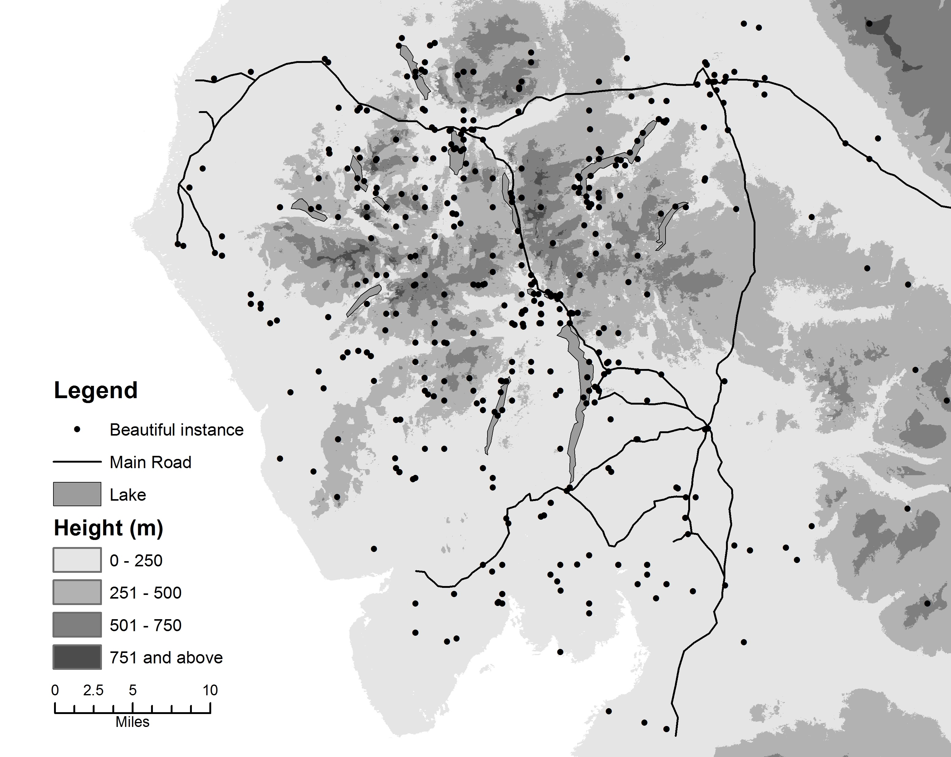
Place-name | Search-term | Author | Date | Genre
Wyburn | Beautiful | Joseph Budworth | 1792 | Travelogue
Helvellyn | Beautiful | William Wilberforce | 1779 | Journal
Deepdale Beck | Beautiful | Edward Baines | 1829 | Guide
Glenridding | Beautiful | M. J. B. Baddeley | 1900 | Guide

[Figure 1: Example of a GIS: (a) map based, (b) table]
Figure 1 shows an example of how this structure can be used to represent a source. Using techniques described below, a corpus of 1.5 million words of writing about the English Lake District was converted into a point layer such that each place-name from the text is represented by a point. The points shown represent place-names that occur within the same sentence as the word ‘beautiful.’ The spatial data thus indicate locations that writers within the corpus are associating with ‘beautiful’, the attribute data give more information on this such as the author that the reference was taken from, the date it was written, the genre that author was writing in, and so on. As the spatial data are projected using British National Grid they can be combined with a variety of other layers on the same projection which, in this case, provide context including a line layer showing main roads and a polygon layer showing the major lakes. The final layer is a raster surface representing heights.

Getting sources into GIS
The process of adding spatial data to a source or database is known as georeferencing. In the sciences and social sciences this stage of database creation was often the most time-consuming part of a GIS project because many quantitative sources require polygon boundaries to be digitised which, as will be described below, is a slow and time-consuming process. In the humanities, however, this is frequently less of a problem. Humanities sources are often best represented using points and these are relatively quick and easy to read into GIS form. The easiest way to create a point layer is to start with a table that includes coordinates in two of the columns (one for eastings or longitudes, and one for northings or latitudes). Object-level metadata often takes this form. Converting such a table into a GIS layer is trivial, requiring only a few mouse clicks. The software simply uses the coordinates to create the spatial data which provides the information required to convert the table into a layer.

Place-name | Author | Date
Sca Fell | S.T. Coleridge | 1802
Helvellyn | W. Wordsworth | 1822
Great Gavel | E. Baines | 1829
a. Source table
Place-name | Latitude | Longitude
Fairfield | 54.4973 | -2.9922
Great Gable | 54.4836 | -3.2118
Helvellyn | 54.5304 | -3.0123
Sca Fell | 54.4558 | -3.2133
Skiddaw | 54.6551 | -3.1394
b. Gazetteer
Place-name | Author | Date | Standard place-name | Latitude | Longitude
Sca Fell | S.T. Coleridge | 1802 | Sca Fell | 54.4558 | -3.2133
Helvellyn | W. Wordsworth | 1822 | Helvellyn | 54.5304 | -3.0123
Great Gavel | E. Baines | 1829 | Great Gable | 54.4836 | -3.2118
c. Joined table

[Figure 2: Using a gazetteer]
Where a table contains place-names without coordinates, the required coordinates can often be found using a gazetteer, which, in its simplest form, is a database table that lists place-names and gives coordinates for them. An increasing number of gazetteers are freely available over the internet. Gazetteers can be used to provide coordinates for place-names through the use of a relational join, a database operation in which two tables are effectively joined together using a common field. An example of this is shown in figure 2. As a relational join will only join exact matches, work is often required to standardise the spellings on the input table to match those on the gazetteer. It is good practice to keep the original spellings as well as the standardised versions found in the gazetteer. A user will also usually have to find locations for place-names that are not found in the gazetteer – Google Maps or paper maps may be appropriate for doing this – and may have to disambiguate place-names that may refer to different places such as, for example, ‘London’ which may be in England or Ontario. Despite these issues, given a good gazetteer and a relatively clean set of place-names, this process is quick and effective. Once coordinates have been found we effectively have a table with coordinates that can be converted into a GIS layer as described above.
Where place-names occur in an unstructured text such as a corpus, georeferencing is more difficult because the place-names must be identified in the text. This can be done manually but this is only feasible for relatively small corpora. To automate this process, progress has been made in geoparsing, which involves first automatically identifying place-names in the corpus using natural language processing (NLP) and subsequently matching these to a gazetteer. XML tags that identify the place-names and include their coordinates as attributes are added to the text. The text then needs to be converted to tabular form which usually involves extracting the tagged place-names and some of the text that surrounds them and converting them into a table where each instance of a place-name forms a row. Thus, there is currently no way of completely georeferencing a corpus without converting it into tabular form and thus losing some of the structure of the text.
Digitising lines and polygons is much slower and more time-consuming than creating points. Typically this is done is by first scanning and georeferencing the map that the features will be taken from as described below. Digitising lines is then done by clicking the mouse along the line to capture its shape. Polygons are created by digitising one or more lines to completely enclose an area. Where two polygons share a boundary, for example, the boundary between two administrative units, this usually only needs to be digitised once, with the software being able to work out which polygon is to its left and right.
The data sources above all create vector data. A user may also want to georeference images such as historical maps, in which case it will create a raster image. Taking a historical map as an example, the first stage is to scan or photograph the map creating a bitmap image such as a JPEG or TIFF. This can then be read into GIS software and is georeferenced by giving the software the real-world coordinates of four or more known points on the image such as the four corners. The software uses these to georeference the entire image.

Exploring and manipulating data in GIS
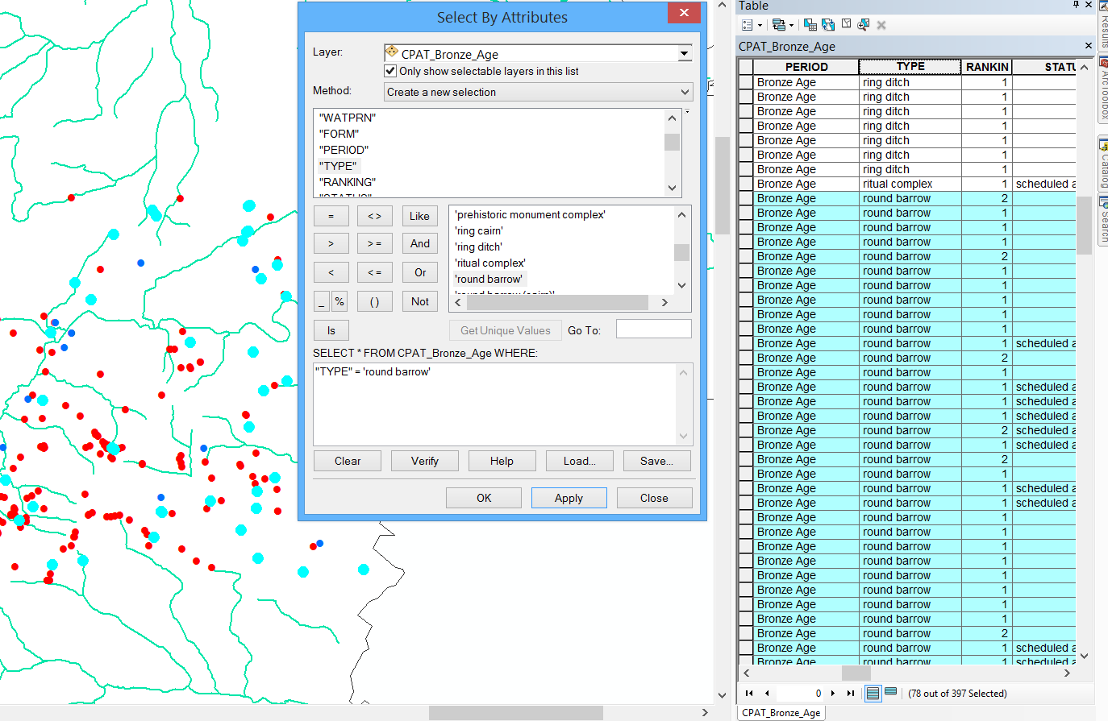
[Figure 3: Selection by attributes in ArcMap.]
One of the most powerful capabilities of GIS, is its ability to query its data in different ways. Searching the database can be done based on spatial criteria, attribute criteria, or combinations of both. Queries based on these criteria are common in humanities research. For instance, in figure 3 an archaeologist who is working with a layer of prehistoric evidence from the national monument record might want to identify all of the Bronze Age round barrows recorded. An attribute query is done to select features based on values stored in attribute data table. In this case, the researcher would select all the features that have the attribute ‘Bronze Age’ in the field called “Period”, and the attribute ‘Round barrow’ in the field called “Class”. This selection is often done using Structured Query Language (SQL). The results of the query will be presented in both tabular and map form.
There are also many instances in which the scholar might want to look for information based on spatial criteria. Simple spatial queries are implemented simply by clicking the spatial data on the map to display the attributes associated to it. Spatial queries can also be done in more sophisticated ways to find out the relationships between features on different layers. One way of doing this is through an overlay operation. For example, a historian working with a WWII dataset might want to:
- Identify all of the concentration camps within modern day Poland using a layer of camp locations and a layer of modern country boundaries;
- Find all the factories destroyed within 1km of a particular river using a layer of factories (including an attribute that flags whether it was destroyed) and a layer of rivers.
In both of these cases the overlay operation combines the spatial and attribute data from the two layers. The second case involves an extra step involving another GIS technique called buffering in which polygons are created that enclose the areas within a set distance of the features on a layer such as within one kilometre of rivers (represented using lines) or ten miles of towns (represented using points).
Using these types of query, questions such as the following can be posed:
- What percentage of the total concentration camps were located in each country?
- What proportion of bombed factories were located near German cities?
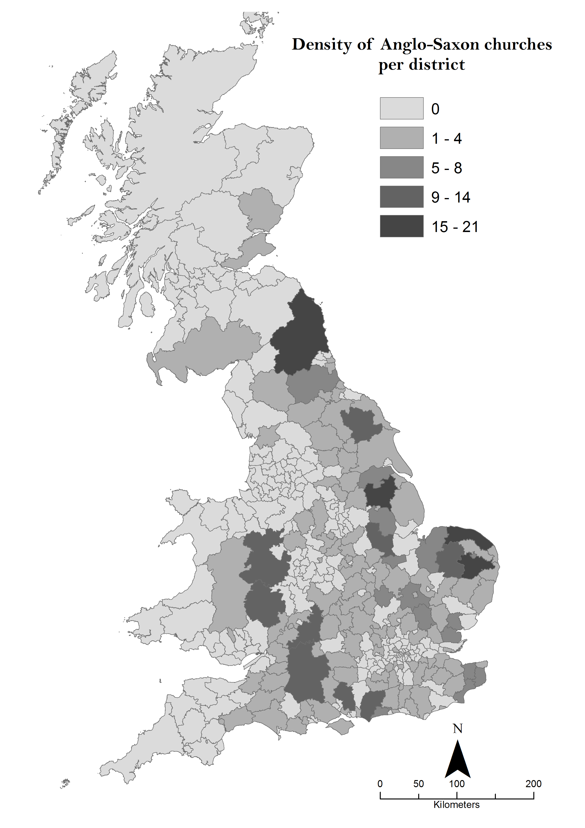
[Figure 4: Map created from the result of an attribute query by spatial location.]
Figure 4 shows an example of the results of an overlay. The map has been created by taking a point layer showing the locations of Anglo-Saxon churches in Britain. This has been overlaid with a polygon layer of modern administrative districts to allocate each church to a district. The total number of churches in each district has then been calculated and the results mapped.

Spatial Analysis
The fact that GIS data combine spatial and attribute data opens up the potential to develop forms of analysis that explicitly include location. These techniques are referred to as spatial analysis and can be defined as a “subset of analytic techniques whose results depend on the locations of the objects of analysis.” These techniques can be statistically complex but do not need to be. They typically aim to identify and summarise spatial patterns within one layer, or the relationships between two or more layers in ways that go beyond simple querying or map overlay. Spatial analysis thus explores what happens where and can be used either to explore data or to test particular hypotheses.
We might want to know exploring a WWI dataset, whether soldiers from particular regiments came from specific neighbourhoods. Using a point layer representing the soldiers’ addresses we can ask: does this point layer exhibit any spatial pattern? If so, what form does it takes? The answer to this will usually be that it is clustered in particular locations, that it is regularly distributed, or that the distribution appears random. Importantly, spatial analysis will allow us to identify how confident are we that the pattern is not random. If the pattern is not random, this would allow us to investigate further the reasons for the pattern by adding additional data. For instance, we might use census data to investigate whether clusters of recruitment are found in areas with particular social or economic characteristics.
Spatial analysis can be combined with textual analysis techniques such as corpus linguistics to create geographical text analysis. This allows us to ask questions such as which locations does the corpus concentrate on, what themes does the text associate with particular locations, and what geography do particular words or themes within the text follow.
These are only few examples of the spatial explorations that can be carried out. There are many kinds of questions in the humanities that involve exploring spatial relationships, and there are numerous techniques, methods and models to explore them. Other methods include: visibility, cost surface, and network analyses. These approaches allow the researcher to investigate issues such as: the role of visibility in the construction of medieval castles or the location of memorial monuments; the role of routes of communication in historical travel writing, or migration during prehistoric times; the centrality of markets in historical commercial enterprises, or the distribution of a particular good, among many others. In addition, although not widely implemented in the humanities yet, geosimulation is a promising approach. Agent based modelling, for instance, can be used in the exploration of the influence of different variables in the outcome of historical battles, or possibly, the dispersion or adoption of an idea or concept.

Cartography and Interactive Mapping
GIS provides powerful cartographic functionality that allow the results of an analysis to be presented to a user/reader, however cartographic design principles need to be understood in order to create meaningful maps from a database. Among the most important, are legibility, visual contrast, hierarchical organisation and balance. A good map should be easy to read and understand, have good visual contrast on the elements presented, and include elements such as a legend, scale bar and north arrow. When creating a map, the author should attempt to follow two rules: first, the map should be stand-alone product that can be understood without referring to any accompanying text, and second that the basic message of the map should be understandable within ten seconds of the user/reader looking at it.
Traditional maps present what the author feels is important to the reader. An alternative approach is to present data to the user and allow them to explore it themselves. A range of related technologies, in particular virtual globes such as Google Earth and internet mapping technologies such as Google Maps and Bing Maps, can be used in partnership with GIS, but are primarily designed to be effective at presenting geographical information over the internet in a readily usable form. To achieve this they usually have user-friendly mapping capabilities but limited database functionality, friendly user interfaces and a soft learning curve. Almost all standard GIS packages allow the conversion of their proprietary file formats into Keyhole Markup Language (KML-an XML notation developed for the creation of geographic annotation and visualisation in Google Earth) allowing GIS data to be shared in a way that is accessible to non-experts.
Humanities sources as varied as twentieth century census data, the history of cities and historical photographs have also been placed on the internet with custom-written interfaces. These sites all use location to structure their data such that users can query them based on location. They differ from traditional maps in that rather than presenting a message to a reader, the user has to develop their own argument by repeatedly querying the sources the site contains.

Conclusions
GIS is a tool that allows the researcher to represent his/her source in a way that combines the thematic with the spatial and thus allows questions to be asked about what is found where. The basic data model used by GIS, combining attribute and spatial data, is crude but nevertheless effective in that it allows researchers to ask questions in which location is important, to integrate different data sets based on where the features they contain are found, to analyse data in ways that are explicitly geographical, and to present the results of the analysis through maps and other forms of visualisation.
There are also limitations with GIS. The GIS data model is centred around the idea that the source under study can be represented in tabular form. While this is fine for sources such as statistics and collections of images, it is clearly less than ideal for texts. Nevertheless, texts can be incorporated into GIS format using the idea that each place-name becomes a row of data in a table. A second limitation is that each item of attribute data can only be associated with a single location. This is fine for most features but is problematic for sources associated with flows such as trades or migrations that have a start and end point and perhaps a route in between. A more fundamental criticism of GIS is that it prioritises space but has only limited functionality to manage time. This is a valid critique but it is important to realise that the human brain is very poor at conceptualising space and time simultaneously and that to understand one it is usually necessary to simplify the other. Another valid critique of GIS is that it insists on precise locations for spatial data and is poor at representing uncertainty in this. This is valid and interpreting spatial patterns requires careful thought about the accuracy, or otherwise, of the locations used.
There are also practical limitations with GIS associated with the investment in time required. Both learning to use GIS software and data into GIS form can be very time-consuming. If the data contain place-names that can be relatively easily georeferenced to points using a gazetteer the georeferencing the data is manageable. Subjects where good gazetteers do not exist, or where lines or polygons need to be digitised, need to be approached with care.
Despite these limitations, we are in the early stages of a step change in the way that geography, location and place are researched within the humanities, enabled by the opportunities that GIS offers within the digital humanities. For those prepared to invest the time – and with the confidence to think innovatively about new approaches to sources and research questions – there are many opportunities to be taken and many rewards to be had.

Works Cited:
M. Aldenderfer and H.D.G. Maschner Anthropology, Space, and Geographic Information Systems. (Oxford University Press, Oxford, 1996)
I. Benenson and P.M. Torrens, Geosimulation: Automata-based modelling of urban phenomena (Chichester: John Wiley, 2004)
D.J. Bodenhamer ‘Narrating space and place’ in Spatial Narratives and Deep Maps, ed. by D.J. Bodenhamer, J. Corrigan and T.M. Harris (Bloomington: Indiana University Press, 2015), pp. 7-27
D.J. Bodenhamer, J. Corrigan and T.M. Harris The Spatial Humanities: GIS and the future of humanities scholarship (Bloomington, IN: Indiana University Press, 2010)
K-T Chang, Introduction to Geographic Information Systems (McGraw Hill: Boston, 2009)
G. Cunfer, On the Great Plains: Agriculture and environment. (College Station, TX: Texas A&M University Press, 2005)
B.D. Dent, J. Torguson and T. Hodler Cartography: Thematic Map Design, 6th edition. (Boston, MA: WCB-McGraw Hill, 2009)
B. Donahue, The Great Meadow: Farmers and the land in colonial Concord.(New Haven: University of Yale Press, 2004)
Dorling D. and Fairburn D. Mapping: Ways of representing the world (Harlow: Longman, 1997)
M.F. Goodchild, ‘Geographical Information Science’ International Journal of Geographical Information Systems, 6 (1992) pp. 31-45.
M.F. Goodchild ‘Geographic information systems and spatial analysis in the social sciences’ in Anthropology, Space, and Geographic Information Systems ed. by M. Aldenerfer and H.D.G. Maschner (New York: Oxford University Press, 1996) pp. 241-250
C. Gordon, Mapping Decline: St. Louis and the fate of the American city (Philadelphia: University of Pennsylvania Press, 2008)
I.N. Gregory ‘Different places, different stories: Infant mortality decline in England & Wales, 1851-1911’ Annals of the Association of American Geographers, 98 (2008) pp. 773-794
I.N. Gregory ‘From Historical GIS to Spatial Humanities: An evolving literature’ in Toward Spatial Humanities: Historical GIS and spatial history, ed. by I.N. Gregory and A. Geddes (Bloomington, IN: Indiana University Press, 2014), pp. 186-202
I. Gregory, D. Cooper, A. Hardie and P. Rayson P. ‘Spatializing and analysing digital texts: Corpora, GIS and places’ in Spatial Narratives and Deep Maps, ed. by D.J. Bodenhamer, J. Corrigan and T.M. Harris (Bloomington: Indiana University Press, 2015) pp. 150-178.
I. Gregory and C. Donaldson ‘Using geographical technologies to understand Lake District literature’ in Literary Mapping in the Digital Age ed. by D. Cooper, C.D. Donaldson and P. Murrieta-Flores (Aldershot: Ashgate, in press)
I.N. Gregory, C. Donaldson, P. Murrieta-Flores and P. Rayson P. ‘Geoparsing, GIS and textual analysis: Current developments in Spatial Humanities research’ International Journal of Humanities and Arts Computing, 9 (2015), pp. 1-14
I.N. Gregory and P.S. Ell Historical GIS: Technologies, methodologies, scholarship (Cambridge: Cambridge University Press, 2007)
I.N. Gregory, C. Donaldson, P. Murrieta-Flores and P. Rayson P. ‘Geoparsing, GIS and textual analysis: Current developments in Spatial Humanities research’ International Journal of Humanities and Arts Computing, 9 (2015), pp. 1-14I.N. Gregory and A. Geddes ‘From Historical GIS to Spatial Humanities: Deepening scholarship and broadening technology’ in Toward Spatial Humanities: Historical GIS and spatial history, ed. by I.N. Gregory and A. Geddes (Bloomington, IN: Indiana University Press, 2014), pp. ix-xix
I. Gregory and A. Hardie ‘Visual GISting: Bringing together corpus linguistics and Geographical Information Systems’ Literary and Linguistic Computing, 26 (2011), pp. 297-314
I.N. Gregory and R.G. Healey, ‘Historical GIS: Structuring, mapping and analysing geographies of the past’ Progress in Human Geography, 31 (2007), pp. 638-653
A.K. Knowles Placing History: How GIS is changing historical scholarship (Redlands, CA: ESRI, 2008)
C. Grover, R, Tobin, K. Byrne, M. Woollard, J. Reid, .S Dunn, and J. Ball, ‘Use of the Edinburgh geoparser for georeferencing digitized historical collections’ Philosophical Transactions of the Royal Society A, 368 (2010), pp. 3875-3889
M.C. Howey ‘Using multi-criteria cost surface analysis to explore past regional landscapes: A case study of ritual activity and social interaction in Michigan, AD 1200–1600’ Journal of Archaeological Science. 34, (2007) pp. 1830-1846
M-H Jang ‘Three-dimensional visualization of an emotional map with geographical information systems: A case study of historical and cultural heritage in the Yeongsan River Basin, Korea.’ International Journal of Geographical Information Science. 26 (2012) pp. 1393-1413
J. Lee and D. Stucky ‘On applying viewshed analysis for determining least-cost paths on Digital Elevation Models’ International Journal of Geographical Information Science. 12 (1999) pp. 891- 905
A.M. MacEachren How Maps Work: Representation, visualisation and design (London: Guildford Press, 1995)
P. Murrieta‐Flores, A. Baron, I. Gregory, A. Hardie and P. Rayson ‘Automatically analyzing large texts in a GIS environment: The Registrar General’s reports and cholera in the 19th century’ Transactions in GIS 19 (2015), pp. 296-320
A.H. Robinson, J.L. Morrison, P.C. Muehrcke, A.J. Kimerling and S.C. Guptill, Elements of Cartography. 6th edition (Chichester: John Wiley & Son, 1995)
H. Southall, R. Mostern and M.L. Berman ‘On historical gazetteers’ International Journal of Humanities and Arts Computing, 5 (2011) pp. 127-145
D. Wheatley and M. Gillings Spatial technology and archaeology: The archaeological applications of GIS. (London: Taylor and Francis, 2000)

Next step readings:
For those wishing to know more about current research using GIS in the Digital Humanities an annotated bibliography is provided by I.N. Gregory ‘From Historical GIS to Spatial Humanities: An evolving literature’ ed. by I.N. Gregory and A. Geddes Toward Spatial Humanities: Historical GIS and spatial history (Bloomington, IN: Indiana University Press, 2014), pp. 186-202. See also many of the works cited in this chapter.
Online lists of useful resources include:
- The Historical GIS Research Network (http://www.hgis.org.uk) which includes listings of both publications and online resources.
- The GeoHumanities Special Interest Group of the Alliance of Digital Humanities Organizations (http://geohumanities.org) which includes an online list of Humanities GIS projects and a GeoDiRT (Digital Research Tools) listing
- The Humanities GIS Zotero Library (https://www.zotero.org/groups/humanitiesgis)
- The University of Saskatchewan’s HGIS Lab provides both an online bibliography and a page of links (http://www.hgis.usask.ca)
For those wishing to learn to use GIS a useful starting point is the lessons provided by the Geospatial Historian site (https://geospatialhistorian.wordpress.com) which also includes more pages of links to projects and resources. A more generic set of training materials, focussed on the QGIS package is available from http://www.qgistutorials.com or, for a wider range of software see http://www.gistutor.com.

Acknowledgement:
The research leading to these results has received funding from the European Research Council (ERC) under the European Union’s Seventh Framework Programme (FP7/2007-2013) / ERC grant “Spatial Humanities: Texts, GIS, places” (agreement number 283850).

Figure Captions:

a. Spatial data
b. A fragment of the attribute data of the ‘beautiful’ layer
Figure 1: Layers in a GIS. The English Lake District showing: a point layer of places described in the corpus as ‘beautiful’, a line layer of main roads, a polygon layer of the major lakes, and a raster surface representing height.

Figure 2: Using a gazetteer to join coordinates to a table. The joined table (c) has been had coordinates added from the gazetteer through the use of a relational join that matches identical place-names. An additional field, standard place-name has been added to allow spellings from the source to be matched with those on the gazetteer.

Figure 3: Selection by attributes in ArcMap. Using as example a layer with archaeological information, we carried out a query selecting by attribute all those records in the ‘CPAT Bronze Age’ layer that correspond to the ‘TYPE’ ‘Round Barrow’. The result show these records highlighted both in the attribute table and the mapped spatial data.

Figure 4: Anglo-Saxon churches per district created by an overlay. The map was produced using an overlay between a polygon layer (districts) and a point layer (Anglo-Saxon churches), which returned a count of points that fall within each polygon.

For how GIS and spatial approaches fit into the humanities see, in particular, D.J. Bodenhamer, J. Corrigan and T.M. Harris The Spatial Humanities: GIS and the future of humanities scholarship (Bloomington, IN: Indiana University Press, 2010). For a review of case studies see: I.N. Gregory ‘From Historical GIS to Spatial Humanities: An evolving literature’ in Toward Spatial Humanities: Historical GIS and spatial history, ed. by I.N. Gregory and A. Geddes (Bloomington, IN: Indiana University Press, 2014), pp. 186-202; and chapters in A.K. Knowles Placing History: How GIS is changing historical scholarship (Redlands, CA: ESRI, 2008).
I.N. Gregory and P.S. Ell Historical GIS: Technologies, methodologies, scholarship (Cambridge: Cambridge University Press, 2007).
See: http://www.esri.com and http://www.mapinfo.com respectively.
See: http://www.qgis.org, http://grass.osgeo.org and http://www.gvsig.com respectively.
M.F. Goodchild, ‘Geographical Information Science’ International Journal of Geographical Information Systems, 6 (1992) pp. 31-45.
M. Aldenderfer and H.D.G. Maschner Anthropology, Space, and Geographic Information Systems. (Oxford University Press, Oxford, 1996).
See, for example, G. Cunfer, On the Great Plains: Agriculture and environment. (College Station, TX: Texas A&M University Press, 2005); B. Donahue, The Great Meadow: Farmers and the land in colonial Concord.(New Haven: University of Yale Press, 2004); C. Gordon, Mapping Decline: St. Louis and the fate of the American city (Philadelphia: University of Pennsylvania Press, 2008); I.N. Gregory ‘Different places, different stories: Infant mortality decline in England & Wales, 1851-1911’ Annals of the Association of American Geographers, 98 (2008) pp. 773-794.
I.N. Gregory and R.G. Healey, ‘Historical GIS: Structuring, mapping and analysing geographies of the past’ Progress in Human Geography, 31 (2007), pp. 638-653.
I.N. Gregory and A. Geddes ‘From Historical GIS to Spatial Humanities: Deepening scholarship and broadening technology’ in Toward Spatial Humanities: Historical GIS and spatial history, ed. by I.N. Gregory and A. Geddes (Bloomington, IN: Indiana University Press, 2014), pp. ix-xix.
D.J. Bodenhamer ‘Narrating space and place’ in Spatial Narratives and Deep Maps, ed. by D.J. Bodenhamer, J. Corrigan and T.M. Harris (Bloomington: Indiana University Press, 2015), pp. 7-27.
A.H. Robinson, J.L. Morrison, P.C. Muehrcke, A.J. Kimerling and S.C. Guptill, Elements of Cartography. 6th edition (Chichester: John Wiley & Son, 1995), chap 5.
H. Southall, R. Mostern and M.L. Berman ‘On historical gazetteers’ International Journal of Humanities and Arts Computing, 5 (2011) pp. 127-145.
See, for example, the Geonames gazetteer http://www.geonames.org and the Getty Thesaurus of Geographical Names http://www.getty.edu/research/tools/vocabularies/tgn. Tools are also available that will use a gazetteer to automatically add coordinates to a list of place-names or addresses such as http://www.findlatitudeandlongitude.com/batch-geocode and http://sandbox.idre.ucla.edu/geocoder.
C. Grover, R, Tobin, K. Byrne, M. Woollard, J. Reid, .S Dunn, and J. Ball, ‘Use of the Edinburgh geoparser for georeferencing digitized historical collections’ Philosophical Transactions of the Royal Society A, 368 (2010), pp. 3875-3889; I.N. Gregory, C. Donaldson, P. Murrieta-Flores and P. Rayson P. ‘Geoparsing, GIS and textual analysis: Current developments in Spatial Humanities research’ International Journal of Humanities and Arts Computing, 9 (2015), pp. 1-14.
I. Gregory, D. Cooper, A. Hardie and P. Rayson P. ‘Spatializing and analysing digital texts: Corpora, GIS and places’ in Spatial Narratives and Deep Maps, ed. by D.J. Bodenhamer, J. Corrigan and T.M. Harris (Bloomington: Indiana University Press, 2015) pp. 150-178.; I. Gregory and C. Donaldson ‘Using geographical technologies to understand Lake District literature’ in Literary Mapping in the Digital Age ed. by D. Cooper, C.D. Donaldson and P. Murrieta-Flores (Aldershot: Ashgate, in press).
M.F. Goodchild ‘Geographic information systems and spatial analysis in the social sciences’ in Anthropology, Space, and Geographic Information Systems ed. by M. Aldenerfer and H.D.G. Maschner (New York: Oxford University Press, 1996) pp. 241-250.
D. Wheatley and M. Gillings Spatial technology and archaeology: The archaeological applications of GIS. (London: Taylor and Francis, 2000).
See, for example: P. Murrieta‐Flores, A. Baron, I. Gregory, A. Hardie and P. Rayson ‘Automatically analyzing large texts in a GIS environment: The Registrar General’s reports and cholera in the 19th century’ Transactions in GIS 19 (2015), pp. 296-320; and I. Gregory and A. Hardie ‘Visual GISting: Bringing together corpus linguistics and Geographical Information Systems’ Literary and Linguistic Computing, 26 (2011), pp. 297-314.
K-T Chang, Introduction to Geographic Information Systems (McGraw Hill: Boston, 2009) chaps. 13, 14 and 17. See also: J. Lee and D. Stucky ‘On applying viewshed analysis for determining least-cost paths on Digital Elevation Models’ International Journal of Geographical Information Science. 12 (1999) pp. 891- 905; M.C. Howey ‘Using multi-criteria cost surface analysis to explore past regional landscapes: A case study of ritual activity and social interaction in Michigan, AD 1200–1600’ Journal of Archaeological Science. 34, (2007) pp. 1830-1846; and M-H Jang ‘Three-dimensional visualization of an emotional map with geographical information systems: A case study of historical and cultural heritage in the Yeongsan River Basin, Korea.’ International Journal of Geographical Information Science. 26 (2012) pp. 1393-1413.
I. Benenson and P.M. Torrens, Geosimulation: Automata-based modelling of urban phenomena (Chichester: John Wiley, 2004).
B.D. Dent, J. Torguson and T. Hodler Cartography: Thematic Map Design, 6th edition. (Boston, MA: WCB-McGraw Hill, 2009); Dorling D. and Fairburn D. Mapping: Ways of representing the world (Harlow: Longman, 1997); A.M. MacEachren How Maps Work: Representation, visualisation and design (London: Guildford Press, 1995); Robinson et al, Elements of Cartography.
http://www.google.com/earth.
See: https://www.google.com/maps and https://www.bing.com/maps respectively.
Examples include: Social Explorer (http://www.socialexplorer.org); Vision of Britain through Time (http://www.visionofbritain.org); the Map of Early Modern London (https://mapoflondon.uvic.ca); Locating London’s Past (http://www.locatinglondon.org) and Enchanting the Desert (http://web.stanford.edu/group/spatialhistory/cgi-bin/site/project.php?id=1061).

