GIS and Literary History: Advancing digital Humanities Research through the spatial analysis of HISTORICAL travel WRITING AND TOPOGRAPHICAL literature
Patricia Murrieta-Flores1, Christopher Donaldson2 and Ian N. Gregory3

p.murrietaflores@chester.ac.uk, Digital Humanities Research Centre, University of Chester
c.e.donaldson@lancaster.ac.uk, Department of History, Lancaster University
i.gregory@lancaster.ac.uk, Department of History, Lancaster University

Abstract
Exploratory studies have demonstrated the benefits of implementing Geographic Information Systems (GIS) technology in literary and cultural-historical research. These studies have done much to affirm the power and flexibility of GIS technology as a resource for humanities scholarship. At the same time, however, these studies share a common limitation in that they tend to rely on the analysis of point-based cartographic representations. Such representations are suitable for modelling quantitative geographical phenomena, but they are inadequate for modelling qualitative human phenomena. This inadequacy constitutes a significant problem for researchers who aspire to analyse the geographical experiences and spatial relationships represented in works of literature, including works that contain accounts of travel. The present article proposes a solution to this problem by demonstrating how advanced spatial analyses within GIS such as Cost-Surface Analysis (CSA) and Least-Cost-Path Analysis (LCP) can be used to facilitate more nuanced interpretations of historical works of travel writing and topographical literature. Specifically, the article explains how GIS, CSA and LCP can be combined to build coherent spatial models of the journeys recorded in the works of three canonical eighteenth-century British travellers, each of whom composed influential accounts of their travels through the English Lake District: the poet Thomas Gray (1716–1771), the naturalist Thomas Pennant (1726–1798) and the agriculturist Arthur Young (1741–1820).
Keywords: Spatial Humanities, Literary GIS, English Literature, Travel writing, English Lake District, Cost Surface Analysis, Least Cost Paths, Digital Mapping

1. Introduction

Geographic Information Systems (GIS) technology has been at the forefront of research in the applied sciences since its inception during the 1960s. In the Humanities, however, the use of GIS has been much more sporadic. This latter trend can principally be attributed to the fact that only some Humanities disciplines routinely engage with the kinds of quantitative and geographical data that GIS were designed to analyse [Pickles 1995] [Bodenhamer et al. 2010, 2015]. Thus, whereas specialists in the discipline of Archaeology have been employing GIS since the early 1980s [Aldenderfer et al. 1996][Fotheringham et al. 2000][Wheatley and Gillings 2002][Conolly and Lake 2006][Parker and Asencio 2008][Okabe 2010][Goodchild and Janelle 2010], in disciplines such as History, equivalent fields of digital research have only emerged over the past two decades [Knowles 2002][Gregory 2003][Gregory and Healey 2007][Knowles and Hiller 2008]. Within Literary Studies, the discipline with which this article is primarily concerned, the turn towards GIS has occurred even more recently and has been driven both by a growing interest in the study of space, place and landscape, and by the refinement of the application of quantitative methods and computational approaches in literary research [Moretti 1998, 2005, 2013][Jockers 2013][Tally 2013][Donaldson et al. 2015][Gregory et al. 2015][Cooper et al. 2016].
These disciplinary trends in Literary Studies have been shaped by pioneering interdisciplinary scholarship, which has enabled literary critics, theorists and historians to work with Geographic Information Scientists on projects that employ GIS in collaborative research. One innovation that has occurred as a result of this research is the implementation of GIS in the study of both individual literary works and literary corpora composed of several works. This development has variously been labelled ‘Literary GIS’ [see Cooper et al. 2016]. Notably, between 2007 and 2008 the British Academy-funded “Mapping the Lakes: A Literary GIS” project at Lancaster University tested the interpretive possibilities of using GIS to compare different literary accounts of the English Lake District: a mountainous region in north-western England that has particularly significant associations with British literature and art [Gregory and Cooper 2009][Cooper and Gregory 2011]. More recently, research projects at the New University of Lisbon, Trinity College Dublin, ETH Zurich, the University of Edinburgh, Cardiff University and Stanford University have adopted similar approaches in order to explore the imaginative and affective geographies of writers and readers, and to examine how these geographies intertwine with one another [Alves and Queiroz 2013][Travis 2015][Piatti 2016][Anderson and Loxley 2016][Anderson at al. 2016][Heuser et al. 2016]. The studies undertaken by these research projects have enriched our understanding both of specific geographies and of the potential of geospatial technologies, including GIS, as resources for literary and cultural-historical research.
At the same time, however, these studies share a common limitation in that they largely rely on the analysis of distribution maps and other kinds of point-based cartographic representations. Point-based mapping techniques are useful for plotting the position of fixed geographical features and for facilitating the implementation of methodologies such as point pattern analysis; but these techniques are also reductive in that they limit the real complexity of places as sites of social engagement and interaction. Although we are accustomed to thinking about places as being “static”, or as being defined by fixed boundaries, their cultural significance is in fact defined by other factors, such as the interconnected flow of experiences that converge in them and the roles they play as nodes in larger spatial networks [Ingold 2009]. Point-based maps are suitable for structuring the analysis of quantitative geographical phenomena, such as proximity and scale; however, they are less adequate for structuring the analysis of qualitative human phenomena, such as the experience of visiting a place or of travelling from one place to another. This is a significant problem for scholars who are engaged in research that aspires to analyse the geographical experiences and spatial relationships represented in literary works and, even more specifically, in works of travel writing and topographical literature. Analysing such works requires us to consider how the accounts they contain are shaped not only by the experience of specific locations, but also by the experience of travelling through and between those locations. We need to come to grips with both of these types of experience in order to appreciate how the authors of the accounts we are reading encountered and apprehended the places and landmarks they describe.
The present article proposes and models a GIS-based approach that can assist with structuring analyses that satisfy these requirements. In what follows, we shall demonstrate how advanced GIS-based spatial analysis, particularly Cost-Surface Analysis (CSA) and Least-Cost-Path Analysis (LCP), can facilitate more nuanced interpretations of historical works of travel writing and topographical literature. Our objective in the following pages shall be to combine these methodologies to perform a spatial analysis of the journeys recorded in the travelogues of three canonical, eighteenth-century British travellers: the poet Thomas Gray (1716–1771), the naturalist Thomas Pennant (1726–1798) and the agriculturist Arthur Young (1741–1820). The travelogues of Gray, Young and Pennant are diverse works, and they reflect the fact that these three writers undertook their journeys for distinctive reasons. For the sake of concision, we shall limit our analyses to the portions of Gray, Young and Pennant’s writings that concern the English Lake District, and we shall focusing on employ GIS, CSA and LCP to investigate how the relative accessibility of the Lakeland landscape influenced both the routes these three travellers followed and, consequently, the experiences documented in their accounts.

2. Enhancing “Literary GIS” through the spatial analysis of historical travel writing and topographical literature

2.1 “Mapping the Lakes”

In engaging with a selection of historical works about the English Lake District, this article aims to extend and refine aspects of the research undertaken by the “Mapping the Lakes” project. The chief case study completed by “Mapping the Lakes” focused on two famous accounts of the Lake District. In that study, Thomas Gray’s Lakeland travelogue (written in 1769) was assessed alongside the letters and notes that a later writer, the Romantic poet Samuel Taylor Coleridge (1772–1834), composed during his ramble through the western fells of the Lake District in 1802. As the findings of this case study demonstrated, although Gray’s and Coleridge’s texts ostensibly contain accounts of the same landscape, a GIS mapping of them reveals a set of radically divergent patterns (Figure 1).
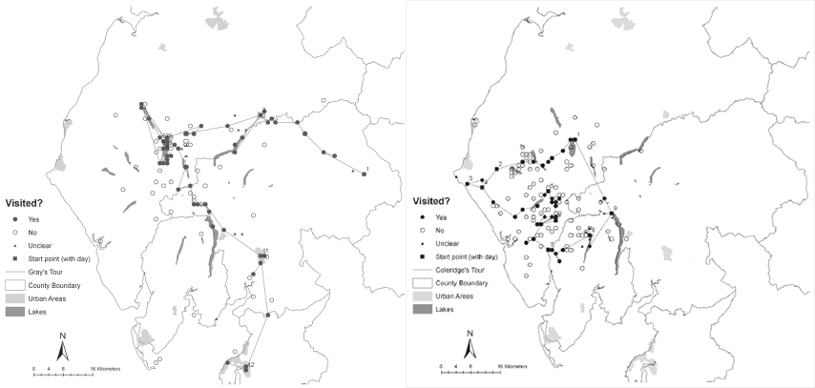
[Insert Figure 1 here: Maps of Gray’s (left) and Coleridge’s (right) tours through the Lake District (Gregory and Cooper 2009); reproduced with the authors’ permission.]

Significantly, these divergent patterns point up a number of the key differences between Gray’s and Coleridge’s excursions. Gray’s tour was a fifteen-day trip by coach and horseback from Brough to Lancaster via the lakes of Ullswater, Derwentwater, Thirlmere and Windermere. Coleridge’s tour, by contrast, was a nine-day odyssey taken on foot from his house in Keswick to the coastal village of St Bees, and thence famously over Scafell Pike to Eskdale and Coniston before returning homeward over Dunmail Raise. These contrasting routes indicate crucial differences in touristic attitudes and practices [Cooper and Gregory 2011: 93–95]. Gray’s account, though famously one of the earliest documents of its kind, exemplifies many of the tendencies of later picturesque tourism in the Lake District. Gray travelled on coach roads in a planned route that took him through densely populated areas to sites of visual grandeur and beauty. Coleridge, by contrast, was a resident of the Lake District at the time he set off for the western fells, and his irregular route reflected his desire to avoid well-trodden paths. In short, whereas Gray was rather unabashedly what we would call a tourist, Coleridge regarded himself as a traveller [see Buzard 1993] [Cooper 2012].

2.2 Enhancing the study of historical travelogues through spatial analysis

In using GIS to ground these interpretations, the study completed by the “Mapping the Lakes” project confirmed that quantitative spatial approaches can play a meaningful role in the qualitative analysis of works of travel writing and topographical literature. Our current research into the implementation of CSA and LCP builds on these results, and it aims to enhance further the use of GIS-based methodologies in literary and cultural-historical scholarship. Our contention is that methods such as CSA and LCP can enable researchers to move beyond merely schematic point-based mapping techniques and towards spatial methodologies that are sensitive to the fact that places are characterised by much more than their geographic location.
As the map displayed in Figure 1 indicates, the “Mapping the Lakes” project used straight lines to represent the itineraries of Gray’s and Coleridge’s Lake District tours. Although this “connect-the-dots” strategy does portray the sequence of places that Gray and Coleridge visited, the geometrical depiction it produces gives us, at best, a superficial understanding of how the physical geography of the Lake District shaped the experiences documented in their accounts. Integrating CSA and LCP, we decided to undertake a more nuanced spatial analysis of a selection of key historical Lake District travelogues. Once again, we decided to focus on Gray’s account, which was composed in 1769 as a series of epistles to his friend Thomas Wharton. But instead of working with Coleridge’s account (which was written more than four decades later), we elected to draw on the accounts of two other writers who toured the Lake District at roughly the same time as Gray did. The first of these writers, again, is Arthur Young, who paid a visit to the Lakes whilst completing an agricultural survey of Northern England in 1768; the second is Thomas Pennant, who passed through the region as part of his tours of Scotland in 1769 and 1772.
Our decision to focus on Gray, Young and Pennant is not, however, solely based on chronology. It is, more significantly, based on the fact that they were the three chief authorities cited in Thomas West’s highly influential A Guide to the Lakes (1778). A foundational work in the history of British tourism, West’s Guide to the Lakes sold through an unprecedented eleven editions and was still being reprinted more than forty years after its initial publication. It was, accordingly, the work through which most late-eighteenth-century and early-nineteenth-century Lake District tourists first encountered Gray, Young and Pennant’s writings about the region. Importantly, however, West’s guide only reproduces portions of each of these writer’s accounts of the Lake District and thus only gives a partial glimpse of the geographies of their Lakeland tours. In using LCP and CSA to investigate Gray, Young and Pennant’s accounts of the Lake District, then, our aim was to achieve a better understanding of the experience of Lake District travellers in the era before the region was popularised by the works of writers such as West. More broadly, our objectives in spatially analysing the tours of these three writers were threefold:
1. In the first place, we wanted to assess the extent to which the Lake District’s topography conditioned Gray, Young and Pennant’s accounts by determining the degree to which the places each writer records having visited either corresponds to or deviates from the corridors formed by the natural contours of the region’s terrain.
2. In the second place, our object was to compare Gray, Young and Pennant’s accounts in order to ascertain whether they collectively or individually favoured particular parts of the Lakeland region, and (whenever a preference for a particular place or type of place could be discerned) to assess the reason for the writers’ attraction to specific locations.
3. Finally, our goal was to employ GIS technology to create not only more accurate visualisations of the routes Gray, Young and Pennant followed, but also to examine the spatial relationship between these and places that were mentioned in these accounts, but were not visited.

3. Simulating and analysing Gray, Young and Pennant’s tours

3.1 Workflow and methodology

We shall proceed to explain the use of CSA and LCP momentarily. Before we do, however, we will first summarize succinctly the steps we took to meet each of our three objectives. The first step in this process was to create a GIS-readable version of the tours documented in Gray, Young and Pennant’s accounts of the Lake District, and this itself involved several stages. First of all, we had to digitise the portions of each writer’s account that dealt with the Lakeland region. This gave us a set of text extracts comprising [Gray 1775, 350–79][Young 1770, III, 117–196][Pennant 1771, 216–20][Pennant 1774, 23–71]. Once we had prepared these extracts, we read them individually to identify and to record every place-name reference each extract contained. These place-names were then manually coded using XML and divided into groups to distinguish the places and landmarks that the writers visited from those they mentioned but did not visit. The places and landmarks tagged as having been visited were then arranged sequentially in a table to form an itinerary for each account. Once tagged, annotated and arranged in this manner, the place-names were geo-referenced using coordinate data from the Old Cumbria Gazetteer [Norgate and Norgate 2012]. The fully georeferenced dataset was then uploaded into ArcGIS. This dataset represents the geographic information contained in Gray, Young and Pennant’s accounts as isolated points on the Lakeland landscape; however, it also provides a platform for performing more sophisticated forms of geographical analysis (such as CSA and LCP) in order to explore these accounts as records of movement through that landscape.
In order to achieve our first objective, we used CSA and LCP to simulate the natural corridors, determining the most efficient route for travelling over the terrain taking into account the relief of the Lake District’s topography. We then implemented a spatial proximity test in order to assess whether the places in itineraries we had extracted from Gray, Young and Pennant’s accounts were closer to the natural corridors formed by the region’s topography than would be expected by chance alone. Performing this test allowed us to ascertain the relative accessibility of the places each writer decided to visit. In order to achieve our second objective, we simulated the routes most likely taken by the three writers according to the places they visited. Taking the journeys of the three authors into account, we then employed a Line Density Analysis (LDA) to identify the most frequented routes in order to determine whether there was a preponderance of attention given to any particular area or region. Finally, in order to achieve our third objective, we carried out another spatial proximity test. In this instance, however, we analysed the spatial relationship between the simulated pathways and those places that were mentioned in Gray, Young and Pennant’s accounts, but which were not actually sites these travellers visited.

3.2 CSA and LCP

The use of CSA and LCP is well established in the applied sciences [Collischonn and Pilar 2000][Yu et al. 2003][Adriaensen et al. 2003][Atkinson et al. 2005][González and Sergel 2007][Howey 2007][LaRue and Nielsen 2008][Wang et al. 2009]. But this is the first time that these methods have been used in Humanities research to analyse the journeys recorded in historical travelogues. Admittedly, there are limitations to employing the geospatial models that CSA and LCP create to study the accounts of historical travellers. Methods such as CSA and LCP are ideal for measuring the degree to which the routes taken by travellers correlate with the contours of the terrain those travellers are traversing. CSA and LCP do not, however, offer much in the way of insight about those traveller’s attitudes towards the landscape through which they are moving or about the ideas they form while moving through it. As GIS-based methods, CSA and LCP rely on computational processes for which quantification is a prerequisite, and much of the information contained in works of travel writing (including feelings, sensations, and intuitions) is not necessarily quantifiable. Such limitations notwithstanding, CSA and LCP can contribute meaningfully to our understanding of historical works of travel writing and topographical literature. In particular, CSA and LCP can assist us with visualising the journeys such works describe, and they can alert us to geographical patterns that are not otherwise readily discernible. In sum, then, these methods are not a substitute for interpretation; rather, they are an aid for guiding critical inquiry and facilitating research.
CSA is a spatial methodology that allows one to determine the “cost” of travelling over a surface by considering not only Euclidean space, but also more complicated factors, such as slope and elevation. In other words, instead of limiting us to the examination of the Cartesian spatial properties of the data, it allows us to consider additional factors such as the contours of the terrain, as well as other variables (such as boundaries and borders) which influence how one moves through the landscape [Murrieta-Flores 2010, 2012]. The first step in creating a cost surface model in a GIS environment involves using a Digital Elevation Model (DEM), which is a raster image that represents the topography of the surface of the earth. Raster images, like DEMs, are similar to digital pictures; they are composed of pixels (or, more properly, cells) to which attribute information has been assigned. In digital pictures, this attribute information typically assigns a colour or shade to each cell. In a DEM, however, the attribute information assigned to each cell relates to the elevation of the portion of the earth’s surface which that cell represents (Figure 2).
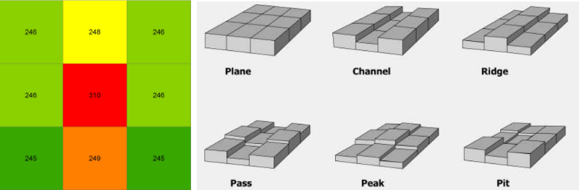
[Insert Figure 2 here: Representation of morphometric types of the terrain in a DEM (after Wood 1996, 112); the information in each cell of the raster image assigns that cell an elevation.]

The second step in performing CSA is to establish the associated cost of traversing the terrain and any impediments (such as rivers or bodies of water) it might contain. This is accomplished by creating a friction surface. Like DEMs, friction surfaces are raster images. In a friction surface, though, the cells that comprise the image contain information about the variables that influence the amount of effort it would take to travel across the terrain being represented. There are several cost functions that can be used to create a friction surface and to derive friction values [Herzog 2010]. The variables used in these functions can take a variety of different costs into account, such as the mode of transportation being used, the type of surface being crossed and the slope of the terrain [Fairén Jiménez 2004][Fairén Jiménez et al. 2006][Fiz and Orengo 2008][Frachetti 2008][Wheatley et al. 2010][Murrieta-Flores 2012][Yubero et al 2015]. These variables can also account for values based on other costs, such as the amount of weight the traveller is carrying or the speed at which the traveller is moving. The values of such costs are stored in each cell of the friction raster map, which is accordingly used to calculate the relative cost of traversing the terrain (Figure 3).
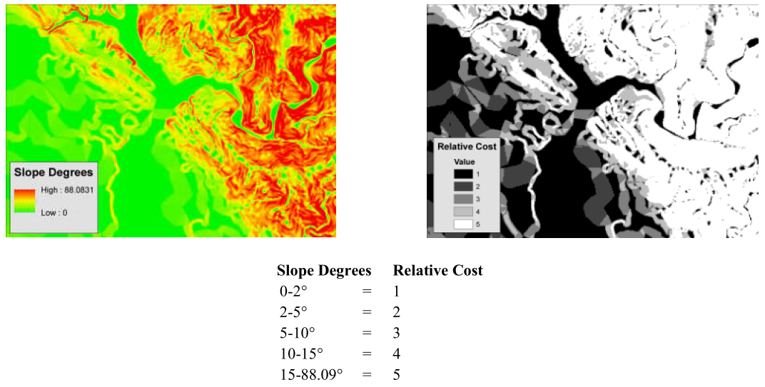

[Insert Figure 3 here: Example of slope surface reclassified into a friction surface depicting a cost from 1 (easy) to 5 (difficult) for traversing the terrain represented.]

The third step in performing the CSA is to derive from the friction surface, a final cost surface. This is done by calculating the cost of traversing the terrain from a source cell or point of origin. This source cell acts as a node from which to begin calculating the cumulative value of traversing the terrain. In this process, the adjacent cell with the lowest cost is searched for repeatedly until each of the cells has a cumulative cost value assigned to it [Lee and Stucky 1999]. The result is a raster image called ‘cost surface’ that depicts the cumulative cost of travelling from a source or point of origin to any other location within the terrain represented (Figure 4). This step is performed multiple times to calculate the cost to travel from each location to any part of the landscape, which result in cost surfaces derived for each place investigated in the corpus.
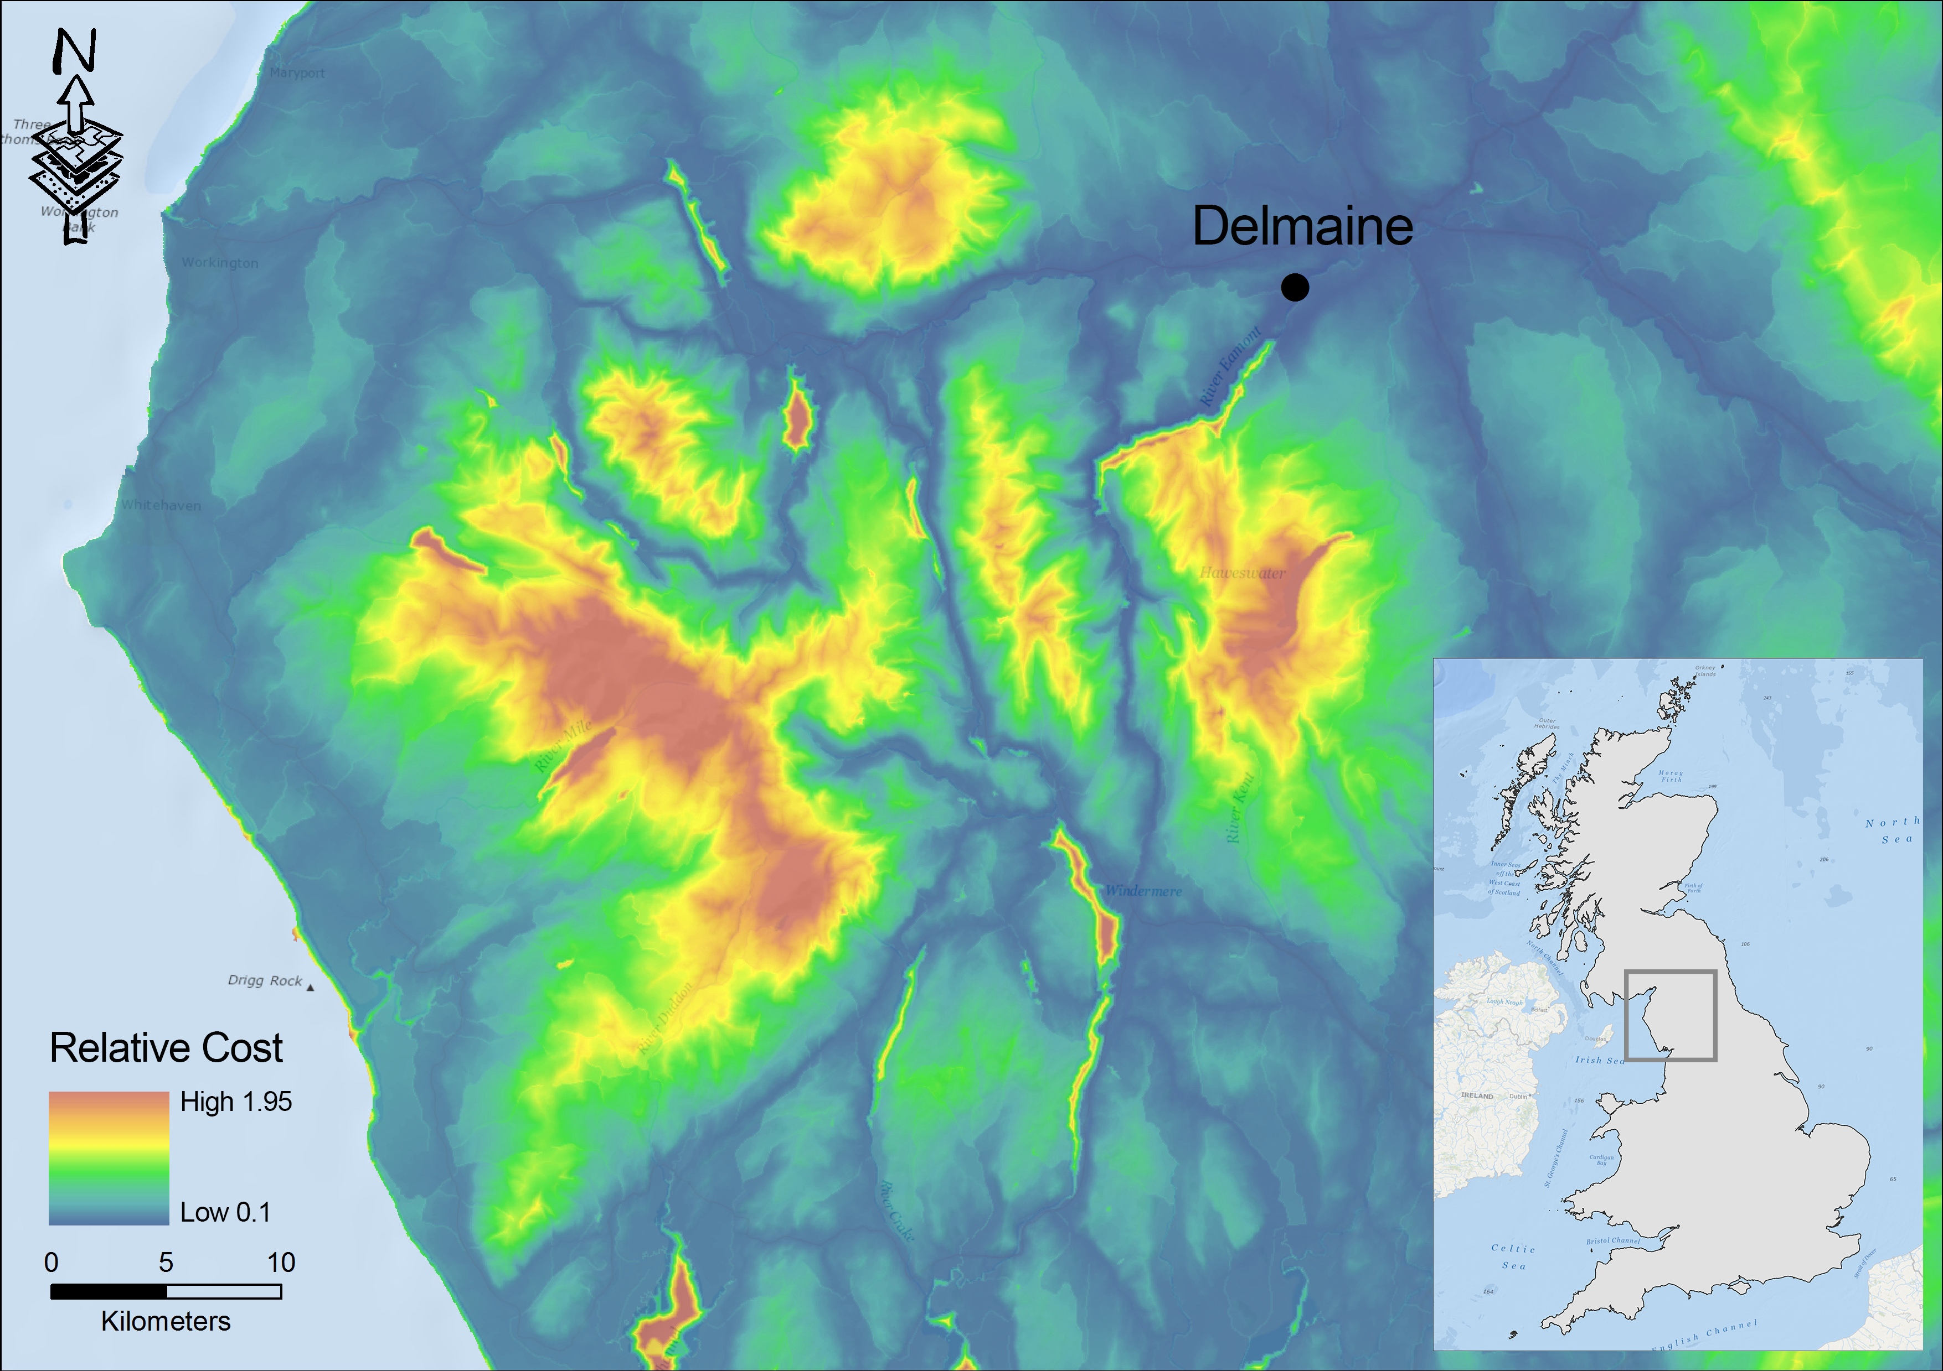[Insert Figure 4 here: An example of cost surface calculated in terms of the cost incurred to reach any place in the Lakeland region from Delmaine; the farther one travels from the node, the greater the cost incurred.]

Once the cost surfaces have been established, one can then proceed with completing LCP. LCP is, essentially, a subsequent set of calculations that determines the path across the cost surface that will cost the traveller the least. The GIS is instructed to create a path across the cost surface following the adjacent cell with the lowest value assigned.

3.3 Implementing CSA and LCP

As with the cost surface, the paths that result from performing LCP analysis are dependent on the cost variables that were used to create the model. For the purposes of this case study, we created two anisotropic models using ArcGIS. Anisotropic models account for the direction of movement in the calculation of the cost, whereas isotropic models do not. It should be noted that for each of our experiments we made use of LCP, and that we created two different models in order to meet our objectives. In order to avoid confusion, when we discuss the results related to our first objective, we shall use the expression ‘natural corridors’ to indicate those paths for which a model was designed to identify the least cost paths for the whole region. When we discuss the results related to our second and third objectives, we shall refer to either ‘simulated pathways’ (or ‘simulated itineraries’) in order to describe the model that was designed to calculate the least cost paths for each of the authors’ tours.

3.3.1 Objective One: The influence of topography

In order to investigate the degree to which the Lake District’s topography may have conditioned the itineraries of Gray, Young and Pennant’s tours, we calculated the least cost paths between the places each author visited. We accounted for three variables in these calculations: 1. the slope of the region’s terrain; 2. the presence of bodies of water; 3. the direction in which Gray, Young and Pennant were each travelling (Figure 5). We then carried out a statistically based spatial proximity test in order to assess the spatial relationship between the places Gray, Young and Pennant visited and the Lake District’s topography. For this, we created a distance index for the accounts of each writer by calculating buffers of 500m from the natural corridors and then counting the number of visited places within each buffer (Figure 6). We then used this data to perform a statistical significance test (Kolmogorov-Smirnov). Our goal was to test whether the places Gray, Young and Pennant visited were closer to the natural corridors than one would expect by chance alone. The significance level set to test the null hypothesis was 0.01, and in all cases it was rejected. As noted above, our goal here was to ascertain the degree to which Gray, Young and Pennant were influenced by a logic of optimality in their journeys: in other words, how closely they followed the natural corridors of the terrain. This suggests that Gray, Young and Pennant did generally follow the natural corridors of the Lake District in their journeys and, accordingly, either that they were able to read the contours of the landscape successfully or, at least, that they were well informed about the most efficient ways to move between the locations through which they travelled.
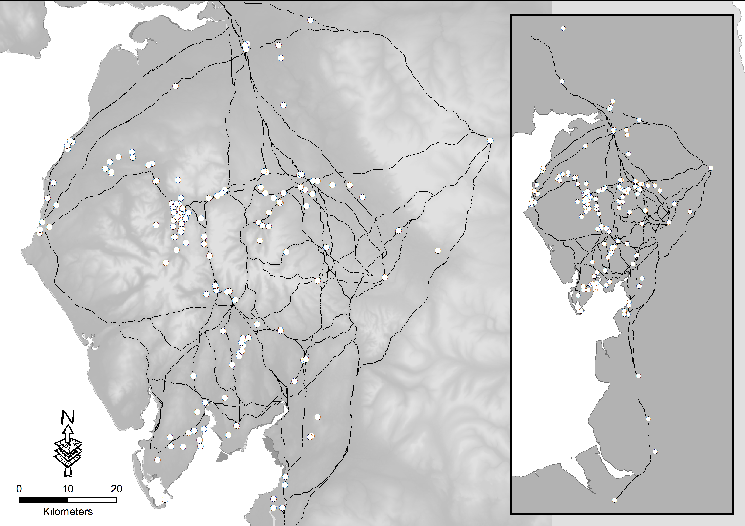
[Insert Figure 5 here: A map of the natural corridors of the region calculated with LCP in GIS and places visited by Gray, Young and Pennant.]
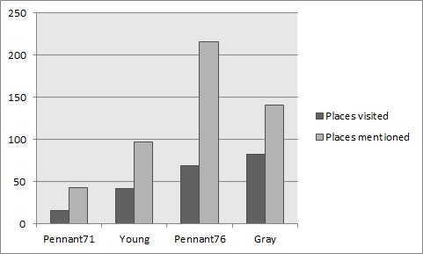
[Insert Figure 6 here: A graph displaying the number of places visited by distance from the natural corridors; the figures summarised here indicate that most of the places Gray, Young and Pennant visited are located either along or near the least cost paths.]

3.3.2 Objective Two: The influence of specific places

Having thus satisfied the first of our three objectives, we then proceeded to determine the extent to which Gray, Young and Pennant emphasised specific portions of the Lake District in their tours. In order to do this, it was necessary to construct simulations of the journeys documented in their accounts. We built these simulations by using each of the places in the itineraries we created for each writer as nodes, and then by using cost surface analysis to calculate the least cost path between them, following the order in which they were visited (Figure 7). After we calculated least cost paths for each account, we then performed a LDA, which allowed us to identify those parts of the landscape through which each of the writers were likely to pass most frequently (Figure 8). Performing these analyses indicates that, collectively, Gray, Young and Pennant spent a significant amount of their time in the Lake District travelling around the lakes of Windermere, Ullswater and Derwentwater. We will offer additional commentary about these findings in the following section. But before concluding, though, it is worth noting that in addition to examining the locations Gray, Young and Pennant visited, we also performed an analysis on the places they mentioned but did not visit.
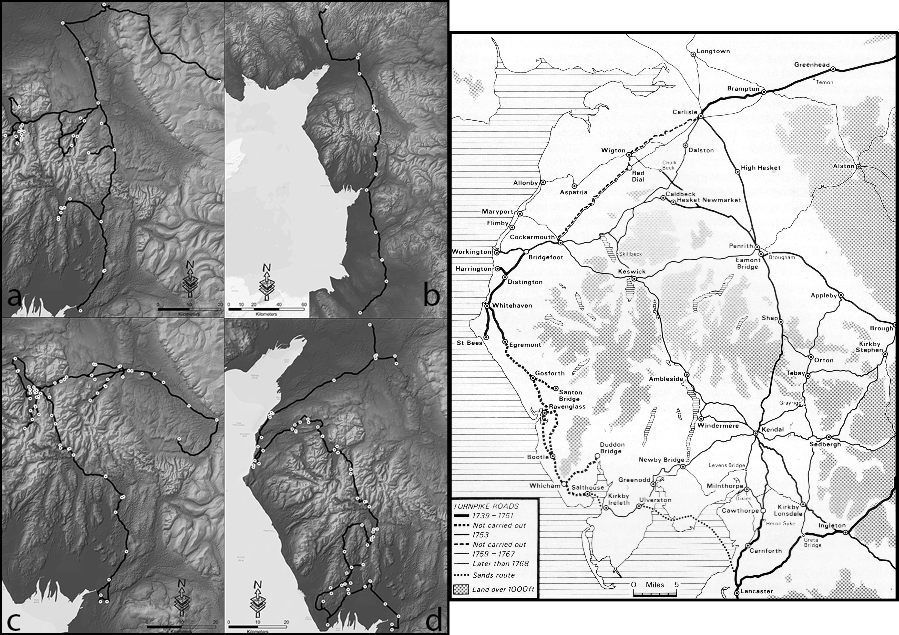
[Insert Figure 7 here: LCPs calculated from the itineraries of a) Young, b) Pennant 1771, c) Gray, and d) Pennant 1774 during their tours. To the right is a map displaying the road network through the Lake District in the18th century (after Hindle 1984; Figure 6.2); reproduced with permission of the author.]
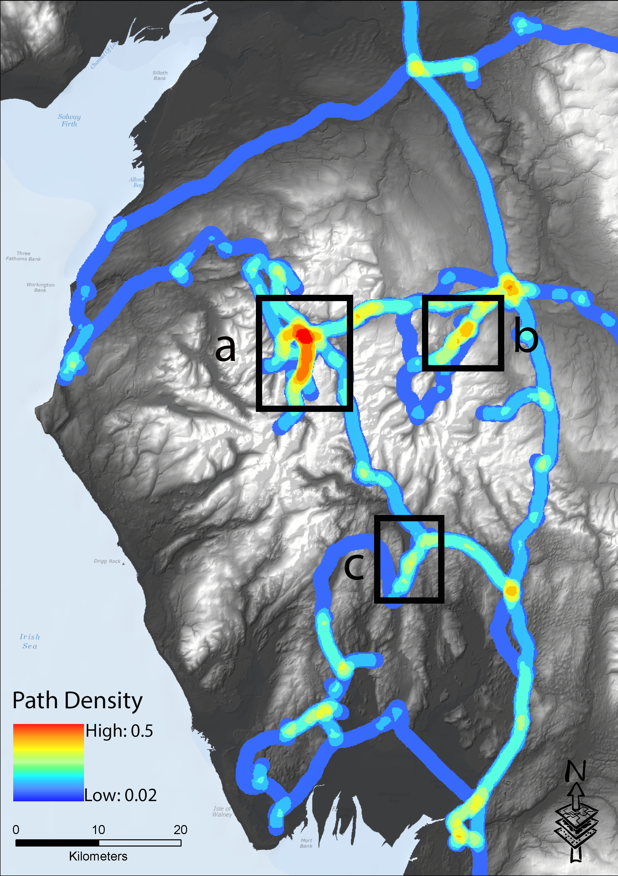
[Insert Figure 8 here: LDA of all LCPs calculated; the key areas marked are a) Derwentwater, b) Ullswater, and c) Windermere.]

3.3.3 Objective Three: The function of places mentioned, but not visited

Our intention, in this case, was to determine the role played by these places in the travel narratives presented in Gray, Young and Pennant’s accounts. Accordingly, after we identified all the places in the four accounts that were mentioned but not visited, we then carried out another spatial proximity test. This time, the distance index for each writer was calculated with buffers of 1 km created from the itineraries simulated and the statistical test was also set to a significance level of 0.01. Our intention was to assess the degree to which the representation of the Lake District in each account was influenced by the places Gray, Young and Pennant visited and the degree to which it was influenced by places that they mentioned but did not visit. The results of this test indicate that the places mentioned but not visited in Gray and Young’s accounts, and in Pennant’s account of his tour of 1772, are closer to the routes they these writers followed than one would expect by chance alone. When it came to Pennant’s account of his 1769 tour, however, the null hypothesis could not be rejected. As we explain below, this result clues us into an important aspect of how Pennant’s 1769 tour stands apart from the other texts assess in this experiment.

4. Analysis and interpretation

We believe that the methods outlined above can facilitate more detailed analyses of how the records of historical travellers were shaped by the contours of the landscapes through which they travelled. What is more, to the degree that we accept those travellers’ accounts as accurate descriptions of their journeys, these methods can furnish useful insights into how their accounts were conditioned by factors including the physical geography of the terrain, the existence of roads and tracks, and the availability of specific kinds of transportation. Our first spatial proximity analysis of the relationship between the tours and the Lake District’s natural corridors demonstrates that all the places Gray, Young and Pennant record visiting are nearer to these pathways than would be expected by chance alone (Figure 5). In other words, although these three writers certainly visited a few places that could be considered remote—even adventurous—their itineraries still closely followed the natural corridors of the Lake District. (Indeed, as indicated in Figure 6, most of the places they visited fall within 500 metres of the region’s natural corridors.)
These initial observations assist us in making some basic distinctions about the tours documented by Gray, Young and Pennant. For instance, they help us to discern that of the four accounts, the itinerary Pennant followed during his 1769 tour was the one that most closely adhered to the natural corridors of the region’s topography. Comparatively, Young and Gray strayed farther from the Lake District’s natural corridors. This finding makes sense, since in 1769 Pennant merely travelled along the outskirts of the Lakeland region whilst on his return from Scotland to his Downing estate. In his tour of 1772, Pennant visited other parts of the Lake District, particularly the Cumberland coast. Here again, however, the analysis shows us that, for the most part, he still followed the natural contours of the region’s terrain.
Beyond facilitating such basic distinctions, the spatial proximity analysis we conducted also helps us to perceive the correspondence between the Lake District’s natural corridors and the routes that were present at the time Gray, Young and Pennant paid their visits to the region. Inasmuch, this analysis enables us to discern that, without exception, all three writers primarily relied on local carriage roads and turnpikes in their travels. At first glance this may seem a minor point, but it is of significant importance. Scholars [Andrews 1989][Ousby 1990][Powell and Hebron 2010] have long credited the accounts of early Lakeland travellers, such as John Dalton and George Smith, with attracting tourists to the region. At the same time, however, these scholars have generally paid less attention to how the improvement of local roadways during the 1750s and 1760s influenced the places to which those tourists were attracted. Brian Paul Hindle, one of the few historians to devote substantial attention to the early history of turnpikes in the Lake District, has observed that the influence of these improvements was twofold. They not only established standard routes that afforded swifter and safer access to several of the region’s main settlements (including Kendal, Keswick, Carlisle, Lancaster and Penrith), but also, in doing so, distinguished the places connected by, or at least visible from, these routes as the sites most worthy of the tourist’s attention [Hindle 1998, 147–77][Bouch et al. 1961, 277–83][Williams 1975].
Accordingly, turning to Figure 8, it makes sense that the parts of the landscape through which Gray, Young and Pennant passed most frequently are located in the eastern half of the region (generally speaking, around the lakes of Ullswater, Derwentwater and Windermere), since these were the sites around which the majority of road improvements occurred. Incidentally, this also helps to explain why neither Gray nor Young nor even Pennant—who travelled through much more of Cumberland—set foot in the western valleys of Wasdale and Ennerdale. Although turnpike acts were passed to improve access to this area in 1750 and 1762, the roads in this remote part of the country remained in disrepair well into the nineteenth century [Hindle 1998, 154][Hodge 1957, 67]. Indeed, whereas West, writing in 1778, could confidently declare that the roads throughout the Lake District had been ‘much improved since Mr. Gray made his tour in 1765 [sic], and Mr. Pennant his in 1772’, as late as 1821 West’s guidebook (then in its eleventh edition) still cautioned tourists that the roads leading to Ennerdale and Wasdale were, as yet, unimproved [West 1778, 2][West 1821: 141]. Roads, in this way, can be seen to have exerted a decided influence over the cultural construction of the Lake District in the eighteenth century: they determined not only which portions of the Lakeland region travellers visited, but also the perspectives those travellers were afforded and, therefore, the descriptions of the region set down in their accounts.
So, in the first instance, Figure 7 shows us that Gray, Young and Pennant chiefly went where the local carriage routes and turnpikes enabled them to go. But how, we might ask, did those roadways shape their impression of the places through which they passed? Cultural historians have often remarked, with due amusement, that tourists in the late 1700s moved from scenic vista to scenic vista, collecting sensations in much the same way that modern tourists collect snapshots and souvenirs. Significantly, however, cultural histories of the Lake District tend to quote passages from eighteenth-century travelogues and guidebooks without commenting on the material conditions that determined the writer’s point of view. Thus, whereas Gray’s panoramic description of Grasmere’s ‘peace, rusticity, and happy poverty’ [1775, 365] is regularly cited as an archetypal display of picturesque sentiment, few scholars have noted that the poet’s perspective of the town was determined by his having first seen it from the road over Dunmail Raise on a sunny autumn afternoon. This is precisely the sort of empirical detail to which reading the tours of Gray, Young and Pennant in relation to visualisations such as the one displayed in Figure 9 helps to alert us. The following examples, from Young’s and Pennant’s accounts of the journey over Shap Fell on the Heron Syke-Eamont Bridge turnpike, help to develop this point further:

Twelve of the fifteen miles from Shapp to Kendal are a continued chain of mountainous moors, totally uncultivated; one dreary prospect, that makes one melancholy to behold. [Young 1770, III, 169]

Pass over Shap Fells, more black, dreary, and melancholy, than any of the Highland hills, being not only very barren but destitute of every picturesque beauty. This barren scene continued till within a small distance of Kendal[.] [Pennant 1771, 219]

When read in isolation, these two passages might seem simply to reflect the late-eighteenth-century vogue for sensational landscape description. When we turn to the map, however, we begin to discern that they are as much shaped by the aesthetic conventions of their era as they are by the situation of the roadway that Young and Pennant followed. With a peak elevation of some 445m above sea level, the route of the old turnpike between Shap and Kendal is notorious for its isolation, exposure and poor weather [Hindle 1998, 157]. (Even today the M6 at Shap, which rises to only some 315m, is considered one of the highest and most treacherous stretches of road in the UK.) It comes as little surprise, then, that Young and Pennant found the landscape around Shap desolate and oppressive.
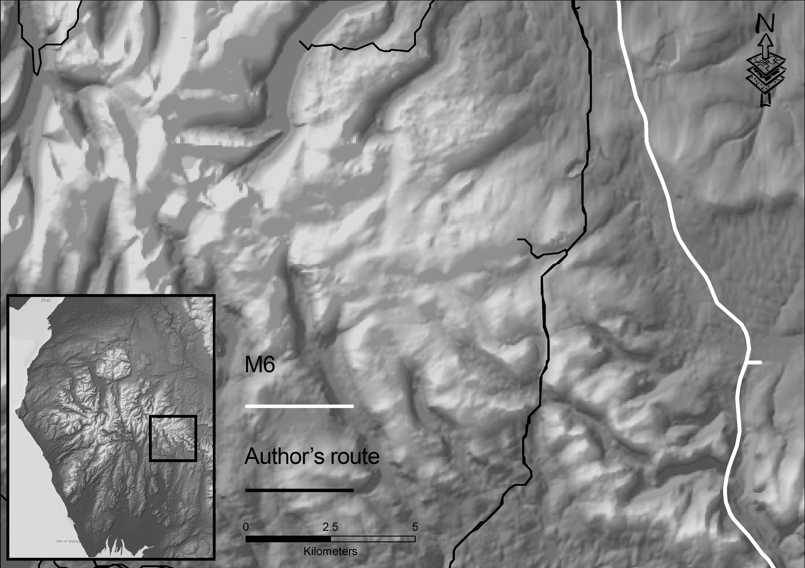[Insert figure 9 here: The route Gray, Young and Pennant followed over Shap Fell and the route of M6.]

This is one of the benefits of using spatial models to study historical works of travel writing and topographical literature: it obliges us to examine local descriptions within the broader geographic context of the traveller’s experience. Rather than thinking in terms of isolated places, the models we have developed emphasize that these writers were describing journeys from place to place. In doing so, these models help remind us that the experience of travelling in the Lake District in the late eighteenth century was not always pleasurable, but that it imposed upon the body in other ways, through the jolts of deep wheel ruts, the hazards of unpaved roads, the exposure to the wind and the rain and the mud. The fact that Gray, Young and Pennant take the time to record these details alongside the various scenes they encounter indicates the importance of the experience of travel in eighteenth-century travel writing and topographical literature. Young in fact goes so far as to include an appendix in the final volume of his Six Months’ Tour, recording the condition of each stretch of road he travelled—often in exasperated detail. Hence, his damning account of the turnpike from Preston to Wigan:

I know not, in the whole range of language, terms sufficiently expressive to describe this infernal road… let me most seriously caution all travellers, who may accidentally purpose to travel this terrible country, to avoid it as they would the devil; for thousand to one but they break their limbs by overthrows or breakings down. They will here meet with rutts [sic] which I actually measured four feet deep, and floating with mud only from a wet summer; what therefore must it be [like] after a winter? … These are not merely opinions, but facts, for I actually passed three carts broken down in these eighteen miles of execrable memory. [Young 1770, IV, 180–81]

Carrying out a spatial analysis to obtain a more precise visualisation of the routes writers like Young might have followed helps put these sorts of commentaries into context.
In addition, the other GIS-based methods we employed allow us to analyse the role that particular places play in the geographies represented in Gray, Young and Pennant’s accounts. For instance, by examining whether the places that were mentioned but not visited in these accounts have a significant spatial relationship with the paths simulating the itineraries of Gray, Young and Pennant, we can assess how the routes they travelled might have influenced the perception of the places and geographies recorded in their tours. The results of the statistical significance test indicate that places mentioned but not visited in Gray and Young’s account, and in Pennant’s 1769 tour, are closer to the routes than one would expect as a matter of chance alone (Table 1). In the case of Pennant’s 1772 tour, however, the null hypothesis could not be rejected, indicating that there appears not to be a significant relationship between the places mentioned but not visited in his account and the simulated pathway we created from it.
This result is significant because it confirms how working with quantitative research techniques can clue us into the qualitative differences between historical works of travel writing. Specifically, it clues us into the fact that whereas Gray and Young’s account, and Pennant’s second account, are all accounts of journeys into the Lake District, Pennant’s first account is actually only an account of a journey that passed by Lake District. As mentioned above, in his first tour, Pennant simply travelled down the turnpikes linking Carlisle, Kendal and Lancaster on his way home from the Highlands. His account of the Lake District in the account he published in 1771 was, therefore, extremely cursory and only made reference to a few famous local places, most of which lay outside his line of travel. Significantly, however, Pennant returned to the region a few years later to view, as he expressed it in his memoirs, ‘those parts of Lancashire, Westmoreland, and Cumberland, which I had not before seen’ [Pennant 1793, 16]. In this second tour (which was published in 1774) Pennant travelled through the Lake District in a manner similar to Gray and Young—hence, the statistical similarity between these three accounts.
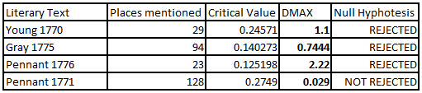
[Insert Table 1 here: Results from the Kolmogorov-Smirnov test assessing the relationship between places only mentioned and the itineraries of the authors.]

Conducting this statistical test, then, enables us to draw a meaningful distinction between the four works in our case study. More generally, it prompts us to think critically about the role that places that were mentioned but not visited plays within each tour. That each of the four works contains references to such places indicates that the accounts of Gray, Young and Pennant are more than mere itineraries; rather, they are descriptive records that attempt to broaden the reader’s awareness of the geography of the Lake District, which was still a relative terra incognita during the late eighteenth century. The fact that each account contains references to places that the writers did not actually visit suggests Gray, Young and Pennant all endeavoured to give their readers a sense of the surrounding countryside. In fact, when one turns back to the works themselves, one begins to see that the place-names that are mentioned but not visited are often invoked in panoramic descriptions. Thus, for example, Pennant’s account of the mountains visible from the ramparts of Carlisle castle [Pennant 1771, 217]:

The castle is ancient, but makes a good appearance at a distance: the view from it is fine, of rich meadows, at this time covered with thousands of cattle, it being fair-day. The Eden here forms two branches, and insulates the ground; over one is a bridge of four, over the other one of nine arches. There is besides a prospect of a rich country, and a distant view of Cold-fells, Cross-fells, Skiddaw, and other mountains.

Elsewhere, one finds that place-names that are mentioned but not visited are also invoked in descriptions of trade, manufacturing and shipping. In these instances, the place-names are typically used to situate the industrial centres of the Lake District in relation to the economic geography of the nation. Hence, Pennant’s observation [Pennant 1771, 217] that salmon from the River Eden are shipped to the markets in Newcastle and London, or, similarly, his later explanation of how Ulverston is connected, via Liverpool, with the slave trade [Pennant 1774, 29]:

Ulverston, a town of about three thousand souls, seated near the water side, and is approachable at high water by vessels of a hundred and fifty tuns [sic]; has a good trade in iron ore, pig and bar iron, bark, lime-stone, oats and barley, and much beans, which last are sent to Leverpool [sic], for the food of the poor enslaved negroes in the Guinea trade. Numbers of cattle are also sold out of the neighborhood, but the commerce in general declines; at present there are not above sixty vessels belonging to the place; formerly about a hundred and fifty mostly let out to freight; but both master and sailors go now to Leverpool for employ.

Significantly, one finds similar passages in Arthur Young’s account, which was in large part a survey of agricultural productivity. Consider, for example, his account of the wool market in Kendal, where he uses place-names to refer to specific market centres as well as to specific breeds of sheep [Young 1770, III, 171]:

The wool they use is chiefly Leicestershire, Warwickshire, and Durham: They generally mix Leicestershire and Durham together. The price 8d. 9d. and 10d. per lb. They send all the manufacture to London by land carriage, which is said to be the longest, for broad wheel wagons, of any stage in England.

These observations, when viewed alongside the results from the second spatial proximity analysis, suggest that places that are mentioned but not visited played a number of important roles within the broader associative geographies of each text. They are invoked not only to describe the surrounding countryside, but also to document how places throughout the greater Lakeland region connect geographically, socially and economically with the wider world.

5. Conclusions

Although the use of spatial analysis in Humanities disciplines such as Literary Studies is still at an early stage, the application of geospatial technologies, such as GIS, has already begun to have a profound influence on the way literary scholars and historians approach the study of space, place and landscape. By implementing the geospatial methods employed in this study, for example, researchers can achieve new insights not only into the cognitive construction of geographies in literary works, but also into “fuzzier” phenomena, such as geographies of absence: places that are not specifically mentioned in a literary work, but nonetheless form part of its implied geography. In addition, the introduction of approaches such as Geographical Text Analysis [Leidner 2008][Martins 2009][Gregory and Cooper 2009][Andogah 2010][Buscaldi 2010][Gregory and Hardie 2011][Rupp et al. 2013][Murrieta-Flores et al. 2015][Porter et al. 2015][Gregory and Donaldson 2016] has resulted in significant improvements in the automated extraction of geographical information from works of literature for the purposes of spatial analysis. As scholars in Literary Studies continue to adopt new computational methods, a growing number of researchers are also embracing GIS techniques to extract, examine and explore the spatial relationships embedded not only in works of non-fiction (such as those analysed above), but also in works of creative fiction as well as poetry and drama [Bushell 2016][Murrieta-Flores and Howell 2017].
The application of GIS technology in Literary Studies represents an important development. Until recently, however, little has been done to implement more creative approaches to mapping a writer’s movement through space. Advancing from point-based representations to the analysis of raster-based pathways is, therefore, a major step forward in the application of spatial technologies for studying works of travel writing and topographical literature. Such works of are, after all, not merely descriptive inventories of places, monuments and buildings; they are narratives that offer first-hand accounts of the journeys of specific individuals. In order to visualise such works adequately we must employ techniques that are capable of representing the places they mention not as discrete locations, but as a series interconnected points along the line of transit that constitutes the narrator’s tour. As noted at the beginning of this article, is only by assessing works of travel writing as journeys that we can understand how the writers of those works encountered the places and landmarks they described. Thus, with respect to Gray, Young and Pennant, it is only by tracing their journeys through the Lake District that we can hope to obtain insights into how the topography of the region—with its valleys, peaks and mountain passes—shaped the local experiences recounted in their travelogues.
The implementation of these methods, however, is as yet imperfect. One significant complication is that the data used to create the Digital Elevation Models (DEMs) used to perform CSA and LCP comes from modern sources (Lidar images and/or satellite or aerial photographs). This means that they contain the elevation data of modern roads, motorways and towns. Although the routes followed by eighteenth-century Lake District tourists often correspond to the routes of the modern road networks in Cumbria, in many instances there are significant differences between the two [Hindle 1998, 154–57]. The accuracy of our data could be greatly enhanced by the creation of historical DEMs. This could be accomplished by modifying and integrating to DEMs data from sources such as historical maps. Another important innovation would be the development of spatial models capable of accounting for more variables. The use of different modes of transportation and surfaces based on time instead of relative cost might also furnish new insights into the empirical realities underlying works of travel narratives. Finally, one must remember that the development of CSA models still relies primarily on quantitative variables and that LCP is still based on a rationale of optimality, which is not always applicable to human behaviour. These are all issues that shall need to be addressed as humanities scholars and Geographic Information Scientists develop, extend and refine the application of geospatial technologies in humanities research.
Based on the study on which we have reported in this article, and the examples cited herein, we can confidently conclude that spatial analysis can facilitate more nuanced interpretations of works of travel writing and topographical literature. The process of creating a spatial dataset from the tours of Gray, Young and Pennant alerted us to details that most previous studies have overlooked. The simulations we created using this dataset have, moreover, provided the foundation for our on-going research into experimental forms of digital literary geography, such as using Google Earth to create interactive virtual tours. We believe that studies, such as the one presented here, can be productively combined with other emergent forms of geospatial technology to foster innovative collaboration between researchers in the Humanities and the Geographic Information Sciences.

Acknowledgments
This research was supported by the European Research Council (ERC) under the European Union’s Seventh Framework Programme (FP7/2007-2013) / ERC grant “Spatial Humanities: Texts, GIS, places” (agreement number 283850). Thanks are also due to the Institute for Historical Research and the North East Forum in Eighteenth-Century and Romantic Studies, as well as to audiences at conferences at the University of Oxford and Lancaster University.

References
[Adriaensen et al. 2003] Adriaensen, F., Chardon, J.P., De Blust, G., Swinnen, E., Villalba, S., Gulinck, H., and Matthysen, E. The application of ‘least-cost’ modelling as a functional landscape model. Landscape and Urban Planning, 64 (4), (2003): 233–247.

[Aldenderfer et al. 1996] Aldenderfer, M.S. and Maschner, H.D.G., eds., Anthropology, space, and geographic information systems. New York: Oxford University Press (1996).
[Alves and Queiroz 2013] Alves, D. and Queiroz, I. Studying urban space and literary representations using GIS: Lisbon, Portugal, 1852-2009. Social Science History. 37, (4) (2013): 457-481.
[Anderson et al. 2016] Anderson, J., Orford, S. and Bohata, K. A New Literary Geography: Establishing a Digital Literary Atlas of Wales and its Borderlands, AHRC Research Project <http://gtr.rcuk.ac.uk/projects?ref=AH/N003764/1>
[Anderson and Loxley 2016] Anderson, M. and Loxley, J. The Digital Poetics of Place-names in Literary Edinburgh. In: Cooper, D., Donaldson, C., and Murrieta-Flores, P., eds. Literary Mapping in the Digital Age. Abingdon, UK; New York: Routledge (2016): 47–66. Digital Research in the Arts and Humanities.
[Andogah 2010] Andogah, G. Geographically Constrained Information Retrieval. PhD Thesis, University of Groningen (2010).
[Atkinson et al. 2005] Atkinson, D.M., Deadman, P., Dudycha, D., and Traynor, S. Multi-criteria evaluation and least cost path analysis for an arctic all-weather road. Applied Geography, 25 (4), (2005): 287–307.

[Bodenhamer et al. 2010] Bodenhamer, D.J., Corrigan, J., and Harris, T.M., eds. The spatial humanities: GIS and the future of humanities scholarship. Bloomington: Indiana University Press (2010).

[Bodenhamer et al. 2013] Bodenhamer, D.J., Harris, T.M., and Corrigan, J. Deep Mapping and the Spatial Humanities. International Journal of Humanities and Arts Computing, 7 (1-2) (2013):170–175.

[Bodenhamer et al. 2015] Bodenhamer, D.J., Corrigan, J., and Harris, T.M., eds. Deep Maps and Spatial Narratives. Bloomington: Indiana University Press (2015).

[Bouch and Gwilyn 1968] Bouch, Charles M. L, and Gwilym P Jones. A Short Economic and Social History of the Lake Counties: 1500-1830. Manchester: Manchester Univ. Press, 1968.

[Buscaldi 2010] Buscaldi, D. “Toponym Disambiguation in Information Retrieval.” PhD Thesis, Universidad Politecnica de Valencia, (2010).

[Bushell 2016] Bushell, S. Mapping Fiction: Spatialising the Literary Work. In: Cooper, D., Donaldson, C., and Murrieta-Flores, P., eds. Literary Mapping in the Digital Age. Abingdon, UK; New York: Routledge (2016): 125–46. Digital Research in the Arts and Humanities.
[Buzard 1993] Buzard, J. The Beaten Track: European Tourism, Literature, and the Ways to Culture, 1800-1918. Oxford, UK; New York: Oxford University Press (1993).

[Collischonnand Pilar 2000] Collischonn, W. and Pilar, J.V. A direction dependent least-cost-path algorithm for roads and canals. International Journal of Geographical Information Science, 14 (4), (2000): 397–406.

[Conolly and Lake 2006] Conolly, J. and Lake, M. Geographical information systems in archaeology. Cambridge, UK; New York: Cambridge University Press (2006).

[Cooper and Gregory 2011] Cooper, D. and Gregory, I.N. Mapping the English Lake District: a literary GIS: Mapping the English Lake District. Transactions of the Institute of British Geographers, 36 (1), (2011): 89–108.

[Cooper 2012] Cooper, D. Critical Literary Cartography: Text, Maps and a Coleridge Noebook. In: Roberts, L. ed. Mapping Cultures: Practices, Places, Performances. Houdsmills, UK: Palgrave Macmillan (2012): 29–52.

[Cooper et al. 2016] Cooper, D., Donaldson, C., and Murrieta-Flores, P., eds. Literary Mapping in the Digital Age. Abingdon, UK; New York: Routledge (2016). Digital Research in the Arts and Humanities.

[Donaldson, Gregory and Murrieta-Flores 2015] Donaldson, C., Gregory, I.N., and Murrieta-Flores, P., 2015. Mapping ‘Wordsworthshire’: A GIS Study of Literary Tourism in Victorian Lakeland. Journal of Victorian Culture, 20 (3), (2015): 287–307.

[Fairén Jiménez 2004] Fairén Jiménez, S. Movilidad y territorialidad. El poblamiento neolítico en las comunidades centro-meridionales Valencianas. Saguntum, (36),( 2004): 23–34.
[Fairén Jiménez, Cruz Berrocal, López Romero, and Walid Sbeinati 2006] Fairén Jiménez, S., Cruz Berrocal, M., López Romero, E., and Walid Sbeinati, S. Las vías pecuarias como elementos arqueológicos. In: I. Grau Mira, ed. La aplicación de los SIG en la arqueología del paisaje. San Vicente del Raspeig: Universidad de Alicante (2006).

[Fiz Fernández and Orengo, 2008] Fiz Fernández, I. and Orengo, H. Simulating communication routes in Mediterranean alluvial plains. In: International Conference on Computer Applications and Quantitative Methods in Archaeology, A. Posluschny, K. Lambers, and I. Herzog, eds. Layers of perception: proceedings of the 35th International Conference on Computer Applications and Quantitative Methods in Archaeology (CAA); Berlin, Germany, April 2-6, 2007. Bonn: Habelt, (2008): 316–321.

[Fotheringham, Brunsdon, and Charlton 2000] Fotheringham, A.S., Brunsdon, C., and Charlton, M. Quantitative geography: perspectives on spatial data analysis. London; Thousand Oaks, Calif: Sage Publications (2000).

[Frachetti 2008] Frachetti, M.D. Variability and dynamic landscapes of mobile pastoralism in ethnography and prehistory. In: H. Barnard and W. Wendrich, eds. The archaeology of mobility: old world and new world nomadism. Los Angeles: Cotsen Institute of Archaeology, University Of California, (2008): 366–396.

[Giraldi, Ferlan, and Romeo 1976] Giraldi, T., Ferlan, I., and Romeo, D. Antitumor activity of equinatoxin. Chemico-Biological Interactions, 13 (3-4), (1976): 199–203.

[Gonzales and Gergel 2007] Gonzales, E.K. and Gergel, S.E. Testing assumptions of cost surface analysis—a tool for invasive species management. Landscape Ecology, 22 (8), (2007): 1155–1168.

[Goodchild, and Janelle, 2010] Goodchild, M.F. and Janelle, D.G. Toward critical spatial thinking in the social sciences and humanities. GeoJournal, 75 (1), (2010): 3–13.

[Gray 1775] Gray, T. The Poems of Mr. Gray, to Which Are Prefixed Memoirs of His Life and Writings. York: H. Hughs (1775).

[Gregory 2003] Gregory, I. A place in history: a guide to using GIS in historical research. Oxford: Oakville, CT: Oxbow; David Brown (2003).

[Gregory, Donaldson, Murrieta-Flores, and Rayson 2015] Gregory, I., Donaldson, C., Murrieta-Flores, P., and Rayson, P. Geoparsing, GIS, and Textual Analysis: Current Developments in Spatial Humanities Research. International Journal of Humanities and Arts Computing, 9 (1), (2015): 1–14.

[Gregory and Cooper 2009] Gregory, I.N. and Cooper, D. Thomas Gray, Samuel Taylor Coleridge and geographical information systems: A literary GIS of two Lake District tours. International Journal of Humanities and Arts Computing, 3 (1-2), (2009): 61–84.

[Gregory and Donaldson 2016] Gregory, I.N. and Donaldson, C. Geographical Text Analysis: Digital Cartographies of Lake District Literature. In: Cooper, D., Donaldson, C., and Murrieta-Flores, P., eds. Literary Mapping in the Digital Age. Abingdon, UK; New York: Routledge (2016): 67–87 Digital Research in the Arts and Humanities.

[Gregory and Hardie 2011] Gregory, I.N. and Hardie, A. Visual GISting: bringing together corpus linguistics and Geographical Information Systems. Literary and Linguistic Computing, 26 (3), (2011): 297–314.

[Gregory and Healey 2007] Gregory, I.N. and Healey, R.G. Historical GIS: structuring, mapping and analysing geographies of the past. Progress in Human Geography, 31 (5), (2007): 638–653.

[Herzog 2013] Herzog, I. Theory and practice of cost functions. In: F. Contreras Cortés, M. Farjas, and F.J. Melero, eds. CAA2010: fusion of cultures: Proceedings of the 38th Annual Conference on Computer Applications and Quantitative Methods in Archaeology, Granada, Spain, April 2010. Oxford: Archaeopress (2013).

[Heuser et al. 2016] Heuser, R., Algee-Hewitt, M., Steiner, E., and Tran, V. Mapping the Emotions of London, 1700-1900: A Crowdsourcing Experiment. In: Cooper, D., Donaldson, C., and Murrieta-Flores, P., eds. Literary Mapping in the Digital Age. Abingdon, UK; New York: Routledge (2016): 25–46. Digital Research in the Arts and Humanities.

[Hindle 1998] Hindle, B.P. Roads and tracks of the Lake District. Rev. ed. Milnthorpe: Cicerone (1998).

[Hodge 1957] Hodge, E.W. Enjoying the Lakes, from post-chaise to national park. Edinburgh: Oliver and Boyd (1957).

[Howey 2007] Howey, M.C.L. Using multi-criteria cost surface analysis to explore past regional landscapes: a case study of ritual activity and social interaction in Michigan, AD 1200–1600. Journal of Archaeological Science, 34 (11), (2007): 1830–1846.

[Ingold 2009] Ingold, T. Against Space: Place, Movement, Knowledge. In: P.W. Kirby, ed. Boundless worlds: an anthropological approach to movement. New York: Berghahn Books, (2009): 29–43.

[Jockers 2013] Jockers, M.L. Macroanalysis: digital methods and literary history. Urbana: University of Illinois Press (2013).

[Knowles 2012] Knowles, A.K., ed. Past time, past place: GIS for history. Redlands, California: ESRI Press (2002).

[Knowles and Hiller 2008] Knowles, A.K. and Hillier, A., eds. Placing history: how maps, spatial data, and GIS are changing historical scholarship. 1st ed. Redlands, California: ESRI Press (2008).

[LaRue and Nielsen 2008] LaRue, M.A. and Nielsen, C.K. Modelling potential dispersal corridors for cougars in midwestern North America using least-cost path methods. Ecological Modelling, 212 (3-4), (2008): 372–381.

[Leidner 2007] Leidner, J.L. Toponym resolution in text: annotation, evaluation and applications of spatial grounding of place names. PhD Thesis. University of Edinburgh (2007).

[Martins 2009] Martins, B. Geographically Aware Web Text Mining. PhD Thesis. University of Lisbon (2009).

[Moretti 2009] Moretti, F., 1999. Atlas of the European novel, 1800-1900. London; New York: Verso (1999).

[Moretti 2007] Moretti, F. Graphs, maps, trees: abstract models for literary history. Paperback ed. London; New York: Verso (2007).

[Moretti 2013] Moretti, F. Distant reading. London; New York: Verso (2013).

[Murrieta-Flores 2012] Murrieta-Flores, P. Understanding human movement through spatial technologies. The role of natural areas of transit in the Late Prehistory of South-western Iberia. Trabajos de Prehistoria, 69 (1), (2012): 103–122.

[Murrieta-Flores et al. 2015] Murrieta-Flores, P., Baron, A., Gregory, I., Hardie, A., and Rayson, P. Automatically Analyzing Large Texts in a GIS Environment: The Registrar General’s Reports and Cholera in the 19th Century: Automatically Analyzing Large Historical Texts in a GIS Environment. Transactions in GIS, 19 (2), (2015): 296–320.

[Murrieta-Flores and Howell 2017-Forthcoming] Murrieta-Flores, P., and Howell, N. Evolving the Spatial Humanities through Medieval Romance: Moving into the digital analysis of vague and imaginary place in historical and literary texts. Article submitted for publication.

[Okabe 2006] Okabe, A., ed. GIS-based studies in the humanities and social sciences. Boca Raton, FL: CRC/Taylor & Francis (2006).

[Ousby 1990] Ousby, I. The Englishman’s England: taste, travel, and the rise of tourism. Cambridge, Cambridge University Press (1990).

[Parker and Asencio 2008] Parker, R.N. and Asencio, E.K. GIS and spatial analysis for the social sciences: coding, mapping and modeling. New York: Routledge (2008).

[Pennant 1771] Pennant, T. A Tour in Scotland, MDCCLXIX. Chester: John Monk (1771).

[Pennant 1774] Pennant, T. A Tour in Scotland and Voyage to the Hebrides. Chester: John Monk (1774).

[Pennant 1793] Pennant, T. The Literary Life of the Late Thomas Pennant, Esq. By Himself. London: Benjamin and John White (1793).

[Piatti 2016] Mapping Fiction: The Theory, Tools and Potentials of Literary Geography. In: Cooper, D., Donaldson, C., and Murrieta-Flores, P., eds. Literary Mapping in the Digital Age. Abingdon, UK; New York: Routledge (2016): 88–101. Digital Research in the Arts and Humanities.

[Pickles 1995] Pickles, J., ed. Ground truth: the social implications of geographic information systems. New York: Guilford Press (1995).

[Porter et al. 2015] Porter, C., Atkinson, P., Gregory, I.N. (2015) Geographical Text Analysis: A new approach to understanding nineteenth-century mortality. Health & Place, 36 (2015): 25-34.

[Powel and Hebron 2010] Powell, C. and Hebron, S. Savage grandeur and noblest thoughts: discovering the Lake District 1750-1820. Grasmere, Cumbria: Wordsworth Trust (2010).

[Rupp et al. 2013] Rupp, C.J., Rayson, P., Baron, A., Donaldson, C., Gregory, I., Hardie, A., and Murrieta-Flores, P. Customising geoparsing and georeferencing for historical texts. IEEE, (2013): 59–62.

[Stucky 1998] Stucky, J.L.D. On applying viewshed analysis for determining least-cost paths on Digital Elevation Models. International Journal of Geographical Information Science, 12 (8), (1998): 891–905.

[Tally 2013] Tally, Robert, Jr. Spatiality. Abingdon, UK; New York: Routledge (2013).

[Travis 2015] Travis, C. Visual Geo-Literary and Historical Analysis, Tweetflickrtubing, and James Joyce’s Ulysses (1922). Annals of the Association of American Geographers, (2015): 1–24.

[Wang, Savage and Bradley 2009] Wang, I.J., Savage, W.K., and Bradley Shaffer, H. Landscape genetics and least-cost path analysis reveal unexpected dispersal routes in the California tiger salamander (Ambystoma californiense). Molecular Ecology, 18 (7), (2009): 1365–1374.

[West 1778] West, T. A Guide to the Lakes: Dedicated to the Lovers of Landscape Studies, and to All who Have Visited, Or Intend to Visit the Lakes in Cumberland, Westmorland, and Lancashire. By the Author of The Antiquities of Furness. London: Richardson and Urquhart, under the Royal Exchange, and W. Pennington, Kendal (1778).

[West 1821] West, T. A Guide to the Lakes, in Cumberland, Westmorland, and Lancashire. 11th ed. Kendal: W. Pennington (1821).

[Wheatley et al. 2010] Wheatley, D., García Sanjuán, L., Murrieta Flores, P.A., and Marquez Perez, J. The megalithic phenomenon in Southern Spain: Approaching the landscape dimension. Oxford Journal of Archaeology, 29 (4), (2010): 387–405.

[Wheatley and Gillings 2002] Wheatley, D. and Gillings, M. Spatial technology and archaeology: the archaeological applications of GIS. New York: Taylor & Francis (2002).

[William 1975] Williams, L.A. Road Transport in Cumbria in the Nineteenth Century. London: George Allen & Unwin (1975)

[Wood 1996] Wood, J. The geomorphological characterisation of digital elevation models. PhD Thesis. University of Leicester, UK (1996).

[Young 1770] Young, A. A six months tour through the north of England. London: Strahan (1770).

[Yu et al 2003] Lee amd Yu, C., Lee, J., and Munro-Stasiuk, M.J. Research Article: Extensions to least-cost path algorithms for roadway planning. International Journal of Geographical Information Science, 17 (4), (2003): 361–376.

[Yubero et al 2015] Yubero-Gómez, M., Rubio-Campillo, X., López-Cachero, F.J., and Esteve-Gràcia, X. Mapping Changes in Late Prehistoric Landscapes: A Case Study in the Northeastern Iberian Peninsula. Journal of Anthropological Archaeology 40 (December), (2015): 123–34.

Pennant, as noted above, passed through the Lakeland region twice and thus provided us with two extracts.

